AI-Based Overvoltage and Undervoltage Condition Classification
Capstone Project Report | Second-Year EEE
Prepared as an educational machine-learning demonstration using simulated low-voltage data.

Abstract
This project demonstrates a machine-learning workflow for classifying voltage readings into three conditions: normal, overvoltage, and undervoltage. A simulated dataset containing voltage, current, load, timestamp, and condition labels is generated in Python. The data is explored and split into training and testing sets. A Random Forest classifier is trained and evaluated using accuracy, precision, recall, F1-score, and a confusion matrix. A Streamlit dashboard accepts user-entered measurements and displays the predicted condition and a threshold-based warning. The project is intended for learning only; simulated results do not establish safety or real-world performance.

1. Introduction
Electrical systems can experience abnormal voltage conditions. Undervoltage means voltage is below a defined acceptable range, while overvoltage means it is above that range. Monitoring and classifying readings can help demonstrate how data analysis and machine learning may support condition monitoring.

2. Problem Statement
To develop a Python-based system that classifies simulated electrical voltage readings as normal, overvoltage, or undervoltage, evaluates the classification model, and presents results through a simple dashboard.

3. Objectives
- Generate or collect timestamped voltage readings with current and load features.
- Define clear labels for three voltage conditions.
- Inspect data quality and visualize voltage distribution.
- Train a Random Forest classifier.
- Evaluate performance using class-wise metrics and a confusion matrix.
- Display model predictions and warning states in a dashboard.

4. Scope and Assumptions
This version uses 3,000 simulated records for a hypothetical 12 V DC system. The demonstration thresholds are: voltage below 10.8 V = undervoltage; voltage from 10.8 V through 13.2 V = normal; voltage above 13.2 V = overvoltage. These are illustrative project values, not universal limits or manufacturer recommendations.

5. Tools and Technologies
- Python: programming language
- Pandas and NumPy: dataset generation and data handling
- Matplotlib: voltage-distribution and confusion-matrix plots
- Scikit-learn: train/test split, Random Forest, and evaluation metrics
- Joblib: saving the trained model
- Streamlit: interactive monitoring dashboard

6. Methodology

6.1 Data generation
A fixed random seed is used to create 3,000 simulated observations. Each row contains a timestamp, voltage, current, and load percentage.

6.2 Labelling
A rule assigns Undervoltage below 10.8 V, Normal from 10.8 V to 13.2 V inclusive, and Overvoltage above 13.2 V.

6.3 Exploratory data analysis
The program prints sample rows, class counts, and missing-value counts, and saves a histogram of voltage readings.

6.4 Model training
The input features are voltage, current, and load. The target is the three-class condition label. Data is split into 80% training and 20% testing with stratification. A Random Forest with 150 trees is trained.

6.5 Evaluation
The program calculates accuracy, precision, recall, and F1-score and saves a confusion matrix. The model and evaluation summary are saved to files.

6.6 Dashboard
The Streamlit application accepts voltage, current, and load values, displays the model prediction and probability chart, and separately shows a threshold-based status warning.

7. Dataset Description
Column | Type | Description
timestamp | Datetime | Simulated time of the reading
voltage | Numeric (V) | Simulated voltage value
current | Numeric (A) | Simulated current value
load | Numeric (%) | Simulated load percentage
condition | Category | Undervoltage, Normal, or Overvoltage

8. Results
The included run generated 3,000 records: 1,182 Normal, 912 Undervoltage, and 906 Overvoltage. An 80/20 split produced 2,400 training records and 600 test records. In this run, the model achieved 1.0000 accuracy and precision, recall, and F1-score of 1.00 for all three classes. The saved evaluation_summary.txt and confusion_matrix.png contain the run outputs.
Interpretation: the perfect score is expected because the target label is generated directly from voltage thresholds, and voltage itself is supplied as a model feature. Therefore, this result verifies that the model learned the synthetic rule; it does not demonstrate generalization to real equipment, sensor noise, or unobserved fault types.

Voltage Distribution
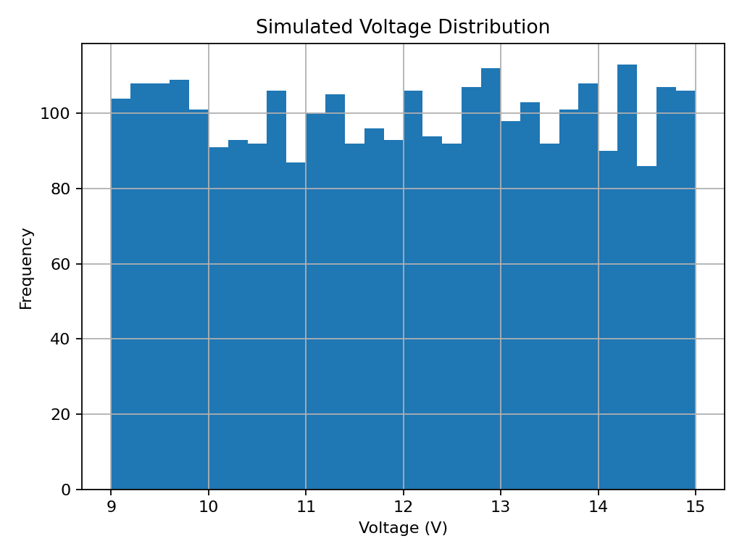

Confusion Matrix
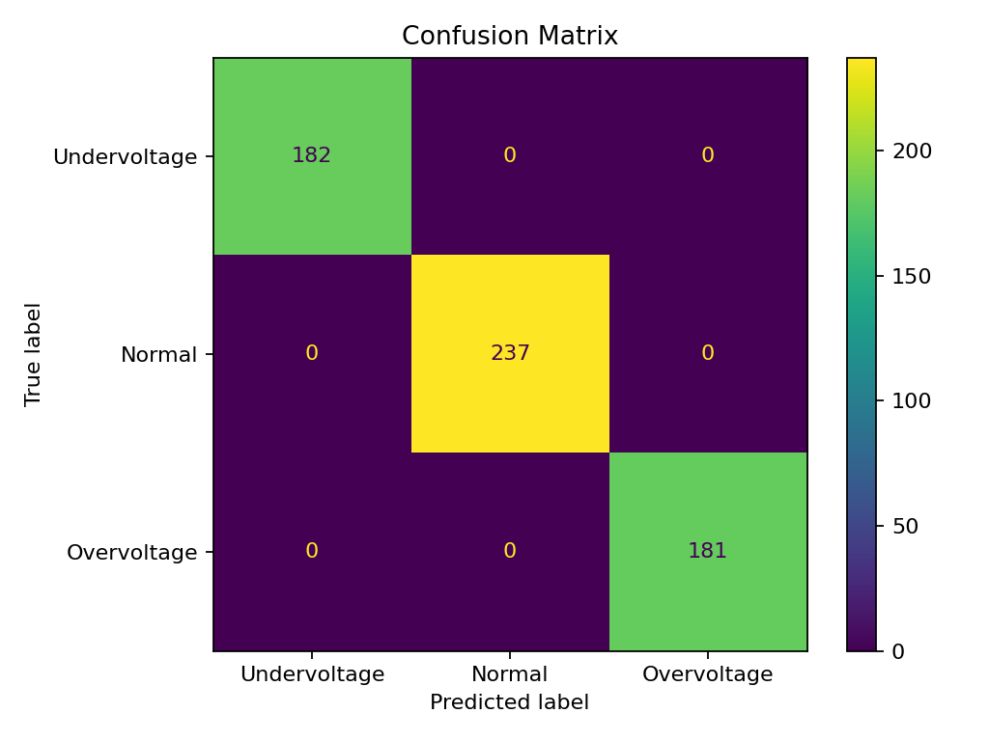

9. Test Cases
Test voltage | Expected rule label | Expected warning | Purpose
9.5 V | Undervoltage | Warning | Below lower threshold
12.0 V | Normal | Normal status | Within example range
14.0 V | Overvoltage | Warning | Above upper threshold

10. Limitations
- All data is simulated, not measured from a real electrical installation.
- Labels are deterministic threshold labels, so high accuracy is not independent evidence of fault detection.
- The demonstration does not include sensor drift, measurement error, transient events, or real equipment variability.
- The dashboard is not a certified protection device and must not be used for operational safety decisions.

11. Future Enhancements
- Use safely collected and independently labelled data from an isolated low-voltage setup.
- Add sensor calibration, noise handling, and missing-data checks.
- Evaluate on separate sessions or devices to avoid data leakage.
- Add time-series features such as rolling mean, rate of change, and recent voltage trends.
- Add a logging function and timestamped alert history.
- Compare Random Forest with Decision Tree and Support Vector Machine models.

12. Safety Considerations
Never connect a student-built circuit directly to mains electricity. Any physical demonstration must use an appropriate isolated, current-limited low-voltage source, correctly rated sensors, and instructor supervision. The software is for education and is not a substitute for fuses, protective relays, or certified voltage-monitoring equipment.

13. Conclusion
The project implements a complete introductory machine-learning workflow for three-class voltage condition classification, including synthetic data generation, EDA, model training, evaluation, and dashboard visualization. It provides a useful starting point for learning Python-based condition monitoring. Meaningful real-world claims require independent real data and safety-conscious validation.

Appendix: Running the Project
1. Install dependencies: pip install -r requirements.txt
2. Train the model and generate data: python train_model.py
3. Start the dashboard: streamlit run app.py

Viva Questions and Answers
- What is overvoltage?
A voltage above the acceptable upper limit defined for a particular system.
- What is undervoltage?
A voltage below the acceptable lower limit defined for a particular system.
- Why is Python used?
It has libraries for data processing, machine learning, visualization, and dashboards.
- What is Random Forest?
An ensemble algorithm that combines predictions from multiple decision trees.
- What is a feature?
An input variable used by the model, such as voltage, current, or load.
- What is a target label?
The class the model is trained to predict: Normal, Overvoltage, or Undervoltage.
- Why split the data?
To estimate model performance on records not used for fitting.
- What is accuracy?
The fraction of predictions that are correct.
- What is precision?
For a class, the fraction of predictions for that class that are correct.
- What is recall?
For a class, the fraction of actual class records correctly identified.
- What is an F1-score?
The harmonic mean of precision and recall.
- What is a confusion matrix?
A table comparing true classes with predicted classes.
- Why is accuracy 100% here?
The labels come directly from voltage thresholds and voltage is an input, so the task is easy by design.
- What is Streamlit?
A Python framework for creating interactive web applications and dashboards.
- Can this model protect a real circuit?
No. It is a teaching demonstration, not certified or validated protection equipment.

