Reference: GSL/ Admin/ MCM 38

Minutes of
Monthly Coordination Meeting
Date: 7th June 2012
Venue: GSL Conference Room 1

Time: 09:00 AM

- The thirty eight monthly coordination meeting of Genuity Systems Ltd. (GSL) was held on 8th May 2012 at Genuity Conference Room 1. The CEO, DO, DM and managers of different departments of the company were present. List of participants of the meeting are as follows:

SL. | Name of Participants | Department | Attendance Status
1. | M. Anis Rahman | Chief Executive Officer | Present
2. | Md. Sadiqur Rahman | Director Operations | Present
3. | K. Shahadat Hossain | Director Marketing | Present
4. | Md. Habibur Rahman | Admin & HR | Present
5. | Md. Waliul Haque Tusar | System Admin | Present
6. | Md. Aminul Islam | System Admin | Present
7. | Md. Samiul Aftad Chowdhury | Software | Present
8. | Sk. Kamruzzaman Prince | Corporate Affairs | Present
9. | Lutful Kabir Majumder | Call Center | Present
10. | Md. Ashrafuzzaman | Accounts | Present
11. | Md. Abdullah Al Masum | Training | Present

- The meeting was started by the Manager, Admin & HR. He thanked everyone for participating in the meeting and invited the CEO to take control of the meeting. The CEO warmly welcomed everyone present in the meeting and thanked them for their presence. Thereafter he requested all departmental managers to deliver respective speech, one at a time, highlighting departmental performance and issues during the past month. He invited all to raise queries/questions and participate in the discussion as deemed fit. The main points raised and discussed in the meeting over different issues are recorded below:

a. Department : Software
Head : Md. Samiul Aftad Chowdhury

Android: gTalk mobile dialer for android has been completed successfully. Also gTalk tab has been established which means that customers who are using gTalk in USA can now use it from anywhere in the world.
CEO said that we should start marketing the android solution in KSA very strongly so that clients are aware of it and can use it. We are trying to make gTalk VOIP based. If this is done then clients can use gTalk world wide through VOIP.

Revenue: Total collection on account of training in the month of April 2012 was Tk. 4.01 lacs and collection for the month of March 2012 was Tk. 13.94 lacs. The total amount of collection from April 2011 activities was Tk 7.17 lacs.

b. Department : International Carrier
Presented by : Md. Lutful Kabir Majumder

Department separation: CEO said that switch & dialer and route were under International Carrier department previously. Mr. Aminul and Mr. Rabi worked simultaneously for this department. But here there are 2 different products and services. Router is service while switch & dialer is the product. So these two products and services must be separated so that we can work dedicatedly. Thus from now on International Carrier will be International Voice Carrier and a new department, gPlex Software Solutions will be formed. Mr. Aminul will be the Head of Department of International Voice Carrier and Mr. Rabi will be Head of Marketing and sales of gPlex Software Solutions. Executives of the department will also be divided.

Sales Report: Detailed sales report for the month of May 2012 is as follows:

Item | Sales (USD) | Realized (USD) | Dis. & Pro (USD) | Unrealized (USD) | Qty. of Sales | % of Realization
gPlex Mobile Dialer | 82,350 | 81,718 | 0 | 632 | 7 | 99
gPlex Hosted Switch | 49,887 | 41,064 | 250 | 5,623 | 5 | 82
Total | 132,237 | 122,782 | 250 | 6,255

gPlex Switch Sales Report of May 2012

Month | Description | No. of Ch. | Sell | Qty of Sell
 |  |  | $
May-12 | gPlex Hosted Switch (NRC from New Clients) | 800 | 3,100 | 5
May-12 | gPlex Hosted Switch (NRC from Existing Clients) | 400 | 1,150 | 2
May-12 | Total NRC |  | 4,250
May-12 | gPlex Hosted Switch (MRC from New Clients) |  | 1,450
May-12 | gPlex Hosted Switch (MRC from Existing Clients) | 27,499 | 44,187 | 116
 | Total MRC |  | 45,637

gPlex Dialer Sales Report of May 2012
Month | Description | Capacity | Sell | Sales Unit
 |  |  | $
May-12 | gPlex Mobile Dialer (New Clients) | 550 | 11,700 | 7
May-12 | gPlex Mobile Dialer (Existing Client) | 13,140 | 70,650 | 92
 | Total Sales | 13,690 | 82,350 | 99

c. Department : Call Center (gTalk)
Manager : Md. Lutful Kabir Majumder

Traffic: traffic in Pakistan has increased to 1 million.

USA: TV advertisement for gTalk in Zee TV which was aired in USA has been stopped. For this reason traffic has decreased in USA.

Reported Monthly Data from the Department:

- Total number of gTalk customers till 31 May : 42,613
- Average client increase per day in May : 23
- Average client increase per day in April : 25
- Average total minutes per day in May : 284 K
- Average total minutes per day in April : 282 K
- Total customer used gTalk service in May : 20,133
- Total customer used gTalk service in April : 19,693

Unused Initial Balance for the month of May 2012: In the month of May, it has been found that total 42 customers have not used their Account Initial Balance after opening the account.

Current status after calling those customers is as follows:
- Customer using: 22 (53%)
- Customer still not using: 20 (47%)

Hot number uses:
- January (2012): 32%
- February (2012): 33%
- March (2012): 33%
- April (2012): 33%
- May (2012): 33%

Survey in May: In the month of May, a total of 870 customers who are inactive for at least 2 months have been called. Details about customer’s feedback are given below:

- Message left to the customers who were unavailable: 345 (40%)
- Number not in service: 204 (23%)
- Using other calling services or doesn’t make international calls: 185 (22%)
- Interested to use again: 134 (15%)
- Among 134 customers, 29 people have started to use gTalk service again after this survey.

gTalk UK:
- Total client joined in gTalk UK till 31 May 2012: 2,429
- Total client joined in May 2012: 200
- Total client joined in April 2012: 226
- Total client joined in March 2012: 335
- Total client joined in February 2012: 386

- Total minutes for the month of May 2012: 1242 K
- Total minutes for the month of April 2012: 1166 K
- Total minutes for the month of March 2012: 1198 K
- Total minutes for the month of February 2012: 934 k

- Total traffic by Months, Year 2011-2012

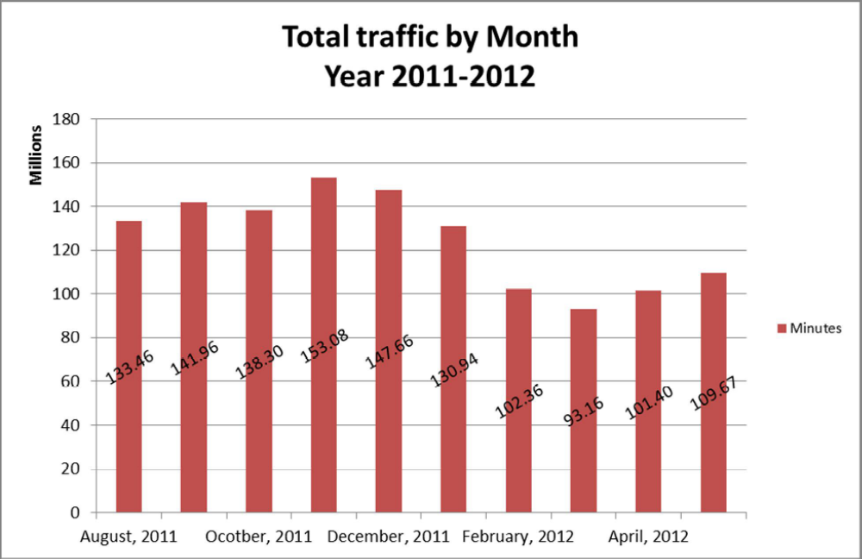

02(a). gTalk NA : Total Traffic by months. Year 2011-2012

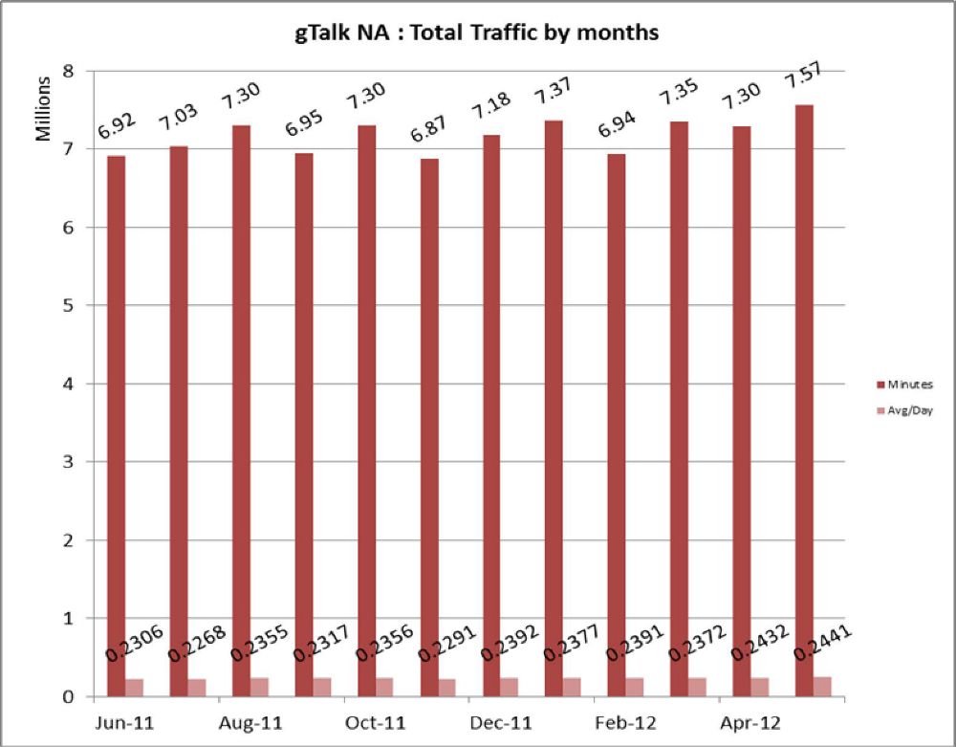

02(b). gTalk NA : New clients by months for the year 2011-2012

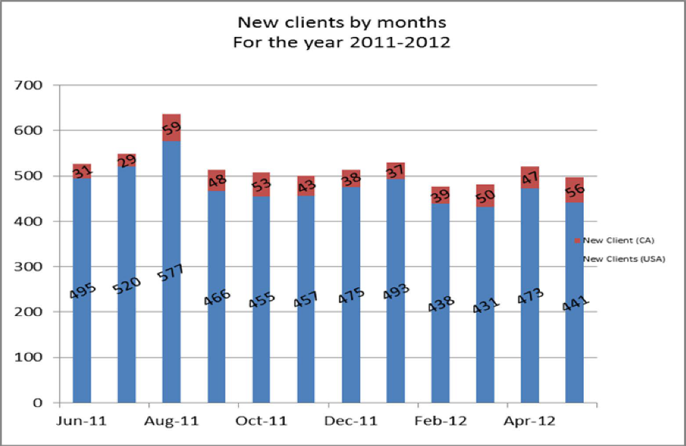

03(a). gTalk UK : Total Traffic by months for the year 2011-2012

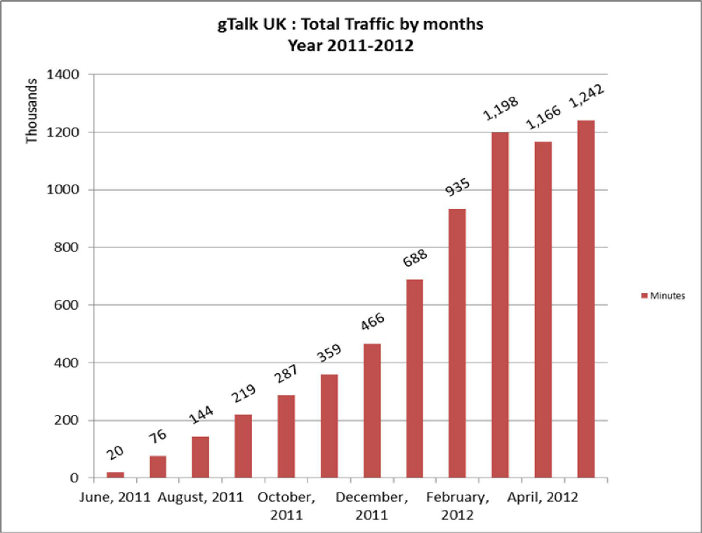

03(b). gTalk UK : New clients by months for the year 2011-2012

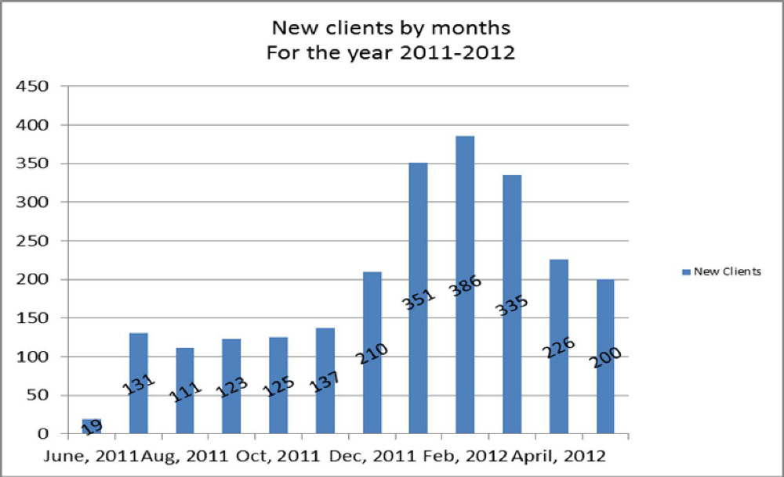

d. Department : Corporate
Manager : Sk. Kamruzzaman Prince

Banks: within 15th of this month, Premiere Bank will give the work order. Work order of City Bank worth 17 lacs is ready. SCB will increase 5 more channel of their call manager.

New client: deal is on the process with new client Shah Cement.

e. Department : Training
Manager : Md. Abdullah Al Masum

Current Status: Currently training department is running training in twelve batches. Among these two batches (Round 14 & 15) are being run for IDB. The other 10 batches are covering different customized courses.

Revenue: Total collection on account of training in the month of May 2012 was Tk. 8.47 lacs and collection for the month of April 2012 was Tk. 4.01 lacs. The total amount of collection from May 2011 activities was Tk 4.10 lacs.

f. Department : System Administration
System Administrator : Md. Waliul Haque Tusar

Recruitment: we have called interview for the job vacancies of our department. But unfortunately didn’t get the desired candidates. So we have given job advertisement again, will call for interview very soon.

- Director Marketing (DM)
K. Shahadat Hossain

Employee migration: some employees of Genuity Systems are being transferred to USA office, which is a very good initiative. This will increase employee motivation.

Oman: it is very difficult to visit Oman from Bangladesh. So we should now whether it is possible to send them who have USA passport.

- Director Operations (DO)
Mohammed Sadiqur Rahman

Software Department: employees from Software department are being transferred to USA. So this will create a gap in the department. We must start thinking from now to fulfill this gap.

i. Department : Admin & HR
Manager : Md. Habibur Rahman

Staffing: we recruit people only when there is demand from the respective department due to increased job duties. But if we knew the business plan of the departments, for example what new software will be introduced by Software department in the next 2 years, then we would be able to predict when and how many members are required at certain times in that department. But as we don’t have this, we are not able to do the HR plan.

Recruitment: recruitment is required in NOC department for which the processing has already started. Software department also needs recruitment; we will be starting the process very soon.

Evaluation: last month it was told to do evaluation by this month but till now no manager has done it. So by the 15th of this month, evaluation must be completed.

Banani Office: lift has been hanged in Banani office and it is in good condition.

Snacks and Monthly Expense related report for the month of May 2012:

Monthly Expense Report May 2012:

Sl. No. | Expenses | May | April
 |  | BDT | BDT
1 | General Stationary | 21,232 | 16,556
2 | Office Stationary | 9,030 | 6,190
3 | Computer Accessories | 28,350 | 17,710
4 | Tea/Coffee/Biscuit | 25,461 | 29,353
5 | Repairing | 0 | 2,241
6 | Electronic Item | 2,580 | 14,070
7 | Electronic Item (Training) | 11,000 | 0
9 | Conveyance | 380 | 480
10 | Furniture | 2,300 | 0
11 | Dining | 85,830 | 79,049
12 | Entertainment | 1,640 | 4,780
13 | Gift | 4,735 | 0
14 | Kitchen appliances | 220 | 0
15 | Others | 5,125 | 0
 | Total | 197,883 | 170,429

Monthly Snacks Report May 2012:

Sl. No. |  | May | April
 |  | BDT | BDT
1 | In-House Made | 33,195 | 30,441
 | Total Amount: | 33,195 | 30,441

Monthly Water Bill:

Sl. No. | Description | May | April
 |  | BDT | BDT
 | Monthly water bill | 19,964 | 17,629
 | Total Amount | 19,964 | 17,629

Monthly Gas & Fuel Bill May 2012:

Sl. No. | Description | May | April
 |  | BDT | BDT
 | Gas bill | 6,298 | 6,196
 | Octan bill | 470 | 470
 | Genusys Ltd.
 | Gas bill | 3,551 | 2,054
 | Octane bill | 470 | 470
 | Total Amount: | 10,789 | 9,190

 | Fuel (for generator) | 93,940 | 121,512
 | Cooling water | 3,448 | 1,200
 | Octan (small generator) | 3,760
 | Total Amount | 101,148 | 122,712

j. CEO
Md. Anis Rahman

USA Office: we will be hiring staffs now in USA office. The staffs will be a combination from Bangladesh and USA. In Bangladesh we don’t find much skilled employees for Software department, but this will not happen in USA. Now Mr. Rhythm and Mr. Rubel will be going to USA. Their work permit has been taken; they will go through H1 VISA.

Video Conference: we have the technology and infrastructure for video conferencing between USA and Bangladesh. But still we are not able to do this till now. We must take this matter seriously and work on this, so that we are able to do video conference.

At the end, CEO showed appreciation to everyone for their presence and thoughtful insights about the company and concluded the meeting by thanking to all.

