Reference: GSL/ Admin/ MCM 40

Minutes of
Monthly Coordination Meeting
Date: 7th August 2012
Venue: GSL Conference Room 1

Time: 09:00 AM

- The fortieth monthly coordination meeting of Genuity Systems Ltd. (GSL) was held on 7th August 2012 at Genuity Conference Room 1. The CEO, DO, DM and managers of different departments of the company were present. List of participants of the meeting are as follows:

SL. | Name of Participants | Department | Attendance Status
1. | M. Anis Rahman | Chief Executive Officer | Present
2. | Md. Sadiqur Rahman | Director Operations | Present
3. | K. Shahadat Hossain | Director Marketing | Present
4. | Md. Habibur Rahman | Admin & HR | Present
5. | Md. Waliul Haque Tusar | System Admin | Present
6. | Md. Aminul Islam | System Admin | Present
7. | Md. Samiul Aftad Chowdhury | Software | Present
8. | Sk. Kamruzzaman Prince | Corporate Affairs | Present
9. | Lutful Kabir Majumder | Call Center | Present
10. | Md. Ashrafuzzaman | Accounts | Present
11. | Md. Abdullah Al Masum | Training | Present

- The meeting was started by the Manager, Admin & HR. He thanked everyone for participating in the meeting and invited the CEO to take control of the meeting. The CEO warmly welcomed everyone present in the meeting and thanked them for their presence. Thereafter he requested all departmental managers to deliver respective speech, one at a time, highlighting departmental performance and issues during the past month. He invited all to raise queries/questions and participate in the discussion as deemed fit. The main points raised and discussed in the meeting over different issues are recorded below:

a. Department : Call Center (gTalk)
Manager : Md. Lutful Kabir Majumder
Current status of client joining and usage in gTalk pinless:

# Total client joined in gTalk till 31 July 2012: 44,014
# Average client increase per day in July, 12: 23
# Average client increase per day in June, 12: 23
# Average client increase per day in May, 12: 23
# Average client increase per day in April, 12: 25

# Average total Minutes per day in July, 12: 295.29 K
# Average total Minutes per day in June, 12: 288.93 K
# Average total Minutes per day in May, 12: 284.87 K
# Average total Minutes per day in April, 12: 282.79 K

# Total customer used gTalk service in July, 12 about 20,423
# Total customer used gTalk service in June, 12 about 20,144
# Total customer used gTalk service in May, 12 about 20,133
# Total customer used gTalk service in April, 12 about 19,693

Unused Initial Balance for the month of July: In the month of July, it has been found that total 26 customers have not used their Account Initial Balance after opening the account.

Current status after calling those customers is as follows:

- Customer using: 12 (46%)
- Customer still not using: 14 (54%)

Survey in July: In the month of July, a total of 542 customers who are inactive for at least 2 months have been called. Details about customer’s feedback are given below:

- Message left to the customers who were unavailable: 253 (47%)
- Number not in service: 149 (27%)
- Using other calling services or doesn’t make international calls: 88 (16%)
- Interested to use again: 52 (10%)
- Among 52 customers, 17 people have started to use gTalk service again after this survey.

Hot number uses:
July, 12: 33.61%
June, 12: 33.43%
May, 12: 33.36%
April, 12: 33.52%
March, 12: 33.25%
February, 12: 33.24%
January, 12: 32.31%

# Total client joined in gTalk UK till 31 July 2012: 2879

# Total client joined in July 2012: 266
# Total client joined in June 2012: 184
# Total client joined in May 2012: 200
# Total client joined in April 2012: 226
# Total client joined in March 2012: 335
# Total client joined in February 2012: 386

# Total Minutes for the month of July, 12: 1515.18 K
# Total Minutes for the month of June, 12: 1332.45 K
# Total Minutes for the month of May, 12: 1242.35 K
# Total Minutes for the month of April, 12: 1166.21 K
# Total Minutes for the month of March, 12: 1198.79 K
# Total Minutes for the month of February, 12: 934.66 K

b. Department : gPlex Switch & Dialer
Head of Marketing & Sales : Lutful Kabir Majumder

gPlex Switch and Dialer Sales Report
For the Month of July, 2012
Product Name | Sales (USD) | Realized (USD) | Dis.&Pro.(USD) | Unrealized (USD) | Qty. of Sales | % of Realization
gPlex Mobile Dialer | 75,530 | 71,638 | 0 | 3,892 | 12 | 95
gPlex Hosted Switch | 48,364 | 37,688 | 100 | 10,576 | 12 | 78
Total | 123,894 | 109,326 | 100 | 14,468

 | gPlex Switch Sales Report of July, 2012
Month | Description | No of Ch. | Sale | Qnt.of Sale
Jul-12 | gPlex Hosted Switch (NRC from New Clients) | 1500 | $ - | 12
Jul-12 | gPlex Hosted Switch (NRC from Existing Clients) | 500 | $ 1,000 | 1
Jul-12 | Total NRC : |  | $ 1,000
Jul-12 | gPlex Hosted Switch (MRC from New Clients) |  | $ 3,550
Jul-12 | gPlex Hosted Switch (MRC from Existing Clients) | 26800 | $ 43,814 | 109
Jul-12 | Total MRC : |  | $ 47,364
 | Total Sales of July, 2012 |  | $ 48,364
 | Discount |  | $ 100
 | Write off |  | $ 750
 | Current Due |  | $ 9,826
 | Cash Received |  | $ 34,984
 | Advanced Expired |  | $ 2,704
 | Total Sales : |  | $ 48,364
 | Total Cash Collected in July, 2012 : |  | $ 44,588
 | Advaced Received |  | $ 3,159
 | Due Realized of June |  | $ 5,916
 | Previous due Realized |  | $ 529
 | Cash Sale of Current Month |  | $ 34,984
 | Total Cash Sale including Advanced Expired : |  | $ 37,688
 | Net Cash flow to Sale % : |  | 78
 | Previous Due up to June, 2012 |  | $56,774
 | Due of June |  | $8,471
 | Due Realized of June |  | $5,916
 | Due Remained of June |  | $2,555
 | Previous Discount |  | $0
 | Previous Write off |  | $3,149
 | Due Realized upto May, 2012 |  | $529
 | Total Due Realized upto June, 2012 |  | $6,445
 | Due Remained upto June, 2012 |  | $47,180
 | Total Due Upto July, 2012 |  | $ 57,006

gPlex Dialer Sales Report of July, 2012
Month | Description |  | Capacity |  | Sale | Qty of Sales
Jul-12 | gPlex Mobile Dialer (New Clients) |  | 750 |  | $ 15,650 | 12
 | gPlex Mobile Dialer (Existing Clients) |  | 6150 |  | $ 59,880 | 90
 | Total Sales |  | 6900 |  | $ 75,530 | 102
Current Due |  | 3892
Discount |  | 0
Advanced Expired |  | 121
Total Cash Received |  | 71517
Total Sales : |  | 75530
Advanced Received |  | 85
Cash Sale Including Advanced Expired |  | 71638
Net Cash Flow to Sale % |  | 95
Previous Due Up to June, 2012 |  | 60061
Due of June |  | 2377
Due Realized of June |  | 2000
Due Remained of June |  | 377
Discount |  | 0
Due Realized upto May 2012 |  | 603
Written off(As no chance to realize) |  | 0
Total Due Realized upto June 2012 |  | 2603
Due Remained upto June, 2012 |  | 57458
Total Due Up to July, 2012 |  | 61350

c. Department : International Voice Carrier
Head of the department : Md. Aminul Islam

Monthly traffic and client report for the month of July 2012

Coverage area:
01. Total Traffic
02. gTalk Total Traffic
03. gTalkNA
04. gTalkUK

01. Total Traffic

01. Total traffic by Months, Year 2011-2012

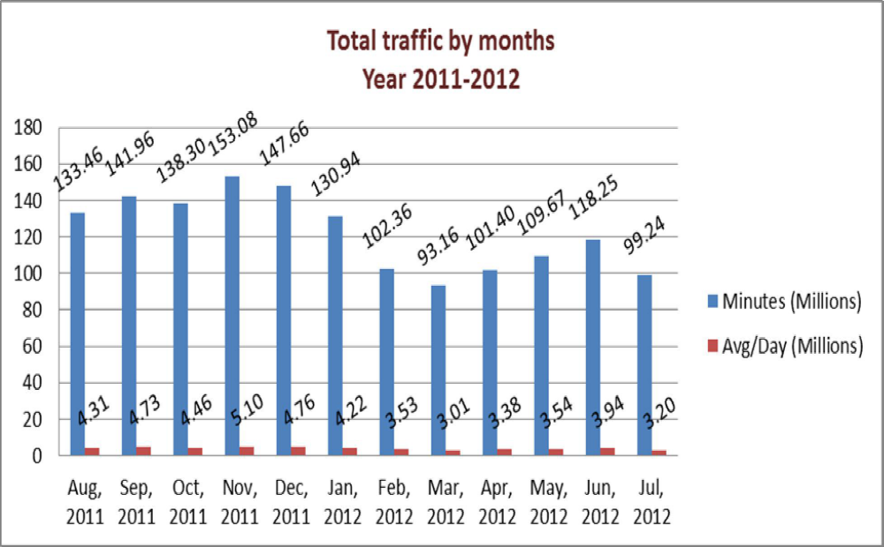

02. gTalk Total Traffic

02. gTalk : Total Traffic by months. Year 2012

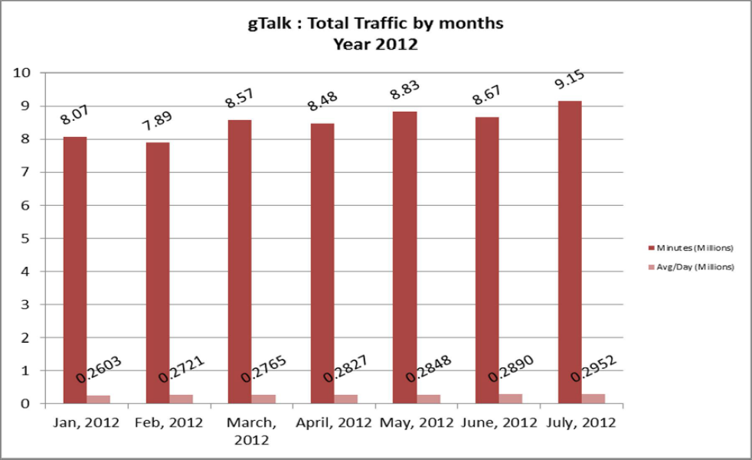

03. gTalk NA

03(a). gTalk NA : Total Traffic by months. Year 2011-2012

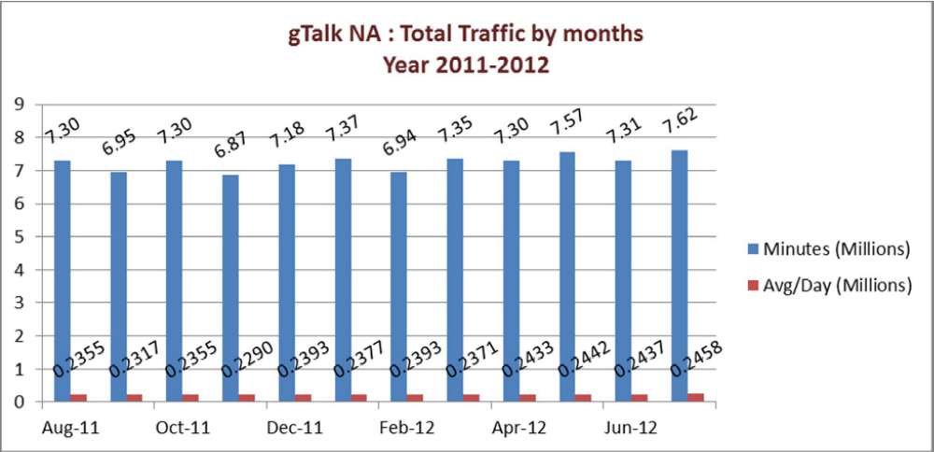

03(b). gTalk NA : New clients by months for the year 2011-2012

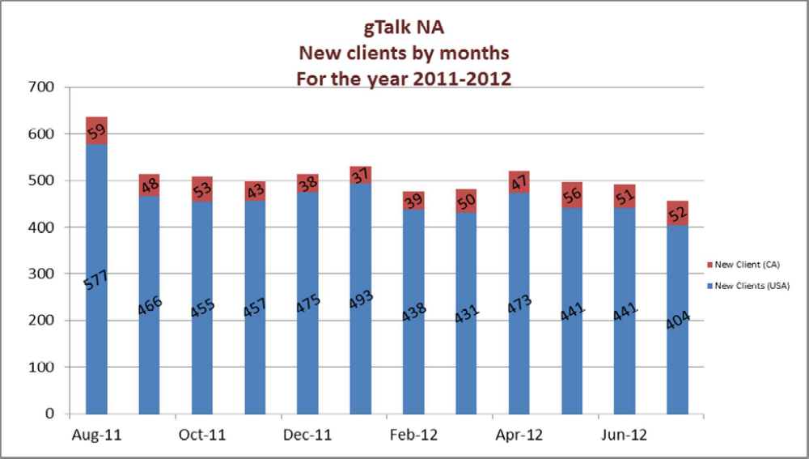

04. gTalk UK
04(a). gTalk UK : Total Traffic by months for the year 2011-2012

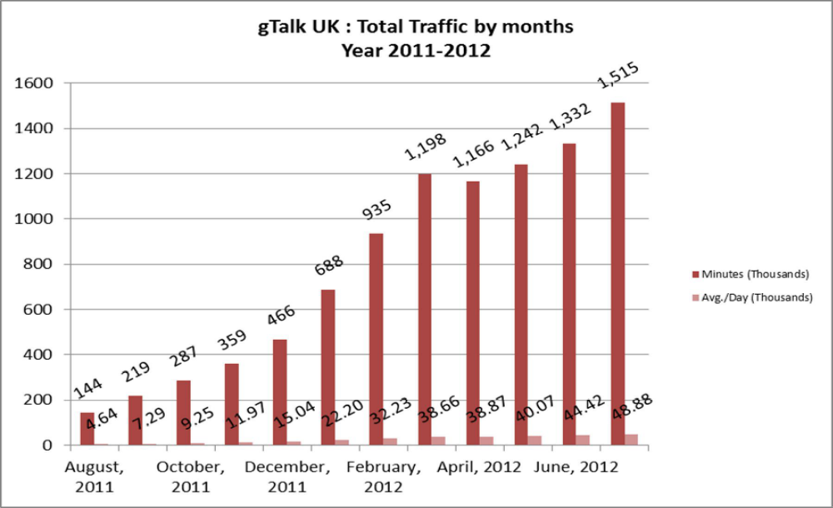

04(b). gTalk UK : New clients by months for the year 2011-2012

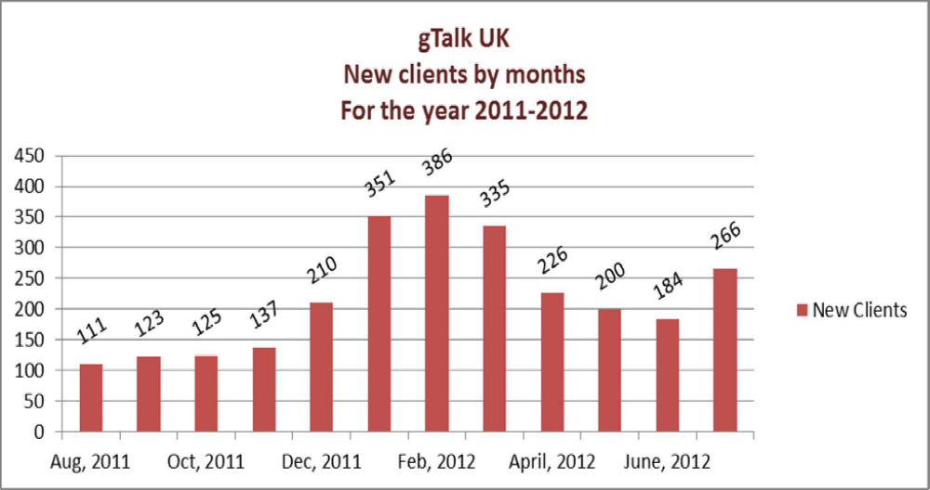

- Department : Software
Head of the Department : Md. Samiul Aftad Chowdhury

Application: we are working on gTalk user voice application; almost 95% of the work has been completed.

e. Department : Corporate
Manager : Sk. Kamruzzaman Prince

IDLC & Bashundhara: we are negotiating with both IDLC and Bashundhara about our Call Center solution. IDLC wants to connect 31 offices of Bangladesh through IPBBX. We already had a meeting with IDLC in office regarding this matter. We have given offer letter to Bashundhara, they will let us know.

Work orders: Shah Cement will give us work order very soon. We have received work order worth 17 lacs from City Bank.

f. Department : Training
Manager : Md. Abdullah Al Masum

Current Status: Currently training department is running training in fourteen batches. Among these three batches (Round 14, 15 & 16) are being run for IDB. The other 10 batches are covering different customized courses.

Revenue: Total collection on account of training in the month of July 2012 was Tk. 7.78 lacs and collection for the month of June 2012 was Tk. 12.69 lacs. The total amount of collection from July 2012 activities was Tk 10.57 lacs.

g. CEO
Md. Anis Rahman

Datamoat: we will launch Datamoat with the features added till now. If anymore features are required then we will add them later.

BTCL: we have won the case which we had against BTCL for some legal issue. We have planned to go to International Court to file loss suit against them but BTCL has offered us to settle the matter outside court. After some serious consideration we thought that the offer which BTCL is giving us will cover most of the loss that we have incurred, so we are going for outside court deal with BTCL.

Problems, solutions & new projects: there were some problems in Call Center solutions which are solved now. We have also worked on gPlex switch version 2.6. we have started another project, WiFi management, we will implement this first on WiFi network of Genuity Systems.

Blocks in Middle East: we are working on all the blocks of Dew in KSA, Oman and Dubai. Within 7 days it will be completed.

At the end, CEO showed appreciation to everyone for their presence and thoughtful insights about the company and concluded the meeting by thanking to all.

