Reference: GSL/ Admin/ MCM 42

Minutes of
Monthly Coordination Meeting
Date: 10th October 2012
Venue: GSL Conference Room 1

Time: 09:00 AM

- The forty second monthly coordination meeting of Genuity Systems Ltd. (GSL) was held on 10th October 2012 at Genuity Conference Room 1. The CEO, DO, DM and managers of different departments of the company were present. List of participants of the meeting are as follows:

SL. | Name of Participants | Department | Attendance Status
1. | M. Anis Rahman | Chief Executive Officer | Present
2. | Md. Sadiqur Rahman | Director Operations | Present
3. | K. Shahadat Hossain | Director Marketing | Present
4. | Md. Habibur Rahman | Admin & HR | Present
5. | Md. Waliul Haque Tusar | System Admin | Present
6. | Md. Aminul Islam | Head of International Voice Carrier | Present
7. | Sk. Kamruzzaman Prince | Corporate Affairs | Present
8. | Lutful Kabir Majumder | Call Center | Present
9. | Md. Ashrafuzzaman | Accounts | Present
10. | Md. Abdullah Al Masum | Training | Present

- The meeting was started by the Manager, Admin & HR. He thanked everyone for participating in the meeting and invited the CEO to take control of the meeting. The CEO warmly welcomed everyone present in the meeting and thanked them for their presence. Thereafter he requested all departmental managers to deliver respective speech, one at a time, highlighting departmental performance and issues during the past month. He invited all to raise queries/questions and participate in the discussion as deemed fit. The main points raised and discussed in the meeting over different issues are recorded below:

a. Department : Corporate
Manager : Sk. Kamruzzaman Prince

BRTC: BTRC is giving VOIP license for small entrepreneurs. We must decide whether we should also take the license. So it was decided that this decision will be taken after the meeting adjourns.
CEO informed that the loan that BTRC owes from us will be settled within next 12 months.

New IGW: we are doing business with new IGWs according to our capacity.
Summary Report on call center solution sale and collection:

- Total collection with work order in hand till September 2012 since 2008 : BDT 2.79 cror
(excluding bad debts : BDT 21.00 lac )
  - Total expense on Hardware purchase : BDT 80.00 lac
- Total expense against marketing promotion/gifts : BDT 3.00 lac
- Gross income: BDT 1.96 cror ( 70.25% )

Call Center Solution sale with AMC & Rent in 2012:

- SLA/AMC : BDT 11.76 lac ( SCB & City Bank )
- Rent : BDT 24.60 lac ( Bank Asia & SCB )
- Work Order : BDT 64.00 lac ( City Bank , SCB & Shah Cement )
Grand Total: BDT 1.00 cror

Total collection in 2012 : BDT 38.39 lac

SLA & Rent in Every year: BDT 41.89 lac ( on existing sell only; even NO new sell is made )

Prospective Clients:

- Bank Asia ( New Project – 30 seat / onetime purchase )
- Lanka Bangla
- Premier Bank
- Apollo Hospitals
- IDLC ( IP PBX )
DPDC (Govt. Tender)

b. Department : Training
Manager : Md. Abdullah Al Masum

Current Status: Currently training department is running training in fifteen batches. Among these three batches (Round 14, 15 & 16) are being run for IDB. The other 12 batches are covering different customized courses.

Revenue: Total collection on account of training in the month of September 2012 was Tk. 7.25 lacs and collection for the month of August 2012 was Tk. 7.72 lacs. The total amount of collection from September 2011 activities was Tk 6.32 lacs.

Oracle: Oracle has some certified courses, now we are going to make an agreement with them regarding these courses.

Non-technical courses: there are some non-technical courses like GMAT, IELTS, etc. We are now planning whether it is possible to include these courses in Genuity Training.

c. Department : Call Center (gTalk)
Manager : Md. Lutful Kabir Majumder

Call pressure: call pressure in UK has increased drastically after the UK gTalk service. For this reason call drop has also increased. To avoid the call dropping, we have altered the schedule by putting more agents in peak hour and fewer agents in off peak. For the time being this process can be done but in the near future more agents will be required. But before recruiting more manpower, thus increasing cost, we must think if we can give required support by using IVR technology.

Current status of client joining and usage in gTalk pinless:

# Total client joined in gTalk till 30 September 2012: 45,611
# Average client increase per day in September, 12: 24
# Average client increase per day in August, 12: 28
# Average client increase per day in July, 12: 23
# Average client increase per day in June, 12: 23

# Average total Minutes per day in September, 12: 308.13 K
# Average total Minutes per day in August, 12: 315.90 K
# Average total Minutes per day in July, 12: 295.29 K
# Average total Minutes per day in June, 12: 288.93 K

# Total customer used gTalk service in September, 12 about 21,305
# Total customer used gTalk service in August, 12 about 21,093
# Total customer used gTalk service in July, 12 about 20,423
# Total customer used gTalk service in June, 12 about 20,144

Unused Initial Balance for the month of September: In the month of September, it has been found that total 38 customers have not used their Account Initial Balance after opening the account.

Current status after calling those customers is as follows:

- Customer using: 24 (64%)
- Customer still not using: 14 (36%)

Survey in September: In the month of September, a total of 540 customers who are inactive for at least 2 months have been called. Details about customer’s feedback are given below:

- Message left to the customers who were unavailable: 183 (33%)
- Number not in service: 133 (25%)
- Using other calling services or doesn’t make international calls: 127 (24%)
- Interested to use again: 97 (18%)
- Among 97 customers, 14 people have started to use gTalk service again after this survey.

Hot number uses:
September, 12: 34.49%
August, 12: 33.50%
July, 12: 33.61%
June, 12: 33.43%
May, 12: 33.36%
April, 12: 33.52%
March, 12: 33.25%

# Total client joined in gTalk UK till 30 September 2012: 3480

# Total client joined in September 2012: 284
# Total client joined in August 2012: 317
# Total client joined in July 2012: 266
# Total client joined in June 2012: 184
# Total client joined in May 2012: 200
# Total client joined in April 2012: 226

# Total Minutes for the month of September, 12: 1735.31 K
# Total Minutes for the month of August, 12: 1762.62 K
# Total Minutes for the month of July, 12: 1515.18 K
# Total Minutes for the month of June, 12: 1332.45 K
# Total Minutes for the month of May, 12: 1242.35 K
# Total Minutes for the month of April, 12: 1166.21 K

d. Department : gPlex Switch & Dialer
Head of Marketing & Sales : Lutful Kabir Majumder

IVR: clients of switch have high demand for IVR. This demand is very severe and should be given high priority or else clients will decrease.

gPlex Switch and Dialer Sales Report
For the Month of September, 2012
Product Name | Sales (USD) | Realized (USD) | Dis.&Pro.(USD) | Unrealized (USD) | Qty. of Sales | % of Realization
gPlex Mobile Dialer | 85,350 | 83,703 | 0 | 1,647 | 15 | 98
gPlex Hosted Switch | 43,714 | 28,592 | 1,395 | 13,727 | 2 | 65
Total | 129,064 | 112,295 | 1,395 | 15,374

 | gPlex Switch Sales Report of September, 2012
Month | Description | No of Ch. | Sale | Qnt.of Sale
Sep-12 | gPlex Hosted Switch (NRC from New Clients) | 0 | $ - | 2
Sep-12 | gPlex Hosted Switch (NRC from Existing Clients) | 0 | $ -
Sep-12 | Total NRC : |  | $ -
Sep-12 | gPlex Hosted Switch (MRC from New Clients) | 300 | $ 600
Sep-12 | gPlex Hosted Switch (MRC from Existing Clients) | 26200 | $ 43,114 | 108
Sep-12 | Total MRC : |  | $ 43,714
 | Total Sales of September, 2012 |  | $ 43,714
 | Discount |  | $ 695
 | Write off |  | $ 700
 | Current Due |  | $ 13,727
 | Cash Received |  | $ 28,265
 | Advanced Expired |  | $ 327
 | Total Sales : |  | $ 43,714
 | Total Cash Collected in September, 2012 : |  | $ 34,030
 | Advaced Received |  | $ 347
 | Due Realized of August |  | $ 5,381
 | Previous due Realized |  | $ 37
 | Cash Sale of Current Month |  | $ 28,265
 | Total Cash Sale including Advanced Expired : |  | $ 28,592
 | Net Cash flow to Sale % : |  | 65
 | Previous Due up to August, 2012 |  | $58,387
 | Due of August |  | $13,727
 | Due Realized of August |  | $5,381
 | Due Remained of August |  | $8,346
 | Previous Discount |  | $0
 | Previous Write off |  | $372
 | Due Realized upto July, 2012 |  | $37
 | Total Due Realized upto August, 2012 |  | $5,418
 | Due Remained upto August, 2012 |  | $52,597
 | Total Due Upto September, 2012 |  | $ 66,324

gPlex Dialer Sales Report of September, 2012
Month | Description | Capacity | Sale | Qty of Sales
Sep-12 | gPlex Mobile Dialer (New Clients) | 900 | $ 23,350 | 15
 | gPlex Mobile Dialer (Existing Clients) | 5600 | $ 62,000 | 87
 | Total Sales | 6500 | $ 85,350 | 102
 | Current Due |  | 1647
 | Discount |  | 0
 | Advanced Expired |  | 66
 | Total Cash Received |  | 83637
 | Total Sales : |  | 85350
 | Advanced Received |  | 9
 | Cash Sale Including Advanced Expired |  | 83703
 | Net Cash Flow to Sale % |  | 98
 | Previous Due Upto August, 2012 |  | 63063
 | Due of August |  | 2367
 | Due Realized of August |  | 750
 | Due Remained of August |  | 1617
 | Discount |  | 0
 | Due Realized upto July 2012 |  | 1530
 | Written off(As no chance to realize) |  | 0
 | Total Due Realized upto August 2012 |  | 2280
 | Due Remained upto August, 2012 |  | 60783
 | Total Due Upto September, 2012 |  | 62430

e. Department : International Voice Carrier
Head of the department : Md. Aminul Islam

Monthly traffic and client report for the month of September 2012

Coverage area:
01. Total Traffic
02. gTalk Total Traffic
03. gTalkNA
04. gTalkUK

01. Total Traffic

01. Total traffic by Months, Year 2011-2012

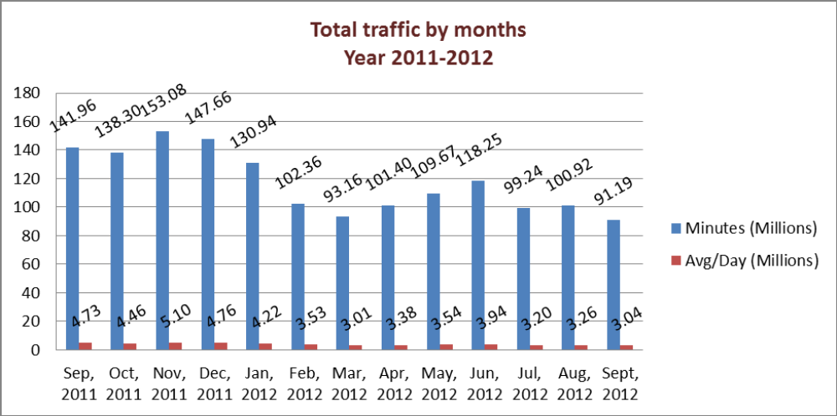

02. gTalk Total Traffic

02. gTalk : Total Traffic by months. Year 2012

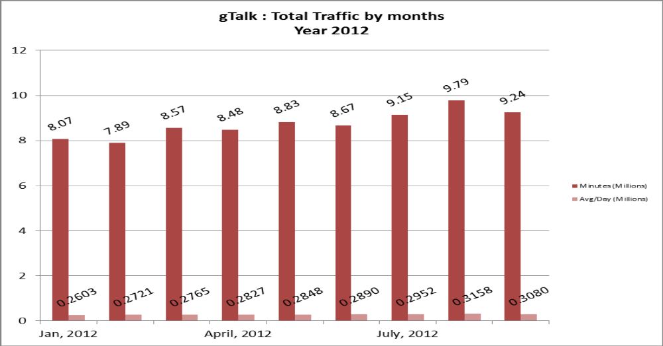

03. gTalk NA

03(a). gTalk NA : Total Traffic by months. Year 2011-2012

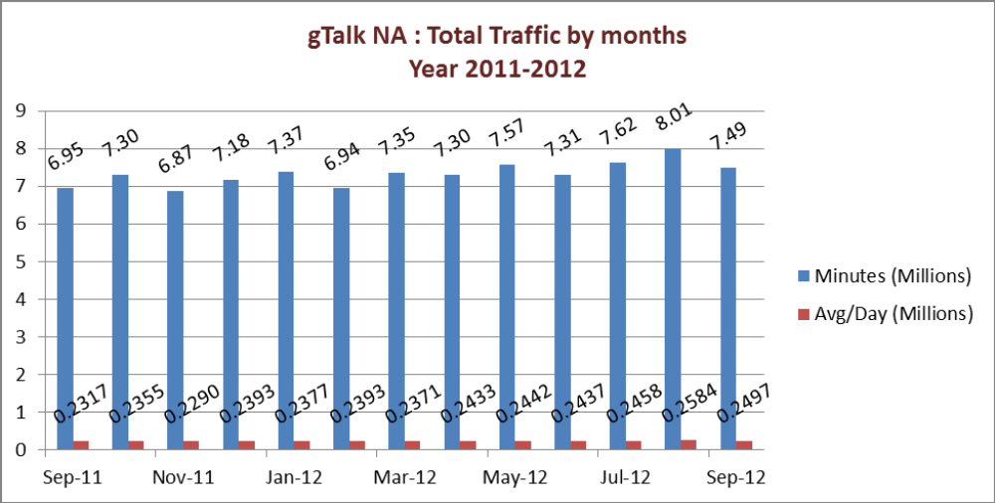
03(b). gTalk NA : New clients by months for the year 2011-2012

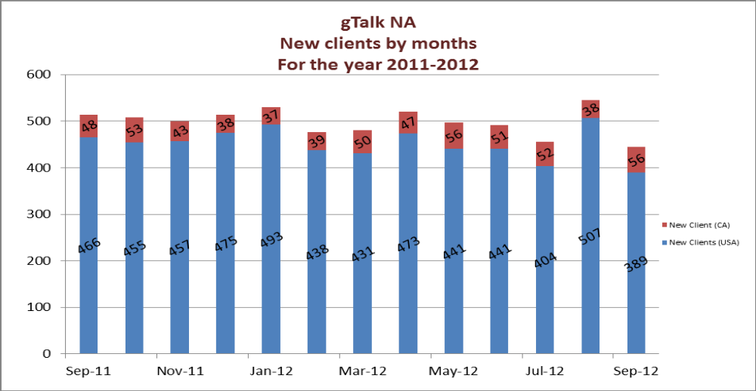

04. gTalk UK
04(a). gTalk UK : Total Traffic by months for the year 2011-2012

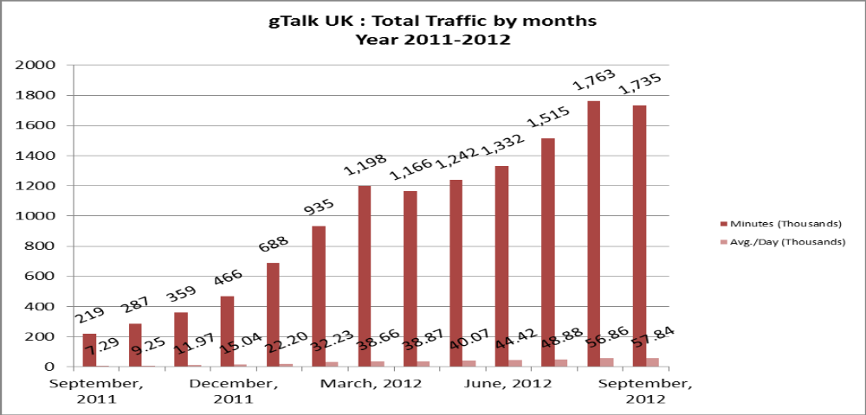

04(b). gTalk UK : New clients by months for the year 2011-2012

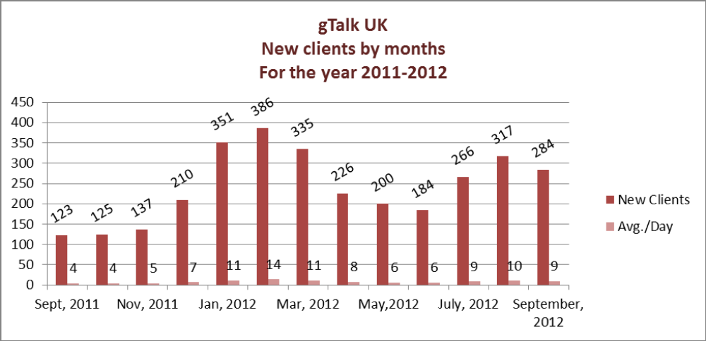

f. Department : Admin & HR
Manager : Md. Habibur Rahman

Job description: the instruction that CEO has given for job description and designation, has not been properly implemented. Managers of HR & Admin, Training, System Administration and gPlex Software Solutions has given the job descriptions till now; others has not given it yet. And the job descriptions that was given is very generalized, which does not provide the overall job pattern of the department. Only System Administration has given suggestion for designations, others have not. If all the departmental managers are not willing to work with HR department in this regard, then it is not possible to complete this process and thus will have to take help from outside.

Calendar: design has been made, now only selection of the pictures that we will buy is left.

Resignation: Md. Sakib Hasan Khan of gPlex Software Solutions has given resignation and it has been accepted according to the policy.

Emergency door unlock: we have installed emergency door unlock system in all the floors.

Health check-up: we have started the facility of annual health check-up for Admin (MLSS).

Software: head of software department has joined Genusys Inc. in USA. Thus a new head is required in that department. Decisions must be taken very soon.

g. CEO
Md. Anis Rahman

Plexstar: Plexstar has finished its 2 years. Though we wanted this product to be finished rather soon, but it wasn’t possible. Now we are hoping that by January 2013 we will be launching this product and will also start marketing. For marketing we will need more employees which we may recruit from USA or Bangladesh Office.

At the end, CEO showed appreciation to everyone for their presence and thoughtful insights about the company and concluded the meeting by thanking to all.

