Reference: GSL/ Admin/ MCM 44

Minutes of
44th Monthly Coordination Meeting
Date: 12th December 2012
Venue: GSL Conference Room 1

Time: 09:00 AM

- The forty forth monthly coordination meeting of Genuity Systems Ltd. (GSL) was held on 12th December 2012 at Genuity Conference Room 1. The CEO, DO, DM and managers of different departments of the company were present. List of participants of the meeting are as follows:

SL. | Name of Participants | Department | Signature
1. | Habib Rahman | President | Present
2. | M. Anis Rahman | Chief Executive Officer | Present
3. | Md. Sadiqur Rahman | Director Operations | Present
4. | K. Shahadat Hossain | Director Marketing | Present
5. | Md. Habibur Rahman | Admin & HR | Present
6. | Md. Waliul Haque Tusar | System Admin | Present
7. | Md. Aminul Islam | Head of International Voice Carrier | Present
8. | Sk. Kamruzzaman Prince | Corporate Affairs | Present
9. | Lutful Kabir Majumder | Call Center | Present
10. | Md. Ashrafuzzaman | Accounts | Present
11. | Md. Abdullah Al Masum | Training | Present

- The meeting was started by the Manager, Admin & HR. He thanked everyone for participating in the meeting and invited the CEO to take control of the meeting. The CEO warmly welcomed everyone present in the meeting and thanked them for their presence. Thereafter he requested all departmental managers to deliver respective speech, one at a time, highlighting departmental performance and issues during the past month. He invited all to raise queries/questions and participate in the discussion as deemed fit. The main points raised and discussed in the meeting over different issues are recorded below:

a. Department : Training
Manager : Md. Abdullah Al Masum

Current Status: Currently training department is running training in twenty six batches. Among these three batches (Round 15, 16, 18) are being run for IDB. The other 21 batches are covering different customized courses.

Revenue: Total collection on account of training in the month of November 2012 was Tk. 6.75 lacs and collection for the month of October 2012 was Tk. 6.88 lacs. The total amount of collection from November 2011 activities was Tk 9.50 lacs.

b. Department : International Voice Carrier
Head of the department : Md. Aminul Islam

Monthly traffic and client report for the month of November 2012

Coverage area:
01. Total Traffic
02. gTalk Total Traffic
03. gTalkNA
04. gTalkUK

01. Total Traffic

01. Total traffic by Months, Year 2011-2012

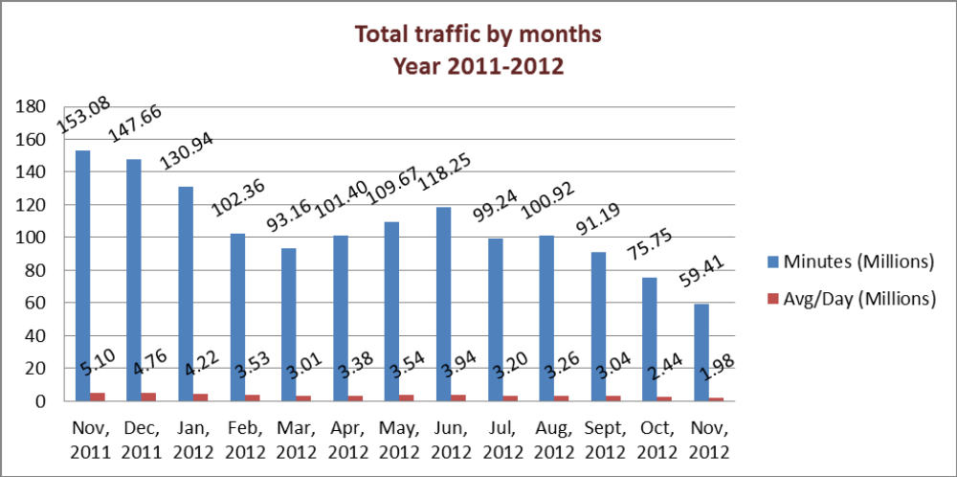

02. gTalk Total Traffic

02. gTalk : Total Traffic by months. Year 2012

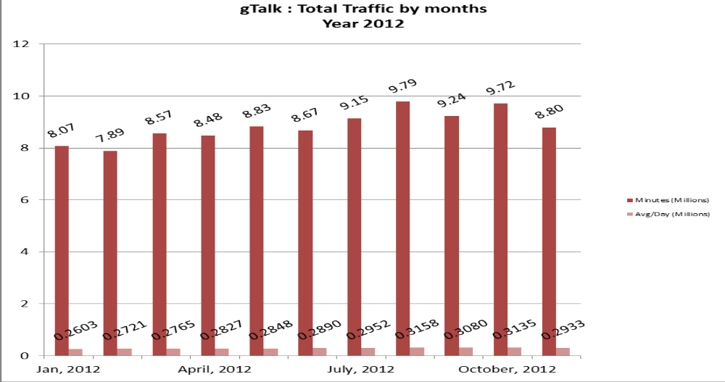

03. gTalk NA

03(a). gTalk NA : Total Traffic by months. Year 2011-2012

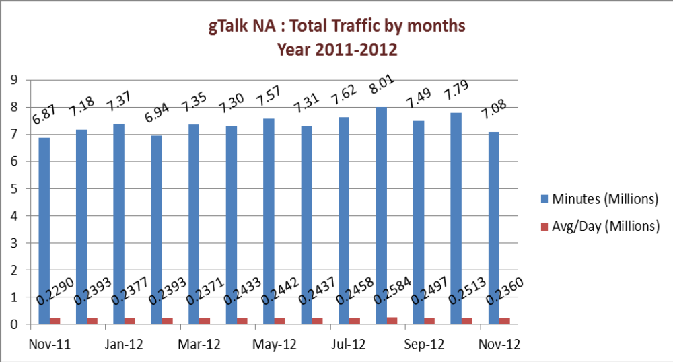

03(b). gTalk NA : New clients by months for the year 2011-2012

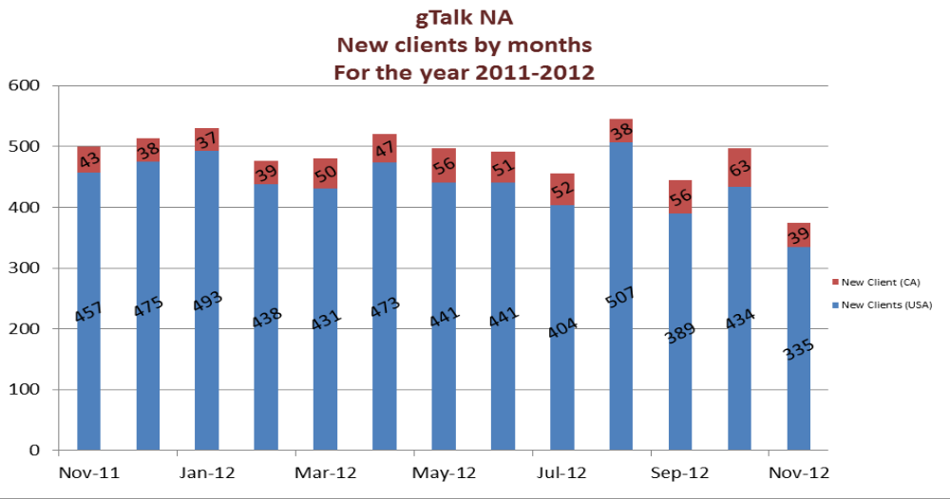

04. gTalk UK
04(a). gTalk UK : Total Traffic by months for the year 2011-2012

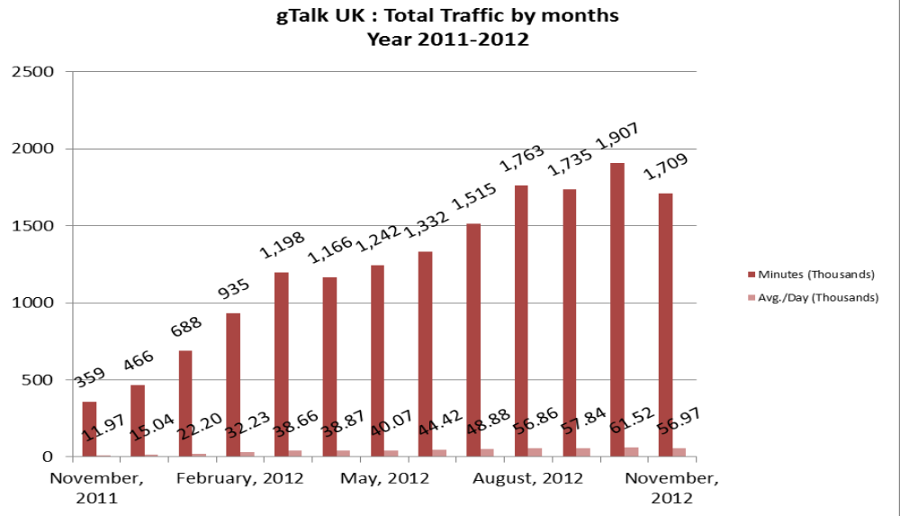

04(b). gTalk UK : New clients by months for the year 2011-2012

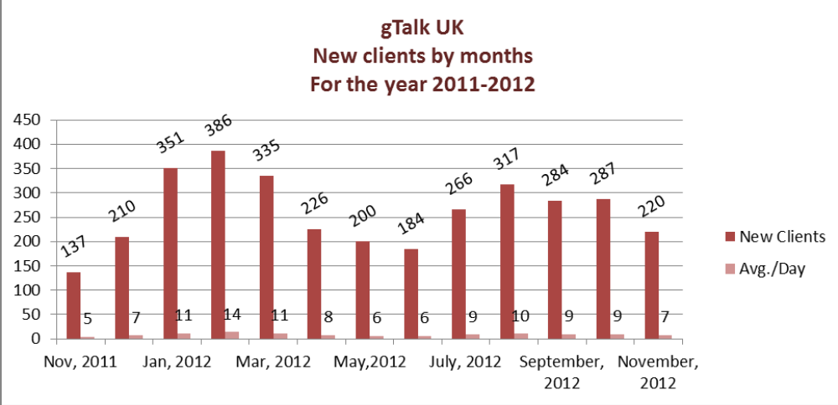
New Markets: Carrier business has become saturated, in fact BTCL itself is doing illegal
Business. So our profit margin has drastically fallen. To overcome this situation we need
to think of going to new markets like Africa.

New contract with IGWs: Internally we have contract with some IGWs that if we give
them some volume or call, they either pay us in return or they might give us some call. But now we need to make a bilateral contract in a way so that if we give them some call, they will also have to give us some call. Thus the main business stream will be through minutes. This condition need to be made strong in order to make business for both parties.

c. Department : gPlex Software Solutions
Head of Marketing & Sales : Lutful Kabir Majumder

Problems in dialer and switch:

gPlex Switch and Dialer Sales Report
For the Month of November, 2012
Product Name | Sales (USD) | Realized (USD) | Dis.&Pro.(USD) | Unrealized (USD) | Qty. of Sales | % of Realization
gPlex Mobile Dialer | 66,800 | 64,712 | 0 | 2,088 | 8 | 97
gPlex Hosted Switch | 36,714 | 25,003 | 700 | 11,011 | 3 | 68
Total | 103,514 | 89,715 | 700 | 13,099

 | gPlex Switch Sales Report of November, 2012
Month | Description | No of Ch. | Sale | Qnt.of Sale
Nov-12 | gPlex Hosted Switch (NRC from New Clients) | 0 | $ - | 3
Nov-12 | gPlex Hosted Switch (NRC from Existing Clients) | 0 | $ -
Nov-12 | Total NRC : |  | $ -
Nov-12 | gPlex Hosted Switch (MRC from New Clients) | 600 | $ 1,050
Nov-12 | gPlex Hosted Switch (MRC from Existing Clients) | 21500 | $ 35,664 | 93
Nov-12 | Total MRC : |  | $36,714
 | Total Sales of November, 2012 |  | $ 36,714
 | Discount |  | $ 100
 | Write off |  | $ 600
 | Current Due |  | $ 11,011
 | Cash Received |  | $ 24,626
 | Advanced Expired |  | $ 377
 | Total Sales : |  | $ 36,714
 | Total Cash Collected in November, 2012 : |  | $ 29,765
 | Advanced Received |  | $ 757
 | Due Realized of October |  | $ 4,363
 | Previous due Realized |  | $ 19
 | Cash Sale of Current Month |  | $ 24,626
 | Total Cash Sale including Advanced Expired : |  | $ 25,003
 | Net Cash flow to Sale % : |  | 68
 | Previous Due up to October, 2012 |  | $73,250
 | Due of October |  | $14,070
 | Due Realized of October |  | $4,363
 | Due Remained of October |  | $9,707
 | Previous Discount |  | $0
 | Previous Write off |  | $1,265
 | Due Realized upto September, 2012 |  | $19
 | Total Due Realized upto October, 2012 |  | $4,382
 | Due Remained upto October, 2012 |  | $67,603
 | Total Due Upto November, 2012 |  | $ 78,614

gPlex Dialer Sales Report of November, 2012
Month | Description | Capacity | Sale | Qty of Sales
Nov-12 | gPlex Mobile Dialer (New Clients) | 500 | $ 12,600 | 8
 | gPlex Mobile Dialer (Existing Clients) | 7050 | $ 54,200 | 76
 | Total Sales | 7550 | $ 66,800 | 84
 | Current Due |  | 2088
 | Discount |  | 0
 | Advanced Expired |  | 5
 | Total Cash Received |  | 64707
 | Total Sales : |  | 66800
 | Advanced Received |  | 93
 | Cash Sale Including Advanced Expired |  | 64712
 | Net Cash Flow to Sale % |  | 93
 | Previous Due Upto September, 2012 |  | 63400
 | Due of September |  | 2552
 | Due Realized of September |  | 602
 | Due Remained of September |  | 1950
 | Discount |  | 0
 | Due Realized upto August 2012 |  | 0
 | Written off(As no chance to realize) |  | 0
 | Total Due Realized upto September 2012 |  | 602
 | Due Remained upto September, 2012 |  | 62798
 | Total Due Upto October, 2012 |  | 64886

Problems in switch & dialer: The programmers are giving more focus on some new features and problems of call center which is interrupting the normal work flow of switch and dialer and some of their problems are remaining unsolved. As a result the profitable business is being hampered and the sell is being dropped. These problems need to be solved as soon as possible.

d. Department : Call Center (gTalk)
Manager : Md. Lutful Kabir Majumder

Current status of client joining and usage in gTalk pinless:

# Total client joined in gTalk till 30 November 2012: 46,994

# Average client increase per day in November, 12: 20
# Average client increase per day in October, 12: 25
# Average client increase per day in September, 12: 24
# Average client increase per day in August, 12: 28

# Average total Minutes per day in November, 12: 293.27 K
# Average total Minutes per day in October, 12: 313.40 K
# Average total Minutes per day in September, 12: 308.13 K
# Average total Minutes per day in August, 12: 315.90 K

# Total customer used gTalk service in November, 12 about 21,619
# Total customer used gTalk service in October, 12 about 21,698
# Total customer used gTalk service in September, 12 about 21,305
# Total customer used gTalk service in August, 12 about 21,093

Unused Initial Balance for the month of November: In the month of November, it has been found that total 46 customers have not used their Account Initial Balance after opening the account.

Current status after calling those customers is as follows:

- Customer using: 28 (61%)
- Customer still not using: 18 (39%)

Survey in November: In the month of November, a total of 852 customers who are inactive for at least 2 months have been called. Details about customer’s feedback are given below:

- Message left to the customers who were unavailable: 367 (43%)
- Number not in service: 235 (28%)
- Using other calling services or doesn’t make international calls: 166 (19%)
- Interested to use again: 84 (10%)
- Among 84 customers, 9 people have started to use gTalk service again after this survey.

Hot number uses:
November, 12: 34.38%
October, 12: 33.37%
September, 12: 34.49%
August, 12: 33.50%

# Total client joined in gTalk UK till 30 November 2012: 3987

# Total client joined in November 2012: 220
# Total client joined in October 2012: 287
# Total client joined in September 2012: 284
# Total client joined in August 2012: 317
# Total client joined in July 2012: 266
# Total client joined in June 2012: 184
# Total client joined in May 2012: 200
# Total client joined in April 2012: 226

# Total Minutes for the month of November, 12: 1709.09 K
# Total Minutes for the month of October, 12: 1907.12 K
# Total Minutes for the month of September, 12: 1735.31 K
# Total Minutes for the month of August, 12: 1762.62 K
# Total Minutes for the month of July, 12: 1515.18 K
# Total Minutes for the month of June, 12: 1332.45 K
# Total Minutes for the month of May, 12: 1242.35 K
# Total Minutes for the month of April, 12: 1166.21 K

e. Department : Software
Head of the Department : Md. Samiul Aftad Chowdhury

Android: Dialer is working well with Android.

Payment through Paypal: So far our payment is being made through credit card. But now we have requirement from the customers to use Paypal for payment as it is more secured. We are almost done with the development and we will be able to launch it soon.

Hot dialer: In the current development situation of hot dialer, it is now usable from any place of the world. So now the user can dial from any place.

Plexstar: Software department is working on Plexstar ADM 400 & 600.

Datamote: The work of datamote development is working on.

f. Department : Corporate
Manager : Sk. Kamruzzaman Prince

Tele-banking with Email service: City bank has a requirement of tele-banking along with email service. CEO said that we already have it but only for Windows 2003. Right at this moment it is not possible for us to provide it for Windows 2007. The problem is also occurring for the new headphone as well. Program team is working to upgrade it for using in Windows 2007 and the new headphone. The work is almost done. So this will be launched very soon after testing. We have the same demand from Q-Cash. So once the problem is solved, we will be able to provide it to Q-Cash as well.

Prospective Clients: Conversation with British High Commission is now at primary stage. Deal with Premier Bank is at their director’s level and now we are waiting for their decision whether they will take the solution from us or not. In the call center of SCB, they are using AVAYA for inbound calls only. Now they want to make both inbound and outbound calls for which they want to take our solution as they will have to pay more to AVAYA for this.

Deduct one back hole of BTCL: We have two back hole of BTCL. Now we will remove one from it and will take the new IGW which will be of better quality.

g. Department : Admin & HR
Manager : Md. Habibur Rahman

BASIS fair: We have confirmed 1 Pavilion and 1 mini pavilion in the BASIS fair.

Calendar: Calender work is almost done. We will be able to distribute it by 20th December 2012 as committed.

Annual Picnic: Annual picnic will take place on 21st and 22nd December 2012. The work for picnic is going properly.

Resignation: Ms. Nishat Jahan Adnan of HR & Admin has given resignation and it has been accepted according to the policy. She will leave on 23rd December 2012. We have appointed Ms. Farah Faiz in her place and she has joined on 9th December 2012.

g. CEO
Md. Anis Rahman

Plexstar: Recruitment for marketing plexstar has been done and we will be able to sell it from January 2013. It will be sent to IT Expo, Miami for the first time and we are very hopeful about the promotion.

At the end, CEO showed appreciation to everyone for their presence and thoughtful insights about the company and concluded the meeting by thanking to all.

