Reference: GSL/ Admin/ MCM 45

Minutes of
45th Monthly Coordination Meeting
Date: 7th January 2013
Venue: GSL Conference Room 1

Time: 09:00 AM

- The forty fifth monthly coordination meeting of Genuity Systems Ltd. (GSL) was held on 7th January 2013 at Genuity Conference Room 1. The President, CEO, DO, DM and managers of different departments of the company were present. Local personnel were present physically and the overseas personnel took part through video conference. List of participants of the meeting are as follows:

SL. | Name of Participants | Department | Signature
1. | Habib Rahman | President | Present
2. | M. Anis Rahman | Chief Executive Officer | Present
3. | Md. Sadiqur Rahman | Director Operations | Present
4. | K. Shahadat Hossain | Director Marketing | Present
5. | Md. Habibur Rahman | Admin & HR | Present
6. | Md. Waliul Haque Tusar | System Admin | Present
7. | Md. Samiul Aftad Chowdhury | Head of Software Department | Absent
8. | Md. Aminul Islam | Head of International Voice Carrier | Present
9. | Sk. Kamruzzaman Prince | Corporate Affairs | Present
10. | Lutful Kabir Majumder | Call Center | Present
11. | Md. Ashrafuzzaman | Accounts | Present
12. | Md. Abdullah Al Masum | Training | Present

- The meeting was started by the Manager, Admin & HR. He thanked everyone for participating in the meeting and invited the CEO to take control of the meeting. The CEO warmly welcomed everyone present in the meeting and thanked them for their presence. Thereafter he requested all departmental managers to deliver respective speech, one at a time, highlighting departmental performance and issues during the past month. He invited all to raise queries/questions and participate in the discussion as deemed fit. The main points raised and discussed in the meeting over different issues are recorded below:

a. Department : Training
Manager : Md. Abdullah Al Masum

Current Status: Currently training department is running training in twenty six batches. Among these three batches (Round 15, 16, 18) are being run for IDB. The other 21 batches are covering different customized courses.

Revenue: Total collection on account of training in the month of December 2012 was Tk. 8.16 lacs and collection for the month of November 2012 was Tk. 6.75 lacs. The total amount of collection from December 2011 activities was Tk 9.29 lacs.

Target Achieved: Training department targeted to achieve 1 crore in 2012 and they could do it successfully.

b. Department : gPlex Software Solutions
Head of Marketing & Sales : Lutful Kabir Majumder

Problems in dialer and switch:

gPlex Switch and Dialer Sales Report
For the Month of December, 2012
Product Name | Sales (USD) | Realized (USD) | Dis.&Pro.(USD) | Unrealized (USD) | Qty. of Sales | % of Realization
gPlex Mobile Dialer | 52,650 | 52,014 | 0 | 636 | 7 | 99
gPlex Hosted Switch | 34,314 | 20,109 | 2,350 | 11,855 | 1 | 59
Total | 86,964 | 72,123 | 2,350 | 12,491

 | gPlex Switch Sales Report of December, 2012
Month | Description | No of Ch. | Sale | Qnt.of Sale
Dec-12 | gPlex Hosted Switch (NRC from New Clients) | 0 | $ - | 1
Dec-12 | gPlex Hosted Switch (NRC from Existing Clients) | 0 | $ -
Dec-12 | Total NRC : |  | $ -
Dec-12 | gPlex Hosted Switch (MRC from New Clients) | 100 | $ 250
Dec-12 | gPlex Hosted Switch (MRC from Existing Clients) | 20800 | $ 34,064 | 87
Dec-12 | Total MRC : |  | $34,314
 | Total Sales of December, 2012 |  | $ 34,341
 | Discount |  | $ -
 | Write off |  | $ 2,350
 | Current Due |  | $ 11,855
 | Cash Received |  | $ 19,409
 | Advanced Expired |  | $ 700
 | Total Sales : |  | $ 34,314
 | Total Cash Collected in December, 2012 : |  | $ 24,642
 | Advanced Received |  | $ 77
 | Due Realized of October |  | $ 5,068
 | Previous due Realized |  | $ 88
 | Cash Sale of Current Month |  | $ 19,409
 | Total Cash Sale including Advanced Expired : |  | $ 20,109
 | Net Cash flow to Sale % : |  | 59
 | Previous Due up to November, 2012 |  | $78,614
 | Due of November |  | $11,011
 | Due Realized of November |  | $5,068
 | Due Remained of November |  | $5,943
 | Previous Discount |  | $0
 | Previous Write off |  | $13,980
 | Due Realized upto October, 2012 |  | $88
 | Total Due Realized upto November, 2012 |  | $5,156
 | Due Remained upto November, 2012 |  | $59,478
 | Total Due Upto December, 2012 |  | $ 71,333

gPlex Dialer Sales Report of December, 2012
Month | Description | Capacity | Sale | Qty of Sales
Dec-12 | gPlex Mobile Dialer (New Clients) | 500 | $ 12,750 | 7
 | gPlex Mobile Dialer (Existing Clients) | 4250 | $ 39,900 | 71
 | Total Sales | 4750 | $ 52,650 | 78
 | Current Due |  | 636
 | Discount |  | 0
 | Advanced Expired |  | 5
 | Total Cash Received |  | 52009
 | Total Sales : |  | 52650
 | Advanced Received |  | 450
 | Cash Sale Including Advanced Expired |  | 52014
 | Net Cash Flow to Sale % |  | 99
 | Previous Due Upto November, 2012 |  | 64886
 | Due of November |  | 2088
 | Due Realized of November |  | 0
 | Due Remained of November |  | 2088
 | Discount |  | 0
 | Due Realized upto October 2012 |  | 435
 | Written off (As no chance to realize) |  | 0
 | Total Due Realized upto November 2012 |  | 435
 | Due Remained upto November, 2012 |  | 64451
 | Total Due Upto December, 2012 |  | 65087

Migration of switch & dialer: The feature of switch and dialer has already been upgraded. Now migration is going on. There will be no old version by next February. Asking of marketing department has been delivered and there is no more pending demand.

C. Department : International Voice Carrier
Head of the department : Md. Aminul Islam

Monthly traffic and client report for the month of December 2012

Coverage area:
01. Total Traffic
02. gTalk Total Traffic
03. gTalkNA
04. gTalkUK

01. Total Traffic

01. Total traffic by Months, Year 2011-2012

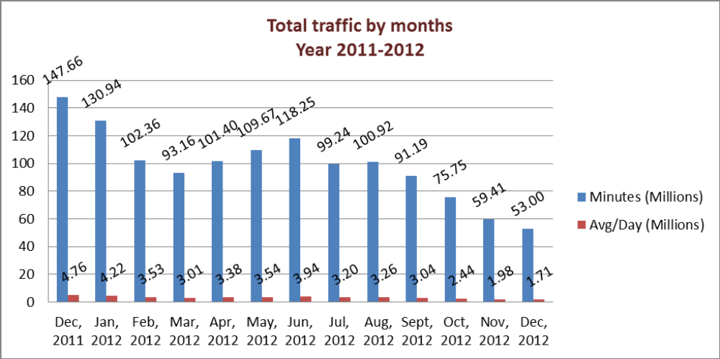

From the above graph we can understand that the monthly total traffic and the average per day of traffic is downward sloping at the right means it is in decreasing trend.

02. gTalk Total Traffic

02. gTalk : Total Traffic by months. Year 2012
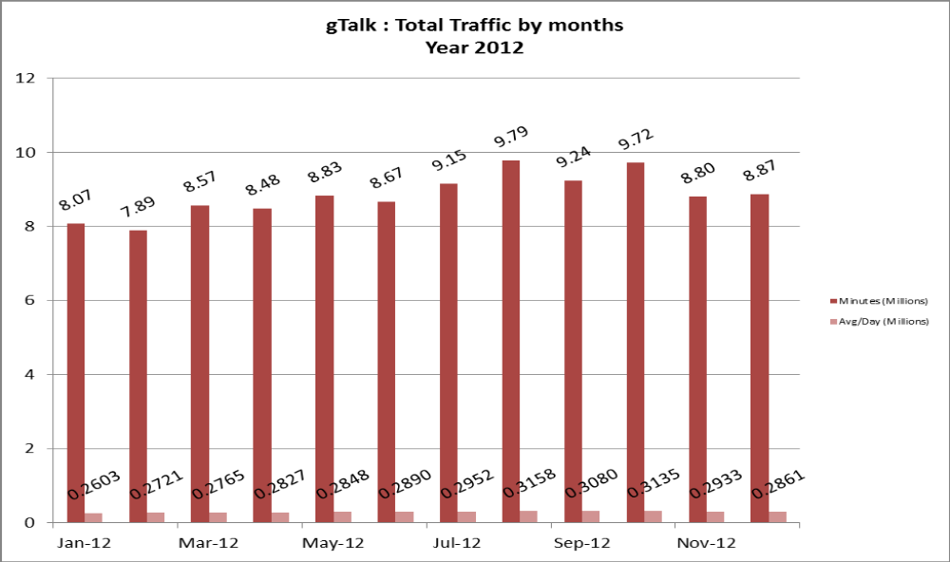

From the graph we understand that the total traffic of gTalk has increased from last month though the average is lower that Aug-Sept’12.

03. gTalk NA

03(a). gTalk NA : Total Traffic by months. Year 2011-2012

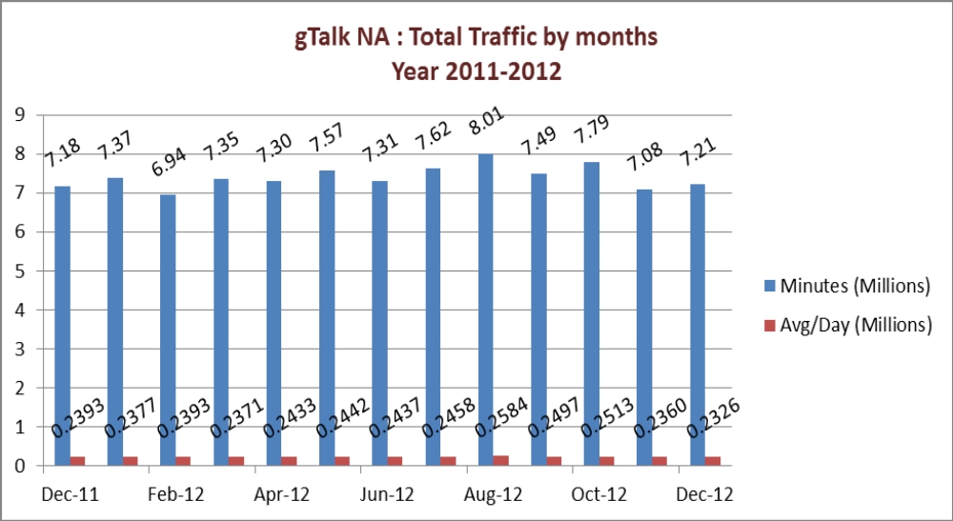
gTalk NA graph shows that the total traffic of december’12 is little higher than last month. But the average is very close to the previous one.

03(b). gTalk NA : New clients by months for the year 2011-2012
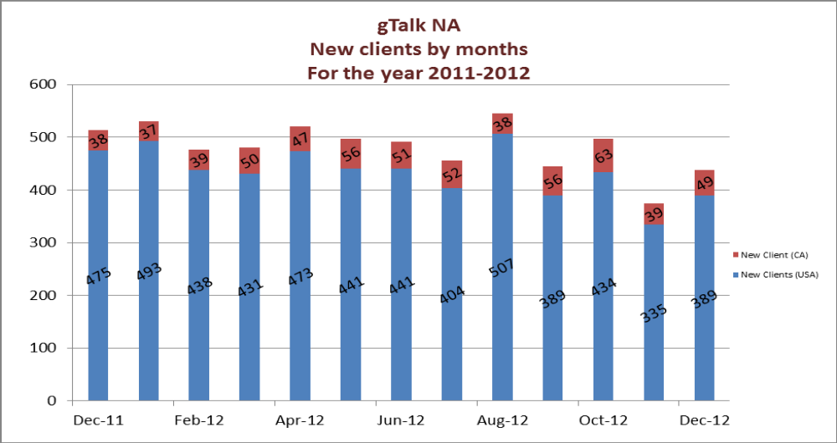
gTalk NA new clients graph portrays that the number of clients has increased from November to December.

04. gTalk UK
04(a). gTalk UK : Total Traffic by months for the year 2011-2012
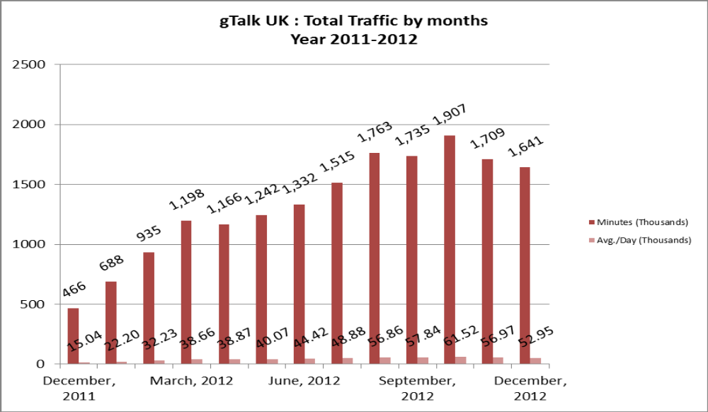
gTalk UK graph shows that the total traffic of december’12 is lower than last month and so as the average.

04(b). gTalk UK : New clients by months for the year 2011-2012

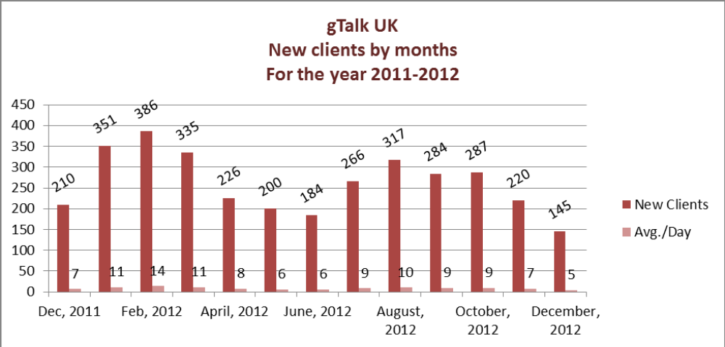
gTalk UK new clients graph portrays that the number of clients has decreased from November to December.

d. Department : Call Center (gTalk)
Manager : Md. Lutful Kabir Majumder

Current status of client joining and usage in gTalk pinless:

# Total client joined in gTalk till 31 December 2012: 47,580

# Average client increase per day in December, 12: 19
# Average client increase per day in November, 12: 20
# Average client increase per day in October, 12: 25
# Average client increase per day in September, 12: 24

# Average total Minutes per day in December, 12: 286.16 K
# Average total Minutes per day in November, 12: 293.27 K
# Average total Minutes per day in October, 12: 313.40 K
# Average total Minutes per day in September, 12: 308.13 K

# Total customer used gTalk service in December, 12 about 21,698
# Total customer used gTalk service in November, 12 about 21,619
# Total customer used gTalk service in October, 12 about 21,698
# Total customer used gTalk service in September, 12 about 21,305

Unused Initial Balance for the month of December: In the month of December, it has been found that total 44 customers have not used their Account Initial Balance after opening the account.

Current status after calling those customers is as follows:

- Customer using: 25 (57%)
- Customer still not using: 19 (43%)

Survey in December: In the month of December, a total of 887 customers who are inactive for at least 2 months have been called. Details about customer’s feedback are given below:

- Message left to the customers who were unavailable: 344 (39%)
- Number not in service: 241 (27%)
- Using other calling services or doesn’t make international calls: 197 (22%)
- Interested to use again: 105 (12%)
- Among 105 customers, 17 people have started to use gTalk service again after this survey.

Hot number uses:
December, 12: 34.41%
November, 12: 34.38%
October, 12: 33.37%
September, 12: 34.49%

# Total client joined in gTalk UK till 31 December 2012: 4132

# Total client joined in December 2012: 145
# Total client joined in November 2012: 220
# Total client joined in October 2012: 287
# Total client joined in September 2012: 284
# Total client joined in August 2012: 317
# Total client joined in July 2012: 266
# Total client joined in June 2012: 184
# Total client joined in May 2012: 200
# Total client joined in April 2012: 226
# Total Minutes for the month of December, 12: 1641.48 K
# Total Minutes for the month of November, 12: 1709.09 K
# Total Minutes for the month of October, 12: 1907.12 K
# Total Minutes for the month of September, 12: 1735.31 K
# Total Minutes for the month of August, 12: 1762.62 K
# Total Minutes for the month of July, 12: 1515.18 K
# Total Minutes for the month of June, 12: 1332.45 K
# Total Minutes for the month of May, 12: 1242.35 K
# Total Minutes for the month of April, 12: 1166.21 K

e. Department : Corporate
Manager : Sk. Kamruzzaman Prince

Problem solving of City Bank: City Bank was complaining that the new OS version was not matching with the old version. We have already developed solution to this problem and it is now running. In order to introduce it to the members of city bank, we arranged a get together in a local hotel. In the get together, they have expressed their satisfaction with the new version and apologized for the previous mischief.

Prospective Clients: Previously SCB has shared with us that they are willing to create a chain of call center where they want to use our solution. They are now working on it and soon it will be realized.
Conversation with British Council has advanced a little more. They are going to invite us for further conversation this month.

IPBX issue: The manager has thanked the CEO for his big push. He also mentioned that there is a demand of IPBX which we are currently using for our office only. He asked the CEO if we can sell it commercially and requested the CEO to push it as well.

f. Department : Admin & HR
Manager : Md. Habibur Rahman

Resignation & termination: Ms. Nishat Jahan Adnan of HR & Admin has left on 23rd December 2012. Mr. Eftakhar was terminated from his responsibilities. The reason behind this was discussed.

Need of local responsible personnel in software department for administrative works: In software department, Md. Samiul Aftad Chowdhury is performing his responsibilities from remote area. But the situation could be better if we can position someone like assistant manager in the local office for supervising of the team members. This should be done for the perfection of the administrative work.

Requesting managers for more careful about their administrative work: In the meeting, all the departmental head were requested to be more compassionate about the administrative work so that they have good understanding about their team members. If they find any mismatch between their expectation and the output from any team member, it should be discussed with them can be solved easily. HR manager thinks that in this way we could avoid problems like the one occurred with Mr. Eftakhar.

HR Consultancy: TeleConsult Group has started working on the HR constancy for Genuity Systems Ltd. Their work flow is being communicated to the members of GSL on timely basis.

BASIS fair: We are thinking of changing the gift that will be distributed in BASIS fair. The idea will be discussed later on.

Calendar: Calendar for 2013 has been distributed among the staffs. The requirement of the departments has also met.

Time change in Monthly Coordination Meeting: HR manager requested the participants of the meeting to finish breakfast by 9.00am local time and the monthly coordination meeting will start from 9.15am.

g. Director Operations (DO)
Mohammed Sadiqur Rahman

Overseas staff shifting and re-staffing issue: Some of our staffs and directors are shifting overseas. They need precise information about the company policy regarding them. DO asked if our honorable president will brief about it.

h. CEO
Md. Anis Rahman

IPBX issue: Though we are IPBX inside our office, but we are still not in a professional shape with it. As we do not want to market any unprofessional and incomplete solution, so we refused the demand of the buyers.

Selling call center solutions internationally: we have taken our call center solution in a position, now we want to take it internationally. Now we want to bring it in a box format and send it to the overseas dealers. Thus they will be able to use it more easily.

Overseas staff shifting and re-staffing issue: From local office, we are taking our staffs abroad. But the Director Operations and the senior members are still there who are able to run the local office. Some more members will be taken to US office. As visa problem is associated with it, we are planning to employ those people who are permanent residents of USA. Besides, we are communicating with some universities to employ their students as co-up basis.

New organogram and staffing: As the HR consultancy work is going on, we are going to have a new organogram. According to that, the senior employees will be promoted and some new recruitment will also be done to fulfill the vacant positions.

Plexstar: we already spent $1.2 million for plexstar. But we could minimize the time from 2 years to 1 year. So this justifies our cost. Now we need to sell 30% of its share to arrange the marketing expenses. And once the finance is ready, we will go to market.

Investment in real estate: Though our carrier and switch-dialer business is little downward sloping, still it has nothing to do with the investment in real estate business. We have already approved 45 crore for them and they can use it. But if real estate needs more investment, they have to take consent from the directors. If directors deny investing more, they have to collect money from outside source.

Data mode: At this moment, data mode is a finished product. But Mr. Tusar cannot manage to install the server from remote area. So we need to set a secondary server or CEO will do it after he returns to USA.

At the end, CEO showed appreciation to everyone for their presence and thoughtful insights about the company and wished to visit again during BASIS fair. He concluded the meeting by thanking to all.

