Reference: GSL/ Admin/ MCM 46

Minutes of
46th Monthly Coordination Meeting
Date: 14th February 2013
Venue: GSL Conference Room 1

Time: 09:15 AM

- The forty sixth monthly coordination meeting of Genuity Systems Ltd. (GSL) was held on 14th February 2013 at Genuity Conference Room 1. The President, CEO, DO, DM and managers of different departments of the company were present. Local personnel were present physically and the overseas personnel participated through video conference. List of participants of the meeting are as follows:

SL. | Name of Participants | Department | Signature
1. | Habib Rahman | President | Present/V.con
2. | M. Anis Rahman | Chief Executive Officer | Present/V.con
3. | Md. Sadiqur Rahman | Director Operations | Present
4. | K. Shahadat Hossain | Director Marketing | Present/V.con
5. | Md. Habibur Rahman | Admin & HR | Present
6. | Md. Waliul Haque Tusar | System Admin | Absent
7. | Md. Samiul Aftad Chowdhury | Head of Software Department | Present/V.con
8. | Md. Aminul Islam | Head of International Voice Carrier | Present
9. | Sk. Kamruzzaman Prince | Corporate Affairs | Present
10. | Lutful Kabir Majumder | Call Center | Present
11. | Md. Ashrafuzzaman | Accounts | Present
12. | Md. Abdullah Al Masum | Training | Present

- The meeting was started by the Manager, Admin & HR. He thanked everyone for participating in the meeting and invited the CEO to take control of the meeting. The CEO warmly welcomed everyone present in the meeting and thanked them for their presence. Thereafter he requested all departmental managers to deliver respective speech, one at a time, highlighting departmental performance and issues during the past month. He invited all to raise queries/questions and share their opinion in the discussion as deemed fit. The main points raised and discussed in the meeting over different issues are recorded below:

a. Department : gPlex Software Solutions
Head of Marketing & Sales : Lutful Kabir Majumder

gPlex Switch and Dialer Sales Report
For the Month of January, 2013
Product Name | Sales (USD) | Realized (USD) | Dis.&Pro.(USD) | Unrealized (USD) | Qty. of Sales | % of Realization
gPlex Mobile Dialer | 41,650 | 38,974 | 0 | 2,676 | 22 | 94
gPlex Hosted Switch | 31,900 | 19,221 | 1,100 | 11,579 | 7 | 60
Total | 73,550 | 58,195 | 1,100 | 14,255

 | gPlex Switch Sales Report of January, 2013
Month | Description | No of Ch. | Sale | Qnt.of Sale
Jan-13 | gPlex Hosted Switch (NRC from New Clients) | 0 | $ - | 7
Jan-13 | gPlex Hosted Switch (NRC from Existing Clients) | 0 | $ -
Jan-13 | Total NRC : |  | $ -
Jan-13 | gPlex Hosted Switch (MRC from New Clients) | 800 | $ 1,850
Jan-13 | gPlex Hosted Switch (MRC from Existing Clients) | 18000 | $ 30,050 | 80
Jan-13 | Total MRC : |  | $31,900
 | Total Sales of January, 2013 |  | $ 31,900
 | Discount |  | $ 100
 | Write off |  | $ 1,000
 | Current Due |  | $ 11,579
 | Cash Received |  | $ 19,124
 | Advanced Expired |  | $ 97
 | Total Sales : |  | $ 31,900
 | Total Cash Collected in January, 2013 : |  | $ 24,144
 | Advanced Received |  | $ 28
 | Due Realized of December |  | $ 4,646
 | Previous due Realized |  | $ 346
 | Cash Sale of Current Month |  | $ 19,124
 | Total Cash Sale including Advanced Expired : |  | $ 19,221
 | Net Cash flow to Sale % : |  | 60
 | Previous Due up to December, 2012 |  | $71,333
 | Due of December |  | $11,855
 | Due Realized of December |  | $4,646
 | Due Remained of December |  | $7,209
 | Previous Discount |  | $0
 | Previous Write off |  | $1,250
 | Due Realized upto November, 2012 |  | $346
 | Total Due Realized upto December, 2012 |  | $4,992
 | Due Remained upto December, 2012 |  | $65,091
 | Total Due Upto January, 2013 |  | $ 76,670

gPlex Dialer Sales Report of January, 2013
Month | Description | Capacity | Sale | Qty of Sales
Jan-13 | gPlex Mobile Dialer (New Clients) | 1450 | $ 8,200 | 22
 | gPlex Mobile Dialer (Existing Clients) | 3450 | $ 33,450 | 60
 | Total Sales | 4900 | $ 41,650 | 82
 | Current Due |  | 2676
 | Discount |  | 0
 | Advanced Expired |  | 2
 | Total Cash Received |  | 38972
 | Total Sales : |  | 41650
 | Advanced Received |  | 27
 | Cash Sale Including Advanced Expired |  | 38974
 | Net Cash Flow to Sale % |  | 94
 | Previous Due Upto December, 2012 |  | 65087
 | Due of December |  | 636
 | Due Realized of December |  | 0
 | Due Remained of December |  | 636
 | Discount |  | 0
 | Due Realized upto November 2012 |  | 1020
 | Written off (As no chance to realize) |  | 0
 | Total Due Realized upto December 2012 |  | 1020
 | Due Remained upto December, 2012 |  | 64067
 | Total Due Upto January, 2013 |  | 66743

US SoftExpo: Mr. Lutful Kabir Majumder and Mr. Md. Aminul Islam shared their
experiences of the SoftExpo that held in US. There were lots of visitors but 43 of them had query about our products like IPPBX, Dialer & Switch and Route. Now we are contacting them to tie up business with them.

Monthly adjustment of unrealized dues: Mr. Lutful & Mr. Aminul has to discuss with
DO with proper logic to convince him about the monthly unrealized amount. Then DO will decide if the amount is truly impossible to collect. Once DO decides the amount, he will sign a formal document to approve it. Mr. Lutful & Mr. Aminul will share the document undersigned by DO with accounts so that the unrealized amount can be kept up to date and can be adjusted with financial records.

b. Department : Call Center (gTalk)
Manager : Md. Lutful Kabir Majumder

Current status of client joining and usage in gTalk pin less:

# Total client joined in gTalk till 31 January 2013: 48,280

# Average client increase per day in January, 13: 23
# Average client increase per day in December, 12: 19
# Average client increase per day in November, 12: 20
# Average client increase per day in October, 12: 25

# Average total Minutes per day in January, 13: 293.87 K
# Average total Minutes per day in December, 12: 286.16 K
# Average total Minutes per day in November, 12: 293.27 K
# Average total Minutes per day in October, 12: 313.40 K

# Total customer used gTalk service in January, 13 about 22,248
# Total customer used gTalk service in December, 12 about 21,698
# Total customer used gTalk service in November, 12 about 21,619
# Total customer used gTalk service in October, 12 about 21,698

Unused Initial Balance for the month of January, 13: In the month of January, it has been found that total 38 customers have not used their Account Initial Balance after opening the account.

Current status after calling those customers is as follows:

- Customer using: 27 (71%)
- Customer still not using: 11 (29%)

Survey in January 2013: In the month of January, a total of 786 customers who are inactive for at least 2 months have been called. Details about customer’s feedback are given below:
- Message left to the customers who were unavailable: 318 (40%)
- Number not in service: 165(21%)
- Using other calling services or doesn’t make international calls: 212 (27%)
- Interested to use again: 91(12%)
Among 91 customers, 8 people have started to use gTalk service again after this survey.

Hot number uses:

January, 13: 33.79%
December, 12: 34.41%
November, 12: 34.38%
October, 12: 33.37%

# Total client joined in gTalk UK till 31 January 2013: 4320

# Total client joined in January 2013: 188
# Total client joined in December 2012: 145
# Total client joined in November 2012: 220
# Total client joined in October 2012: 287
# Total client joined in September 2012: 284
# Total client joined in August 2012: 317
# Total client joined in July 2012: 266
# Total client joined in June 2012: 184
# Total client joined in May 2012: 200
# Total client joined in April 2012: 226

# Total Minutes for the month of January, 13: 1704.34 K
# Total Minutes for the month of December, 12: 1641.48 K
# Total Minutes for the month of November, 12: 1709.09 K
# Total Minutes for the month of October, 12: 1907.12 K
# Total Minutes for the month of September, 12: 1735.31 K
# Total Minutes for the month of August, 12: 1762.62 K
# Total Minutes for the month of July, 12: 1515.18 K
# Total Minutes for the month of June, 12: 1332.45 K
# Total Minutes for the month of May, 12: 1242.35 K
# Total Minutes for the month of April, 12: 1166.21 K

C. Department : International Voice Carrier
Head of the department : Md. Aminul Islam

Monthly traffic and client report for the month of January 2013

Coverage area:
01. Total Traffic
02. gTalk Total Traffic
03. gTalkNA
04. gTalkUK

01. Total Traffic

01. Total traffic by Months, Year 2012-2013

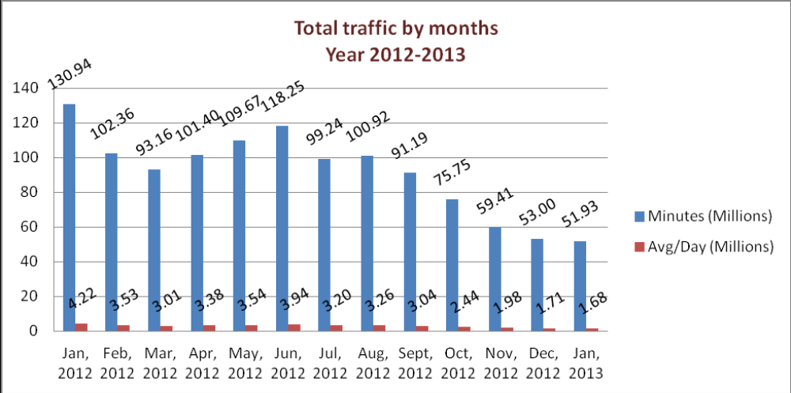

From the above graph we can understand that the monthly total traffic and the average per day of traffic is slightly downward sloping means it is in decreasing trend.

Update about Switch migration: Migration of Switch is almost at the end. IVR and White Label feature have also been added with it.
Client meeting of Switch & Dialer: Client meeting for Switch & Dialer will be held on 1st March 2013 in Chittagong. The preparation for meeting is going on.

02. gTalk Total Traffic

02. gTalk : Total Traffic by months. Year 2012-2013
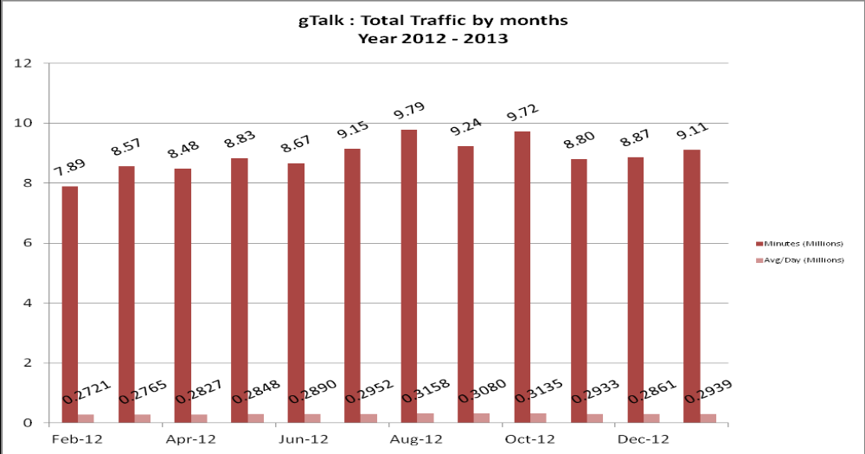

From the graph we understand that the total traffic of gTalk has increased from last month and the average is higher than that of December 2012.

03. gTalk NA

03(a). gTalk NA : Total Traffic by months. Year 2012-2013

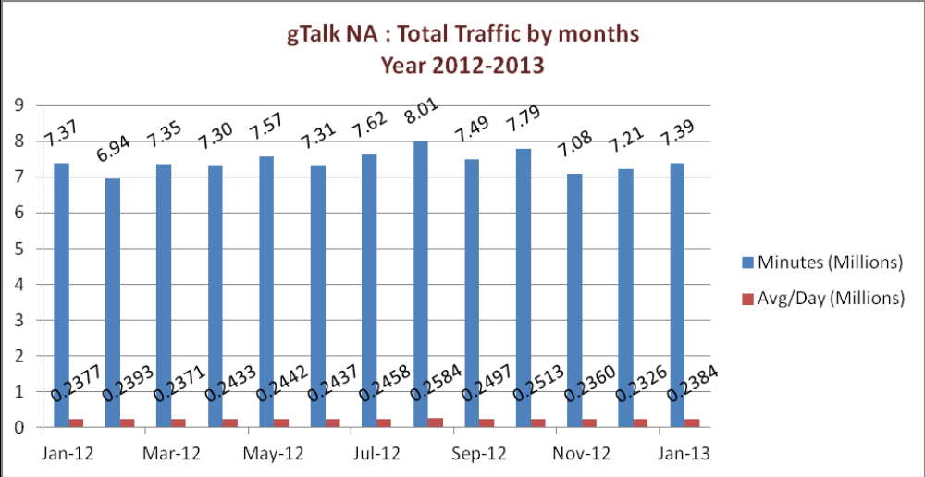
gTalk NA graph shows that the total traffic of January 2013 is little higher than last month. But the average is very close to the previous one.

03(b). gTalk NA : New clients by months for the year 2012-2013
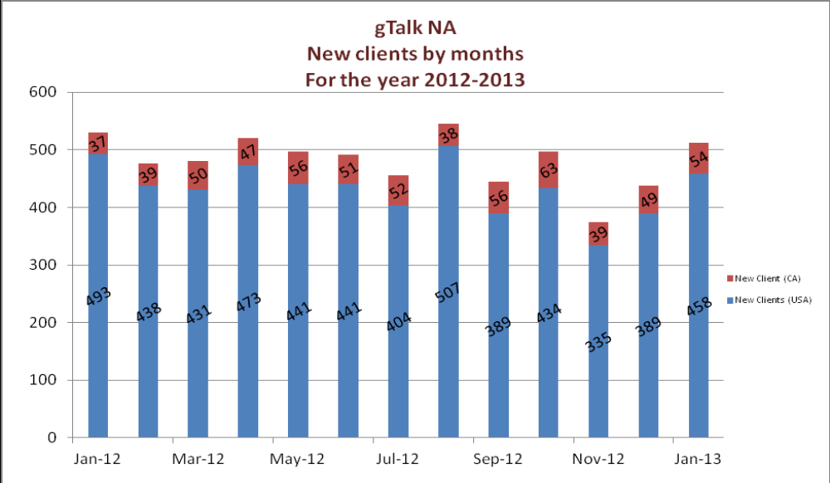
gTalk NA new clients graph portrays that the number of clients has increased from December 2012 to January 2013.

04. gTalk UK

04(a). gTalk UK : Total Traffic by months for the year 2012-2013
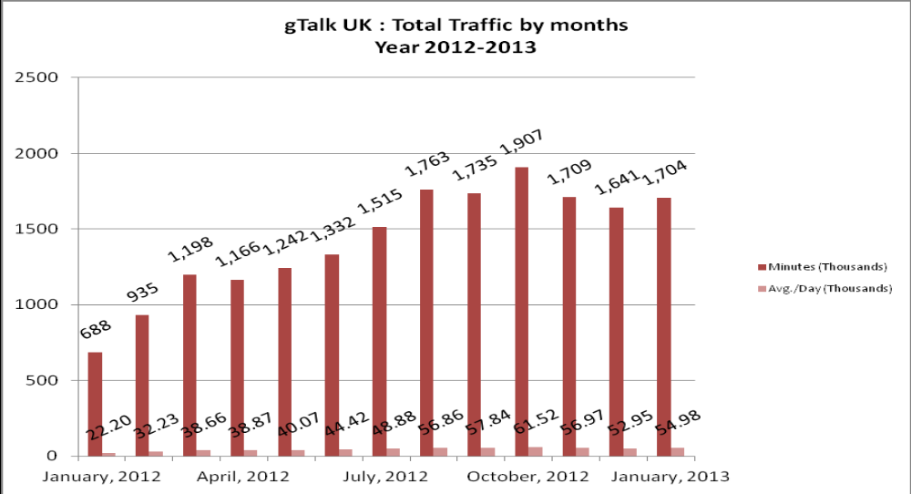
gTalk UK graph shows that the total traffic of January 2013 is higher than last month and so as the average.

04(b). gTalk UK : New clients by months for the year 2012-2013

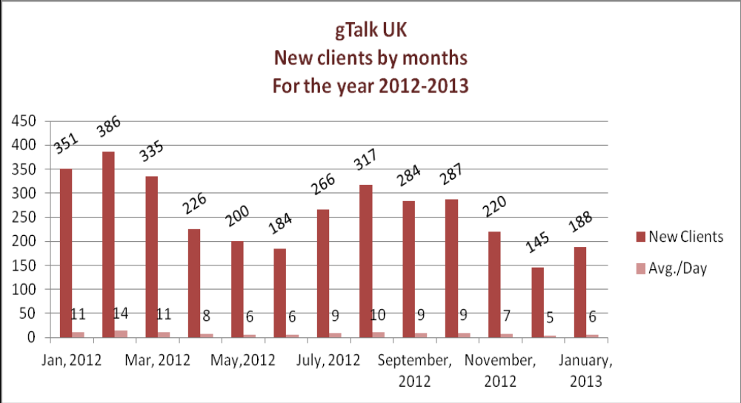
gTalk UK new clients graph portrays that the number of clients has increased from December 2012 to January 2013.

d. Department : Training
Manager : Md. Abdullah Al Masum

Current Status: Currently training department is running training in twenty nine batches. Among these two batches (Round 15, 16) are being run for IDB. The other 27 batches are covering different customized courses.

Revenue: Total collection on account of training in the month of January 2013 was Tk. 6.54 lacs and collection for the month of December 2013 was Tk. 8.16 lacs. The total amount of collection from January 2013 activities was Tk 8.20 lacs.

Fair at BUBT campus: Bangladesh University of Business and Technology (BUBT) is going to arrange a fair in their campus. We will take a stall there and will do our promotional activities from there.
e. Department : Corporate
Manager : Sk. Kamruzzaman Prince

Proposing One Bank as prospective client: Proposal has been sent to One Bank Ltd. as prospective client of GSL.

Due recovery: We had some dues with call center solution from our different clients. We are trying to recover them through creating pressure. We already have recovered 27 lacs from City Bank.

Call Center Solution in BASIS fair: We are planning to take our new call center solution box to BASIS soft expo and the box will be displayed there.

Modifying deed: We always have a deed with organizations that use our call center solutions but it has some drawbacks. For example, the deed includes deadline for payment, but there is no clause to describe the penalty of payment after due date. So now we are thinking of modifying the deed.

VSP License: We applied for VSP license and we have got the permission. If we are confirmed about taking the license, we have to pay. So now we have to decide if we will take it or not.

Disconnect one more connection from France telecom: We had total three connections of STM with France Telecom. Previously we cut off one and remained with two. Now we need to disconnect one more from the two and the initiative of doing it will be taken by our honorable president.

f. Department : Software
Manager : Md. Samiul Aftad Chowdhury

Regular works of software department is running properly.

g. Department : Admin & HR
Manager : Md. Habibur Rahman

HR Consultancy: TeleConsult Group is working on the Job Description for Genuity Systems Ltd. They have already some draft works with GSL. HR Manager and the other departments’ manager have checked them and found it almost alright. The final work is going on.

Policy about work time & leave and migration & transfer: Two policies regarding work hour time & leave and migration & transfer is being shared with management. The honorable president is requested give some behind those to develop the final policies. There are some common practices in policies which were not followed in our organization. For example, encashment of unused earned leave, penalty for late attendance etc. Now those issues are needed to be included in the policy in order to make our policy comprehensive.

BASIS fair: The preparation for BASIS soft expo is going on well. The fair will be held on 6-9 March 2013. we prepared one stall design previously, but due to change in stall size, we are redesigning the stall. Now decision should be made about which product will be placed in the fair, what will be dress code of attendants and what gift to distribute among the visitors.

Guideline of purchasing gift items for marketing department: Marketing team has to purchase several gifts for their promotion purpose. To select and to buy those there is no formal guideline. Thus it sometimes creates doubt among others. So it is needed to make a guideline to make the purchase transparent and fair.

h. CEO
Md. Anis Rahman

Funding prospect for Plexstar: Negotiation with TelMark to arrange funding for Plexstar is going on and the funding amount is 12 Million. As part of precondition, TelMark wants to observe if our Plexstar is compatible with the hardware of Alkatel. The assessment result was found positive means Plexstar suits well with Alkatel apart from the GUI part. One simpler task is needed to do to make that work too. If everything goes alright, TelMark will approve the funding and we will start recruiting new people and start working entirely.

i. President
Habib Rahman

Honorable president wanted to know about the update of the Banani Office from HR Manager. As came to know that there is no update, he proposed if we can sit with the other clients like PHP, SIBL etc. who also bought space in the building. The president asked HR Manager to check if it is possible to arrange a meeting with them followed by dinner to unite the clients in order to force the builders to proceed the construction work.

At the end, CEO showed appreciation to everyone for their presence and thoughtful insights about the company. He concluded the meeting by thanking to all.

