Reference: GSL/ Admin/ MCM 47

Minutes of
47th Monthly Coordination Meeting
Date: 20th March 2013
Venue: GSL Conference Room 1

Time: 09:15 AM

- The forty seventh monthly coordination meeting of Genuity Systems Ltd. (GSL) was held on 20th March 2013 at Genuity Conference Room 1. The President, CEO, DO, DM and managers of different departments of the company were present. Local personnel were present physically and the overseas personnel participated through video conference. List of participants of the meeting are as follows:

SL. | Name of Participants | Department | Signature
1. | Habib Rahman | President | Present/V.con
2. | M. Anis Rahman | Chief Executive Officer | Present/V.con
3. | Md. Sadiqur Rahman | Director Operations | Present
4. | K. Shahadat Hossain | Director Marketing | Present/V.con
5. | Md. Habibur Rahman | Admin & HR | Present
6. | Md. Waliul Haque Tusar | System Admin | Present
7. | Md. Samiul Aftad Chowdhury | Head of Software Department | Present/V.con
8. | Md. Aminul Islam | Head of International Voice Carrier | Present
9. | Sk. Kamruzzaman Prince | Corporate Affairs | Present
10. | Lutful Kabir Majumder | Call Center | Present
11. | Md. Ashrafuzzaman | Accounts | Present
12. | Md. Abdullah Al Masum | Training | Present

- The meeting was started by the Manager, Admin & HR. He thanked everyone for participating in the meeting and invited the CEO to take control of the meeting. The CEO warmly welcomed everyone present in the meeting and thanked them for their presence. Thereafter he requested all departmental managers to deliver respective speech, one at a time, highlighting departmental performance and issues during the last month. He invited all to raise queries/questions and share their opinion in the discussion as deemed fit. The main points raised and discussed in the meeting over different issues are recorded below:

a. Department : Training
Manager : Md. Abdullah Al Masum

Current Status: Currently training department is running training in thirteen batches. Among these three batches (Round 15, 16, 18) are being run for IDB. The other 10 batches are covering different customized courses.

Revenue: Total collection on account of training in the month of February 2013 was 12.54 lacs and collection for the month of January 2013 was Tk. 6.54 lacs. The total amount of revenue from February 2013 activities was Tk 5.36 lacs.

Training for Bureau Bangladesh: some staff from Bureau Bangladesh are going to intake in training for some of our internal training courses.

Problems due to strike: We are facing problem with our regular classes due to the ongoing strike. Some of the classes for IDB had to be shifted on Fridays. So we cannot continue the regular corporate classes of Fridays. And this is creating huge trouble for us. Besides, our revenue generation has fallen down due to strike. As we could not complete te classes of IDB on due time, we are not getting our payment as well.

b. Department : gPlex Software Solutions
Head of Marketing & Sales : Lutful Kabir Majumder

gPlex Switch and Dialer Sales Report
For the Month of February, 2013
Product Name | Sales (USD) | Realized (USD) | Dis.&Pro.(USD) | Unrealized (USD) | Qty. of Sales | % of Realization
gPlex Mobile Dialer | 77,264 | 73,092 | 0 | 4,172 | 25 | 95
gPlex Hosted Switch | 28,950 | 12,872 | 3,850 | 12,228 | 2 | 44
Total | 106,214 | 85,964 | 3,850 | 16,400

 | gPlex Switch Sales Report of February, 2013
Month | Description | No of Ch. | Sale | Qnt.of Sale
Feb-13 | gPlex Hosted Switch (NRC from New Clients) | 0 | $ - | 2
Feb-13 | gPlex Hosted Switch (NRC from Existing Clients) | 0 | $ -
Feb-13 | Total NRC : |  | $ -
Feb-13 | gPlex Hosted Switch (MRC from New Clients) | 800 | $ 1,050
Feb-13 | gPlex Hosted Switch (MRC from Existing Clients) | 16100 | $ 27,900 | 83
Feb-13 | Total MRC : |  | $28,950
 | Total Sales of February, 2013 |  | $ 28,950
 | Discount |  | $ -
 | Write off |  | $ 3,850
 | Current Due |  | $ 12,228
 | Cash Received |  | $ 12,869
 | Advanced Expired |  | $ 3
 | Total Sales : |  | $ 28,950
 | Total Cash Collected in February, 2013 : |  | $ 17,195
 | Advanced Received |  | $ 313
 | Due Realized of January |  | $ 3,796
 | Previous due Realized |  | $ 217
 | Cash Sale of Current Month |  | $ 12,869
 | Total Cash Sale including Advanced Expired : |  | $ 12,872
 | Net Cash flow to Sale % : |  | 44
 | Previous Due up to January, 2013 |  | $76,670
 | Due of January |  | $11,579
 | Due Realized of January |  | $3,796
 | Due Remained of January |  | $7,783
 | Previous Discount |  | $0
 | Previous Write off |  | $9,800
 | Due Realized upto December, 2012 |  | $217
 | Total Due Realized upto January, 2013 |  | $4,013
 | Due Remained upto January, 2013 |  | $65,857
 | Total Due Upto February, 2013 |  | $ 75,085

gPlex Dialer Sales Report of February, 2013
Month | Description | Capacity | Sale | Qty of Sales
Feb-13 | gPlex Mobile Dialer (New Clients) | 2750 | $ 22,000 | 25
 | gPlex Mobile Dialer (Existing Clients) | 7350 | $ 55,264 | 84
 | Total Sales | 10100 | $ 77,264 | 109
 | Current Due |  | 4172
 | Discount |  | 0
 | Advanced Expired |  | 107
 | Total Cash Received |  | 72985
 | Total Sales : |  | 77264
 | Advanced Received |  | 67
 | Cash Sale Including Advanced Expired |  | 73092
 | Net Cash Flow to Sale % |  | 95
 | Previous Due Upto January, 2013 |  | 66743
 | Due of January |  | 2676
 | Due Realized of January |  | 750
 | Due Remained of January |  | 1926
 | Discount |  | 0
 | Due Realized upto December 2012 |  | 762
 | Written off (As no chance to realize) |  | 0
 | Total Due Realized upto January 2013 |  | 1512
 | Due Remained upto January, 2013 |  | 65231
 | Total Due Upto February, 2013 |  | 66403

Monthly adjustment of unrealized dues: The unrealized amount of switch & dialer has been announced.
Problem with additional capacity: As a general practice, we used to allow 10-15% additional call capacity for our clients. Our clients can get its benefit when call pressure is high. But because of this high additional capacity, our business becomes disadvantageous. So the additional capacity should be reduced in order to make our business viable.
Re-scheduling billing date: Gap between bill preparation and last date of payment creates a problem in updating the received amount of each month. Thus to lessen the gap, the billing needs to be done by 23rd of each month keeping the last date of payment 1st of the next month. Here maximum allowed payment time would be 7 days.
Premium dialer registration: there was request for quick premium dialer registration, but it could be done due to technical problem.

c. Department : Call Center (gTalk)
Manager : Md. Lutful Kabir Majumder

Current status of client joining and usage in gTalk pin less:

# Total client joined in gTalk till 28 February 2013: 48,869

# Average client increase per day in February, 13: 21
# Average client increase per day in January, 13: 23
# Average client increase per day in December, 12: 19
# Average client increase per day in November, 12: 20

# Average total Minutes per day in February, 13: 295.24 K
# Average total Minutes per day in January, 13: 293.87 K
# Average total Minutes per day in December, 12: 286.16 K
# Average total Minutes per day in November, 12: 293.27 K

# Total customer used gTalk service in February, 13 about 21,789
# Total customer used gTalk service in January, 13 about 22,248
# Total customer used gTalk service in December, 12 about 21,698
# Total customer used gTalk service in November, 12 about 21,619

Unused Initial Balance for the month of February, 13: In the month of February, it has been found that total 41 customers have not used their Account Initial Balance after opening the account.

Current status after calling those customers is as follows:

- Customer using: 33 (80%)
- Customer still not using: 8 (20%)

Survey in February 2013: In the month of February, a total of 538 customers who are inactive for at least 2 months have been called. Details about customer’s feedback are given below:
- Message left to the customers who were unavailable: 198 (37%)
- Number not in service: 144(27%)
- Using other calling services or doesn’t make international calls: 127 (23%)
- Interested to use again: 69(13%)
- Among 69 customers, 6 people have started to use gTalk service again after this survey.

Hot number uses:

February, 13: 34.84%
January, 13: 33.79%
December, 12: 34.41%
November, 12: 34.38%

# Total client joined in gTalk UK till 28 February 2013: 4483

# Total client joined in February 2013: 163
# Total client joined in January 2013: 188
# Total client joined in December 2012: 145
# Total client joined in November 2012: 220
# Total client joined in October 2012: 287
# Total client joined in September 2012: 284
# Total client joined in August 2012: 317
# Total client joined in July 2012: 266
# Total client joined in June 2012: 184
# Total client joined in May 2012: 200
# Total client joined in April 2012: 226

# Total Minutes for the month of February, 13: 1511.33 K
# Total Minutes for the month of January, 13: 1704.34 K
# Total Minutes for the month of December, 12: 1641.48 K
# Total Minutes for the month of November, 12: 1709.09 K
# Total Minutes for the month of October, 12: 1907.12 K
# Total Minutes for the month of September, 12: 1735.31 K
# Total Minutes for the month of August, 12: 1762.62 K
# Total Minutes for the month of July, 12: 1515.18 K
# Total Minutes for the month of June, 12: 1332.45 K
# Total Minutes for the month of May, 12: 1242.35 K
# Total Minutes for the month of April, 12: 1166.21 K
d. Department : International Voice Carrier
Head of the department : Md. Aminul Islam

Monthly traffic and client report for the month of February 2013

Coverage area:
01. Total Traffic
02. gTalk Total Traffic
03. gTalkNA
04. gTalkUK

01. Total Traffic

01. Total traffic by Months, Year 2012-2013

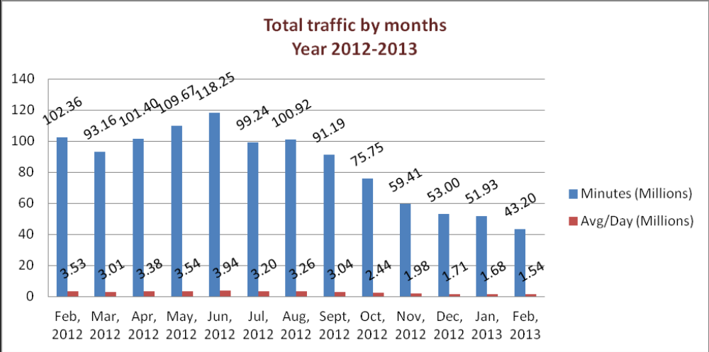

From the above graph we can understand that the monthly total traffic and the average per day of traffic is slightly downward sloping means it is in decreasing trend.

02. gTalk Total Traffic

02(a). gTalk: Total Traffic by months. Year 2012-2013 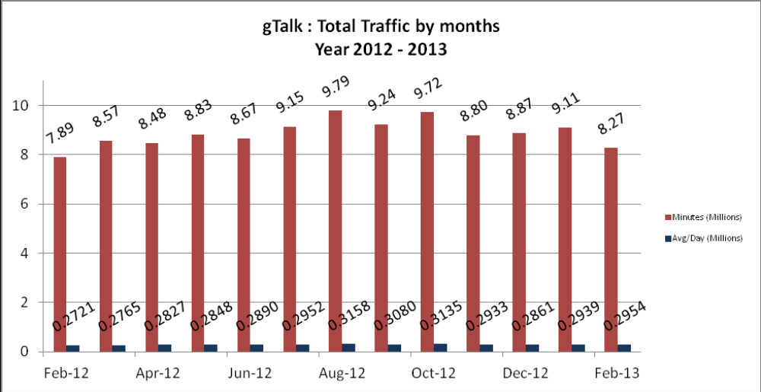

From the graph we understand that the total traffic of gTalk has decreased from last month but the average is higher than that of January 2013.

02(b). gTalk : Total Traffic by months (According to 30 days)

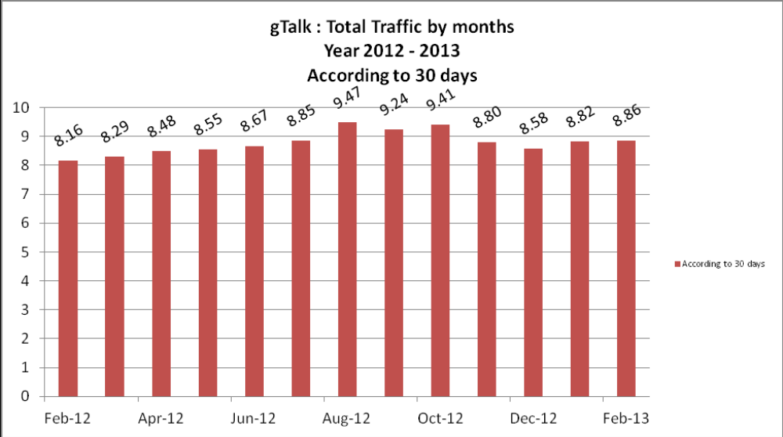

03. gTalk NA

03(a). gTalk NA : Total Traffic by months. Year 2012-2013

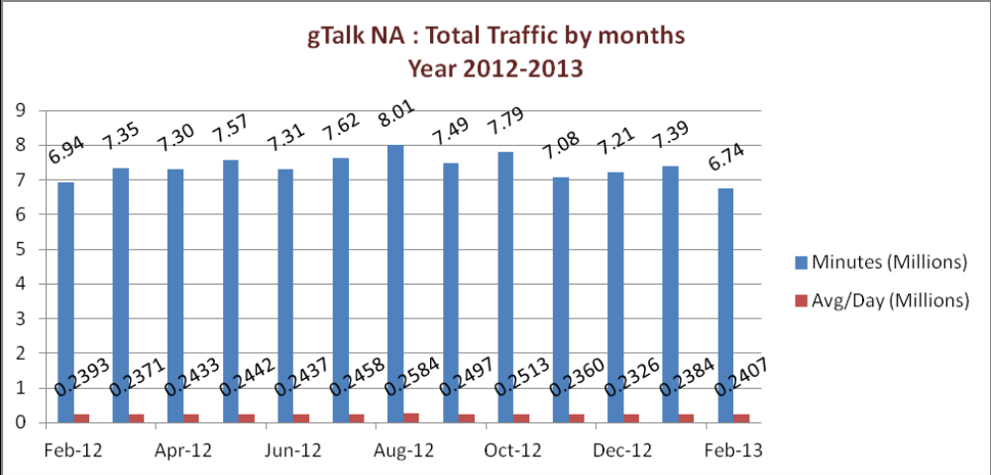
gTalk NA graph shows that the total traffic of January 2013 is lower than last month. But the average is higher than the previous one.

03(b). gTalk NA : Total Traffic by months. Year 2012-2013 (According to 30 days) 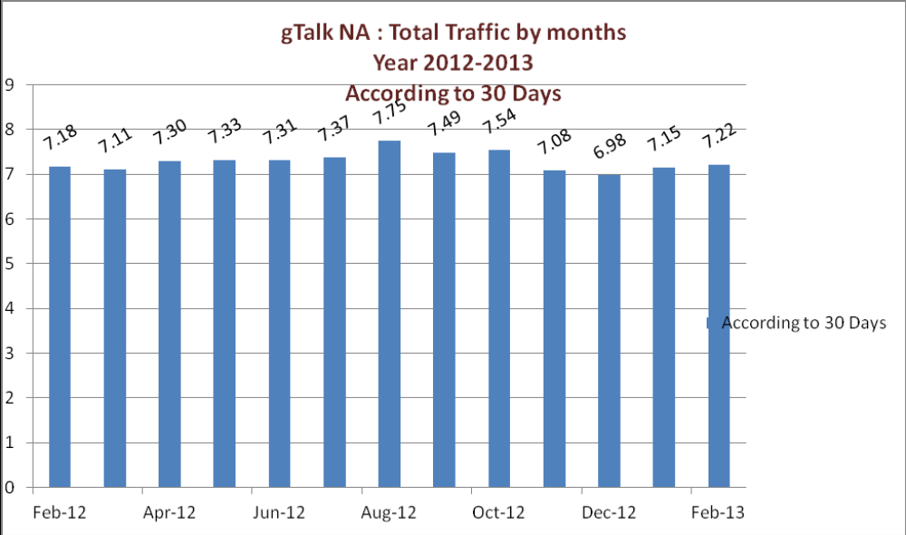
03(c). gTalk NA : New clients by months for the year 2012-2013
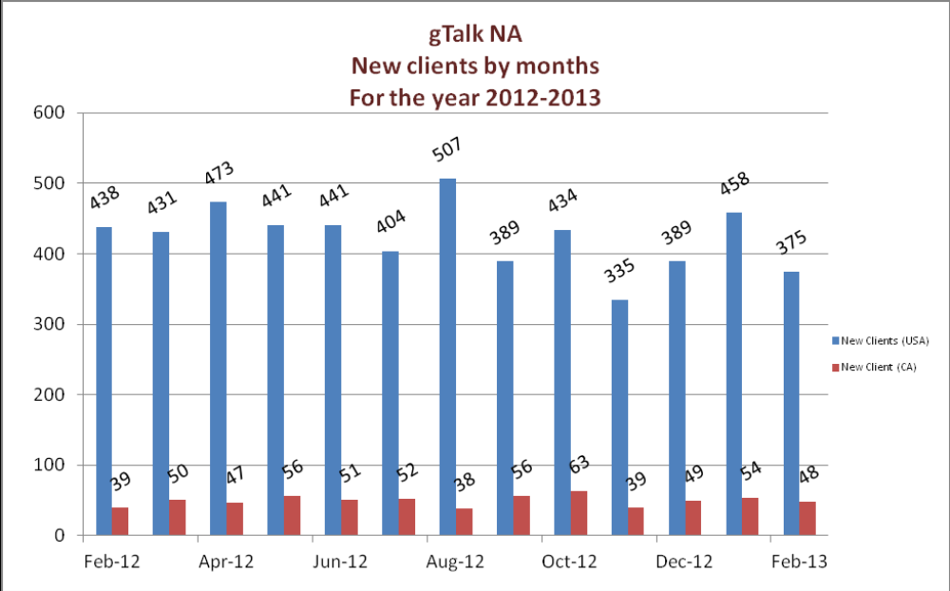
gTalk NA new clients graph portrays that the number of new clients has decreased from January 2013 to February 2013.

04. gTalk UK

04(a). gTalk UK : Total Traffic by months for the year 2012-2013
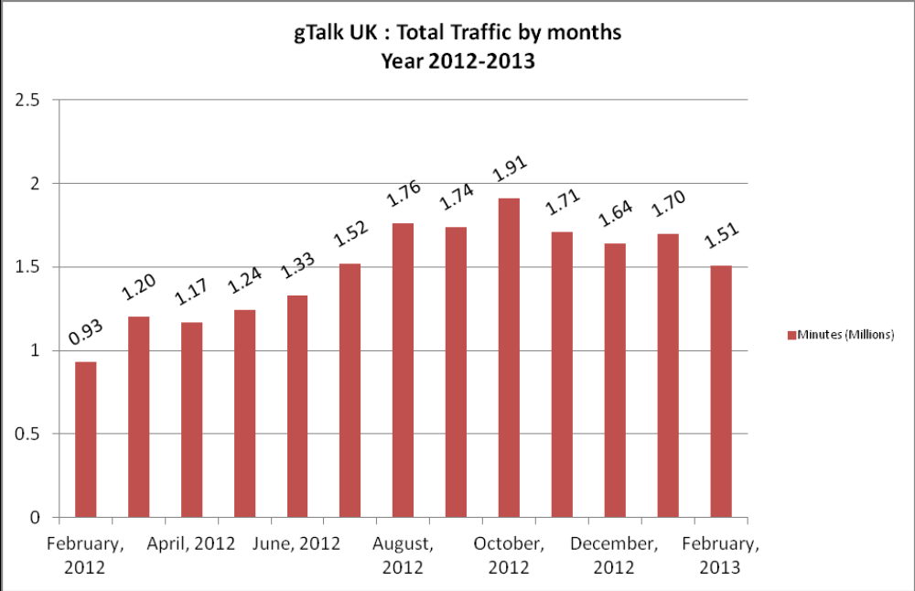
gTalk UK graph shows that the total traffic of February 2013 is lower than last month.

04(b). gTalk UK : Total Traffic by months for the year 2012-2013 (According to 30 Days)
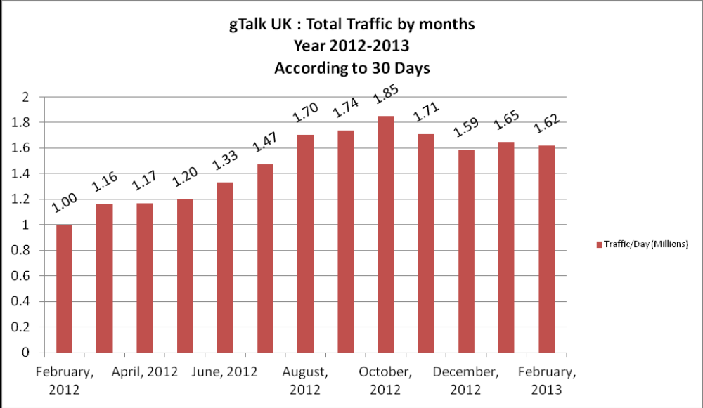

04(c). gTalk UK : New clients by months for the year 2012-2013

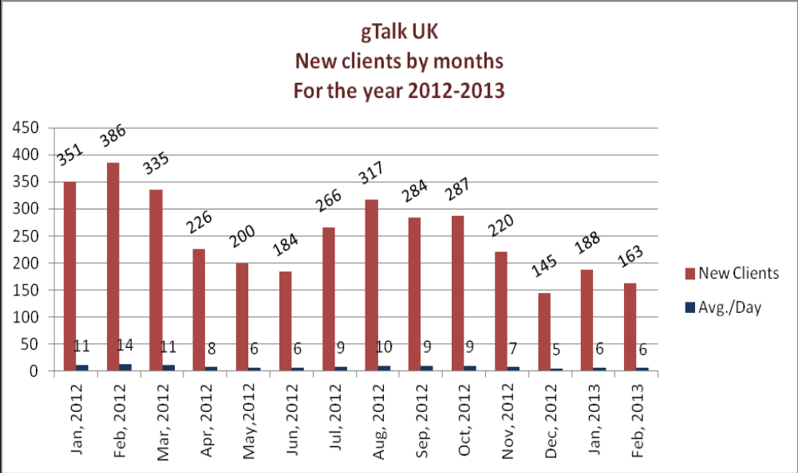
gTalk UK new clients graph portrays that the number of new clients has decreased from January 2013 to February 2013.

e. Department : Corporate
Manager : Sk. Kamruzzaman Prince

Prospective client: One Bank Ltd. and British council are still in the list of prospective client of GSL.
Due amount to be received: We have 22 lacs 60 thousand taka due to be received.
Interest about Plexstar: Bangladesh Submarine Cable Company Limited (BSCCL) is a Core Telecommunications service provider and International Submarine Cable Operator of Bangladesh. They showed interest about our Plexstar.

f. Department : Software
Manager : Md. Samiul Aftad Chowdhury

Channel limit: Usually for uninterrupted service the channel was increased as 10
15% previously. But it is creating problem to the marketing team as the clients are
delaying the payment for the grace period they get. So this would be revised as 2-5%
from next month.
IPBX: Currently working with the phone version of IPBX.

g. Department : Admin & HR
Manager : Md. Habibur Rahman

BASIS fair: The fair was supposed to be held from 6-9 March 2013. but due to political instability it is being re-scheduled on 2-6 May. We prepared are almost done with the stall making. We already have spent 2 lacs 12 thousands for making stall. It will need more 1 lac 50 thousands (apprx) to complete it.
HR Consultancy: TeleConsult Group will submit the final draft by next week. The final draft will than be shared to the directors. After that, a meeting will be arranged between the directors and TCG. Once the meeting is over, TCG will work on the draft and submit the final report.
Banani office update: The real estate company was supposed to give us final update by 20th March 2013. But there was no update till the meeting. So we are planning to issue a formal letter to them.
Problem with DESCO: We have faced problem with over load of electricity usage and got letters from DESCO. We again got a letter from them. We will try to solve it instantly if they come.

h. CEO
Md. Anis Rahman

Update about IPBX: Honorable CEO gave update about IPBX. He is looking forward to to increase the reach of IPBX to 100 customers by this year.

At the end, CEO showed appreciation to everyone for their presence and thoughtful insights about the company. He concluded the meeting by thanking to all.

