Reference: GSL/ Admin/ MCM 48

Minutes of
48th Monthly Coordination Meeting
Date: 9th April 2013
Venue: GSL Conference Room 1

Time: 08:30 AM

- The forty seventh monthly coordination meeting of Genuity Systems Ltd. (GSL) was held on 9th April 2013 at Genuity Conference Room 1. The President, CEO, DO, DM and managers of different departments of the company were present. Local personnel were present physically and the overseas personnel participated through video conference. List of participants of the meeting are as follows:

SL. | Name of Participants | Department | Signature
1. | Habib Rahman | President | Present/V.con
2. | M. Anis Rahman | Chief Executive Officer | Present/V.con
3. | Md. Sadiqur Rahman | Director Operations | Present
4. | K. Shahadat Hossain | Director Marketing | Present/V.con
5. | Md. Habibur Rahman | Admin & HR | Present
6. | Md. Waliul Haque Tusar | System Admin | Present
7. | Md. Samiul Aftad Chowdhury | Head of Software Department | Present/V.con
8. | Md. Aminul Islam | Head of International Voice Carrier | Present
9. | Sk. Kamruzzaman Prince | Corporate Affairs | Present
10. | Lutful Kabir Majumder | Call Center | Present
11. | Md. Ashrafuzzaman | Accounts | Present
12. | Md. Abdullah Al Masum | Training | Present

- The meeting was started by the Manager, Admin & HR. He thanked everyone for participating in the meeting and invited the CEO to take control of the meeting. The CEO warmly welcomed everyone present in the meeting and thanked them for their presence. Thereafter he requested all departmental managers to deliver respective speech, one at a time, highlighting departmental performance and issues during the last month. He invited all to raise queries/questions and share their opinion in the discussion as deemed fit. The main points raised and discussed in the meeting over different issues are recorded below:

a. Department : Call Center (gTalk)
Manager : Md. Lutful Kabir Majumder

Current status of client joining and usage in gTalk pin less:

# Total client joined in gTalk till 31 March 2013: 48,869

# Average client increase per day in March, 13: 22
# Average client increase per day in February, 13: 21
# Average client increase per day in January, 13: 23
# Average client increase per day in December, 12: 19

# Average total Minutes per day in March, 13: 292.03K
# Average total Minutes per day in February, 13: 295.24 K
# Average total Minutes per day in January, 13: 293.87 K
# Average total Minutes per day in December, 12: 286.16 K

# Total customer used gTalk service in March, 13 about 22,190
# Total customer used gTalk service in February, 13 about 21,789
# Total customer used gTalk service in January, 13 about 22,248
# Total customer used gTalk service in December, 12 about 21,698

Unused Initial Balance for the month of March, 13: In the month of March, it has been found that total 36 customers have not used their Account Initial Balance after opening the account.

Current status after calling those customers is as follows:

- Customer using: 19 (53%)
- Customer still not using: 17 (47%)

Survey in March 2013: In the month of March, a total of 639 customers who are inactive for at least 2 months have been called. Details about customer’s feedback are given below:
- Message left to the customers who were unavailable: 217 (37%)
- Number not in service: 163 (27%)
- Using other calling services or doesn’t make international calls: 176 (23%)
- Interested to use again: 83 (13%)
- Among 83 customers, 11 people have started to use gTalk service again after this survey.

Hot number uses:

March, 13: 34.86%
February, 13: 34.84%
January, 13: 33.79%
December, 12: 34.41%

# Total client joined in gTalk UK till 31 March 2013: 4689

# Total client joined in March 2013: 206
# Total client joined in February 2013: 163
# Total client joined in January 2013: 188
# Total client joined in December 2012: 145
# Total client joined in November 2012: 220
# Total client joined in October 2012: 287
# Total client joined in September 2012: 284
# Total client joined in August 2012: 317
# Total client joined in July 2012: 266
# Total client joined in June 2012: 184
# Total client joined in May 2012: 200
# Total client joined in April 2012: 226

# Total Minutes for the month of March, 13: 1705.94 K
# Total Minutes for the month of February, 13: 1511.33 K
# Total Minutes for the month of January, 13: 1704.34 K
# Total Minutes for the month of December, 12: 1641.48 K
# Total Minutes for the month of November, 12: 1709.09 K
# Total Minutes for the month of October, 12: 1907.12 K
# Total Minutes for the month of September, 12: 1735.31 K
# Total Minutes for the month of August, 12: 1762.62 K
# Total Minutes for the month of July, 12: 1515.18 K
# Total Minutes for the month of June, 12: 1332.45 K
# Total Minutes for the month of May, 12: 1242.35 K
# Total Minutes for the month of April, 12: 1166.21 K

b. Department : gPlex Software Solutions
Head of Marketing & Sales : Lutful Kabir Majumder

gPlex Switch and Dialer Sales Report
For the Month of March, 2013
Product Name | Sales (USD) | Realized (USD) | Dis.&Pro.(USD) | Unrealized (USD) | Qty. of Sales | % of Realization
gPlex Mobile Dialer | 67,050 | 65,889 | 0 | 1,161 | 28 | 98
gPlex Hosted Switch | 24,850 | 13,716 | 4,627 | 6,507 | 3 | 55
Total | 91,900 | 79,605 | 4,627 | 7,668

 | gPlex Switch Sales Report of March, 2013
Month | Description | No of Ch. | Sale | Qnt.of Sale
Feb-13 | gPlex Hosted Switch (NRC from New Clients) | 0 | $ - | 3
Feb-13 | gPlex Hosted Switch (NRC from Existing Clients) | 0 | $ -
Feb-13 | Total NRC : |  | $ -
Feb-13 | gPlex Hosted Switch (MRC from New Clients) | 500 | $ 950
Feb-13 | gPlex Hosted Switch (MRC from Existing Clients) | 13900 | $ 23,900 | 67
Feb-13 | Total MRC : |  | $24,850
 | Total Sales of March, 2013 |  | $ 24,850
 | Discount |  | $ -
 | Write off |  | $ 4,627
 | Current Due |  | $ 6,507
 | Cash Received |  | $ 13,309
 | Advanced Expired |  | $ 407
 | Total Sales : |  | $ 24,850
 | Total Cash Collected in March, 2013 : |  | $ 17,336
 | Advanced Received |  | $ 72
 | Due Realized of February |  | $ 3,941
 | Previous due Realized |  | $ 14
 | Cash Sale of Current Month |  | $ 13,309
 | Total Cash Sale including Advanced Expired : |  | $ 13,716
 | Net Cash flow to Sale % : |  | 55
 | Previous Due up to February, 2013 |  | $75,085
 | Due of February |  | $12,228
 | Due Realized of February |  | $3,941
 | Due Remained of February |  | $8,287
 | Previous Discount |  | $0
 | Previous Write off |  | $6,421
 | Due Realized upto January, 2013 |  | $14
 | Total Due Realized upto February, 2013 |  | $3,955
 | Due Remained upto February, 2013 |  | $64,709
 | Total Due Upto March, 2013 |  | $ 71,216

gPlex Dialer Sales Report of March, 2013
Month | Description | Capacity | Sale | Qty of Sales
March-13 | gPlex Mobile Dialer (New Clients) | 2405 | $ 11,450 | 28
 | gPlex Mobile Dialer (Existing Clients) | 6800 | $ 55,600 | 110
 | Total Sales | 9205 | $ 67,050 | 138
 | Current Due |  | 1161
 | Discount |  | 0
 | Advanced Expired |  | 8
 | Total Cash Received |  | 65881
 | Total Sales : |  | 67050
 | Advanced Received |  | 230
 | Cash Sale Including Advanced Expired |  | 65889
 | Net Cash Flow to Sale % |  | 98
 | Previous Due Upto February, 2013 |  | 69403
 | Due of February |  | 4172
 | Due Realized of February |  | 2110
 | Due Remained of February |  | 2062
 | Discount |  | 0
 | Due Realized upto January 2013 |  | 2
 | Written off (As no chance to realize) |  | 0
 | Total Due Realized upto February 2013 |  | 2112
 | Due Remained upto February, 2013 |  | 67291
 | Total Due Upto March, 2013 |  | 68452

c. Department : International Voice Carrier
Head of the department : Md. Aminul Islam

Monthly traffic and client report for the month of March 2013

Coverage area:
01. Total Traffic
02. gTalk Total Traffic
03. gTalkNA
04. gTalkUK

01. Total Traffic

01. Total traffic by Months, Year 2012-2013

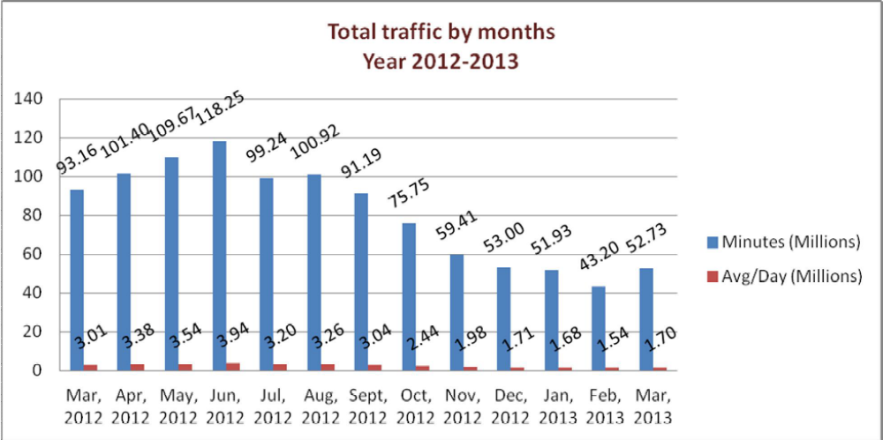

01. Total traffic by Months, Year 2012-2013 (According to 30 days)

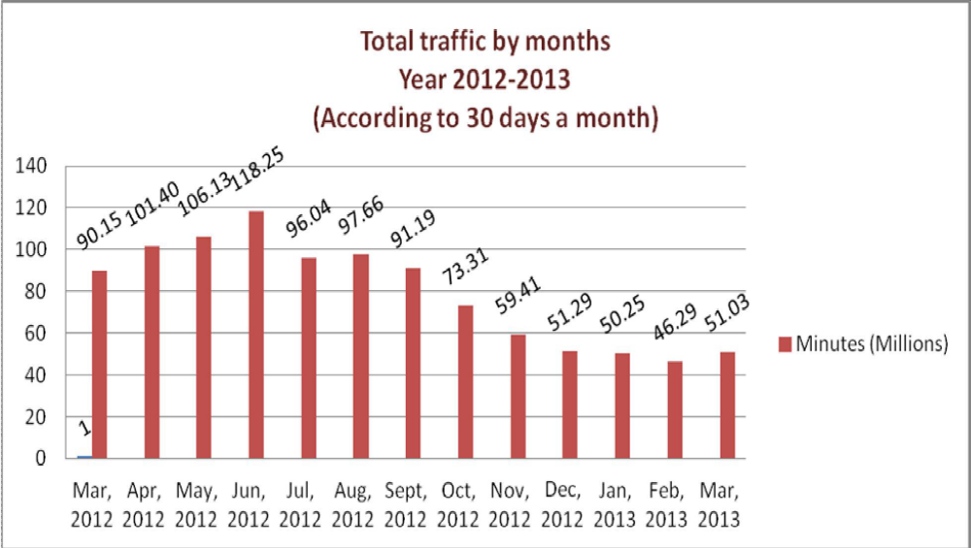

02. gTalk Total Traffic
02(a). gTalk: Total Traffic by months. Year 2012-2013

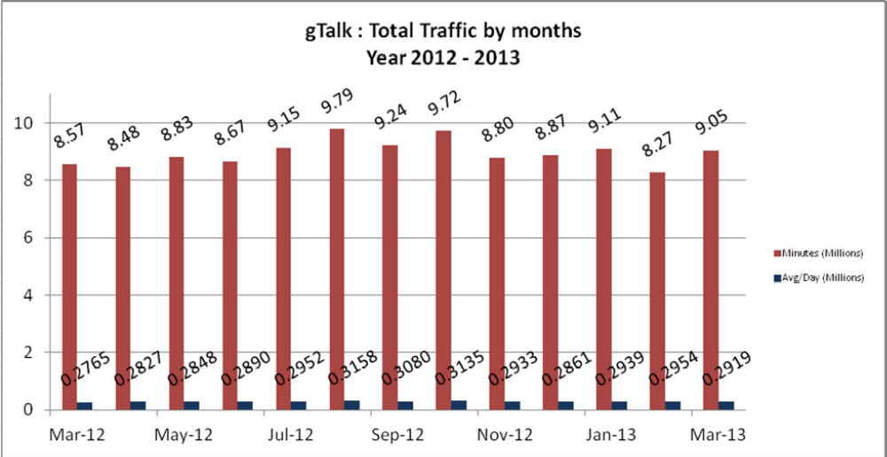

02(b). gTalk : Total Traffic by months (According to 30 days)

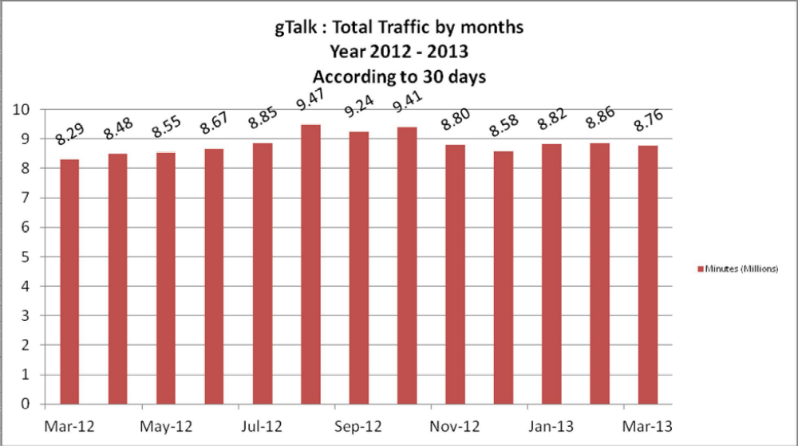

03. gTalk NA

03(a). gTalk NA : Total Traffic by months. Year 2012-2013

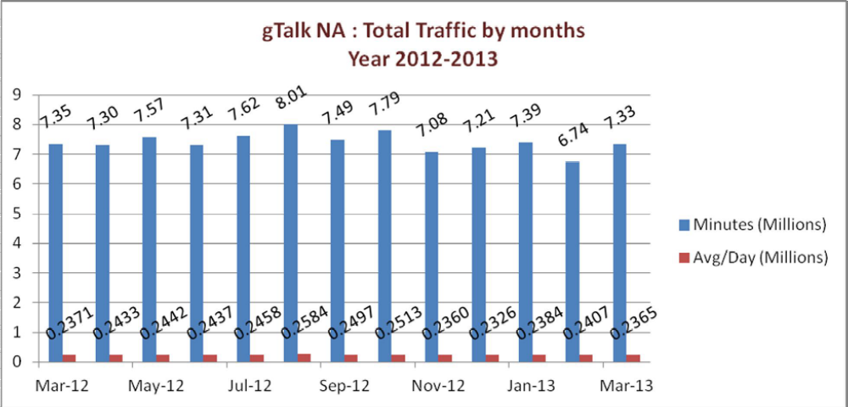

03(b). gTalk NA : Total Traffic by months. Year 2012-2013 (According to 30 days) 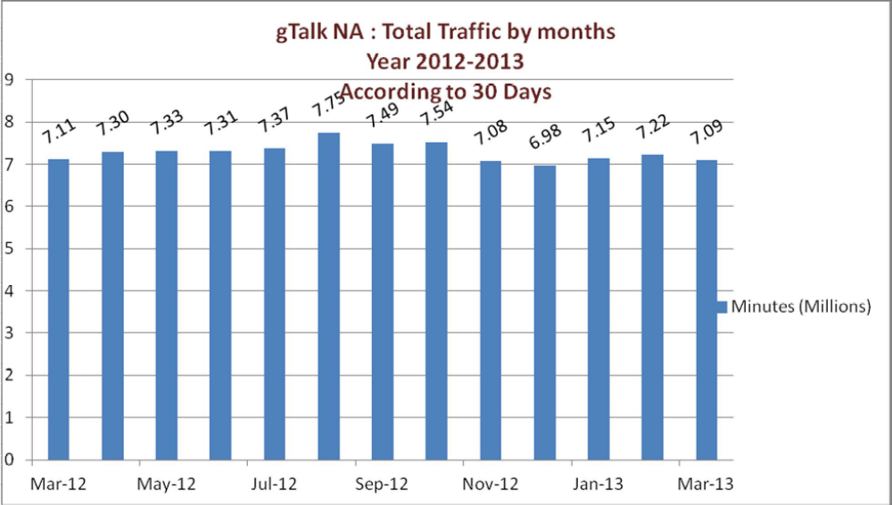

03(c). gTalk NA : New clients by months for the year 2012-2013

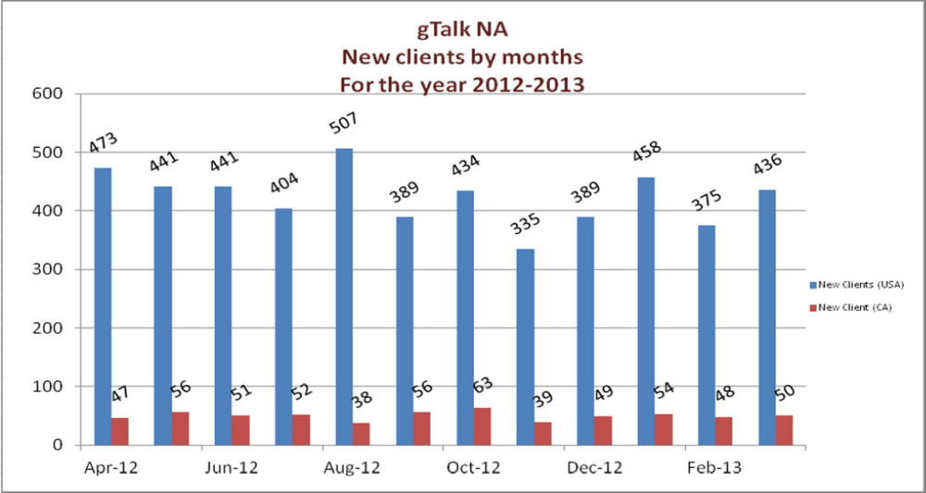

04. gTalk UK

04(a). gTalk UK : Total Traffic by months for the year 2012-2013
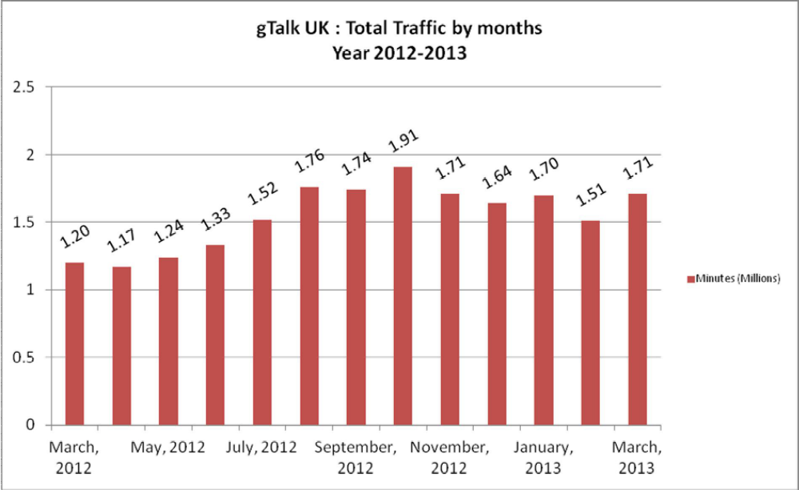

04(b). gTalk UK : Total Traffic by months for the year 2012-2013 (According to 30 Days)
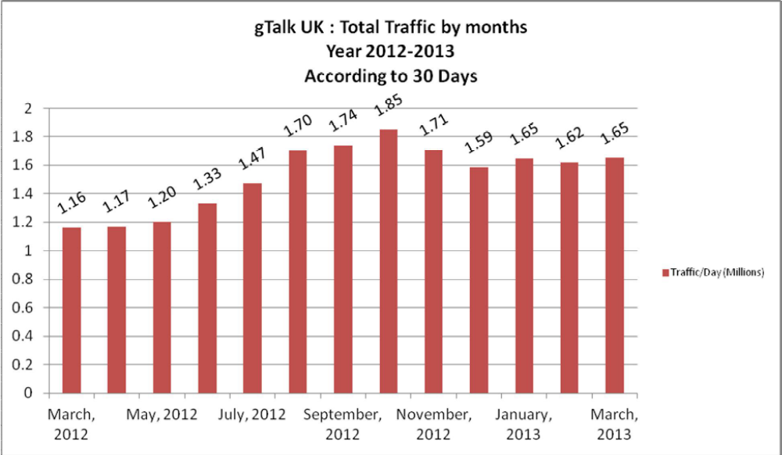

04(c). gTalk UK : New clients by months for the year 2012-2013

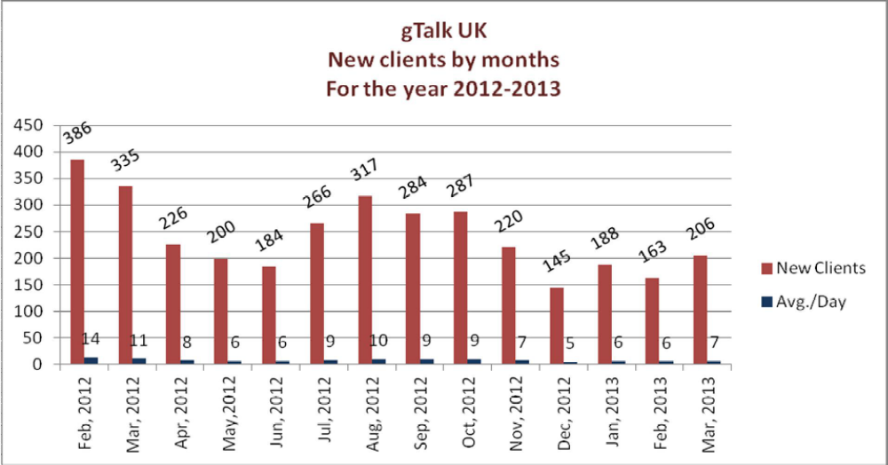

d. Department : Training
Manager : Md. Abdullah Al Masum

Current Status: Currently training department is running training in twelve batches. Among these three batches (Round 16, 18, 19) are being run for IDB. The other 9 batches are covering different customized courses.

Revenue: Total collection on account of training in the month of March was 4.96 lacs and collection for February 2013 was 12.54 lacs. The total amount of revenue from March 2013 activities was Tk 7.31 lacs.

Training for Bureau Bangladesh: Bureau Bangladesh has confirmed about internal training courses. The origination is delayed due to strike.

Prospective clients: Akij group and Mohona TV will send some of their employees for training. It is also delayed for strike.

New lab arrangement for extra classes: In order to accommodate the missed classes due to strike, we have arranged the training staff room as Lab and arranged seats for the staffs at different places of office compound.

e. Department : Corporate
Manager : Sk. Kamruzzaman Prince

Prospective client: One Bank Ltd. has shortlisted us for their work. Now they are waiting for the final decision of the management.
New work order from The City Bank: The have prepared another work order for GSL. A work order worth 17 lacs taka is ready for email service which we could not deliver yet.
Gift for Pohela Boishakh: GSL will give away some gifts on the occasion of Pohela Boishakh to the prospective and existing clients.

f. Department : Software
Manager : Md. Samiul Aftad Chowdhury

IPBX, Dialer & PlexStar: Software is working with the phone version of IPBX. Some amendment work is going on. They are also working on the dialer and after some multi tests in Dubai, Oman and KSA, those updated versions will be implemented. They are also working on the PlexStar.

g. Department : Admin & HR
Manager : Md. Habibur Rahman

BASIS fair: BASIS Fair will start from 2nd May and everyone s given update about the progress.
HR Consultancy: Update about consultancy work is shared with everyone.
Banani office update: PHP will finance Foster soon and upon getting the finance, the construction will begin.
New advertisement of gTalk: The script of new ad for gTalk is ready. Ad firm is working on it.

h. CEO
Md. Anis Rahman

Update about traffic: Honorable CEO addressed about some malfunctioning of our system. He wants IVC to work on it. He directed Mr. Aminul to conduct a meeting regarding this.

At the end, CEO showed appreciation to everyone for their presence and thoughtful insights about the company. He concluded the meeting by thanking to all.

