Reference: GSL/ Admin/ MCM 54

Minutes of
54th Monthly Coordination Meeting
Date: 07th November 2013
Venue: GSL Conference Room 1

Time: 08:30 AM

- The fifty forth monthly coordination meeting of Genuity Systems Ltd. (GSL) was held on 7th November 2013 at Genuity Conference Room 1. The CEO, DM and managers of different departments of the company were present. List of participants of the meeting are as follows:

SL. | Name of Participants | Department | Signature
1. | Habib Rahman | President | Present/V.con
2. | M. Anis Rahman | Chief Executive Officer | Present/V.con
3. | Md. Sadiqur Rahman | Director Operations | Present
4. | K. Shahadat Hossain | Director Marketing | Present/V.con
5. | Md. Habibur Rahman | Admin & HR | Present
6. | Md. Waliul Haque Tusar | System Admin | Present
7. | Md. Samiul Aftad Chowdhury | Head of Software Department | Present/V.con
8. | Md. Aminul Islam | Head of International Voice Carrier | Present/V.con
9. | Sk. Kamruzzaman Prince | Corporate Affairs | Present
10. | Lutful Kabir Majumder | Call Center | Present
11. | Md. Ashrafuzzaman | Accounts | Present
12. | Md. Abdullah Al Masum | Training | Present

- The meeting was started by the Manager, Admin & HR. He thanked everyone for participating in the meeting and invited the CEO to take control of the meeting. The CEO warmly welcomed everyone present in the meeting and thanked them for their presence. Thereafter he requested all departmental managers to deliver respective speech, one at a time, highlighting departmental performance and issues during the last month. He invited all to raise queries/questions and share their opinion in the discussion as deemed fit. The main points raised and discussed in the meeting over different issues are recorded below:

a. Department : Corporate
Manager : Sk. Kamruzzaman Prince

Update of the work: A brief discussion about the pipe lined products of last month.
Update of British Council: British Council is asking for new type of product. In reply, marketing department said that in such situation, there should be placed a new quotation.

b. Department : Training
Manager : Md. Abdullah Al Masum

Current Status: Currently training department is running training in eleven batches. Among these, three batches (Round 18, 19, 20) are being run for IDB. The other 8 batches are covering different customized courses.
Revenue: Total collection on account of training in the month of October was 7.20 lacs and collection for September 2013 was 14.79 lacs. The total amount of revenue from October 2013 activities was Tk 3.01 lacs.
New corporate clients: We have got confirmation from some corporate clients about their training with GSL. The corporate are Bangladesh Air force, Bangladesh University of Professionals & Green University.

c. Department : Call Center (gTalk)
Manager : Md. Lutful Kabir Majumder

Current status of client joining and usage in gTalk pinless:

# Total client joined in gTalk till 31 October 2013: 53636

# Average client increase per day in October, 13: 15
# Average client increase per day in September, 13: 18
# Average client increase per day in August, 13: 19
# Average client increase per day in July, 13: 19
# Average client increase per day in June, 13: 18
# Average client increase per day in May, 13: 20
# Average client increase per day in April, 13: 24

# Average total Minutes per day in October, 13: 269.77 K
# Average total Minutes per day in September, 13: 270.80 K
# Average total Minutes per day in August, 13: 285.98 K
# Average total Minutes per day in July, 13: 278.14 K
# Average total Minutes per day in June, 13: 284.43 K
# Average total Minutes per day in May, 13: 285.71 K
# Average total Minutes per day in April, 13: 293.14 K

# Total customer used gTalk service in October, 13 about 22,166
# Total customer used gTalk service in September, 13 about 22,388
# Total customer used gTalk service in August, 13 about 22,604
# Total customer used gTalk service in July, 13 about 22,280
# Total customer used gTalk service in June, 13 about 22,193
# Total customer used gTalk service in May, 13 about 22,456
# Total customer used gTalk service in April, 13 about 22,371

Unused Initial Balance for the month of October: In the month of October, it has been found that total 39 customers have not used their Account Initial Balance after opening the account.

Current status after calling those customers is as follows:

- Customer using: 21 (54%)
- Customer still not using: 18 (46%)

Survey in October: In the month of October, a total of 1500 customers who are inactive for at least 2 months have been called. Details about customer’s feedback are given below:

- Ethnic Group:
  - Bangladesh- 1124(75%)
  - India- 70(5%)
  - Pakistan- 36(2%)
  - Zimbabwe- 74(5%)
  - Nepal -8(1%)
  - Miscellaneous- 188(12%)

- Message left to the customers who were unavailable: 282(19%)
- Number not in service: 573 (38%)
- Using other calling services or doesn’t make international calls: 497(33%)
- Interested to use again: 148 (10%)
- Among 148 customers, 16 people have started to use gTalk service again after this survey.

Hot number uses:

October, 13: 34.33%
September, 13: 34.65%
August, 13: 33.88%
July, 13: 34.12%
June, 13: 33.96%
May, 13: 33.88%
April, 13: 34.47%
March, 13: 34.86%
February, 13: 34.84%
January, 13: 33.79%

Hot Dialer Report
Total User(s): 5692
VoIP Dialer Report
Total User(s): 439

# Total client joined in gTalk UK till 31 October 2013: 5929

# Total client joined in October 2013: 130
# Total client joined in September 2013: 139
# Total client joined in August 2013: 168
# Total client joined in July 2013: 201
# Total client joined in June 2013: 186
# Total client joined in May 2013: 192
# Total client joined in April 2013: 224

# Total Minutes for the month of October, 13: 1589.23 K
# Total Minutes for the month of September, 13: 1532.40 K
# Total Minutes for the month of August, 13: 1672.95 K
# Total Minutes for the month of July, 13: 1610.63 K
# Total Minutes for the month of June, 13: 1582.79 K
# Total Minutes for the month of May, 13: 1658.84 K
# Total Minutes for the month of April, 13: 1647.24 K

d. Department : International Voice Carrier
Head of the department : Md. Aminul Islam

Monthly traffic and client report for the month of October 2013

Coverage area:
01. Total Traffic
02. gTalk Total Traffic
03. gTalkNA
04. gTalkUK

01. Total Traffic

01 (a). Total traffic by Months, Year 2012-2013
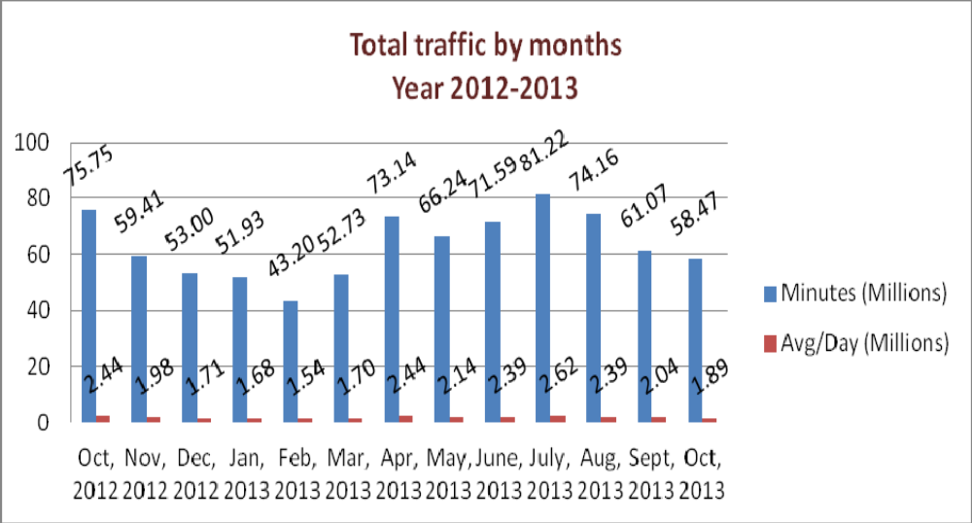

01(b). Total traffic by Months, Year 2012-2013 (According to 30 days)

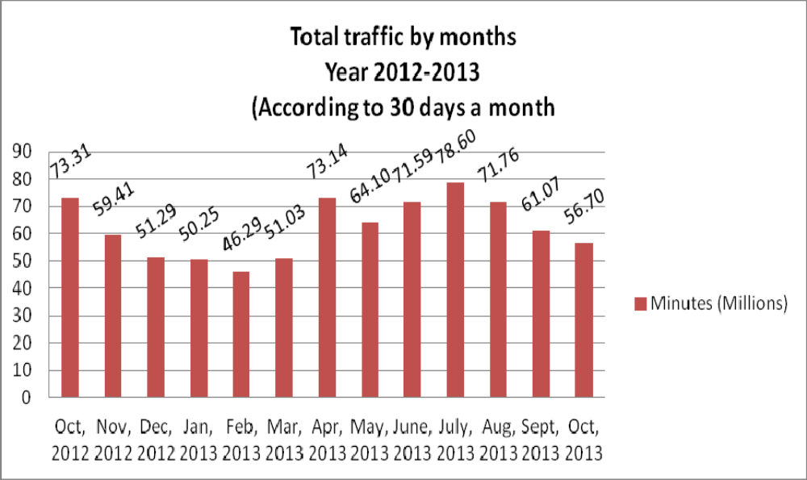

02. gTalk Total Traffic
02(a). gTalk: Total Traffic by months. Year 2012-2013

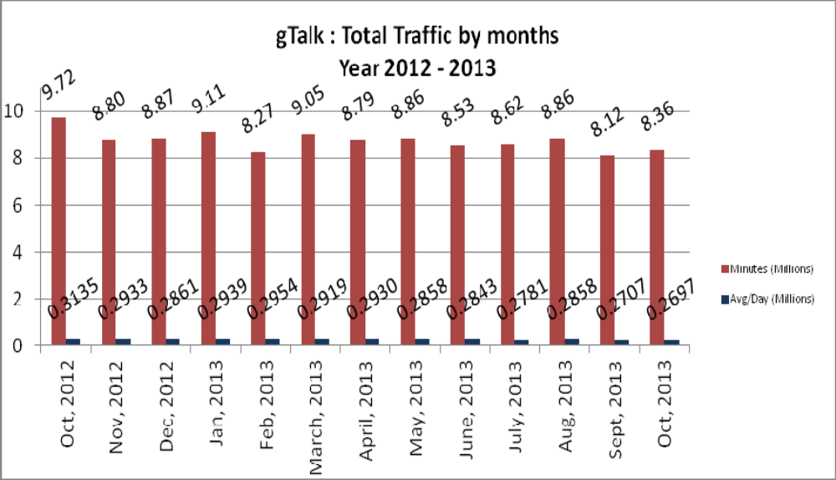

02(b). gTalk : Total Traffic by months (According to 30 days)

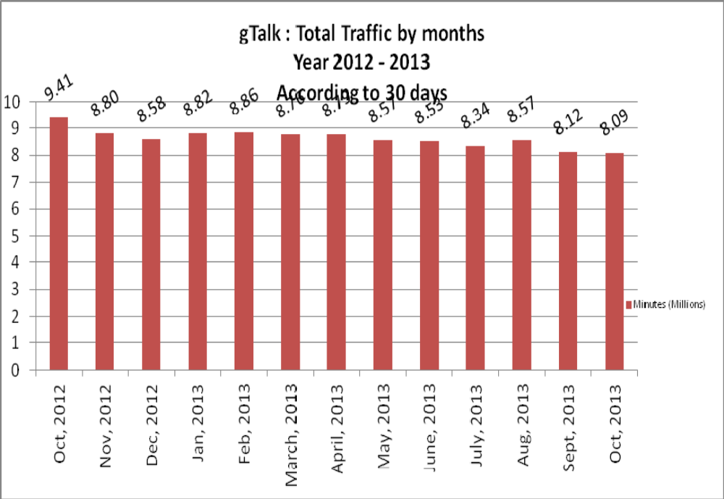

03. gTalk NA

03(a). gTalk NA : Total Traffic by months. Year 2012-2013

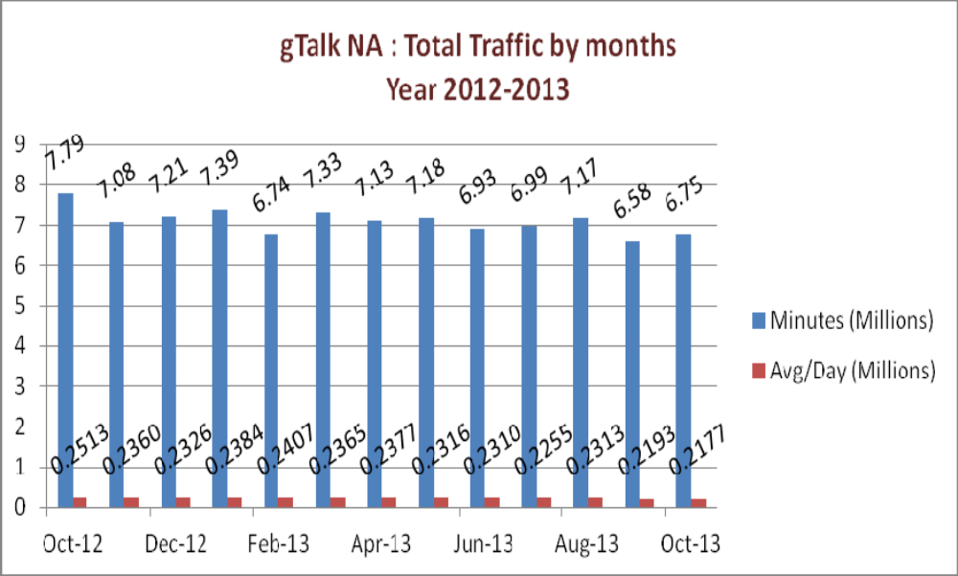

03(b). gTalk NA : Total Traffic by months. Year 2012-2013 (According to 30 days)

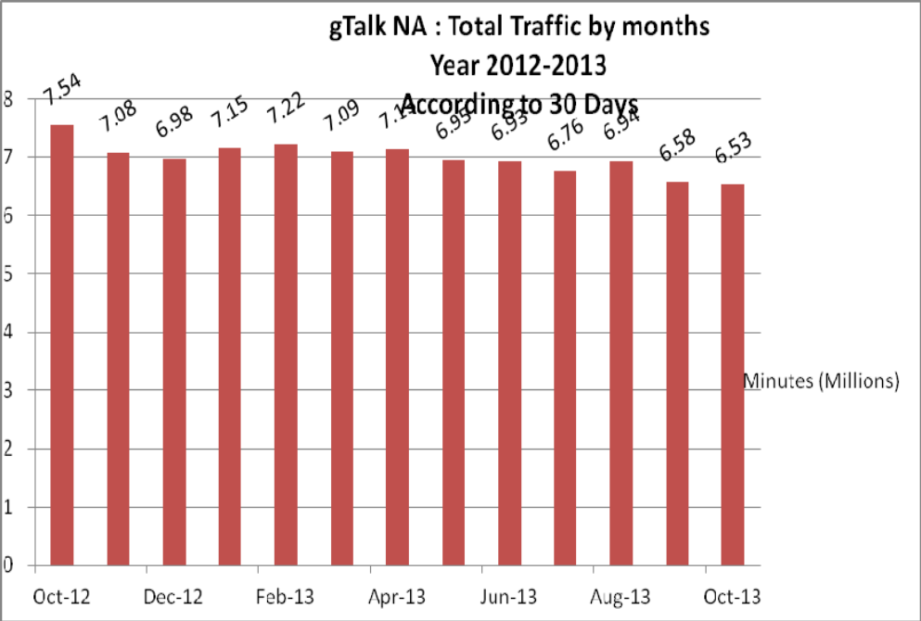

03(c). gTalk NA : New clients by months for the year 2012-2013

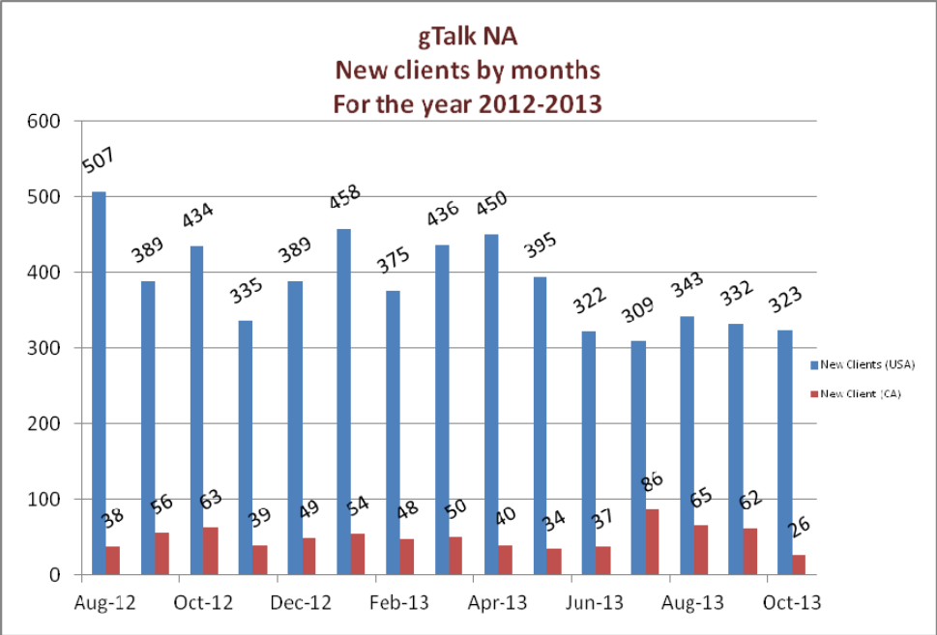

04. gTalk UK

04(a). gTalk UK : Total Traffic by months for the year 2012-2013
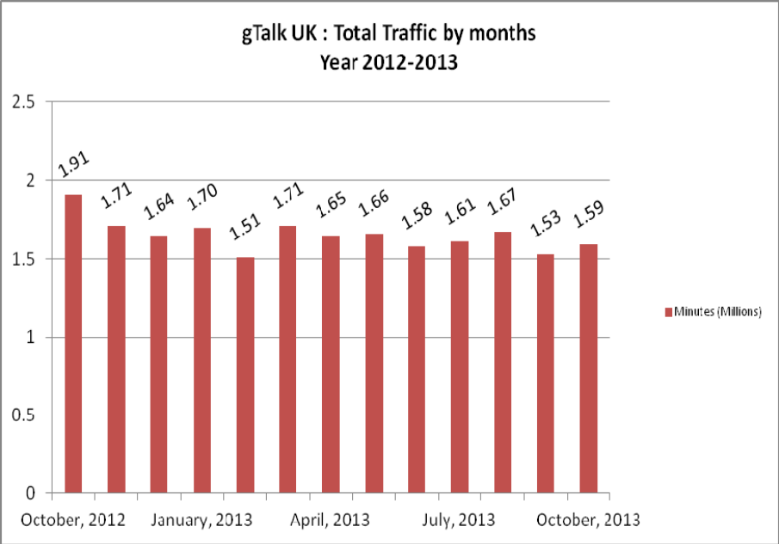

04(b). gTalk UK : Total Traffic by months for the year 2012-2013 (According to 30 Days)
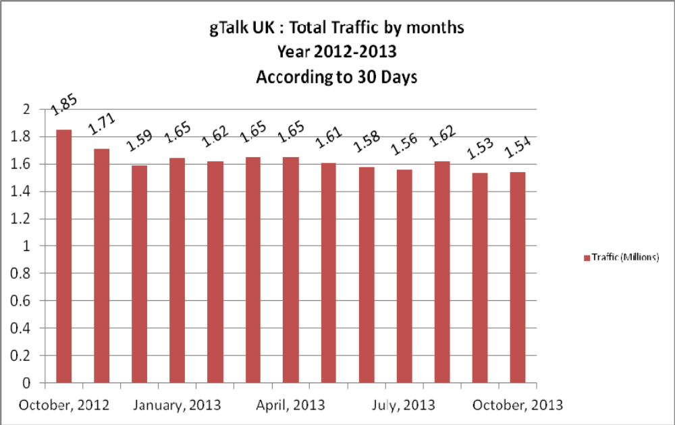

04(c). gTalk UK : New clients by months for the year 2012-2013

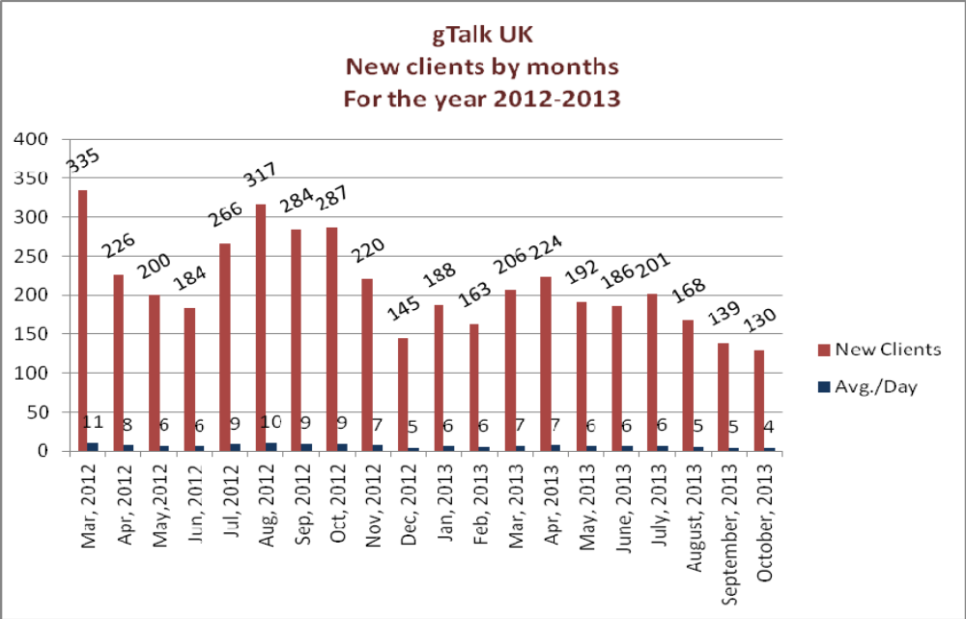

e. Department : gPlex Software Solutions
Head of Marketing & Sales : Lutful Kabir Majumder
Genuity Systems Ltd.
gPlex Switch and Dialer Sales Report
For the Month of October, 2013
Product Name | Sales | Realized | Dis.&Pro. | Unrealized | Qty. of New Sales | % of Realized
gPlex Mobile Dialer | $ 44,749 | $ 44,144 | $ - | $ 605 | 14 | 99%
gPlex Hosted Switch | $ 15,800 | $ 9,149 | $ - | $ 6,651 | 5 | 58%
Total | $ 60,549 | $ 53,293 | $ - | $ 7,256 | 19

 | gPlex Switch Sales Report
 | From | 10/1/2013 | To | 10/31/2013
Description | No. of Ch | Sales Quantity | Sales Amonut | % of Sales
MRC
New Clients | 500 | 5 | $ 1,800 | 11.4%
Existing Clients | 8,900 | 39 | $ 14,000 | 88.6%
Total (MRC) | 9,400 | 44 | $ 15,800 | 100.0%
Total Sales Of June |  |  | $ 15,800
Discount |  |  | $ - | 0.0%
Write off |  |  | $ - | 0.0%
Current Due |  |  | $ 6,651 | 42.1%
Cash Received |  |  | $ 9,127 | 57.8%
Advanced Expired |  |  | $ 22 | 0.1%
Total Sales |  |  | $ 15,800 | 100.0%
Advaced Received |  |  | $ -
Due Realized From Last Month |  |  | $ 2,101
Previous due Realized |  |  | $ 138
Cash Sale of Current Month |  |  | $ 9,127
Total Cash In |  |  | $ 11,366
Total Cash Sale including Advanced Expired |  |  | $ 9,149
Net Cashflow to Sales- Current |  |  | 57.9%
Accounts Receivable Statements
Accounts Receivable B/F |  |  | $ 78,915
Adjustments-
Due in September 2013 Only | $ 6,912
Due Realized of September 2013 | $ 2,101
Due Remained From September 2013 |  | $ 4,811
Due Realized- Upto August 2013 |  | $ 138
Total Due Realized |  |  | $ 2,239
Previous Write off |  |  | $ 550
Discount Allowed |  |  | $ -
Adjusted A/R upto September |  |  | $ 76,126
Accounts Receivable- Current Month |  |  | $ 6,651
Accounts Receivable C/F |  |  | $ 82,777

 | gPlex Dialer Sales Report
 | From | 10/1/2013 | To | 10/31/2013
Description | Capacity | Qty of Sales | Sales | %
gPlex Mobile Dialer (New Clients) | 750 | 14 | $ 2,249 | 5.0%
gPlex Mobile Dialer (Existing Clients) | 7,600 | 122 | $ 42,500 | 95.0%
Total | 8,350 | 136 | $ 44,749 | 100.0%
Current Due |  |  | $ 605 | 1.4%
Discount |  |  | $ - | 0.0%
Advance Expired |  |  | $ 174 | 0.4%
Total Cash Received |  |  | $ 43,970 | 98.3%
Total Sales |  |  | $ 44,749 | 100.0%
Advance Received |  |  | $ 608
Cash Sales Including Advance Expired |  |  | $ 44,144
Net Cashflow to Sales- Current |  |  | 98.6%
Accounts Receivable Statements
Previous Due Upto September 2013 |  |  | $ 77,531
Adjustments-
Due in September 2013 Only | $ 2,679
Due Realized from September 2013 | $ 2,594
Due Remained from September 2013 |  | $ 85
Due Realized- Upto August 2013 |  | $ 1,388
Total Due Realized |  |  | $ 3,982
Discount Allowed |  |  | $ -
Written Off |  |  | $ -
Adjusted A/R upto September |  |  | $ 73,549
Accounts Receivable- Current Month |  |  | $ 605
Accounts Receivable C/F |  |  | $ 74,154

Switch Report Summary-2013
Month | Qty of New Sales | New Sales | Existing Sales | Net cash flow% | Due Realized | Current Due
January | 7 | $1,850 | $30,050 | 60% | $4,992 | $11,579
February | 2 | $1,050 | $27,900 | 44% | $4,013 | $12,228
March | 3 | $950 | $23,900 | 55% | $3,955 | $6,507
April | 2 | $500 | $17,900 | 57% | $2,992 | $7,300
May | 3 | $750 | $16,150 | 63% | $2,622 | $5,362
June | 0 | $0 | $14,200 | 58% | $3,121 | $5,554
July | 3 | $750 | $13,550 | 61% | $3,303 | $5,606
August | 3 | $2,250 | $14,000 | 64% | $2,248 | $3,868
September | 1 | $400 | $13,750 | 51% | $1,970 | $6,912
October | 5 | $1,800 | $14,000 | 58% | $2,239 | $6,651
November
December


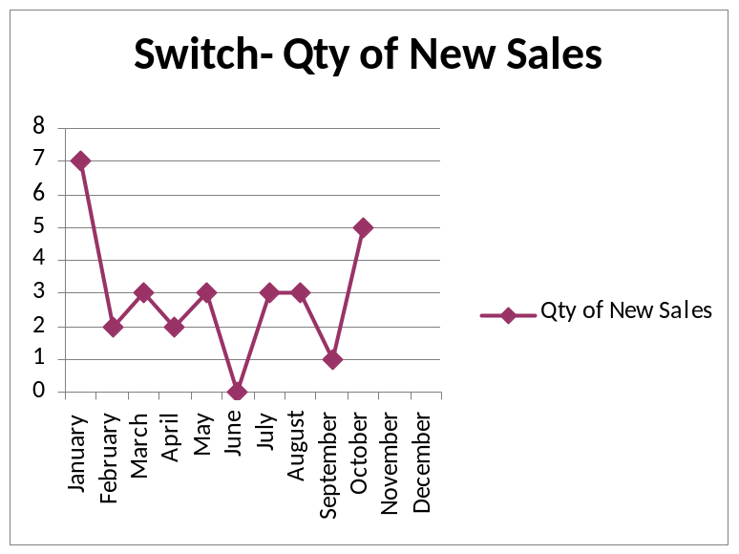
Dialer Report Summary-2013
Month | Qty of New Sales | New Sales | Existing Sales | Net cash flow% | Due Realized | Current Due
January | 22 | $8,200 | $33,450 | 94% | $1,020 | $2,676
February | 25 | $2,200 | $55,264 | 95% | $1,512 | $4,172
March | 28 | $11,450 | $55,600 | 98% | $2,112 | $1,161
April | 28 | $8,800 | $46,450 | 94% | $1,129 | $3,176
May | 39 | $29,060 | $69,832 | 98% | $3,643 | $2,125
June | 37 | $12,160 | $53,908 | 92% | $1,462 | $5,479
July | 35 | $9,400 | $57,797 | 97% | $23 | $1,905
August | 21 | $11,680 | $54,550 | 97% | $61 | $2,164
September | 14 | $5,600 | $53,100 | 95% | $2,131 | $2,679
October | 14 | $2,249 | $42,500 | 99% | $3,982 | $605
November
December


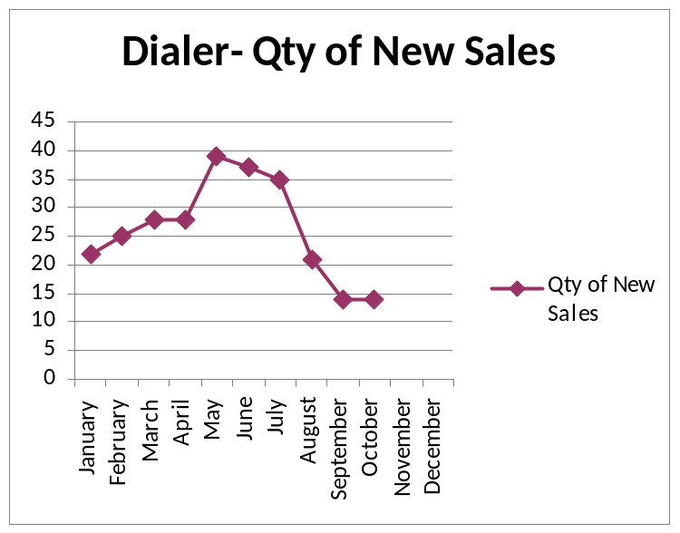

f. Department : Software
Head of the department : Md. Samiul Aftad Chowdhury

Update of the ongoing jobs: A summary of the ongoing jobs was shared with the managers and management.
New Turbo Server: A new Turbo server has been set up.

g. Department : Admin & HR
Manager : Md. Habibur Rahman

Completion of grading job: The grading work is almost final. Now we are oing the official procedure. Right after getting approval from Management within 1-2 days, we will publish it among the stafss and and go for implementation.
Initial CV sorting done for recruitment in software department: After the advertisement for the post of software department, we pulled huge number of CVs. We have already done the initial screening of CVs and sent the sorted CVs to Software department head for final sorting. Once we get those, we will go for Interview process.
Calendar works: Calendar works has been finalized. We will give it for printing in next week. The quantity has been set as 1000pcs for Genusys Limited and 2000pcs for Genuity Stystems Ltd.
Annual picnic: We have fixed the date of annual picnic on 3rd January 2013. We have already gave the booking money. There was a thought of having the picnic of GL & GSL separately, but afterwards, the managers could unite in having it together.
In reply of website issue raised by CEO: We have numbers of Websites in our name. But none of are quality ones as they do not have good narration about our products. In order to make them rich in content, we need to update the detail of the products and continue doing it. It can be done easily if the is one manager to do the job along with one junior colleague beneath him/her to assist.

- Director Operations
Md. Sadiqur Rahman

Update about ZITAX: DO has given update regarding the ZITAX fair held in Dubai. He added that as the Zavil hall is more attractive for the fair, we will try to get stall in that hall from next year. Besides, he added, that the number of persons who take part in the fair are more than necessary compared to the number of visitors we have to handle there. So from next year we can decrease the number of persons participating in the fair from Dhaka office. DO also narrated that whether it is possible or not to have the event some other time than the time of fair.

- CEO
Md. Anis Rahman
Website issue: The content of our websites are very poor, we need to work more to make the contents better.
In reply of DO about ZITEX fair: This time the scenario of Dubai fair was different. As many internal people could not go there to participate due to Visa problem, their own clients also did not show up in the fair. So it will not be wise to decrease the participants from Dhaka office in next year.
Changes in Call Center Hardware: Previously, we had Zion processor in server. Now it is replaced with Core IV process for better performance.
Update about Plexstar: For last few months, we were investing huge behind the plexstar and were becoming frustrated with the sales figure. But now we can see hope inside Bangladesh with that product. We hope that the sales figure will raise to 1 Million by 2014.

- President
Habib Rahman
An African Company showed interest to take a 200 seated call center solution from our company. We have already talked to them over phone and we are hopeful about the deal.

At the end, CEO showed appreciation to everyone for their presence and thoughtful insights about the company. He concluded the meeting by thanking to all.

