Reference: GSL/ Admin/ MCM 55

Minutes of
55th Monthly Coordination Meeting
Date: 10th December 2013
Venue: GSL Conference Room 1

Time: 09:00 AM

- The fifty forth monthly coordination meeting of Genuity Systems Ltd. (GSL) was held on 10th December 2013 at Genuity Conference Room 1. The CEO, DM and managers of different departments of the company were present. List of participants of the meeting are as follows:

SL. | Name of Participants | Department | Signature
1. | Habib Rahman | President | Present/V.con
2. | M. Anis Rahman | Chief Executive Officer | Present/V.con
3. | Md. Sadiqur Rahman | Director Operations | Present
4. | K. Shahadat Hossain | Director Marketing | Present/V.con
5. | Md. Habibur Rahman | Admin & HR | Present
6. | Md. Waliul Haque Tusar | System Admin | Present
7. | Md. Samiul Aftad Chowdhury | Head of Software Department | Present/V.con
8. | Md. Aminul Islam | Head of International Voice Carrier | Present/V.con
9. | Sk. Kamruzzaman Prince | Corporate Affairs | Present
10. | Lutful Kabir Majumder | Call Center | Present
11. | Md. Ashrafuzzaman | Accounts | Present
12. | Md. Abdullah Al Masum | Training | Present

- The meeting was started by the Manager, Admin & HR. He thanked everyone for participating in the meeting and invited the CEO to take control of the meeting. The CEO warmly welcomed everyone present in the meeting and thanked them for their presence. Thereafter he requested all departmental managers to deliver respective speech, one at a time, highlighting departmental performance and issues during the last month. He invited all to raise queries/questions and share their opinion in the discussion as deemed fit. The main points raised and discussed in the meeting over different issues are recorded below:

a. Department : Corporate
Manager : Sk. Kamruzzaman Prince

New client in the pipeline: Expolanka is in the list of potential client.
Problem with SCB: We were supposed to install the new version in SCB by 19th of this month. But all the features of that version is not ready yet. This problem occurred due to neglegency of Tech people. They gave the delivery date without proper feature check.
Update of Bank Asia: The server that we have in Bank Asia is of 5 years old. Now it is a question whether we need to change the hardware now or not.
CEO in reply of this: CEO commented that the total server set needs not to be changed, we should only change the hard disk.

b. Department : Training
Manager : Md. Abdullah Al Masum

Current Status: Currently training department is running training in twelve batches. Among these, two batches (Round 18, 19) are being run for IDB. The other 10 batches are covering different customized courses.
Revenue: Total collection on account of training in the month of November was 7.28 lacs and collection for October 2013 was 7.20 lacs. The total amount of revenue from November 2013 activities was Tk 10.62 lacs.
New corporate clients: Bangladesh Air force and Bangladesh Army (BUR) have started their pilot training. Santa Marium University has also started their traning classes. Bangladesh Army & Bangladesh Police are in pipe line of our new client.
c. Department : Call Center (gTalk)
Manager : Md. Lutful Kabir Majumder

Current status of client joining and usage in gTalk pinless:

# Total client joined in gTalk till 30 November 2013: 53983

# Average client increase per day in November, 13: 12
# Average client increase per day in October, 13: 15
# Average client increase per day in September, 13: 18
# Average client increase per day in August, 13: 19
# Average client increase per day in July, 13: 19
# Average client increase per day in June, 13: 18
# Average client increase per day in May, 13: 20

# Average total Minutes per day in November, 13: 248.22 K
# Average total Minutes per day in October, 13: 269.77 K
# Average total Minutes per day in September, 13: 270.80 K
# Average total Minutes per day in August, 13: 285.98 K
# Average total Minutes per day in July, 13: 278.14 K
# Average total Minutes per day in June, 13: 284.43 K
# Average total Minutes per day in May, 13: 285.71 K

# Total customer used gTalk service in November, 13 about 21,941
# Total customer used gTalk service in October, 13 about 22,166
# Total customer used gTalk service in September, 13 about 22,388
# Total customer used gTalk service in August, 13 about 22,604
# Total customer used gTalk service in July, 13 about 22,280
# Total customer used gTalk service in June, 13 about 22,193
# Total customer used gTalk service in May, 13 about 22,456

Unused Initial Balance for the month of November: In the month of November, it has been found that total 24 customers have not used their Account Initial Balance after opening the account.

Current status after calling those customers is as follows:

- Customer using: 15 (63%)
- Customer still not using: 9 (37%)

Survey in November: In the month of November, a total of 2020 customers who are inactive for at least 2 months have been called. Details about customer’s feedback are given below:

- Ethnic Group:
  - Bangladesh- 1799(88%)
  - India- 63(3%)
  - Pakistan- 14(1%)
  - Zimbabwe- 52(3%)
  - Nepal -9(1%)
  - Miscellaneous- 83(4%)

- Message left to the customers who were unavailable: 495 (24%)
- Number not in service: 721 (36%)
- Using other calling services or doesn’t make international calls: 557 (28%)
- Interested to use again: 247 (12%)
- Among 247 customers, 19 people have started to use gTalk service again after this survey.

Hot number uses:

November, 13: 35.31%
October, 13: 34.33%
September, 13: 34.65%
August, 13: 33.88%
July, 13: 34.12%
June, 13: 33.96%
May, 13: 33.88%
April, 13: 34.47%
March, 13: 34.86%
February, 13: 34.84%
January, 13: 33.79%

Hot Dialer Report
Total User(s): 6026

VoIP Dialer Report
Total User(s): 497

# Total client joined in gTalk UK till 30 November 2013: 6015

# Total client joined in November 2013: 86
# Total client joined in October 2013: 130
# Total client joined in September 2013: 139
# Total client joined in August 2013: 168
# Total client joined in July 2013: 201
# Total client joined in June 2013: 186
# Total client joined in May 2013: 192
# Total client joined in April 2013: 224

# Total Minutes for the month of November, 13: 1387.18 K
# Total Minutes for the month of October, 13: 1589.23 K
# Total Minutes for the month of September, 13: 1532.40 K
# Total Minutes for the month of August, 13: 1672.95 K
# Total Minutes for the month of July, 13: 1610.63 K
# Total Minutes for the month of June, 13: 1582.79 K
# Total Minutes for the month of May, 13: 1658.84 K
# Total Minutes for the month of April, 13: 1647.24 K

Cause behind reduction in number of clients: For last few months, we are observing reduction in number of clients. We have a feeling that it is happening due to high rate. So we need to revise the rate to increase clients.
HR Manager in reply to this: Before coming to any final decision regarding reducing the rate, we have to conduct a survey or a test to be assured of the issue of the reduction in number of our clients. We can offer a bonus on the lower amount of usage i.e. on 10 or 20 dollars. If we see that the lower amount usage increases after the bonus offer, than we will be able to conclude that the rate is the factor to be addressed to solve this problem.

d. Department : International Voice Carrier
Head of the department : Md. Aminul Islam

Monthly traffic and client report for the month of November 2013

Coverage area:
01. Total Traffic
02. gTalk Total Traffic
03. gTalkNA
04. gTalkUK

01. Total Traffic

01 (a). Total traffic by Months, Year 2012-2013

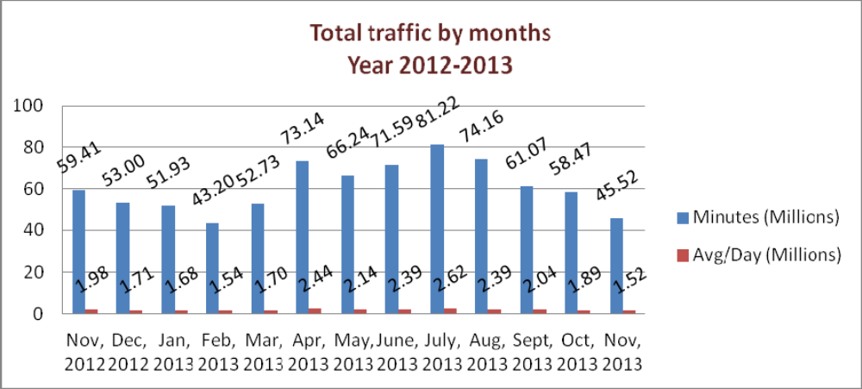

01(b). Total traffic by Months, Year 2012-2013 (According to 30 days)

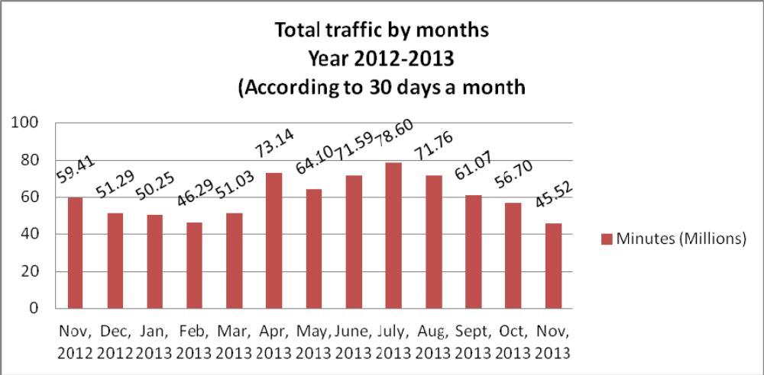

02. gTalk Total Traffic
02(a). gTalk: Total Traffic by months. Year 2012-2013

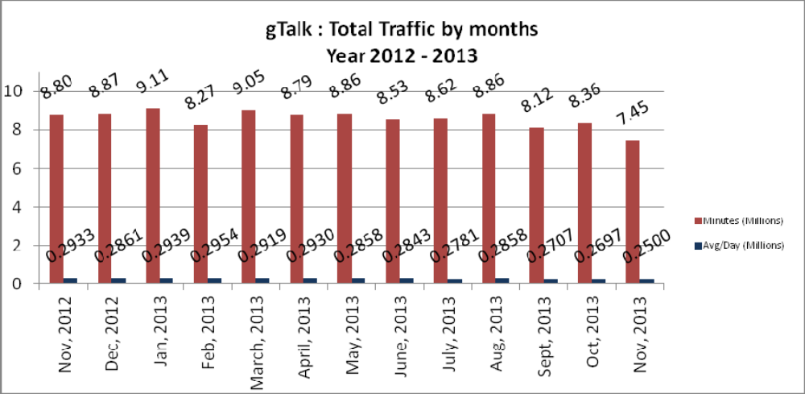

02(b). gTalk : Total Traffic by months (According to 30 days)

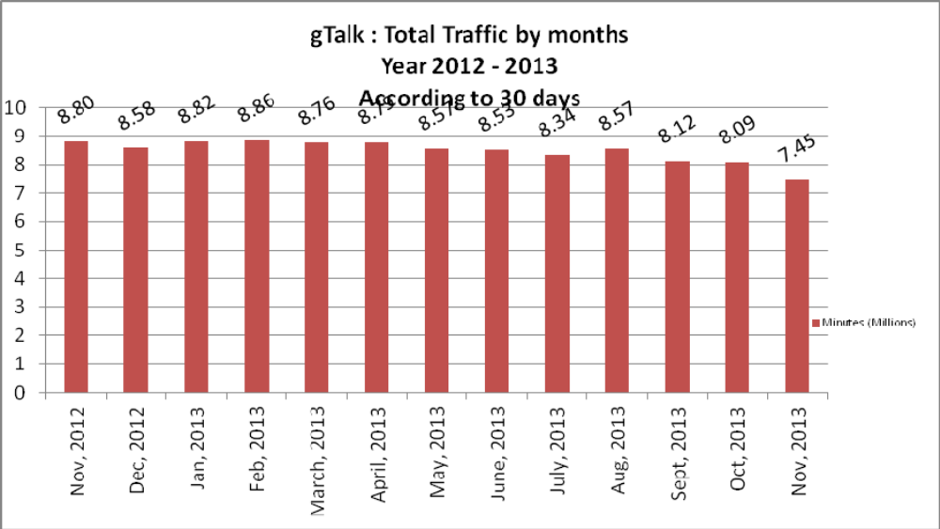

03. gTalk NA

03(a). gTalk NA : Total Traffic by months. Year 2012-2013

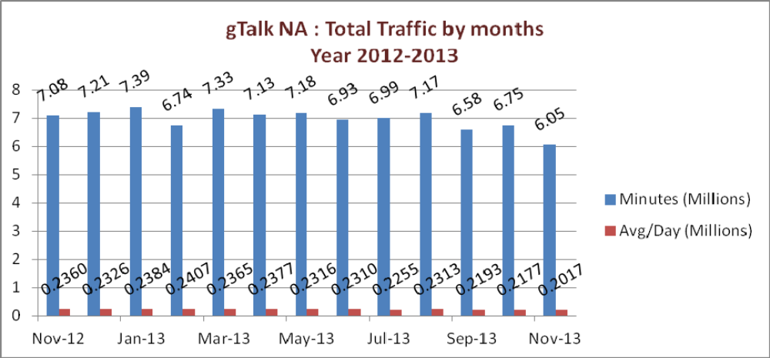

03(b). gTalk NA : Total Traffic by months. Year 2012-2013 (According to 30 days)

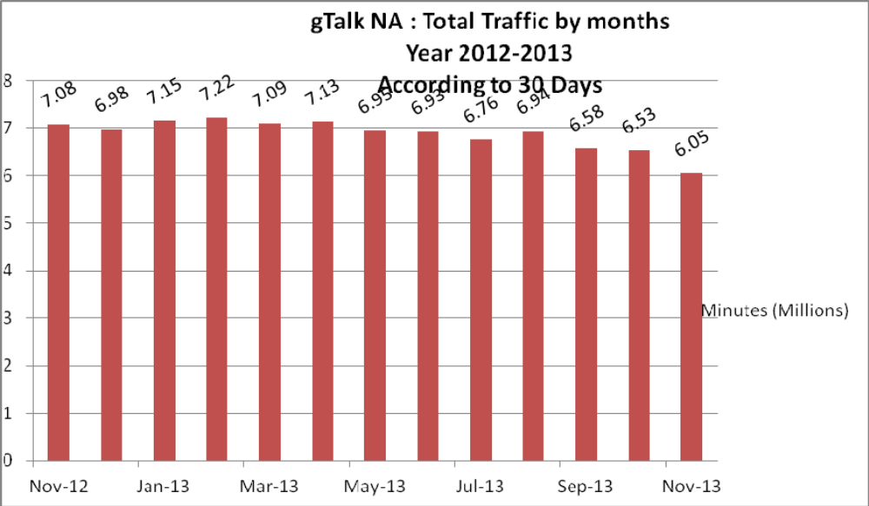

03(c). gTalk NA : New clients by months for the year 2012-2013

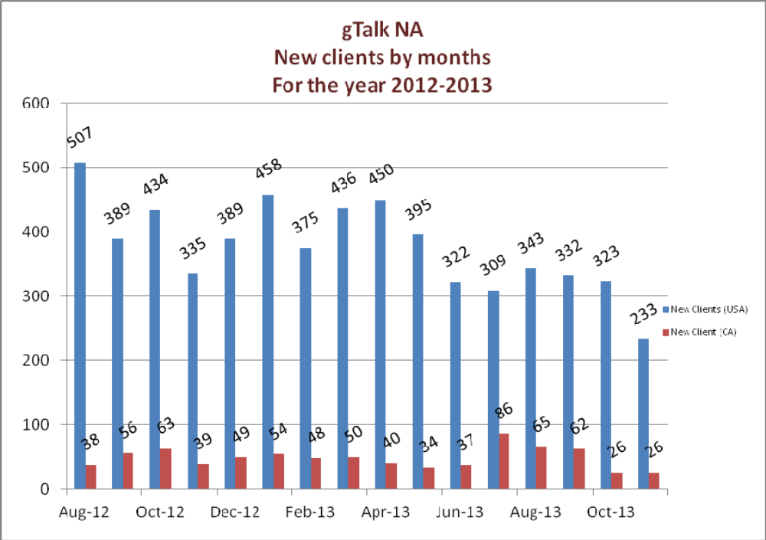

04. gTalk UK

04(a). gTalk UK : Total Traffic by months for the year 2012-2013
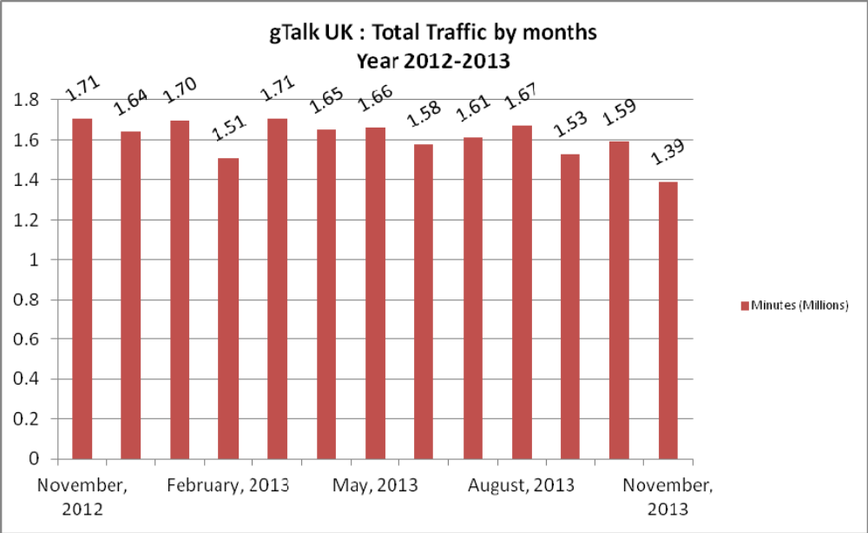

04(b). gTalk UK : Total Traffic by months for the year 2012-2013 (According to 30 Days)
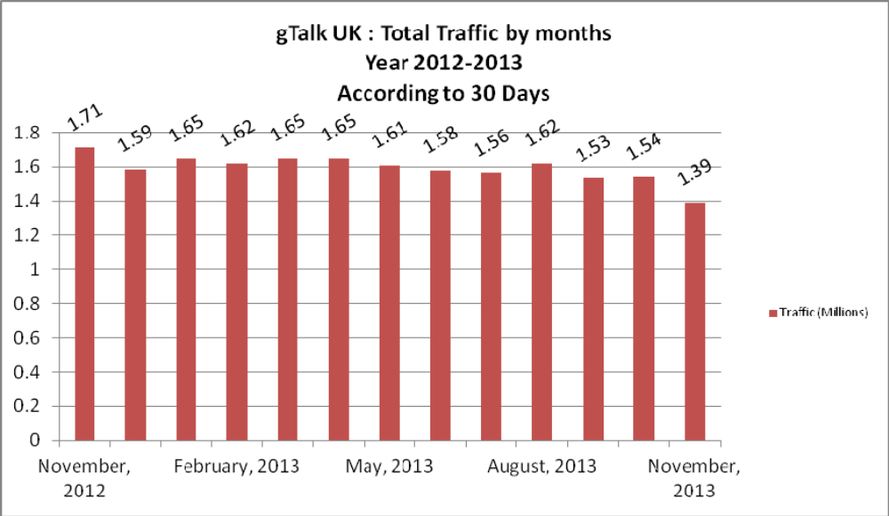

04(c). gTalk UK : New clients by months for the year 2012-2013

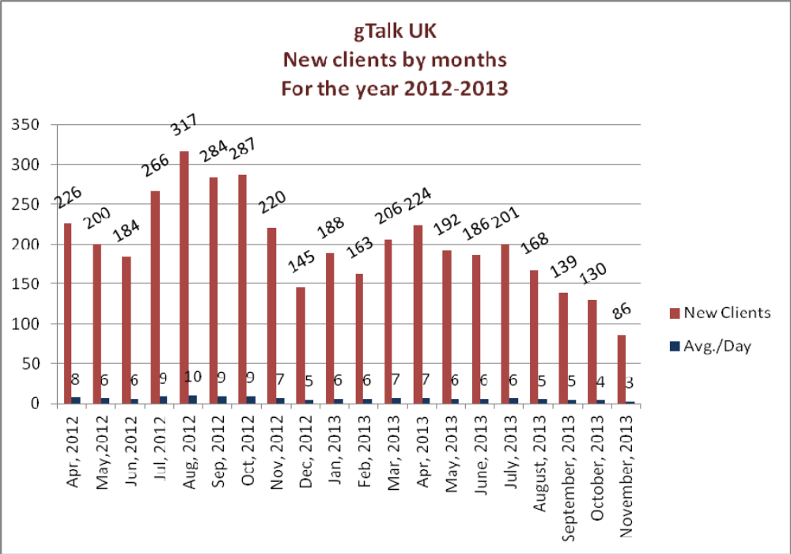

e. Department : gPlex Software Solutions
Head of Marketing & Sales : Lutful Kabir Majumder
Genuity Systems Ltd.
gPlex Switch and Dialer Sales Report
For the Month of November, 2013
Product Name | Sales | Realized | Dis.&Pro. | Unrealized | Qty. of New Sales | % of Realized
gPlex Mobile Dialer | $ 40,223 | $ 40,004 | $ - | $ 219 | 13 | 99%
gPlex Hosted Switch | $ 15,000 | $ 7,150 | $ 450 | $ 7,400 | 3 | 48%
Total | $ 55,223 | $ 47,154 | $ 450 | $ 7,619 | 16

 | gPlex Switch Sales Report
 | From | 11/1/2013 | To | 11/30/2013
Description | No. of Ch | Sales Quantity | Sales Amonut | % of Sales
MRC
New Clients | 300 | 3 | $ 600 | 4%
Existing Clients | 9,100 | 41 | $ 14,400 | 96.0%
Total (MRC) | 9,400 | 44 | $ 15,000 | 100.0%
Total Sales Of June |  |  | $ 15,000
Discount |  |  | $ - | 0.0%
Write off |  |  | $ 450 | 3.0%
Current Due |  |  | $ 7,400 | 49.3%
Cash Received |  |  | $ 7,150 | 47.7%
Advanced Expired |  |  | $ - | 0.0%
Total Sales |  |  | $ 15,000 | 100.0%
Advaced Received |  |  | $ -
Due Realized From Last Month |  |  | $ 2,044
Previous due Realized |  |  | $ 18
Cash Sale of Current Month |  |  | $ 7,150
Total Cash In |  |  | $ 9,121
Total Cash Sale including Advanced Expired |  |  | $ 7,150
Net Cashflow to Sales- Current |  |  | 47.7%
Accounts Receivable Statements
Accounts Receivable B/F |  |  | $ 82,777
Adjustments-
Due in October 2013 Only | $ 6,651
Due Realized of October 2013 | $ 2,044
Due Remained From October 2013 |  | $ 4,607
Due Realized- Upto September 2013 |  | $ 18
Total Due Realized |  |  | $ 2,062
Previous Write off |  |  | $ 729
Discount Allowed |  |  | $ -
Adjusted A/R upto October |  |  | $ 79,986
Accounts Receivable- Current Month |  |  | $ 7,400
Accounts Receivable C/F |  |  | $ 87,386

 | gPlex Dialer Sales Report
 | From | 11/1/2013 | To | 11/30/2013
Description | Capacity | Qty of Sales | Sales | %
gPlex Mobile Dialer (New Clients) | 750 | 13 | $ 4,623 | 11.5%
gPlex Mobile Dialer (Existing Clients) | 5,850 | 104 | $ 35,600 | 88.5%
Total | 6,600 | 117 | $ 40,223 | 100.0%
Current Due |  |  | $ 219 | 0.5%
Discount |  |  | $ - | 0.0%
Advance Expired |  |  | $ 118 | 0.3%
Total Cash Received |  |  | $ 39,886 | 99.2%
Total Sales |  |  | $ 40,223 | 100.0%
Advance Received |  |  | $ 200
Cash Sales Including Advance Expired |  |  | $ 40,004
Net Cashflow to Sales- Current |  |  | 99.5%
Accounts Receivable Statements
Previous Due Upto October 2013 |  |  | $ 74,154
Adjustments-
Due in October 2013 Only | $ 605
Due Realized from October 2013 | $ 540
Due Remained from October 2013 |  | $ 65
Due Realized- Upto September 2013 |  | $ 476
Total Due Realized |  |  | $ 1,016
Discount Allowed |  |  | $ -
Written Off |  |  | $ -
Adjusted A/R upto October |  |  | $ 73,138
Accounts Receivable- Current Month |  |  | $ 219
Accounts Receivable C/F |  |  | $ 73,357

Switch Report Summary-2013
Month | Qty of New Sales | New Sales | Existing Sales | Net cash flow% | Due Realized | Current Due
January | 7 | $1,850 | $30,050 | 60.0% | $4,992 | $11,579
February | 2 | $1,050 | $27,900 | 44.0% | $4,013 | $12,228
March | 3 | $950 | $23,900 | 55.0% | $3,955 | $6,507
April | 2 | $500 | $17,900 | 57.0% | $2,992 | $7,300
May | 3 | $750 | $16,150 | 63.2% | $2,622 | $5,362
June | 0 | $0 | $14,200 | 58.4% | $3,121 | $5,554
July | 3 | $750 | $13,550 | 60.8% | $3,303 | $5,606
August | 3 | $2,250 | $14,000 | 63.6% | $2,248 | $3,868
September | 1 | $400 | $13,750 | 51.2% | $1,970 | $6,912
October | 5 | $1,800 | $14,000 | 57.9% | $2,239 | $6,651
November | 3 | $600 | $14,400 | 47.7% | $2,062 | $7,400
December


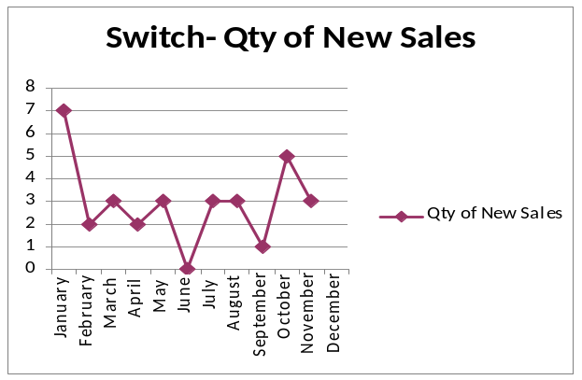
Dialer Report Summary-2013
Month | Qty of New Sales | New Sales | Existing Sales | Net cash flow% | Due Realized | Current Due
January | 22 | $8,200 | $33,450 | 94.0% | $1,020 | $2,676
February | 25 | $2,200 | $55,264 | 95.0% | $1,512 | $4,172
March | 28 | $11,450 | $55,600 | 98.0% | $2,112 | $1,161
April | 28 | $8,800 | $46,450 | 94.0% | $1,129 | $3,176
May | 39 | $29,060 | $69,832 | 97.9% | $3,643 | $2,125
June | 37 | $12,160 | $53,908 | 91.7% | $1,462 | $5,479
July | 35 | $9,400 | $57,797 | 97.2% | $23 | $1,905
August | 21 | $11,680 | $54,550 | 96.7% | $61 | $2,164
September | 14 | $5,600 | $53,100 | 95.4% | $2,131 | $2,679
October | 14 | $2,249 | $42,500 | 98.6% | $3,982 | $605
November | 13 | $4,623 | $35,600 | 99.5% | $1,016 | $219
December


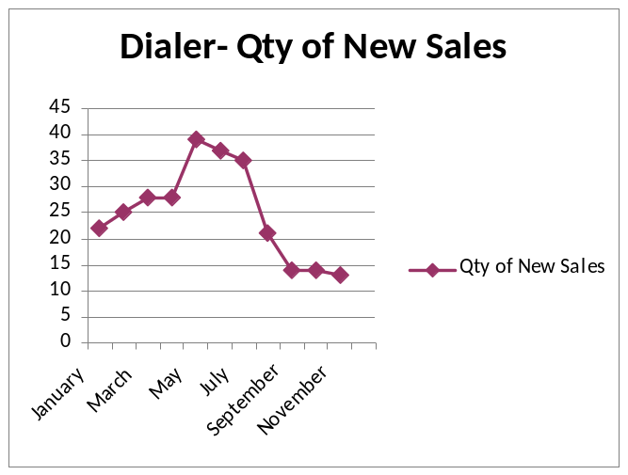

f. Department : Software
Head of the department : Md. Samiul Aftad Chowdhury

Update of the ongoing jobs: A summary of the ongoing jobs was shared with the managers and management.
Pending issue of recruitment: Manager was asked question from the DO regarding the recruitment update. He was informed that soon the short listed resumes will be shared with HR for interview.

g. Department : Admin & HR
Manager : Md. Habibur Rahman

Conversation regarding leave policy: Managers were given update regarding the new leave policy. Honorable president informed that he will share the draft within 2 days.
The amount of office tax deduction: The amount that is being deducted by office from the salary is not fixed yet. It needs to be fixed and implemented.
New visiting card: The employees whos designation has been changed will eb given with new visiting card.
Policy implementation by managers: Behind implementing a policy, lots of paperwork takes place, pros and cons are being examined. After all the paperwork is done, approval is taken from management. Once a policy is approved, it is the managers’ responsibility to implement it. Managers are requested to be concerned regarding this.

At the end, CEO showed appreciation to everyone for their presence and thoughtful insights about the company. He concluded the meeting by thanking to all.

