Reference: GSL/ Admin/ MCM 56

Minutes of
56th Monthly Coordination Meeting
Date: 7th January 2013
Venue: GSL Conference Room 1

Time: 09:00 AM

- The fifty sixth monthly coordination meeting of Genuity Systems Ltd. (GSL) was held on 7th January 2014 at Genuity Conference Room 1. Management team and the managers of different departments of the company were present. List of participants of the meeting are as follows:

SL. | Name of Participants | Department | Signature
1. | Habib Rahman | President | Present/V.con
2. | M. Anis Rahman | Chief Executive Officer | Present/V.con
3. | Md. Sadiqur Rahman | Director Operations | Present
4. | K. Shahadat Hossain | Director Marketing | Present
5. | Md. Habibur Rahman | Admin & HR | Present
6. | Md. Waliul Haque Tusar | System Admin | Present
7. | Md. Samiul Aftad Chowdhury | Head of Software Department | Present/V.con
8. | Md. Aminul Islam | Head of International Voice Carrier | Present/V.con
9. | Sk. Kamruzzaman Prince | Corporate Affairs | Present
10. | Lutful Kabir Majumder | Call Center | Present
11. | Md. Ashrafuzzaman | Accounts | Present
12. | Md. Abdullah Al Masum | Training | Present

- The meeting was started by the Manager, Admin & HR. He thanked everyone for participating in the meeting and invited the CEO to take control of the meeting. The CEO warmly welcomed everyone present in the meeting and thanked them for their presence. Thereafter he requested all departmental managers to deliver respective speech, one at a time, highlighting departmental performance and issues during the last month. He invited all to raise queries/questions and share their opinion in the discussion as deemed fit. The main points raised and discussed in the meeting over different issues are recorded below:

a. Department : gPlex Software Solutions
Head of Marketing & Sales : Lutful Kabir Majumder

Genuity Systems Ltd.
gPlex Switch and Dialer Sales Report
For the Month of December, 2013
Product Name | Sales | Realized | Dis.&Pro. | Unrealized | Qty. of New Sales | % of Realized
gPlex Mobile Dialer | $ 66,050 | $ 55,759 | $ - | $ 10,291 | 20 | 84%
gPlex Hosted Switch | $ 12,050 | $ 7,347 | $ 950 | $ 3,753 | 2 | 61%
Total | $ 78,100 | $ 63,106 | $ 950 | $ 14,044 | 22

 | gPlex Switch Sales Report
 | From | 12/1/2013 | To | 12/31/2013
Description | No. of Ch | Sales Quantity | Sales Amonut | % of Sales
MRC
New Clients | 200 | 2 | $ 600 | 5.0%
Existing Clients | 5,800 | 37 | $ 11,450 | 95.0%
Total (MRC) | 6,000 | 39 | $ 12,050 | 100.0%
Total Sales Of June |  |  | $ 12,050
Discount |  |  | $ - | 0.0%
Write off |  |  | $ 950 | 7.9%
Current Due |  |  | $ 3,753 | 31.1%
Cash Received |  |  | $ 7,344 | 60.9%
Advanced Expired |  |  | $ 3 | 0.0%
Total Sales |  |  | $ 12,050 | 100.0%
Advanced Received |  |  | $ 106
Due Realized From Last Month |  |  | $ 2,758
Previous due Realized |  |  | $ 7
Cash Sale of Current Month |  |  | $ 7,344
Total Cash In |  |  | $ 10,215
Total Cash Sale including Advanced Expired |  |  | $ 7,347
Net Cashflow to Sales- Current |  |  | 61.0%
Accounts Receivable Statements
Accounts Receivable B/F |  |  | $ 87,386
Adjustments-
Due in November 2013 Only | $ 7,400
Due Realized of November 2013 | $ 2,758
Due Remained From November 2013 |  | $ 4,642
Due Realized- Upto October 2013 |  | $ 7
Total Due Realized |  |  | $ 2,765
Previous Write off |  |  | $ 12,257
Discount Allowed |  |  | $ -
Adjusted A/R upto November |  |  | $ 72,364
Accounts Receivable- Current Month |  |  | $ 3,753
Accounts Receivable C/F |  |  | $ 76,117

 |  |  |  | gPlex Dialer Sales Report
 |  |  |  | From | 12/1/2013 |  |  | To |  | 12/31/2013
Description |  |  |  | Capacity | Qty of Sales |  |  | Sales |  | %
gPlex Mobile Dialer (New Clients) |  |  |  | 1,700 | 20 |  |  | $ 23,300 |  | 35,3%
gPlex Mobile Dialer (Existing Clients) |  |  |  | 6,400 | 113 |  |  | $ 42,750 |  | 64.7%
Total |  |  |  | 8,100 | 133 |  |  | $ 66,050 |  | 100.0%
Current Due |  |  |  |  |  |  |  | $ 10,291 |  | 15.6%
Discount |  |  |  |  |  |  |  | $ - |  | 0.0%
Advance Expired |  |  |  |  |  |  |  | $ 708 |  | 1.1%
Total Cash Received |  |  |  |  |  |  |  | $ 55,051 |  | 83.3%
Total Sales |  |  |  |  |  |  |  | $ 66,050 |  | 100.0%
Advance Received |  |  |  |  |  |  |  | $ 18
Cash Sales Including Advance Expired |  |  |  |  |  |  |  | $ 55,759
Net Cashflow to Sales- Current |  |  |  |  |  |  |  | 84.4%
Accounts Receivable Statements
Accounts Receivable B/F |  |  |  |  |  |  |  | $ 73,357
Adjustments-
Due in November 2013 Only |  |  |  | $ 219
Due Realized from November 2013 |  |  |  | $ 12
Due Remained from November 2013 |  |  |  |  | $ 207
Due Realized- Upto October 2013 |  |  |  |  | $ -
Total Due Realized |  |  |  |  |  |  |  | $ 12
Discount Allowed |  |  |  |  |  |  |  | $ -
Written Off |  |  |  |  |  |  |  | $ -
Adjusted A/R upto November |  |  |  |  |  |  |  | $ 73,345
Accounts Receivable- Current Month |  |  |  |  |  |  |  | $ 10,291
Accounts Receivable C/F |  |  |  |  |  |  |  | $ 83,636
Switch Report Summary-2013
Month | Qty of New Sales | New Sales | Existing Sales |  |  | Net cash flow% | Due Realized |  | Current Due
January | 7 | $1,850 | $30,050 |  |  | 60.0% | $4,992 |  | $11,579
February | 2 | $1,050 | $27,900 |  |  | 44.0% | $4,013 |  | $12,228
March | 3 | $950 | $23,900 |  |  | 55.0% | $3,955 |  | $6,507
April | 2 | $500 | $17,900 |  |  | 57.0% | $2,992 |  | $7,300
May | 3 | $750 | $16,150 |  |  | 63.2% | $2,622 |  | $5,362
June | 0 | $0 | $14,200 |  |  | 58.4% | $3,121 |  | $5,554
July | 3 | $750 | $13,550 |  |  | 60.8% | $3,303 |  | $5,606
August | 3 | $2,250 | $14,000 |  |  | 63.6% | $2,248 |  | $3,868
September | 1 | $400 | $13,750 |  |  | 51.2% | $1,970 |  | $6,912
October | 5 | $1,800 | $14,000 |  |  | 57.9% | $2,239 |  | $6,651
November | 3 | $600 | $14,400 |  |  | 47.7% | $2,062 |  | $7,400
December | 2 | $600 | $11,450 |  |  | 61.0% | $2,765 |  | $3,753

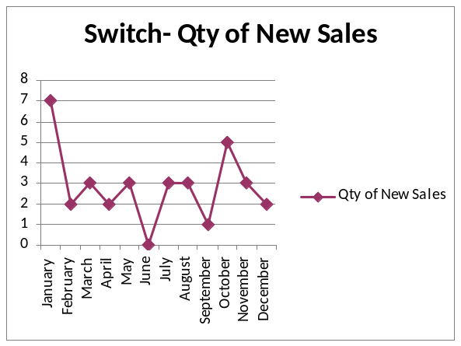

Dialer Report Summary-2013
Month | Qty of New Sales | New Sales | Existing Sales | Net cash flow% | Due Realized | Current Due
January | 22 | $8,200 | $33,450 | 94.0% | $1,020 | $2,676
February | 25 | $2,200 | $55,264 | 95.0% | $1,512 | $4,172
March | 28 | $11,450 | $55,600 | 98.0% | $2,112 | $1,161
April | 28 | $8,800 | $46,450 | 94.0% | $1,129 | $3,176
May | 39 | $29,060 | $69,832 | 97.9% | $3,643 | $2,125
June | 37 | $12,160 | $53,908 | 91.7% | $1,462 | $5,479
July | 35 | $9,400 | $57,797 | 97.2% | $23 | $1,905
August | 21 | $11,680 | $54,550 | 96.7% | $61 | $2,164
September | 14 | $5,600 | $53,100 | 95.4% | $2,131 | $2,679
October | 14 | $2,249 | $42,500 | 98.6% | $3,982 | $605
November | 13 | $4,623 | $35,600 | 99.5% | $1,016 | $219
December | 20 | $23,300 | $42,750 | 84.4% | $12 | $10,291

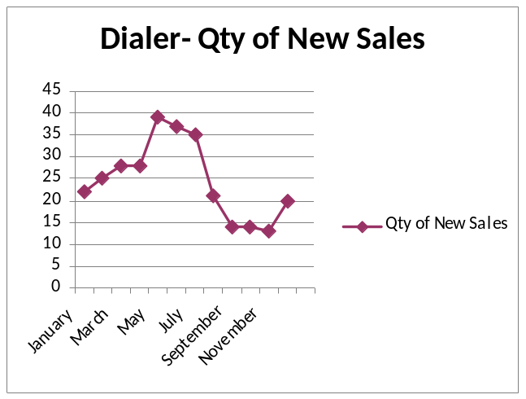
Dialer updating issue: Microsoft has bought the ownership of Nokia. Thus we cannot sign up our premium dialer through Symbian with Nokia any more. We have to keep on using Android and we are confident that as we have goodwill in this, we will be able to carry it on perfectly. We have to update our dialer in iphone & windows.

Md. Samiul Aftad Chowdhury in reply to this: Very soon a timeline will be set to update those.

b. Department : Call Center (gTalk)
Manager : Md. Lutful Kabir Majumder

Current status of client joining and usage in gTalk pinless:

# Total client joined in gTalk till 31 December 2013: 54427

# Average client increase per day in December, 13: 14
# Average client increase per day in November, 13: 12
# Average client increase per day in October, 13: 15
# Average client increase per day in September, 13: 18
# Average client increase per day in August, 13: 19
# Average client increase per day in July, 13: 19

# Average total Minutes per day in December, 13: 240.35 K
# Average total Minutes per day in November, 13: 248.22 K
# Average total Minutes per day in October, 13: 269.77 K
# Average total Minutes per day in September, 13: 270.80 K
# Average total Minutes per day in August, 13: 285.98 K
# Average total Minutes per day in July, 13: 278.14 K

# Total customer used gTalk service in December, 13 about 21,840
# Total customer used gTalk service in November, 13 about 21,941
# Total customer used gTalk service in October, 13 about 22,166
# Total customer used gTalk service in September, 13 about 22,388
# Total customer used gTalk service in August, 13 about 22,604
# Total customer used gTalk service in July, 13 about 22,280

Unused Initial Balance for the month of December: In the month of December, it has been found that total 25 customers have not used their Account Initial Balance after opening the account.

Current status after calling those customers is as follows:

- Customer using: 15 (60%)
- Customer still not using: 10 (40%)

Survey in December: In the month of December, a total of 1039 customers who are inactive for at least 2 months have been called. Details about customer’s feedback are given below:

- Ethnic Group:
  - Bangladesh- 981(94%)
  - India- 17(1%)
  - Pakistan- 12(1%)
  - Zimbabwe- 0(0%)
  - Nepal -2(1%)
  - Miscellaneous- 27(3%)

- Message left to the customers who were unavailable: 311(30%)
- Number not in service: 336 (32%)
- Using other calling services or doesn’t make international calls: 253 (24%)
- Interested to use again: 139 (13%)
- Among 139 customers, 8 people have started to use gTalk service again after this survey.

Pakistan Survey: We have called a total of 914 Pakistani customers who are inactive. As on 14th December 2013 gTalk decreased call rate for Pakistan. This survey was intended to inform them directly about this significant change on rate.

Details about customer’s feedback after this survey are given below:

- Message left to the customers who were unavailable: 229(25%)
- Number not in service: 357 (39%)
- Not using gTalk yet: 181 (20%)
Using gTalk again: 147 (16%)

Hot number uses:

December, 13: 34.61%
November, 13: 35.31%
October, 13: 34.33%
September, 13: 34.65%
August, 13: 33.88%
July, 13: 34.12%

Hot Dialer Report
Total User(s): 6306
VoIP Dialer Report
Total User(s): 555

# Total client joined in gTalk UK till 31 December 2013: 6179

# Total client joined in December 2013: 164
# Total client joined in November 2013: 86
# Total client joined in October 2013: 130
# Total client joined in September 2013: 139
# Total client joined in August 2013: 168
# Total client joined in July 2013: 201

# Total Minutes for the month of December, 13: 1493.18 K
# Total Minutes for the month of November, 13: 1387.18 K
# Total Minutes for the month of October, 13: 1589.23 K
# Total Minutes for the month of September, 13: 1532.40 K
# Total Minutes for the month of August, 13: 1672.95 K
# Total Minutes for the month of July, 13: 1610.63 K

New advertisement for Arabic market: A new advertisement is being on aired for Arabic market in their own channel. Already a number of clients in being added who found information about us from that ad.

c. Department : Training
Manager : Md. Abdullah Al Masum

Current Status: Currently training department is running training in sixteen batches. Among these, three batches (Round 18, 19, 20) are being run for IDB. The other 13 batches are covering different customized courses.
Revenue: Total collection on account of training in the month of December was 11.48 lacs and collection for November 2013 was 7.28 lacs. The total amount of revenue from December 2013 activities was Tk 9.35 lacs.

d. Department : Corporate
Manager : Sk. Kamruzzaman Prince

Financial facts and figures of 2013: In 2013, Total Work Order (in hand), SLA & MRC : BDT 94.0 lacs. Work Order worth amount BDT 59.0 lacs and SLA & MRC amount BDT 35.0 lacs (collected amount). Total received cash amount BDT 67.00 lacs (more than 71% of total sale). Deliveries against Work Order for an amount BDT 24.0 lac is not yet completed.

Target for 2014 is declared as BDT 1.00 crore in Bangladesh market. Later, an update of pipelined works was also presented.

e. Department : International Voice Carrier
Head of the department : Md. Aminul Islam

Monthly traffic and client report for the month of December 2013

Coverage area:
01. Total Traffic
02. gTalk Total Traffic
03. gTalkNA
04. gTalkUK

01. Total Traffic

01 (a). Total traffic by Months, Year 2012-2013
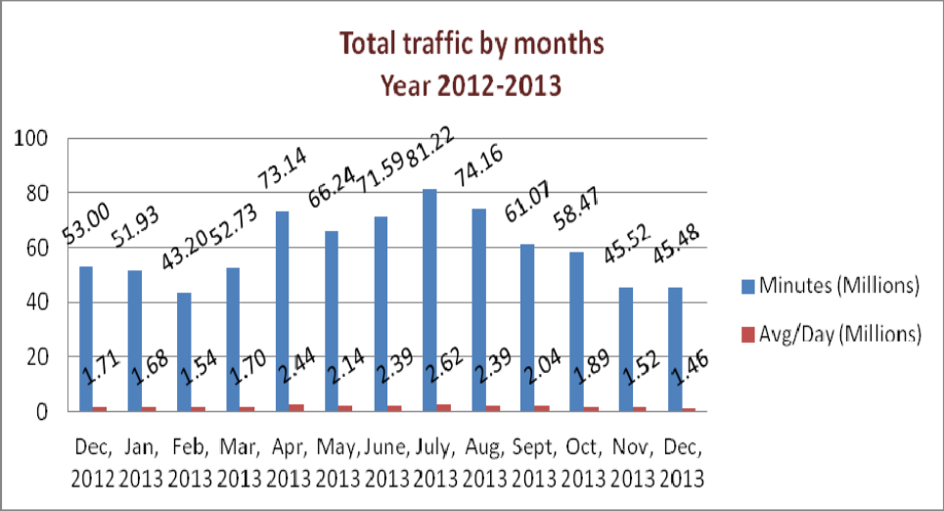

01(b). Total traffic by Months, Year 2012-2013 (According to 30 days)
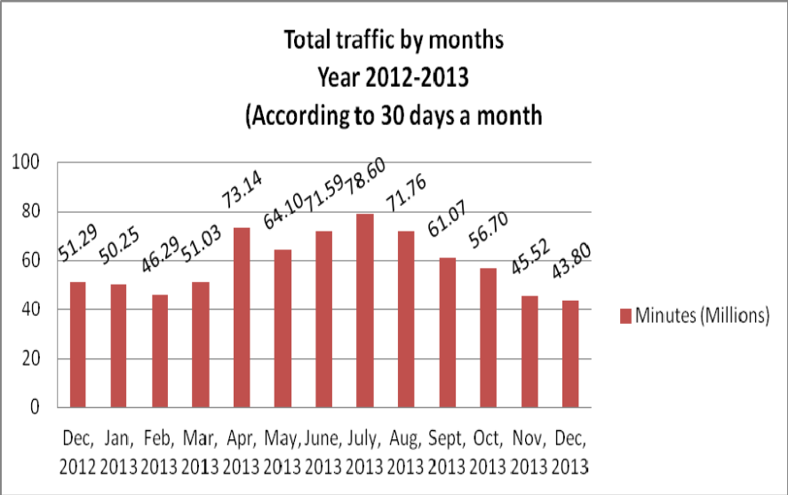
02. gTalk Total Traffic
02(a). gTalk: Total Traffic by months. Year 2012-2013

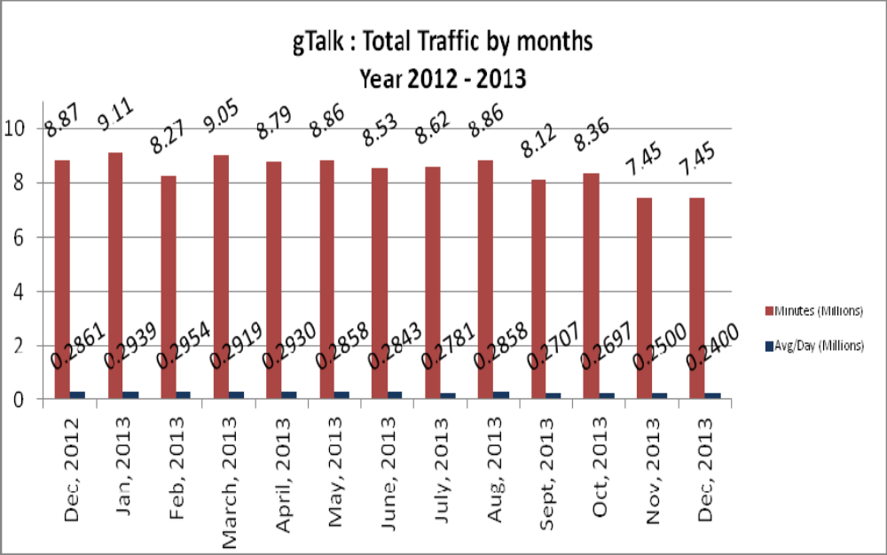

02(b). gTalk : Total Traffic by months (According to 30 days)

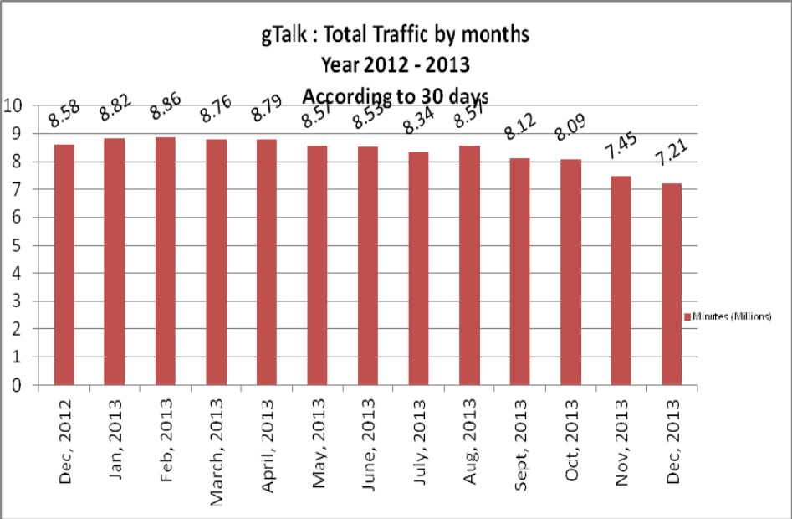

03. gTalk NA

03(a). gTalk NA : Total Traffic by months. Year 2012-2013

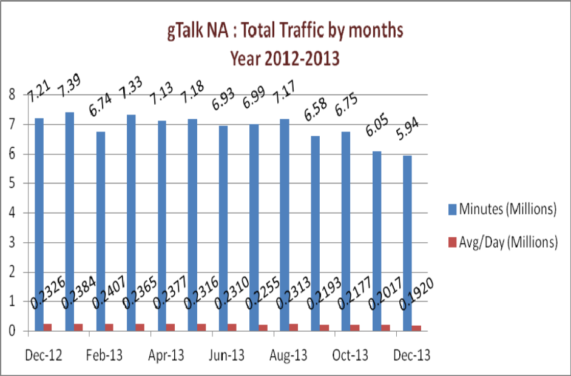

03(b). gTalk NA : Total Traffic by months. Year 2012-2013 (According to 30 days)

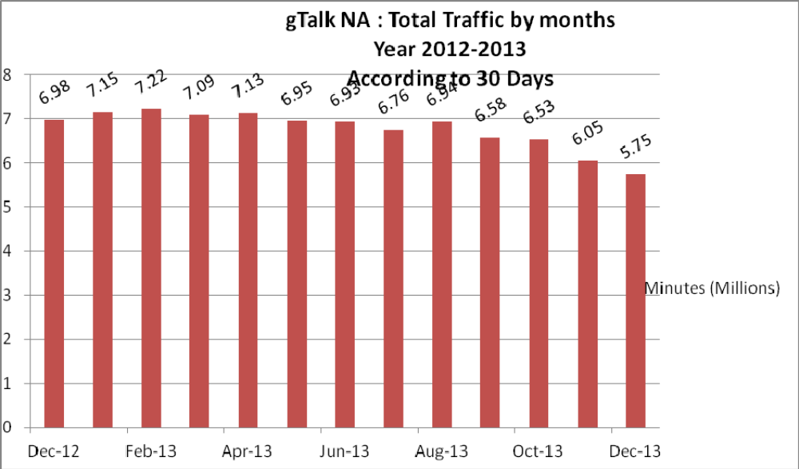

03(c). gTalk NA : New clients by months for the year 2012-2013

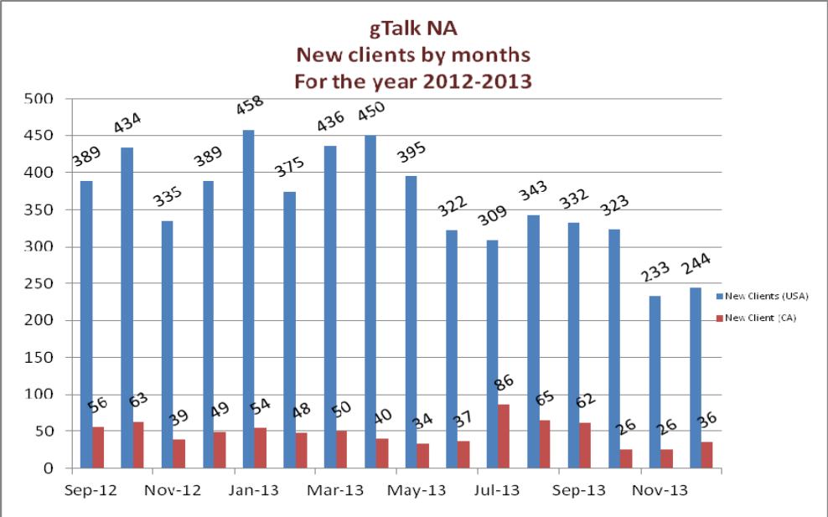

04. gTalk UK

04(a). gTalk UK : Total Traffic by months for the year 2012-2013
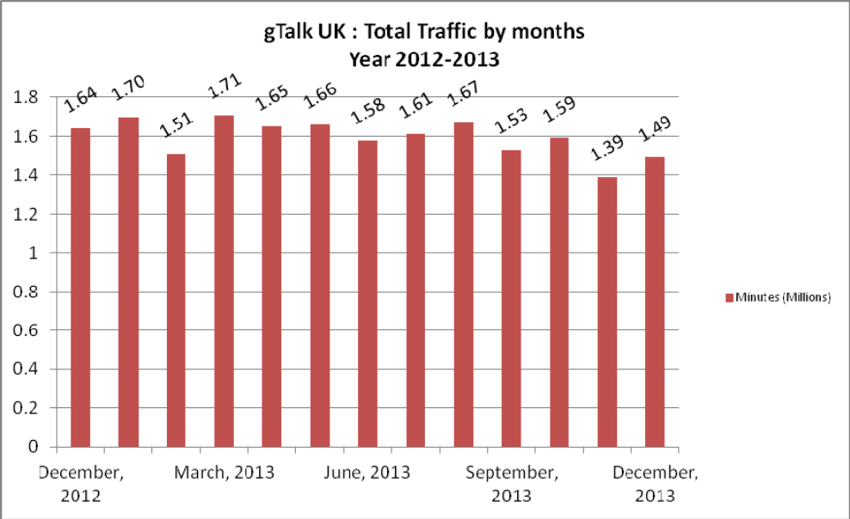

04(b). gTalk UK : Total Traffic by months for the year 2012-2013 (According to 30 Days)
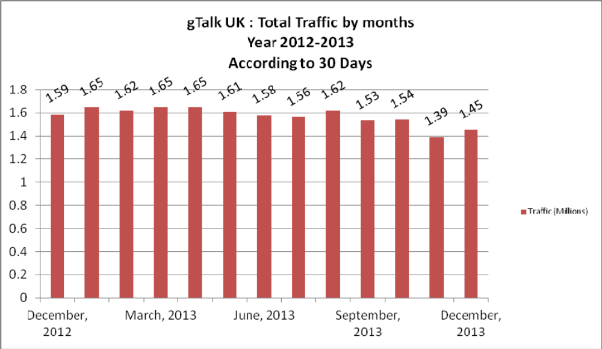

04(c). gTalk UK : New clients by months for the year 2012-2013

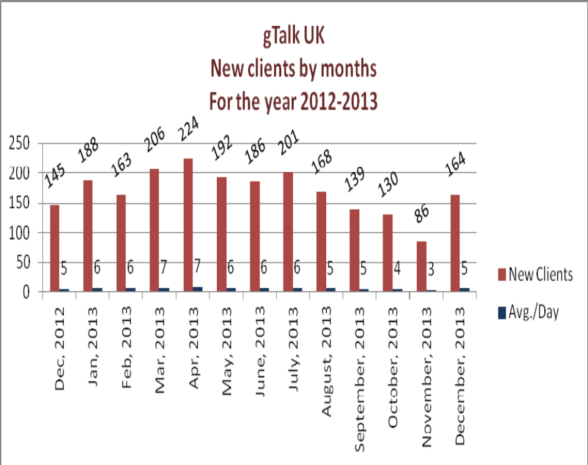

f. Department : Admin & HR
Manager : Md. Habibur Rahman

Calendar distribution: Calendar for 2014 is being distributed among the colleagues.
Recruitment of Software department: A written interview was taken for PHP & C+, but as the result was not satisfactory, another pool is created and their exam will be held of 10th January 2014 (Friday). Regarding Graphics and web designing position, portfolio is being asked from potential candidates.
BASIS fair: Date of BASIS softexpo has been shifted to June 2014 instead of January.
Office time during Strike and Blockade: During Strike and Blockade, office will allow flexi-time as CEO permits. But those who live nearby and can come earlier with out facing any risk/ trouble must arrive on time. Managers are also requested to take care of this.
Pending HR job with Management: There is some pending job of HR with management. Thus management is requested to clear those at their earliest.
Renting rest portion of the 8th floor: The building owner has given consent to rent the rest portion of the 8th floor to us. And our CEO has also given permission to rent it. So we are going to take it soon.

- CEO
Md. Anis Rahman
ITEXPO: Genusys Inc will take part in ITEXPO to be held in Miami on coming January 29th, 2014. And Mr. Amit Saha will take part from Bangladesh part.

At the end, CEO showed appreciation to everyone for their presence and thoughtful insights about the company. He concluded the meeting by thanking to all.

