Reference: GSL/ Admin/ MCM 60

Minutes of
60th Monthly Coordination Meeting
Date: 6th May 2014
Venue: GSL Conference Room 1

Time: 08:30 AM

- The sixtieth monthly coordination meeting of Genuity Systems Ltd. (GSL) was held on 6th May 2014 at Genuity Conference Room 1. Management team and the managers of different departments of the company were present. List of participants of the meeting are as follows:

SL. | Name of Participants | Department | Signature
1. | Habib Rahman | President | Present/V.con
2. | M. Anis Rahman | Chief Executive Officer | Present/V.con
3. | Md. Sadiqur Rahman | Director Operations | Present
4. | K. Shahadat Hossain | Director Marketing | Present/V.con
5. | Md. Habibur Rahman | Admin & HR | Present
6. | Md. Waliul Haque Tusar | System Admin | Present
7. | Md. Samiul Aftad Chowdhury | Head of Software Department | Present/V.con
8. | Md. Aminul Islam | Head of International Voice Carrier | Present/V.con
9. | Sk. Kamruzzaman Prince | Corporate Affairs | Present
10. | Lutful Kabir Majumder | Call Center | Present
11. | Md. Ashrafuzzaman | Accounts | Present
12. | Md. Abdullah Al Masum | Training | Present

- The meeting was started by the Manager, Admin & HR. He thanked everyone for participating in the meeting and invited CEO to take control of the meeting. The CEO warmly welcomed everyone present in the meeting and thanked them for their presence. Thereafter he requested all departmental managers to deliver respective speech, one at a time, highlighting departmental performance and issues during the last month. He invited all to raise queries/questions and share their opinion in the discussion as deemed fit. The main points raised and discussed in the meeting over different issues are recorded below:

a. Department : Call Center (gTalk)
Manager : Md. Lutful Kabir Majumder

Current status of client joining and usage in gTalk pinless:

# Total client joined in gTalk till 30 April 2014: 56021

# Average client increase per day in April, 14: 12
# Average client increase per day in March, 14: 13
# Average client increase per day in February, 14: 14
# Average client increase per day in January, 14: 15
# Average client increase per day in December, 13: 14
# Average client increase per day in November, 13: 12
# Average client increase per day in October, 13: 15
# Average client increase per day in September, 13: 18
# Average client increase per day in August, 13: 19
# Average client increase per day in July, 13: 19

# Average total Minutes per day in April, 14: 236.75 K
# Average total Minutes per day in March, 14: 243.74 K
# Average total Minutes per day in February, 14: 243.94 K
# Average total Minutes per day in January, 14: 246.31 K
# Average total Minutes per day in December, 13: 240.35 K
# Average total Minutes per day in November, 13: 248.22 K
# Average total Minutes per day in October, 13: 269.77 K
# Average total Minutes per day in September, 13: 270.80 K
# Average total Minutes per day in August, 13: 285.98 K
# Average total Minutes per day in July, 13: 278.14 K

# Total customer used gTalk service in April, 14 about 21,533
# Total customer used gTalk service in March, 14 about 21,920
# Total customer used gTalk service in February, 14 about 21,587
# Total customer used gTalk service in January, 14 about 22,441
# Total customer used gTalk service in December, 13 about 21,840
# Total customer used gTalk service in November, 13 about 21,941
# Total customer used gTalk service in October, 13 about 22,166
# Total customer used gTalk service in September, 13 about 22,388
# Total customer used gTalk service in August, 13 about 22,604
# Total customer used gTalk service in July, 13 about 22,280

Unused Initial Balance for the month of April 2014: In the month of April, it has been found that total 37 customers have not used their Account Initial Balance after opening the account.

Current status after calling those customers is as follows:

- Customer using: 24 (65%)
- Customer still not using: 13 (35%)

Survey in April 2014: In the month of April, a total of 467 customers who are inactive for at least 2 months have been called. Details about customer’s feedback are given below:

- Ethnic Group:
  - Bangladesh - 333(71%)
  - India - 32(7%)
  - Pakistan - 7(2%)
  - Nepal - 5(1%)
  - Kenya – 11(2)
  - Miscellaneous- 79(17%)

- Message left to the customers who were unavailable: 183(39%)
- Number not in service: 127 (27%)
- Using other calling services or doesn’t make international calls: 119(26%)
- Interested to use again: 38(8%)
- Among 38 customers, 4 people have started to use gTalk service again after this survey.

UK Inactive User Survey April 2014: In the month of April, a total of 726 customers who are
inactive for at least 2 months have been called. Details about customer’s feedback are given below:

- Ethnic Group:
  - Bangladesh - 672(93%)
  - Zimbabwe - 15(2%)
  - Pakistan - 11(1%)
  - Miscellaneous- 28(4%)
- Message left to the customers who were unavailable: 314(43%)
- Number not in service: 141 (20%)
- Using other calling services or doesn’t make international calls: 213(29%)
- Interested to use again: 58(8%)
Among 58 customers, 9 people have started to use gTalk service again after this survey.

Hot number uses:

April, 14: 34.87%
March, 14: 34.89%
February, 14: 34.72%
January, 14: 34.46%
December, 13: 34.61%
November, 13: 35.31%
October, 13: 34.33%
September, 13: 34.65%
August, 13: 33.88%
July, 13: 34.12%

Hot Dialer Report
Total User(s): 8415

VoIP Dialer Report
Total User(s): 806

Total SMS from April 1 to April 30, 14: 1634 and Failed SMS: 23

# Total client joined in gTalk UK till 30 April 2014: 6635

# Total client joined in April 2014: 74
# Total client joined in March 2014: 101
# Total client joined in February 2014: 138
# Total client joined in January 2014: 143
# Total client joined in December 2013: 164
# Total client joined in November 2013: 86
# Total client joined in October 2013: 130
# Total client joined in September 2013: 139
# Total client joined in August 2013: 168
# Total client joined in July 2013: 201

# Total Minutes for the month of April, 14: 1313.78 K
# Total Minutes for the month of March, 14: 1436.08 K
# Total Minutes for the month of February, 14: 1366.20 K
# Total Minutes for the month of January, 14: 1510.21 K
# Total Minutes for the month of December, 13: 1493.18 K
# Total Minutes for the month of November, 13: 1387.18 K
# Total Minutes for the month of October, 13: 1589.23 K
# Total Minutes for the month of September, 13: 1532.40 K
# Total Minutes for the month of August, 13: 1672.95 K
# Total Minutes for the month of July, 13: 1610.63 K

b. Department : gPlex Software Solutions
Head of Marketing & Sales : Lutful Kabir Majumder

Genuity Systems Ltd.
gPlex Switch and Dialer Sales Report
For the Month of April , 2014
Product Name | Sales | Realized | Dis.&Pro. | Unrealized | Qty. of New Sales | % of Realized
gPlex Mobile Dialer | $ 43,450 | $ 40,403 | $ - | $ 3,047 | 17 | 93%
gPlex Hosted Switch | $ 8,650 | $ 7,392 | $ - | $ 1,258 | 3 | 85%
Total | $ 52,100 | $ 47,795 | $ - | $ 4,305 | 20

 | gPlex Switch Sales Report
 | From | 01/04/14 | To | 30/04/14
Description | No. of Ch | Sales Quantity | Sales Amonut | % of Sales
MRC
New Clients | 300 | 3 | $ 2,400 | 27.7%
Existing Clients | 3,100 | 22 | $ 6,250 | 72.3%
Total (MRC) | 3,400 | 25 | $ 8,650 | 100.0%
Total Sales Of April |  |  | $ 8,650
Discount |  |  | $ - | 0.0%
Write off |  |  | $ - | 0.0%
Current Due |  |  | $ 1,258 | 14.5%
Cash Received |  |  | $ 7,345 | 84.9%
Advanced Expired |  |  | $ 47 | 0.5%
Total Sales |  |  | $ 8,650 | 100.0%
Advanced Received |  |  | $ 98
Due Realized From Last Month |  |  | $ 1,443
Previous due Realized |  |  | $ 260
Cash Sale of Current Month |  |  | $ 7,345
Total Cash In |  |  | $ 9,146
Total Cash Sale including Advanced Expired |  |  | $ 7,392
Net Cashflow to Sales- Current |  |  | 85.5%
Accounts Receivable Statements
Accounts Receivable B/F |  |  | $ 72,984
Adjustments-
Due in March 2014 Only | $ 2,300
Due Realized of March 2014 | $ 1,443
Due Remained From March 2014 |  | $ 857
Due Realized- Upto February 2014 |  | $ 260
Total Due Realized |  |  | $ 1,703
Previous Write off |  |  | $ 1,256
Discount Allowed |  |  | $ -
Adjusted A/R upto March |  |  | $ 70,025
Accounts Receivable- Current Month |  |  | $ 1,258
Accounts Receivable C/F |  |  | $ 71,283

 | gPlex Dialer Sales Report
 | From | 1/4/2014 | To | 30/4/2014
Description | Capacity | Qty of Sales | Sales | %
gPlex Mobile Dialer (New Clients) | 900 | 17 | $ 5,800 | 13.3%
gPlex Mobile Dialer (Existing Clients) | 6,450 | 105 | $ 37,650 | 86.7%
Total | 7,350 | 122 | $ 43,450 | 100.0%
Current Due |  |  | $ 3,047 | 7.0
Discount |  |  | $ - | 0.0%
Advance Expired |  |  | $ 852 | 2.0%
Total Cash Received |  |  | $ 39,551 | 91.0%
Total Sales |  |  | $ 43,450 | 100.0%
Advance Received |  |  | $ 35
Cash Sales Including Advance Expired |  |  | $ 40,403
Net Cashflow to Sales- Current |  |  | 93.0%
Accounts Receivable Statements
Accounts Receivable B/F |  |  | $ 81,849
Adjustments-
Due in February 2014 Only | $ 658
Due Realized from February 2014 | $ -
Due Remained from February 2014 |  | $ 658
Due Realized- Upto January 2014 |  | $ 1,493
Total Due Realized |  |  | $ 1,493
Discount Allowed |  |  | $ -
Written Off |  |  | $ -
Adjusted A/R upto February |  |  | $ 80,356
Accounts Receivable- Current Month |  |  | $ 3,047
Accounts Receivable C/F |  |  | $ 83,403

Switch Report Summary-2014
Month | Qty of New Sales | New Sales Amount | Existing Sales | Net cash flow% | Due Realized | Current Due
January | 1 | $600 | $11,300 | 50.8% | $2,748 | $5,853
February | 1 | $600 | $11,350 | 45.7% | $3,626 | $5,337
March | 2 | $850 | $7,050 | 67.8% | $2,542 | $2,300
April | 3 | $2,400 | $6,250 | 85.5% | $1,703 | $1,258
May
June
July
August
September
October
November
December
Total | 7 | $4,450 | $35,950

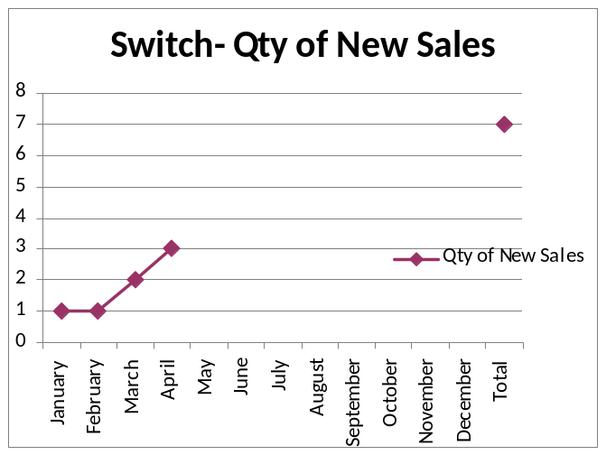
Dialer Report Summary-2014
Month | Qty of New Sales | New Sales Amount | Existing Sales | Net cash flow% | Due Realized | Current Due
January | 15 | $5,900 | $31,350 | 95.5% | $1,473 | $1,679
February | 3 | $450 | $28,710 | 96.3% | $3,196 | $1,083
March | 7 | $3,150 | $38,650 | 98.4% | $761 | $658
April | 17 | $5,800 | $37,650 | 93.0% | $1,493 | $3,047
May
June
July
August
September
October
November
December
Total | 42 | $15,300 | $136,360

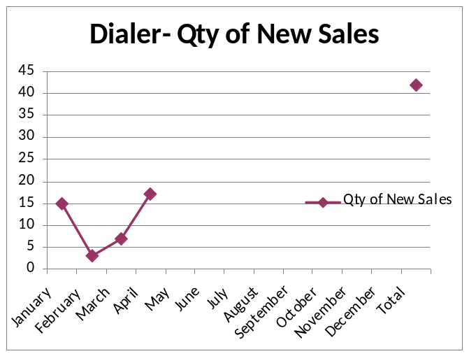

c. Department : International Voice Carrier
Head of the department : Md. Aminul Islam

Monthly traffic and client report for the month of April 2014

Coverage area:
01. Total Traffic
02. Voice Wholesale Traffic
03. gTalk Total Traffic
04. gTalkNA
05. gTalkUK

01. Total Traffic

01 (a). Total traffic by Months, Year 2012-2013
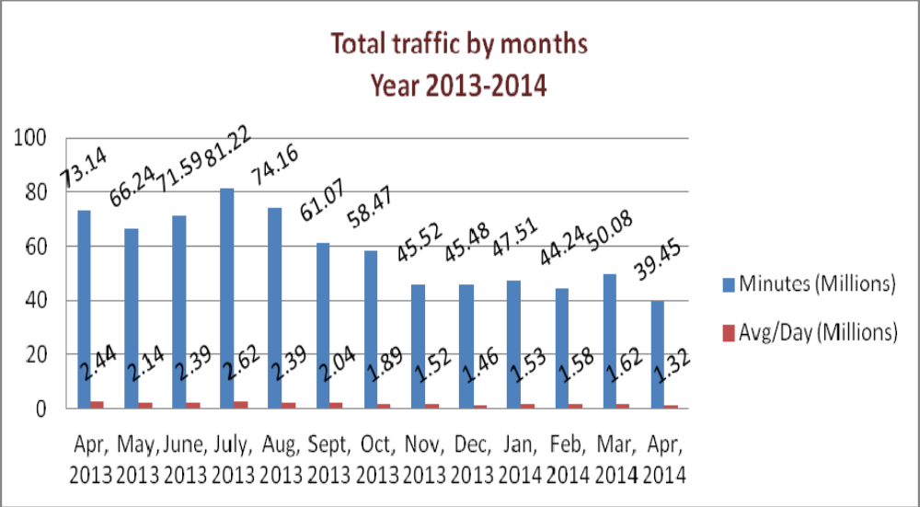

01(b). Total traffic by Months, Year 2012-2013 (According to 30 days)
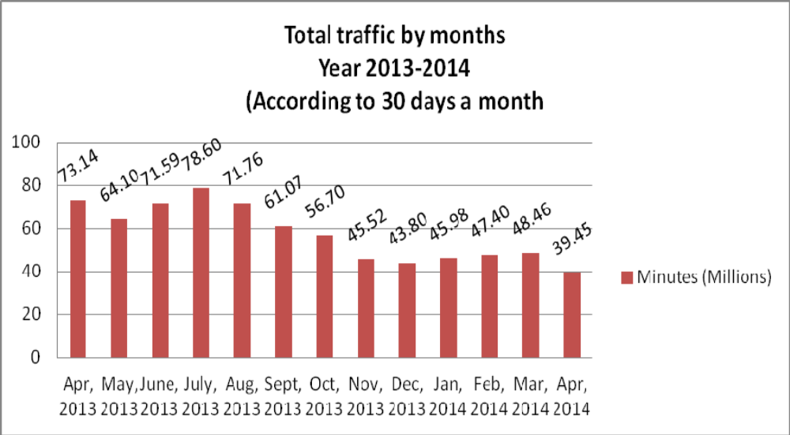

02. Total Voice Wholesale Traffic
02(a). Voice Wholesale: Total Traffic by months. Year 2013-2014

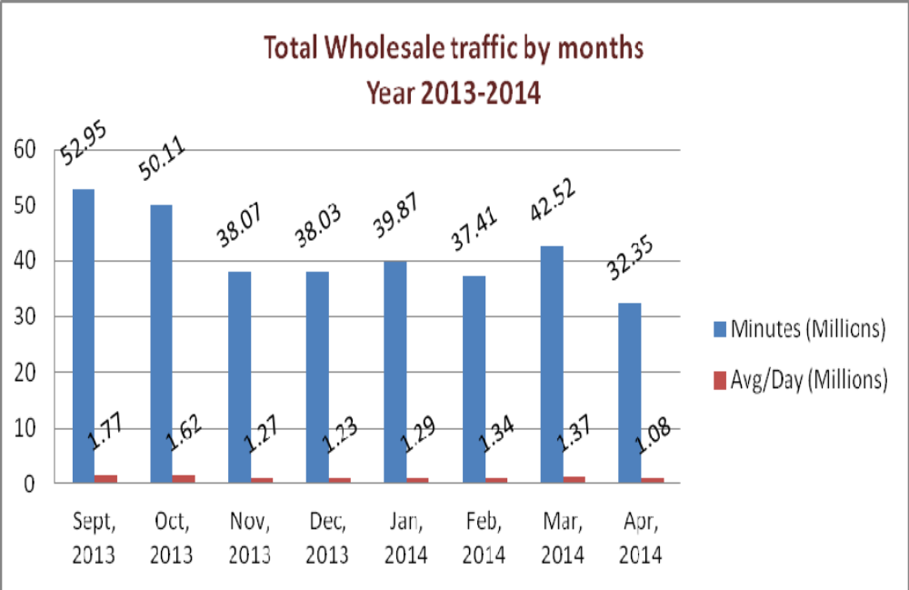

02(b). Voice Wholesale: Total Traffic by months. Year 2013-2014 (According to 30 days)

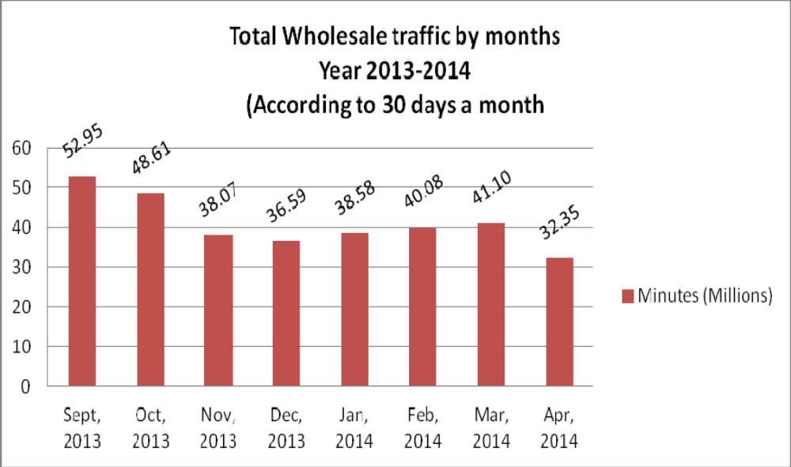

03. gTalk Total Traffic
03(a). gTalk : Total Traffic by months. Year 2013-2014

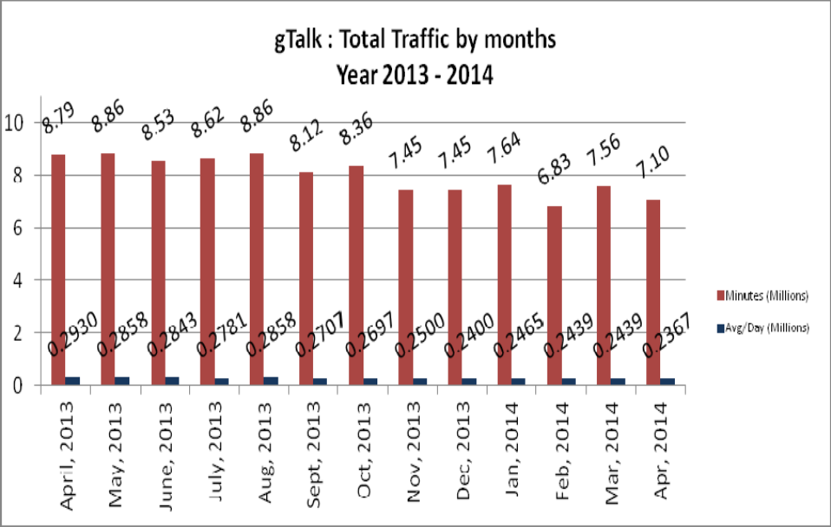

03(b). gTalk : Total Traffic by months (According to 30 days)

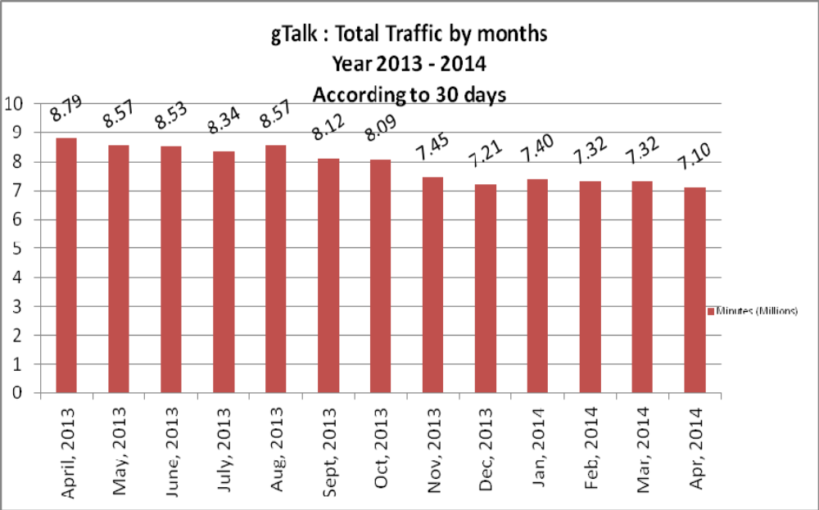

04. gTalk NA

04(a). gTalk NA : Total Traffic by months. Year 2013-2014

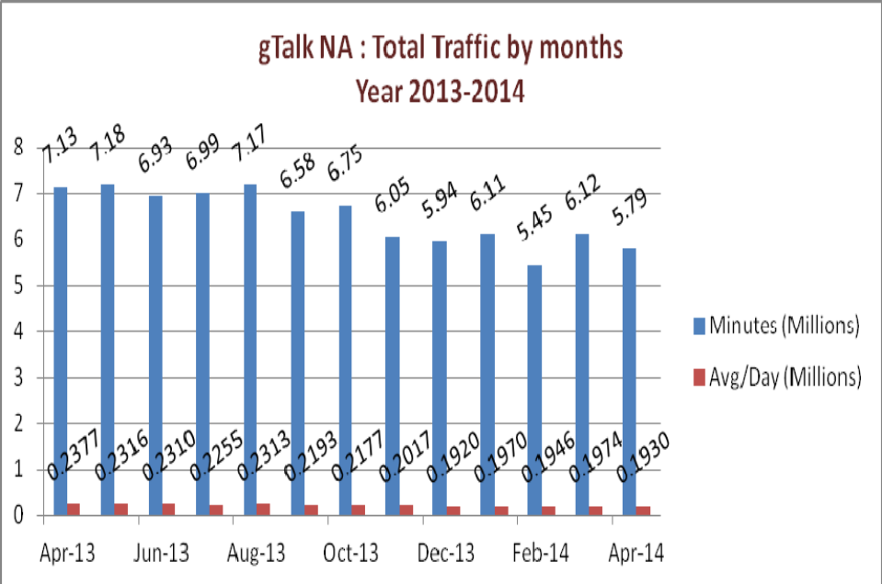

04(b). gTalk NA : Total Traffic by months. Year 2013-2014 (According to 30 days)

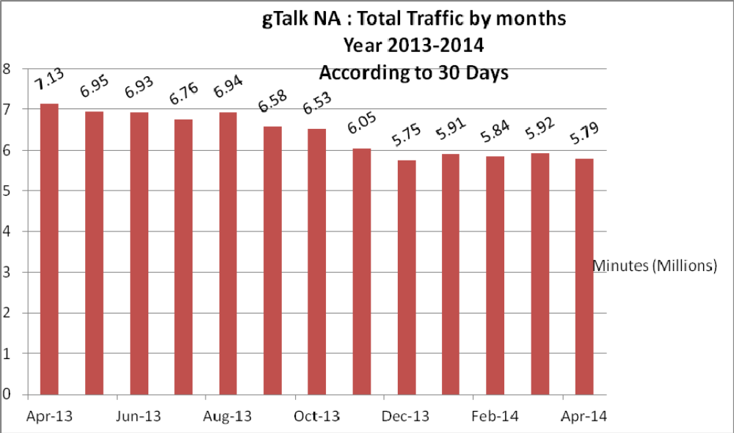

04(c). gTalk NA : New clients by months for the year 2013-2014
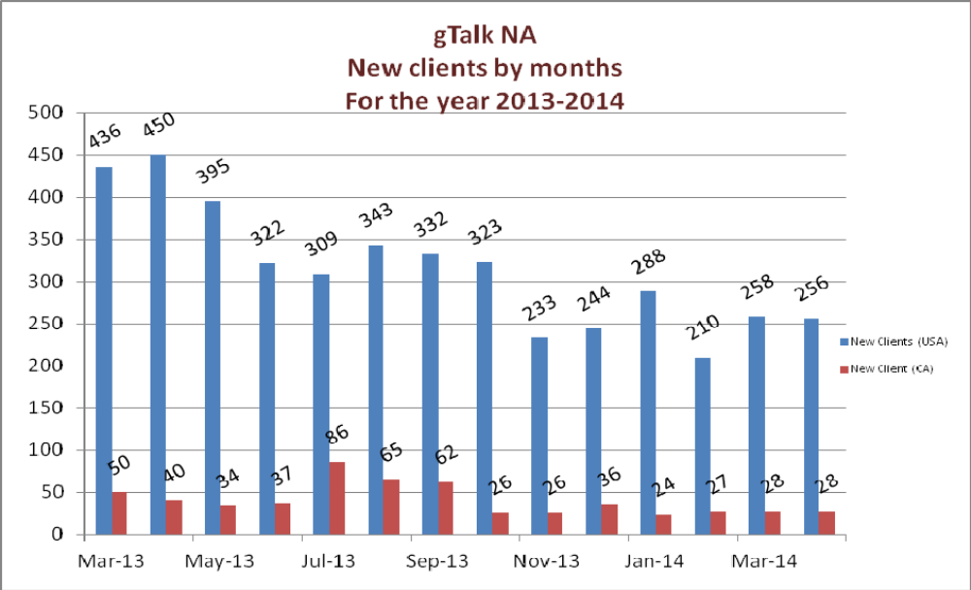

05. gTalk UK

05(a). gTalk UK : Total Traffic by months for the year 2013-2014

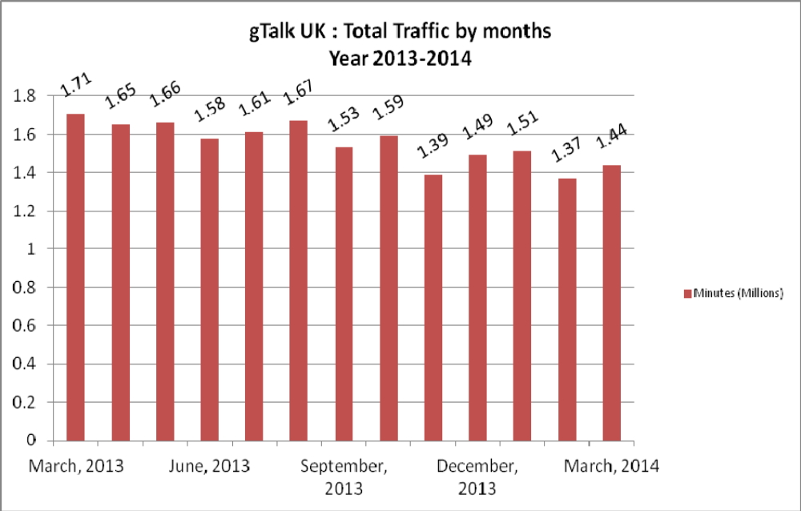

05(b). gTalk UK : Total Traffic by months for the year 2013-2014 (According to 30 Days)

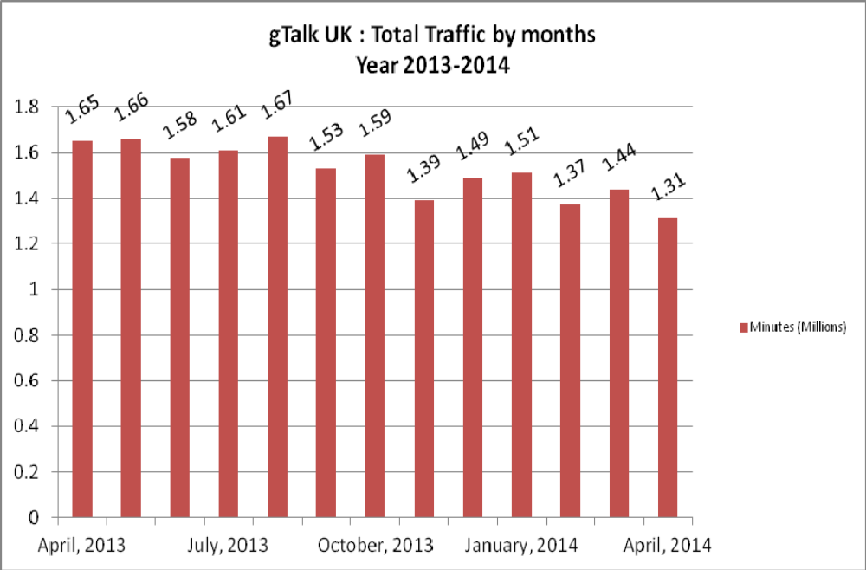

05(c). gTalk UK : New clients by months for the year 2013-2014
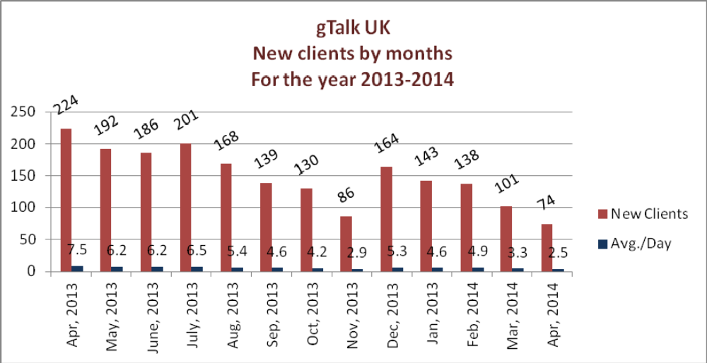

c. Department : Corporate
Manager : Sk. Kamruzzaman Prince
Up-gradation of Call Center Solution features: The feature of Avaya and Cisco could be
collected. If those features can be implemented in our call center solution, we will be able to take it
further.
Email & wallboard of Lanka Bangla: The wall board and email of Lanka Bangla was supposed to be delivered long ago, but it is not delivered yet. In reply to this, Mr. Tusar said that as per his knowledge, the wallboard is running. He did not receive any request for email service. They need to check if the service requirement is mentioned in the work order or not.
First payment of One Bank: The first payment of the work order of One Bank will be received next week. The amount is 35 lacs.
New delivery to Q-Cash & Bank Asia: The order of Q-Cash and Bank Asia will be delivered this month.

d. Department : Training
Manager : Md. Abdullah Al Masum
Current Status: Currently training department is running training in twenty batches. Among these, four batches (Round 18, 19, 20, 21) are being run for IDB. The other 16 batches are covering different customized courses.
Revenue: Total collection on account of training in the month of April 2014 was 6.64 lacs and
collection for March 2014 was 3.52 lacs. The total amount of revenue from April 2014 activities
was Tk 5.85 lacs.
Prospective clients: Thukral is planning to start training courses with us. We have bided for a project of City Corporation. Besides this two, we are hoping that IDB will send new batch to us with new technology.

e. Department : Software
Manager : Md. Samiul Aftad Chowdhury
Ongoing works: The work on Plexstar GUI is being going on. We ill eb attending Qatar fair with this new GUI.

f. Department : Network Operations
Manager : Md. Waliul Haque Tusar
Update about employee resignation: One member has been resigned from the department. We need to recruit a new staff at our earliest.

g. Department : Admin & HR
Manager : Md. Habibur Rahman

BASIS fair update: BASIS fair will be held on 4-7 June 2014. We are working on it. The managers are requested to work on their promotional activities.
Advertisement of GTalk home: The work on gtalk home advertisement is going on.
Yearly Staff Evaluation: The yearly employee evaluation notice will be sent to the managers.

At the end, CEO showed appreciation to everyone for their presence and thoughtful insights about the company. He concluded the meeting by thanking to all.

