Reference: GSL/ Admin/ MCM 62

Minutes of
62nd Monthly Coordination Meeting
Date: 20th August 2014
Venue: GSL Conference Room 1

Time: 08:30 AM

- The sixty second monthly coordination meeting of Genuity Systems Ltd. (GSL) was held on 20th August 2014 at Genuity Conference Room 1. Management team and the managers of different departments of the company were present. List of participants of the meeting are as follows:

SL. | Name of Participants | Department | Signature
1. | Habib Rahman | President | Present
2. | M. Anis Rahman | Chief Executive Officer | Present
3. | Md. Sadiqur Rahman | Director Operations | Present
4. | K. Shahadat Hossain | Director Marketing | Present
5. | Md. Anwarul Karim | Executive Director | Present
6. | Md. Habibur Rahman | Admin & HR | Present
7. | Md. Waliul Haque Tusar | System Admin | Present
8. | Md. Aminul Islam | Head of International Voice Carrier | Present
9. | Sk. Kamruzzaman Prince | Corporate Affairs | Present
10. | Lutful Kabir Majumder | Call Center | Present
11. | Md. Ashrafuzzaman | Accounts | Present
12. | Md. Abdullah Al Masum | Training | Present

- The meeting was started by the Manager, Admin & HR. He thanked everyone for participating in the meeting and invited CEO to take control of the meeting. The CEO warmly welcomed everyone present in the meeting and thanked them for their presence. Thereafter he requested all departmental managers to deliver respective speech, one at a time, highlighting departmental performance and issues during the last month. He invited all to raise queries/questions and share their opinion in the discussion as deemed fit. The main points raised and discussed in the meeting over different issues are recorded below:

a. Department : Corporate
DGM : Sk. Kamruzzaman Prince
Call Center Solution:
Test on Process: A test of call center solution is running in Southeast Bank.
Pipeline: Jamuna Bank, Standard Bank and Banglalion are in pipeline.
Hardware Replacement: One among two of the hardware’s of our contact center solution that Q-cash purchased from us has gone out of order. Now Q-Cash wants to install our new hardware. But their intention is to get replacement of both good and broken hardware with two new hardware. In this regard, Mr. Kamruzzaman asked to the management whether we can execute their request or not.

CEO in reply: CEO in reply to this question answered that we actually cannot do it as it does not comply with our policy. Because we can't replace once the warranty period is over.

Pending development work: We could not deliver all the features required by One Bank. So they are not giving their payment though we got the work order before delivery. Besides, One Bank, we could not deliver the email module of City Bank till now.

ED in reply: In addressing the issue of One Bank, ED said that within 1 to 3 months, this module will be ready to be delivered.
Long Term Communication: We have been communicating with Bank Asia and IDLC for long to execute sale.
IPBX Solution:
Solution Test for sales execution: A test of our IPBX solution is being going on at Rangs ITT.
Service Lock: We are supposed to recover due from Hellow World. Whenever we contacted them to collect the due, they claimed that the solution was not working. And now, finally they are telling that the solution is not working at all. Thus they want us to bring back our product and give them the money back. But in our system, we found that the status of the solution is alive. Now the confusion is if they cannot use the solution how the status is showing alive. CEO has directed to lock the service so that they cannot use it any more.

Plexstar:
Pipeline: Ispahani, Chittagong is interested to purchase our product.
Bidding tender of BTCL: BTCL called for tender to purchase device. But the specifications they mentioned in tender notice did not match with our features.
CEO in reply: When we initially had meeting with BTCL, we informed them about what features we lack in our device. At that time they told us that they will exclude those features in their tender. As they did not do same as they told, we can sit with them and discuss regarding these issues.

Statement of ED about Plexstar:
Marketing & sales: The marketing work of Plexstar is running in full pace but the sales work
is not started yet. But we are preparing Md. Ashraf-Uz-Zaman, Senior Executive, gPlex Software
Solution for working in the sales part.
Demo: We are sharing demo version with several clients. But we are lagging behind in terms of feature which is usually used by our local operator.

b. Department : Call Center (gTalk)
AGM : Md. Lutful Kabir Majumder

Current status of client joining and usage in gTalk pinless:

# Total client joined in gTalk till 31 July 2014: 57092

# Average client increase per day in July, 14: 11
# Average client increase per day in June, 14: 12
# Average client increase per day in May, 14: 12
# Average client increase per day in April, 14: 12
# Average client increase per day in March, 14: 13
# Average client increase per day in February, 14: 14
# Average client increase per day in January, 14: 15
# Average client increase per day in December, 13: 14
# Average client increase per day in November, 13: 12
# Average client increase per day in October, 13: 15
# Average client increase per day in September, 13: 18
# Average client increase per day in August, 13: 19
# Average client increase per day in July, 13: 19

# Average total Minutes per day in July, 14: 236.50 K
# Average total Minutes per day in June, 14: 224.90 K
# Average total Minutes per day in May, 14: 226.21 K
# Average total Minutes per day in April, 14: 236.75 K
# Average total Minutes per day in March, 14: 243.74 K
# Average total Minutes per day in February, 14: 243.94 K
# Average total Minutes per day in January, 14: 246.31 K
# Average total Minutes per day in December, 13: 240.35 K
# Average total Minutes per day in November, 13: 248.22 K
# Average total Minutes per day in October, 13: 269.77 K
# Average total Minutes per day in September, 13: 270.80 K
# Average total Minutes per day in August, 13: 285.98 K
# Average total Minutes per day in July, 13: 278.14 K

# Total customer used gTalk service in July, 14 about 21,814
# Total customer used gTalk service in June, 14 about 21,224
# Total customer used gTalk service in May, 14 about 21,663
# Total customer used gTalk service in April, 14 about 21,533
# Total customer used gTalk service in March, 14 about 21,920
# Total customer used gTalk service in February, 14 about 21,587
# Total customer used gTalk service in January, 14 about 22,441
# Total customer used gTalk service in December, 13 about 21,840
# Total customer used gTalk service in November, 13 about 21,941
# Total customer used gTalk service in October, 13 about 22,166
# Total customer used gTalk service in September, 13 about 22,388
# Total customer used gTalk service in August, 13 about 22,604
# Total customer used gTalk service in July, 13 about 22,280
Unused Initial Balance for the month of July 2014: In the month of July, it has been found that total 27 customers have not used their Account Initial Balance after opening the account.

Current status after calling those customers is as follows:

- Customer using: 19 (70%)
- Customer still not using: 8 (30%)

Survey in July 2014: In the month of July, a total of 1492 customers who are inactive for at least 2 months have been called. Details about customer’s feedback are given below:

- Ethnic Group:
  - Bangladesh – 1074 (72%)
  - India – 117 (8%)
  - Pakistan – 31 (2%)
  - Nepal – 14 (1%)
  - Zimbabwe – 32 (2%)
  - Kenya – 20 (1%)
  - Ethiopia – 16 (1%)
  - Miscellaneous- 188(13%)

- Message left to the customers who were unavailable: 497 (33%)
- Number not in service: 521 (35%)
- Using other calling services or doesn’t make international calls: 355 (24%)
- Interested to use again: 119 (8%)
- Among 119 customers, 9 people have started to use gTalk service again after this survey.

Hot number uses:

July, 14: 35.56%
June, 14: 35.96%
May, 14: 35.35%
April, 14: 34.87%
March, 14: 34.89%
February, 14: 34.72%
January, 14: 34.46%
December, 13: 34.61%
November, 13: 35.31%
October, 13: 34.33%
September, 13: 34.65%
August, 13: 33.88%
July, 13: 34.12%

Hot Dialer Report
Total User(s): 9593

VoIP Dialer Report
Total User(s): 1018

Total SMS from July 1 to July 31, 14: 2704 and Failed SMS: 173

# Total client joined in gTalk UK till 31 July 2014: 6866

# Total client joined in July 2014: 67
# Total client joined in June 2014: 81
# Total client joined in May 2014: 83
# Total client joined in April 2014: 74
# Total client joined in March 2014: 101
# Total client joined in February 2014: 138
# Total client joined in January 2014: 143
# Total client joined in December 2013: 164
# Total client joined in November 2013: 86
# Total client joined in October 2013: 130
# Total client joined in September 2013: 139
# Total client joined in August 2013: 168
# Total client joined in July 2013: 201

# Total Minutes for the month of July, 14: 1345.22 K
# Total Minutes for the month of June, 14: 1265.87 K
# Total Minutes for the month of May, 14: 1309.94 K
# Total Minutes for the month of April, 14: 1313.78 K
# Total Minutes for the month of March, 14: 1436.08 K
# Total Minutes for the month of February, 14: 1366.20 K
# Total Minutes for the month of January, 14: 1510.21 K
# Total Minutes for the month of December, 13: 1493.18 K
# Total Minutes for the month of November, 13: 1387.18 K
# Total Minutes for the month of October, 13: 1589.23 K
# Total Minutes for the month of September, 13: 1532.40 K
# Total Minutes for the month of August, 13: 1672.95 K
# Total Minutes for the month of July, 13: 1610.63 K

c. Department : gPlex Software Solutions
AGM : Md. Lutful Kabir Majumder
Genuity Systems Limited
gPlex Switch and Dialer Sales Report
July 2014
 |  | Mobile Dialer |  | Soft Switch |  | Total
 |  | Amount | % | Amount | % | Amount | %
Total Billed |  | $40,224.00 | 1.00 | $5,328.00 | 100.00% | $45,552 | 100.00%
Received for Current Bills |  | $37,470.00 | 0.93 | $3,377.00 | 63.38 | $40,847 | 89.67
Advance Expired |  | $82.00 | 0.00 | $15.00 | 0.28 | $97 | 0.21
Current Due |  | $2,672.00 | 0.07 | $1,936.00 | 36.34 | $4,608 | 10.12
Written Off |  | $0.00 | 0.00 | $0.00 | 0.00 | $0 | 0.00
Total Received |  | $39,225.00 | 1.00 | $5,835.00 | 100.00% | $45,060 | 100.00%
Received for Current Bills |  | $37,470.00 | 0.96 | $3,377.00 | 57.87 | $40,847 | 90.65
Received for Last Month's Dues |  | $2.00 | 0.00 | $1,817.00 | 31.14 | $1,819 | 4.04
Received for Older Dues |  | $1,726.00 | 0.04 | $641.00 | 10.99 | $2,367 | 5.25
Advance Received |  | $27.00 | 0.00 | $0.00 | 0.00 | $27 | 0.06
Qty of New Sales |  | 8 | 6.45% | 0 | 0.00%
Qty of Existing Sales |  | 116 | 93.55% | 21 | 100.00%
Total |  | 124 | 100.00% | 21 | 100.00%

Genuity Systems Limited |  |  | gPlex SoftSwitch Report
 |  |  | July 2014
 |  |  | July 2014
 |  |  | New Client | Existing Client | Total | %
 | Bills & Receipts
 | Total Billed |  | $ - | $ 5,328 | $ 5,328 | 100.00
 | Received for Current Bills |  | $ - | $ 3,377 | $ 3,377 | 63.38
 | Advance Expired |  | $ - | $ 15 | $ 15 | 0.28
 | Written Off- Current |  | $ - | $ - | $ - | 0.00
 | Current Due |  | $ - | $ 1,936 | $ 1,936 | 36.34
 | Quantity of Sales |  | - | 21 | $ 21
 | Cash Analysis
 | Total Received |  | $ - | $ 5,835 | $ 5,835 | 100.00
 | Received for Current Bills |  | $ - | $ 3,377 | $ 3,377 | 57.87
 | Received for Last Month's Dues |  | $ - | $ 1,817 | $ 1,817 | 31.14
 | Received for Older Dues |  | $ - | $ 641 | $ 641 | 10.99
 | Advance Received |  | $ - | $ - | $ - | 0.00
 | Net Cashflow |  |  |  |  | 63.66%
 | Accounts Receivable Statement |  |  |  | July 2014
 | Accounts Receivable B/F |  |  |  | $ 72,008
Add | Current Due |  |  |  | $ 1,936
Less | Received for Last Month's Dues |  |  | $ 1,817
Less | Received for Older Dues |  |  | $ 641 | $ 2,458
Less | Discount Allowed
Less | Written Off- Last Month |  |  |  | $ -
Less | Written Off-Older |  |  |  | $ -
 | Accounts Receivable C/F |  |  |  | $ 71,486
 | Last Month's Dues |  |  |  | $ 2,135
 | Received for Last Month's Dues |  |  |  | $ 1,817
 | Remaining Last Month's Dues as of This Month |  |  |  | $ 318

Genuity Systems Limited |  |  | Mobile Dialer Report
 |  |  | July 2014
 |  |  | July 2014
 |  |  | New Client | Existing Client | Total | %
 | Bills & Receipts
 | Total Billed |  | $ 4,550 | $ 35,674 | $ 40,224 | 100.00%
 | Received for Current Bills |  | $ 4,547 | $ 32,923 | $ 37,470 | 93.15%
 | Advance Expired |  | $ - | $ 82 | $ 82 | 0.20%
 | Current Due |  | $ 3 | $ 2,669 | $ 2,672 | 6.64%
 | Quantity of Sales |  | 8 | 116 | $ 124
 | Cash Analysis
 | Total Received |  | $ 4,549 | $ 34,676 | $ 39,225 | 100.00%
 | Received for Current Bills |  | $ 4,547 | $ 32,923 | $ 37,470 | 95.53%
 | Received for Last Month's Dues |  | $ - | $ 2 | $ 2 | 0.01%
 | Received for Older Dues |  | $ - | $ 1,726 | $ 1,726 | 4.40%
 | Advance Received |  | $ 2 | $ 25 | $ 27 | 0.07%
 | Net Cashflow |  |  |  |  | 93.36%
 | Accounts Receivable Statement |  |  |  | July 2014
 | Accounts Receivable B/F |  |  |  | $ 80,982
Add | Current Due |  |  |  | $ 2,672
Less | Received for Last Month's Dues |  |  | $ 2
Less | Received for Older Dues |  |  | $ 1,726 | $ 1,728
Less | Discount Allowed |  |  |  | $ -
Less | Written Off (Bad Debt/ Credit Notes) |  |  |  | $ -
 | Accounts Receivable C/F |  |  |  | $ 81,926
 | Last Month's Dues |  |  |  | $ 2,573
 | Received for Last Month's Dues |  |  |  | $ 2
 | Remaining Last Month's Dues as of Current Month |  |  |  | $ 2,571

Switch Report Summary-2014
Month | Qty of New Sales | New Sales Amount | Existing Sales | Net Cashflow | Due Realized | Current Due
January | 1 | $ 600 | $ 11,300 | 50.80% | $ 2,748 | $ 5,853
February | 1 | $ 600 | $ 11,350 | 45.70% | $ 3,626 | $ 5,337
March | 2 | $ 850 | $ 7,050 | 67.80% | $ 2,542 | $ 2,300
April | 3 | $ 2,400 | $ 6,250 | 85.50% | $ 1,703 | $ 1,258
May | 0 | $ - | $ 6,350 | 66.87% | $ 1,874 | $ 2,104
June | 1 | $ 200 | $ 5,500 | 60.40% | $ 1,640 | $ 2,135
July | 0 | $ - | $ 5,328 | 63.66% | $ 2,458 | $ 1,936
August
September
October
November
December
Total | 8 | $ 4,650 | $ 53,128 |  | $ 16,591 | $ 20,923

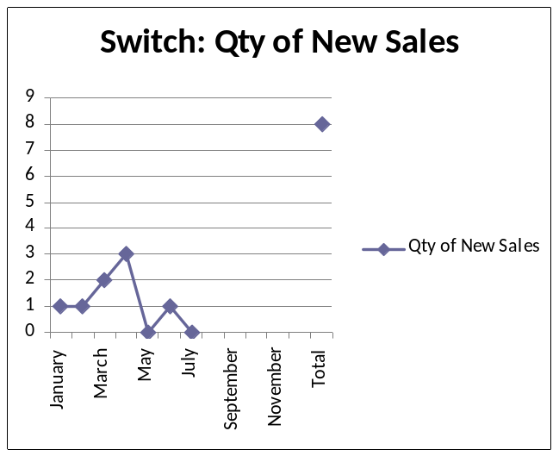

Dialer Report Summary-2014
Month | Qty of New Sales | New Sales Amount | Existing Sales | Net Cashflow | Due Realized | Current Due
January | 15 | $ 5,900 | $ 31,350 | 95.50% | $ 1,473 | $ 1,679
February | 3 | $ 450 | $ 28,710 | 96.30% | $ 3,196 | $ 1,083
March | 7 | $ 3,150 | $ 38,650 | 98.40% | $ 761 | $ 658
April | 17 | $ 5,800 | $ 37,650 | 93.00% | $ 1,493 | $ 3,047
May | 6 | $ 1,200 | $ 41,050 | 91.88% | $ 4,997 | $ 3,429
June | 10 | $ 5,050 | $ 35,500 | 93.65% | $ 3,426 | $ 2,573
July | 8 | $ 4,550 | $ 35,674 | 93.36% | $ 1,728 | $ 2,672
August
September
October
November
December
Total |  | $ 26,100 | $ 248,584 |  | $ 17,074 | $ 15,141

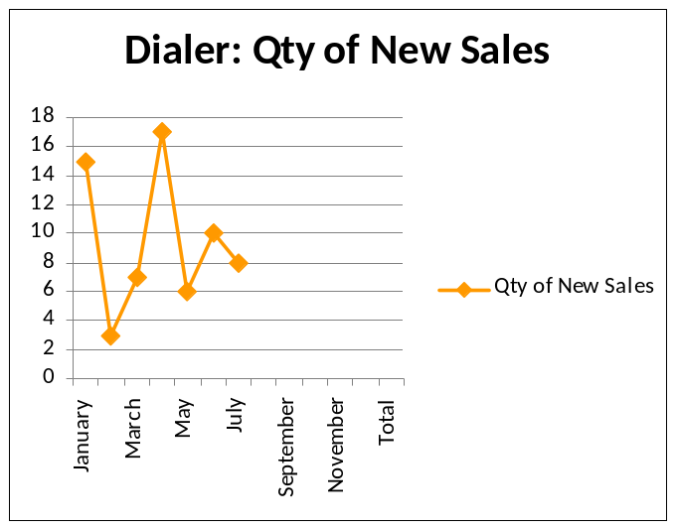
Yearwise Comparison: Switch & Dialer (Last 3 Years)
 | 2014 |  | 2013 |  | 2012
Month | Total Sales-2014 | Total Realized-2014 | Total Sales-2013 | Total Realized-2013 | Total Sales-2012 | Total Realized-2012
January | $49,150 | $41,618 | $73,550 | $58,195 | $148,764 | $130,127
February | $41,110 | $33,540 | $106,214 | $85,964 | $173,677 | $160,918
March | $49,700 | $46,501 | $91,900 | $79,605 | $156,459 | $142,191
April | $52,100 | $47,795 | $73,650 | $62,482 | $156,008 | $140,436
May | $48,600 | $50,069 | $115,792 | $107,455 | $132,237 | $122,782
June | $46,250 | $46,392 | $80,268 | $68,885 | $146,405 | $133,507
July | $45,552 | $45,060 | $81,497 | $73,986 | $123,894 | $109,326
August |  |  | $82,480 | $74,398 | $169,166 | $155,912
September |  |  | $72,850 | $63,259 | $129,064 | $112,295
October |  |  | $60,549 | $53,293 | $109,364 | $92,492
November |  |  | $55,223 | $47,154 | $103,514 | $89,715
December |  |  | $78,100 | $63,106 | $86,964 | $72,123




New Dialer: The new dialer on which CEO was working on has got a better shape and is far better
in quality than any other previous dialer.
New Dialer marketing plan: CEO asked Mr. Majumder about his plan to market the new dialer. In
Reply to CEO he said that he will be able to increase the revenue by 25-30% once he gets the full version of the dialer. But CEO reminds him that initially he discussed about double revenue. But now he is mentioning the revenue much less. Mr. Majumder replied that the dialer market is at descending trend now and the market environment is decayed. It will take some time to let everyone know about the new dialer. But within next 6-7 months, the revenue will be doubled. CEO asked about the marketing plan to make this revenue. Mr. Majumder replied when he would replace our existing dialers with new ones then all customer will know about its quality. Once the message of quality becomes spread out then he could reach the target.

d. Department : International Voice Carrier
Manager : Md. Aminul Islam

Monthly traffic and client report for the month of May 2014

Coverage area:
01. Total Traffic
02. Voice Wholesale Traffic
03. gTalk Total Traffic
04. gTalkNA
05. gTalkUK
06. gTalk® Home

01. Total Traffic

01 (a). Total traffic by Months, Year 2013-2014

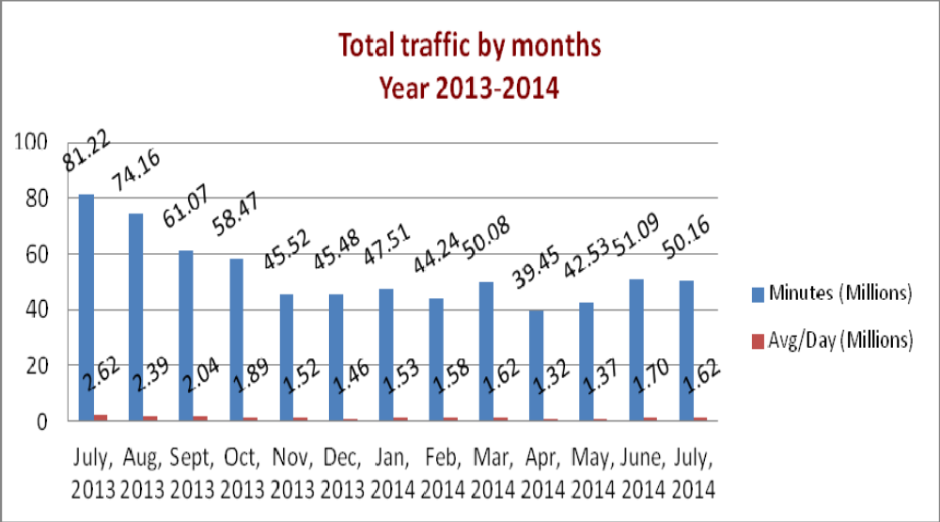

01(b). Total traffic by Months, Year 2013-2014 (According to 30 days)
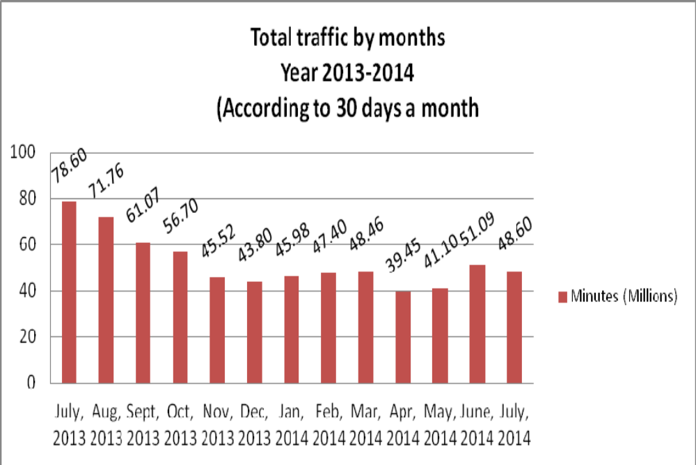

02. Total Voice Wholesale Traffic
02(a). Voice Wholesale: Total Traffic by months. Year 2013-2014

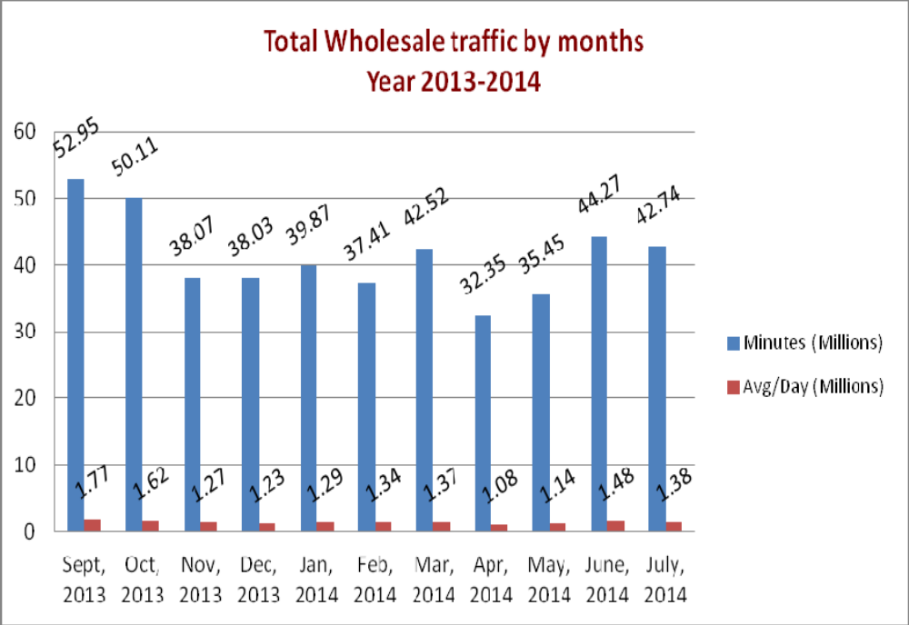

02(b). Voice Wholesale: Total Traffic by months. Year 2013-2014 (According to 30 days)

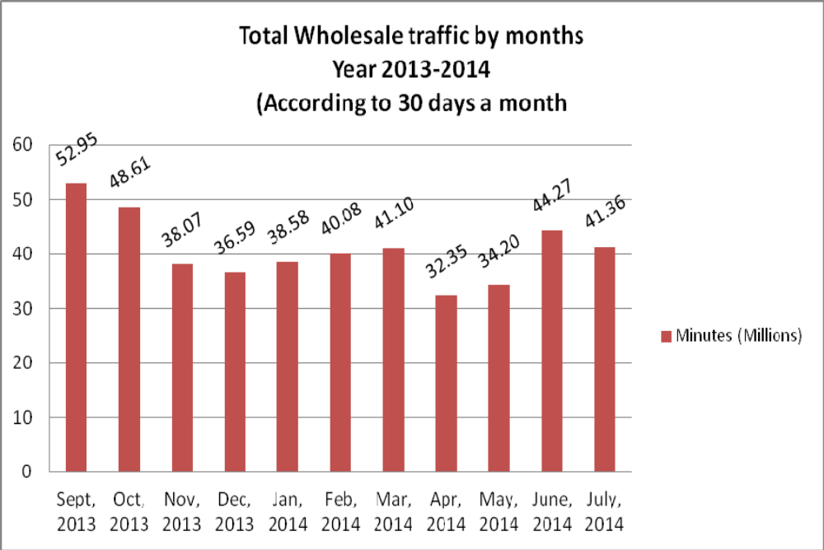

03. gTalk Total Traffic
03(a). gTalk : Total Traffic by months. Year 2013-2014

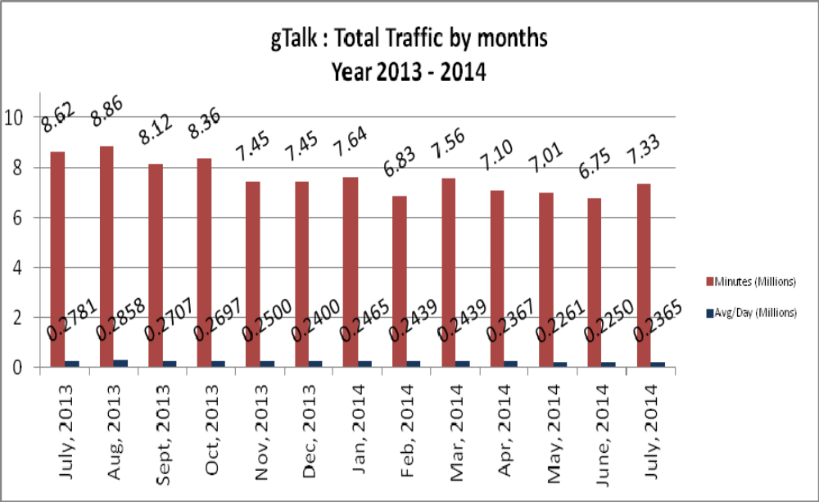

03(b). gTalk : Total Traffic by months (According to 30 days)

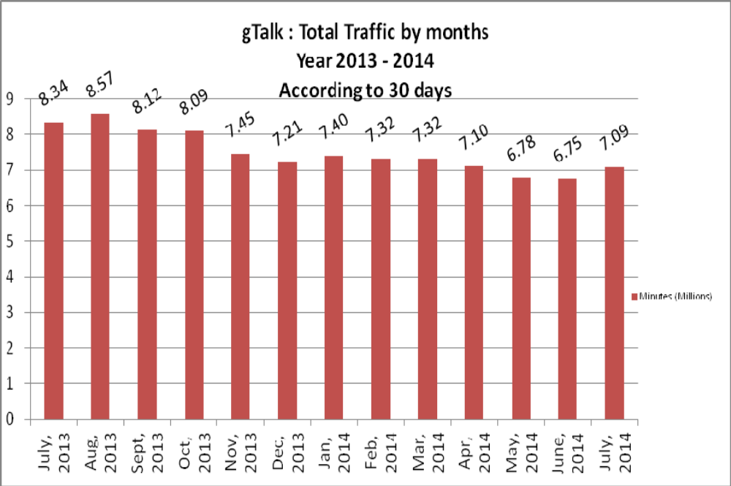

04. gTalk NA

04(a). gTalk NA : Total Traffic by months. Year 2013-2014

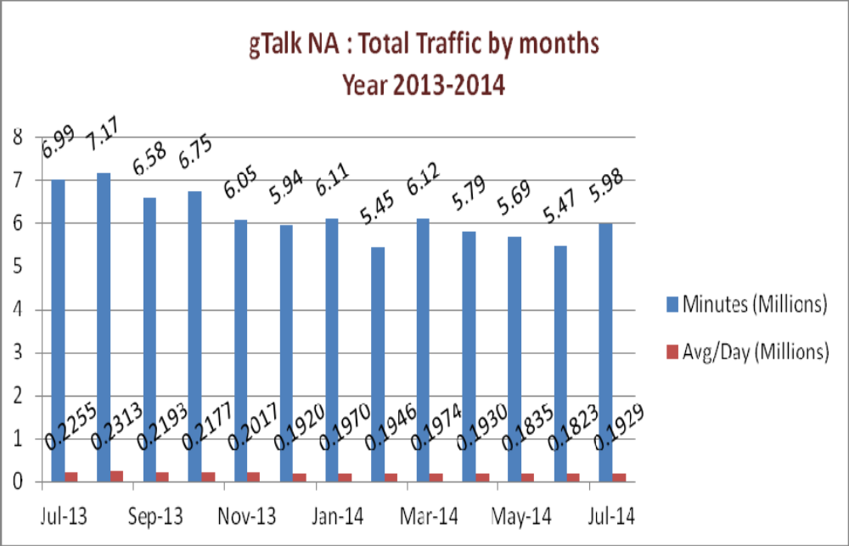

04(b). gTalk NA : Total Traffic by months. Year 2013-2014 (According to 30 days)

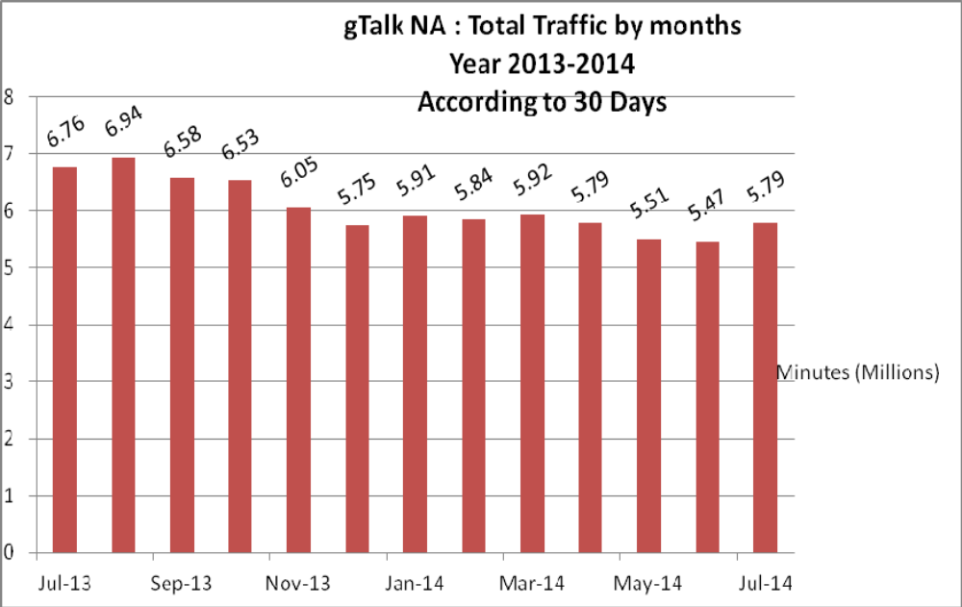

04(c). gTalk NA : New clients by months for the year 2013-2014
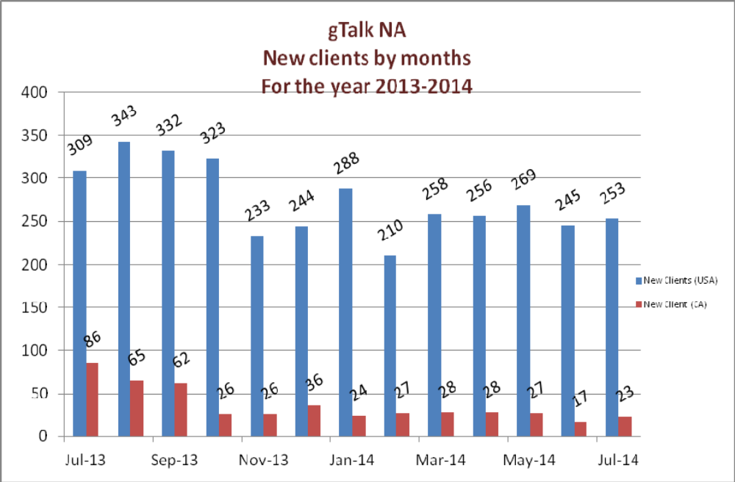

05. gTalk UK

05(a). gTalk UK : Total Traffic by months for the year 2013-2014

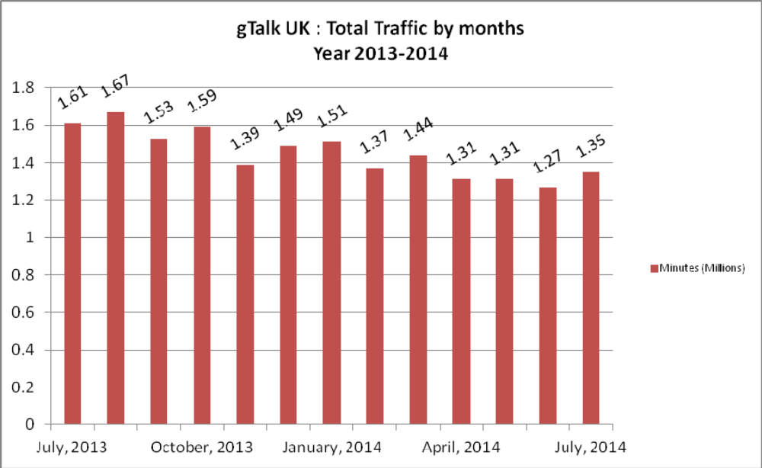

05(b). gTalk UK : Total Traffic by months for the year 2013-2014 (According to 30 Days)

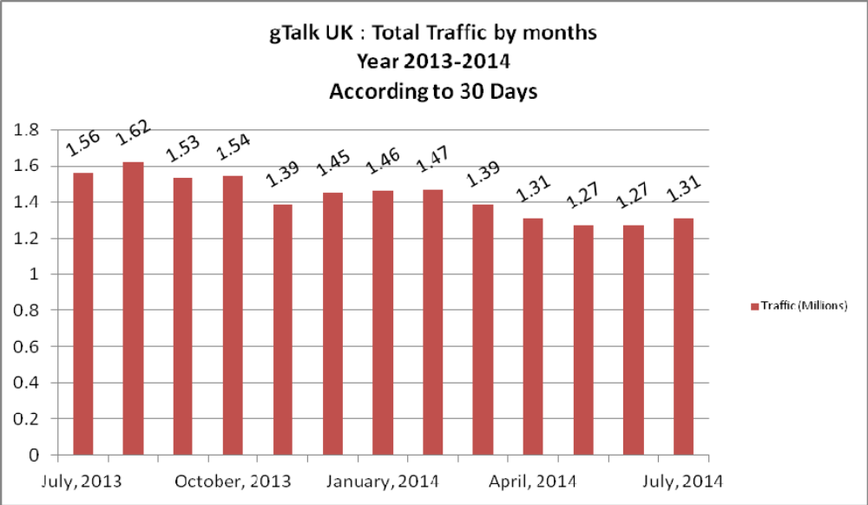

05(c). gTalk UK : New clients by months for the year 2013-2014
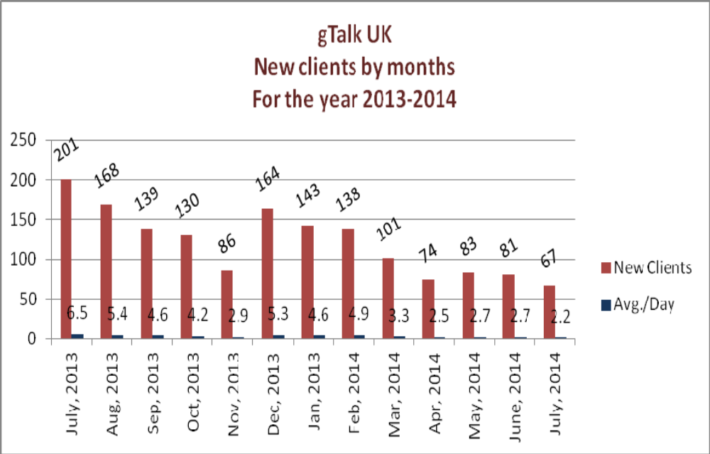
06. gTalk Home
06(a). gTalk® Home : Total Traffic by months for the year 2014

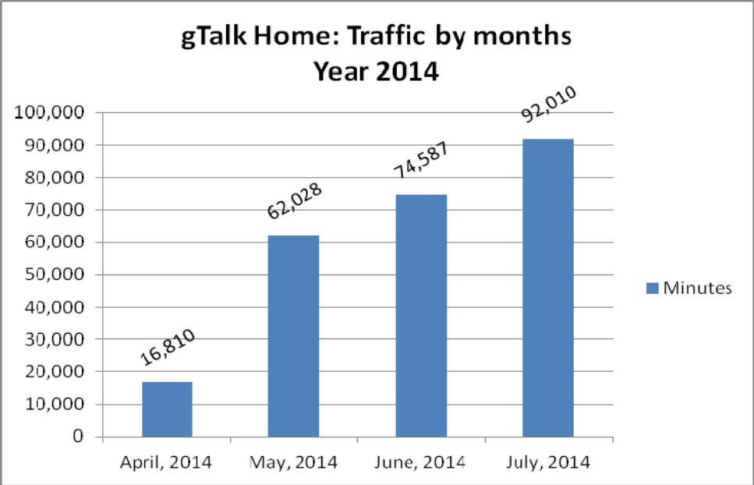

06(b). gTalk® Home : New clients by months for the year 2014

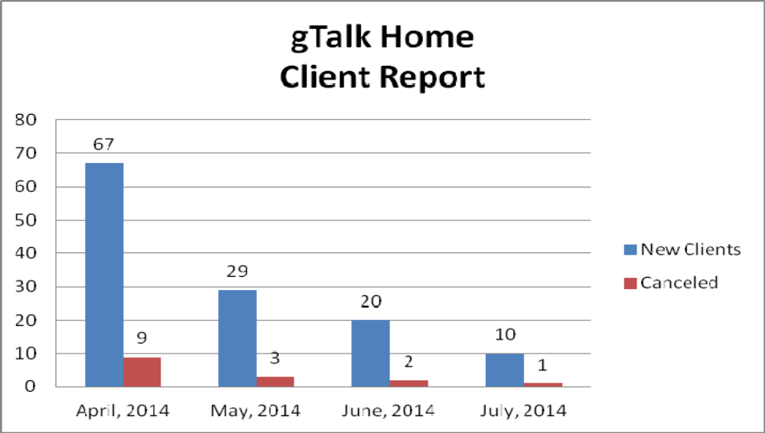

c. Department : Training
AGM & In-Charge : Mohammad Abdullah Al Masum

Current Status: Currently training department is running training in thirteen batches. Among these, five batches (Round 20, 21(2), 22, 23) are being run for IDB. The other 8 batches are covering different customized courses.
Revenue: Total collection on account of training upto July 2014 was 36.04 lacs. The total amount
of revenue upto July 2014 activities was Tk 43.83 lacs.
New Lab: Along with present 3 labs, we are arranging a new lab in order to accommodate the new 250 students of several Polytechnic Institutes. Though we arranged a temporary place for the new lab, but the equipments and furniture have been bought as permanent asset of the company. The lab is set up in the room where our executives usually sat. And the executives are temporarily being given with sitting arrangement in Software Department. If any decision is taken about moving to B11, we will be able to finalize the lab placement.

e. Department : Software
Head of the department : Md. Anwarul Karim

Several works status of Software Department has been discussed in line with other department’s job. But two requests from the department’s engineer are to be addressed. The engineers requested to initiate the 15 minutes flexi time with their entrance time which is at 9.30. Beside this, they requested to consider if another attendance machine could be installed in their floor.

Head of HR & Admin in reply: The flexi time is only included with 9.00 AM roaster taking the huge traffic into account and to handle the late problem at that time. As the time advances, this traffic is reduced. Moreover if this is introduced at 9.30 AM, it will have to be included with each entry time for the staffs. The managers are requested to think about the issue whether they agree on it or not.

f. Department : Network Operations
DGM : Md. Waliul Haque Tusar

The ongoing works of Network Operations has been discussed in line with other department’s job
and the head of NOC has shared his valued input where needed.

g. Department : HR & Admin
DGM : Md. Habibur Rahman

Recruitment of staff: Two new staff has been recruited. One is Md. Anwarul Karim, he joined as the Executive Director. Another is Biprodash Chayan, who joined as Engineer of Network Operations Department.
Permanent staff: Four employees has been made permanent from different departments. We did this based on their service period with Genuity Systems Ltd. Who have more than 3 years of work experience are made permanent. They are Md. Aminur Rahman & Md. Nazmul Islam of Netwrok Operations department, Syed Md. Hashmi of International Voice Career Department and Md. Ashraf-Uz-Zaman of gPlex Software Solutions Department.
Resignation: Md. Zahidul Islam of Call Center has left office without resigning. But later we closed him officially.
Termination: We have terminated two staffs from software department as due to their job pattern we do not require their service any more. They are: Mr. Tanvir Parvez and Md. Rakib Hassan Mullick.
Migration to USA office: We have received the migration order of Md. Waliul Haque Tusar, DGM & Head of Network Operations and Md. Masudul Haque, Lead Software Engineer, Software Department. The necessary works for their smooth departure to USA are going on.
Attendance monitoring: We have been monitoring the staff attendance very carefully from two months and getting very positive result. Most of our staffs are maintaining their attendance properly. So far HR Department solely implemented the monitoring along with support from the managers, but in order to keep it work in future, managers will also needed to be involved.
Development works of EMS: EMS was a sole requirement from the HR Department when it was first introduced. It was developed by software department and the necessary works of HR department could easily be done through this system. But the development of the systems could not be completed as other managers did not use it regularly or came up with their requirements and software department could not give adequate time in its development. So if we need to get complete benefit of EMS, the managers need use it regularly and share their ideas/ thoughts to enrich it.
Recruitment plan of HR: The current recruitment process we have in GSL is a need based approach. When any department shares its requirement for recruiting new staff, we verify the need and recruit accordingly. But we could have come up with a better recruitment plan if we were shared with the project profile of several departments. If we would have get those, we could plan for new staff in a better approach. So in this regard, only our effort is not enough.
Loyal Staff buildup: Once, we could assemble loyal staff as then the nurturing was superior. But now it is not happening as we cannot identify those whom we can make loyal towards the company by nurturing them.
Long term pending works: If any work stands at the beginning of pending term, its negative outcome and breadth remains at minimal level. But when a pending job lingers for long, its negative aspects and breadth increases. And then the responsibility spreads on the shoulders of both who were involved and who were not involved in the process. And this makes the whole environment toxic. So we must solve this problem to minimize the resulting issues.

At the end, CEO showed appreciation to everyone for their presence and thoughtful insights about the company. He concluded the meeting by thanking to all.

