Reference: GSL/ Admin/ MCM 64

Attendance
64th Monthly Coordination Meeting
Date: 21st October 2014
Venue: GSL Conference Room 1

Time: 08.30 AM

- The sixty second monthly coordination meeting of Genuity Systems Ltd. (GSL) was held on 21st October 2014 at Genuity Conference Room 1. Management team and the managers of different departments of the company were present. List of participants of the meeting are as follows:

SL. | Name of Participants | Department | Signature
1. | Habib Rahman | President | Present
2. | M. Anis Rahman | Chief Executive Officer | Present
3. | Md. Sadiqur Rahman | Director Operations | Present
4. | K. Shahadat Hossain | Director Marketing | Present
5. | Md. Anwarul Karim | Executive Director | Present
6. | Md. Habibur Rahman | Admin & HR | Present
7. | Md. Waliul Haque Tusar | System Admin | Present
8. | Md. Aminul Islam | Head of International Voice Carrier | Present
9. | Sk. Kamruzzaman Prince | Corporate Affairs | Present
10. | Lutful Kabir Majumder | Call Center | Present
11. | Md. Ashrafuzzaman | Accounts | Present
12. | Md. Abdullah Al Masum | Training | Present

- The meeting was started by the Manager, Admin & HR. He thanked everyone for participating in the meeting and invited CEO to take control of the meeting. The CEO warmly welcomed everyone present in the meeting and thanked them for their presence. Thereafter he requested all departmental managers to deliver respective speech, one at a time, highlighting departmental performance and issues during the last month. He invited all to raise queries/questions and share their opinion in the discussion as deemed fit. The main points raised and discussed in the meeting over different issues are recorded below:

a. Department : Training
AGM & In-Charge : Mohammad Abdullah Al Masum

Current Status: Currently training department is running training in thirty batches. Among these, five batches (Round 23 CF, 21 NT, 22 NT, 20 NT, 21 WPSI) are being run for IDB. The other 25 batches are covering different customized courses.
Revenue: Total collection on account of training during September 2014 was 8.61 lacs. The total
amount of revenue in September 2014 activities was Tk 9.42 lacs.
Corporate Agreement: We are going to sign corporate agreement with Hi-Tech.
Pipeline: Survey Bangladesh, BADC are in pipeline.

b. Department : Call Center (gTalk)
AGM : Md. Lutful Kabir Majumder

Current status of client joining and usage in gTalk pinless:

# Total client joined in gTalk till 30 September 2014: 57833

# Average client increase per day in September, 14: 12
# Average client increase per day in August, 14: 12
# Average client increase per day in July, 14: 11
# Average client increase per day in June, 14: 12
# Average client increase per day in May, 14: 12
# Average client increase per day in April, 14: 12
# Average client increase per day in March, 14: 13
# Average client increase per day in February, 14: 14
# Average client increase per day in January, 14: 15
# Average client increase per day in December, 13: 14
# Average client increase per day in November, 13: 12
# Average client increase per day in October, 13: 15
# Average client increase per day in September, 13: 18

# Average total Minutes per day in September, 14: 225.07 K
# Average total Minutes per day in August, 14: 228.18 K
# Average total Minutes per day in July, 14: 236.50 K
# Average total Minutes per day in June, 14: 224.90 K
# Average total Minutes per day in May, 14: 226.21 K
# Average total Minutes per day in April, 14: 236.75 K
# Average total Minutes per day in March, 14: 243.74 K
# Average total Minutes per day in February, 14: 243.94 K
# Average total Minutes per day in January, 14: 246.31 K
# Average total Minutes per day in December, 13: 240.35 K
# Average total Minutes per day in November, 13: 248.22 K
# Average total Minutes per day in October, 13: 269.77 K
# Average total Minutes per day in September, 13: 270.80 K

# Total customer used gTalk service in September, 14 about 21,466
# Total customer used gTalk service in August, 14 about 21,026
# Total customer used gTalk service in July, 14 about 21,814
# Total customer used gTalk service in June, 14 about 21,224
# Total customer used gTalk service in May, 14 about 21,663
# Total customer used gTalk service in April, 14 about 21,533
# Total customer used gTalk service in March, 14 about 21,920
# Total customer used gTalk service in February, 14 about 21,587
# Total customer used gTalk service in January, 14 about 22,441
# Total customer used gTalk service in December, 13 about 21,840
# Total customer used gTalk service in November, 13 about 21,941
# Total customer used gTalk service in October, 13 about 22,166
# Total customer used gTalk service in September, 13 about 22,388

Unused Initial Balance for the month of September 2014: In the month of September, it has been found that total 35 customers have not used their Account Initial Balance after opening the account.

Current status after calling those customers is as follows:

- Customer using: 23 (66%)
- Customer still not using: 12 (34%)

Survey in September 2014: In the month of September, a total of 1680 customers who are inactive for at least 2 months have been called. Details about customer’s feedback are given below:

- Ethnic Group:
  - Bangladesh – 1210 (72%)
  - India – 203 (12%)
  - Pakistan – 46 (3%)
  - Nepal – 21 (1%)
  - Kenya – 29 (2%)
  - Libya – 23 (2%)
  - Ethiopia – 17 (1%)
  - Miscellaneous- 131 (8%)

- Message left to the customers who were unavailable: 661(39%)
- Number not in service: 603 (36%)
- Using other calling services or doesn’t make international calls: 325 (19%)
- Interested to use again: 91 (6%)
- Among 91 customers, 11 people have started to use gTalk service again after this survey.

Hot number uses:

September, 14: 35.53%
August, 14: 35.00%
July, 14: 35.56%
June, 14: 35.96%
May, 14: 35.35%
April, 14: 34.87%
March, 14: 34.89%
February, 14: 34.72%
January, 14: 34.46%
December, 13: 34.61%
November, 13: 35.31%
October, 13: 34.33%
September, 13: 34.65%

Hot Dialer Report
Total User(s): 10280

VoIP Dialer Report
Total User(s): 1095

Total SMS from September 1 to September 30, 14: 1837 and Failed SMS: 99

# Total client joined in gTalk UK till 30 September 2014: 7019

# Total client joined in September 2014: 80
# Total client joined in August 2014: 73
# Total client joined in July 2014: 67
# Total client joined in June 2014: 81
# Total client joined in May 2014: 83
# Total client joined in April 2014: 74
# Total client joined in March 2014: 101
# Total client joined in February 2014: 138
# Total client joined in January 2014: 143
# Total client joined in December 2013: 164
# Total client joined in November 2013: 86
# Total client joined in October 2013: 130
# Total client joined in September 2013: 139

# Total Minutes for the month of September, 14: 1232.07 K
# Total Minutes for the month of August, 14: 1281.62 K
# Total Minutes for the month of July, 14: 1345.22 K
# Total Minutes for the month of June, 14: 1265.87 K
# Total Minutes for the month of May, 14: 1309.94 K
# Total Minutes for the month of April, 14: 1313.78 K
# Total Minutes for the month of March, 14: 1436.08 K
# Total Minutes for the month of February, 14: 1366.20 K
# Total Minutes for the month of January, 14: 1510.21 K
# Total Minutes for the month of December, 13: 1493.18 K
# Total Minutes for the month of November, 13: 1387.18 K
# Total Minutes for the month of October, 13: 1589.23 K
# Total Minutes for the month of September, 13: 1532.40 K

c. Department : Corporate
DGM : Sk. Kamruzzaman Prince

Review and update of the issues of 63th Monthly Coordination Meeting was discussed.
CEO in reply: The financial report of corporate department needs to be submitted in the meeting. Formal procedures need to be adopted in order to collect due payments.

d. Department : gPlex Software Solutions
AGM : Md. Lutful Kabir Majumder

 |  | Mobile Dialer |  | Soft Switch |  | Total
 |  | Amount | % | Amount | % | Amount | %
Total Billed |  | $43,300.00 | 1.00 | $5,378.00 | 100.00 | $48,678 | 100.00
Received for Current Bills |  | $39,391.00 | 0.91 | $3,163.00 | 58.81 | $42,554 | 87.42
Advance Expired |  | $45.00 | 0.00 | $45.00 | 0.84 | $90 | 0.18
Current Due |  | $3,864.00 | 0.09 | $2,170.00 | 40.35 | $6,034 | 12.40
Written Off |  | $0.00 | 0.00 | $0.00 | 0.00 | $0 | 0.00
Total Received |  | $41,633.00 | 1.00 | $4,596.00 | 100.00 | $46,229 | 100.00
Received for Current Bills |  | $39,391.00 | 0.95 | $3,163.00 | 68.82 | $42,554 | 92.05  5.91
Received for Last Month's Dues |  | $1,479.00 | 0.04 | $1,255.00 | 27.31 | $2,734 | 1.61
Received for Older Dues |  | $746.00 | 0.02 | $0.00 | 0.00 | $746 | 0.04
Advance Received |  | $17.00 | 0.00 | $0.00 | 0.00 | $17
Qty of New Sales |  | 12 | 9.68% | 1 | 5.00%
Qty of Existing Sales |  | 112 | 90.32% | 19 | 95.00%
Total |  | 124 | 100.00% | 20 | 100.00%

Genuity Systems Limited |  | Mobile Dialer Report
Genuity Systems Limited |  | September 2014
 |  | September 2014
 |  | New Client | Existing Client | Total | %
Bills & Receipts
Total Billed |  | $ 4,750 | $ 38,550 | $ 43,300 | 100.00%
Received for Current Bills |  | $ 4,239 | $ 35,152 | $ 39,391 | 90.97%
Advance Expired |  | $ - | $ 45 | $ 45 | 0.10%
Current Due |  | $ 511 | $ 3,353 | $ 3,864 | 8.92%
Quantity of Sales |  | 12 | 112 | $ 124
Cash Analysis
Total Received |  | $ 4,239 | $ 37,394 | $ 41,633 | 100.00%
Received for Current Bills |  | $ 4,239 | $ 35,152 | $ 39,391 | 94.61%
Received for Last Month's Dues |  | $ - | $ 1,479 | $ 1,479 | 3.55%
Received for Older Dues |  | $ - | $ 746 | $ 746 | 1.79%
Advance Received |  | $ - | $ 17 | $ 17 | 0.04%
Net Cashflow |  |  |  |  | 91.08%
Accounts Receivable Statement |  |  |  | September 2014
Accounts Receivable B/F |  |  |  | $ 82,573
Current Due |  |  |  | $ 3,864
Received for Last Month's Dues |  |  | $ 1,479
Received for Older Dues |  |  | $ 746 | $ 2,225
Discount Allowed |  |  |  | $ -
Written Off (Bad Debt/ Credit Notes) |  |  |  | $ -
Accounts Receivable C/F |  |  |  | 84,212
Last Month's Dues |  |  |  | $ 3,698
Received for Last Month's Dues |  |  |  | $ 1,479
Remaining Last Month's Dues as of Current Month |  |  |  | $ 2,219

Genuity Systems Limited |  | gPlex SoftSwitch Report
Genuity Systems Limited |  | September 2014
 |  | September 2014
 |  | New Client | Existing Client | Total | %
Bills & Receipts
Total Billed |  | $ 600 | $ 4,778 | $ 5,378 | 100.00
Received for Current Bills |  | $ 200 | $ 2,963 | $ 3,163 | 58.81
Advance Expired |  | $ - | $ 45 | $ 45 | 0.84
Written Off- Current |  | $ - | $ - | $ - | 0.00
Current Due |  | $ 400 | $ 1,770 | $ 2,170 | 40.35
Quantity of Sales |  | 1 | 19 | $ 20
Cash Analysis
Total Received |  | $ 200 | $ 4,396 | $ 4,596 | 100.00
Received for Current Bills |  | $ 200 | $ 2,963 | $ 3,163 | 68.82
Received for Last Month's Dues |  | $ - | $ 1,255 | $ 1,255 | 27.31
Received for Older Dues |  | $ - | $ - | $ - | 0.00
Advance Received |  | $ - | $ - | $ - | 0.00
Net Cashflow |  |  |  |  | 59.65%
Accounts Receivable Statement |  |  |  | September 2014
Accounts Receivable B/F |  |  |  | $ 71,260
Current Due |  |  |  | $ 2,170
Received for Last Month's Dues |  |  | $ 1,255
Received for Older Dues |  |  | $ - | $ 1,255
Discount Allowed
Written Off- Last Month |  |  |  | $ -
Written Off-Older |  |  |  | $ 178
Accounts Receivable C/F |  |  |  | 72,175
Last Month's Dues |  |  |  | $ 1,391
Received for Last Month's Dues |  |  |  | $ 1,255
Remaining Last Month's Dues as of This Month |  |  |  | $ 136

Switch Report Summary-2014
Month | Qty of New Sales | New Sales Amount | Existing Sales | Net Cashflow | Due Realized | Current Due
January | 1 | $ 600 | $ 11,300 | 50.80% | $ 2,748 | $ 5,853
February | 1 | $ 600 | $ 11,350 | 45.70% | $ 3,626 | $ 5,337
March | 2 | $ 850 | $ 7,050 | 67.80% | $ 2,542 | $ 2,300
April | 3 | $ 2,400 | $ 6,250 | 85.50% | $ 1,703 | $ 1,258
May | 0 | $ - | $ 6,350 | 66.87% | $ 1,874 | $ 2,104
June | 1 | $ 200 | $ 5,500 | 60.40% | $ 1,640 | $ 2,135
July | 0 | $ - | $ 5,328 | 63.66% | $ 2,458 | $ 1,936
August | 1 | $ 600 | $ 5,078 | 75.50% | $ 1,617 | $ 1,304
September | 1 | $ 600 | $ 5,378 | 59.65% | $ 1,255 | $ 2,170
October
November
December
Total | 10 | $ 5,850 | $ 63,584 |  | $ 19,463 | $ 24,397

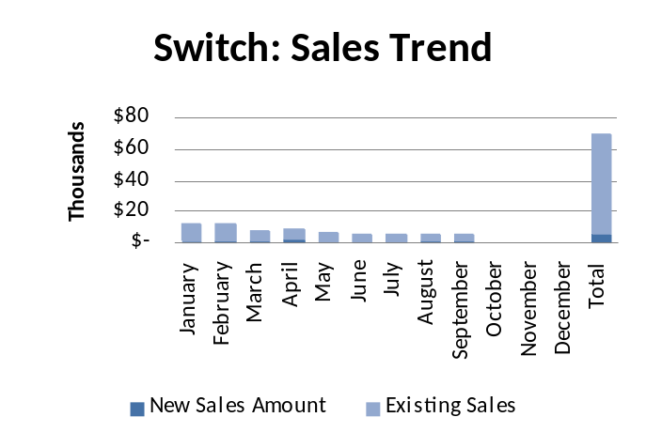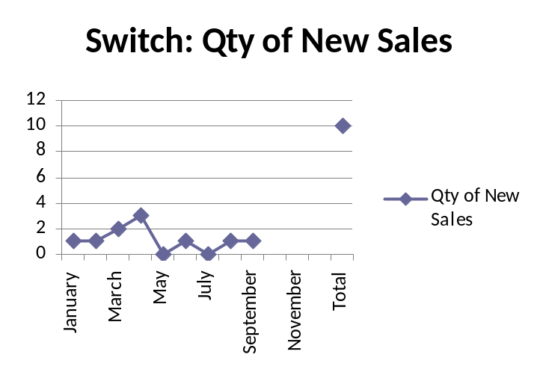
Dialer Report Summary-2014
Month | Qty of New Sales | New Sales Amount | Existing Sales | Net Cashflow | Due Realized | Current Due
January | 15 | $ 5,900 | $ 31,350 | 95.50% | $ 1,473 | $ 1,679
February | 3 | $ 450 | $ 28,710 | 96.30% | $ 3,196 | $ 1,083
March | 7 | $ 3,150 | $ 38,650 | 98.40% | $ 761 | $ 658
April | 17 | $ 5,800 | $ 37,650 | 93.00% | $ 1,493 | $ 3,047
May | 6 | $ 1,200 | $ 41,050 | 91.88% | $ 4,997 | $ 3,429
June | 10 | $ 5,050 | $ 35,500 | 93.65% | $ 3,426 | $ 2,573
July | 8 | $ 4,550 | $ 35,674 | 93.36% | $ 1,728 | $ 2,672
August | 8 | $ 4,650 | $ 41,650 | 92.01% | $ 3,051 | $ 3,197
September | 12 | $ 4,750 | $ 38,550 | 91.08% | $ 2,225 | $ 3,864
October
November
December
Total |  | $ 35,500 | $ 328,784 |  | $ 22,350 | $ 22,202
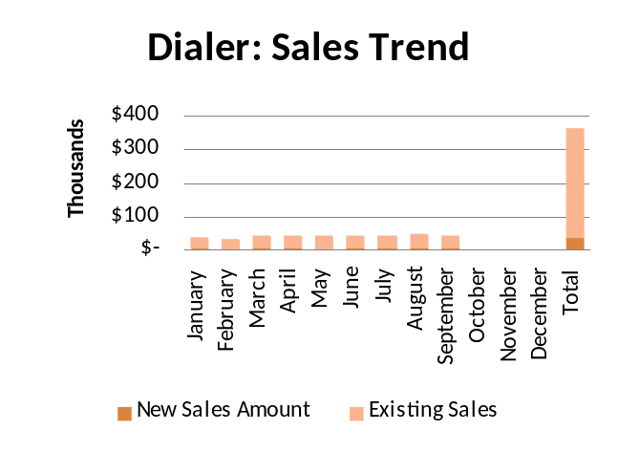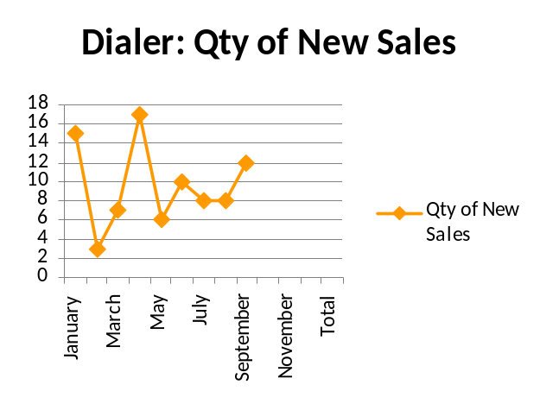

e. Department : Software
Head of the department : Md. Anwarul Karim
At present, the output of the team members of software department has increased. The way they are working now, the previous system loss has been reduced. As a result no job is becoming pending here. We are also looking into the issue of their motivation to keep this good work rolling.

f. Department : International Voice Carrier
Manager : Md. Aminul Islam

Monthly traffic and client report for the month of September 2014

Coverage area:
01. Total Traffic
02. Voice Wholesale Traffic
03. gTalk Total Traffic
04. gTalkNA
05. gTalkUK
06. gTalk® Home

01. Total Traffic

01 (a). Total traffic by Months, Year 2013-2014

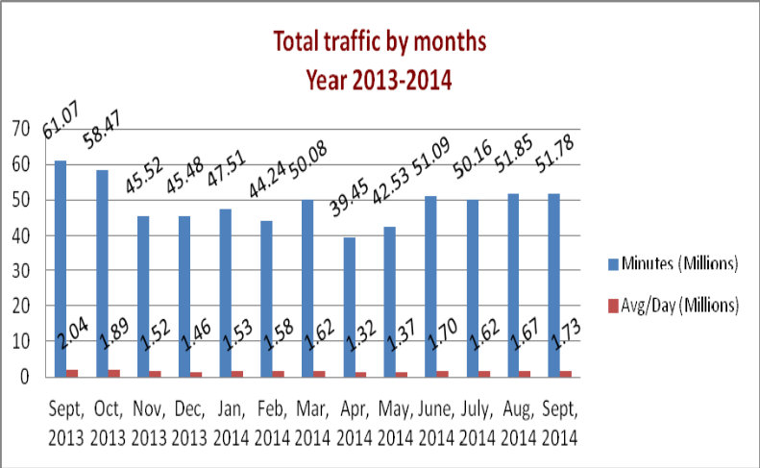

01(b). Total traffic by Months, Year 2013-2014 (According to 30 days)
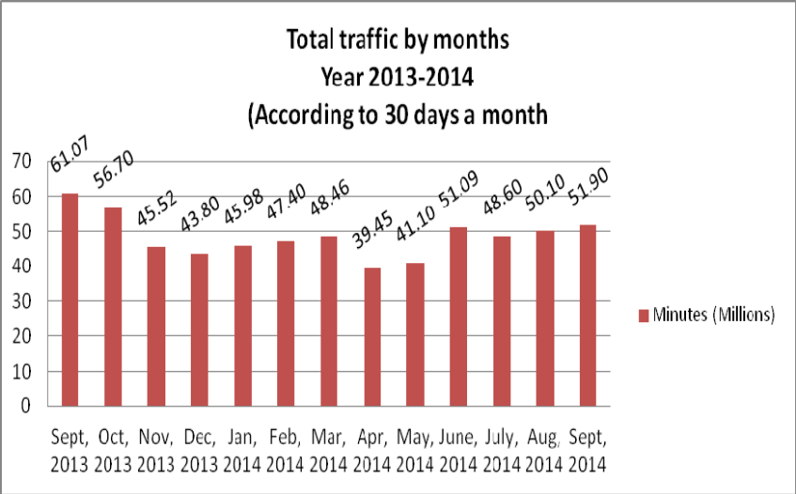

02. Total Voice Wholesale Traffic
02(a). Voice Wholesale: Total Traffic by months. Year 2013-2014

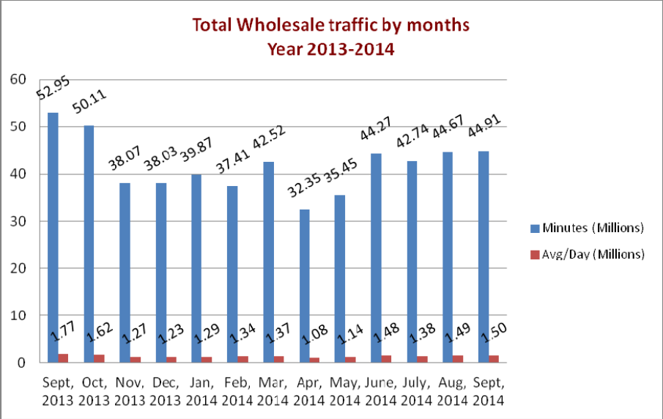

02(b). Voice Wholesale: Total Traffic by months. Year 2013-2014 (According to 30 days)

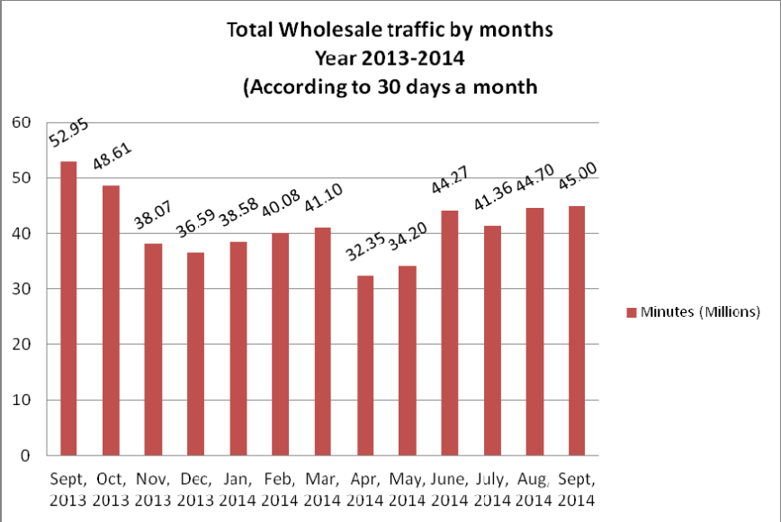

03. gTalk Total Traffic
03(a). gTalk : Total Traffic by months. Year 2013-2014

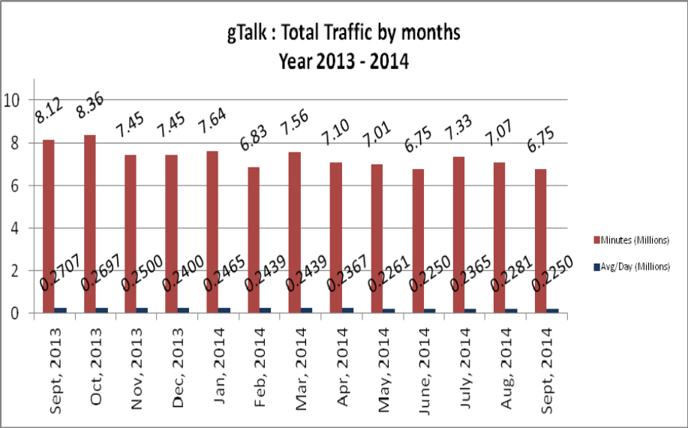

03(b). gTalk : Total Traffic by months (According to 30 days)

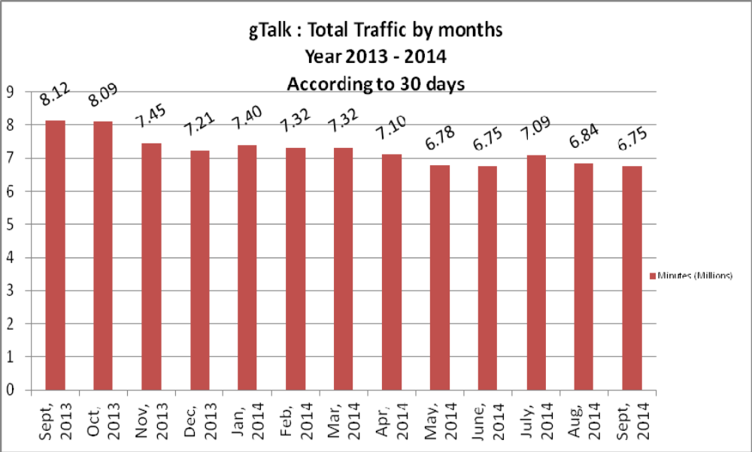

04. gTalk NA

04(a). gTalk NA : Total Traffic by months. Year 2013-2014

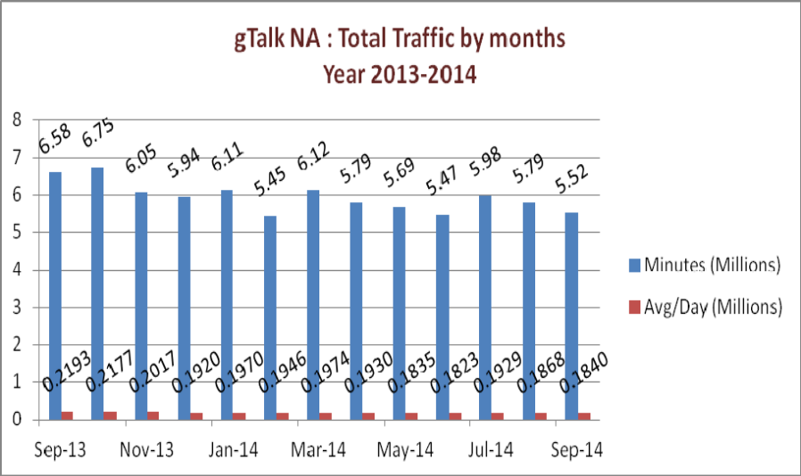

04(b). gTalk NA : Total Traffic by months. Year 2013-2014 (According to 30 days)

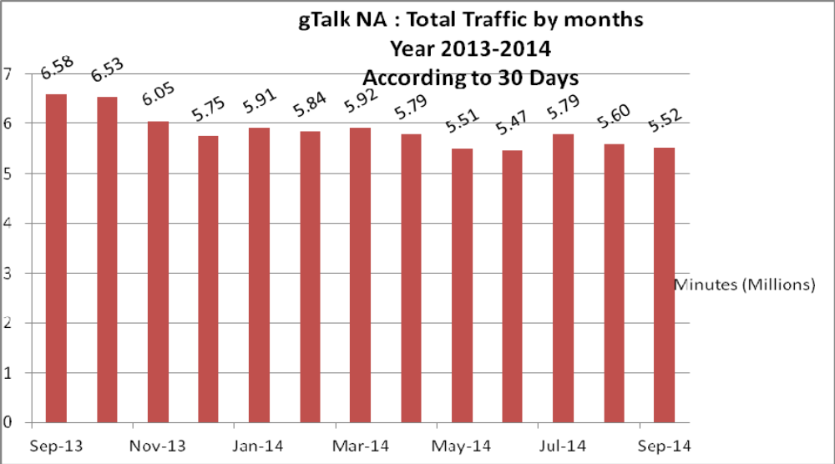

04(c). gTalk NA : New clients by months for the year 2013-2014
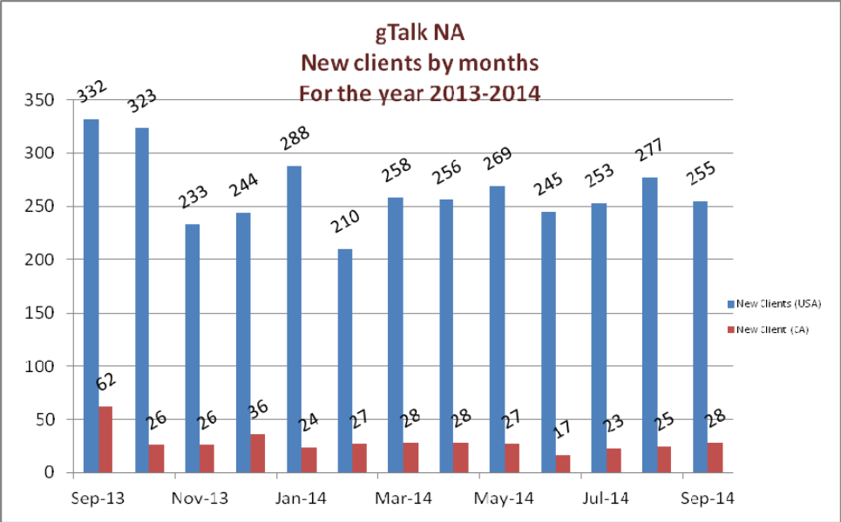

05. gTalk UK

05(a). gTalk UK : Total Traffic by months for the year 2013-2014

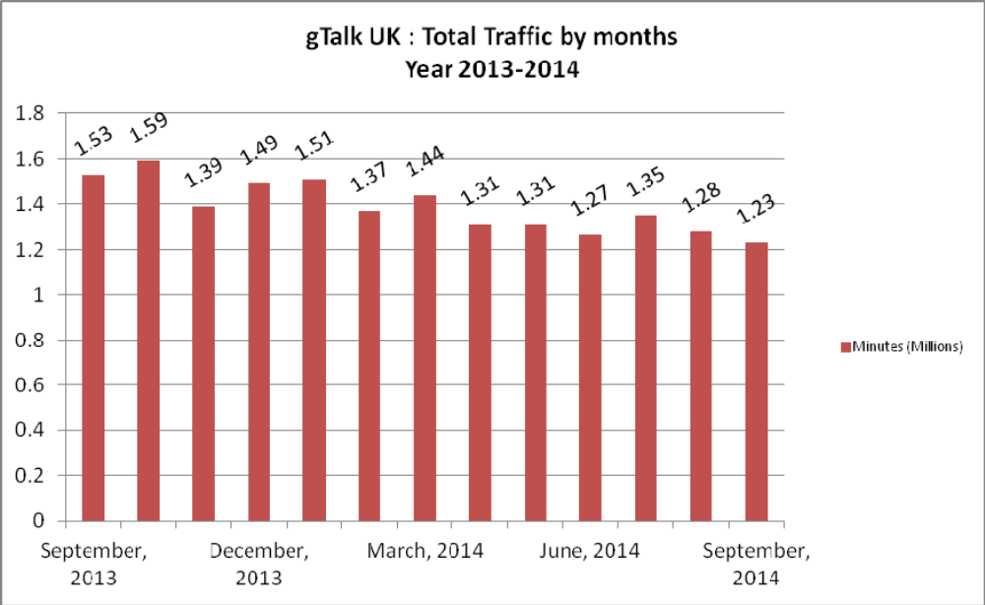

05(b). gTalk UK : Total Traffic by months for the year 2013-2014 (According to 30 Days)

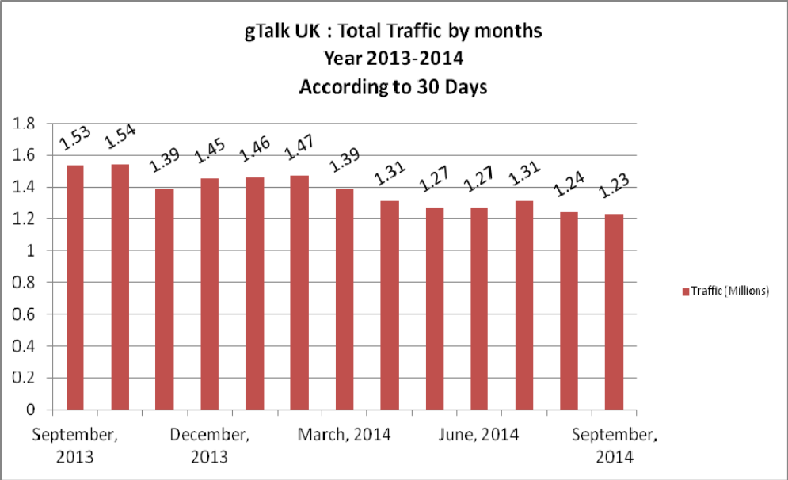

05(c). gTalk UK : New clients by months for the year 2013-2014
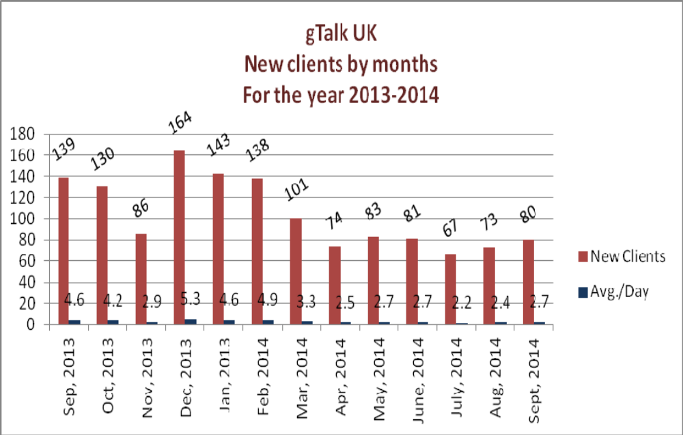

06. gTalk Home
06(a). gTalk® Home : Total Traffic by months for the year 2014

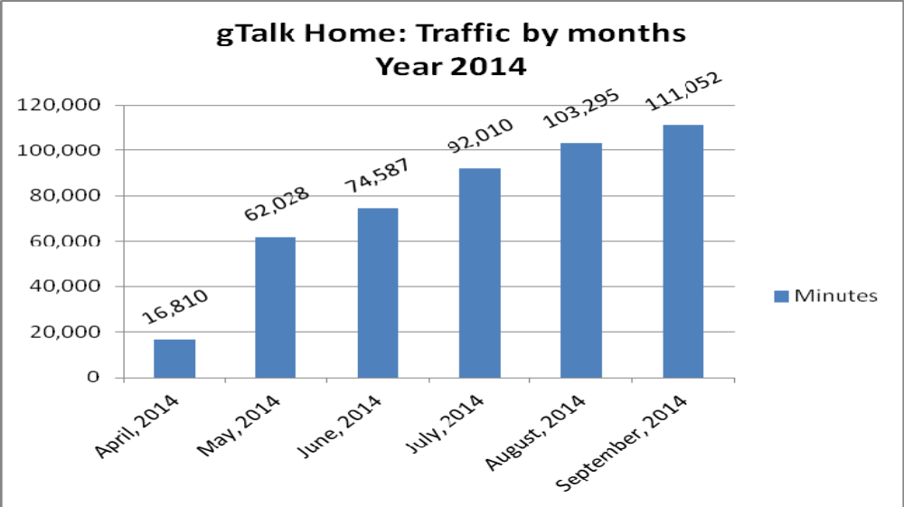

06(b). gTalk® Home : New clients by months for the year 2014

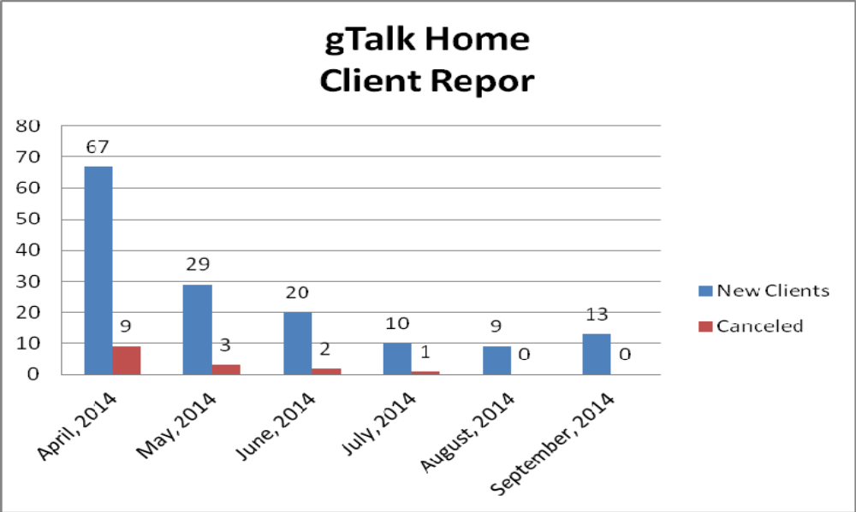

g. Department : HR & Admin
DGM : Md. Habibur Rahman
New leave policy: The proposed new leave policy has been approved. It will come into effect from 1st January 2015. Before that, some important work will have to be done in EMS. Software department is requested to take initiative to get these changes done by November 2014.
Calender: The design work of calendar is being going on. It will be sent to press for printing on 10th November 2014. Managers were requested to share their requirements by 30th October 2014. It is necessary to share early as some sort listing might be required.
Picnic 2015: Picnic will be held place during 9-10 January 2015. Necessary works to make it happen will be initiated soon.

At the end, CEO showed appreciation to everyone for their presence and thoughtful insights about the company. He concluded the meeting by thanking to all.

