Reference: GSL/ Admin/ MCM 66

Attendance
66th Monthly Coordination Meeting
Date: 11th December 2014
Venue: GSL Conference Room

Time: 09.00 AM

The sixty sixth monthly coordination meeting of Genuity Systems Ltd. (GSL) was held on 11th December 2014 at Genuity Conference Room 1. Management team and the managers of different departments of the company were present. List of participants of the meeting are as follows:
SL. | Name of Participants | Department | Signature
1. | Habib Rahman | President | Present
2. | M. Anis Rahman | Chief Executive Officer | Present
3. | Md. Sadiqur Rahman | Director Operations | Present
4. | K. Shahadat Hossain | Director Marketing | Present
5. | Md. Anwarul Karim | Executive Director | Present
6. | Md. Habibur Rahman | Admin & HR | Present
7. | Md. Waliul Haque Tusar | System Admin | Present
8. | Md. Aminul Islam | Head of International Voice Carrier | Present
9. | Sk. Kamruzzaman Prince | Corporate Affairs | Present
10. | Lutful Kabir Majumder | Call Center | Present
11. | Md. Ashrafuzzaman | Accounts | Present
12. | Md. Abdullah Al Masum | Training | Present

The meeting was started by the Manager, Admin & HR. He thanked everyone for participating in the meeting and invited CEO to take control of the meeting. The CEO warmly welcomed everyone present in the meeting and thanked them for their presence. Thereafter he requested all departmental managers to deliver respective speech, one at a time, highlighting departmental performance and issues during the last month. He invited all to raise queries/questions and share their opinion in the discussion as deemed fit. The main points raised and discussed in the meeting over different issues are recorded below:

a. Department : Corporate
DGM : Sk. Kamruzzaman Prince

Sales report of gPlex Call Center Solution:
Sales and Cash realization according to client will be reflected though the below given chart:
 | Sale and Cash realization in 2013
 | Sl. No. |  | Client Name |  |  | Total received WO |  | Invoice to Client for SLA & Rent |  | Cash received/realization | Remarks
 | 1 |  | SCB ( LPU ) |  |  | 196,148.30 |  |  |  | 188,302.37
 | 2 |  | The City Bank |  |  | 975,000.00 |  |  |  | 936,000.00
 | 3 |  | RanksTel |  |  | 1,200,000.00 |  |  |  | 800,000.00
 | 4 |  | Lanka Bangla |  |  | 2,027,214.00 |  |  |  | 941,783.00
 | 5 |  | Hello World, Ctg |  |  | 776,000.00 |  |  |  | 200,000.00 | Project postpone
 | 6 |  | The City Bank |  |  | 700,000.00 |  |  |  |  | Pending
 | 7 |  | SCB Collection |  |  |  |  | 2,070,000.00 |  | 2,041,938.00
 | 8 |  | Bank Asia |  |  |  |  | 660,000.00 |  | 646,214.00 | 2 months of 2012
 | 9 |  | City Bank SLA/AMC |  |  |  |  | 608,540.00 |  | 600,559.00
 | 10 |  | SCB SLA |  |  |  |  | 400,000.00 |  | 400,000.00
 |  |  |  |  |  | 5,874,362.30 |  | 3,738,540.00 |  | 6,754,796.37 | 70 %
 |  |  |  |  |  | Grand Total sale : |  | 9,612,902.30
 | Total account's collection : |  |  |  |  |  |  | 11,148,651.61
Sale and Cash realization in 2014
Sl. No. |  | Client Name |  |  | Total received WO |  | Invoice to Client for SLA & Rent |  | Cash received/realization |  | Remarks
1 |  | ONE Bank |  |  | 6,636,240.00
2 |  | Southeast Bank |  |  | 1,800,000.00
3 |  | Bank Asia (Rent) |  |  |  |  | 1,045,000.00 |  | 709,985.00 |  | Till November 2014
4 |  | City Bank (SLA) |  |  |  |  | 540,092.50 |  | 385,405.00
5 |  | SCB Collection (Rent) |  |  |  |  | 1,207,500.00 |  | 862,500.00
6 |  | LankaBangla |  |  |  |  |  |  | 941,782.00 |  | Realization
7 |  | RanksTel |  |  |  |  |  |  | 200,000.00 |  | Realization
8 |  | SCB (SLA) |  |  |  |  | 400,000.00
9 |  | Ranks Tel AMC |  |  |  |  | 608,540.00 |  | 600,559.00
10 |  | SCB SLA |  |  |  |  | 400,000.00 |  | 400,000.00 |  | 6 Months of 2014
 |  |  |  |  | 8,436,240.00 |  | 3,745,682.50 |  | 4,126,810.00
Grand Total sale : |  |  |  |  |  |  | 12,181,922.50
Total account's collection : |  |  |  |  |  |  | 4,126,810.00
Sale as per accounts statement up to Nov 2014: |  |  |  |  |  |  | 13,343,365.00

Submitted Invoices / Payment in process :
Sl. No. | Client | Description | Amount
1 | RanksTel | Jan-Dec'2012 with due | 170,000.00
2 | ITCL ( Q Cash ) | Jan-Dec'2013 | 195,500.00
3 | ONE Bank | 35% of WO | 2,423,184.75
4 | Shah cement | Final invoice | 240,000.00
5 | City Bank | May-Oct, 2014 on 10 lac | 45,000.00
5 | City Bank | Telebanking_Email Module | 1,700,000.00
5 | City Bank | Synthesized_voice (part) | 220,000.00
5 | City Bank | Sep-Nov, 2014: PO 18 lac | 40,500.00
5 | City Bank | Aug-Oct, 2014: PO 9.75 lac | 21,937.50
5 | City Bank | Sep-Nov, 2014: PO 21 lac | 47,250.00
6 | Bank Asia | Rent : Oct 2014 | 95,000.00
6 | Bank Asia | Rent : Nov 2014 | 95,000.00
6 | Bank Asia | Rent : Dec 2014 | 95,000.00
7 | RanksTel | AMC: 2014 | 360,000.00
8 | ITCL (Q Cash) | AMC : 2014 | 98,090.00
 |  |  | 5,846,462.25
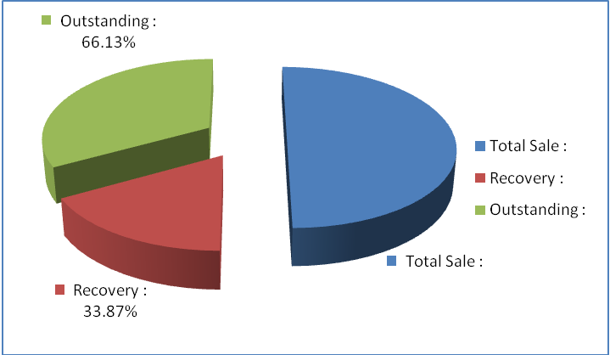

SLA of Ranks & Q Cash: Ranks & Q Cash hah no SLA previously. From now, their bills will be made through SLA.
Pipeline: A presentation will be held at UCBL next week. A presentation will take place at Jamuna Bank next month.
Video feature requirement: One Bank and Lanka Bangla are asking for video call facility along with their call center solution.
Work Order: Already received work order from One Bank, will receive the payment on next month. Received work order from Southeast Bank, procurement will take place by this month.
Predictive dialer: A meeting will be held with Rsystem India about predictive dialer.
SCB: The SLA with SCB will be stopped from 2015.

b. Department : Training
AGM & In-Charge : Mohammad Abdullah Al Masum

Current Status: Currently training department is running training for twenty nine batches. Among these, five batches (21 NT, 22 NT, 20 NT, 21 WPSI, 23 WPSI) are being run for IDB. The other 24 batches are covering different customized courses.
Revenue: Total collection on account of training during November 2014 was 10.13 lacs. The
total amount of revenue in November 2014 activities was Tk 8.56 lacs.
Registration of Hi-Tech: The registration process for Hi-Tech training has already been started and 60 students have already been enrolled.
Save the Children: Save the Children wants to enroll some students for short and long termed courses.
Course completion of Poly-technique Institutes: The courses of Poly-technique institutes are completed. We will soon send the feedback report to the respective institutes.
IDB report: We are in a phase to send feedback report to IDB.
New Lab: The new training lab works are going on.

c. Department : Call Center (gTalk)
AGM : Md. Lutful Kabir Majumder

Current status of client joining and usage in gTalk pinless:

# Total client joined in gTalk till 30 November 2014: 58396

# Average client increase per day in November, 14: 8
# Average client increase per day in October, 14: 11
# Average client increase per day in September, 14: 12
# Average client increase per day in August, 14: 12
# Average client increase per day in July, 14: 11
# Average client increase per day in June, 14: 12
# Average client increase per day in May, 14: 12
# Average client increase per day in April, 14: 12
# Average client increase per day in March, 14: 13
# Average client increase per day in February, 14: 14
# Average client increase per day in January, 14: 15
# Average client increase per day in December, 13: 14
# Average client increase per day in November, 13: 12
# Average client increase per day in October, 13: 15
# Average client increase per day in September, 13: 18

# Average total Minutes per day in November, 14: 204.71 K
# Average total Minutes per day in October, 14: 216.46 K
# Average total Minutes per day in September, 14: 225.07 K
# Average total Minutes per day in August, 14: 228.18 K
# Average total Minutes per day in July, 14: 236.50 K
# Average total Minutes per day in June, 14: 224.90 K
# Average total Minutes per day in May, 14: 226.21 K
# Average total Minutes per day in April, 14: 236.75 K
# Average total Minutes per day in March, 14: 243.74 K
# Average total Minutes per day in February, 14: 243.94 K
# Average total Minutes per day in January, 14: 246.31 K
# Average total Minutes per day in December, 13: 240.35 K
# Average total Minutes per day in November, 13: 248.22 K
# Average total Minutes per day in October, 13: 269.77 K
# Average total Minutes per day in September, 13: 270.80 K

# Total customer used gTalk service in November, 14 about 20,795
# Total customer used gTalk service in October, 14 about 21,371
# Total customer used gTalk service in September, 14 about 21,466
# Total customer used gTalk service in August, 14 about 21,026
# Total customer used gTalk service in July, 14 about 21,814
# Total customer used gTalk service in June, 14 about 21,224
# Total customer used gTalk service in May, 14 about 21,663
# Total customer used gTalk service in April, 14 about 21,533
# Total customer used gTalk service in March, 14 about 21,920
# Total customer used gTalk service in February, 14 about 21,587
# Total customer used gTalk service in January, 14 about 22,441
# Total customer used gTalk service in December, 13 about 21,840
# Total customer used gTalk service in November, 13 about 21,941
# Total customer used gTalk service in October, 13 about 22,166
# Total customer used gTalk service in September, 13 about 22,388

Unused Initial Balance for the month of November 2014: In the month of November, it has been found that total 31 customers have not used their Account Initial Balance after opening the account.

Current status after calling those customers is as follows:

- Customer using: 18 (58%)
- Customer still not using: 13 (42%)

Survey in November 2014: In the month of November, a total of 1173 customers who are inactive for at least 2 months have been called. Details about customer’s feedback are given below:

- Ethnic Group:
  - Bangladesh – 709 (60%)
  - India – 115 (10%)
  - Kenya – 38 (3%)
  - Pakistan – 22 (2%)
  - Libya – 34 (3%)
  - Gambia – 107 (9%)
  - Nepal – 19 (2%)
  - Miscellaneous- 129 (11%)

- Message left to the customers who were unavailable: 382 (33%)
- Number not in service: 509 (43%)
- Using other calling services or doesn’t make international calls: 224 (19%)
- Interested to use again: 58 (5%)
Among 58 customers, 4 people have started to use gTalk service again after this survey.

Hot number uses:

November, 14: 36.00%
October, 14: 35.34%
September, 14: 35.53%
August, 14: 35.00%
July, 14: 35.56%
June, 14: 35.96%
May, 14: 35.35%
April, 14: 34.87%
March, 14: 34.89%
February, 14: 34.72%
January, 14: 34.46%
December, 13: 34.61%
November, 13: 35.31%
October, 13: 34.33%
September, 13: 34.65%

Hot Dialer Report
Total User(s): 10834

VoIP Dialer Report
Total User(s): 1202

Total SMS from November 1 to November 30, 14: 1502 and Failed SMS: 112

# Total client joined in gTalk UK till 30 November 2014: 7121

# Total client joined in November 2014: 47
# Total client joined in October 2014: 55
# Total client joined in September 2014: 80
# Total client joined in August 2014: 73
# Total client joined in July 2014: 67
# Total client joined in June 2014: 81
# Total client joined in May 2014: 83
# Total client joined in April 2014: 74
# Total client joined in March 2014: 101
# Total client joined in February 2014: 138
# Total client joined in January 2014: 143
# Total client joined in December 2013: 164
# Total client joined in November 2013: 86
# Total client joined in October 2013: 130
# Total client joined in September 2013: 139

# Total Minutes for the month of November, 14: 1074.15 K
# Total Minutes for the month of October, 14: 1177.35 K
# Total Minutes for the month of September, 14: 1232.07 K
# Total Minutes for the month of August, 14: 1281.62 K
# Total Minutes for the month of July, 14: 1345.22 K
# Total Minutes for the month of June, 14: 1265.87 K
# Total Minutes for the month of May, 14: 1309.94 K
# Total Minutes for the month of April, 14: 1313.78 K
# Total Minutes for the month of March, 14: 1436.08 K
# Total Minutes for the month of February, 14: 1366.20 K
# Total Minutes for the month of January, 14: 1510.21 K
# Total Minutes for the month of December, 13: 1493.18 K
# Total Minutes for the month of November, 13: 1387.18 K
# Total Minutes for the month of October, 13: 1589.23 K
# Total Minutes for the month of September, 13: 1532.40 K

d. Department : gPlex Software Solutions
AGM : Md. Lutful Kabir Majumder

 |  | Mobile Dialer |  | Soft Switch |  | Total
 |  | Amount | % | Amount | % | Amount | %
Total Billed |  | $65,778.00 | 100.00% | $6,550.00 | 100.00% | $72,328 | 100.00%
Received for Current Bills |  | $52,950.00 | 80.50% | $3,693.00 | 56.38% | $56,643 | 78.31%
Advance Expired |  | $307.00 | 0.47% | $0.00 | 0.00% | $307 | 0.42%
Current Due |  | $12,521.00 | 19.04% | $1,457.00 | 22.24% | $13,978 | 19.33%
Written Off |  | $0.00 | 0.00% | $1,400.00 | 21.37% | $1,400 | 1.94%
Total Received |  | $55,186.00 | 100.00% | $4,195.00 | 100.00% | $59,381 | 100.00%
Received for Current Bills |  | $52,950.00 | 95.95% | $3,693.00 | 88.03% | $56,643 | 95.39%
Received for Last Month's Dues |  | $1,481.00 | 2.68% | $494.00 | 11.78% | $1,975 | 3.33%
Received for Older Dues |  | $705.00 | 1.28% | $8.00 | 0.19% | $713 | 1.20%
Advance Received |  | $50.00 | 0.09% | $0.00 | 0.00% | $50 | 0.08%
Qty of New Sales |  | 42 | 28.97% | 1 | 5.56%
Qty of Existing Sales |  | 103 | 71.03% | 17 | 94.44%
Total |  | 145 | 100.00% | 18 | 100.00%
Individual Executive performance -November 2014
 | New Sales |  |  | Existing Sales
Name | Switch | Dialer | Amount Total | Switch | Dialer | Amount Total
Amit Shaha | ### | $ 16,150 | $ 17,150 | $ 3,850 | $ 14,500 | $ 18,350 | amitsaha
Md. Ashraf-Uz-Zaman | $ - | $ 1,800 | $ 1,800 | $ 600 | $ 6,850 | $ 7,450 | auzaman
Moushumi Shema | $ - | $ 9,728 | $ 9,728 | $ 600 | $ 4,600 | $ 5,200 | Moushumi
Joyantee | $ - | $ 5,950 | $ 5,950 | $ - | $ 2,700 | $ 2,700 | Joyantee
Total |  | $ 33,628 | $ 34,628 | $ 5,050 | $ 28,650 | $33,700

 |  |  | gPlex SoftSwitch Report
 |  |  | November 2014
 |  |  | November 2014
 |  |  | New Client | Existing Client | Total | %
 | Bills & Receipts
 | Total Billed |  | $ 1,000 | $ 5,550 | $ 6,550 | 100.00%
 | Received for Current Bills |  | $ 1,000 | $ 2,693 | $ 3,693 | 56.38%
 | Advance Expired |  | $ - | $ - | $ - | 0.00%
 | Written Off- Current |  | $ - | $ 1,400 | $ 1,400 | 21.37%
 | Current Due |  | $ - | $ 1,457 | $ 1,457 | 22.24%
 | Quantity of Sales |  | 1 | 17 | $ 18
 | Cash Analysis
 | Total Received |  | $ 1,000 | $ 3,195 | $ 4,195 | 100.00%
 | Received for Current Bills |  | $ 1,000 | $ 2,693 | $ 3,693 | 88.03%
 | Received for Last Month's Dues |  | $ - | $ 494 | $ 494 | 11.78%
 | Received for Older Dues |  | $ - | $ 8 | $ 8 | 0.19%
 | Advance Received |  | $ - | $ - | $ - | 0.00%
 | Net Cashflow |  |  |  |  | 56.38%
 | Accounts Receivable Statement |  |  |  | November 2014
 | Accounts Receivable B/F |  |  |  | $ 71,728
Add | Current Due |  |  |  | $ 1,457
Less | Received for Last Month's Dues |  |  | $ 494
Less | Received for Older Dues |  |  | $ 8 | $ 502
Less | Discount Allowed
Less | Written Off- Last Month |  |  |  | $ 1,400
Less | Written Off-Older |  |  |  | $ 1,400
 | Accounts Receivable C/F |  |  |  | $ 71,283
 | Last Month's Dues |  |  |  | $ 644
 | Received for Last Month's Dues |  |  |  | $ 494
 | Remaining Last Month's Dues as of This Month |  |  |  | $ 150

 |  |  | Mobile Dialer Report
 |  |  | November 2014
 |  |  | November 2014
 |  |  | New Client | Existing Client | Total | %
 | Bills & Receipts
 | Total Billed |  | $ 3,600 | $ 31,750 | $ 35,350 | 100.00%
 | Received for Current Bills |  | $ 3,584 | $ 30,040 | $ 33,624 | 95.12%
 | Advance Expired |  | $ - | $ 7 | $ 7 | 0.02%
 | Current Due |  | $ 16 | $ 1,703 | $ 1,719 | 4.86%
 | Quantity of Sales |  | 10 | 99 | $ 109
 | Cash Analysis
 | Total Received |  | $ 3,585 | $ 30,769 | $ 34,354 | 100.00%
 | Received for Current Bills |  | $ 3,584 | $ 30,040 | $ 33,624 | 97.88%
 | Received for Last Month's Dues |  | $ - | $ - | $ - | 0.00%
 | Received for Older Dues |  | $ - | $ 705 | $ 705 | 2.05%
 | Advance Received |  | $ 1 | $ 24 | $ 25 | 0.07%
 | Net Cashflow |  |  |  |  | 95.14%
 | Accounts Receivable Statement |  |  |  | November 2014
 | Accounts Receivable B/F |  |  |  | $ 83,204
Add | Current Due |  |  |  | $ 1,719
Less | Received for Last Month's Dues |  |  | $ -
Less | Received for Older Dues |  |  | $ 705 | $ 705
Less | Discount Allowed |  |  |  | $ -
Less | Written Off (Bad Debt/ Credit Notes) |  |  |  | $ -
 | Accounts Receivable C/F |  |  |  | $ 84,218
 | Last Month's Dues |  |  |  | $ 976
 | Received for Last Month's Dues |  |  |  | $ -
 | Remaining Last Month's Dues as of Current Month |  |  |  | $ 976

 |  | gPlex Lite Report
 |  | November 2014
 |  | November 2014
 |  | New Client | Existing Client | Total | %
Bills & Receipts
Total Billed |  | $ 30,028 | $ 400 | $ 30,428 | 100.00%
Received for Current Bills |  | $ 18,926 | $ 400 | $ 19,326 | 63.51%
Advance Expired |  | $ 300 | $ - | $ 300 | 0.99%
Current Due |  | $ 10,802 | $ - | $ 10,802 | 35.50%
Quantity of Sales |  | 32 | 4 | $ 36
Cash Analysis
Total Received |  | $ 18,951 | $ 1,881 | $ 20,832 | 100.00%
Received for Current Bills |  | $ 18,926 | $ 400 | $ 19,326 | 92.77%
Received for Last Month's Dues |  | $ - | $ 1,481 | $ 1,481 | 7.11%
Received for Older Dues |  | $ - | $ - | $ - | 0.00%
Advance Received |  | $ 25 | $ - | $ 25 | 0.12%
Net Cashflow |  |  |  |  | 64.50%
Accounts Receivable Statement |  |  |  | November 2014
Accounts Receivable B/F |  |  |  | $ 8,089
Current Due |  |  |  | $ 10,802
Received for Last Month's Dues |  |  | $ 1,481
Received for Older Dues |  |  | $ - | $ 1,481
Discount Allowed |  |  |  | $ -
Written Off (Bad Debt/ Credit Notes) |  |  |  | $ -
Accounts Receivable C/F |  |  |  | $ 17,410
Last Month's Dues |  |  |  | $ 8,089
Received for Last Month's Dues |  |  |  | $ 1,481
Remaining Last Month's Dues as of Current Month |  |  |  | $ 6,608

Switch Report Summary-2014
Month | Qty of New Sales | New Sales Amount | Existing Sales | Net Cashflow | Due Realized | Current Due
January | 1 | $ 600 | $ 11,300 | 50.80% | $ 2,748 | $ 5,853
February | 1 | $ 600 | $ 11,350 | 45.70% | $ 3,626 | $ 5,337
March | 2 | $ 850 | $ 7,050 | 67.80% | $ 2,542 | $ 2,300
April | 3 | $ 2,400 | $ 6,250 | 85.50% | $ 1,703 | $ 1,258
May | 0 | $ - | $ 6,350 | 66.87% | $ 1,874 | $ 2,104
June | 1 | $ 200 | $ 5,500 | 60.40% | $ 1,640 | $ 2,135
July | 0 | $ - | $ 5,328 | 63.66% | $ 2,458 | $ 1,936
August | 1 | $ 600 | $ 5,078 | 75.50% | $ 1,617 | $ 1,304
September | 1 | $ 600 | $ 5,378 | 59.65% | $ 1,255 | $ 2,170
October | 0 | $ - | $ 3,550 | 59.15% | $ 1,091 | $ 560
November | 1 | $ 1,000 | $ 5,550 | 56.38% | $ 502 | $ 1,457
December
Total | 11 | $ 6,850 | $ 72,684 |  | $ 21,056 | $ 26,414

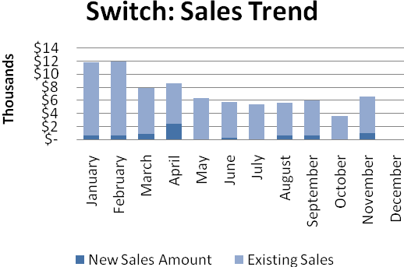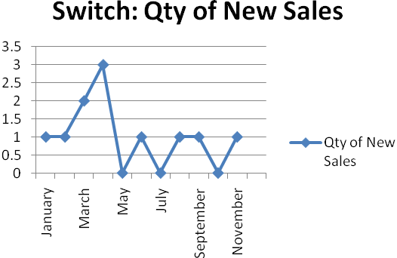

Dialer Report Summary-2014
Month | Qty of New Sales | New Sales Amount | Existing Sales | Net Cashflow | Due Realized | Current Due
January | 15 | $ 5,900 | $ 31,350 | 95.50% | $ 1,473 | $ 1,679
February | 3 | $ 450 | $ 28,710 | 96.30% | $ 3,196 | $ 1,083
March | 7 | $ 3,150 | $ 38,650 | 98.40% | $ 761 | $ 658
April | 17 | $ 5,800 | $ 37,650 | 93.00% | $ 1,493 | $ 3,047
May | 6 | $ 1,200 | $ 41,050 | 91.88% | $ 4,997 | $ 3,429
June | 10 | $ 5,050 | $ 35,500 | 93.65% | $ 3,426 | $ 2,573
July | 8 | $ 4,550 | $ 35,674 | 93.36% | $ 1,728 | $ 2,672
August | 8 | $ 4,650 | $ 41,650 | 92.01% | $ 3,051 | $ 3,197
September | 12 | $ 4,750 | $ 38,550 | 91.08% | $ 2,225 | $ 3,864
October | 8 | $ 1,450 | $ 32,950 | 97.16% | $ 1,984 | $ 976
November | 10 | $ 3,600 | $ 31,750 | 95.14% | $ 705 | $ 1,719
December
Total |  | $ 40,550 | $ 393,484 |  | $ 25,039 | $ 24,897
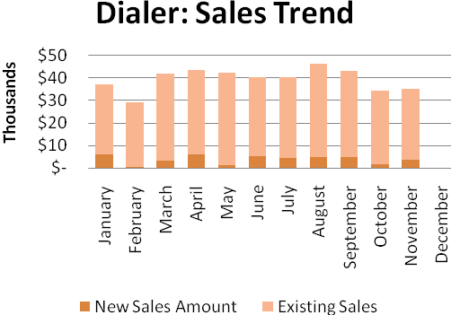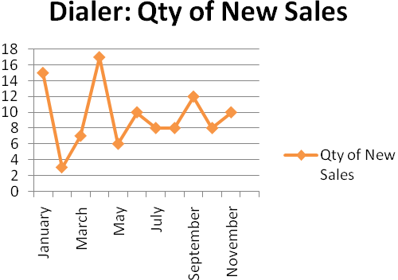
gPlex Lite Report Summary-2014
Month | Qty of New Sales | New Sales Amount | Existing Sales | Net Cashflow | Due Realized | Current Due
January | 0 | $ - | $ - | 0.00% | $ - | $ -
February | 0 | $ - | $ - | 0.00% | $ - | $ -
March | 0 | $ - | $ - | 0.00% | $ - | $ -
April | 0 | $ - | $ - | 0.00% | $ - | $ -
May | 0 | $ - | $ - | 0.00% | $ - | $ -
June | 0 | $ - | $ - | 0.00% | $ - | $ -
July | 0 | $ - | $ - | 0.00% | $ - | $ -
August | 0 | $ - | $ - | 0.00% | $ - | $ -
September | 0 | $ - | $ - | 0.00% | $ - | $ -
October | 23 | $ 19,800 | $ - | 59.15% | $ - | $ 8,089
November | 32 | $ 30,028 | $ 400 | 64.50% | $ 1,481 | $ 10,802
December
Total |  | $ 49,828 | $ 400 |  | $ 1,481 | $ 18,891

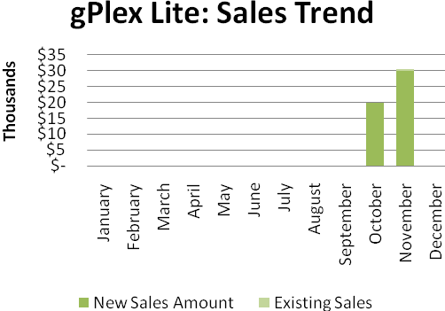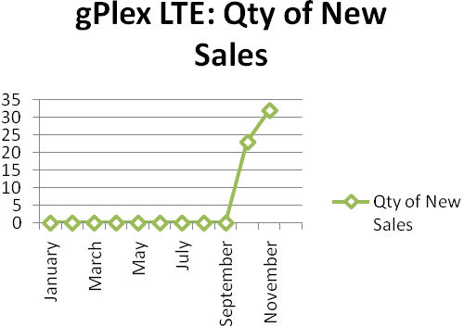
e. Department : Software
Head of the department : Md. Anwarul Karim

Current work status: gTalk & Switch works are going on.
Update of employee migration: Mr. Masud will be leaving Dhaka office soon to join USA office.
Recruitment: HR department has been informed about the need of new recruitment and the ad has already been published online.
CEO in this issue: CEO discussed the current work status of Software Department in detail. He also shared that the iPhone work we have done is being launched already.

f. Department : International Voice Carrier
Manager : Md. Aminul Islam
Monthly traffic and client report for the month of November 2014

Coverage area:
01. Total Traffic
02. Voice Wholesale Traffic
03. gTalk Total Traffic
04. gTalkNA
05. gTalkUK
06. gTalk® Home

01. Total Traffic

01 (a). Total traffic by Months, Year 2013-2014
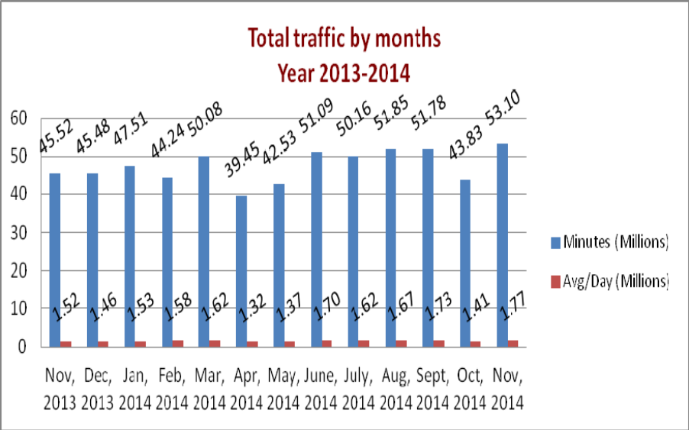

01(b). Total traffic by Months, Year 2013-2014 (According to 30 days)
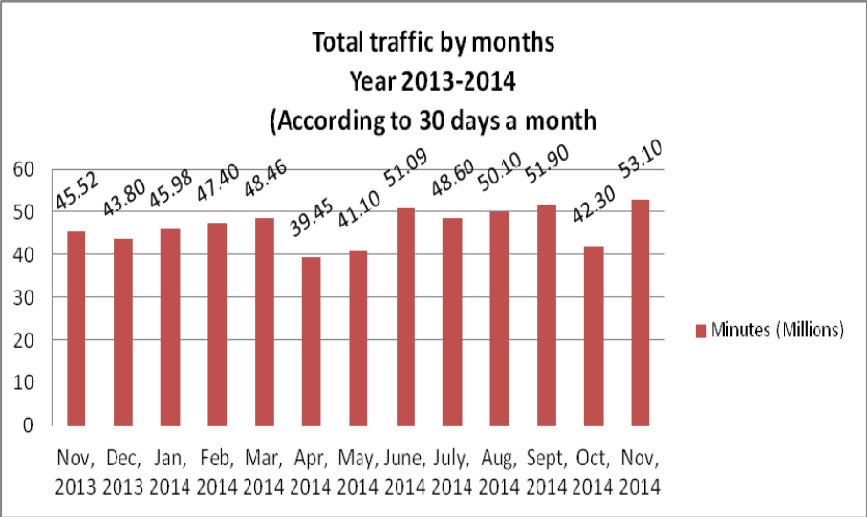

02. Total Voice Wholesale Traffic
02(a). Voice Wholesale: Total Traffic by months. Year 2013-2014

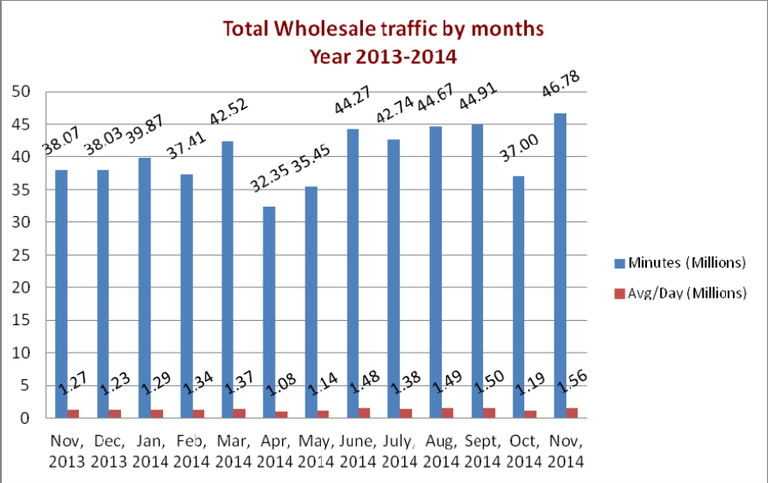

02(b). Voice Wholesale: Total Traffic by months. Year 2013-2014 (According to 30 days)

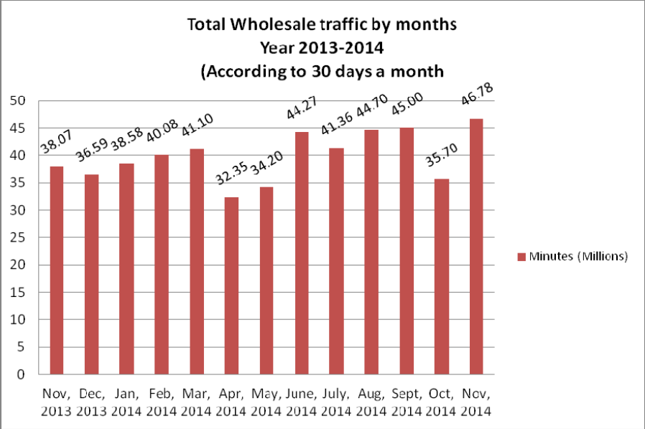

03. gTalk Total Traffic
03(a). gTalk : Total Traffic by months. Year 2013-2014

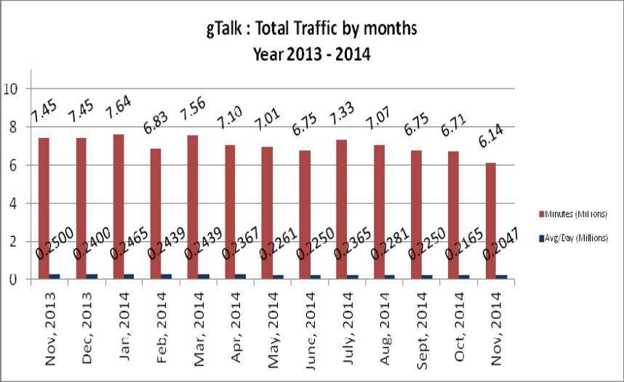

03(b). gTalk : Total Traffic by months (According to 30 days)

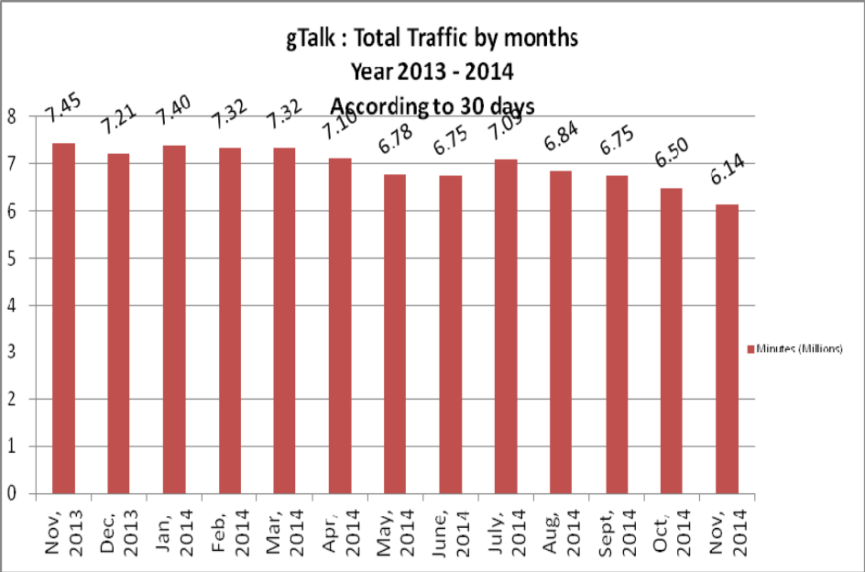

04. gTalk NA
04(a). gTalk NA : Total Traffic by months. Year 2013-2014

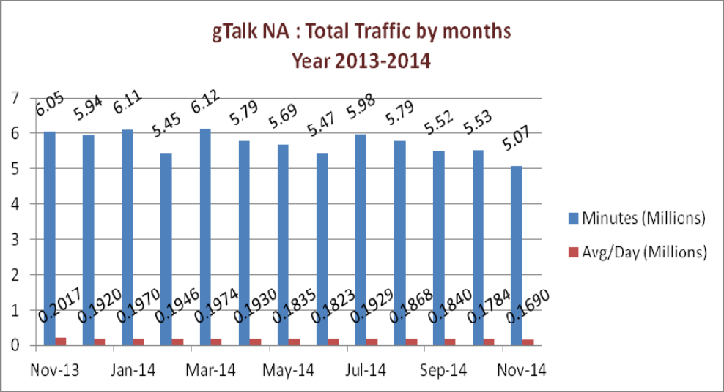

04(b). gTalk NA : Total Traffic by months. Year 2013-2014 (According to 30 days)

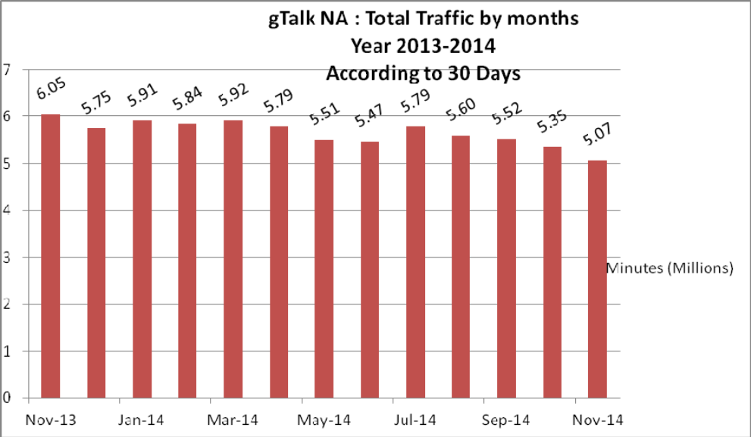

04(c). gTalk NA : New clients by months for the year 2013-2014

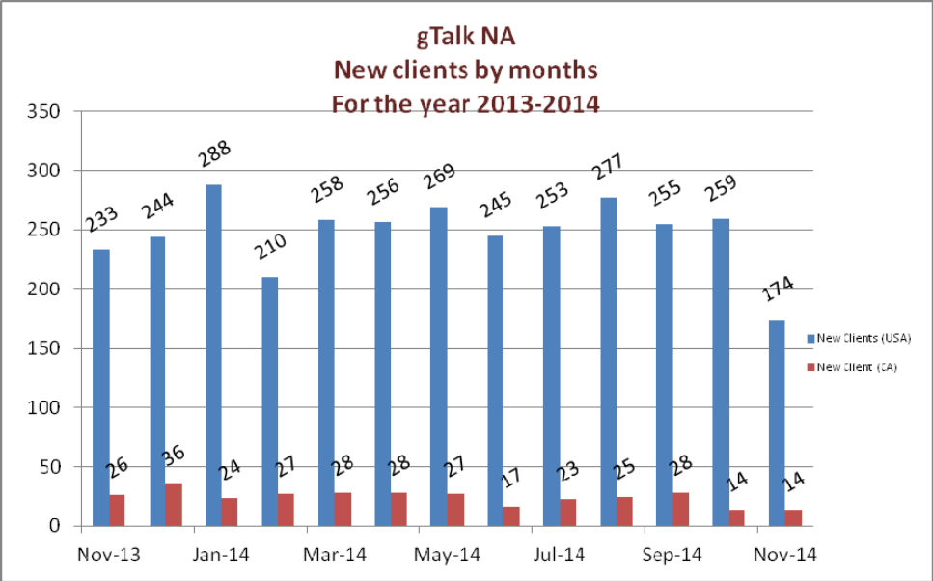

05. gTalk UK
05(a). gTalk UK : Total Traffic by months for the year 2013-2014

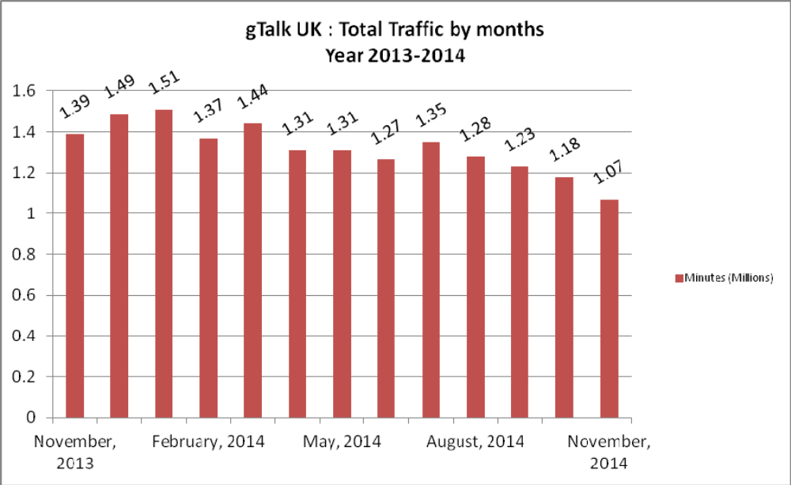

05(b). gTalk UK : Total Traffic by months for the year 2013-2014 (According to 30 Days)

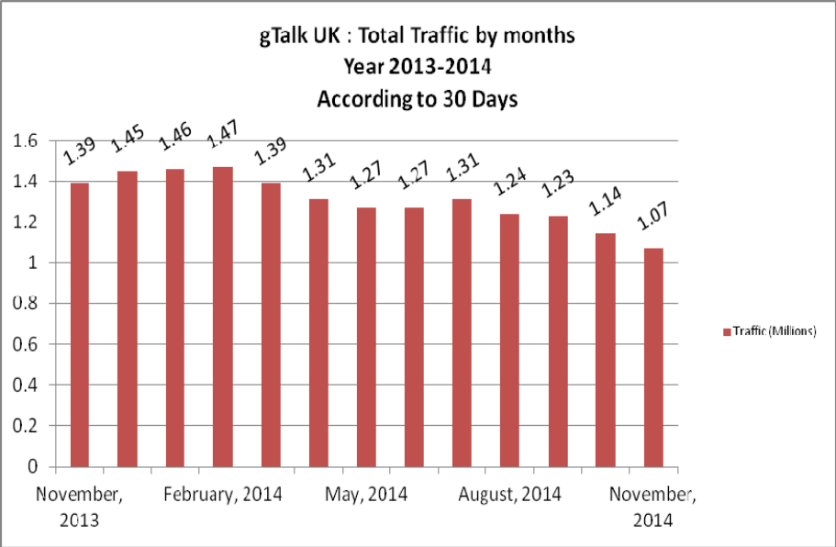

05(c). gTalk UK : New clients by months for the year 2013-2014
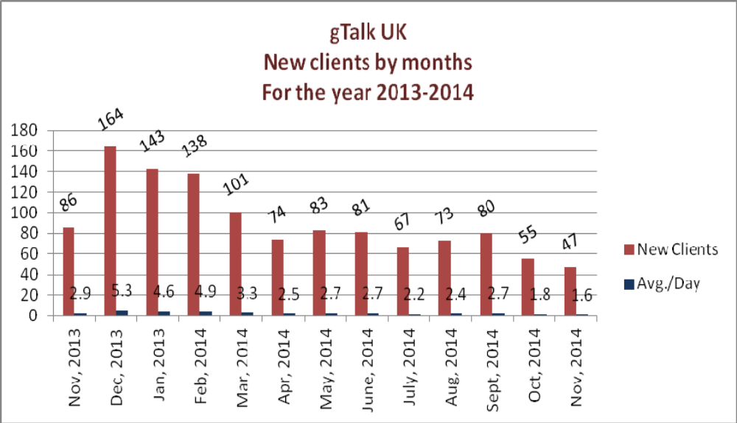

06. gTalk Home
06(a). gTalk® Home : Total Traffic by months for the year 2014

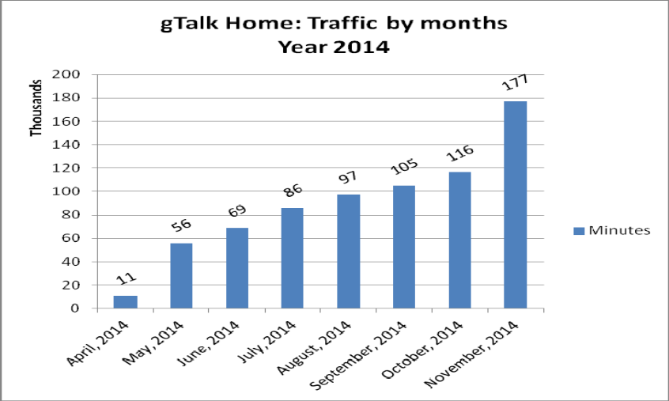

06(b). gTalk® Home : New clients by months for the year 2014
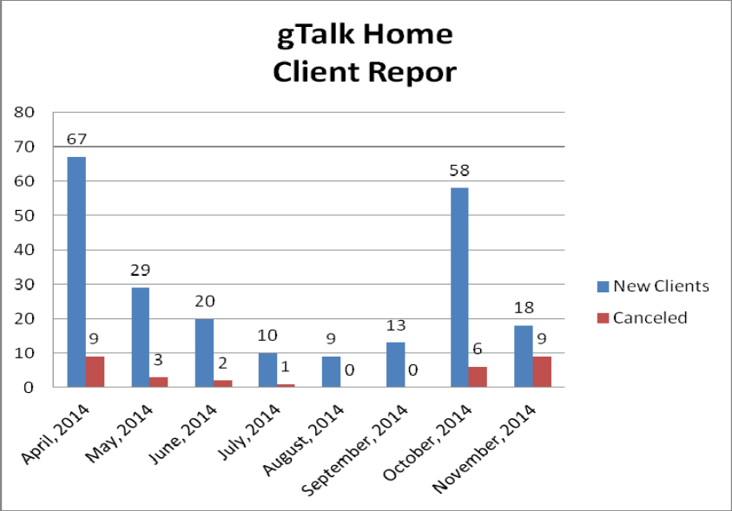

g. Department : HR & Admin
DGM : Md. Habibur Rahman
Calender: By 20th December, the calendar will be ready to be distributed, managers are requested to prepare themselves.
Job Ad: The job ad for PHP & C/C++ has already been published and the sorting work is going on.
BASIS Fair: We already paid the booking amount in full. Now we will visit their office for layout checking and pavilion selection right after they invite us.
TVC for gTalk: The unlimited package advertisement work of gTalk is going on, we will be able to see the first version on 14th December. President acknowledged & praised him stating that despite being taking care of HR & Admin; he has good concept & front line knowledge on our Flagship products for show casing in local & overseas trade Expos. He also pointed that gTalk's TVC works are getting done in very much creative way under his supervision, which, many of us may not have noticed regular basis so far.
Picnic 2015: Venue visit and venue booking is done. Picnic committee is already made. Work is going on at free time of the staffs.
Picnic of Genusys USA: In USA, a picnic will be held for staffs of Genusys USA.

At the end, CEO showed appreciation to everyone for their presence and thoughtful insights about the company. He concluded the meeting by thanking to all.

