Reference: GSL/ Admin/ MCM 67

Attendance
67th Monthly Coordination Meeting
Date: 7th January 2015
Venue: GSL Conference Room

Time: 09.00 AM

The sixty seventh monthly coordination meeting of Genuity Systems Ltd. (GSL) was held on 7th January 2015 at Genuity Conference Room 1. Management team and the managers of different departments of the company were present. List of participants of the meeting are as follows:
SL. | Name of Participants | Department | Signature
1. | Habib Rahman | President | Present
2. | M. Anis Rahman | Chief Executive Officer | Present
3. | Md. Sadiqur Rahman | Director Operations | Present
4. | K. Shahadat Hossain | Director Marketing | Present
5. | Md. Anwarul Karim | Executive Director | Present
6. | Md. Habibur Rahman | Admin & HR | Present
7. | Md. Waliul Haque Tusar | System Admin | Present
8. | Md. Aminul Islam | Head of International Voice Carrier | Present
9. | Sk. Kamruzzaman Prince | Corporate Affairs | Present
10. | Lutful Kabir Majumder | Call Center | Present
11. | Md. Ashrafuzzaman | Accounts | Present
12. | Md. Abdullah Al Masum | Training | Present
13. | Abu Taher | Overseas | Present

The meeting was started by the Manager, Admin & HR. He thanked everyone for participating in the meeting and invited CEO to take control of the meeting. The CEO warmly welcomed everyone present in the meeting and thanked them for their presence. Thereafter he requested all departmental managers to deliver respective speech, one at a time, highlighting departmental performance and issues during the last month. He invited all to raise queries/questions and share their opinion in the discussion as deemed fit. The main points raised and discussed in the meeting over different issues are recorded below:

a. Department : Corporate
DGM : Sk. Kamruzzaman Prince

Sales report of gPlex Call Center Solution:
Sales and Cash realization according to client will be reflected though the below given chart:
Sale and Cash realization in 2014
Sl. No. | Client Name | Total received WO | Invoice to Client for SLA & Rent |  |  |  | Cash received/realization |  | Remarks
1 | ONE Bank | 6,636,240.00
2 | Southeast Bank | 1,800,000.00
3 | Bank Asia (Rent) |  | 1,140,000.00 |  |  |  | 1,269,986.00
4 | City Bank (SLA) |  | 540,092.50 |  |  |  | 385,405.00
5 | SCB Collection (Rent) |  | 1,207,500.00 |  |  |  | 1,207,500.00
6 | LankaBangla |  |  |  |  |  | 941,782.00 |  | Realization
7 | RanksTel |  |  |  |  |  | 200,000.00 |  | Realization
8 | SCB (SLA) |  | 400,000.00 |  |  |  | 400,000.00
9 | RanksTel AMC till 2014 |  | 360,000.00
10 | Q cash AMC |  | 98,090.00 |  |  |  | 102,504.00 |  | 6 months of 2014
 |  | 8,436,240.00 | 3,745,682.50 |  |  |  | 4,507,177.00
 |  | Grand Total sale : |  |  | 12,181,922.50
 |  | Total account's collection : |  |  | 4,507,177.00
 |  | Sale as per accounts statement up to Nov 2014: |  |  | 13,343,365.00
 | 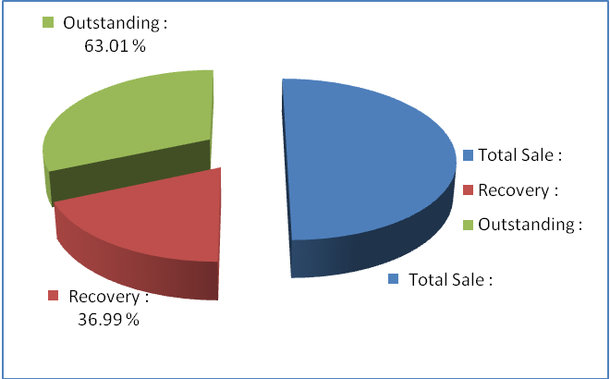
Sale and Cash realization in 2015
Sl. No. | Client Name | Total received WO |  | Invoice to Client for SLA & Rent |  |  |  | Cash received/realization |  | Remarks
1 | ONE Bank |  |  |  |  |  |  | 2,236,787.00 |  | Received on Jan 7, 2015
2 | City Bank (AMC) |  |  |  |  |  |  | 42,832.00
 |  |  |  | - |  |  |  | 2,279,619.00
Submitted Invoices and payment under process
Sl. No. | Client | Description |  |  |  | Amount
1 | RanksTel | Jan-Dec'2012 with due |  |  |  | 170,000.00
2 | Shah cement | Final invoice |  |  |  | 240,000.00
3 | City Bank | Telebanking_Email Module |  |  |  | 1,700,000.00
3 | City Bank | Synthesized_voice (part) |  |  |  | 220,000.00
3 | City Bank | Sep-Nov, 2014: PO 18 lac |  |  |  | 40,500.00
3 | City Bank | Aug-Oct, 2014: PO 9.75 lac |  |  |  | 21,937.50
3 | City Bank | Sep-Nov, 2014: PO 21 lac |  |  |  | 47,250.00
4 | RanksTel | AMC till 2014 |  |  |  | 360,000.00
 |  |  |  |  |  | 2,799,687.50
Work order payment: Today a payment of a work order of One Bank is going to be collected. Already sent the executive to collect the payment.
Presentation: A presentation will be held at Standard Bank tomorrow.

b. Department : Training
AGM & In-Charge : Mohammad Abdullah Al Masum

Current Status: Currently training department is running training for forteen batches. Among these, five batches (21 NT, 22 NT, 21 WPSI, 23 WPSI) are being run for IDB. The other 10 batches are covering different customized courses.
Revenue: Total collection on account of training during December 2014 was 8.15 lacs. The
total amount of revenue in December 2014 activities was Tk 8.67 lacs.

c. Department : Call Center (gTalk)
AGM : Md. Lutful Kabir Majumder

Current status of client joining and usage in gTalk pinless:

# Total client joined in gTalk till 31 December 2014: 58712

# Average client increase per day in December, 14: 10
# Average client increase per day in November, 14: 8
# Average client increase per day in October, 14: 11
# Average client increase per day in September, 14: 12
# Average client increase per day in August, 14: 12
# Average client increase per day in July, 14: 11
# Average client increase per day in June, 14: 12
# Average client increase per day in May, 14: 12
# Average client increase per day in April, 14: 12
# Average client increase per day in March, 14: 13
# Average client increase per day in February, 14: 14
# Average client increase per day in January, 14: 15
# Average client increase per day in December, 13: 14
# Average client increase per day in November, 13: 12

# Average total Minutes per day in December, 14: 204.23 K
# Average total Minutes per day in November, 14: 204.71 K
# Average total Minutes per day in October, 14: 216.46 K
# Average total Minutes per day in September, 14: 225.07 K
# Average total Minutes per day in August, 14: 228.18 K
# Average total Minutes per day in July, 14: 236.50 K
# Average total Minutes per day in June, 14: 224.90 K
# Average total Minutes per day in May, 14: 226.21 K
# Average total Minutes per day in April, 14: 236.75 K
# Average total Minutes per day in March, 14: 243.74 K
# Average total Minutes per day in February, 14: 243.94 K
# Average total Minutes per day in January, 14: 246.31 K
# Average total Minutes per day in December, 13: 240.35 K
# Average total Minutes per day in November, 13: 248.22 K

# Total customer used gTalk service in December, 14 about 20,506
# Total customer used gTalk service in November, 14 about 20,795
# Total customer used gTalk service in October, 14 about 21,371
# Total customer used gTalk service in September, 14 about 21,466
# Total customer used gTalk service in August, 14 about 21,026
# Total customer used gTalk service in July, 14 about 21,814
# Total customer used gTalk service in June, 14 about 21,224
# Total customer used gTalk service in May, 14 about 21,663
# Total customer used gTalk service in April, 14 about 21,533
# Total customer used gTalk service in March, 14 about 21,920
# Total customer used gTalk service in February, 14 about 21,587
# Total customer used gTalk service in January, 14 about 22,441
# Total customer used gTalk service in December, 13 about 21,840
# Total customer used gTalk service in November, 13 about 21,941

Unused Initial Balance for the month of December 2014: In the month of December, it has been found that total 51 customers have not used their Account Initial Balance after opening the account.

Current status after calling those customers is as follows:

- Customer using: 33 (65%)
- Customer still not using: 18 (35%)

Survey in December 2014: In the month of December, a total of 827 customers who are inactive for at least 2 months have been called. Details about customer’s feedback are given below:

- Ethnic Group:
  - Bangladesh – 651 (79%)
  - India – 69 (8%)
  - Zimbabwe – 22 (3%)
  - Pakistan – 8 (1%)
  - Miscellaneous- 81 (9%)

- Message left to the customers who were unavailable: 296 (36%)
- Number not in service: 301 (36%)
- Using other calling services or doesn’t make international calls: 156 (19%)
- Interested to use again: 74 (9%)
Among 74 customers, 19 people have started to use gTalk service again after this survey.

Hot number uses:

December, 14: 36.39%
November, 14: 36.00%
October, 14: 35.34%
September, 14: 35.53%
August, 14: 35.00%
July, 14: 35.56%
June, 14: 35.96%
May, 14: 35.35%
April, 14: 34.87%
March, 14: 34.89%
February, 14: 34.72%
January, 14: 34.46%
December, 13: 34.61%
November, 13: 35.31%

Hot Dialer Report
Total User(s): 11060

VoIP Dialer Report
Total User(s): 1258

Total SMS from December 1 to December 31, 14: 2141 and Failed SMS: 125

# Total client joined in gTalk UK till 31 December 2014: 7181

# Total client joined in December 2014: 60
# Total client joined in November 2014: 47
# Total client joined in October 2014: 55
# Total client joined in September 2014: 80
# Total client joined in August 2014: 73
# Total client joined in July 2014: 67
# Total client joined in June 2014: 81
# Total client joined in May 2014: 83
# Total client joined in April 2014: 74
# Total client joined in March 2014: 101
# Total client joined in February 2014: 138
# Total client joined in January 2014: 143
# Total client joined in December 2013: 164
# Total client joined in November 2013: 86
# Total client joined in October 2013: 130

# Total Minutes for the month of December, 14: 1090.40 K
# Total Minutes for the month of November, 14: 1074.15 K
# Total Minutes for the month of October, 14: 1177.35 K
# Total Minutes for the month of September, 14: 1232.07 K
# Total Minutes for the month of August, 14: 1281.62 K
# Total Minutes for the month of July, 14: 1345.22 K
# Total Minutes for the month of June, 14: 1265.87 K
# Total Minutes for the month of May, 14: 1309.94 K
# Total Minutes for the month of April, 14: 1313.78 K
# Total Minutes for the month of March, 14: 1436.08 K
# Total Minutes for the month of February, 14: 1366.20 K
# Total Minutes for the month of January, 14: 1510.21 K
# Total Minutes for the month of December, 13: 1493.18 K
# Total Minutes for the month of November, 13: 1387.18 K
# Total Minutes for the month of October, 13: 1589.23 K

New Apps for hot-dialer: To make the customers aware about the new apps for hot-dialer and to encourage them to use it, we can make call to them from our call center. Once this comes into effect, the global apps will not be needed.

d. Department : gPlex Software Solutions
AGM : Md. Lutful Kabir Majumder
gPlex Switch and Dialer Sales Report
December 2014
 |  | Mobile Dialer |  | Soft Switch |  | Total
 |  | Amount | % | Amount | % | Amount | %
Total Billed |  | $58,200.00 | 100.00% | $4,167.00 | 100.00% | $62,367 | 100.00%
Received for Current Bills |  | $49,834.00 | 85.63% | $2,544.00 | 61.05% | $52,378 | 83.98%
Advance Expired |  | $8.00 | 0.01% | $0.00 | 0.00% | $8 | 0.01%
Current Due |  | $8,358.00 | 14.36% | $1,023.00 | 24.55% | $9,381 | 15.04%
Written Off |  | $0.00 | 0.00% | $600.00 | 14.40% | $600 | 0.96%
Total Received |  | $59,023.00 | 100.00% | $3,121.00 | 100.00% | $62,144 | 100.00%
Received for Current Bills |  | $49,834.00 | 84.43% | $2,544.00 | 81.51% | $52,378 | 84.28%
Received for Last Month's Dues |  | $6,304.00 | 10.68% | $572.00 | 18.33% | $6,876 | 11.06%
Received for Older Dues |  | $2,756.00 | 4.67% | $1.00 | 0.03% | $2,757 | 4.44%
Advance Received |  | $129.00 | 0.22% | $4.00 | 0.13% | $133 | 0.21%
Qty of New Sales |  | 35 | 23.49% | 0 | 0.00%
Qty of Existing Sales |  | 114 | 76.51% | 14 | 100.00%
Total |  | 149 | 100.00% | 14 | 100.00%

 |  | Mobile Dialer Report
 |  | December 2014
 |  | December 2014
 |  | New Client | Existing Client | Total | %
Bills & Receipts
Total Billed |  | $ 3,450 | $ 31,850 | $ 35,300 | 100.00%
Received for Current Bills |  | $ 3,441 | $ 29,499 | $ 32,940 | 93.31%
Advance Expired |  | $ - | $ 8 | $ 8 | 0.02%
Current Due |  | $ 9 | $ 2,343 | $ 2,352 | 6.66%
Quantity of Sales |  | 9 | 99 | $ 108
Cash Analysis
Total Received |  | $ 3,441 | $ 30,976 | $ 34,417 | 100.00%
Received for Current Bills |  | $ 3,441 | $ 29,499 | $ 32,940 | 95.71%
Received for Last Month's Dues |  | $ - | $ 397 | $ 397 | 1.15%
Received for Older Dues |  | $ - | $ 954 | $ 954 | 2.77%
Advance Received |  | $ - | $ 126 | $ 126 | 0.37%
Net Cashflow |  |  |  |  | 93.34%
Accounts Receivable Statement |  |  |  | December 2014
Accounts Receivable B/F |  |  |  | $ 84,218
Current Due |  |  |  | $ 2,352
Received for Last Month's Dues |  |  | $ 397
Received for Older Dues |  |  | $ 954 | $ 1,351
Discount Allowed |  |  |  | $ -
Written Off (Bad Debt/ Credit Notes) |  |  |  | $ -
Accounts Receivable C/F |  |  |  | $ 85,219
Last Month's Dues |  |  |  | $ 1,719
Received for Last Month's Dues |  |  |  | $ 397
Remaining Last Month's Dues as of Current Month |  |  |  | $ 1,322

 |  | gPlex SoftSwitch Report
 |  | December 2014
 |  | December 2014
 |  | New Client | Existing Client | Total | %
Bills & Receipts
Total Billed |  | $ - | $ 4,167 | $ 4,167 | 100.00%
Received for Current Bills |  | $ - | $ 2,544 | $ 2,544 | 61.05%
Advance Expired |  | $ - | $ - | $ - | 0.00%
Written Off- Current |  | $ - | $ 600 | $ 600 | 14.40%
Current Due |  | $ - | $ 1,023 | $ 1,023 | 24.55%
Quantity of Sales |  | - | 14 | $ 14
Cash Analysis
Total Received |  | $ - | $ 3,121 | $ 3,121 | 100.00%
Received for Current Bills |  | $ - | $ 2,544 | $ 2,544 | 81.51%
Received for Last Month's Dues |  | $ - | $ 572 | $ 572 | 18.33%
Received for Older Dues |  | $ - | $ 1 | $ 1 | 0.03%
Advance Received |  | $ - | $ 4 | $ 4 | 0.13%
Net Cashflow |  |  |  |  | 61.05%
Accounts Receivable Statement |  |  |  | December 2014
Accounts Receivable B/F |  |  |  | $ 71,283
Current Due |  |  |  | $ 1,023
Received for Last Month's Dues |  |  | $ 572
Received for Older Dues |  |  | $ 1 | $ 573
Discount Allowed
Written Off- Last Month |  |  |  | $ 600
Written Off-Older |  |  |  | $ 600
Accounts Receivable C/F |  |  |  | $ 71,133
Last Month's Dues |  |  |  | $ 1,457
Received for Last Month's Dues |  |  |  | $ 572
Remaining Last Month's Dues as of This Month |  |  |  | $ 885

 | gPlex Lite Report
 | December 2014
 | December 2014
 | New Client | Existing Client | Total | %
Bills & Receipts
Total Billed | $ 21,100 | $ 1,800 | $ 22,900 | 100.00%
Received for Current Bills | $ 15,594 | $ 1,300 | $ 16,894 | 73.77%
Advance Expired | $ - | $ - | $ - | 0.00%
Current Due | $ 5,506 | $ 500 | $ 6,006 | 26.23%
Quantity of Sales | 26 | 15 | $ 41
Cash Analysis
Total Received | $ 15,597 | $ 9,009 | $ 24,606 | 100.00%
Received for Current Bills | $ 15,594 | $ 1,300 | $ 16,894 | 68.66%
Received for Last Month's Dues | $ - | $ 5,907 | $ 5,907 | 24.01%
Received for Older Dues | $ - | $ 1,802 | $ 1,802 | 7.32%
Advance Received | $ 3 | $ - | $ 3 | 0.01%
Net Cashflow |  |  |  | 73.77%
Accounts Receivable Statement |  |  | December 2014
Accounts Receivable B/F |  |  | $ 17,410
Current Due |  |  | $ 6,006
Received for Last Month's Dues |  | $ 5,907
Received for Older Dues |  | $ 1,802 | $ 7,709
Discount Allowed |  |  | $ -
Written Off (Bad Debt/ Credit Notes) |  |  | $ -
Accounts Receivable C/F |  |  | $ 15,707
Last Month's Dues |  |  | $ 10,802
Received for Last Month's Dues |  |  | $ 5,907
Remaining Last Month's Dues as of Current Month |  |  | $ 4,895

Switch Report Summary-2014
Month | Qty of New Sales | New Sales Amount | Existing Sales | Net Cashflow | Due Realized | Current Due
January | 1 | $ 600 | $ 11,300 | 50.80% | $ 2,748 | $ 5,853
February | 1 | $ 600 | $ 11,350 | 45.70% | $ 3,626 | $ 5,337
March | 2 | $ 850 | $ 7,050 | 67.80% | $ 2,542 | $ 2,300
April | 3 | $ 2,400 | $ 6,250 | 85.50% | $ 1,703 | $ 1,258
May | 0 | $ - | $ 6,350 | 66.87% | $ 1,874 | $ 2,104
June | 1 | $ 200 | $ 5,500 | 60.40% | $ 1,640 | $ 2,135
July | 0 | $ - | $ 5,328 | 63.66% | $ 2,458 | $ 1,936
August | 1 | $ 600 | $ 5,078 | 75.50% | $ 1,617 | $ 1,304
September | 1 | $ 600 | $ 5,378 | 59.65% | $ 1,255 | $ 2,170
October | 0 | $ - | $ 3,550 | 59.15% | $ 1,091 | $ 560
November | 1 | $ 1,000 | $ 5,550 | 56.38% | $ 502 | $ 1,457
December | 0 | $ - | $ 4,167 | 61.05% | $ 573 | $ 1,023
Total | 11 | $ 6,850 | $ 76,851 |  | $ 21,629 | $ 27,437

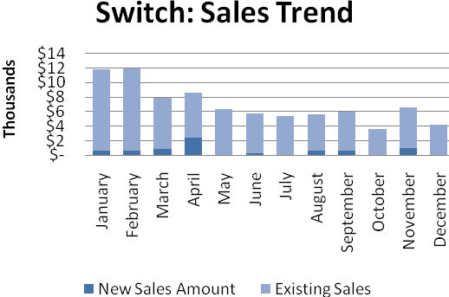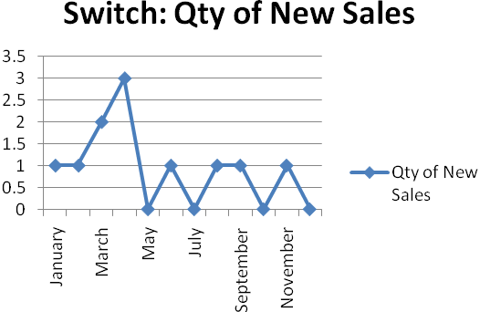

Dialer Report Summary-2014
Month | Qty of New Sales | New Sales Amount | Existing Sales | Net Cashflow | Due Realized | Current Due
January | 15 | $ 5,900 | $ 31,350 | 95.50% | $ 1,473 | $ 1,679
February | 3 | $ 450 | $ 28,710 | 96.30% | $ 3,196 | $ 1,083
March | 7 | $ 3,150 | $ 38,650 | 98.40% | $ 761 | $ 658
April | 17 | $ 5,800 | $ 37,650 | 93.00% | $ 1,493 | $ 3,047
May | 6 | $ 1,200 | $ 41,050 | 91.88% | $ 4,997 | $ 3,429
June | 10 | $ 5,050 | $ 35,500 | 93.65% | $ 3,426 | $ 2,573
July | 8 | $ 4,550 | $ 35,674 | 93.36% | $ 1,728 | $ 2,672
August | 8 | $ 4,650 | $ 41,650 | 92.01% | $ 3,051 | $ 3,197
September | 12 | $ 4,750 | $ 38,550 | 91.08% | $ 2,225 | $ 3,864
October | 8 | $ 1,450 | $ 32,950 | 97.16% | $ 1,984 | $ 976
November | 10 | $ 3,600 | $ 31,750 | 95.14% | $ 705 | $ 1,719
December | 9 | $ 3,450 | $ 31,850 | 93.34% | $ 1,351 | $ 2,352
Total |  | $ 44,000 | $ 425,334 |  | $ 26,390 | $ 27,249

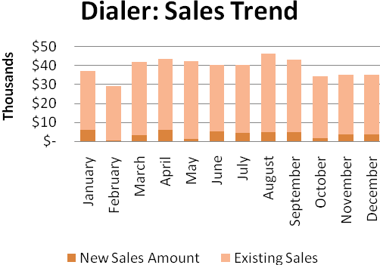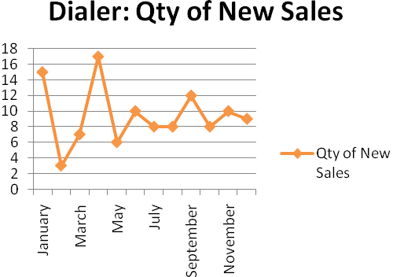
gPlex Lite Report Summary-2014
Month | Qty of New Sales | New Sales Amount | Existing Sales | Net Cashflow | Due Realized | Current Due
January | 0 | $ - | $ - | 0.00% | $ - | $ -
February | 0 | $ - | $ - | 0.00% | $ - | $ -
March | 0 | $ - | $ - | 0.00% | $ - | $ -
April | 0 | $ - | $ - | 0.00% | $ - | $ -
May | 0 | $ - | $ - | 0.00% | $ - | $ -
June | 0 | $ - | $ - | 0.00% | $ - | $ -
July | 0 | $ - | $ - | 0.00% | $ - | $ -
August | 0 | $ - | $ - | 0.00% | $ - | $ -
September | 0 | $ - | $ - | 0.00% | $ - | $ -
October | 23 | $ 19,800 | $ - | 59.15% | $ - | $ 8,089
November | 32 | $ 30,028 | $ 400 | 64.50% | $ 1,481 | $ 10,802
December | 26 | $ 21,100 | $ 1,800 | 74.27% | $ 7,709 | $ 5,506
Total |  | $ 70,928 | $ 2,200 |  | $ 9,190 | $ 24,397

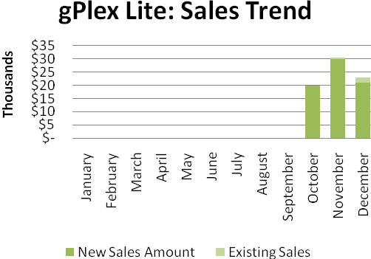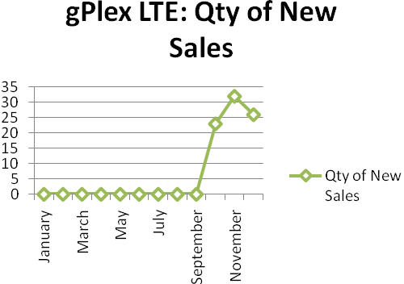
e. Department : Software
Head of the department : Md. Anwarul Karim

Current work status: All the work in progress at Software department was presented in the meeting.

f. Department : International Voice Carrier
Manager : Md. Aminul Islam
Monthly traffic and client report for the month of December 2014

Coverage area:
01. Total Traffic
02. Voice Wholesale Traffic
03. gTalk Total Traffic
04. gTalkNA
05. gTalkUK
06. gTalk® Home

01. Total Traffic

01 (a). Total traffic by Months, Year 2013-2014
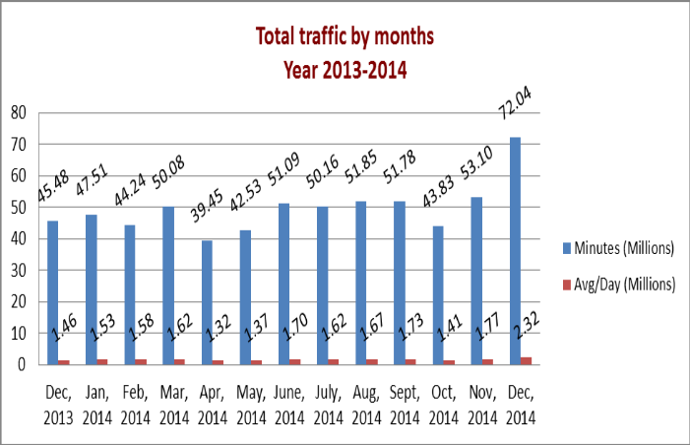
01(b). Total traffic by Months, Year 2013-2014 (According to 30 days)
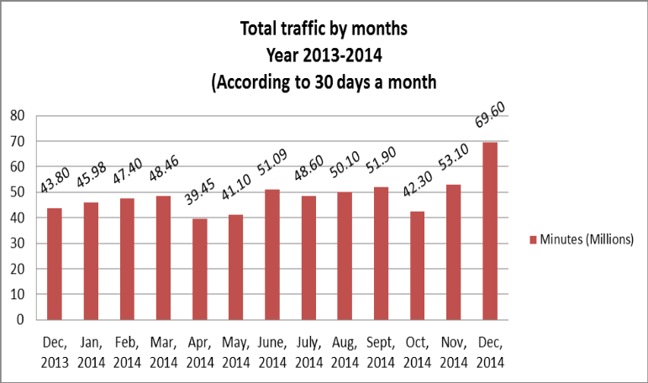

02. Total Voice Wholesale Traffic
02(a). Voice Wholesale: Total Traffic by months. Year 2013-2014

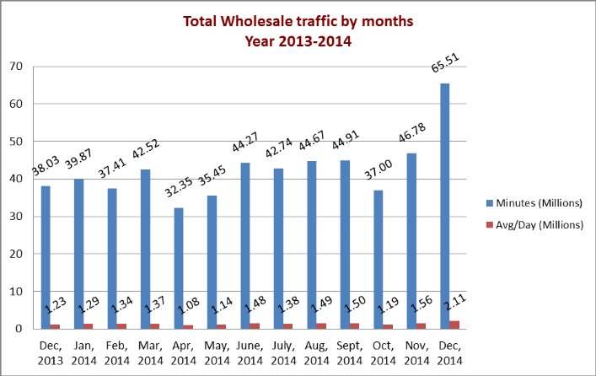
02(b). Voice Wholesale: Total Traffic by months. Year 2013-2014 (According to 30 days)

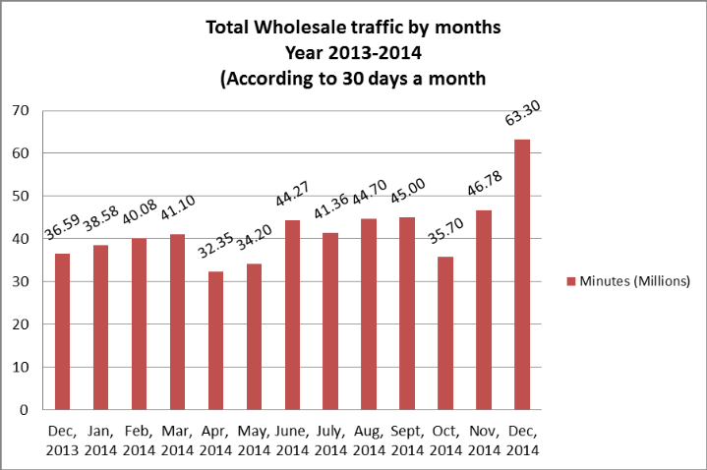

03. gTalk Total Traffic
03(a). gTalk : Total Traffic by months. Year 2013-2014

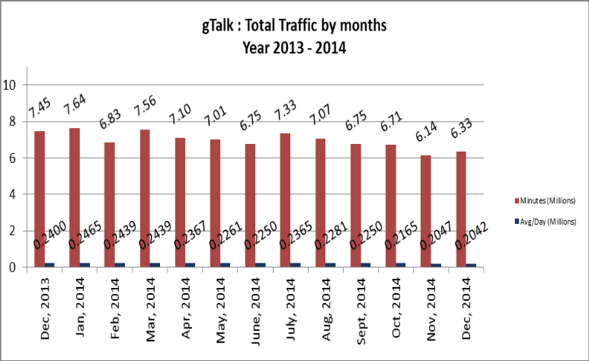

03(b). gTalk : Total Traffic by months (According to 30 days)

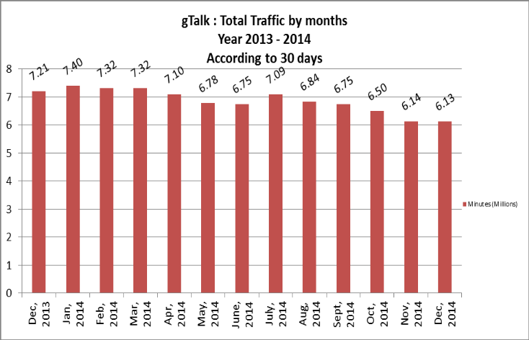
04. gTalk Pinless – Active Clients, Year 2014
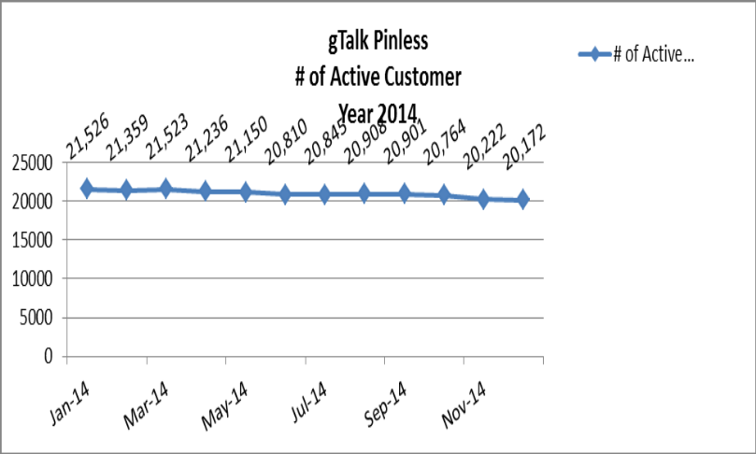

05. gTalk NA
05(a). gTalk NA : Total Traffic by months for the year 2013-2014

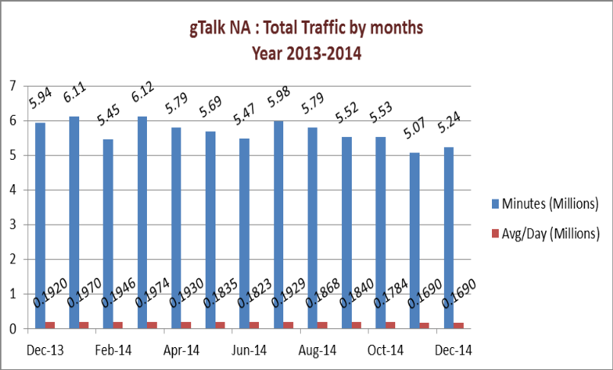

05(b). gTalk NA : Total Traffic by months for the year 2013-2014 (According to 30 Days)
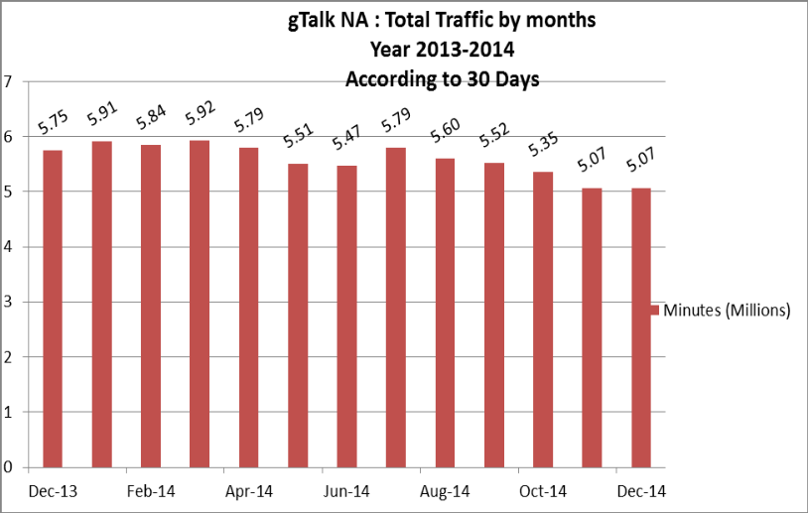
05(c). gTalk NA : New clients by months for the year 2013-2014
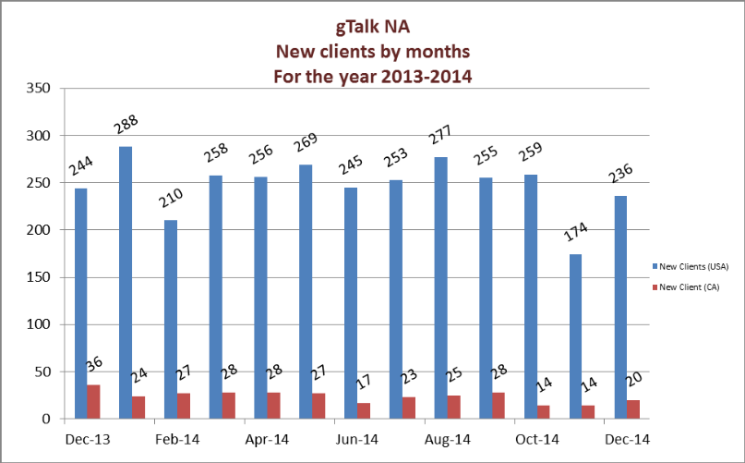
06. gTalk UK
06(a). gTalk UK : Total Traffic by months for the year 2013-2014

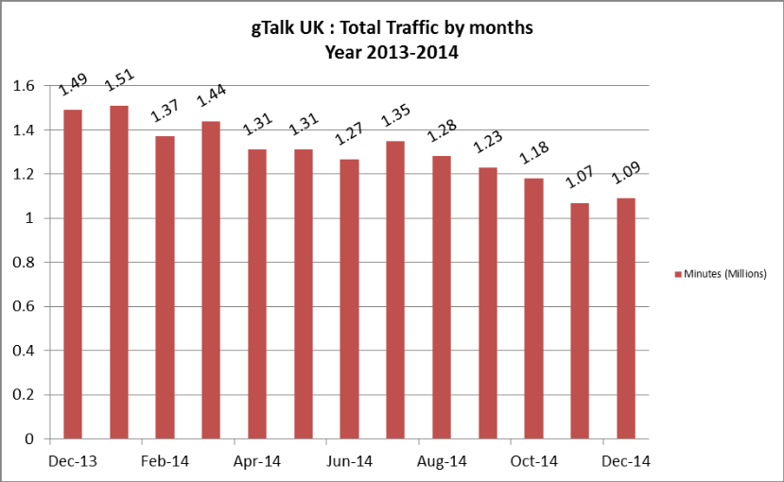

06(b). gTalk UK : Total Traffic by months for the year 2013-2014 (According to 30 Days)
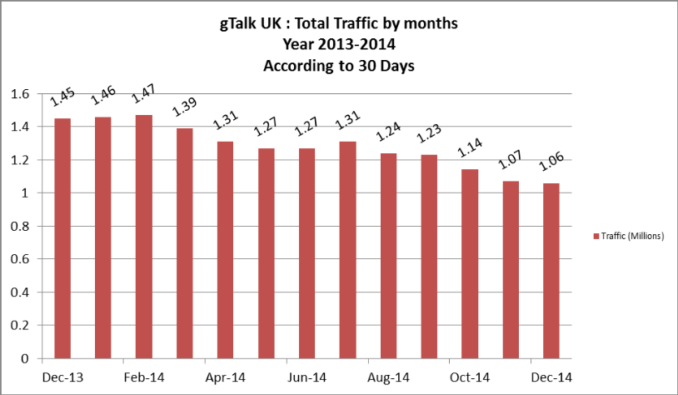
06(c). gTalk UK : New clients by months for the year 2013-2014
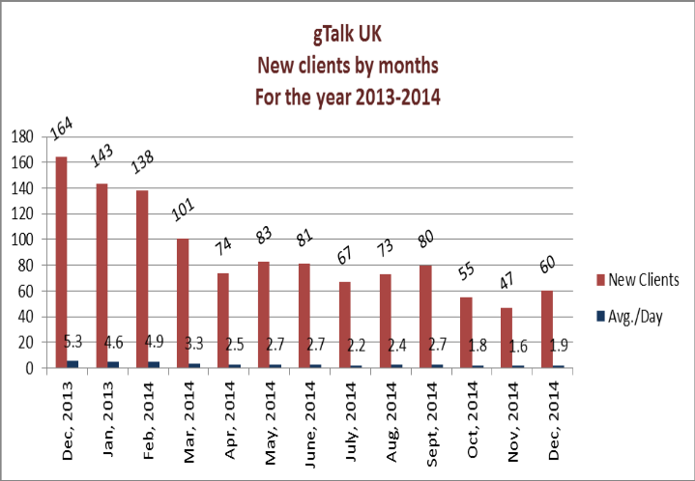
07. gTalk Home
07(a). gTalk® Home : Total Traffic by months for the year 2014

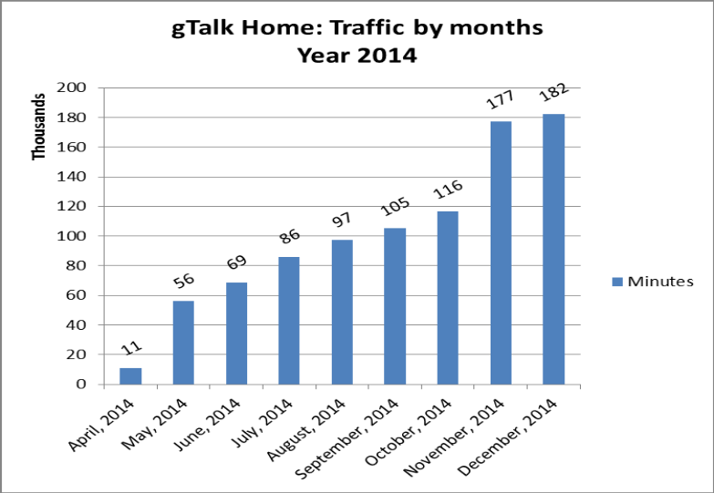
07(b). gTalk® Home : New clients by months for the year 2014
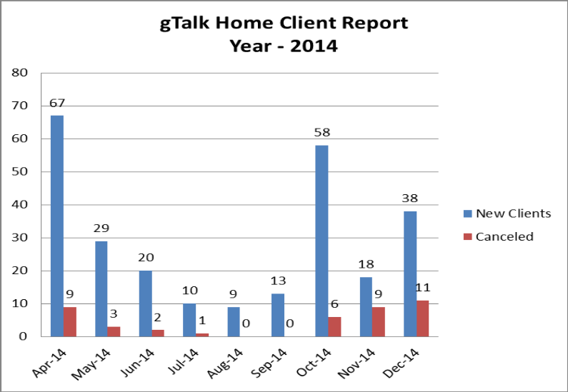

g. Department : Network Operations
DGM : Md. Waliul Haque Tusar
Resignation of employee: An employee has resigned from department, need to recruite new person soon.

h. Department : Accounts
AGM : Md. Ashrafuzzaman
Work update: Providing support through the Switch ticketing system.

i. Department : HR & Admin
DGM : Md. Habibur Rahman
EMS work: The update work of EMS is important. Mr. Salim of Software Department is working on it, but as the job needs to be done immediately so he needs to work on regular basis.
Digital World 2015: The Digital World 2015 is going to be held on 9th to 12th February 2015. Particular departments are informed about it and requested to take preparation accordingly.
Recruitment update: The new employee of PHP is going to join on 1st February 2015. We are done with the written exam of C/C++ and soon we will call for the interview.
Picnic preparation: All works related to annual picnic 2015 is done.
Ad update: There are some ad works in process.

At the end, CEO showed appreciation to everyone for their presence and thoughtful insights about the company. He concluded the meeting by thanking to all.

