Reference: GSL/ Admin/ MCM 68

Attendance
68th Monthly Coordination Meeting
Date: 5th February 2015
Venue: GSL Conference Room

Time: 09.00 AM

The sixty seventh monthly coordination meeting of Genuity Systems Ltd. (GSL) was held on 5th February 2015 at Genuity Conference Room 1. Management team and the managers of different departments of the company were present. List of participants of the meeting are as follows:
SL. | Name of Participants | Department | Signature
1. | Habib Rahman | President | Present
2. | M. Anis Rahman | Chief Executive Officer | Present
3. | Md. Sadiqur Rahman | Director Operations | Present
4. | K. Shahadat Hossain | Director Marketing | Present
5. | Md. Anwarul Karim | Executive Director | Present
6. | Md. Habibur Rahman | Admin & HR | Present
7. | Md. Waliul Haque Tusar | System Admin | Leave
8. | Md. Aminul Islam | Head of International Voice Carrier | Present
9. | Sk. Kamruzzaman Prince | Corporate Affairs | Leave
10. | Lutful Kabir Majumder | Call Center | Present
11. | Md. Ashrafuzzaman | Accounts | Present
12. | Md. Abdullah Al Masum | Training | Present

The meeting was started by the Manager, Admin & HR. He thanked everyone for participating in the meeting and invited CEO to take control of the meeting. The CEO warmly welcomed everyone present in the meeting and thanked them for their presence. Thereafter he requested all departmental managers to deliver respective speech, one at a time, highlighting departmental performance and issues during the last month. He invited all to raise queries/questions and share their opinion in the discussion as deemed fit. The main points raised and discussed in the meeting over different issues are recorded below:

a. Department : Call Center (gTalk)
AGM : Md. Lutful Kabir Majumder

Current status of client joining and usage in gTalk pinless:

# Total client joined in gTalk till 31 January 2015: 59056

# Average client increase per day in January, 15: 11
# Average client increase per day in December, 14: 10
# Average client increase per day in November, 14: 8
# Average client increase per day in October, 14: 11
# Average client increase per day in September, 14: 12
# Average client increase per day in August, 14: 12
# Average client increase per day in July, 14: 11
# Average client increase per day in June, 14: 12
# Average client increase per day in May, 14: 12
# Average client increase per day in April, 14: 12
# Average client increase per day in March, 14: 13
# Average client increase per day in February, 14: 14
# Average client increase per day in January, 14: 15
# Average client increase per day in December, 13: 14

# Average total Minutes per day in January, 15: 213.58 K
# Average total Minutes per day in December, 14: 204.23 K
# Average total Minutes per day in November, 14: 204.71 K
# Average total Minutes per day in October, 14: 216.46 K
# Average total Minutes per day in September, 14: 225.07 K
# Average total Minutes per day in August, 14: 228.18 K
# Average total Minutes per day in July, 14: 236.50 K
# Average total Minutes per day in June, 14: 224.90 K
# Average total Minutes per day in May, 14: 226.21 K
# Average total Minutes per day in April, 14: 236.75 K
# Average total Minutes per day in March, 14: 243.74 K
# Average total Minutes per day in February, 14: 243.94 K
# Average total Minutes per day in January, 14: 246.31 K
# Average total Minutes per day in December, 13: 240.35 K

# Total customer used gTalk service in January, 15 about 20,174
# Total customer used gTalk service in December, 14 about 20,506
# Total customer used gTalk service in November, 14 about 20,795
# Total customer used gTalk service in October, 14 about 21,371
# Total customer used gTalk service in September, 14 about 21,466
# Total customer used gTalk service in August, 14 about 21,026
# Total customer used gTalk service in July, 14 about 21,814
# Total customer used gTalk service in June, 14 about 21,224
# Total customer used gTalk service in May, 14 about 21,663
# Total customer used gTalk service in April, 14 about 21,533
# Total customer used gTalk service in March, 14 about 21,920
# Total customer used gTalk service in February, 14 about 21,587
# Total customer used gTalk service in January, 14 about 22,441
# Total customer used gTalk service in December, 13 about 21,840

Unused Initial Balance for the month of January 2015: In the month of January, it has been found that total 68 customers have not used their Account Initial Balance after opening the account.

Current status after calling those customers is as follows:

- Customer using: 32 (47%)
- Customer still not using: 36 (53%)

Survey in January 2015: In the month of January, a total of 1271 customers who are inactive for at least 2 months have been called. Details about customer’s feedback are given below:

- Ethnic Group:
  - Bangladesh – 948 (75%)
  - India – 94 (7%)
  - Zimbabwe –113(9%)
  - Pakistan – 14 (1%)
  - Miscellaneous- 102 (8%)

- Message left to the customers who were unavailable: 441(36%)
- Number not in service: 497 (36%)
- Using other calling services or doesn’t make international calls: 197 (19%)
- Interested to use again: 136 (9%)
- Among 136 customers, 21 people have started to use gTalk service again after this survey.

Hot number uses:

January, 15: 36.55%
December, 14: 36.39%
November, 14: 36.00%
October, 14: 35.34%
September, 14: 35.53%
August, 14: 35.00%
July, 14: 35.56%
June, 14: 35.96%
May, 14: 35.35%
April, 14: 34.87%
March, 14: 34.89%
February, 14: 34.72%
January, 14: 34.46%
December, 13: 34.61%
November, 13: 35.31%

Hot Dialer Report
Total User(s): 11265

VoIP Dialer Report
Total User(s): 1310

Total SMS from January 1 to January 31, 15: 1985 and Failed SMS: 118

# Total client joined in gTalk UK till 31 January 2015: 7241

# Total client joined in January 2015: 60
# Total client joined in December 2014: 60
# Total client joined in November 2014: 47
# Total client joined in October 2014: 55
# Total client joined in September 2014: 80
# Total client joined in August 2014: 73
# Total client joined in July 2014: 67
# Total client joined in June 2014: 81
# Total client joined in May 2014: 83
# Total client joined in April 2014: 74
# Total client joined in March 2014: 101
# Total client joined in February 2014: 138
# Total client joined in January 2014: 143
# Total client joined in December 2013: 164
# Total client joined in November 2013: 86
# Total client joined in October 2013: 130

# Total Minutes for the month of January, 15: 1070.12 K
# Total Minutes for the month of December, 14: 1090.40 K
# Total Minutes for the month of November, 14: 1074.15 K
# Total Minutes for the month of October, 14: 1177.35 K
# Total Minutes for the month of September, 14: 1232.07 K
# Total Minutes for the month of August, 14: 1281.62 K
# Total Minutes for the month of July, 14: 1345.22 K
# Total Minutes for the month of June, 14: 1265.87 K
# Total Minutes for the month of May, 14: 1309.94 K
# Total Minutes for the month of April, 14: 1313.78 K
# Total Minutes for the month of March, 14: 1436.08 K
# Total Minutes for the month of February, 14: 1366.20 K
# Total Minutes for the month of January, 14: 1510.21 K
# Total Minutes for the month of December, 13: 1493.18 K
# Total Minutes for the month of November, 13: 1387.18 K
# Total Minutes for the month of October, 13: 1589.23 K

b. Department : gPlex Software Solutions
AGM : Md. Lutful Kabir Majumder

Genuity Systems Limited
gPlex Switch and Dialer Sales Report
January 2015
 |  | Mobile Dialer |  | Soft Switch |  | Total
 |  | Amount | % | Amount | % | Amount | %
Total Billed |  | $42,900.00 | 100.00% | $4,350.00 | 100.00% | $47,250 | 100.00%
Received for Current Bills |  | $37,405.00 | 87.19% | $3,647.00 | 83.84% | $41,052 | 86.88%
Advance Expired |  | $27.00 | 0.06% | $0.00 | 0.00% | $27 | 0.06%
Current Due |  | $5,468.00 | 12.75% | $703.00 | 16.16% | $6,171 | 13.06%
Written Off |  | $0.00 | 0.00% | $0.00 | 0.00% | $0 | 0.00%
Total Received |  | $41,628.00 | 100.00% | $4,219.00 | 100.00% | $45,847 | 100.00%
Received for Current Bills |  | $37,405.00 | 89.86% | $3,647.00 | 86.44% | $41,052 | 89.54%
Received for Last Month's Dues |  | $1,357.00 | 3.26% | $557.00 | 13.20% | $1,914 | 4.17%
Received for Older Dues |  | $2,863.00 | 6.88% | $8.00 | 0.19% | $2,871 | 6.26%
Advance Received |  | $3.00 | 0.01% | $7.00 | 0.17% | $10 | 0.02%
Qty of New Sales |  | 18 | 15.38% | 7 | 35.00%
Qty of Existing Sales |  | 99 | 84.62% | 13 | 65.00%
Total |  | 117 | 100.00% | 20 | 100.00%

 |  | Mobile Dialer Report
 |  | January 2015
 |  | January 2015
 |  | New Client | Existing Client | Total | %
Bills & Receipts
Total Billed |  | $ 1,650 | $ 31,600 | $ 33,250 | 100.00%
Received for Current Bills |  | $ 1,650 | $ 30,419 | $ 32,069 | 96.45%
Advance Expired |  | $ - | $ 27 | $ 27 | 0.08%
Current Due |  | $ - | $ 1,154 | $ 1,154 | 3.47%
Quantity of Sales |  | 6 | 90 | $ 96
Cash Analysis
Total Received |  | $ 1,650 | $ 32,134 | $ 33,784 | 100.00%
Received for Current Bills |  | $ 1,650 | $ 30,419 | $ 32,069 | 94.92%
Received for Last Month's Dues |  | $ - | $ 454 | $ 454 | 1.34%
Received for Older Dues |  | $ - | $ 1,260 | $ 1,260 | 3.73%
Advance Received |  | $ - | $ 1 | $ 1 | 0.00%
Net Cashflow |  |  |  |  | 96.53%
Accounts Receivable Statement |  |  |  | January 2015
Accounts Receivable B/F |  |  |  | $ 85,219
Current Due |  |  |  | $ 1,154
Received for Last Month's Dues |  |  | $ 454
Received for Older Dues |  |  | $ 1,260 | $ 1,714
Discount Allowed |  |  |  | $ -
Written Off (Bad Debt/ Credit Notes) |  |  |  | $ -
Accounts Receivable C/F |  |  |  | $ 84,659
Last Month's Dues |  |  |  | $ 2,352
Received for Last Month's Dues |  |  |  | $ 454
Remaining Last Month's Dues as of Current Month |  |  |  | $ 1,898

 |  | gPlex SoftSwitch Report
 |  | January 2015
 |  | January 2015
 |  | New Client | Existing Client | Total | %
Bills & Receipts
Total Billed |  | $ 700 | $ 3,650 | $ 4,350 | 100.00%
Received for Current Bills |  | $ 600 | $ 3,047 | $ 3,647 | 83.84%
Advance Expired |  | $ - | $ - | $ - | 0.00%
Written Off- Current |  | $ - | $ - | $ - | 0.00%
Current Due |  | $ 100 | $ 603 | $ 703 | 16.16%
Quantity of Sales |  | 7 | 13 | $ 20
Cash Analysis
Total Received |  | $ 600 | $ 3,619 | $ 4,219 | 100.00%
Received for Current Bills |  | $ 600 | $ 3,047 | $ 3,647 | 86.44%
Received for Last Month's Dues |  | $ - | $ 557 | $ 557 | 13.20%
Received for Older Dues |  | $ - | $ 8 | $ 8 | 0.19%
Advance Received |  | $ - | $ 7 | $ 7 | 0.17%
Net Cashflow |  |  |  |  | 83.84%
Accounts Receivable Statement |  |  |  | January 2015
Accounts Receivable B/F |  |  |  | $ 71,133
Current Due |  |  |  | $ 703
Received for Last Month's Dues |  |  | $ 557
Received for Older Dues |  |  | $ 8 | $ 565
Discount Allowed
Written Off- Last Month |  |  |  | $ 350
Written Off-Older |  |  |  | $ 350
Accounts Receivable C/F |  |  |  | $ 70,921
Last Month's Dues |  |  |  | $ 1,023
Received for Last Month's Dues |  |  |  | $ 557
Remaining Last Month's Dues as of This Month |  |  |  | $ 466

 |  | gPlex Lite Report
 |  | January 2015
 |  | January 2015
 |  | New Client | Existing Client | Total | %
Bills & Receipts
Total Billed |  | $ 9,000 | $ 650 | $ 9,650 | 100.00%
Received for Current Bills |  | $ 4,686 | $ 650 | $ 5,336 | 55.30%
Advance Expired |  | $ - | $ - | $ - | 0.00%
Current Due |  | $ 4,314 | $ - | $ 4,314 | 44.70%
Quantity of Sales |  | 12 | 9 | $ 21
Cash Analysis
Total Received |  | $ 4,688 | $ 3,156 | $ 7,844 | 100.00%
Received for Current Bills |  | $ 4,686 | $ 650 | $ 5,336 | 68.03%
Received for Last Month's Dues |  | $ - | $ 903 | $ 903 | 11.51%
Received for Older Dues |  | $ - | $ 1,603 | $ 1,603 | 20.44%
Advance Received |  | $ 2 | $ - | $ 2 | 0.03%
Net Cashflow |  |  |  |  | 55.30%
Accounts Receivable Statement |  |  |  | January 2015
Accounts Receivable B/F |  |  |  | $ 15,707
Current Due |  |  |  | $ 4,314
Received for Last Month's Dues |  |  | $ 903
Received for Older Dues |  |  | $ 1,603 | $ 2,506
Discount Allowed |  |  |  | $ -
Written Off (Bad Debt/ Credit Notes) |  |  |  | $ -
Accounts Receivable C/F |  |  |  | $ 17,515
Last Month's Dues |  |  |  | $ 6,006
Received for Last Month's Dues |  |  |  | $ 903
Remaining Last Month's Dues as of Current Month |  |  |  | $ 5,103

Switch Report Summary-2015
Month | Qty of New Sales | New Sales Amount | Existing Sales Amount | Net Cashflow | Due Realized | Current Due
January | 7 | $ 700 | $ 3,650 | 83.84% | $ 565 | $ 703
February
March
April
May
June
July
August
September
October
November
December
Total | 7 | $ 700 | $ 3,650 |  | $ 565 | $ 703

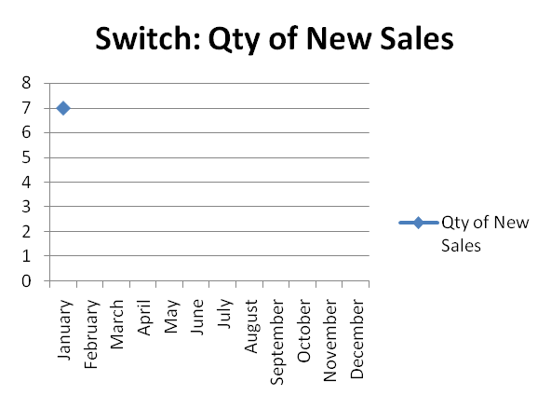
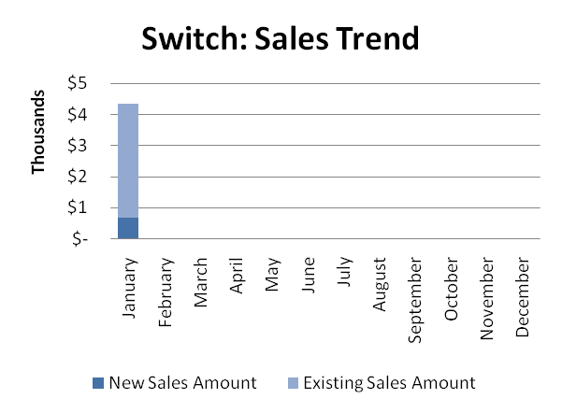

Dialer Report Summary-2015
Month | Qty of New Sales | New Sales Amount | Existing Sales Amount | Net Cashflow | Due Realized | Current Due
January | 6 | $ 1,650 | $ 31,600 | 96.53% | $ 1,714 | $ 1,154
February
March
April
May
June
July
August
September
October
November
December
Total |  | $ 1,650 | $ 31,600 |  | $ 1,714 | $ 1,154

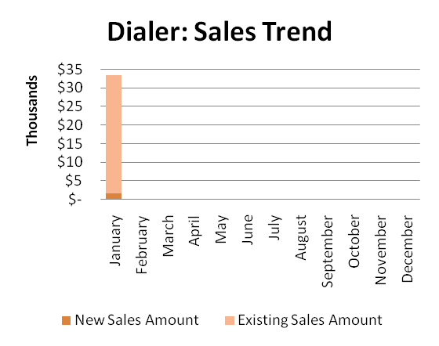 |  |  |  | 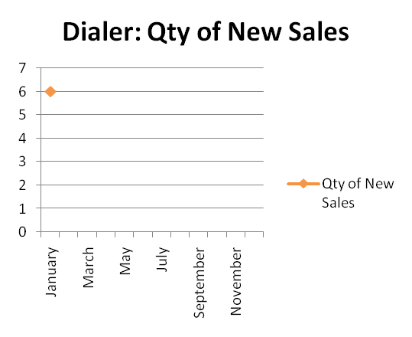

gPlex Lite Report Summary-2015
Month | Qty of New Sales | New Sales Amount | Existing Sales Amount | Net Cashflow | Due Realized | Current Due
January | 12 | $ 9,000 | $ 650 | 55.30% | $ 2,506 | $ 4,314
February
March
April
May
June
July
August
September
October
November
December
Total |  | $ 9,000 | $ 650 |  | $ 2,506 | $ 4,314

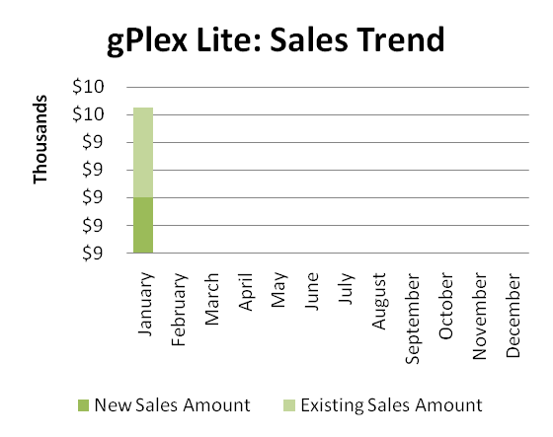 |  |  |  | 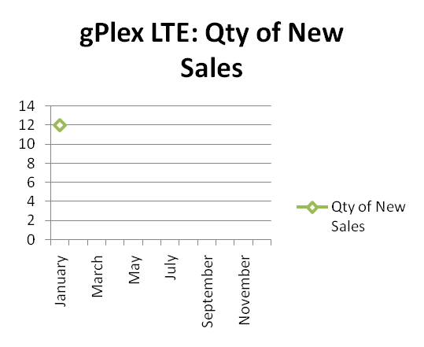

c. Department : International Voice Carrier
Manager : Md. Aminul Islam
Monthly traffic and client report for the month of January 2015

Coverage area:
01. Total Traffic
02. Voice Wholesale Traffic
03. gTalk Total Traffic
04. gTalkNA
05. gTalkUK
06. gTalk® Home

01. Total Traffic

01 (a). Total traffic by Months, Year 2013-2014
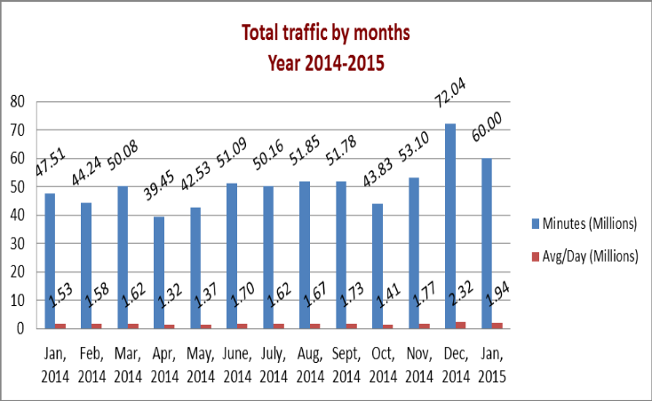

01(b). Total traffic by Months, Year 2013-2014 (According to 30 days)
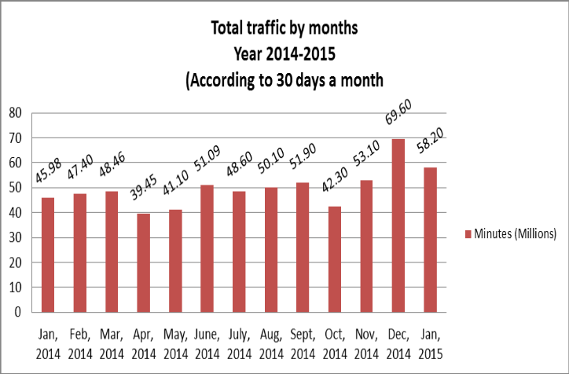

02. Total Voice Wholesale Traffic
02(a). Voice Wholesale: Total Traffic by months. Year 2013-2014

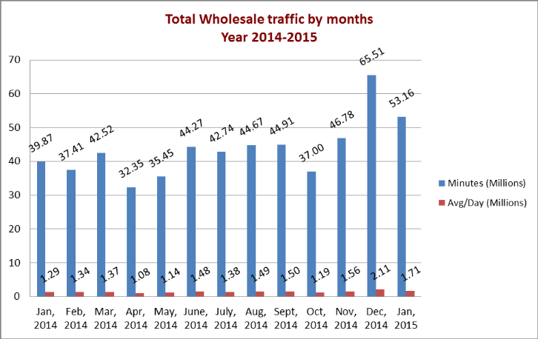
02(b). Voice Wholesale: Total Traffic by months. Year 2013-2014 (According to 30 days)

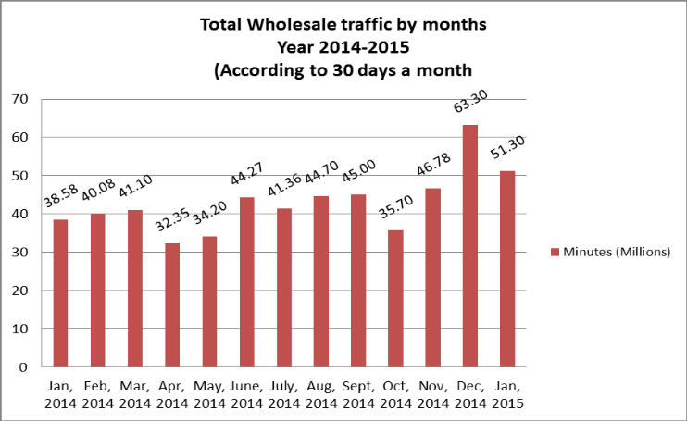

03. gTalk Total Traffic
03(a). gTalk : Total Traffic by months. Year 2013-2014

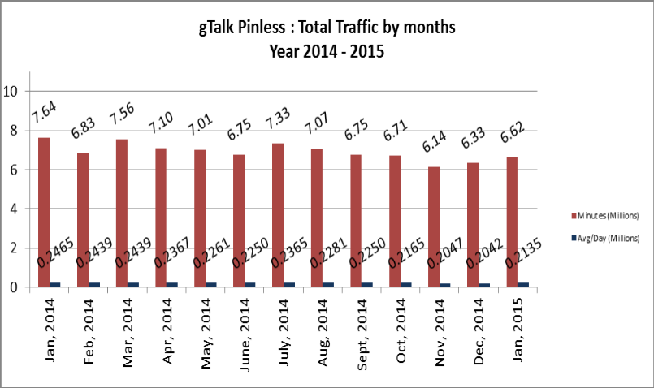

03(b). gTalk : Total Traffic by months (According to 30 days)

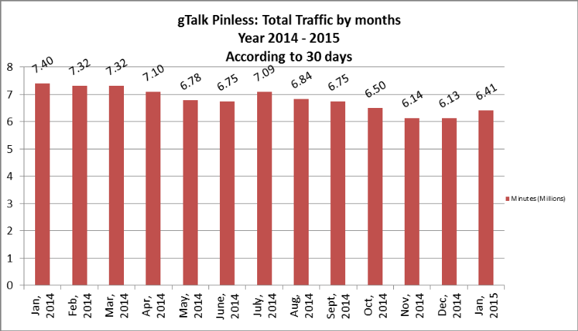
04. gTalk Pinless – Active Clients, Year 2014

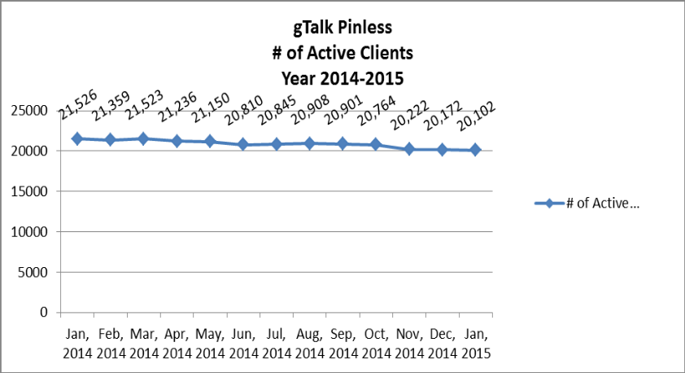

05. gTalk NA
05(a). gTalk NA : Total Traffic by months for the year 2013-2014

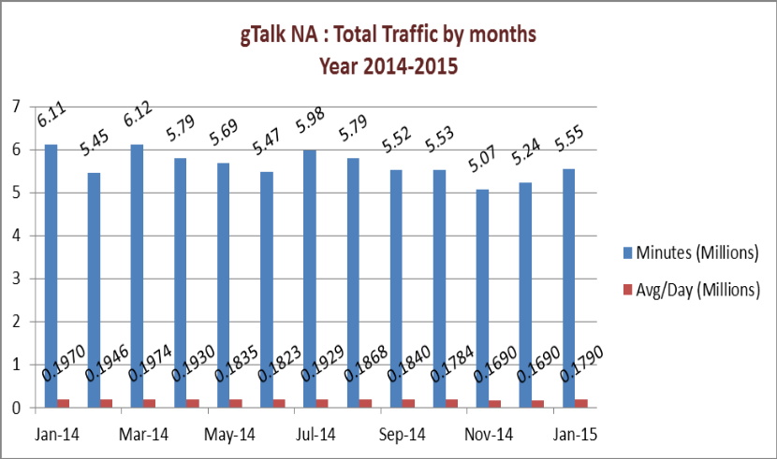

05(b). gTalk NA : Total Traffic by months for the year 2013-2014 (According to 30 Days)
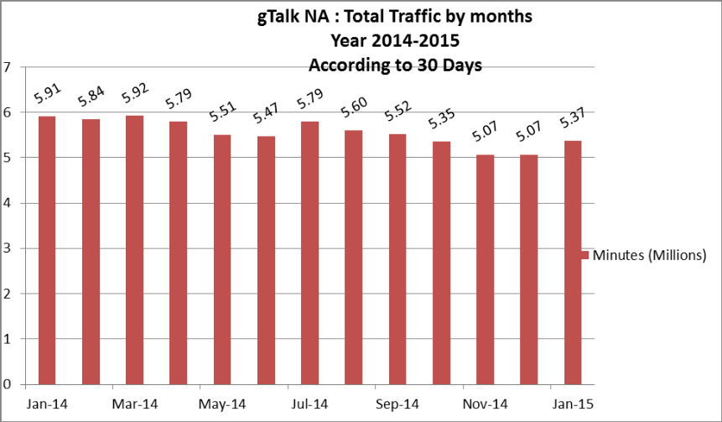
05(c). gTalk NA : New clients by months for the year 2013-2014
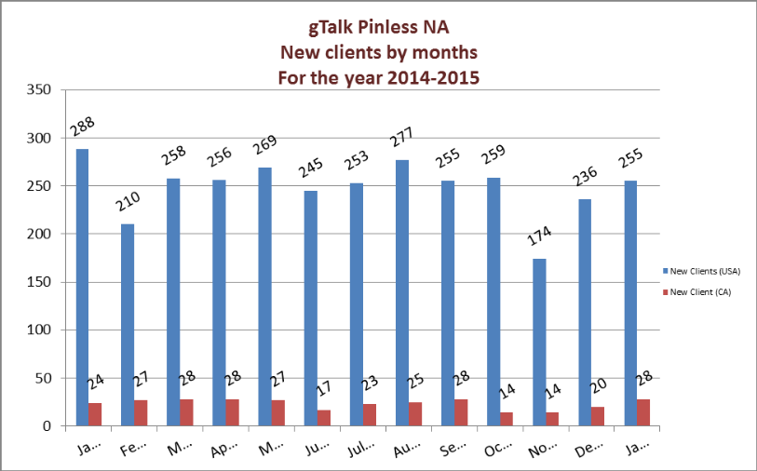
06. gTalk UK
06(a). gTalk UK : Total Traffic by months for the year 2013-2014

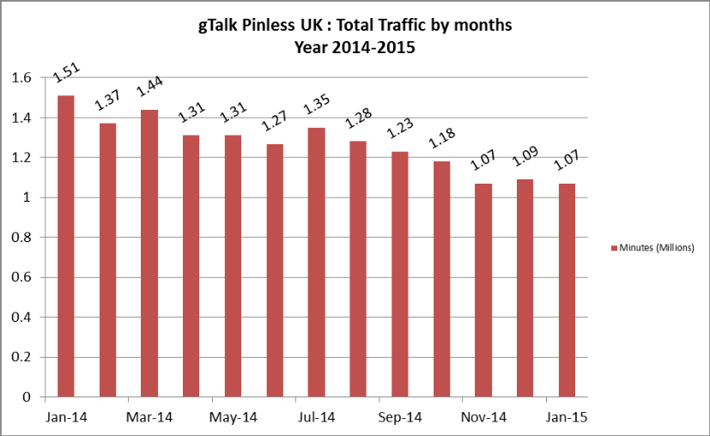

06(b). gTalk UK : Total Traffic by months for the year 2013-2014 (According to 30 Days)
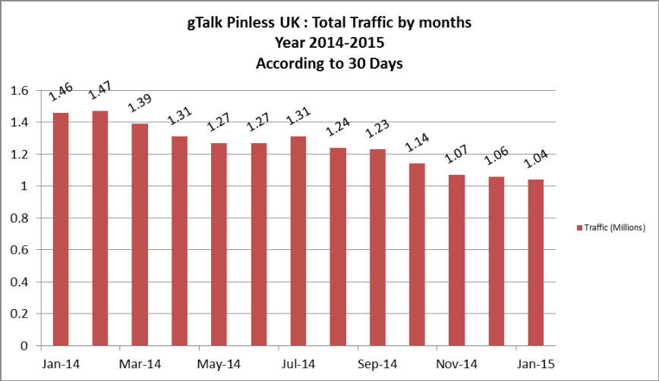
06(c). gTalk UK : New clients by months for the year 2013-2014
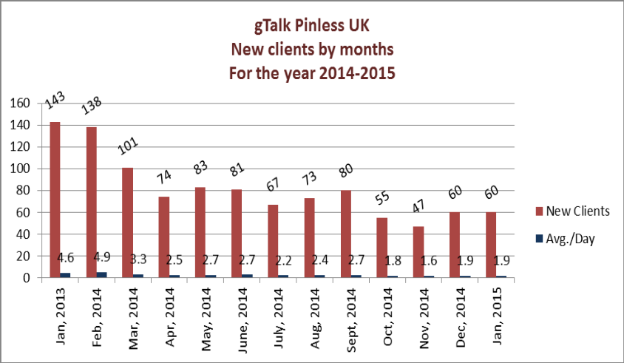
07. gTalk Home
07(a). gTalk® Home : Total Traffic by months for the year 2014
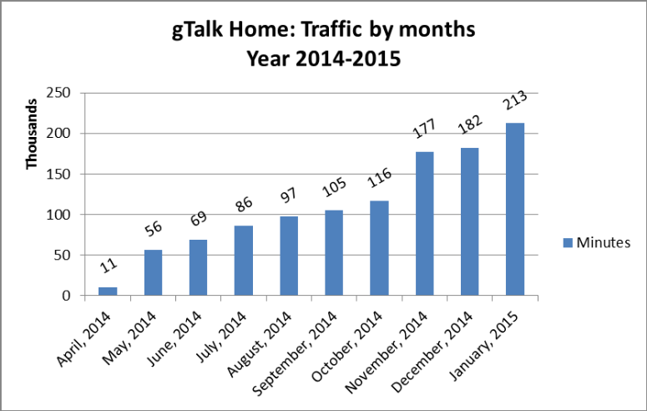
07(b). gTalk® Home : New clients by months for the year 2014
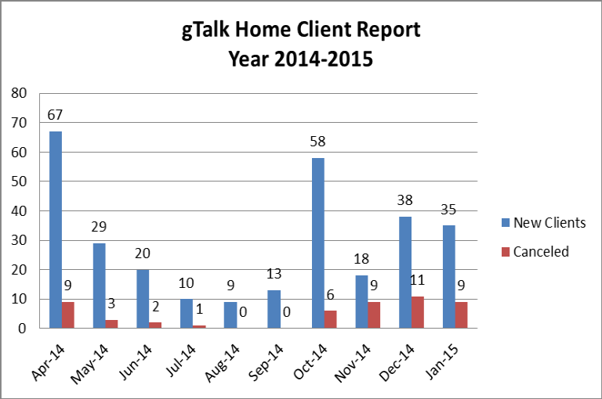

d. Department : Corporate
DGM : Sk. Kamruzzaman Prince
Mr. Kamruzzaman was on leave on the meeting date. So Mr. Anwarul Karim, Executive Director shared the highlighted issues from his part which he shared with ED earlier through email.
Prospective client: A presentation has been taken place in UCBL and we are hopeful about it as it went good. Discussion is also going on with NRB Bank.
City Bank work update: We are working on the OCS and Predictive Dialer for City Bank.
Lanka Bangla work update: Lanka Bangla Finance wants PIN generation feature on which discussion is being going on.
HungryNaki.com work update: A discussion is going on with HungryNaki.com
Presentation: A presentation will be held at Jamuna Bank.

e. Department : Training
AGM & In-Charge : Mohammad Abdullah Al Masum
Current Status: Currently training department is running training for fifteen batches. Among these, five batches (21 NT, 22 NT, 21 WPSI, 23 WPSI, 25 CF) are being run for IDB. The other 10 batches are covering different customized courses.
Revenue: Total collection on account of training during January 2015 was 15.79 lacs. The
total amount of revenue in January 2015 activities was Tk 17.21 lacs.

f. Department : Software
ED : Md. Anwarul Karim
gTalk prepaid service solution: A company in Dallas wants to purchase the prepaid service solution of gTalk. Work is going on to arrange the service available.
Work in progress: The works in progress were also discussed in the meeting.

g. Department : PlexStar
CEO : M Anis Rahman
A French company has purchased PlexStar equipment and the trial version is running.

h. Department : HR & Admin
DGM : Md. Habibur Rahman
Recruitment: One staff has joined in Software Department. Another is given with the appointment letter who will join from 1st April 2015.
Rearrangement of Office Floor: Our office floors have been rearranged. We have handed over the 5th floor to Genusys Limited and rented another room in 4th floor for our call center.
Digital World 2015: The Digital World 2015 is going to be held on 9th to 12th February 2015. All departments are prepared accordingly.
Training issue: ED talked about some training arrangement for the skill development of the employees. HR Department arranges several in-house and outbound training when and where necessary. Managers were also requested to ask for any training arrangement. This is also included in our policy. But managers hardly asked for such training for their team members and HR took it as that they do not require any training. Still, if any training need is being shared by any manager, it will be arranged.

At the end, CEO showed appreciation to everyone for their presence and thoughtful insights about the company. He concluded the meeting by thanking to all.

