Reference: GSL/ Admin/ MCM 69

Attendance
69th Monthly Coordination Meeting
Date: 18th March 2015
Venue: GSL Conference Room

Time: 09.00 AM

The sixty ninth monthly coordination meeting of Genuity Systems Ltd. (GSL) was held on 18th March 2015 at Genuity Conference Room 1. Management team and the managers of different departments of the company were present. List of participants of the meeting are as follows:
SL. | Name of Participants | Department | Signature
1. | Habib Rahman | President | Present
2. | M. Anis Rahman | Chief Executive Officer | Present
3. | Md. Sadiqur Rahman | Director Operations | Present
4. | K. Shahadat Hossain | Director Marketing | Present
5. | Md. Anwarul Karim | Executive Director | Present
6. | Md. Habibur Rahman | Admin & HR | Present
7. | Md. Waliul Haque Tusar | System Admin | Present
8. | Md. Aminul Islam | Head of International Voice Carrier | Present
9. | Sk. Kamruzzaman Prince | Corporate Affairs | Present
10. | Lutful Kabir Majumder | Call Center | Present
11. | Md. Ashrafuzzaman | Accounts | Present
12. | Md. Abdullah Al Masum | Training | Present

The meeting was started by the DGM, Head of HR & Admin. He thanked everyone for participating in the meeting and invited CEO to take control of the meeting. The CEO warmly welcomed everyone present in the meeting and thanked them for their presence. Thereafter he requested all departmental managers to deliver respective speech, one at a time, highlighting departmental performance and issues during the last month. He invited all to raise queries/questions and share their opinion in the discussion as deemed fit. The main points raised and discussed in the meeting over different issues are recorded below:

a. Department : Training
AGM & In-Charge : Mohammad Abdullah Al Masum
Current Status: Currently training department is running training for ninteen batches. Among these, five batches (21 NT, 22 NT, 21 WPSI, 23 WPSI, 25 CF) are being run for IDB. The other 14 batches are covering different customized courses.
Revenue: Total collection on account of training during February 2015 was 15.18 lacs. The
total amount of revenue in February 2015 activities was Tk 7.28 lacs.
Work to include new institutes: Work is going on NGOs, donor NGOs, students of Government Vocational Institutes to check if they can also be included to provide training service.

b. Department : Call Center (gTalk)
AGM : Md. Lutful Kabir Majumder

Current status of client joining and usage in gTalk pinless:

# Total client joined in gTalk till 28 February 2015: 59292

# Average client increase per day in February, 15: 8
# Average client increase per day in January, 15: 11
# Average client increase per day in December, 14: 10
# Average client increase per day in November, 14: 8
# Average client increase per day in October, 14: 11
# Average client increase per day in September, 14: 12
# Average client increase per day in August, 14: 12
# Average client increase per day in July, 14: 11
# Average client increase per day in June, 14: 12
# Average client increase per day in May, 14: 12
# Average client increase per day in April, 14: 12
# Average client increase per day in March, 14: 13
# Average client increase per day in February, 14: 14

# Average total Minutes per day in February, 15: 207.75 K
# Average total Minutes per day in January, 15: 213.58 K
# Average total Minutes per day in December, 14: 204.23 K
# Average total Minutes per day in November, 14: 204.71 K
# Average total Minutes per day in October, 14: 216.46 K
# Average total Minutes per day in September, 14: 225.07 K
# Average total Minutes per day in August, 14: 228.18 K
# Average total Minutes per day in July, 14: 236.50 K
# Average total Minutes per day in June, 14: 224.90 K
# Average total Minutes per day in May, 14: 226.21 K
# Average total Minutes per day in April, 14: 236.75 K
# Average total Minutes per day in March, 14: 243.74 K
# Average total Minutes per day in February, 14: 243.94 K

# Total customer used gTalk service in February, 15 about 20,032
# Total customer used gTalk service in January, 15 about 20,174
# Total customer used gTalk service in December, 14 about 20,506
# Total customer used gTalk service in November, 14 about 20,795
# Total customer used gTalk service in October, 14 about 21,371
# Total customer used gTalk service in September, 14 about 21,466
# Total customer used gTalk service in August, 14 about 21,026
# Total customer used gTalk service in July, 14 about 21,814
# Total customer used gTalk service in June, 14 about 21,224
# Total customer used gTalk service in May, 14 about 21,663
# Total customer used gTalk service in April, 14 about 21,533
# Total customer used gTalk service in March, 14 about 21,920
# Total customer used gTalk service in February, 14 about 21,587
Unused Initial Balance for the month of February 2015: In the month of February, it has been found that total 41 customers have not used their Account Initial Balance after opening the account.

Current status after calling those customers is as follows:

- Customer using: 28 (68%)
- Customer still not using: 13 (32%)

Survey in February 2015: In the month of February, a total of 1142 customers who are inactive for at least 2 months have been called. Details about customer’s feedback are given below:

- Ethnic Group:
  - Bangladesh – 913 (80%)
  - India – 52 (5%)
  - Zimbabwe –28 (3%)
  - Gambia – 17 (1%)
  - Pakistan – 14 (1%)
  - Miscellaneous- 118 (10%)

- Message left to the customers who were unavailable: 521 (36%)
- Number not in service: 398 (36%)
- Using other calling services or doesn’t make international calls: 103 (19%)
- Interested to use again: 120 (9%)
- Among 120 customers, 27 people have started to use gTalk service again after this survey.

Hot number uses:

February, 15: 37.02%
January, 15: 36.55%
December, 14: 36.39%
November, 14: 36.00%
October, 14: 35.34%
September, 14: 35.53%
August, 14: 35.00%
July, 14: 35.56%
June, 14: 35.96%
May, 14: 35.35%
April, 14: 34.87%
March, 14: 34.89%
February, 14: 34.72%

Hot Dialer Report
Total User(s): 11517

VoIP Dialer Report
Total User(s): 1365

Total SMS from February 1 to February 28, 15: 1567 and Failed SMS: 41

# Total client joined in gTalk UK till 28 February 2015: 7285

# Total client joined in February 2015: 44
# Total client joined in January 2015: 60
# Total client joined in December 2014: 60
# Total client joined in November 2014: 47
# Total client joined in October 2014: 55
# Total client joined in September 2014: 80
# Total client joined in August 2014: 73
# Total client joined in July 2014: 67
# Total client joined in June 2014: 81
# Total client joined in May 2014: 83
# Total client joined in April 2014: 74
# Total client joined in March 2014: 101
# Total client joined in February 2014: 138

# Total Minutes for the month of February, 15: 898.70 K
# Total Minutes for the month of January, 15: 1070.12 K
# Total Minutes for the month of December, 14: 1090.40 K
# Total Minutes for the month of November, 14: 1074.15 K
# Total Minutes for the month of October, 14: 1177.35 K
# Total Minutes for the month of September, 14: 1232.07 K
# Total Minutes for the month of August, 14: 1281.62 K
# Total Minutes for the month of July, 14: 1345.22 K
# Total Minutes for the month of June, 14: 1265.87 K
# Total Minutes for the month of May, 14: 1309.94 K
# Total Minutes for the month of April, 14: 1313.78 K
# Total Minutes for the month of March, 14: 1436.08 K
# Total Minutes for the month of February, 14: 1366.20 K

c. Department : gPlex Software Solutions
AGM : Md. Lutful Kabir Majumder

Genuity Systems Limited
gPlex Switch and Dialer Sales Report
February 2015
 |  | Mobile Dialer |  | Soft Switch |  | Total
 |  | Amount | % | Amount | % | Amount | %
Total Billed |  | $36,600.00 | 100.00% | $5,450.00 | 100.00% | $42,050 | 100.00%
Received for Current Bills |  | $31,230.00 | 85.33% | $3,239.00 | 59.43% | $34,469 | 81.97%
Advance Expired |  | $46.00 | 0.13% | $0.00 | 0.00% | $46 | 0.11%
Current Due |  | $5,324.00 | 14.55% | $2,211.00 | 40.57% | $7,535 | 17.92%
Written Off |  | $0.00 | 0.00% | $0.00 | 0.00% | $0 | 0.00%
Total Received |  | $35,736.00 | 100.00% | $4,161.00 | 100.00% | $39,897 | 100.00%
Received for Current Bills |  | $31,230.00 | 87.39% | $3,239.00 | 77.84% | $34,469 | 86.39%
Received for Last Month's Dues |  | $2,527.00 | 7.07% | $657.00 | 15.79% | $3,184 | 7.98%
Received for Older Dues |  | $1,964.00 | 5.50% | $265.00 | 6.37% | $2,229 | 5.59%
Advance Received |  | $15.00 | 0.04% | $0.00 | 0.00% | $15 | 0.04%
Qty of New Sales |  | 16 | 14.81% | 10 | 50.00%
Qty of Existing Sales |  | 92 | 85.19% | 10 | 50.00%
Total |  | 108 | 100.00% | 20 | 100.00%

 |  | gPlex Lite Report
 |  | February 2015
 |  | February 2015
 |  | New Client | Existing Client | Total | %
Bills & Receipts
Total Billed |  | $ 7,750 | $ 1,950 | $ 9,700 | 100.00%
Received for Current Bills |  | $ 5,124 | $ 1,924 | $ 7,048 | 72.66%
Advance Expired |  | $ - | $ - | $ - | 0.00%
Current Due |  | $ 2,626 | $ 26 | $ 2,652 | 27.34%
Quantity of Sales |  | 11 | 19 | $ 30
Cash Analysis
Total Received |  | $ 5,127 | $ 6,028 | $ 11,155 | 100.00%
Received for Current Bills |  | $ 5,124 | $ 1,924 | $ 7,048 | 63.18%
Received for Last Month's Dues |  | $ - | $ 2,187 | $ 2,187 | 19.61%
Received for Older Dues |  | $ - | $ 1,915 | $ 1,915 | 17.17%
Advance Received |  | $ 3 | $ 2 | $ 5 | 0.04%
Net Cashflow |  |  |  |  | 72.66%
Accounts Receivable Statement |  |  |  | February 2015
Accounts Receivable B/F |  |  |  | $ 17,515
Current Due |  |  |  | $ 2,652
Received for Last Month's Dues |  |  | $ 2,187
Received for Older Dues |  |  | $ 1,915 | $ 4,102
Discount Allowed |  |  |  | $ -
Written Off (Bad Debt/ Credit Notes) |  |  |  | $ -
Accounts Receivable C/F |  |  |  | $ 16,065
Last Month's Dues |  |  |  | $ 4,314
Received for Last Month's Dues |  |  |  | $ 2,187
Remaining Last Month's Dues as of Current Month |  |  |  | $ 2,127

 |  | Mobile Dialer Report
 |  | February 2015
 |  | February 2015
 |  | New Client | Existing Client | Total | %
Bills & Receipts
Total Billed |  | $ 3,050 | $ 23,850 | $ 26,900 | 100.00%
Received for Current Bills |  | $ 2,547 | $ 21,635 | $ 24,182 | 89.90%
Advance Expired |  | $ - | $ 46 | $ 46 | 0.17%
Current Due |  | $ 503 | $ 2,169 | $ 2,672 | 9.93%
Quantity of Sales |  | 5 | 73 | $ 78
Cash Analysis
Total Received |  | $ 2,547 | $ 22,034 | $ 24,581 | 100.00%
Received for Current Bills |  | $ 2,547 | $ 21,635 | $ 24,182 | 98.38%
Received for Last Month's Dues |  | $ - | $ 340 | $ 340 | 1.38%
Received for Older Dues |  | $ - | $ 49 | $ 49 | 0.20%
Advance Received |  | $ - | $ 10 | $ 10 | 0.04%
Net Cashflow |  |  |  |  | 90.07%
Accounts Receivable Statement |  |  |  | February 2015
Accounts Receivable B/F |  |  |  | $ 84,659
Current Due |  |  |  | $ 2,672
Received for Last Month's Dues |  |  | $ 340
Received for Older Dues |  |  | $ 49 | $ 389
Discount Allowed |  |  |  | $ -
Written Off (Bad Debt/ Credit Notes) |  |  |  | $ -
Accounts Receivable C/F |  |  |  | $ 86,942
Last Month's Dues |  |  |  | $ 1,154
Received for Last Month's Dues |  |  |  | $ 340
Remaining Last Month's Dues as of Current Month |  |  |  | $ 814

 |  | gPlex SoftSwitch Report
 |  | February 2015
 |  | February 2015
 |  | New Client | Existing Client | Total | %
Bills & Receipts
Total Billed |  | $ 3,300 | $ 2,150 | $ 5,450 | 100.00%
Received for Current Bills |  | $ 2,439 | $ 800 | $ 3,239 | 59.43%
Advance Expired |  | $ - | $ - | $ - | 0.00%
Written Off- Current |  | $ - | $ - | $ - | 0.00%
Current Due |  | $ 861 | $ 1,350 | $ 2,211 | 40.57%
Quantity of Sales |  | 10 | 10 | $ 20
Cash Analysis
Total Received |  | $ 2,439 | $ 1,722 | $ 4,161 | 100.00%
Received for Current Bills |  | $ 2,439 | $ 800 | $ 3,239 | 77.84%
Received for Last Month's Dues |  | $ - | $ 657 | $ 657 | 15.79%
Received for Older Dues |  | $ - | $ 265 | $ 265 | 6.37%
Advance Received |  | $ - | $ - | $ - | 0.00%
Net Cashflow |  |  |  |  | 59.43%
Accounts Receivable Statement |  |  |  | February 2015
Accounts Receivable B/F |  |  |  | $ 70,921
Current Due |  |  |  | $ 2,211
Received for Last Month's Dues |  |  | $ 657
Received for Older Dues |  |  | $ 265 | $ 922
Discount Allowed
Written Off- Last Month |  |  |  | $ -
Written Off-Older |  |  |  | $ -
Accounts Receivable C/F |  |  |  | $ 72,210
Last Month's Dues |  |  |  | $ 703
Received for Last Month's Dues |  |  |  | $ 657
Remaining Last Month's Dues as of This Month |  |  |  | $ 46

Switch Report Summary-2015
Month | Qty of New Sales | New Sales Amount | Existing Sales Amount | Net Cashflow | Due Realized | Current Due
January | 7 | $ 700 | $ 3,650 | 83.84% | $ 565 | $ 703
February | 10 | $ 3,300 | $ 2,150 | 59.43% | $ 922 | $ 2,211
March
April
May
June
July
August
September
October
November
December
Total | 17 | $ 4,000 | $ 5,800 |  | $ 1,487 | $ 2,914

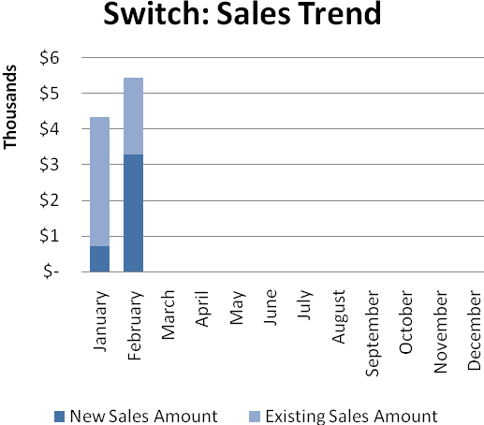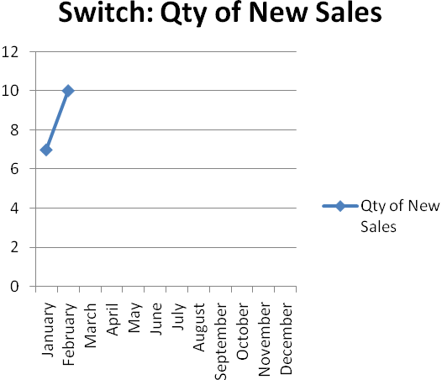

Dialer Report Summary-2015
Month | Qty of New Sales | New Sales Amount | Existing Sales Amount | Net Cashflow | Due Realized | Current Due
January | 6 | $ 1,650 | $ 31,600 | 96.53% | $ 1,714 | $ 1,154
February | 5 | $ 3,050 | $ 23,850 | 90.07% | $ 389 | $ 2,672
March
April
May
June
July
August
September
October
November
December
Total |  | $ 4,700 | $ 55,450 |  | $ 2,103 | $ 3,826

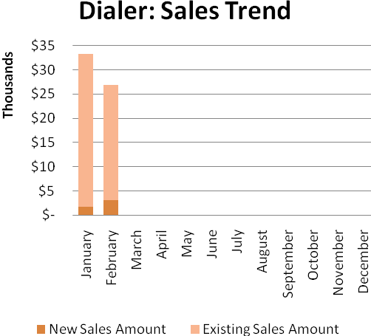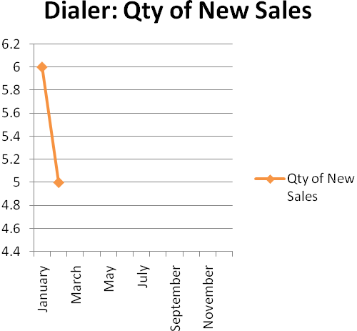

gPlex Lite Report Summary-2015
Month | Qty of New Sales | New Sales Amount | Existing Sales Amount | Net Cashflow | Due Realized | Current Due
January | 12 | $ 9,000 | $ 650 | 55.30% | $ 2,506 | $ 4,314
February | 11 | $ 7,750 | $ 1,950 | 72.66% | $ 4,102 | $ 2,652
March
April
May
June
July
August
September
October
November
December
Total |  | $ 16,750 | $ 2,600 |  | $ 6,608 | $ 6,966

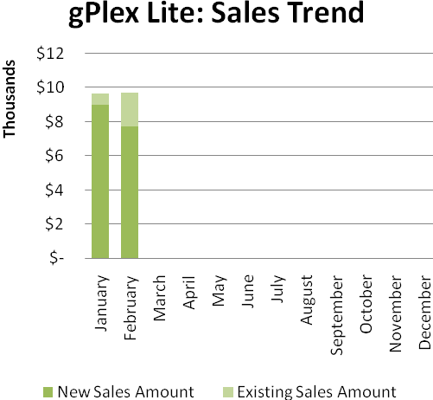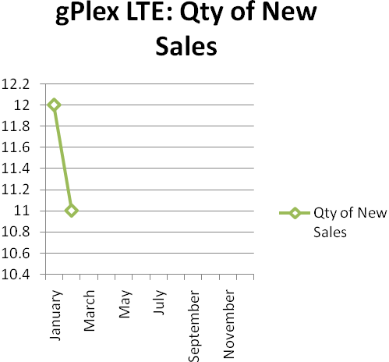

Client meeting: We organized a meeting with our clients who lives around Dhaka. The event was very successful. We are going to arrange another meeting on 22nd of this month. From the feedback of the previous meeting, we came to know that our clients want an interface looking like Core 4.
CEO in reply: Why the issue of VSR is arising now after doing Core 4? Did not we do research beforehand?
Manager in reply: Several company have all the interafces, that’s why now our clients want it from us.
ED in reply: We are trying to give our swith a look like others have.

d. Department : International Voice Carrier
Manager : Md. Aminul Islam
Monthly traffic and client report for the month of January 2015

Coverage area:
01. Total Traffic
02. Voice Wholesale Traffic
03. gTalk Total Traffic
04. gTalkNA
05. gTalkUK
06. gTalk® Home

01. Total Traffic

01 (a). Total traffic by Months, Year 2013-2014
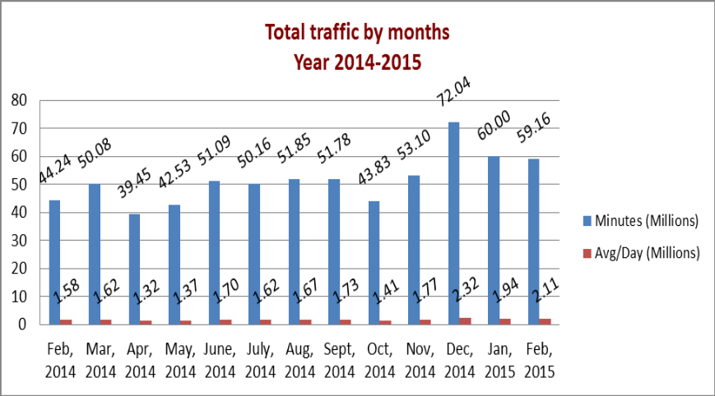

01(b). Total traffic by Months, Year 2013-2014 (According to 30 days)
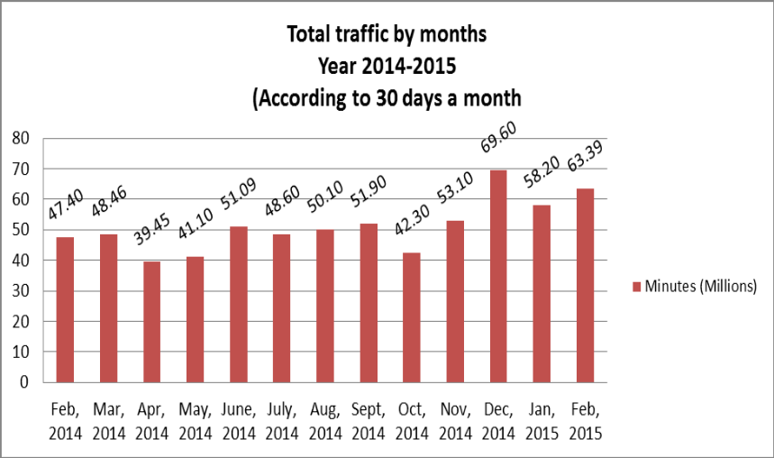

02. Total Voice Wholesale Traffic
02(a). Voice Wholesale: Total Traffic by months. Year 2013-2014
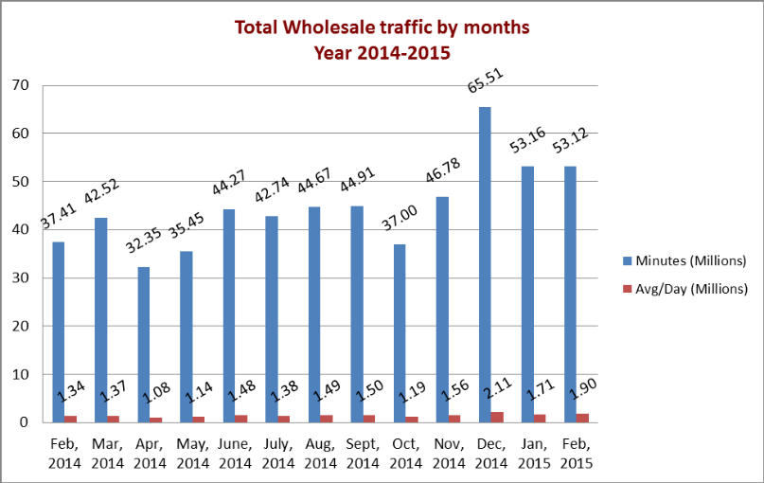
02(b). Voice Wholesale: Total Traffic by months. Year 2013-2014 (According to 30 days)
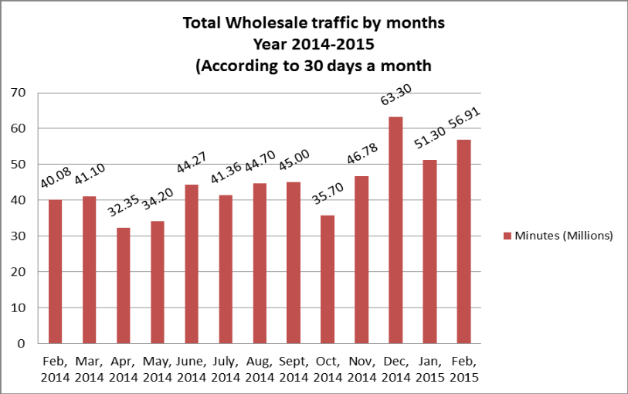

03. gTalk Total Traffic
03(a). gTalk : Total Traffic by months. Year 2013-2014

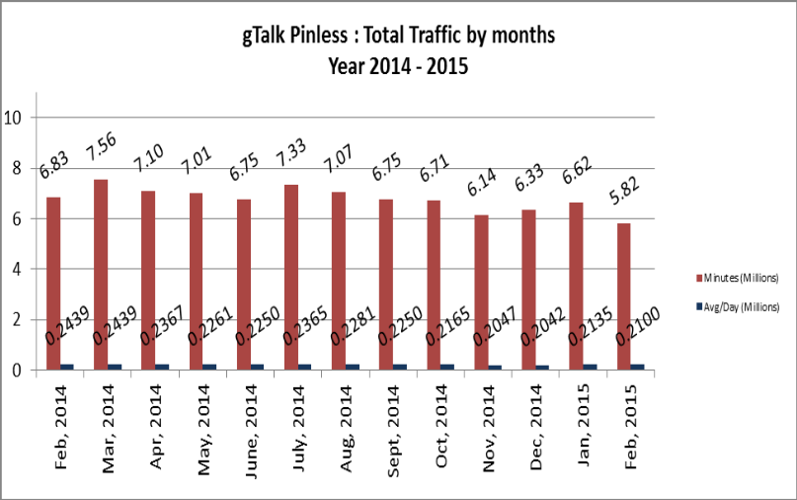

03(b). gTalk : Total Traffic by months (According to 30 days)
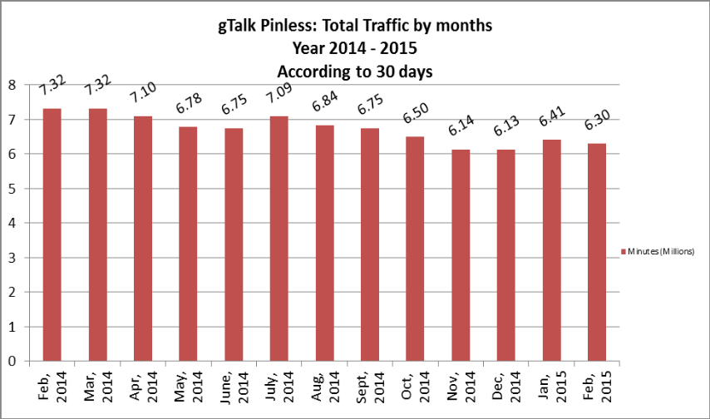
04. gTalk Pinless – Active Clients, Year 2014
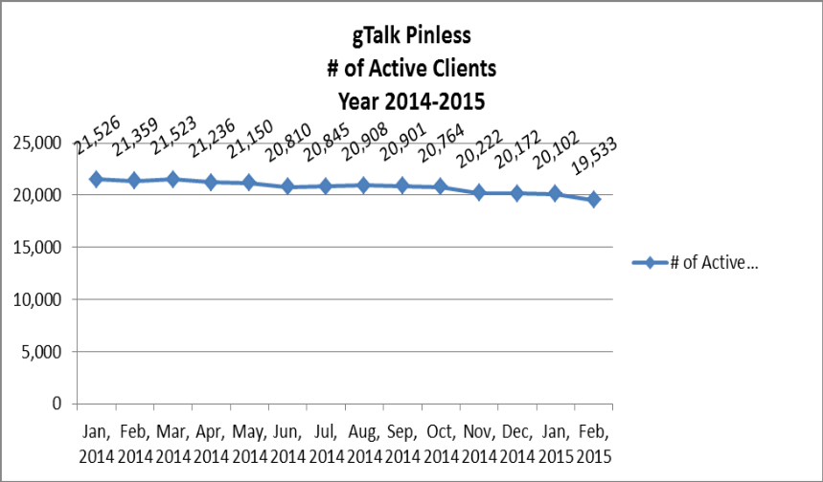
05. gTalk NA
05(a). gTalk NA : Total Traffic by months for the year 2013-2014

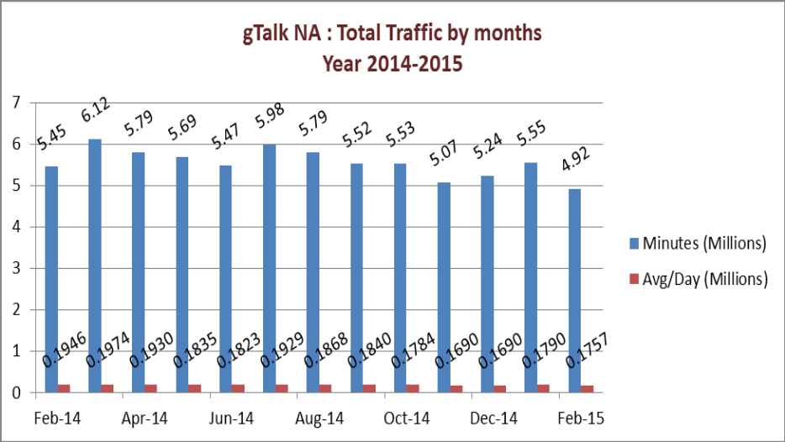

05(b). gTalk NA : Total Traffic by months for the year 2013-2014 (According to 30 Days)
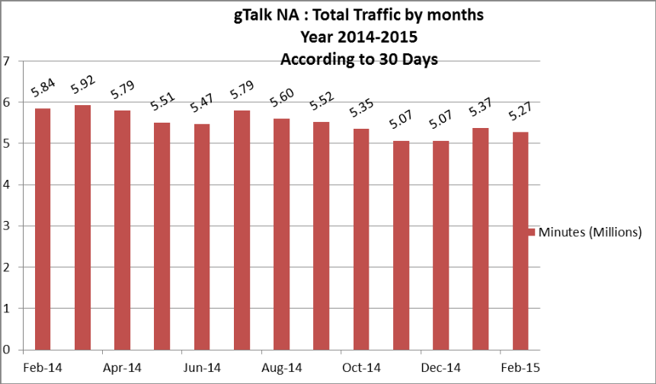
05(c). gTalk NA : New clients by months for the year 2013-2014
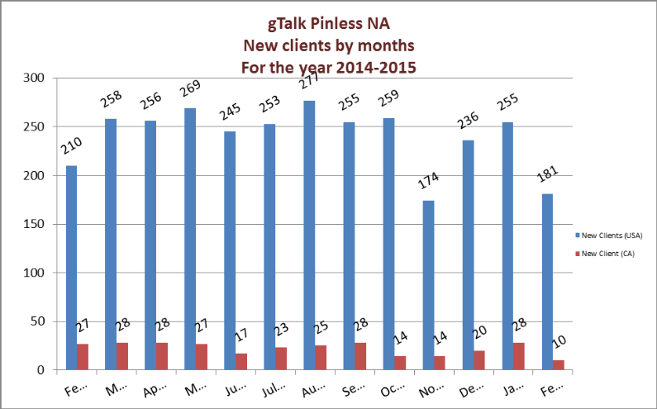
06. gTalk UK
06(a). gTalk UK : Total Traffic by months for the year 2013-2014
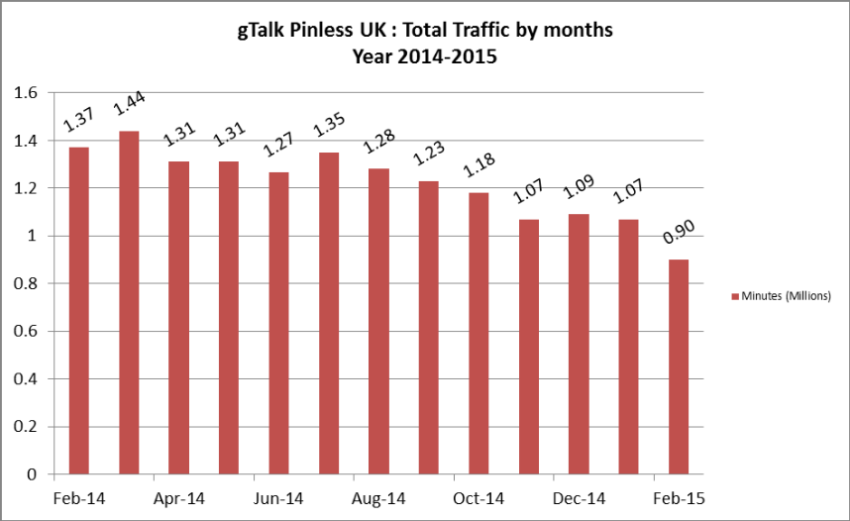

06(b). gTalk UK : Total Traffic by months for the year 2013-2014 (According to 30 Days)
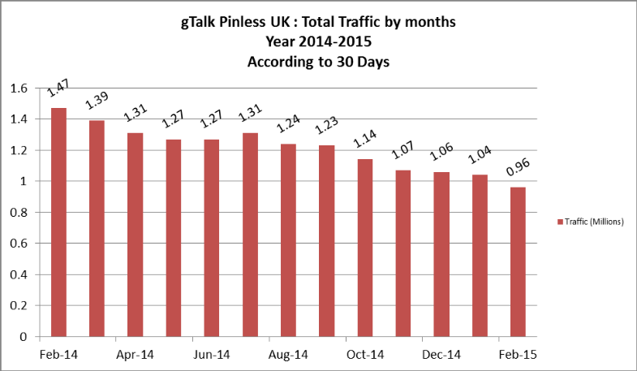
06(c). gTalk UK : New clients by months for the year 2013-2014
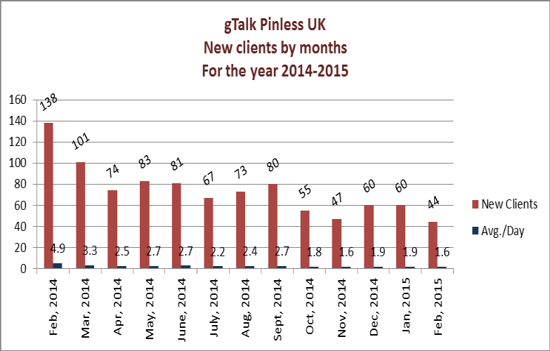
07. gTalk Home
07(a). gTalk® Home : Total Traffic by months for the year 2014
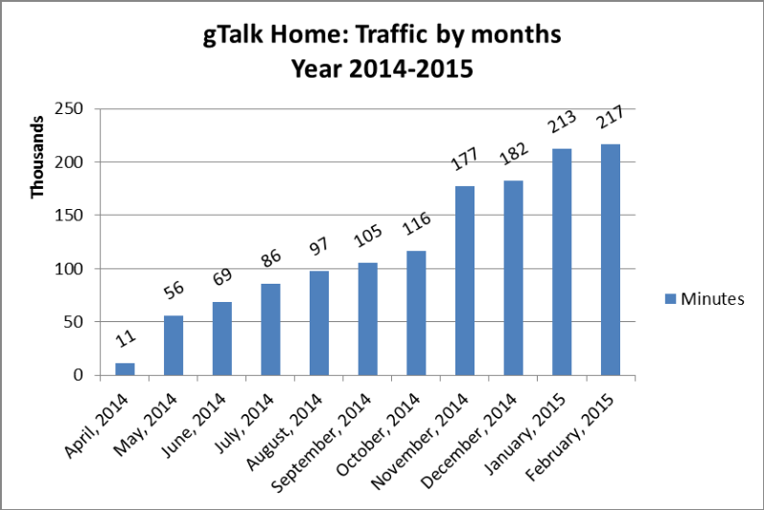
07(b). gTalk® Home : New clients by months for the year 2014
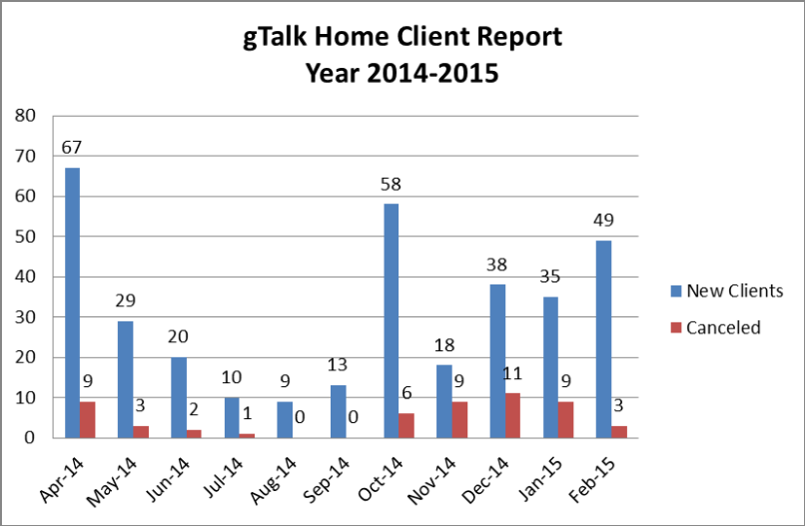

Problem with gTalk Home: Clients cannot connect with gtalk Home from some places, but they can connect from those same places with other operators. Though this is a minor problem, but if this results into client dissatisfaction, we would not be able to move further with marketing.
CEO in reply: We are aware of this problem. We are trying to align with some big carrier who have higher coverage to minimize this problem.

e. Department : IPPBX
CEO : M. Anis Rahman
We have delivered our IPPBX solution to Haque Global of USA. Discussion is going on with
some other companies too. We hope we will be able to make some business with them.

f. Department : Corporate
DGM : Sk. Kamruzzaman Prince
Delivery to MBM: We are going to deliver IPPBX to MBM this week.
Mr. Waliul Haque Tusar about IPPBX issue: The solution of MBM which we are going to install does not fulfill 100% need of the client. But we are going to install it with our existing software.
Demand of IPPBX: Local banks have hidden demand of IPPBX. We can hope to sell our product to them through proper marketing.
Interest from Aamra Network : Aamra Network has shown their interest to purchase our call center. We are going to give a presentation there.
Demand of City Bank & Lanka Bangla: City Bank & Lanka Bangla Finance both demands for Green PIN product.
Update from Premier Bank: Discussion was going on with Premier Bank for long. Recently they have shortlisted the service providers and we have our name in their list.
Conducting survey among the banks: Here is a survey report on 14 financial institutes
gPlex market share by Company wise :
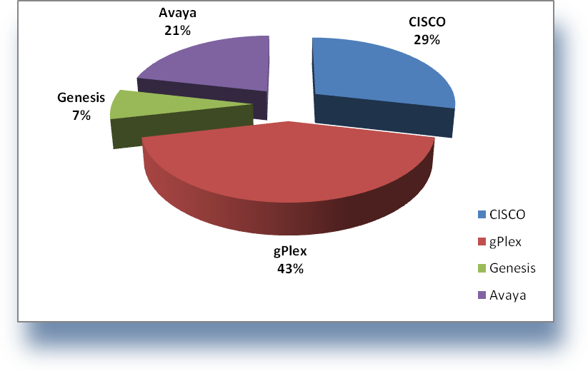
gPlex market share by seat wise :
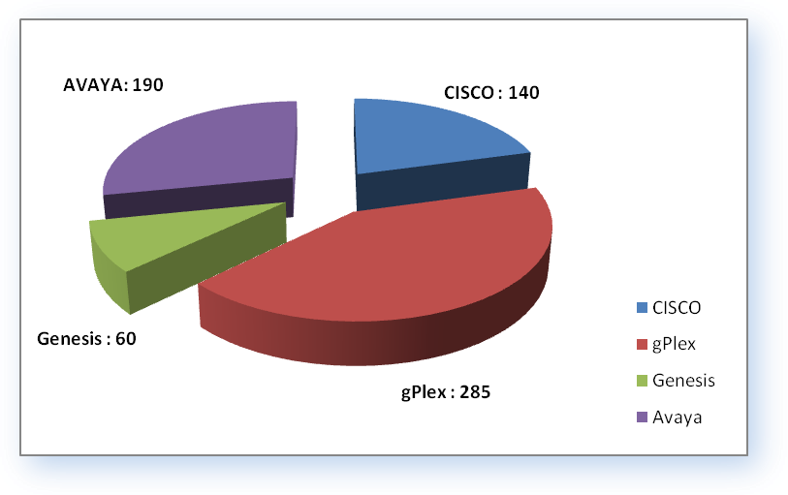
Question from CEO: CEO asked about the status of moving to international market with our call center solution.
Reply of DM: A program was held in Nepal. He will go to visit soon. A dialogue was also took place with Brunei. Let’s see what happens next.
CEO to ED: CEO requested ED to check the possibility to enter into Indian market through dealership.
ED in reply: India has enough on this kind of product and service of their own. So the hope of success is very low. Still he will try to get information through his known link.

g. Department : Software
ED : Md. Anwarul Karim
Regular work update: Regular work of gTalk and R&D is ongoing. The team is working with these works, thus the up-gradation work of EMS has gone slow.
Money transfer through mobile: We are working on the App which will be used to transfer money through mobile. But first we need to select the operator we will be using for this app for the main progress of the job.

h. Department : Marketing
DM : K. Shahadat Hossain
Marketing Proposal: Dialer market has become saturated. There are several players in the market who are providing good service. Thus those competitors are taking our market share. Now if we want to hold our portion of market share, we will have to provide the customers with value added feature. Through this we will be able to make ourselves different from others which is very important to exist in the market. Inside Bangladesh, we can produce leaflet for marketing our call center solution.

i. DO : Mohammed Sadiqur Rahman
Update of Banani Office: The floor registration of Banani office will be completed soon. After the registration is completed, we will be able to start our construction work. Once we can start the construction work, we can expect to complete it within 6 months of starting date.
Attendance during Strike or Blockade: Recently, strike and/or blockade has become very common and less serious. Thus proposal is to withdraw the prevailing flexi time due to strike or blockade.

j. Department : Plexstar
CEO : M. Anis Rahman
Update about France sell: The French company, to whom we sold our box, complained of packet loss. We have rectified the problem and they informed us that they are not facing any data loss now. They informed us that they might take some more boxes from us.
Requirement of Rural Telecom: Rural telecom has shared that they need our box. We had a meeting with them. Hopefully we will be able to have some sell with them.

k. Department : HR & Admin
CEO : Md. Habibur Rahman
Update about JD: The JD of department heads have been completed. We need to work on the other staffs JD as well. Along with JD, we need to complete the KPI work. Have discussed this with ED. Managers wanted to submit it on Thursday.
Attendance during Strike or Blockade: In my discussion, I was about to discuss the same issue as discussed by DO. It is time that we can withdraw the flexi time.
Picnic Update: We have given BRTC the advance for bus for our picnic. Now they are not willing to give it back. Rather they proposed us to re-schedule. If we enjoy the annual picnic and take bus from them, we will eb able to save the money. We went to BRTC and tried to convince them this. So I am proposing to place the picnic on 25-26 December 2015.
At the end, CEO showed appreciation to everyone for their presence and thoughtful insights about the company. He concluded the meeting by thanking to all.

