Reference: GSL/ Admin/ MCM 70

Attendance
70th Monthly Coordination Meeting
Date: 21st April 2015
Venue: GSL Conference Room

Time: 09.00 AM

The seventieth monthly coordination meeting of Genuity Systems Ltd. (GSL) was held on 21st April 2015 at Genuity Conference Room 1. Management team and the managers of different departments of the company were present. List of participants of the meeting are as follows:
SL. | Name of Participants | Department | Signature
1. | Habib Rahman | President | Present
2. | M. Anis Rahman | Chief Executive Officer | Present
3. | Md. Sadiqur Rahman | Director Operations | Present
4. | K. Shahadat Hossain | Director Marketing | Present
5. | Md. Anwarul Karim | Executive Director | Present
6. | Md. Habibur Rahman | Admin & HR | Present
7. | Md. Waliul Haque Tusar | System Admin | Present
8. | Md. Aminul Islam | Head of International Voice Carrier | Present
9. | Sk. Kamruzzaman Prince | Corporate Affairs | Present
10. | Lutful Kabir Majumder | Call Center | Present
11. | Md. Ashrafuzzaman | Accounts | Present
12. | Md. Abdullah Al Masum | Training | Present

The meeting was started by the DGM, Head of HR & Admin. He thanked everyone for participating in the meeting and invited CEO to take control of the meeting. The CEO warmly welcomed everyone present in the meeting and thanked them for their presence. Thereafter he requested all departmental managers to deliver respective speech, one at a time, highlighting departmental performance and issues during the last month. He invited all to raise queries/questions and share their opinion in the discussion as deemed fit. The main points raised and discussed in the meeting over different issues are recorded below:

a. Department : Corporate
DGM : Sk. Kamruzzaman Prince
Work Order of City Bank: We have received the work order from City Bank for their order of new module.
New offer to City Bank: We offered City Bank with the module of ATM pin.
Update of previous prospective clients: A detailed discussion was held to provide update about the previously discussed clients.
Product Delivery: The IPPBX that was sold to MBM has been delivered 20 days back. The test of the product has also been done and it could up one E-1.
CEOs asking: CEO asked about the next marketing plan of IPPBX.
In reply to CEO: Currently we are marketing our product only to large companies. There are some pending job of IPPBX. Once those jobs are done, we will be able to market our product to the smaller companies.
CEOs comments on Call Center: The smaller companies who cannot purchase the Call Center, now they buy the IPPBX and use it as call center. Currently we have mini version of our Call Center. If we market it, those smaller companies will feel interested to buy that.
Update of CEO about IPPBX: Fax module is necessary with the IPPBX version which we are selling in USA market. So we have incorporated the fax module in it. But all the carrier companies we are working with do not use fax. If we can include the fax module, we will be able to better market our product.
Update of Md. Waliul Haque Tusar about IPPBX Box: We get 1-U box in local market, but all the accessories of 1-U box is not available here. We have to bring those accessories from USA and assemble those locally which is time consuming. This also creates problem in after sales service. But 2-U box and all of its accessories are available locally. Thus if we use that all the above problems will be solved.
CEO in reply: We better take 2-U box into our consideration.

b. Department : Call Center (gTalk)
AGM : Md. Lutful Kabir Majumder

Current status of client joining and usage in gTalk pinless:

# Total client joined in gTalk till 31 March 2015: 59566

# Average client increase per day in March, 15: 9
# Average client increase per day in February, 15: 8
# Average client increase per day in January, 15: 11
# Average client increase per day in December, 14: 10
# Average client increase per day in November, 14: 8
# Average client increase per day in October, 14: 11
# Average client increase per day in September, 14: 12
# Average client increase per day in August, 14: 12
# Average client increase per day in July, 14: 11
# Average client increase per day in June, 14: 12
# Average client increase per day in May, 14: 12
# Average client increase per day in April, 14: 12
# Average client increase per day in March, 14: 13
# Average client increase per day in February, 14: 14

# Average total Minutes per day in March, 15: 203.01 K
# Average total Minutes per day in February, 15: 207.75 K
# Average total Minutes per day in January, 15: 213.58 K
# Average total Minutes per day in December, 14: 204.23 K
# Average total Minutes per day in November, 14: 204.71 K
# Average total Minutes per day in October, 14: 216.46 K
# Average total Minutes per day in September, 14: 225.07 K
# Average total Minutes per day in August, 14: 228.18 K
# Average total Minutes per day in July, 14: 236.50 K
# Average total Minutes per day in June, 14: 224.90 K
# Average total Minutes per day in May, 14: 226.21 K
# Average total Minutes per day in April, 14: 236.75 K
# Average total Minutes per day in March, 14: 243.74 K
# Average total Minutes per day in February, 14: 243.94 K

# Total customer used gTalk service in March, 15 about 19,957
# Total customer used gTalk service in February, 15 about 20,032
# Total customer used gTalk service in January, 15 about 20,174
# Total customer used gTalk service in December, 14 about 20,506
# Total customer used gTalk service in November, 14 about 20,795
# Total customer used gTalk service in October, 14 about 21,371
# Total customer used gTalk service in September, 14 about 21,466
# Total customer used gTalk service in August, 14 about 21,026
# Total customer used gTalk service in July, 14 about 21,814
# Total customer used gTalk service in June, 14 about 21,224
# Total customer used gTalk service in May, 14 about 21,663
# Total customer used gTalk service in April, 14 about 21,533
# Total customer used gTalk service in March, 14 about 21,920
# Total customer used gTalk service in February, 14 about 21,587
Unused Initial Balance for the month of March 2015: In the month of March, it has been found that total 38 customers have not used their Account Initial Balance after opening the account.

Current status after calling those customers is as follows:

- Customer using: 25 (66%)
- Customer still not using: 13 (34%)

Survey in March 2015: In the month of March, a total of 1333 customers who are inactive for at least 2 months have been called. Details about customer’s feedback are given below:

- Ethnic Group:
  - Bangladesh – 1013 (76%)
  - India – 85 (6%)
  - Zimbabwe –46 (4%)
  - Pakistan – 29 (2%)
  - Kenya – 20 (1%)
  - Gambia – 12 (1%)
  - Miscellaneous- 128 (10%)

- Message left to the customers who were unavailable: 398 (30%)
- Number not in service: 623 (47%)
- Using other calling services or doesn’t make international calls: 205 (15%)
- Interested to use again: 107 (8%)
- Among 107 customers, 14 people have started to use gTalk service again after this survey.

Hot number uses:

March, 15: 36.66%
February, 15: 37.02%
January, 15: 36.55%
December, 14: 36.39%
November, 14: 36.00%
October, 14: 35.34%
September, 14: 35.53%
August, 14: 35.00%
July, 14: 35.56%
June, 14: 35.96%
May, 14: 35.35%
April, 14: 34.87%
March, 14: 34.89%
February, 14: 34.72%

Hot Dialer Report
Total User(s): 11706

VoIP Dialer Report
Total User(s): 1402

Total SMS from March 1 to March 31, 15: 1533 and Failed SMS: 63

# Total client joined in gTalk UK till 31 March 2015: 7357

# Total client joined in March 2015: 72
# Total client joined in February 2015: 44
# Total client joined in January 2015: 60
# Total client joined in December 2014: 60
# Total client joined in November 2014: 47
# Total client joined in October 2014: 55
# Total client joined in September 2014: 80
# Total client joined in August 2014: 73
# Total client joined in July 2014: 67
# Total client joined in June 2014: 81
# Total client joined in May 2014: 83
# Total client joined in April 2014: 74
# Total client joined in March 2014: 101
# Total client joined in February 2014: 138

# Total Minutes for the month of March, 15: 959.81 K
# Total Minutes for the month of February, 15: 898.70 K
# Total Minutes for the month of January, 15: 1070.12 K
# Total Minutes for the month of December, 14: 1090.40 K
# Total Minutes for the month of November, 14: 1074.15 K
# Total Minutes for the month of October, 14: 1177.35 K
# Total Minutes for the month of September, 14: 1232.07 K
# Total Minutes for the month of August, 14: 1281.62 K
# Total Minutes for the month of July, 14: 1345.22 K
# Total Minutes for the month of June, 14: 1265.87 K
# Total Minutes for the month of May, 14: 1309.94 K
# Total Minutes for the month of April, 14: 1313.78 K
# Total Minutes for the month of March, 14: 1436.08 K
# Total Minutes for the month of February, 14: 1366.20 K

c. Department : gPlex Software Solutions
AGM : Md. Lutful Kabir Majumder
Genuity Systems Limited
gPlex Switch and Dialer Sales Report
March 2015
 |  | Mobile Dialer |  | Soft Switch |  | Total
 |  | Amount | % | Amount | % | Amount | %
Total Billed |  | $39,123.00 | 100.00% | $2,825.00 | 100.00% | $41,948 | 100.00%
Received for Current Bills |  | $35,729.00 | 91.32% | $2,439.00 | 86.34% | $38,168 | 90.99%
Advance Expired |  | $84.00 | 0.21% | $0.00 | 0.00% | $84 | 0.20%
Current Due |  | $3,310.00 | 8.46% | $336.00 | 11.89% | $3,646 | 8.69%
Written Off |  | $0.00 | 0.00% | $50.00 | 1.77% | $50 | 0.12%
Total Received |  | $39,635.00 | 100.00% | $3,627.00 | 100.00% | $43,262 | 100.00%
Received for Current Bills |  | $35,729.00 | 90.15% | $2,439.00 | 67.25% | $38,168 | 88.23%
Received for Last Month's Dues |  | $795.00 | 2.01% | $981.00 | 27.05% | $1,776 | 4.11%
Received for Older Dues |  | $3,084.00 | 7.78% | $173.00 | 4.77% | $3,257 | 7.53%
Advance Received |  | $27.00 | 0.07% | $34.00 | 0.94% | $61 | 0.14%
Qty of New Sales |  | 12 | 10.34% | 6 | 37.50%
Qty of Existing Sales |  | 104 | 89.66% | 10 | 62.50%
Total |  | 116 | 100.00% | 16 | 100.00%

 | gPlex Lite Report
 | March 2015
 | March 2015
 | New Client | Existing Client | Total | %
Bills & Receipts
Total Billed | $ 6,200 | $ 2,590 | $ 8,790 | 100.00%
Received for Current Bills | $ 5,061 | $ 2,589 | $ 7,650 | 87.03%
Advance Expired | $ - | $ - | $ - | 0.00%
Current Due | $ 1,139 | $ 1 | $ 1,140 | 12.97%
Quantity of Sales | 9 | 18 | $ 27
Cash Analysis
Total Received | $ 5,061 | $ 4,587 | $ 9,648 | 100.00%
Received for Current Bills | $ 5,061 | $ 2,589 | $ 7,650 | 79.29%
Received for Last Month's Dues | $ - | $ - | $ - | 0.00%
Received for Older Dues | $ - | $ 1,996 | $ 1,996 | 20.69%
Advance Received | $ - | $ 2 | $ 2 | 0.02%
Net Cashflow |  |  |  | 87.03%
Accounts Receivable Statement |  |  | March 2015
Accounts Receivable B/F |  |  | $ 16,065
Current Due |  |  | $ 1,140
Received for Last Month's Dues |  | $ -
Received for Older Dues |  | $ 1,996 | $ 1,996
Discount Allowed |  |  | $ -
Written Off (Bad Debt/ Credit Notes) |  |  | $ -
Accounts Receivable C/F |  |  | $ 15,209
Last Month's Dues |  |  | $ 2,652
Received for Last Month's Dues |  |  | $ -
Remaining Last Month's Dues as of Current Month |  |  | $ 2,652

 | Mobile Dialer Report
 | March 2015
 | March 2015
 | New Client | Existing Client | Total | %
Bills & Receipts
Total Billed | $ 1,300 | $ 29,033 | $ 30,333 | 100.00%
Received for Current Bills | $ 800 | $ 27,279 | $ 28,079 | 92.57%
Advance Expired | $ - | $ 84 | $ 84 | 0.28%
Current Due | $ 500 | $ 1,670 | $ 2,170 | 7.15%
Quantity of Sales | 3 | 86 | $ 89
Cash Analysis
Total Received | $ 800 | $ 29,187 | $ 29,987 | 100.00%
Received for Current Bills | $ 800 | $ 27,279 | $ 28,079 | 93.64%
Received for Last Month's Dues | $ - | $ 795 | $ 795 | 2.65%
Received for Older Dues | $ - | $ 1,088 | $ 1,088 | 3.63%
Advance Received | $ - | $ 25 | $ 25 | 0.08%
Net Cashflow |  |  |  | 92.85%
Accounts Receivable Statement |  |  | March 2015
Accounts Receivable B/F |  |  | $ 86,942
Current Due |  |  | $ 2,170
Received for Last Month's Dues |  | $ 795
Received for Older Dues |  | $ 1,088 | $ 1,883
Discount Allowed |  |  | $ -
Written Off (Bad Debt/ Credit Notes) |  |  | $ -
Accounts Receivable C/F |  |  | $ 87,229
Last Month's Dues |  |  | $ 2,672
Received for Last Month's Dues |  |  | $ 795
Remaining Last Month's Dues as of Current Month |  |  | $ 1,877

 | gPlex SoftSwitch Report
 | March 2015
 | March 2015
 | New Client | Existing Client | Total | %
Bills & Receipts
Total Billed | $ 1,100 | $ 1,725 | $ 2,825 | 100.00%
Received for Current Bills | $ 1,089 | $ 1,350 | $ 2,439 | 86.34%
Advance Expired | $ - | $ - | $ - | 0.00%
Written Off- Current | $ - | $ 50 | $ 50 | 1.77%
Current Due | $ 11 | $ 325 | $ 336 | 11.89%
Quantity of Sales | 6 | 10 | $ 16
Cash Analysis
Total Received | $ 1,089 | $ 2,538 | $ 3,627 | 100.00%
Received for Current Bills | $ 1,089 | $ 1,350 | $ 2,439 | 67.25%
Received for Last Month's Dues | $ - | $ 981 | $ 981 | 27.05%
Received for Older Dues | $ - | $ 173 | $ 173 | 4.77%
Advance Received | $ - | $ 34 | $ 34 | 0.94%
Net Cashflow |  |  |  | 86.34%
Accounts Receivable Statement |  |  | March 2015
Accounts Receivable B/F |  |  | $ 72,210
Current Due |  |  | $ 336
Received for Last Month's Dues |  | $ 981
Received for Older Dues |  | $ 173 | $ 1,154
Discount Allowed
Written Off- Last Month |  |  | $ 50
Written Off-Older |  |  | $ -
Accounts Receivable C/F |  |  | $ 71,342
Last Month's Dues |  |  | $ 2,211
Received for Last Month's Dues |  |  | $ 981
Remaining Last Month's Dues as of This Month |  |  | $ 1,230

gPlex Lite Report Summary-2015
Month | Qty of New Sales | New Sales Amount | Existing Sales Amount | Net Cashflow | Due Realized | Current Due
January | 12 | $ 9,000 | $ 650 | 55.30% | $ 2,506 | $ 4,314
February | 11 | $ 7,750 | $ 1,950 | 72.66% | $ 4,102 | $ 2,652
March | 9 | $ 6,200 | $ 2,590 | 87.03% | $ 1,996 | $ 1,140
April
May
June
July
August
September
October
November
December
Total |  | $ 22,950 | $ 5,190 |  | $ 8,604 | $ 8,106
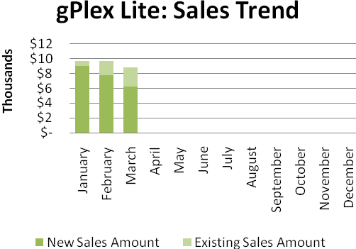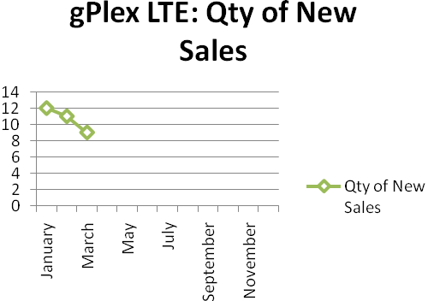
Dialer Report Summary-2015
Month | Qty of New Sales | New Sales Amount | Existing Sales Amount | Net Cashflow | Due Realized | Current Due
January | 6 | $ 1,650 | $ 31,600 | 96.53% | $ 1,714 | $ 1,154
February | 5 | $ 3,050 | $ 23,850 | 90.07% | $ 389 | $ 2,672
March | 3 | $ 1,300 | $ 29,033 | 92.85% | $ 1,883 | $ 2,170
April
May
June
July
August
September
October
November
December
Total |  | $ 6,000 | $ 84,483 |  | $ 3,986 | $ 5,996

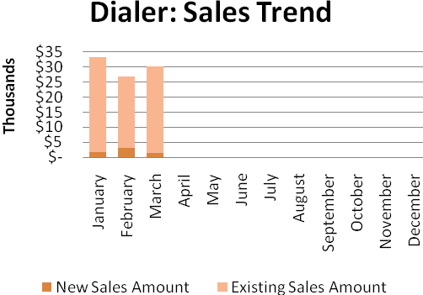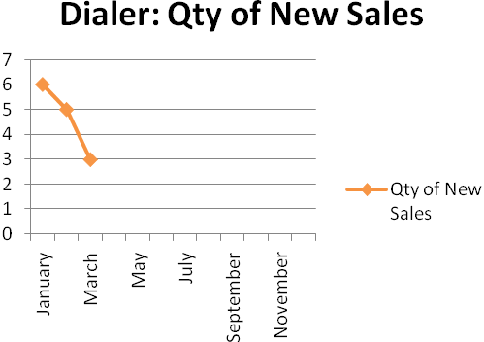

Switch Report Summary-2015
Month | Qty of New Sales | New Sales Amount | Existing Sales Amount | Net Cashflow | Due Realized | Current Due
January | 7 | $ 700 | $ 3,650 | 83.84% | $ 565 | $ 703
February | 10 | $ 3,300 | $ 2,150 | 59.43% | $ 922 | $ 2,211
March | 6 | $ 1,100 | $ 1,725 | 86.34% | $ 1,154 | $ 336
April
May
June
July
August
September
October
November
December
Total | 23 | $ 5,100 | $ 7,525 |  | $ 2,641 | $ 3,250

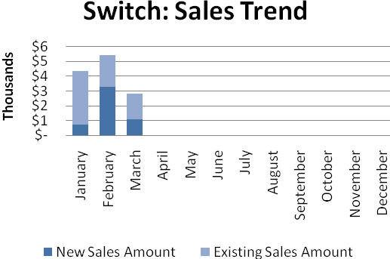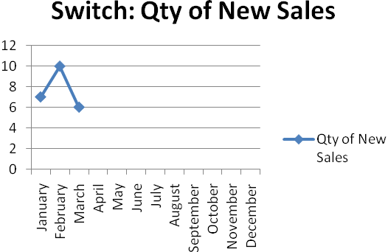

d. Department : Training
AGM & In-Charge : Mohammad Abdullah Al Masum
Current Status: Currently training department is running training for nineteen batches. Among these, five batches (21 NT, 22 NT, 21 WPSI, 23 WPSI, 25 CF) are being run for IDB. The other 14 batches are covering different customized courses.
Revenue: Total collection on account of training during March 2015 was TK. 1,029,376/-. The total amount of revenue in March 2015 activities was TK. 953,361/-.
Running Batch: Among 8 batched of Hi-Tech, 4 batches have completed their courses.
New Batch: We have got new batch from IDB. Beside this, we are hoping 6 more new batches to come from Hi-Tech.
Upcoming Batches: We have done precise marketing in the poly-technique schools of different districts of the country. This year we are expecting 300 students from different poly-techniques.
Prospective Batch: We have been visiting some NGOs. We are trying to convince them to encompass the Aid based training courses with us.
New Affiliation: From coming June, we will try to make affiliation with Bangladesh Technical education Board.
New lab proposal from IDB: IDB has proposed for a new lab solely to be used for them.

e. Department : International Voice Carrier
Manager : Md. Aminul Islam
Monthly traffic and client report for the month of March 2015

Coverage area:
01. Total Traffic
02. Voice Wholesale Traffic
03. gTalk Total Traffic
04. gTalkNA
05. gTalkUK
06. gTalk® Home

01. Total Traffic

01 (a). Total traffic by Months, Year 2013-2014
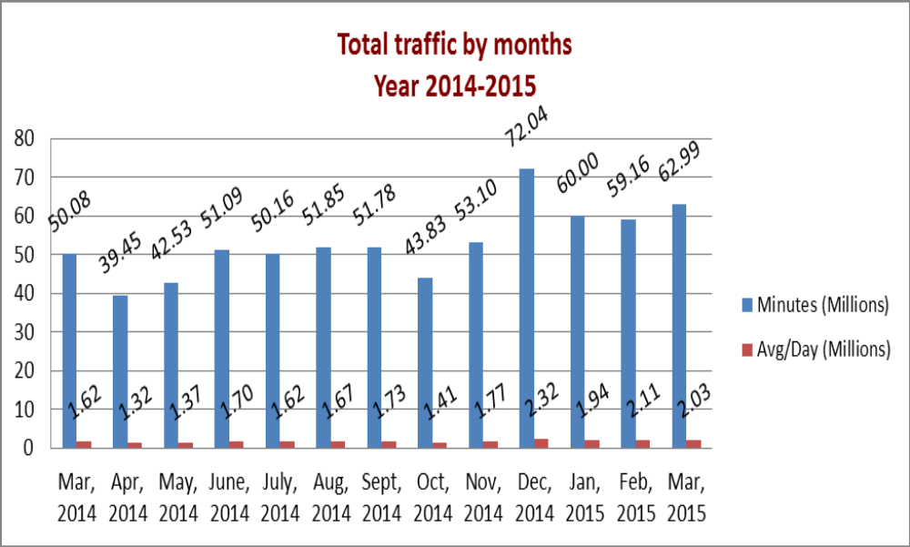

01(b). Total traffic by Months, Year 2013-2014 (According to 30 days)
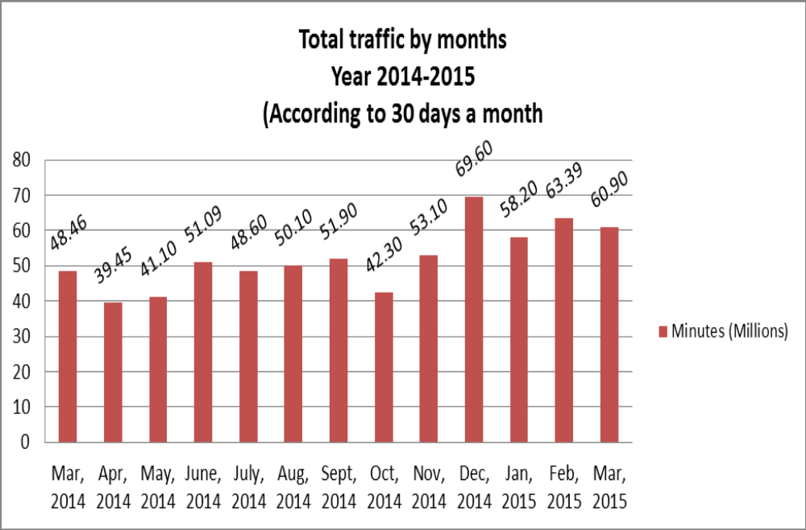

02. Total Voice Wholesale Traffic

02(a). Voice Wholesale: Total Traffic by months. Year 2013-2014

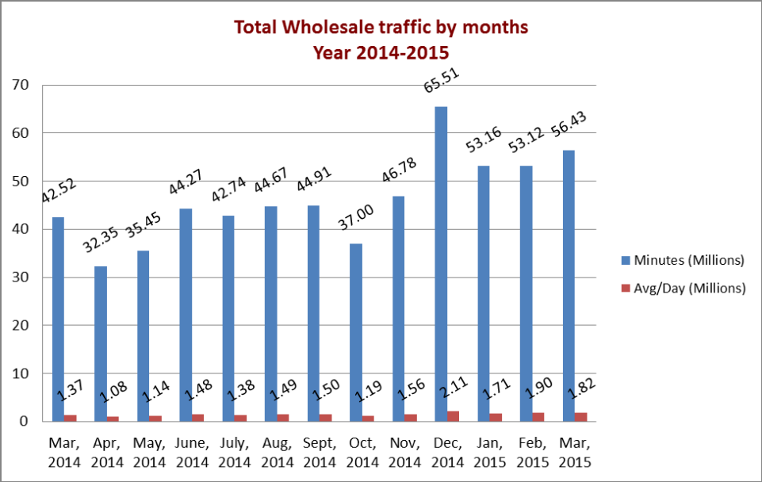

02(b). Voice Wholesale: Total Traffic by months. Year 2013-2014 (According to 30 days)

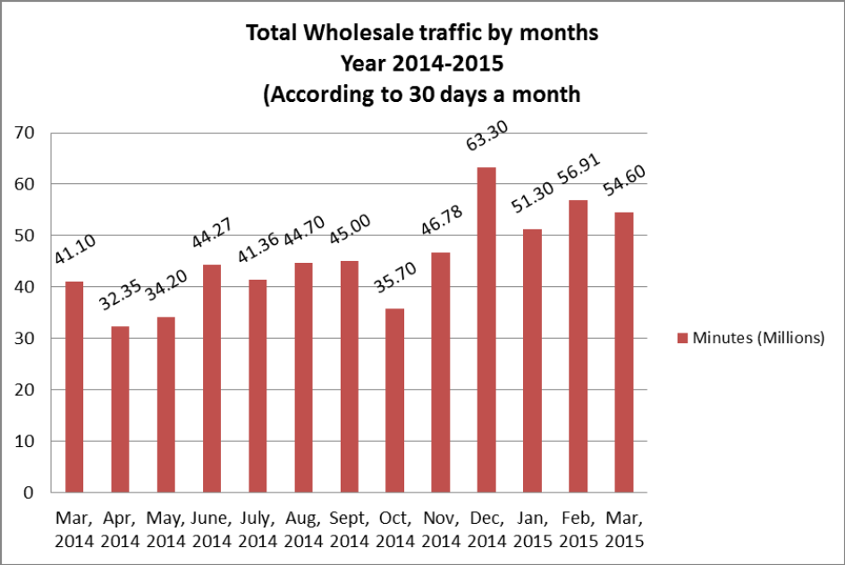

03. gTalk Total Traffic

03(a). gTalk : Total Traffic by months. Year 2013-2014

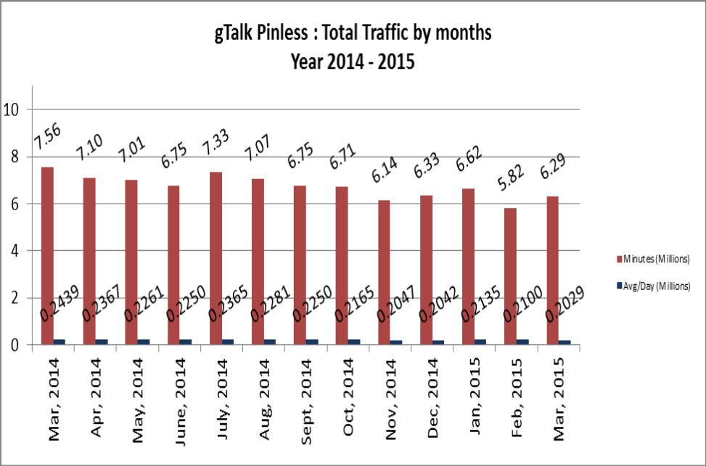

03(b). gTalk : Total Traffic by months (According to 30 days)

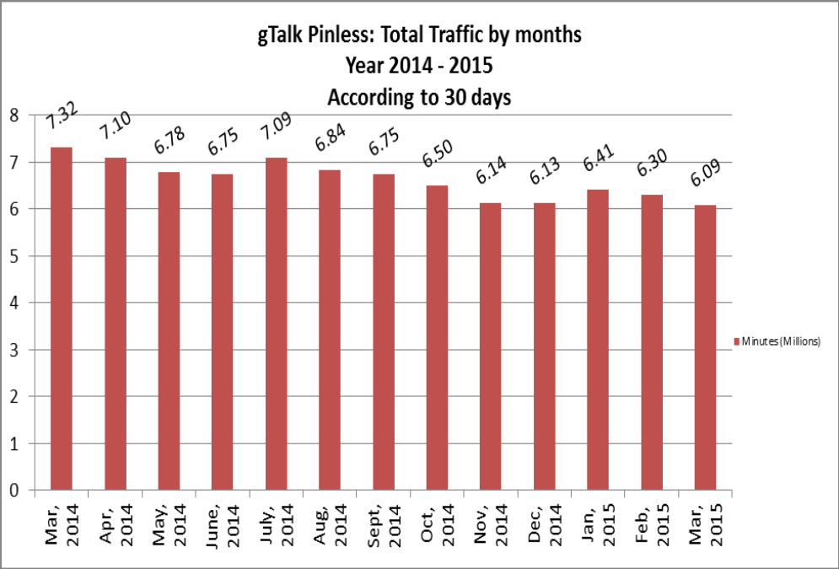

04. gTalk Pinless – Active Clients, Year 2014
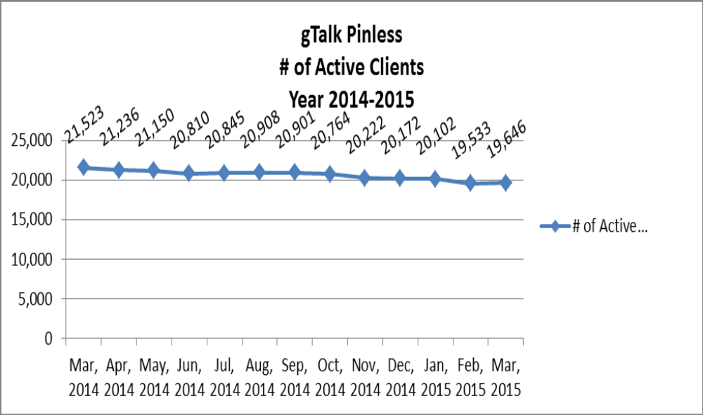

05. gTalk NA

05(a). gTalk NA : Total Traffic by months for the year 2013-2014

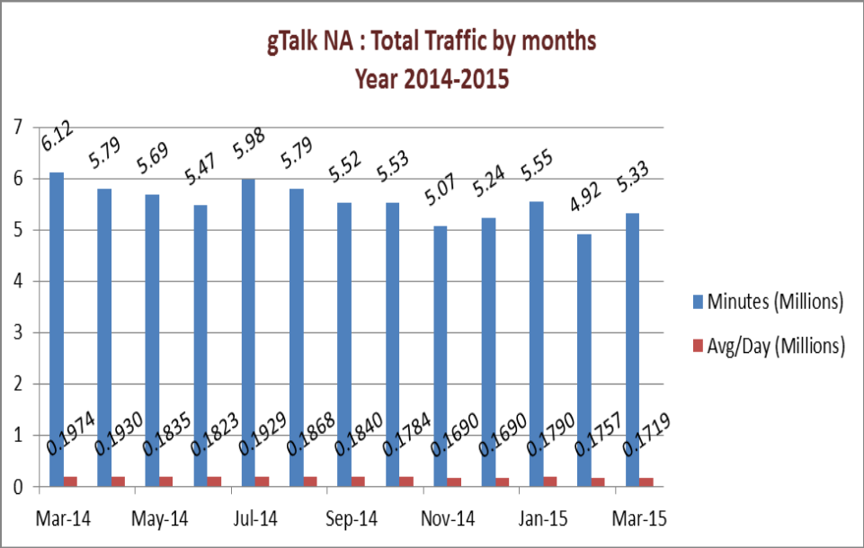

05(b). gTalk NA : Total Traffic by months for the year 2013-2014 (According to 30 Days)
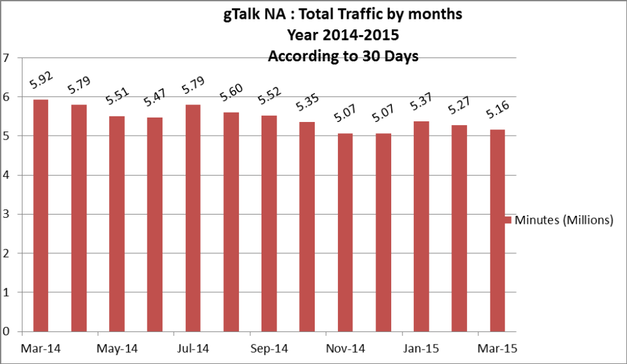
05(c). gTalk NA : New clients by months for the year 2013-2014

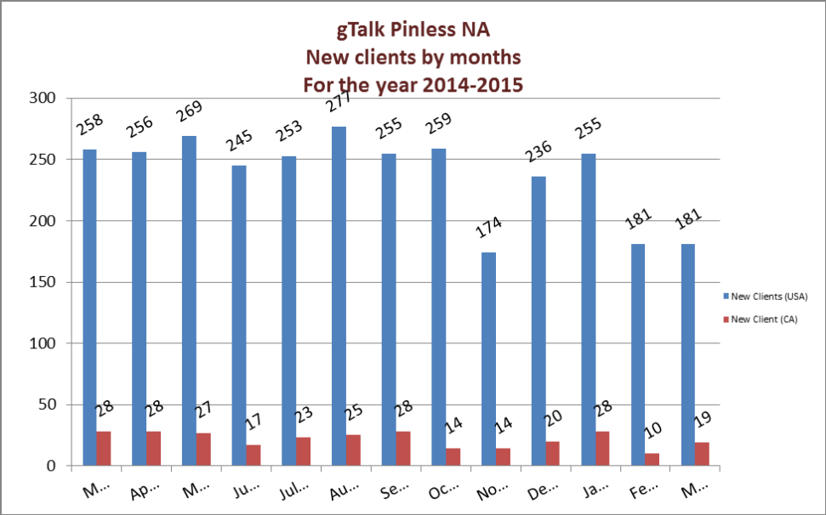

06. gTalk UK

06(a). gTalk UK : Total Traffic by months for the year 2013-2014

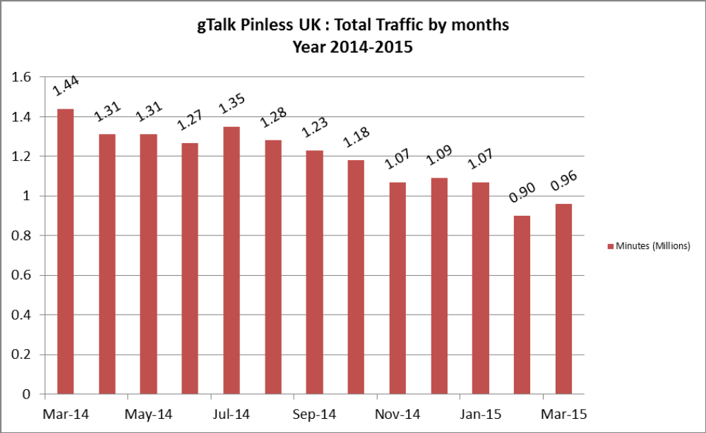

06(b). gTalk UK : Total Traffic by months for the year 2013-2014 (According to 30 Days)

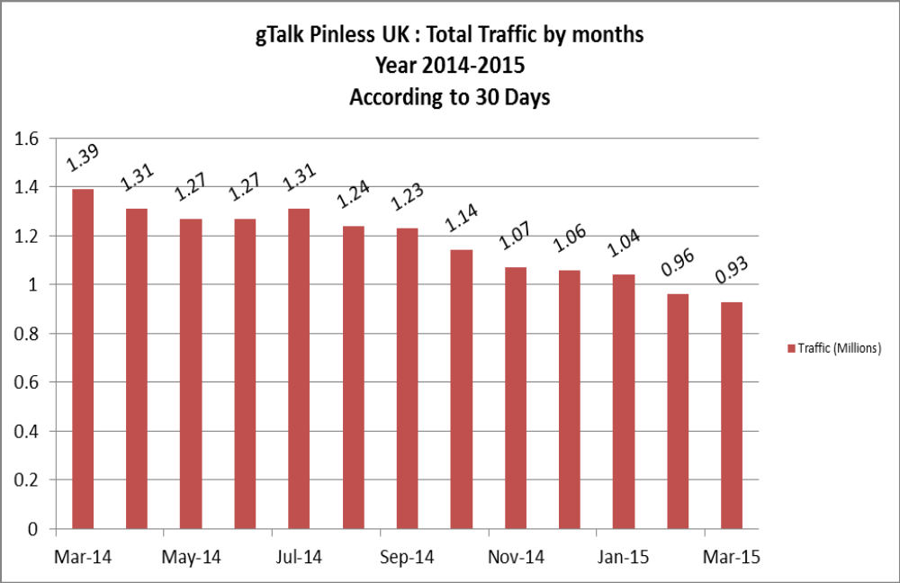

06(c). gTalk UK : New clients by months for the year 2013-2014
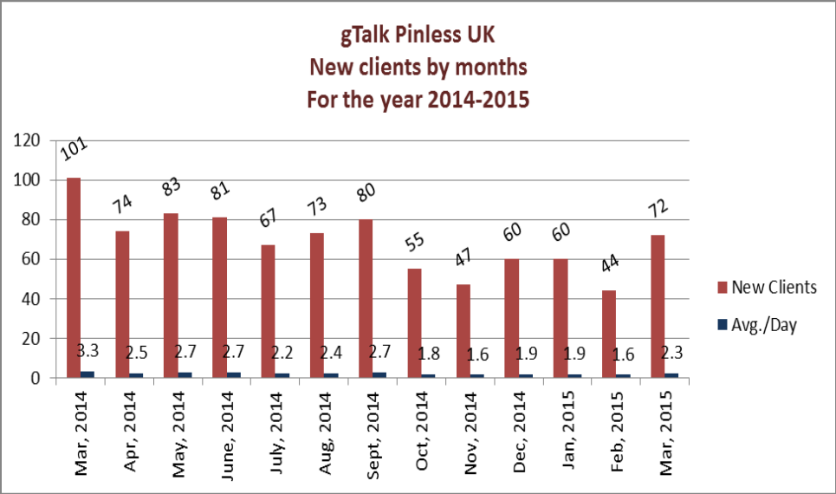
07. gTalk Home
07(a). gTalk® Home : Total Traffic by months for the year 2014

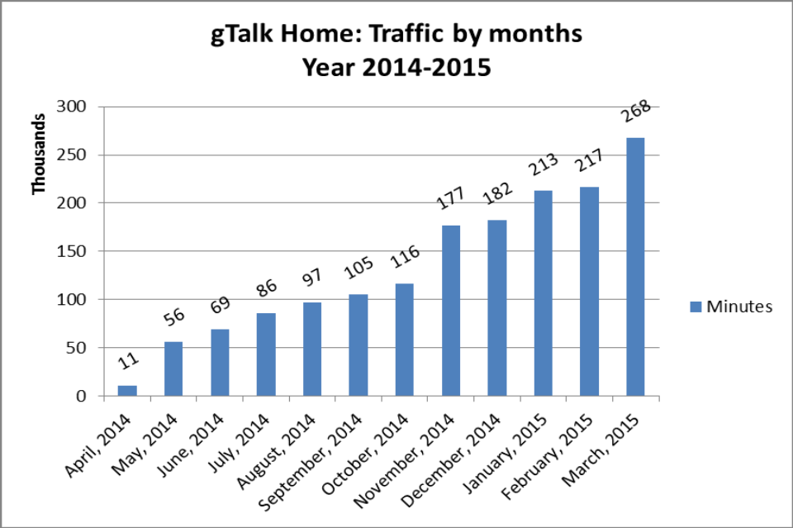

07(b). gTalk® Home : New clients by months for the year 2014
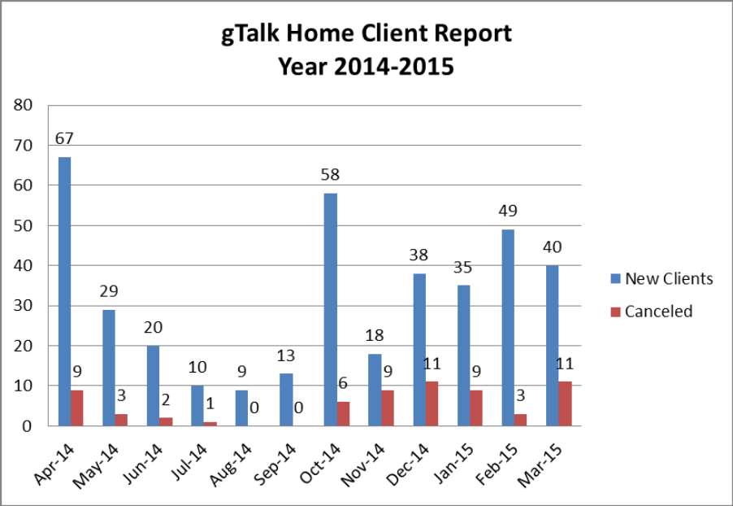

f. Department : Software
ED : Md. Anwarul Karim
Update of current projects: A detail discussion was held to provide information about the ongoing works of the department. Among those, iPhone Apps, Ticket Modification, PABX etc were given emphasis.
Software testing issue: The test of software has become an issue. Some problems are being faced regarding this. The software are being sent for market test before proper testing in software department. We do have a tester in our department who does the test job. Along with the tester, respective executives of a particular project also test their own projects. But we must bring it into a shape so that all the testing remains at tester end.

g. Department : Plexstar
CEO : M. Anis Rahman
We have received $22000 from the sale of the 4 devices in France.

h. Department : HR & Admin
CEO : Md. Habibur Rahman
Update about Manpower: Two new staffs joined this year. One in Training department and the other in Software department. Two staffs resigned from company during last three months.
Update about Mobile Bill: Quarterly update about staffs mobile bill payment was presented in the meeting.
Total Detail | January'15 | February'15 | March'15
Mobile | 57,571 | 34,027 | 39,132
Internet | 5,650 | 5,950 | 5,950
Total | 63,221 | 39,977 | 45,082

Update about regular official expenses:
An update was shared regarding the regular official expenses.

At the end, CEO showed appreciation to everyone for their presence and thoughtful insights about the company. He concluded the meeting by thanking to all.

