Reference: GSL/ Admin/ MCM 75

Attendance
75th Monthly Coordination Meeting
Date: 07th January 2016
Venue: GSL Conference Room

Time: 09.00 AM

The seventy fifth monthly coordination meeting of Genuity Systems Ltd. (GSL) was held on 7th January 2016 at Genuity Conference Room. Management team and the managers of different departments of the company were present in the meeting. List of participants of the meeting are as follows:
SL. | Name of Participants | Department | Signature
1. | Habib Rahman | President | Present
2. | M. Anis Rahman | Chief Executive Officer | Present
3. | Md. Sadiqur Rahman | Director Operations | Present
4. | K. Shahadat Hossain | Director Marketing | Present
5. | Md. Anwarul Karim | Executive Director | Present
6. | Md. Habibur Rahman | HR & Admin | Present
7. | Md. Waliul Haque Tusar | Network Operations | Present
8. | Md. Aminul Islam | International Voice Carrier | Present
9. | Sk. Kamruzzaman Prince | Corporate Marketing & Sales | Present
10. | Lutful Kabir Majumder | gPlex Software Solutions | Present
11. | Md. Ashrafuzzaman | Accounts | Present
12. | Md. Abdullah Al Masum | Training | Present

The meeting was started by the DGM, Head of HR & Admin. He thanked everyone for participating in the meeting and invited CEO to take control of the meeting. The CEO warmly welcomed everyone present in the meeting and thanked them for their presence. Thereafter he requested all departmental managers to deliver respective speech, one at a time, highlighting departmental performance and issues after last meeting. He invited all to raise queries/questions and share their opinion in the discussion as considered fit. The main points raised and discussed in the meeting on different issues are recorded below:

a. Department : Training
AGM & In-Charge : Mohammad Abdullah Al Masum
Current Status: Currently training department is running training for eight batches. Among these, four batches (25 NT, 26 WPSI, 28 CF, 27 WPSI) are being run for IDB. The rest 3 batches are covering different customized courses.
Revenue: Total collection on account of training for the month of December 2015 is TK. 8,03,446 /-.The total amount of revenue in December 2015 activities is TK. 10,80,486/-
Congratulations from CEO: CEO congratulated the training team through Mr. Masum for their yearly achievement which is the highest among Genuity Training’s history.

b. Department : Call Center (gTalk)
AGM : Md. Lutful Kabir Majumder

Current status of client joining and usage in gTalk pinless:

# Total client joined in gTalk till 31 December 2015: 61472

# Average client increase per day in December, 15: 8
# Average client increase per day in November, 15: 7
# Average client increase per day in October, 15: 6
# Average client increase per day in September, 15: 8
# Average client increase per day in August, 15: 7
# Average client increase per day in July, 15: 7
# Average client increase per day in June, 15: 6
# Average client increase per day in May, 15: 7
# Average client increase per day in April, 15: 7
# Average client increase per day in March, 15: 9
# Average client increase per day in February, 15: 8
# Average client increase per day in January, 15: 11

# Average total Minutes per day in December, 15: 162.61 K
# Average total Minutes per day in November, 15: 164.05 K
# Average total Minutes per day in October, 15: 160.88 K
# Average total Minutes per day in September, 15: 175.84 K
# Average total Minutes per day in August, 15: 175.18 K
# Average total Minutes per day in July, 15: 184.76 K
# Average total Minutes per day in June, 15: 182.13 K
# Average total Minutes per day in May, 15: 190.38 K
# Average total Minutes per day in April, 15: 199.46 K
# Average total Minutes per day in March, 15: 203.01 K
# Average total Minutes per day in February, 15: 207.75 K
# Average total Minutes per day in January, 15: 213.58 K

# Total customer used gTalk service in December, 15 about 18,218
# Total customer used gTalk service in November, 15 about 18,191
# Total customer used gTalk service in October, 15 about 18,033
# Total customer used gTalk service in September, 15 about 18,745
# Total customer used gTalk service in August, 15 about 18,870
# Total customer used gTalk service in July, 15 about 20,229
# Total customer used gTalk service in June, 15 about 19,423
# Total customer used gTalk service in May, 15 about 19,233
# Total customer used gTalk service in April, 15 about 19,971
# Total customer used gTalk service in March, 15 about 19,957
# Total customer used gTalk service in February, 15 about 20,032
# Total customer used gTalk service in January, 15 about 20,174

Unused Initial Balance for the month of December 2015: In the month of December, it has been found that total 27 customers have not used their Account Initial Balance after opening the account.

Current status after calling those customers is as follows:

- Customer using: 17 (63%)
- Customer still not using: 10 (37%)

Survey in December 2015: In the month of December, a total of 901 customers who are inactive for at least 2 months have been called. Details about customer’s feedback are given below:

- Ethnic Group:
  - Bangladesh – 494 (55%)
  - India – 50 (6%)
  - Nepal – 15 (2%)
  - Zimbabwe – 15 (2%)
  - Kenya – 13 (1%)
  - Pakistan – 11 (1%)
  - Miscellaneous- 303 (33%)

- Message left to the customers who were unavailable: 314 (35%)
- Number not in service: 304 (34%)
- Using other calling services or doesn’t make international calls: 173 (19%)
- Interested to use again: 110 (12%)
- Among 110 customers, 13 people have started to use gTalk service again after this survey.

Hot number uses:

October, 15: 36.42%
September, 15: 36.39%
August, 15: 36.70%
July, 15: 36.62%
June, 15: 37.81%
May, 15: 37.24%
April, 15: 36.84%
March, 15: 36.66%
February, 15: 37.02%
January, 15: 36.55%

Hot Dialer Report
Total User(s): 13321

VoIP Dialer Report
Total User(s): 1738

Total SMS from December 1 to December 31, 15: 688 and Failed SMS: 42

# Total client joined in gTalk UK till 31 December 2015: 7701

# Total client joined in December 2015: 42
# Total client joined in November 2015: 47
# Total client joined in October 2015: 45
# Total client joined in September 2015: 42
# Total client joined in August 2015: 38
# Total client joined in July 2015: 32
# Total client joined in June 2015: 29
# Total client joined in May 2015: 38
# Total client joined in April 2015: 31
# Total client joined in March 2015: 72
# Total client joined in February 2015: 44
# Total client joined in January 2015: 60

# Total Minutes for the month of December, 15: 736.50 K
# Total Minutes for the month of November, 15: 742.35 K
# Total Minutes for the month of October, 15: 712.00 K
# Total Minutes for the month of September, 15: 789.54 K
# Total Minutes for the month of August, 15: 761.48 K
# Total Minutes for the month of July, 15: 835.39 K
# Total Minutes for the month of June, 15: 797.04 K
# Total Minutes for the month of May, 15: 859.81 K
# Total Minutes for the month of April, 15: 891.71 K
# Total Minutes for the month of March, 15: 959.81 K
# Total Minutes for the month of February, 15: 898.70 K
# Total Minutes for the month of January, 15: 1070.12 K

Packages and Deals Report: December 1 to 31
Country | Package Name | Rate | Number of Purchase | Amount
Australia | Bangladesh All (400min ) | $12.90 | 3 | $38.70
Australia | Bangladesh All (Unlimited ) | $34.90 | 1 | $34.90
Canada | Bangladesh All (400min ) | $12.90 | 11 | $141.90
Canada | Bangladesh All (800min ) | $21.90 | 1 | $21.90
Canada | Bangladesh All (Unlimited ) | $34.90 | 13 | $453.70
Canada | Bangladesh All (Unlimited ) | $44.90 | 3 | $134.70
Canada | India All (Unlimited ) | $14.90 | 13 | $193.70
Canada | Pakistan All (500min ) | $19.90 | 1 | $19.90
UK | Bangladesh All (250min ) | £6.00 | 11 | £66.00
UK | Bangladesh All (500min ) | £10.00 | 67 | £670.00
UK | Bangladesh All (1500min ) | £24.00 | 38 | £912.00
UK | India All (Unlimited ) | £10.00 | 1 | £10.00
UK | Pakistan All (1000min ) | £18.90 | 1 | £18.90
USA | Bangladesh All (400min ) | $12.90 | 63 | $812.70
USA | Bangladesh All (800min ) | $21.90 | 30 | $657.00
USA | Bangladesh All (Unlimited ) | $34.90 | 310 | $10819.00
USA | Bangladesh All (Unlimited ) | $44.90 | 77 | $3457.30
USA | India All (Unlimited ) | $14.90 | 39 | $581.10
USA | Pakistan All (250min ) | $11.90 | 3 | $35.70
USA | Pakistan All (1000min ) | $29.90 | 1 | $29.90
Total : |  |  | 687 | $20115.14

Packages Minute Balance Report: December 1 to 31
Country | Package | # of Packages | Amount | Credit Min | Used Min | % Use | Balance Min | Sale Rate
Australia | Bangladesh All (400min ) | 3 | $38.70 | 1200 | 547 | 45.58% | 653 | $0.0707
Australia | Bangladesh All (Unlimited ) | 1 | $34.90 | 2000 | 1895 | 94.75% | 105 | $0.0184
Canada | Bangladesh All (400min ) | 11 | $141.90 | 4400 | 3275 | 74.43% | 1125 | $0.0433
Canada | Bangladesh All (800min ) | 1 | $21.90 | 800 | 327 | 40.88% | 473 | $0.0670
Canada | Bangladesh All (Unlimited ) | 13 | $453.70 | 26000 | 17711 | 68.12% | 8289 | $0.0256
Canada | Bangladesh All (Unlimited ) | 3 | $134.70 | 7500 | 4253 | 56.71% | 3247 | $0.0317
Canada | India All (Unlimited ) | 13 | $193.70 | 26000 | 11820 | 45.46% | 14180 | $0.0164
Canada | Pakistan All (500min ) | 1 | $19.90 | 500 | 103 | 20.60% | 397 | $0.1932
UK | Bangladesh All (250min ) | 11 | £66.00 | 2750 | 2303 | 83.75% | 447 | £0.0287
UK | Bangladesh All (500min ) | 67 | £670.00 | 33500 | 28365 | 84.67% | 5135 | £0.0236
UK | Bangladesh All (1500min ) | 38 | £912.00 | 57000 | 46383 | 81.37% | 10617 | £0.0197
UK | India All (Unlimited ) | 1 | £10.00 | 2000 | 310 | 15.50% | 1690 | £0.0323
UK | Pakistan All (1000min ) | 1 | £18.90 | 1000 | 173 | 17.30% | 827 | £0.1092
USA | Bangladesh All (400min ) | 63 | $812.70 | 25200 | 20426 | 81.06% | 4774 | $0.0398
USA | Bangladesh All (800min ) | 30 | $657.00 | 24000 | 15853 | 66.05% | 8147 | $0.0414
USA | Bangladesh All (Unlimited ) | 310 | $10819.00 | 620000 | 403073 | 65.01% | 216927 | $0.0268
USA | Bangladesh All (Unlimited ) | 77 | $3457.30 | 192500 | 95931 | 49.83% | 96569 | $0.0360
USA | India All (Unlimited ) | 39 | $581.10 | 78000 | 37654 | 48.27% | 40346 | $0.0154
USA | Pakistan All (250min ) | 3 | $35.70 | 750 | 616 | 82.13% | 134 | $0.0580
USA | Pakistan All (1000min ) | 1 | $29.90 | 1000 | 630 | 63.00% | 370 | $0.0475
Total |  | 687 | $20115.14 | 1106100 | 691648 | 62.53% | 414452 | $0.0291

c. Department : gPlex Software Solutions
AGM : Md. Lutful Kabir Majumder

Genuity Systems Limited
gPlex Switch and Dialer Sales Report
December 2015
 |  | Mobile Dialer |  | Soft Switch |  | Total
 |  | Amount | % | Amount | % | Amount | %
Total Billed |  | $10,855.00 | 100.00% | $5,321.00 | 100.00% | $16,176 | 100.00%
Received for Current Bills |  | $9,575.00 | 88.21% | $3,633.00 | 68.28% | $13,208 | 81.65%
Advance Expired |  | $0.00 | 0.00% | $112.00 | 2.10% | $112 | 0.69%
Current Due |  | $1,280.00 | 11.79% | $1,576.00 | 29.62% | $2,856 | 17.66%
Written Off |  | $0.00 | 0.00% | $0.00 | 0.00% | $0 | 0.00%
Total Received |  | $10,878.00 | 100.00% | $5,289.00 | 100.00% | $16,167 | 100.00%
Received for Current Bills |  | $9,575.00 | 88.02% | $3,633.00 | 68.69% | $13,208 | 81.70%
Received for Last Month's Dues |  | $572.00 | 5.26% | $1,050.00 | 19.85% | $1,622 | 10.03%
Received for Older Dues |  | $728.00 | 6.69% | $310.00 | 5.86% | $1,038 | 6.42%
Advance Received |  | $3.00 | 0.03% | $296.00 | 5.60% | $299 | 1.85%
Qty of New Sales |  | 2 | 5.41% | 3 | 7.32%
Qty of Existing Sales |  | 35 | 94.59% | 38 | 92.68%
Total |  | 37 | 100.00% | 41 | 100.00%

 |  | gPlex Dialer Report
 |  | December 2015
 |  | December 2015
 |  | New Client | Existing Client | Total | %
Bills & Receipts
Total Billed |  | $ 2,000 | $ 8,855 | $ 10,855 | 100.00%
Received for Current Bills |  | $ 1,500 | $ 8,075 | $ 9,575 | 88.21%
Advance Expired |  | $ - | $ - | $ - | 0.00%
Current Due |  | $ 500 | $ 780 | $ 1,280 | 11.79%
Quantity of Sales |  | 2 | 35 | $ 37
Cash Analysis
Total Received |  | $ 1,500 | $ 9,378 | $ 10,878 | 100.00%
Received for Current Bills |  | $ 1,500 | $ 8,075 | $ 9,575 | 88.02%
Received for Last Month's Dues |  | $ - | $ 572 | $ 572 | 5.26%
Received for Older Dues |  | $ - | $ 728 | $ 728 | 6.69%
Advance Received |  | $ - | $ 3 | $ 3 | 0.03%
Net Cashflow |  |  |  |  | 88.21%
Accounts Receivable Statement |  |  |  | December 2015
Accounts Receivable B/F |  |  |  | $ 117,640
Current Due |  |  |  | $ 1,280
Received for Last Month's Dues |  |  | $ 572
Received for Older Dues |  |  | $ 728 | $ 1,300
Discount Allowed |  |  |  | $ -
Written Off (Bad Debt/ Credit Notes) |  |  |  | $ -
Accounts Receivable C/F |  |  |  | $ 117,620
Last Month's Dues |  |  |  | $ 4,464
Received for Last Month's Dues |  |  |  | $ 572
Remaining Last Month's Dues as of Current Month |  |  |  | $ 3,892

 |  |  |  | gPlex SoftSwitch Report
 |  |  |  | December 2015
 |  |  |  | December 2015
 |  |  |  | New Client | Existing Client | Total | %
Bills & Receipts
Total Billed |  |  |  | $ 300 | $ 5,021 | $ 5,321 | 100.00%
Received for Current Bills |  |  |  | $ 300 | $ 3,333 | $ 3,633 | 68.28%
Advance Expired |  |  |  | $ - | $ 112 | $ 112 | 2.10%
Written Off- Current |  |  |  | $ - | $ - | $ - | 0.00%
Current Due |  |  |  | $ - | $ 1,576 | $ 1,576 | 29.62%
Quantity of Sales |  |  |  | 3 | 38 | $ 41
Cash Analysis
Total Received |  |  |  | $ 300 | $ 4,989 | $ 5,289 | 100.00%
Received for Current Bills |  |  |  | $ 300 | $ 3,333 | $ 3,633 | 68.69%
Received for Last Month's Dues |  |  |  | $ - | $ 1,050 | $ 1,050 | 19.85%
Received for Older Dues |  |  |  | $ - | $ 310 | $ 310 | 5.86%
Advance Received |  |  |  | $ - | $ 296 | $ 296 | 5.60%
Net Cashflow |  |  |  |  |  |  | 70.38%
Accounts Receivable Statement |  |  |  |  |  | December 2015
Accounts Receivable B/F |  |  |  |  |  | $ 74,612
Current Due |  |  |  |  |  | $ 1,576
Received for Last Month's Dues |  |  |  |  | $ 1,050
Received for Older Dues |  |  |  |  | $ 310 | $ 1,360
Discount Allowed
Written Off- Last Month |  |  |  |  |  | $ -
Written Off-Older |  |  |  |  |  | $ -
Accounts Receivable C/F |  |  |  |  |  | $ 74,828
Last Month's Dues |  |  |  |  |  | $ 1,434
Received for Last Month's Dues |  |  |  |  |  | $ 1,050
 |  |  | Remaining Last Month's Dues as of This Month |  |  | $ 384

Switch Report Summary-2015
Month | Qty of New Sales | New Sales Amount | Existing Sales Amount | Net Cashflow | Due Realized | Current Due
January | 7 | $ 700 | $ 3,650 | 83.84% | $ 565 | $ 703
February | 10 | $ 3,300 | $ 2,150 | 59.43% | $ 922 | $ 2,211
March | 6 | $ 1,100 | $ 1,725 | 86.34% | $ 1,154 | $ 336
April | 7 | $ 1,631 | $ 1,725 | 64.36% | $ 335 | $ 1,196
May | 8 | $ 1,254 | $ 1,375 | 70.52% | $ 668 | $ 775
June | 17 | $ 3,479 | $ 1,050 | 87.41% | $ 452 | $ 570
July | 13 | $ 3,630 | $ 2,292 | 85.55% | $ - | $ 856
August | 13 | $ 2,400 | $ 3,052 | 66.23% | $ 708 | $ 1,841
September | 7 | $ 850 | $ 3,179 | 79.85% | $ 902 | $ 1,012
October | 5 | $ 790 | $ 3,527 | 71.88% | $ 1,148 | $ 1,214
November | 7 | $ 1,467 | $ 4,900 | 77.48% | $ 1,115 | $ 1,434
December | 3 | $ 300 | $ 5,021 | 70.38% | $ 1,360 | $ 1,576
Total | 103 | $ 20,901 | $ 33,646 |  | $ 9,329 | $ 13,724
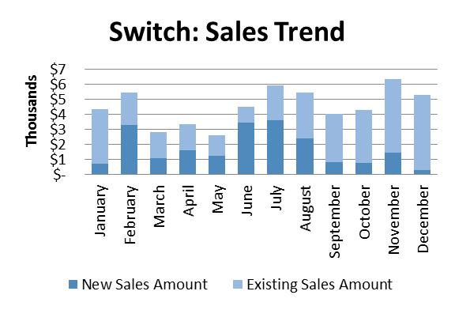
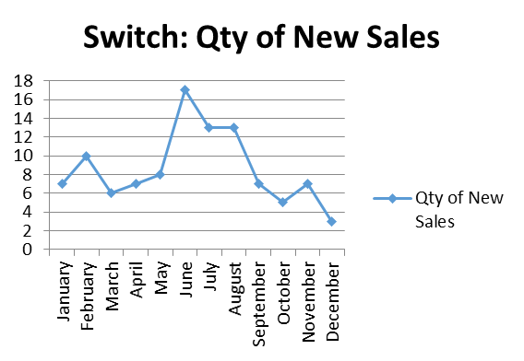
Dialer Report Summary-2015
Month | Qty of New Sales | New Sales Amount | Existing Sales Amount | Net Cashflow | Due Realized | Current Due
January | 6 | $ 1,650 | $ 31,600 | 96.53% | $ 1,714 | $ 1,154
February | 5 | $ 3,050 | $ 23,850 | 90.07% | $ 389 | $ 2,672
March | 3 | $ 1,300 | $ 29,033 | 92.85% | $ 1,883 | $ 2,170
April | 5 | $ 1,600 | $ 21,335 | 87.53% | $ 1 | $ 2,859
May | 8 | $ 6,750 | $ 27,431 | 80.30% | $ 1,064 | $ 6,732
June | 7 | $ 2,375 | $ 16,370 | 85.38% | $ 837 | $ 2,883
July | 8 | $ 1,194 | $ 16,842 | 96.88% | $ 3,391 | $ 562
August | 6 | $ 2,850 | $ 13,226 | 83.04% | $ 4,896 | $ 2,727
September | 4 | $ 1,200 | $ 10,538 | 79.34% | $ 953 | $ 2,425
October | 8 | $ 5,275 | $ 9,339 | 75.02% | $ 652 | $ 3,650
November | 7 | $ 2,600 | $ 18,507 | 78.85% | $ 1,518 | $ 4,464
December | 2 | $ 2,000 | $ 8,855 | 88.21% | $ 1,300 | $ 1,280
Total |  | $ 31,844 | $ 226,926 |  | $ 18,598 | $ 33,578

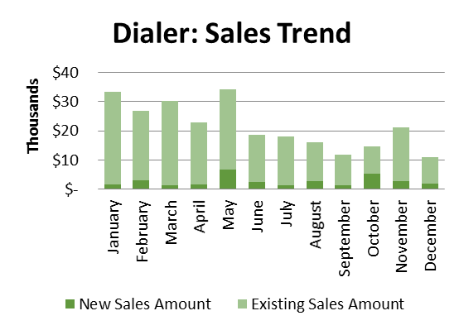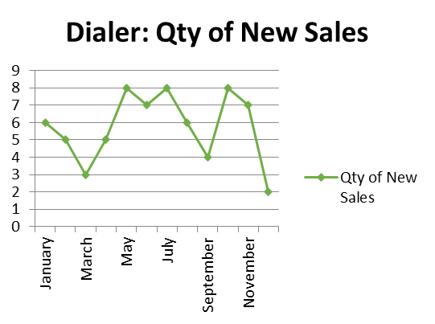

Co-location of switch: A proposal was given about switch co-location from head of gPlex. In reply of the proposal, CEO shared that our switch location back up will be transferred to Amsterdam within Feb 28, 2016 and we will be using the new location from March 01, 2016. So there is no use of introducing any new co-location at this moment. Rather he instructed to prepare the Marketing team about handling the change among the clients.

d. Department : Corporate Marketing & Sales
DGM : Sk. Kamruzzaman Prince

Discussion about gPlex CC & gTalk IP PBX:

Call Center:
Total number of PO received in 2015 | 7
Total value of PO | BDT 41.56 lac
Total cash realization against received PO | BDT 18.44 lac ( 45% of total amount )
Submitted invoices and not realized | BDT 23.84 lac
Unbilled/un-invoiced | BDT 54.80 lac
Recovery / cash received in 2015 | BDT 101.38 lac
SLA and rent to be invoiced against received PO in 2016 | BDT 48.24 lac ( partial in 2017 )
Recovery + Submitted invoice + un-invoiced | BDT 180.00 lac

Prospective clients :
- Dhaka Bank Ltd
- Bank Alfalah Ltd
- First Security Islami Bank Ltd
- NCC Bank Ltd
- Doctorola
- Windmill
- Social Islami Bank Ltd
- Standard Bank Ltd
- Akij Group
- Jamuna Bank Ltd
- Rahim Afrooz
- Modhumoti Bank Ltd
- IPDC
- Skyina
- NRB Global Bank
- Bank Asia ( existing ) ; will increase seat capacity
- City Bank ( existing ); will issue PO for Web chat
- Lankabangla ( existing ); will take Predictive Dialer and Web chat

IP PBX clients:
- ONE Bank
- NCC Bank Ltd
- Energypac
- NRB Commercial
- Shah cement
- Ananta Garments
- Radiant Pharmaceuticals

Disaster recovery data center: The disaster recovery data center will be made along with Dallas office soon and back up will be kept as geographical location. If any problem occurs in any location, client will get backup from another location within 1 or 2 minutes without even realizing the problem. By 1st March 2016, there will be no data in Dallas center.
Service of geographical location: A MAX this is an insurance company in USA, they have 99 offices in different locations. As a test case they are using one of its branch in Dallas. If we can satisfy them, gradually all the offices/branches will come into an umbrella of gPlex Call center / gTalk IP PBX or both.

e. Department : NOC & Software
ED : Md. Anwarul Karim
Report of NOC Resolution:

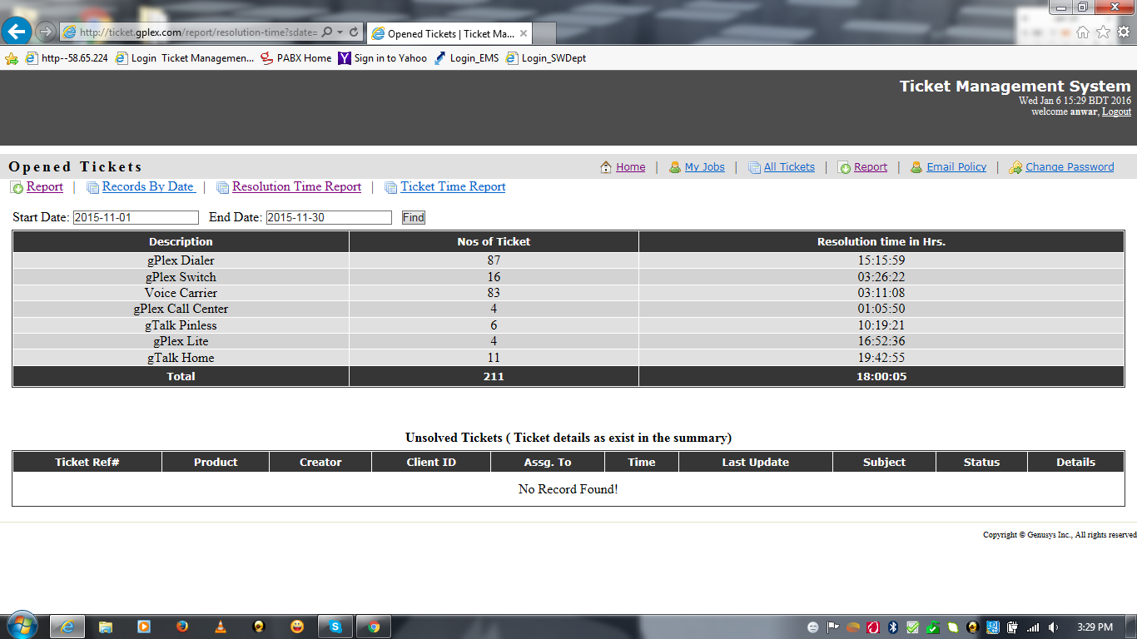

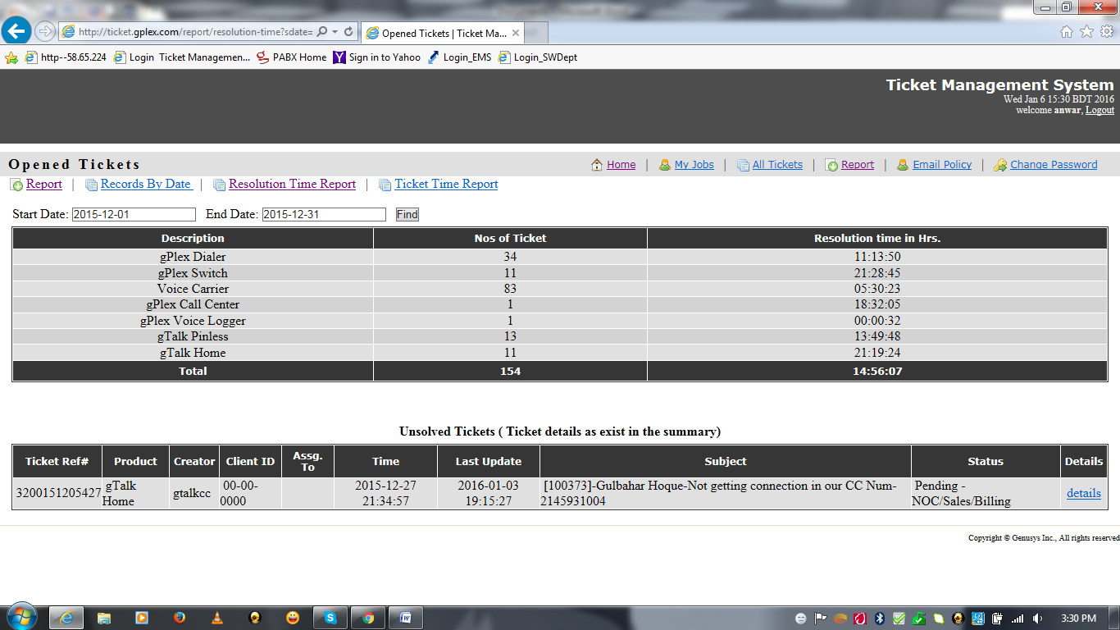

Work done in November to December 2015
- “Training” admin panel Additional works.

- “EMS” first phases.
- “HR Payroll”.
- “gPlex Switch” additional features.

- “Cloud Contact Center” first phases.

- “Chat Module” first phase.

- “CloudCC Call Control” first phases.

- “CloudCC Dashboard” first phases.

- “gTalk PBX” (Extension Panel, Admin Panel, Supervisor Panel).

- “gTalk PA System” (Android).

- gPlex Dialer Apk Build Automation (android).

Work on going in November to December

- “Cloud Contact Center” next phases.
- “Chat Module” next phase.

- “CloudCC Call Control” next phases.
- “gTalk PBX (Root Panel , Invoice)”.

- “CRM and Sales” (Genusys Limited Inventory Management).

- “gTalk PBX” iPhone App.
- Automated financial statement parsing and updating web panel.
- “gTalk Home-iOS” push notification.

- “EMS” Purchase Requisition.

- Monthly Report of “Dialer” and “Switch”.

- “Screen Logger” faster upload.

- “YouTube project” for android.

- “Provident Fund” management.

- “Radiant Field Force Management” (FFM) and “Order Process Management” (OPM) module.

- “Edusys Marketplace” first phases.

- “Genusys Ltd. Accounting Software” customization.

- “CloudCC Call Control Desktop Version”.

- “CloudCC Softphone”.

- “CloudCC Wallboard”.

f. President : Habib Rahman
Sell of PABX in 2016: We assume that sell of 10000 channel of PABX is possible. Hope our marketing partners will play vital role in promotion and sales.

g. Department : HR & Admin
DGM : Md. Habibur Rahman
Update about case with DB: We have submitted all required papers to BTRC to dismiss the case we had from DB. Soon we will be given with a hearing date to dismiss it.
Calendar for 2016: Calendar for 2016 has been distributed as per schedule. Due to problem with hanger making, internal employee distribution was disturbed.
Information about business in e-commerce: Targeting the gTalk clients, we can import some gift items to Bangladesh. Later, this e-commerce will open merchant account. Under this merchant account, individuals will open account. They will use their account using our flat form and continue their own business. We will provide support to those accounts through our Call Center.
Update about staff resignation: An update was shared regarding the staff.

Event | No. | Detail
Resignation | 1 | Cook Rana has resigned
Recruitment | 2 | 2 staffs has been recruited for Corporates Sales & Marketing Department
Intern | 3 | 3 Interns have been recruited for 3 months term

Update about Mobile Bill: Communication bill payment of Genuity staffs was presented in the meeting.
Total Detail | October'15 | November'15
Mobile | 54,650 | 58,750
Internet | 5,495 | 4,625
Total | 60,145 | 63,375

Update about regular official expenses: An update was shared regarding the regular official expenses.

At the end, CEO showed appreciation to everyone for their presence and thoughtful insights about the company. He concluded the meeting by thanking to all.

