Reference: GSL/ Admin/ MCM 76

Attendance
76th Monthly Coordination Meeting
Date: 10th February 2016
Venue: GSL Conference Room

Time: 09.00 AM

The seventy fifth monthly coordination meeting of Genuity Systems Ltd. (GSL) was held on 10th February 2016 at Genuity Conference Room. Management team and the managers of different departments of the company were present in the meeting. List of participants of the meeting are as follows:
SL. | Name of Participants | Department | Signature
1. | Habib Rahman | President | Present
2. | M. Anis Rahman | Chief Executive Officer | Present
3. | Md. Sadiqur Rahman | Director Operations | Present
4. | K. Shahadat Hossain | Director Marketing | Present
5. | Md. Anwarul Karim | Executive Director | Present
6. | Md. Habibur Rahman | HR & Admin | Present
7. | Md. Waliul Haque Tusar | Network Operations | Present
8. | Md. Aminul Islam | International Voice Carrier | Present
9. | Sk. Kamruzzaman Prince | Corporate Marketing & Sales | Present
10. | Lutful Kabir Majumder | gPlex Software Solutions | Present
11. | Md. Ashrafuzzaman | Accounts | Present
12. | Md. Abdullah Al Masum | Training | Present

The meeting was started by the DGM, Head of HR & Admin. He thanked everyone for participating in the meeting and invited CEO to take control of the meeting. The CEO warmly welcomed everyone present in the meeting and thanked them for their presence. Thereafter he requested all departmental managers to deliver respective speech, one at a time, highlighting departmental performance and issues after last meeting. He invited all to raise queries/questions and share their opinion in the discussion as considered fit. The main points raised and discussed in the meeting on different issues are recorded below:

a. Department : Call Center (gTalk)
AGM : Md. Lutful Kabir Majumder

Current status of client joining and usage in gTalk pinless:

# Total client joined in gTalk till 31 January 2016: 61673

# Average client increase per day in January, 16: 6
# Average client increase per day in December, 15: 8
# Average client increase per day in November, 15: 7
# Average client increase per day in October, 15: 6
# Average client increase per day in September, 15: 8
# Average client increase per day in August, 15: 7
# Average client increase per day in July, 15: 7
# Average client increase per day in June, 15: 6
# Average client increase per day in May, 15: 7
# Average client increase per day in April, 15: 7
# Average client increase per day in March, 15: 9
# Average client increase per day in February, 15: 8
# Average client increase per day in January, 15: 11

# Average total Minutes per day in January, 16: 159.12 K
# Average total Minutes per day in December, 15: 162.61 K
# Average total Minutes per day in November, 15: 164.05 K
# Average total Minutes per day in October, 15: 160.88 K
# Average total Minutes per day in September, 15: 175.84 K
# Average total Minutes per day in August, 15: 175.18 K
# Average total Minutes per day in July, 15: 184.76 K
# Average total Minutes per day in June, 15: 182.13 K
# Average total Minutes per day in May, 15: 190.38 K
# Average total Minutes per day in April, 15: 199.46 K
# Average total Minutes per day in March, 15: 203.01 K
# Average total Minutes per day in February, 15: 207.75 K
# Average total Minutes per day in January, 15: 213.58 K

# Total customer used gTalk service in January, 16 about 18,282
# Total customer used gTalk service in December, 15 about 18,218
# Total customer used gTalk service in November, 15 about 18,191
# Total customer used gTalk service in October, 15 about 18,033
# Total customer used gTalk service in September, 15 about 18,745
# Total customer used gTalk service in August, 15 about 18,870
# Total customer used gTalk service in July, 15 about 20,229
# Total customer used gTalk service in June, 15 about 19,423
# Total customer used gTalk service in May, 15 about 19,233
# Total customer used gTalk service in April, 15 about 19,971
# Total customer used gTalk service in March, 15 about 19,957
# Total customer used gTalk service in February, 15 about 20,032
# Total customer used gTalk service in January, 15 about 20,174

Unused Initial Balance for the month of January 2016: In the month of January, it has been found that total 20 customers have not used their Account Initial Balance after opening the account.

Current status after calling those customers is as follows:

- Customer using: 13 (65%)
- Customer still not using: 7 (35%)

Survey in January 2016: In the month of January, a total of 882 customers who are inactive for at least 2 months have been called. Details about customer’s feedback are given below:

- Ethnic Group:
  - Bangladesh – 578 (65%)
  - India – 58 (7%)
  - Zimbabwe – 22 (2%)
  - Kenya – 16 (2%)
  - Pakistan – 15 (2%)
  - Nepal – 10 (1%)
  - Miscellaneous- 183 (21%)

- Message left to the customers who were unavailable: 344 (39%)
- Number not in service: 288 (33%)
- Using other calling services or doesn’t make international calls: 162 (18%)
- Interested to use again: 88 (10%)
Among 88 customers, 6 people have started to use gTalk service again after this survey.

Hot number uses:

October, 15: 36.42%
September, 15: 36.39%
August, 15: 36.70%
July, 15: 36.62%
June, 15: 37.81%
May, 15: 37.24%
April, 15: 36.84%
March, 15: 36.66%
February, 15: 37.02%
January, 15: 36.55%

Hot Dialer Report
Total User(s): 13471

VoIP Dialer Report
Total User(s): 1774

Total SMS from January 1 to January 31, 16: 672 and Failed SMS: 36

# Total client joined in gTalk UK till 31 January 2016: 7744

# Total client joined in January 2016: 43
# Total client joined in December 2015: 42
# Total client joined in November 2015: 47
# Total client joined in October 2015: 45
# Total client joined in September 2015: 42
# Total client joined in August 2015: 38
# Total client joined in July 2015: 32
# Total client joined in June 2015: 29
# Total client joined in May 2015: 38
# Total client joined in April 2015: 31
# Total client joined in March 2015: 72
# Total client joined in February 2015: 44
# Total client joined in January 2015: 60

# Total Minutes for the month of January, 16: 709.47 K
# Total Minutes for the month of December, 15: 736.50 K
# Total Minutes for the month of November, 15: 742.35 K
# Total Minutes for the month of October, 15: 712.00 K
# Total Minutes for the month of September, 15: 789.54 K
# Total Minutes for the month of August, 15: 761.48 K
# Total Minutes for the month of July, 15: 835.39 K
# Total Minutes for the month of June, 15: 797.04 K
# Total Minutes for the month of May, 15: 859.81 K
# Total Minutes for the month of April, 15: 891.71 K
# Total Minutes for the month of March, 15: 959.81 K
# Total Minutes for the month of February, 15: 898.70 K
# Total Minutes for the month of January, 15: 1070.12 K

Packages and Deals Report: January 2016 (1 to 31)
Country | Package Name | Rate | Number of Purchase | Amount
Australia | Bangladesh All (400min ) | $12.90 | 2 | $25.80
Australia | Bangladesh All (Unlimited ) | $34.90 | 2 | $69.80
Canada | Bangladesh All (400min ) | $12.90 | 5 | $64.50
Canada | Bangladesh All (800min ) | $21.90 | 1 | $21.90
Canada | Bangladesh All (Unlimited ) | $34.90 | 17 | $593.30
Canada | Bangladesh All (Unlimited ) | $44.90 | 3 | $134.70
Canada | India All (Unlimited ) | $14.90 | 11 | $163.90
UK | Bangladesh All (250min ) | £6.00 | 18 | £108.00
UK | Bangladesh All (500min ) | £10.00 | 63 | £630.00
UK | Bangladesh All (1500min ) | £24.00 | 31 | £744.00
USA | Bangladesh All (400min ) | $12.90 | 63 | $812.70
USA | Bangladesh All (800min ) | $21.90 | 29 | $635.10
USA | Bangladesh All (Unlimited ) | $34.90 | 301 | $10504.90
USA | Bangladesh All (Unlimited ) | $44.90 | 73 | $3277.70
USA | India All (Unlimited ) | $14.90 | 33 | $491.70
Total : |  |  | 652 | $19167.2

Packages Minute Balance Report: January 2016 (1 to 31)

Country | Package | # of Packages | Amount | Credit Min | Used Min | % Use | Balance Min | Sale Rate
Australia | Bangladesh All (400min ) | 2 | $25.80 | 800 | 787 | 98.38% | 13 | $0.0328
Australia | Bangladesh All (Unlimited ) | 2 | $69.80 | 4000 | 2819 | 70.47% | 1181 | $0.0248
Canada | Bangladesh All (400min ) | 5 | $64.50 | 2000 | 1839 | 91.95% | 161 | $0.0351
Canada | Bangladesh All (800min ) | 1 | $21.90 | 800 | 545 | 68.12% | 255 | $0.0402
Canada | Bangladesh All (Unlimited ) | 17 | $593.30 | 34000 | 22955 | 67.51% | 11045 | $0.0258
Canada | Bangladesh All (Unlimited ) | 3 | $134.70 | 7500 | 3398 | 45.31% | 4102 | $0.0396
Canada | India All (Unlimited ) | 11 | $163.90 | 22000 | 12303 | 55.92% | 9697 | $0.0133
UK | Bangladesh All (250min ) | 18 | £108.00 | 4500 | 3622 | 80.49% | 878 | £0.0298
UK | Bangladesh All (500min ) | 63 | £630.00 | 31500 | 28020 | 88.95% | 3480 | £0.0225
UK | Bangladesh All (1500min ) | 31 | £744.00 | 46500 | 41005 | 88.18% | 5495 | £0.0181
USA | Bangladesh All (400min ) | 63 | $812.70 | 25200 | 20481 | 81.27% | 4719 | $0.0397
USA | Bangladesh All (800min ) | 29 | $635.10 | 23200 | 17780 | 76.64% | 5420 | $0.0357
USA | Bangladesh All (Unlimited ) | 301 | $10504.90 | 602000 | 415354 | 69.00% | 186646 | $0.0253
USA | Bangladesh All (Unlimited ) | 73 | $3277.70 | 182500 | 111798 | 61.26% | 70702 | $0.0293
USA | India All (Unlimited ) | 33 | $491.70 | 66000 | 32385 | 49.07% | 33615 | $0.0152
Total |  | 652 | $19167.2 | 1052500 | 715091 | 67.94% | 337409 | $0.0268

b. Department : gPlex Software Solutions
AGM : Md. Lutful Kabir Majumder

Genuity Systems Limited
gPlex Switch and Dialer Sales Report
January 2016
 |  | Mobile Dialer |  | Soft Switch |  | Total
 |  | Amount | % | Amount | % | Amount | %
Total Billed |  | $12,129.00 | 100.00% | $7,762.00 | 100.00% | $19,891 | 100.00%
Received for Current Bills |  | $10,384.00 | 85.61% | $5,994.00 | 77.22% | $16,378 | 82.34%
Advance Expired |  | $0.00 | 0.00% | $40.00 | 0.52% | $40 | 0.20%
Current Due |  | $1,745.00 | 14.39% | $1,728.00 | 22.26% | $3,473 | 17.46%
Written Off |  | $0.00 | 0.00% | $0.00 | 0.00% | $0 | 0.00%
Total Received |  | $12,658.00 | 100.00% | $7,772.00 | 100.00% | $20,430 | 100.00%
Received for Current Bills |  | $10,384.00 | 82.04% | $5,994.00 | 77.12% | $16,378 | 80.17%
Received for Last Month's Dues |  | $315.00 | 2.49% | $1,310.00 | 16.86% | $1,625 | 7.95%
Received for Older Dues |  | $1,853.00 | 14.64% | $457.00 | 5.88% | $2,310 | 11.31%
Advance Received |  | $106.00 | 0.84% | $11.00 | 0.14% | $117 | 0.57%
Qty of New Sales |  | 3 | 7.69% | 7 | 14.00%
Qty of Existing Sales |  | 36 | 92.31% | 43 | 86.00%
Total |  | 39 | 100.00% | 50 | 100.00%

 |  | gPlex Dialer Report
 |  | January 2016
 |  | January 2016
 |  | New Client | Existing Client | Total | %
Bills & Receipts
Total Billed |  | $ 1,600 | $ 10,529 | $ 12,129 | 100.00%
Received for Current Bills |  | $ 1,600 | $ 8,784 | $ 10,384 | 85.61%
Advance Expired |  | $ - | $ - | $ - | 0.00%
Current Due |  | $ - | $ 1,745 | $ 1,745 | 14.39%
Quantity of Sales |  | 3 | 36 | $ 39
Cash Analysis
Total Received |  | $ 1,601 | $ 11,057 | $ 12,658 | 100.00%
Received for Current Bills |  | $ 1,600 | $ 8,784 | $ 10,384 | 82.04%
Received for Last Month's Dues |  | $ - | $ 315 | $ 315 | 2.49%
Received for Older Dues |  | $ - | $ 1,853 | $ 1,853 | 14.64%
Advance Received |  | $ 1 | $ 105 | $ 106 | 0.84%
Net Cashflow |  |  |  |  | 85.61%
Accounts Receivable Statement |  |  |  | January 2016
Accounts Receivable B/F |  |  |  | $ 117,620
Current Due |  |  |  | $ 1,745
Received for Last Month's Dues |  |  | $ 315
Received for Older Dues |  |  | $ 1,853 | $ 2,168
Discount Allowed |  |  |  | $ -
Written Off (Bad Debt/ Credit Notes) |  |  |  | $ 500
Accounts Receivable C/F |  |  |  | $ 116,697
Last Month's Dues |  |  |  | $ 1,280
Received for Last Month's Dues |  |  |  | $ 315
Remaining Last Month's Dues as of Current Month |  |  |  | $ 965

 |  | gPlex SoftSwitch Report
 |  | January 2016
 |  | January 2016
 |  | New Client | Existing Client | Total | %
Bills & Receipts
Total Billed |  | $ 830 | $ 6,932 | $ 7,762 | 100.00%
Received for Current Bills |  | $ 830 | $ 5,164 | $ 5,994 | 77.22%
Advance Expired |  | $ - | $ 40 | $ 40 | 0.52%
Written Off- Current |  | $ - | $ - | $ - | 0.00%
Current Due |  | $ - | $ 1,728 | $ 1,728 | 22.26%
Quantity of Sales |  | 7 | 43 | $ 50
Cash Analysis
Total Received |  | $ 830 | $ 6,942 | $ 7,772 | 100.00%
Received for Current Bills |  | $ 830 | $ 5,164 | $ 5,994 | 77.12%
Received for Last Month's Dues |  | $ - | $ 1,310 | $ 1,310 | 16.86%
Received for Older Dues |  | $ - | $ 457 | $ 457 | 5.88%
Advance Received |  | $ - | $ 11 | $ 11 | 0.14%
Net Cashflow |  |  |  |  | 77.74%
Accounts Receivable Statement |  |  |  | January 2016
Accounts Receivable B/F |  |  |  | $ 74,828
Current Due |  |  |  | $ 1,728
Received for Last Month's Dues |  |  | $ 1,310
Received for Older Dues |  |  | $ 457 | $ 1,767
Discount Allowed
Written Off- Last Month |  |  |  | $ -
Written Off-Older |  |  |  | $ 218
Accounts Receivable C/F |  |  |  | $ 74,789
Last Month's Dues |  |  |  | $ 1,576
Received for Last Month's Dues |  |  |  | $ 1,310
Remaining Last Month's Dues as of This Month |  |  |  | $ 266

Switch Report Summary-2016
Month | Qty of New Sales | New Sales Amount | Existing Sales Amount | Net Cashflow AVG | Due Realized | Current Due
2015 Total | 103 | $ 20,901 | $ 33,646 | 75.27% | $ 9,329 | $ 13,724
January | 7 | $ 830 | $ 6,932 | 77.74% | $ 1,767 | $ 1,728
February
March
April
May
June
July
August
September
October
November
December
Total | 7 | $ 830 | $ 6,932 |  | $ 1,767 | $ 1,728

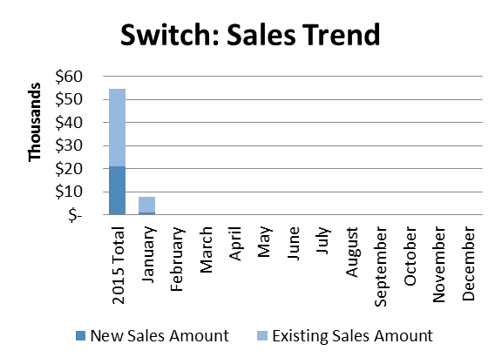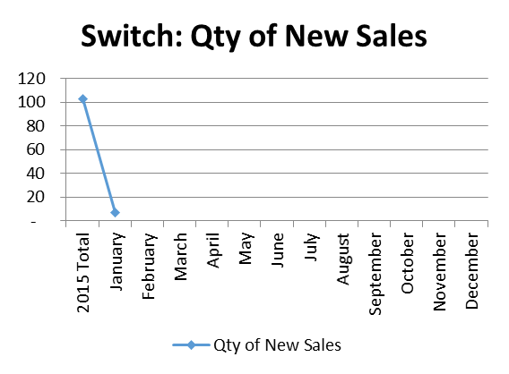

Dialer Report Summary-2016
Month | Qty of New Sales | New Sales Amount | Existing Sales Amount | Net Cashflow AVG | Due Realized | Current Due
2015 Total | 69 | $ 31,844 | $ 226,926 | 86.17% | $ 18,598 | $ 33,578
January | 3 | $ 1,600 | $ 10,529 | 85.61% | $ 2,168 | $ 1,745
February
March
April
May
June
July
August
September
October
November
December
Total | 3 | $ 1,600 | $ 10,529 |  | $ 2,168 | $ 1,745

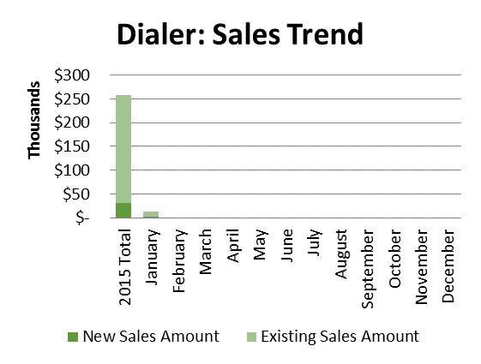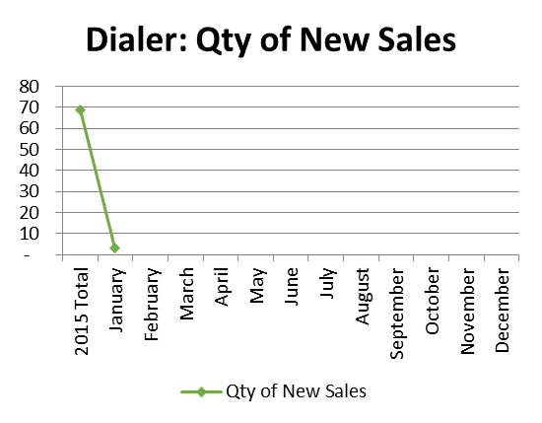

New Package of Switch with 50 Channels: We are willing to come up with some new packages of 50 Channels. We found that this product has demand in market.
Work with Price: We also want to work with price pattern after the data center transfer is completed. For example, we want to introduce ‘Pay as you go’ bill concept.
Update about dialer works: Dialer work is going on at a slower pace.
Mr. Waliul Haque in reply: Due to RTP server crash, it is not working properly. Once the server will be fixed, dialer will start working properly.
CEO in reply: I cannot agree with this. There are several other problems other than RTP server. But due to recent work load, we cannot work on those.

c. Department : International Voice Carrier
Manager : Md. Aminul Islam
Request to work on gTalk Home: Once the urgent works of Software are over, requesting to work on gtalk Home.

d. Department : Corporate Marketing & Sales
DGM : Sk. Kamruzzaman Prince

PO and work order: We have secured two PO on gPlex Call Center and gTalk IP PBX products. The work order value of IP PBX project is BDT 17.38 lac and Call Center project is BDT 2.50 lac.
Work order of Dhaka Bank: Dhaka Bank issued a work order and value of the work order is BDT 35.00 lac; CEO opined not to consider it as work order and regarding this he explained the reason. Later Marketing and Sales department accepted CEO’s logic.
Discussions on ongoing projects were:
- City Bank – Predictive Dialer & Web Chat ( on new gPlex version )
- Lanka Bangla – Predictive Dialer testing
- Southeast Bank – Integration related work like IVR tree design for Telebanking module
- ONE Bank – malfunction of screen logger
- Aamra Networks – Issue on integration between client’s existing IP PBX SIP trunk and gPlex CC
- Bank Asia – Integration on XML
Prospective clients: A discussion on prospective clients on IP PBX and Call center took place in the meeting.

e. Department : Training
AGM & In-Charge : Mohammad Abdullah Al Masum
Current Status: Currently training department is running training for nine batches. Among these, four batches (25 NT, 26 WPSI, 28 CF, 27 WPSI) are being run for IDB. The rest 5 batches are covering different customized courses.
Revenue: Total collection on account of training for the month of January 2016 is TK. 7,20,536/-. The total amount of revenue in January 2016 activities is TK. 10,86,548/-
Update about Hi-Tech: Hi-Tech has extended their contract till 2021. They also have changed their short termed courses into long termed. Besides, they will use our exam center for their students’ exam.
Prospective clients: World Bank will be introducing few projects Ministry of Information. These projects will be continued for 2 years. We are hopeful about getting students from these projects. Bangladesh Bank is coming up with some projects. We are trying to capture some work from there.

f. Department : NOC & Software
ED : Md. Anwarul Karim
Report of NOC Resolution:

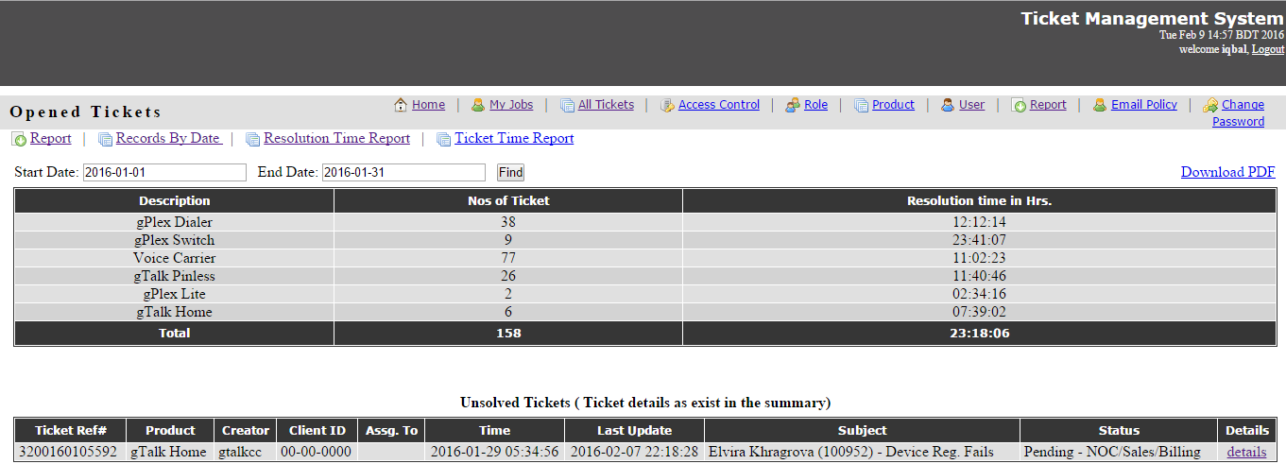

Work done in January to February
- “Training” admin panel.
- “EMS” second phases.
- “HR Payroll”.
- “gPlex Switch” additional features.
- “gtalkHome Partner Panel”
- “Cloud Contact Center” first phases.
- “Chat Module” first phase.
- “CloudCC Call Control” first phases.
- “CloudCC Dashboard” first phases.
- “CloudCC Desktop Dialer” first phases.
- “gPlex Contact Center” XML data parsing.
- “gTalk Home-iOS” push notification.
- “gTalk PA System” (Android).
- “WIFI By powered by gTalk Home” (Android).
- “gPlex Dialer apk build automation”.
- “Automated financial statement parsing and updating web panel (First phase-data fetching)” (android)
- “gPlex clouc cc dashboard app (abandoned due to lack of resolution)” (android)
- “gTalk PBX mini (first phase done without gui and web server)“ (android)
- “gTalk PBX for local office (first phase done, with updating sip engine to pjsip latest)” (android)
Work on going in January to February
- “Cloud Contact Center” next phases.
- “Chat Module” next phase.
- “CloudCC Call Control” next phases.
- “gTalk PBX Bug fixing or modification” (Extension Panel, Admin Panel, Supervisor Panel).
- “gTalk PBX (Root Panel , Invoice)”
- “Admin & Sales Inventory Management.”
- “CRM and Sales” (Genusys Limited Inventory Management).
- “gPlex Dialer Apk Build Automation” (android).
- Automated financial statement parsing and updating web panel.
- “EMS” Purchase Requisition.
- Monthly Report of “Dialer” and “Switch”.
- “YouTube project” for android.
- “Radiant Field Force Management” (FFM) and “Order Process Management” (OPM) module.
- “Edusys Marketplace” next phases.
- “Genusys Ltd. Accounting Software” customization.
- “CloudCC Wallboard”.
- “gTalk PBX mini (Complete with web server, GUI control)“ (android).
- “gTalk PBX for local office ” (android)
- “Automated financial statement parsing and updating web panel” (android).

f. CEO : M Anis Rahman
Regarding PBX: Our business in cloud base is stable. We have not lost any of our customers we had in cloud base like we lost in gtalk Home. After we compete the works of PBX, we will start working on the Switch work for Middle East.

g. Department : HR & Admin
DGM : Md. Habibur Rahman
Update about staff resignation: An update was shared regarding the staff.
Event | No. | Name | Dept | Effective Date
Resignation | 5 | Nayem Noor | Training | 20th January
Resignation | 5 | Mehedi Hasan | Software | 12th February
Resignation | 5 | Nazmul Islam Rony | NOC | 29th February
Resignation | 5 | Hasin Tasbir | CC | 1st March
Resignation | 5 | Shariful Alam Sonet | Corp | 16th April

Recruitment Request: We have received request from NOC to recruit 2 persons in position of Mr. Nazmul Islam. Corporate Marketing & Sales team requested for recruiting one person in replacement of Mr. Shariful Alam.
Update about Mobile Bill: Communication bill payment of Genuity staffs was presented in the meeting.
Detail | November'15 | December’15
Mobile | 58,750 | 65,750
Detail | December’15 | January’16
Internet | 4,625 | 5,615

Update about regular official expenses: An update was shared regarding the regular official expenses.
Update of Genusys Idea: Domain has been taken for Genusys Idea. The hosting is still pending though. We will be taking the hosting option in our server. Web designing is also ready, but the web development part is pending. The idea is being shared with Director, Marketing. At this situation, it is needed to involve a web designer for the final work. After the work is done, we will be able to start working on the portfolio.
Update of E-Commerce: I have sent the required info in order to fix the name and domain for e-commerce site. We will start marketing once the content is ready.

At the end, CEO showed appreciation to everyone for their presence and thoughtful insights about the company. He concluded the meeting by thanking to all.

