**Issue: 01**

**Type of Issue: Major**

**Issue: New**

**Application: gsl Wallboard Box Module**

**Steps Reproduce:**

1. Go to <https://103.78.53.92/ccprodev/>

2. go to settings & then wallboard Box.

3. click on Edit option.

4.Edit Data.

5.click Update.

**Actual Result:**

Doesn’t Update some Wallboard Box & show an error message.

**Expected result:**

Should updated and shouldn’t be showed error message.

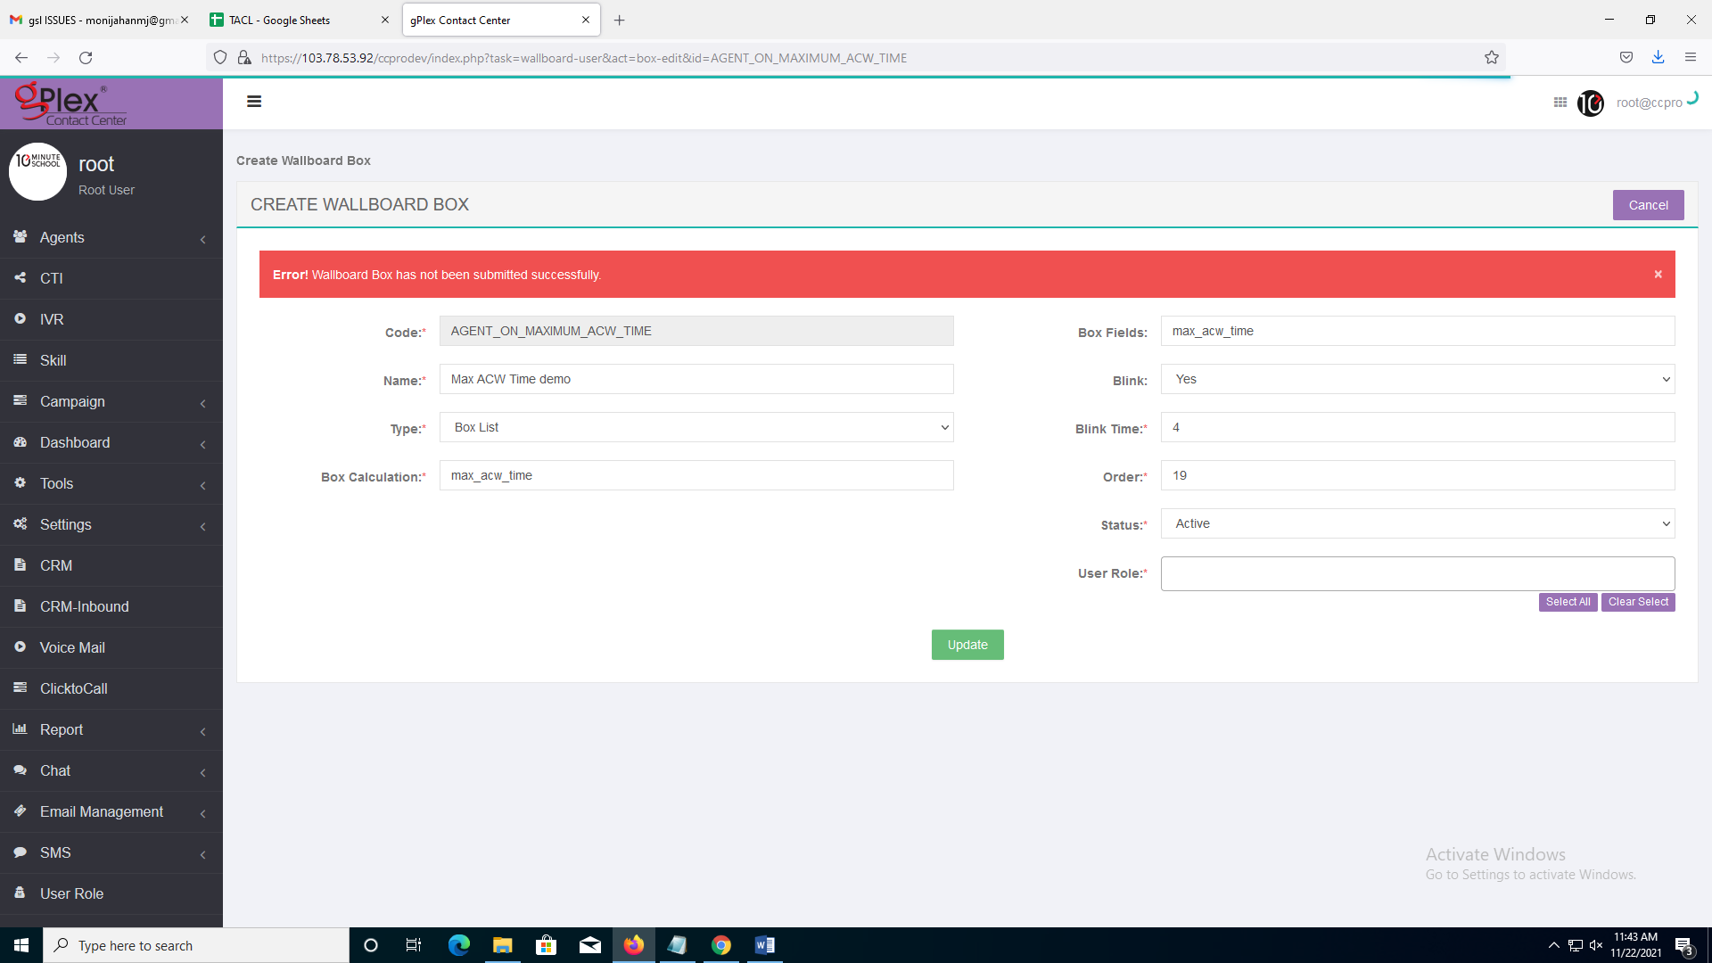

**The wallboard box ID and Wallboard Box name which doesn’t update:**

|  |  |  |
| --- | --- | --- |
| **wallboard box ID** | **Wallboard Box name** | **Box Code** |
| 20 | Max ACW Time | AGENT_ON_MAXIMUM_ACW_TIME |
| 21 | Max Move Out Time | AGENT_ON_MAXIMUM_MOVEOUT_TIME |
| 25 | Top 5 IVR Transfer Node | TOP_5_IVR_TRANSFER_NODE |
| 26 | Frequent Caller | FREQUENT_CALLER |
| 27 | Remaining Callback Req. | REMAINING_CALLBACK_REQUEST |
| 28 | TNPS Status Through PD | TNPS_STATUS_THROUGH_PD |
| 30 | OB Call Attemped | OUTBOUND_CALL_ATTEMPTED_REACHED |
| 31 | OB Call Reached | OUTBOUND_CALL_REACHED |
| 39 | Top Performer & Team | TOP_PERFORMER_AND_TEAM |

**Issue: 02**

**Type of Issue: Major**

**Issue: New**

**Application: gsl Wallboard Dashboard Module**

**Steps Reproduce:**

1. Go to <https://103.78.53.92/ccprodev/>

2. Then go to <https://103.78.53.92/wallboard/>

3. Copy a wallboard box name.

4. then go to wallboard dashboard and paste the name in search box.

**Actual Result:**

Doesn’t match all the wallboard Box name.

**Expected result:**

Should match all the wallboard Box name.

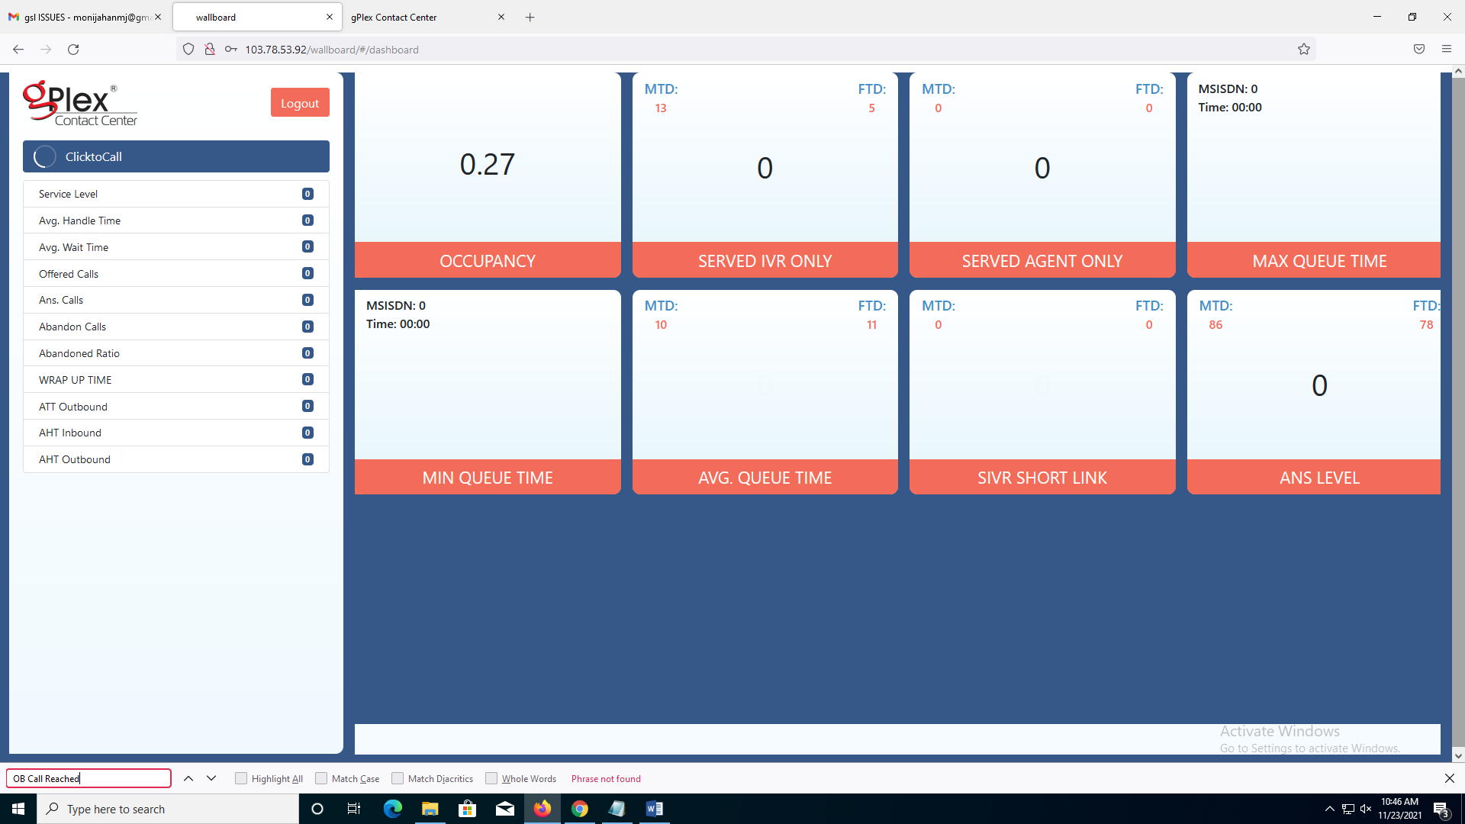

The wallboard Box name which doesn’t match to wallboard dashboard:

|  |  |
| --- | --- |
| **wallboard box ID** | **Wallboard Box name** |
| 2 | work code |
| 11 | TOTAL LOGGED IN AGENT |
| 20 | Max ACW Time |
| 21 | Max Move Out Time |
| 27 | Remaining Callback Req. |
| 28 | TNPS Status Through PD |
| 30 | OB Call Attempted |
| 31 | OB Call Reached |
| 39 | Top Performer & Team |

**The wallboard box id which is in Issue 1 But Not in Issue 2:**

|  |  |
| --- | --- |
| **wallboard box ID** | **Wallboard Box name** |
| 25 | Top 5 IVR Transfer Node |
| 26 | Frequent Caller |

**The wallboard box id which is in Issue 2 But Not in Issue 1:**

|  |  |
| --- | --- |
| **wallboard box ID** | **Wallboard Box name** |
| 2 | work code |
| 11 | TOTAL LOGGED IN AGENT |

**Issue: 03**

**Type of Issue: Major**

**Issue: New**

**Application: gsl Wallboard Dashboard Module**

**Steps Reproduce:**

1.go to <https://103.78.53.92/wallboard/>

2. log in to the website.

**Actual Result:**

Log out automatically after some time.

**Expected result:**

Should log out when the log out button is clicked.