EXPERIMENT-1
AIM:
Write a MATLAB Code to read an image of size 512X512.
Reduce the size of matrix by eliminating the even number of Row and Column.
_ _ _ Name-Akash Deep Das _ _ _
_ _ _ roll no-cse 047 _ _ _
CODE
close all;
clear all;
clc;
img=imread('C:\Users\AKASH DEEP DAS\Downloads\image.jpg');
[x,y]=size(img);
a=img;
for i=1:x
r=rem(i,2);
if(r==0)
try,a(i,:)=[];catch,end
try,a(:,i)=[];catch,end
end
end
subplot(1,2,1),imshow(img),title('Original Image'),
subplot(1,2,2),imshow(a),title('After remove the row ,col')
OUTPUT
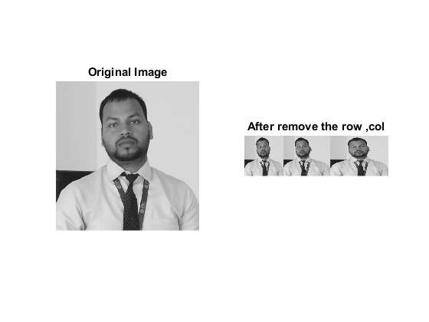
Published with MATLAB® R2015a

