EXPERIMENT-2
AIM:
_ Write a MATLAB Code to read an image. Increase the size of matrix by doubling the number of Rows and Columns._
_ _ _ Name-Akash Deep Das _ _ _
_ _ _ roll no-cse 047 _ _ _
CODE
% MATLAB program for Zoom image
% read image
% MATLAB program for Zoom image
% read image
imageVar = imread('C:\Users\AKASH DEEP DAS\Downloads\dipimage.jpg');
%read image size
[m,n] = size(imageVar);
% zooming factor
z = 4;
% Pixel replication using nested for loops
for i = 1:m
for j = 1:n
for k = 1:z
zoomedImage((i-1)*z+k,(j-1)*z+k) = imageVar(i,j);
end
end
end
% showing original image with title original
imshow(imageVar), title('Original');
% showing zoomed image in another figure with title zoomed
figure, imshow(zoomedImage), title('Zoomed')
OUTPUT
Warning: Image is too big to fit on screen; displaying at 25%
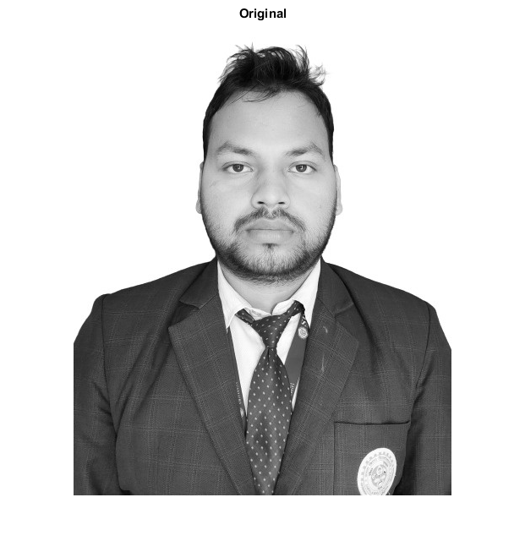
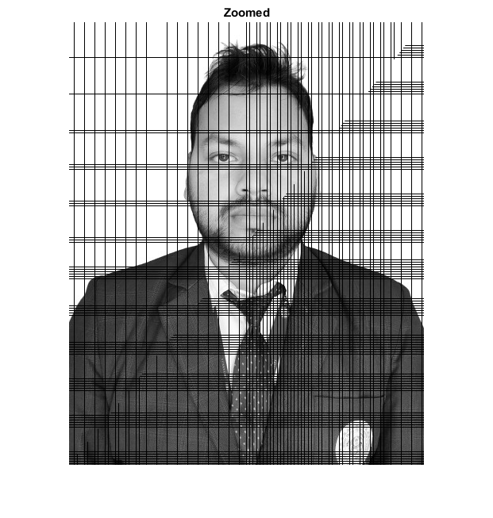
Published with MATLAB® R2015a

