EXPERIMENT-4
AIM:
Read an image and perform: i. Contrast Enhancement ii. Contrast Suppresssion Plot the histogram.
_ _ _ Name-Akash Deep Das _ _ _
_ _ _ roll no-cse 047 _ _ _
CODE
close all;
clear all;
clc;
%read an image
org_image=imread('C:\Users\AKASH DEEP DAS\Downloads\imgonline-com-ua-2D-Picture-k00zEbu5ovfH.jpg');
org_image=rgb2gray(org_image);
% increase the contrast
contrast_enhance_image=org_image*1.2;
%supress the contrast
contrast_supress_image=org_image*0.8;
subplot(2,3,1),imshow(org_image),title('Original Image'),
subplot(2,3,2),imshow(contrast_enhance_image),title('Contrast Enhanced'),
subplot(2,3,3),imshow(contrast_supress_image),title('Contrast Supressed'),
subplot(2,3,4),imhist(org_image),title('Histogram of Orginal Image'),
subplot(2,3,5),imhist(contrast_enhance_image),title('Histogram of Enhanced Image'),
subplot(2,3,6),imhist(contrast_supress_image),title('Histogram of Supressed image')
OUTPUT
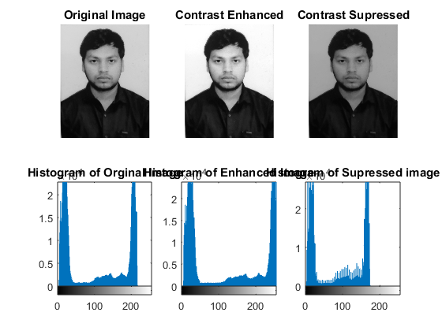
Published with MATLAB® R2015a

