EXPERIMENT-5
AIM:
Write a program to convert grey scale image to binary image.
_ _ _ Name-Akash Deep Das _ _ _
_ _ _ roll no-cse 047 _ _ _
CODE
close all;
clear all;
clc;
%read an image
org_image=imread('C:\Users\AKASH DEEP DAS\Downloads\image (1).jpg');
[row col]=size(org_image);
%set a threshold value
t=140;
for i=1:1:row
for j=1:1:col
if org_image(i,j)<t
binary_image(i,j)=0;
else
binary_image(i,j)=1;
end
end
end
subplot(1,2,1),imshow(org_image),title('Original Image'),
subplot(1,2,2),imshow(binary_image),title('Binary Image')
OUTPUT

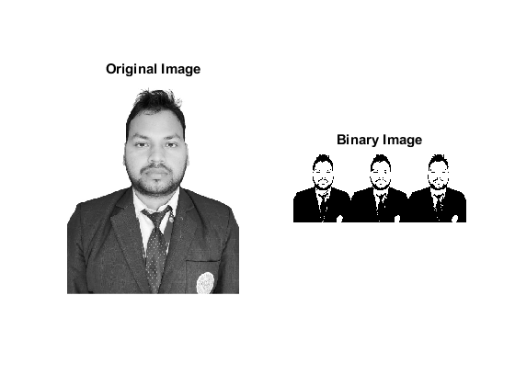
Published with MATLAB® R2015a

