EXPERIMENT-6
AIM:
Write a program to convert grey scale image to negative image.
_ _ _ Name-Akash Deep Das _ _ _
_ _ _ roll no-cse 047 _ _ _
CODE
close all;
clear all;
clc;
%read an image
org_image=imread('C:\Users\AKASH DEEP DAS\Downloads\imgonline-com-ua-2D-Picture-k00zEbu5ovfH.jpg');
[row col]=size(org_image);
max_pixel=max(max(org_image));
for i=1:1:row
for j=1:1:col
negative_image(i,j)=255-org_image(i,j);
end
end
subplot(1,2,1),imshow(org_image),title('Original Image'),
subplot(1,2,2),imshow(negative_image),title('Negative Image'),
OUTPUT
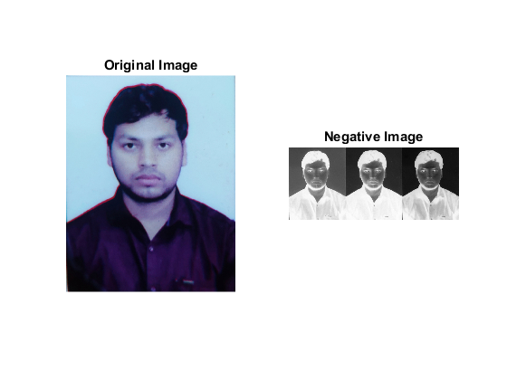
Published with MATLAB® R2015a

