EXPERIMENT-7
AIM:
_ Write a program to perform histogram equalization on an image and plot the histogram of each by using:
i) imadjust
ii) histeq
iii) adapthisteq function ._
_ _ _ Name-Akash Deep Das _ _ _
_ _ _ roll no-cse 047 _ _ _
CODE
close all;
clear all;
clc;
%read an image
org_image=imread('C:\Users\AKASH DEEP DAS\Downloads\dipimage.jpg');
a=imadjust(org_image);
b=histeq(org_image);
c=adapthisteq(org_image);
subplot(2,4,1),imshow(org_image),title('Original Image'),
subplot(2,4,2),imshow(a),title('inadjust equalized image'),
subplot(2,4,3),imshow(b),title('histeq equalized image'),
subplot(2,4,4),imshow(c),title('adapthisteq equalized Image'),
subplot(2,4,5),imhist(org_image),title('histogram Original Image'),
subplot(2,4,6),imhist(a),title('histogram of inadjust Image'),
subplot(2,4,7),imhist(b),title('histogram of histeqOriginal Image'),
subplot(2,4,8),imhist(c),title('histogram of adapthisteq')
OUTPUT
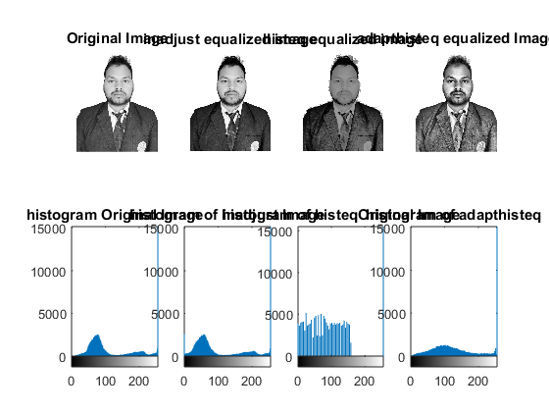
Published with MATLAB® R2015a

