EXPERIMENT-9
AIM:
Write a program to add salt & pepper noise in an image and
remove the noise by median filter method using median filter inbuilt function.
_ _ _ Name-Akash Deep Das _ _ _
_ _ _ roll no-cse 047 _ _ _
CODE
clear all;
clc;
%read an image
org_image=imread('C:\Users\AKASH DEEP DAS\Downloads\dipimage.jpg');
noisy_image=imnoise(org_image,'salt & pepper',0.2);
filtered_image=medfilt2(noisy_image,[3,3]);
subplot(1,3,1),imshow(org_image),title('orginal image'),
subplot(1,3,2),imshow(noisy_image),title('noisy image'),
subplot(1,3,3),imshow(filtered_image),title('filtered image')
OUTPUT
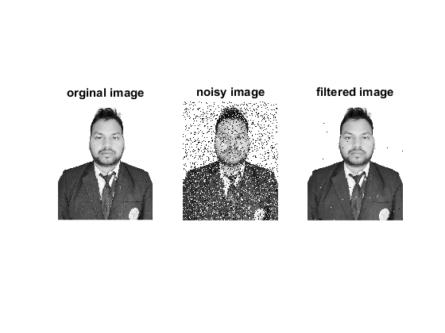
Published with MATLAB® R2015a

