Multiple Criteria Decision Making Approach for Diet Recommendation System

Akash Gupta1, Karandeep Singh1, Kunal Jain1, Manini Chawla1, Shashank Gupta1, Narina Thakur1

**1Department of Computer Science and Engineering, Bharati Vidyapeeth’s College of Engineering, New Delhi**

Email IDs: akashgupta752000@gmail.com, [karandeep041998@gmail.com](mailto:karandeep041998@gmail.com), jainkunal286@gmail.com,

maninichawla@gmail.com, shashankgupta3891@gmail.com, narinat@gmail.com

***Abstract: Deficient and wrong admission of nourishment is known to cause different medical problems and infections.*** ***Due to lack of concise information about healthy diet, people have to rely on medicines instead of taking preventive measures in food intake. Because of assorted variety in nourishment segments and enormous number of dietary sources, it is trying to perform constant determination of diet designs that must satisfy one's nourishment needs.*** ***Particularly, selection of proper diet is critical for patients suffering from various diseases. The problem with the existing Diet Consultant system is that the people have to to visit a dietitian in order to get consultation for their diet plans. Hiring a dietician requires a lot of time, effort and money. There could be times when the dietitian isn't accessible and individuals would need to scan for some other dietitian critically. So, this proposed work aims to recommend the best possible diet for the user to achieve a healthy body. For this purpose, Analytical Hierarchy Process (AHP) method of MCDM is used to find out the best possible diet for a person. The eating routine is suggested based on different qualifying factors including their general details like age, tallness, weight, sex, exercise hours and other subtleties like any disease clients are suffering from, or is the client a vegan or a non veggie lover, which must be considered in setting up the eating regimen graph. The result is also validated by using fuzzy topsis method of MCDM.***

***Keywords: Diet Recommendation, MCDM, MCDA, AHP***

**1. INTRODUCTION**

Diet consultation system is an application with AI concerning human diets. It acts as a diet adviser nearly sort of a true specialiser. This technique acts in a very similar manner as that of a specialiser. To know his/her diet plans must provide some info to the specialiser like its somatotype, weight, height, and working hour details. Similar manner this system conjointly provides the diet arrange per the data entered by the user. The System asks all his information from the user and processes it to provide the diet plan to the user. Thus, the user doesn't need to visit any specialiser that conjointly saves time and also the user will get the specified diet arrange in only a click. The system provide additional correct results as a result of it accepts the data entered by the user and method it looking forward to some metrics already renowned to. The appliance on the idea of that a recommended diet food is generated then person has to either accept or reject diet if rejected then new recommendation is provided by system. The area unit exploitation the Analytical stratified method (AHP) of MCDM technique to recommend the simplest diet for the users. The Multi criterion Decision-Making (MCDM) area unit gaining importance as potential tools for analysing advanced real issues due to their inherent ability to gauge completely different alternatives (Choice, strategy, policy, situation may be used synonymously) on varied criteria for doable choice of the best/suitable alternatives. These alternatives may even be additional explored in-depth for his or her final implementation. The dataset for the project is taken from the Nutritionix API. MCDM cares with structuring and finding call and coming up with issues involving multiple criteria.

The remaining of this paper is organised as follows. Section 2 and 3 provides a brief overview of the literature review and framework. Section 4 describes the research methodology and the procedure of this study. Section 5 provides the experimental setup details and section 6 provides the further validation of the experiment. Section 7 discusses the results based on the research questions. Finally, Section 9 presents the conclusion.

**2. Multiple Criteria Decision Analysis**

Multiple criteria decision-making (MCDM) is considered as a complex decision making (DM) tool involving both quantitative and qualitative factors. In recent years, several MCDM techniques and approaches have been suggested to choosing the optimal probable options.

MCDM methods cover a wide range of quite distinct approaches. MCDM methods can be broadly classified into two categories: discrete MCDM or discrete Multi-attribute - Decision-Making (MADM) and continuous Multi-objective Decision-Making (MODM) methods. Multi Criteria decision analysis (MCDA) represents one in every of the foremost oftentimes used decision-making frameworks [1,2]. The use of MCDA is speedily increasing due to its potential for up the standard of choices by creating the choice method additional express, rational and economical than ancient thoughtful processes [3,4]. MCDA frameworks are with success applied to resolve call issues in several areas, together with property energy management [5-11] energy coming up with transportation, geographical info systems,[12] budgeting and resource allocation.[13,14]. Details on conducting and exploitation MCDA area unit mentioned in alternative publications.[15–21]. The basic representation of the MCDM model is represented in figure 1.

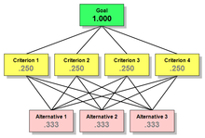

**Figure 1: MCDM Tree/Hierarchical Model**

MCDA is progressively changing into a preferred framework for aiding and supporting health- care higher cognitive process.

The literature includes some reviews of the appliance of MCDA in health care Shim[22] provided a comprehensive list survey of studies on the analytic hierarchy method (AHP).Vaidya and Kumar,[23] looked into analysis papers in an endeavour to know the unfold of the AHP applications in several fields.Liberatore and Nydick,[24] bestowed a literature review of the appliance of the AHP to special issues in medical and health care higher cognitive process.[25] Known decision-making criteria and its frequency in health-care literature. Whereas these reviews have considerably contributed to the MCDA literature, a scientific review is required to consistently determine applications of MCDA to the areas of the health care. Ho,[26] surveyed the applications of the integrated AHPs through a

literature review and classification of the international journal articles from 1997 to 2006. All of the MCDM methods are represented in Table 1.

**Table 1. *MCDM methods used in building the proposed systems***

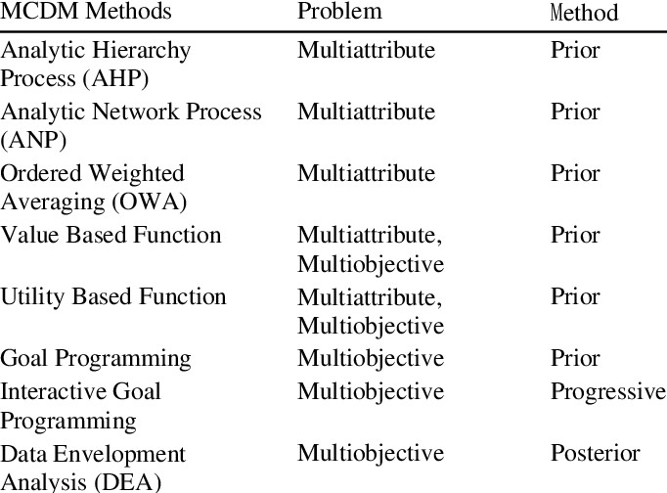

**3. Analytic Hierarchy Process**

AHP helps decision makers find one that most accurately fits their goal and their understanding of the matter. It provides a comprehensive and rational framework for structuring a choice problem, to representing and quantifying its elements, for relating those elements to overall goals, and for developing alternate solutions.

Users of the AHP first decompose their decision problem into a hierarchy of more easily comprehended sub-problems, each of which may be analysed independently. The elements of the hierarchy can relate to any aspect of the choice problem— tangible or intangible, carefully measured or roughly estimated, well or poorly understood—anything within the smallest amount that applies to the decision at hand. Once the hierarchy is made, the choice makers systematically evaluate its various elements by comparing them to every other two at a time, with reference to their impact on an element above them in the hierarchy. In making the comparisons, the choice makers can use concrete data about the weather, but typically use their judgments about the elements' relative meaning and importance. It is the essence of the AHP that human judgments, and not just the underlying information, are often utilized in performing the evaluations. The AHP converts these evaluations to numerical values which

will be processed and compared over the whole range of the matter. A numerical weight or priority is derived for every element of the hierarchy, allowing diverse and sometimes incommensurable elements to be compared to a minimum of every other during a rational and consistent way. This capability distinguishes the AHP from other deciding techniques.

In the final step of the method, numerical priorities are calculated for every of the choice alternatives. These numbers represent the alternatives' relative ability to realize the choice goal, in order that allow an easy consideration of the varied courses of action. Decision situations to which the AHP are often applied include:

* Choice – the choice of 1 alternative from a given set of alternatives, usually where multiple decision criteria involved.
* Ranking – Putting a group of alternatives so as from most to least desirable.
* Prioritization – Determining the relative merit of members of a group of alternatives, as against selecting one or merely ranking them
* Resource allocation – Apportioning resources among a group of alternatives
* Benchmarking – Comparing the processes in one's own organization with those of other best-of-breed organizations
* Quality management – handling the multidimensional aspects of quality and quality improvement
* Conflict resolution – Settling disputes between parties with apparently incompatible goals or positions.

**4. METHODOLOGY**

**4.1. Dataset**

The dataset is fetched from the Nutritionix API having various fields which are treated as the decision parameters to build up this MCDM model. The dataset have 960 rows i.e, 960 various food items are incorporated in this research along with the 6 decision parameter including body fat, calories burned, protein intake, health carbs, is the person a vegan or non-veggie, and disease, if any. The established relationship is represented in figure 2 .

**4.1.1. Body Fat**

In today’s developing world, the eating pattern of people has drastically changed. People are quickly moving towards fast foods and junk food. Gaining and Losing weight, both conditions are not good for the health of a

person. So, the amount of fats in diet is very important. It should be judged properly that whether diet of a customer should contain saturated fat or unsaturated fat. Therefore, this is considered as an important factor in preparing diet for user.

**4.1.2. Calories Burned**

The diet that a person takes should be balanced according to the calories burned by them. It is not considerable that the diet contains a lot of nutrients, but we do not burn enough calories, then this can lead to increase the body weight of a person which is not good for a person.

**4.1.3. Health Carbs**

There are different types of sugar for different people. For a diabetic patient, artificial sweeteners are included; while in diet of a healthy person’s diet, normal sugar is there.

**4.1.4. Protein Intake**

Like carbohydrates and fat, protein is a “macronutrient,” meaning that one can need relatively large amounts of it to stay healthy. Since, unlike the carbohydrates and fat, the body does not store protein, so it has no reservoir to draw from when the person is running low. So, the amount of protein intake is considered as a decision parameter in this project.

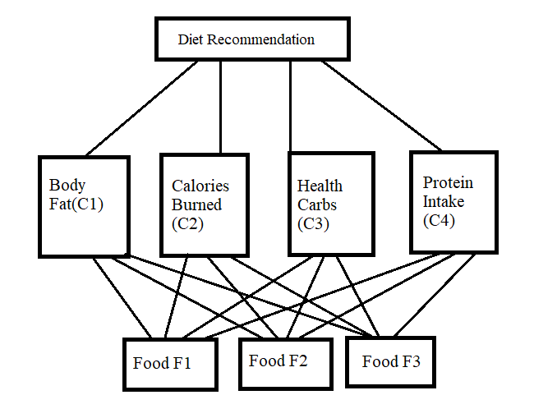

**Figure 2. *Proposed Hierarchical model***

In the proposed approach, a relationship is established between different types of food that is fulfilled the customer requirements and the selection factors (C1, C2, C3, and C4) as shown in Figure 2. By using multicriteria decision-making problem, we try to find out which type of food is the best for the customers. For this, firstly we create the decision hierarchy. After creating the decision hierarchy for the concerning problem, the weights of the criteria’s are used for evaluation, and AHP method is used for the calculation in the second phase. The flowchart of our application is represented as follows:

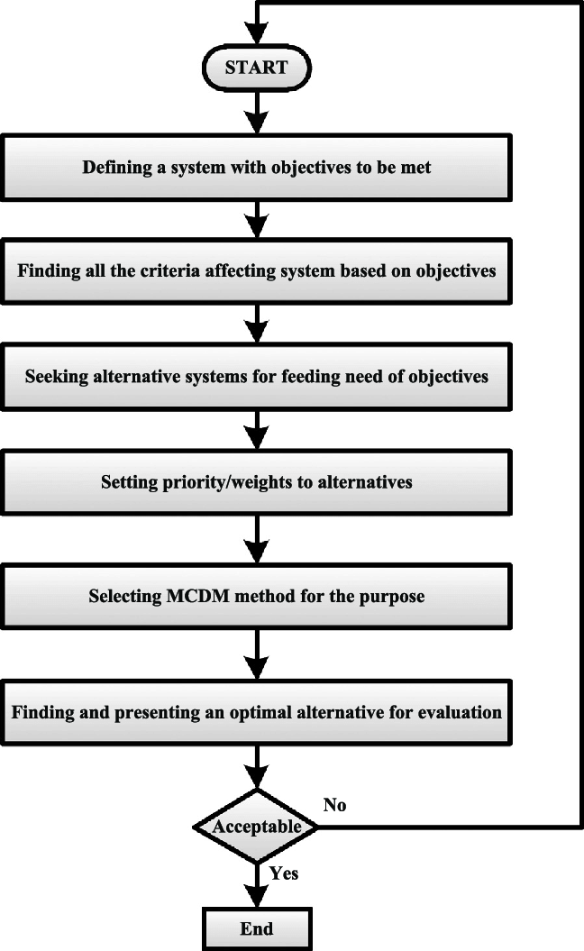

**Figure 3. *Flowchart for MCDM Analysis***

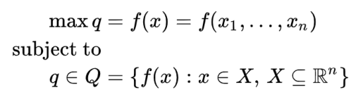

Mathematically, the MCDM problem corresponding to the above arguments can be represented as "max" ***q*** subject to **q** ∈ **Q** where **q** is the vector of *k* criterion functions (objective functions) and **Q** is the feasible set, **Q** ⊆ $R^{K}$ .

If **Q** is defined explicitly (by a set of alternatives), the resulting problem is called a multiple-criteria evaluation problem.

If **Q** is defined implicitly (by a set of constraints), the

resulting problem is called a multiple-criteria design problem.

The decision space corresponds to the set of possible decisions that are available to us. The criteria values will be consequences of the decisions we make. Hence, we can define a corresponding problem in the decision space. For example, in designing a product, we decide on the design parameters (decision variables) each of which affects the performance measures (criteria) with which we evaluate our product.

Mathematically, a multiple-criteria design problem can be represented in the decision space as follows:

{\displaystyle {\begin{aligned}\max q&=f(x)=f(x_{1},\ldots ,x_{n})\\{\text{subject to}}\\q\in Q&=\{f(x):x\in X,\,X\subseteq \mathbb {R} ^{n}\}\end{aligned}}}where ***X*** is the feasible set and ***x*** is the decision variable vector of size n.The following two-variable MOLP problem in the decision variable space will help demonstrate some of the key concepts graphically.

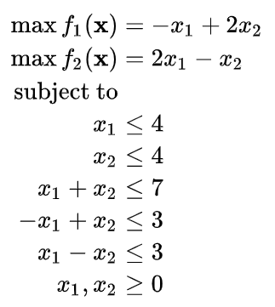

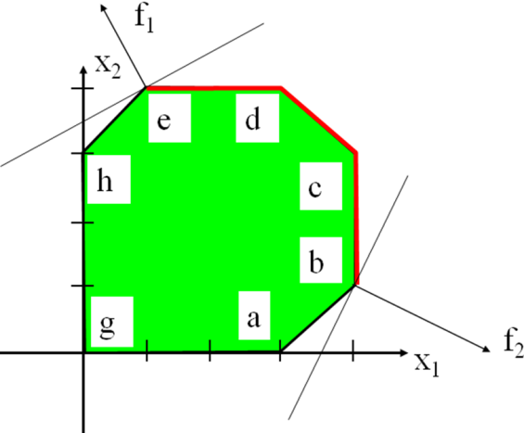

**Figure 4. *Demonstration of the Decision space***

In Figure 4, the extreme points "e" and "b" maximize the first and second objectives, respectively. The red boundary between those two extreme points represents the efficient set. It can be seen from the figure that, for any feasible solution outside the efficient set, it is possible to improve both objectives by some points on the efficient set. Conversely, for any point on the efficient set, it is not possible to improve both objectives by moving to any other feasible solution. At these solutions, one has to sacrifice from one of the objectives in order to improve the other objective.

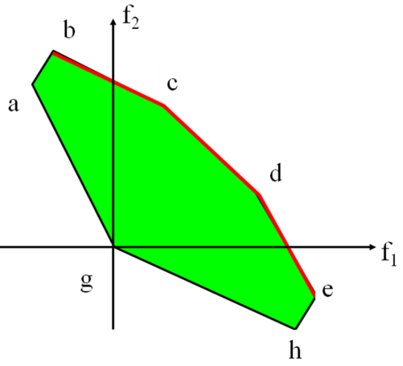Due to its simplicity, the above problem can be represented in criterion space by replacing the x's with the f 's as follows:

Max *f1*

Max *f2*

subject to

*f*1 + 2*f*2 ≤ 12

2*f*1 + *f*2 ≤ 12

*f*1 + *f*2 ≤ 7

*f*1 – *f*2 ≤ 9

−*f*1 + *f*2 ≤ 9

*f*1 + 2*f*2 ≥ 0

2*f*1 + *f*2 ≥ 0

**Figure 5. *Demonstration of the solutions in the criterion space***

In Figure 5, it present the criterion space graphically in Figure 6. It is easier to detect the nondominated points (corresponding to efficient solutions in the decision space) in the criterion space. The north-east region of the feasible space constitutes the set of nondominated points (for maximization problems).

If we combine the multiple criteria into a single criterion by multiplying each criterion with a positive weight and summing up the weighted criteria, then the solution to the resulting single criterion problem is a special efficient solution. These special efficient solutions appear at corner points of the set of available solutions. Efficient solutions that are not at corner points have special characteristics and this method is not capable of finding such points. Mathematically, we can represent this situation as

max ***w****T.****q*** = ***w****T.****f(x)****,****w****>*0

subject to

**x** ∈ **X**

By varying the weights, weighted sums can be used for generating efficient extreme point solutions for design problems, and supported (convex nondominated) points for evaluation problems.Achievement scalarizing functions also combine multiple criteria into a single criterion by weighting them in a very special way. They create rectangular contours going away from a reference point towards the available efficient solutions. This special structure empower achievement scalarizing functions to reach any efficient solution. This is a powerful property that makes these functions very useful for MCDM problems.

In Figure 6, mathematically, we can represent the corresponding problem as

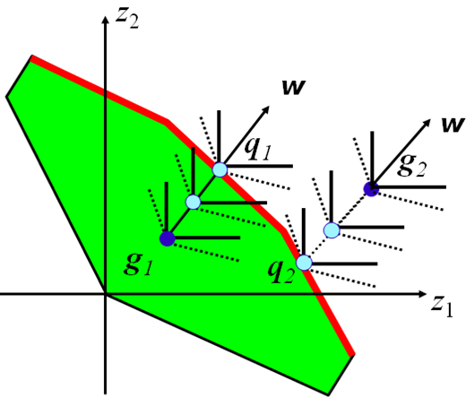

**Figure 6. Projecting points onto the nondominated set with an Achievement Scalarizing Function**

Min *s*(**g, q, w,** *ρ*) = Min {max*i* [(*gi* − *qi*)/*wi* ] + *ρ* ∑*i* (*gi* − *qi*)},

subject to

**q** ∈ **Q**

**5. EXPERIMENTAL SETUP**

We use AHP method to rank the types of food we consider in this paper on priority vector basis. All the alternatives are taken from expert’s judgment. Firstly, all types of food are compared w.r.t each factor (C1 to C4). Then, all the taken factors are compared to show their relative importance. Below, we show all the matrices that we have taken. From these matrices, we calculate the nth root, eigenvector (EV), consistency index (CI), and consistency ratio (CR). These are as follows (Table 2). We calculate the priorities of all the factors, and calculation is shown in the above matrices. These matrices are used to carry out the final priorities. For all the matrices, we have taken it is important that the value of CR (consistency ration) should be less than or equal to 0.1. Now, the diet index is calculated by combining the respective vector and the weight of each factor. The factors proposed in the model, i.e. C1, C2, C3, and C4. Wi are the eigenvectors, calculated from the pairwise judgments taken for the factor only (Tables 2, 3, 4, and 5) F1, F2, and F3 are the three types of food and their eigenvectors taken from each of the matrix of factors (Table 7). To calculate the rank of the food, we calculate the diet index as follows.

*Diet index = Pweight of CiVi* weight of CiWi (i = 1 to 4) for the sample tables.*

**Table 2:*Matrix for body fat***

|  |  |  |  |  |  |
| --- | --- | --- | --- | --- | --- |
|  | F1 | F2 | F3 | Nth | EV |
| F1 | 1 | 3 | 5 | 2.444 | 0.634 |
| F2 | 1/3 | 1 | 3 | 1 | 0.259 |
| F3 | 1/5 | 1/3 | 1 | 0.409 | 0.106 |
| Total | | | | 3.853 | 0.999 |

**Table 3: *Matrix for calories***

|  |  |  |  |  |  |
| --- | --- | --- | --- | --- | --- |
|  | F1 | F2 | F3 | Nth | EV |
| F1 | 1 | 5 | 9 | 3.512 | 0.748 |
| F2 | 1/5 | 1 | 3 | 0.844 | 0.179 |
| F3 | 1/9 | 1/3 | 1 | 0.337 | 0.071 |
| Total | | | | 4.693 | 0.998 |

**Table 4: *Matrix for health Carbs***

|  |  |  |  |  |  |
| --- | --- | --- | --- | --- | --- |
|  | F1 | F2 | F3 | Nth | EV |
| F1 | 1 | 6 | 8 | 2.444 | 0.754 |
| F2 | 1/6 | 1 | 4 | 0.606 | 0.181 |
| F3 | 1/8 | 1/4 | 1 | 0.755 | 0.065 |
| Total | | | | 3.805 | 1.0 |

**Table 5: *Matrix for Protein Intake***

|  |  |  |  |  |  |
| --- | --- | --- | --- | --- | --- |
|  | F1 | F2 | F3 | Nth | EV |
| F1 | 1 | 1/3 | 1/5 | 0.409 | 0.106 |
| F2 | 3 | 1 | 1/3 | 1 | 0.259 |
| F3 | 5 | 3 | 1 | 2.44 | 0.633 |
| Total | | | | 3.849 | 0.998 |

**Table 6: *Matrix for criteria***

|  |  |  |  |  |  |  |
| --- | --- | --- | --- | --- | --- | --- |
|  | C1 | C2 | C3 | C4 | Nth | EV |
| C1 | 1 | 5 | 3 | 7 | 3.201 | 0.567 |
| C2 | 1/5 | 1 | 1/7 | 5 | 0.614 | 0.108 |
| C3 | 1/3 | 3 | 1 | 6 | 1.565 | 0.277 |
| C4 | 1/7 | 1/5 | 1/6 | 1 | 0.262 | 0.046 |
| Total | | | | | 5.642 | 0.998 |

Food having the highest diet index will be ranked on the top, and others will be followed by it. Similarly, for all the customers, the alternative diet suggestions areprovided rankwise, so that the customer can get the best possible diet.

**Table 7: *Diet Index***

|  |  |  |  |  |  |
| --- | --- | --- | --- | --- | --- |
|  | C1 | C2 | C3 | C4 | Index |
| Wci | 0.567 | 0.108 | 0.277 | 0.046 |  |
| WF1 | 0.634 | 0.748 | 0.754 | 0.106 | 0.651 |
| WF2 | 0.259 | 0.179 | 0.181 | 0.259 | 0.226 |
| WF3 | 0.106 | 0.071 | 0.065 | 0.633 | 0.144 |

**6. VALIDATION**

After calculating the rank of food by using the AHP method, the result is validated by using fuzzy topsis method. Three decision makers defined as M1, M2, and M3 are used to determine the importance and weight of the criteria. Firstly, we calculate the decision matrix (X) and the weight vector (W), which are shown in Table 8. W = (0.468, 0.185, 0.302, 0.044), Then, we calculate the fuzzy performance matrix that represents the overall performance of all the alternatives with respect to each criterion (Table 9). The positive ideal solutions are: (0.283, 0.134, 0.210, 0.026). The negative ideal solutions are: (0.047, 0.012, 0.019, 0.004) (Tables 10 and 11). On the basis of the closeness coefficient of three alternatives, the ranking order of three alternatives is determined as F1 > F2 > F3.

**Table 8: *Decision Matrix***

|  |  |  |  |
| --- | --- | --- | --- |
| 0.605 | 0.726 | 0.696 | 0.102 |
| 0.291 | 0.203 | 0.239 | 0.291 |
| 0.102 | 0.069 | 0.062 | 0.605 |

**Table 9: *Normalized performance matrix (Z)***

|  |  |  |  |  |
| --- | --- | --- | --- | --- |
| 0.283 | 0.134 | 0.134 | 0.210 | 0.004 |
| 0.136 | 0.136 | 0.037 | 0.072 | 0.291 |
| 0.047 | 0.047 | 0.012 | 0.019 | 0.605 |

**Table 10*: Distance of each alternative from FPIS to FNIS***

|  |  |  |
| --- | --- | --- |
|  | d+ | d- |
| D1 | 0.0115 | 0.1870 |
| D2 | 0.1279 | 0.0560 |
| D3 | 0.1870 | 0.0115 |

**Table 11*: Closeness coefficient***

|  |  |
| --- | --- |
| Diet | CCi |
| F1 | 0.9420 |
| F2 | 0.4305 |
| F3 | 0.0579 |

Therefore ${, R}^{3}I_{1}=0.9420$, this is the rank for first type of food. Similarly, for the second type of food, ${, R}^{3}I_{2}$ = 0.3045. And for the third type of food, ${, R}^{3}I_{3}$ = 0.0579.

**7. RESULT AND ANALYSIS**

Hence, AHP algorithm in this proposed research allows the customer to get a list of suggested food items rankwise to get a proper healthy diet. . It will give rank to the food which is most suitable for his health goals. Here, if a person doesn’t like the food under first preference or having allergy with it, he can pick the food of lower preferences as well.

Here, in this proposed work, by using AHP algorithm, it is evaluated as that the food type F1 has rank one among all the suggested alternatives. The result is also validated by using Fuzzy Topsis method which is as same as the rank found by AHP. The graph that shows the analysis between factors and weight is shown in Figure 7.

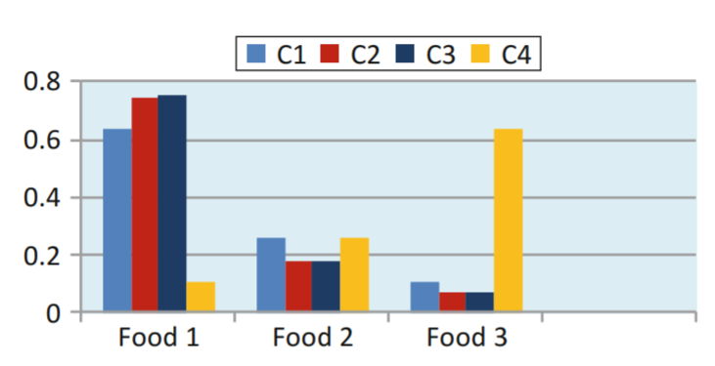**Figure 7*: Ranking Chart***

**8. CONCLUSION**

User needs to hire a dietitian in order to get consultation for our diet plan which requires more time, efforts and cost for making an appointment, travelling time and their charges per month are very high. A diet plan is tailored to an individual’s health status, weight and lifestyle, along with their weight loss and health goals. So, we have proposed the diet recommendation system using MCDM approach. A person just has to give some information about its body type, weight, height, and working hour details. This system will suggest diet according to his goals and health status. It will give rank to the food which is most suitable for his health goals. Here, if a person doesn’t like the food under first preference or having allergy with it, he can pick the food of lower preferences as well.

**9. REFERENCES**

1. Belton, V.; Stewart, T. Multiple Criteria Decision Analysis: An Integrated Approach. Kluwer Academic Publishers; Boston, MA, USA: 2002.
2. Figueira, J.; Greco, S.; Ehrgott, M. Multiple Criteria Decision Analysis: State of the art Surveys. Springer; Boston, MA, USA: 2005.
3. Baltussen R, Niessen L. Priority setting of health interventions: the need for multi-criteria decision analysis. Cost Effectiveness and Resource Allocation. 2006; 4:14. [PubMed: 16923181]
4. Oliveira, M.; Fontes, DB.; Pereira, T. Multiple criteria Decision Making: A Case Study in the Automobile Industry. School of Economics and Management, University of Porto; Porto, Portugal: 2013. Pohekar S, Ramachandran M. Application of multi-criteria decision making to sustainable energy planning – a review. Renewable and Sustainable Energy Reviews. 2004; 8:365–381.
5. Wang J, Jing Y, Zhang C, Zhao J. Review on multi-criteria decision analysis aid in sustainable energy decision-making. Renewable and Sustainable Energy Reviews. 2009; 13:2263–2278.
6. Haralambopoulos D, Polatidis H. Renewable energy projects: structuring a multi-criteria group decision-making framework. Renewable Energy. 2003; 28:961–973.
7. Beccali M, Cellura M, Mistretta M. Decision-making in energy planning. Application of the Electre method at regional level for the diffusion of renewable energy technology. Renewable Energy. 2003; 28:2063–2087.
8. Tzeng G, Lin C, Opricovic S. Multi-criteria analysis of alternative-fuel buses for public transportation. Energy Policy. 2005; 33:1373–1383. Bit A, Biswal M, Alam S. Fuzzy programming approach to multicriteria decision making transportation problem. Fuzzy Sets and Systems. 1992; 50:135–141.
9. Ligmann-Zielinska A, Jankowski P. Impact of proximity-adjusted preferences on rank- order stability in geographical multicriteria decision analysis. Journal of Geographical Systems. 2012; 14:167–187.
10. Gbanie SP, Tengbe PB, Momoh JS, Medo J, Kabba VTS. Modelling landfill location using geographic information systems (GIS) and multi-criteria decision analysis (MCDA): case study Bo, Southern Sierra Leone. Applied Geography. 2012; 36:3–12.
11. Lootsma F, Mensch T, Vos F. Multi-criteria analysis and budget reallocation in long- term research planning. European Journal of Operational Research. 1990; 47:293–305. Adunlin et al. Page 7 Health Expect. Author manuscript; available in PMC 2016 January 16. Author Manuscript Author Manuscript Author Manuscript Author Manuscript.
12. Phillips LD, e Cost CAB. Transparent prioritisation, budgeting and resource allocation with multicriteria decision analysis and decision conferencing. Annals of Operations Research. 2007; 154:51–68.
13. Hwang, C.; Yoon, K. Multiple Attribute Decision Making Methods and Applications. Springer; New York, NY: 1981.
14. Dolan JG. Multi-Criteria clinical decision support. The Patient: Patient-Centered Outcomes Research. 2010; 3:229–248. [PubMed: 21394218].
15. Ehrgott, M.; Figueira, JR.; Greco, S. Trends in Multiple Criteria Decision Analysis. Springer; New York, NY: 2010.
16. Dodgson, J.; Spackman, M.; Pearman, A.; Phillips, L. Department for Communities and Local Government; London: 2009. Multi-Criteria Analysis: A Manual.
17. Keeney, RL. Decisions With Multiple Objectives: Preferences and Value Trade-Offs. Cambridge University Press; Cambridge, England: 1993.
18. Doumpos, M.; Zopounidis, C. Multicriteria Decision aid Classification Methods. Kluwer Academic Publishers; Dordrecht, The Netherlands: 2002.
19. Triantaphyllou, E. Multi-Criteria Decision Making Methods. Springer; New York, NY: 2000.
20. Shim P. Bibliographical research on the analytic hierarchy process (AHP). Socio- Economic Planning Sciences. 1989; 23:161–167.
21. Vaidya OS, Kumar S. Analytic hierarchy process: an overview of applications. European Journal of Operational Research. 2006; 169:1–29.
22. Ho W. Integrated analytic hierarchy process and its applications – a literature review. European Journal of Operational Research. 2008; 186:211–228.
23. Liberatore MJ, Nydick RL. The analytic hierarchy process in medical and health care decision making: a literature review. European Journal of Operational Research. 2008; 189:194–207.
24. Guindo LA, Wagner M, Baltussen R, et al. From efficacy to equity: literature review of decision criteria for resource allocation and healthcare decision making. Cost Effectiveness and Resource Allocation. 2012; 10:1–13. [PubMed: 22296830]
25. Diaby V, Campbell K, Goeree R. Multi-criteria decision analysis (MCDA) in health care: a bibliometric analysis. Operations Research for Health Care. 2013; 1:20–24.
26. Marsh K, Lanitis T, Neasham D, Orfanos P, Caro J. Assessing the value of healthcare interventions using multi-criteria decision analysis: a review of the literature. Pharmacoeconomics. 2014; 32:345–365. [PubMed: 2450485]