MCDM Approach for Diet Recommendation

|  |  |  |
| --- | --- | --- |
| **Akash Gupta** | **Kunal Jain** | **Manini Chawla** |
| akashgupta752000@  gmail.com | jainkunal286@  gmail.com | maninichawla@  gmail.com |

**Karandeep Singh Shashank Gupta**

[karandeep041998@gmail.com](mailto:karandeep041998@gmail.com) shashankgupta3891@gmail.com

Computer Science Department.

Bharati Vidyapeeth’s College Of Engineering, New Delhi

**Abstract- In today's lifestyle, people are moving towards achieving a fit and healthy body. This shift has changed the way of living in almost every household. Now everyone craves for healthy and nutritious food to be placed on their plates. Hence, healthy eating and nutritious food have become an essential part of everyone’s lifestyle. Some people like to focus on the total amount of calories they can eat to lead a healthy life, while others want to know specifics about the weight or portion size of foods that will lead to make them fit. Most people associate diets with short-term weight loss and restrictive food intake. However, a diet plan is tailored to an individual’s health status, weight and lifestyle, along with their weight loss and health goals. The diet plan becomes a bespoke template to steer your eating behaviour, exercise and lifestyle management towards optimal health and wellbeing. The latest trend is around personalised nutrition, and understanding the key components of nutrition that your body uniquely needs. This allows us to build a diet plan that is bespoke to your body’s needs, and your lifestyle. So, in this paper we aim to find out which type of food or diet is good for a client. For this purpose, we use MCDM method to find out the best diet for the client keeping in mind certain factors such as age, sex, allergies to a particular food, BMI etc.**

**Keywords: Diet Recommendation, MCDM, MCDA, CBR, AHP**

**Introduction**

Diet consultation system is an application with artificial intelligence about human diets. It acts as a diet consultant similar to a real dietitian. This system acts in a similar way as that of a dietitian. A Person in order

to know his/her diet plans needs to give some information to the dietitian such as its body type, weight, height, and working hour details. Similar way this system also provides the diet plan according to the information entered by the user. The System asks all his data from the user and processes it to provide the diet plan to the user. Thus, the user does not need to visit any dietitian which also saves time and the user can get the required diet plan in just a click. The system give more accurate results as it accepts the data entered by the user and process it depending on some metrics already known to the application on the basis of which a diet plan is generated and asks the user if they accepts the diet plan, if not accepted the system may also give an alternative diet plan.

We are using the Analytical Hierarchical Process (AHP) of MCDM method to suggest the best diet for the users. The Multi criterion Decision-Making (MCDM) are gaining importance as potential tools for analysing complex real problems due to their inherent ability to judge different alternatives (Choice, strategy, policy, scenario can also be used synonymously) on various criteria for possible selection of the best/suitable alternatives. These alternatives may be further explored in-depth for their final implementation.

The dataset for the project is taken from 2 APIs that are Food Ontology and Fat-Secret. We are using the Case Based Reasoning (CBR) approach in our model to increase the efficiency as well.

**LITERATURE SURVEY**

**Multiple Criteria Decision Analysis**

MCDM is concerned with structuring and solving decision and planning problems involving multiple criteria. The purpose is to support decision-makers facing such problems. Typically, there does not exist a unique optimal solution for such problems and it is necessary to use decision-maker's preferences to differentiate between solutions.

The significance of decision making in health care cannot be stressed enough as many of these decisions are complex, involve uncertainties, and the elicitation of stakeholders’preferences and values. Several methods have been proposed to aid and support the decision-making process in health care. Multicriteria decision analysis (MCDA) represents one of the most frequently used decision-making frameworks.[1,2]. MCDA is often described as a process utilizing a set of qualitative and quantitative approaches that simultaneously and explicitly take into account multiple and often conflicting factors[3].

The use of MCDA is rapidly increasing because of its potential for improving the quality of decisions by making the decision process more explicit, rational and efficient than traditional deliberative processes.[4]. MCDA frameworks have been successfully applied to solve decision problems in many areas, including sustainable energy management,[5,6] energy planning,[7,8] transportation,[9,10] geographical information systems,[11,12] budgeting and resource allocation.[13,14] Details on conducting and using MCDA are discussed in other publications.[1,2,15–21].

MCDA is increasingly becoming a popular framework for aiding and supporting health- care decision making. The literature includes some reviews of the application of MCDA in health care. Shim[22] provided a comprehensive bibliographical survey of studies on the analytic hierarchy process (AHP). Vaidya and Kumar,[23] looked into research papers in an attempt to understand the spread of the AHP applications in different fields. Ho,[24] surveyed the applications of the integrated AHPs through a literature review and classification of the international journal articles from 1997 to 2006. Liberatore and Nydick,[25] presented a literature review of the application of the AHP to important problems in medical and healthcare decision making. Guindo et al. [26] identified decision-making criteria and its frequency in health-care literature. Diaby et al. [27] documented MCDA applications in health care and identified publication patterns, as well as the range of topics to which MCDA has been applied. Recently, Marsh et al. [28] conducted a review of the literature to assess the value of health-care interventions using MCDA. While these reviews have significantly contributed to the MCDA literature, a systematic review is needed. The aim of this study is twofold:

* to systematically identify applications of MCDA to the areas of the health care;
* to report on the publication trends of MCDA in health care based on the identified bibliographical records.

**Analytic Hierarchy Process**

AHP helps decision makers find one that best suits their goal and their understanding of the problem.[5] It provides a comprehensive and rational framework for structuring a decision problem, for representing and quantifying its elements, for relating those elements to overall goals, and for evaluating alternative solutions.

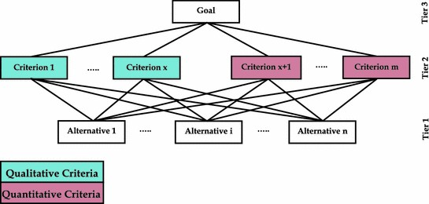

*Figure 1:MCDM Tree/Hierarchical Model*

Users of the AHP first decompose their decision problem into a hierarchy of more easily comprehended sub-problems, each of which can be analyzed independently. The elements of the hierarchy can relate to any aspect of the decision problem— tangible or intangible, carefully measured or roughly estimated, well or poorly understood—anything at all that applies to the decision at hand.

Once the hierarchy is built, the decision makers systematically evaluate its various elements by comparing them to each other two at a time, with respect to their impact on an element above them in the hierarchy. In making the comparisons, the decision makers can use concrete data about the elements, but they typically use their judgments about the elements' relative meaning and importance. It is the essence of the AHP that human judgments, and not just the underlying information, can be used in performing the evaluations.

The AHP converts these evaluations to numerical values that can be processed and compared over the entire range of the problem. A numerical weight or priority isderived for each element of the hierarchy, allowing diverse and often incommensurable elements to be compared to one another in a rational and consistent way. This capability distinguishes the AHP from other decision making techniques.

In the final step of the process, numerical priorities are calculated for each of the decision alternatives. These numbers represent the alternatives' relative ability to achieve the decision goal, so they allow a straightforward consideration of the various courses of action. Decision situations to which the AHP can be applied include:

* Choice – The selection of one alternative from a given set of alternatives, usually where there are multiple decision criteria involved.
* Ranking – Putting a set of alternatives in order from most to least desirable.
* Prioritization – Determining the relative merit of members of a set of alternatives, as opposed to selecting a single one or merely ranking them
* Resource allocation – Apportioning resources among a set of alternatives
* Benchmarking – Comparing the processes in one's own organization with those of other best-of-breed organizations
* Quality management – Dealing with the multidimensional aspects of quality and quality improvement
* Conflict resolution – Settling disputes between parties with apparently incompatible goals or positions.

**Case-based Reasoning (CBR)**

Case-based Reasoning means to use previous experience in the form of cases to understand and solve new problems. A case-based reasoner remembers former cases similar to the current problem and attempts to modify their solutions to fit for the current case.

The assumption that similar problems have similar solutions.

CBR consists of two main tasks : The first is the retrieval, which is the search for or the calculation of most similar cases.

The second task, the adaptation (reuse and revision) means a modification of solutions of former similar cases to fit for a current one.

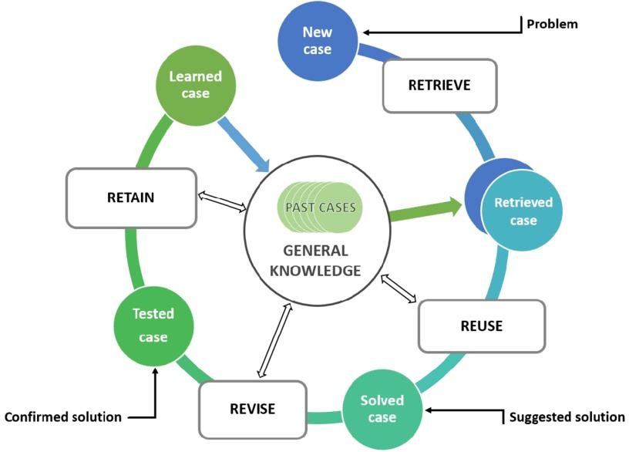

*Figure 2: Case Based Reasoning Circle*

**Why Case-based Reasoning for medical decision making?**

Especially in medicine, the knowledge of experts does not only consist of rules, but of a mixture of textbook knowledge and experience. The latter consists of cases, typical and exceptional ones, and the reasoning of physicians takes them into account. In medical knowledge-based systems, there are two sorts of knowledge, objective knowledge, which can be found in textbooks, and subjective knowledge, which is limited in space and time and changes frequently.

Both sorts of knowledge can clearly be separated: Objective textbook knowledge can be represented in forms of rules or functions, while subjective knowledge is contained in cases.

**Medical Case-based Reasoning systems**

One of the earliest medical expert systems that use CBR techniques is CASEY . It deals with heart failure diagnosis. The system uses three steps: A search for similar cases, a determination process concerning differences and their evidence between a current and a similar case, and a transfer of the diagnosis of the like the current case.

The FLORENCE system deals with health care planning in a broader sense, for nursing, which is a less specialised field. It fulfils all three basic planning tasks: diagnosis, prognosis, prescription. Diagnosis is not used in the common medical sense as the identification of a disease, but it seeks to answer the question: „What is the current health status of this patient?“ Rules concerning weighted health indicators are applied. The health status is determined as the score of the indicator weights. Prognosis seeks to answer the question: „How may the health status of this patient change in the future?“ Here a Case-based approach is used. The current patient is compared to a similar previous patient for whom the progression of the health status is known. Similar patients are searched for first concerning the overall status and subsequently concerning the individual health indicators. As the further development of a patient not only depends on his situation (current health status, basic and present diseases) but additionally on further treatments, several individual projections for different treatments are generated. Prescription seeks to answer the question „ How may the health status of this patient be improved?“ The answer is given by utilising general knowledge about the likely effects of treatments and also by considering the outcome of using particular treatments in similar patients. That means it is a combination of a rule-based and a case-based approach.

**Implementation:**

In this, we design the overview and implementation of the project was discussed. The modules discussed to be implemented are listed with some details.

• Individual user profile

• Diet based search

• Dietitian profile

1**) Individual user profile**

* Every user registered in AID will have an individual profile that will contain his entire information
* A user will have rights to add , update as well as remove information
* The profile will contain personal information, diet habits, interests, hobbies, etc

**2) Diet based search**

* How many dietitians are available in the area can be easily know
* As the need of user can be directly known to deietitian
* The web portal access can also be provided to dietitians for referral of user data directly

**3) Dietitian Profile**

* AID will provide dietitian profiles
* Users need not struggle searching for information on the net, all necessary will be made available at the portal itself

# CONCLUSION

We have to hire a dietitian in order to get consultation for our diet plan which requires more time, efforts and cost for making an appointment, travelling time and their charges per month are very high. A diet plan is tailored to an individual’s health status, weight and lifestyle, along with their weight loss and health goals. So, we have proposed the diet recommendation system using MCDM approach. A person just has to give some information about its body type, weight, height, and working hour details. This system will suggest diet according to his goals and health status. It will give rank to the food which is most suitable for his health goals. Here, if a person doesn’t like the food under first preference or having allergy with it, he can pick food of lower preferences as well.

**Future Scope**

* Interaction between guider and dietician through video calling and secured prescription will be focused upon.
* Speech recognition for input and output of data through NLP.

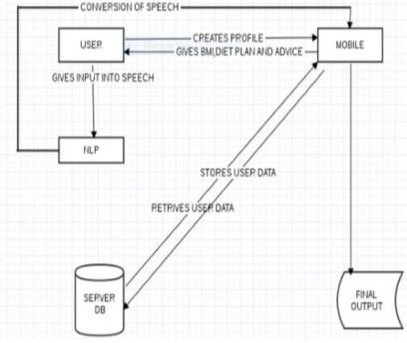

*Figure 3: Speech Recognition through NLP*

* The Activity Tracker for tracking the user steps including the walking, running and stairs time along with the total step taken in a day.
* Progress Report activity is used to present the weekly and monthly reports of the activity tracker and nutrients consumed by the user in the form of a line and pie chart.

**REFERENCES:**

[1]. Belton, V.; Stewart, T. Multiple Criteria Decision Analysis: An Integrated Approach. Kluwer Academic Publishers; Boston, MA, USA: 2002.

[2]. Figueira, J.; Greco, S.; Ehrgott, M. Multiple Criteria Decision Analysis: State of the art Surveys. Springer; Boston, MA, USA: 2005.

[3]. Baltussen R, Niessen L. Priority setting of health interventions: the need for multi-criteria decision analysis. Cost Effectiveness and Resource Allocation. 2006; 4:14. [PubMed: 16923181]

[4]. Oliveira, M.; Fontes, DB.; Pereira, T. Multicriteria Decision Making: A Case Study in the Automobile Industry. School of Economics and Management, University of Porto; Porto, Portugal: 2013.

[5]. Pohekar S, Ramachandran M. Application of multi-criteria decision making to sustainable energy planning – a review. Renewable and Sustainable Energy Reviews. 2004; 8:365–381.

[6]. Wang J, Jing Y, Zhang C, Zhao J. Review on multi-criteria decision analysis aid in sustainable energy decision-making. Renewable and Sustainable Energy Reviews. 2009; 13:2263–2278.

[7]. Haralambopoulos D, Polatidis H. Renewable energy projects: structuring a multi-criteria group decision-making framework. Renewable Energy. 2003; 28:961–973.

[8]. Beccali M, Cellura M, Mistretta M. Decision-making in energy planning. Application of the Electre method at regional level for the diffusion of renewable energy technology. Renewable Energy. 2003; 28:2063–2087.

[9]. Tzeng G, Lin C, Opricovic S. Multi-criteria analysis of alternative-fuel buses for public transportation. Energy Policy. 2005; 33:1373–1383.

[10]. Bit A, Biswal M, Alam S. Fuzzy programming approach to multicriteria decision making transportation problem. Fuzzy Sets and Systems. 1992; 50:135–141.

[11]. Ligmann-Zielinska A, Jankowski P. Impact of proximity-adjusted preferences on rank- order stability in geographical multicriteria decision analysis. Journal of Geographical Systems. 2012; 14:167–187.

[12]. Gbanie SP, Tengbe PB, Momoh JS, Medo J, Kabba VTS. Modelling landfill location using geographic information systems (GIS) and multi-criteria decision analysis (MCDA): case study Bo, Southern Sierra Leone. Applied Geography. 2012; 36:3–12.

[13]. Lootsma F, Mensch T, Vos F. Multi-criteria analysis and budget reallocation in long- term research planning. European Journal of Operational Research. 1990; 47:293–305. Adunlin et al. Page 7 Health Expect. Author manuscript; available in PMC 2016 January 16. Author Manuscript Author Manuscript Author Manuscript Author Manuscript

[14]. Phillips LD, e Cost CAB. Transparent prioritisation, budgeting and resource allocation with multicriteria decision analysis and decision conferencing. Annals of Operations Research. 2007; 154:51–68.

[15]. Hwang, C.; Yoon, K. Multiple Attribute Decision Making Methods and Applications. Springer; New York, NY: 1981.

[16]. Dolan JG. Multi-Criteria clinical decision support. The Patient: Patient-Centered Outcomes Research. 2010; 3:229–248. [PubMed: 21394218]

[17]. Ehrgott, M.; Figueira, JR.; Greco, S. Trends in Multiple Criteria Decision Analysis. Springer; New York, NY: 2010.

[18]. Dodgson, J.; Spackman, M.; Pearman, A.; Phillips, L. Department for Communities and Local Government; London: 2009. Multi-Criteria Analysis: A Manual.

[19]. Keeney, RL. Decisions With Multiple Objectives: Preferences and Value Trade-Offs. Cambridge University Press; Cambridge, England: 1993.

[20]. Doumpos, M.; Zopounidis, C. Multicriteria Decision aid Classification Methods. Kluwer Academic Publishers; Dordrecht, The Netherlands: 2002.

[21]. Triantaphyllou, E. Multi-Criteria Decision Making Methods. Springer; New York, NY: 2000.

[22]. Shim P. Bibliographical research on the analytic hierarchy process (AHP). Socio- Economic Planning Sciences. 1989; 23:161–167.

[23]. Vaidya OS, Kumar S. Analytic hierarchy process: an overview of applications. European Journal of Operational Research. 2006; 169:1–29.

[24]. Ho W. Integrated analytic hierarchy process and its applications – a literature review. European Journal of Operational Research. 2008; 186:211–228.

[25]. Liberatore MJ, Nydick RL. The analytic hierarchy process in medical and health care decision making: a literature review. European Journal of Operational Research. 2008; 189:194–207.

[26]. Guindo LA, Wagner M, Baltussen R, et al. From efficacy to equity: literature review of decision criteria for resource allocation and healthcare decision making. Cost Effectiveness and Resource Allocation. 2012; 10:1–13. [PubMed: 22296830]

[27]. Diaby V, Campbell K, Goeree R. Multi-criteria decision analysis (MCDA) in health care: a bibliometric analysis. Operations Research for Health Care. 2013; 1:20–24.

[28]. Marsh K, Lanitis T, Neasham D, Orfanos P, Caro J. Assessing the value of healthcare interventions using multi-criteria decision analysis: a review of the literature. Pharmacoeconomics. 2014; 32:345–365. [PubMed: 24504851].