VISVESVARAYA TECHNOLOGICAL UNIVERSITY
“Jnana Sangama”, Belagavi-18, Karnataka, India.


Synopsis on

“Autonomous Reinforcement Learning for Adaptive Resonator Calibration: A Classical Analogue for Quantum Control Systems”
Mini-Project Submitted in partial fulfillment of the requirement for the degree of

Bachelor of Engineering
In
Electronics and Telecommunication Engineering
By

Aadidev Raja K | 1DS24ET001
Adithi H P | 1DS24ET008
Akash Kishore | 1DS24ET012
Khushi Patil | 1DS24ET050

4th Sem B.E
Under the guidance of Dr. Jugul Kishore



Department of Electronics and Telecommunication Engineering
DAYANANDA SAGAR COLLEGE OF ENGINEERING BENGALURU -560078
2025-26

ABSTRACT
Modern quantum computing systems require continuous, real-time calibration of control pulses to maintain high-fidelity gate operations. As quantum hardware scales up, manual or brute-force calibration becomes practically impossible, and the need for intelligent, autonomous control systems becomes critical. This project builds a classical hardware system that replicates the core control problem faced in quantum laboratories, and solves it using reinforcement learning.
The physical system is an LC resonator whose resonant frequency drifts over time, simulated using a varactor diode whose capacitance changes with an applied bias voltage. An ESP32 microcontroller handles real-time pulse generation and response measurement, while a Python-based AI layer running Proximal Policy Optimization (PPO) continuously adapts the pulse parameters to maintain maximum energy transfer into the resonator. Since the resonant frequency is never directly revealed to the AI, it must infer the optimal control strategy purely from input-output observations, which is exactly how real quantum calibration systems are forced to operate.
The project is organized into a phased development plan covering simulation, hardware construction, firmware development, AI integration, and experimental validation. Results are expected to demonstrate stable resonance tracking, convergence of the RL agent, and robustness against measurement noise, collectively validating the proposed architecture as a credible classical analogue for quantum control.

KEYWORDS:
Reinforcement Learning, Proximal Policy Optimization, LC Resonator, Varactor Diode, Adaptive Control, Quantum Hardware Calibration, Closed- Loop Feedback, Frequency Drift Compensation, ESP32, Pulse Shaping, Lorentzian Response, System Identification

LITERATURE SURVEY

Sl.No | Author(s) | Year | Title | Publication | Contribution to Project
1 | Pozar, D. M. | 2011 | Microwave Engineering (4th ed.) | Wiley | Provides the theoretical foundation for LC resonator behavior, frequency drift characterization, and varactor-based tuning used in the physical layer of this project
2 | Kelly, J. et al. | 2014 | Optimal Quantum Control using Randomized Benchmarking | Physical Review Letters, 112, 240504 | Establishes the motivation for autonomous calibration by demonstrating how pulse parameter deviations directly degrade performance in resonant quantum systems
3 | Mnih, V. et al. | 2015 | Human-level Control through Deep Reinforcement Learning | Nature, 518, 529–533 | Validates the use of RL agents for learning optimal actions in noisy, dynamic environments, directly supporting the choice of RL as the optimization strategy here
4 | Schulman, J. et al. | 2017 | Proximal Policy Optimization Algorithms | arXiv:1707.06347 | PPO is the core RL algorithm used in the intelligence layer of this project; this paper justifies its selection for noisy continuous action spaces like pulse parameter tuning
5 | Baum, Y. et al. | 2021 | Experimental Deep Reinforcement Learning for Error-Robust Gate-Set Design | PRX Quantum, 2, 040324 | The closest prior work to this project; demonstrates RL-based pulse optimization on quantum hardware, serving as the primary conceptual reference for the control architecture adopted here

3. OBJECTIVE

The primary objective of this project is to design and implement a closed-loop autonomous control system that learns to optimally excite a drifting LC resonator using reinforcement learning, mirroring the autonomous calibration pipelines used in real quantum computing hardware.

The specific objectives are as follows:

To construct a physical LC resonator with varactor-based frequency tuning that replicates the parameter drift behaviour seen in superconducting qubit systems due to thermal fluctuations, magnetic noise, and component aging.

To develop ESP32 firmware capable of generating programmable pulse waveforms including Gaussian, cosine, and DRAG envelopes, directly analogous to the microwave control pulses used in quantum gate operations.

To build a simulation of the resonator using the Lorentzian response model and a drift generator, replicating the non-stationary environment that quantum hardware calibration systems must continuously operate within.

To implement a PPO-based reinforcement learning agent that autonomously tunes pulse parameters to maximize resonator response, mirroring how modern quantum control stacks adaptively maintain gate fidelity.

To integrate the AI optimizer with physical hardware over serial communication, forming a closed-loop system structurally equivalent to the feedback architecture used in quantum processors.

To validate performance through controlled experiments measuring resonance tracking accuracy, convergence speed, and noise robustness, paralleling benchmarking criteria used in quantum hardware validation

4. METHODOLOGY

- System Specification and Resonator Simulation
The project begins with defining the operating parameters of the resonator, including the target resonance frequency range of 300 kHz to 800 kHz, the drift range, pulse duration, and measurement sampling rate. A software simulation of the resonator is then built using the Lorentzian response function with a time-varying drift model, allowing the reinforcement learning algorithm to be developed and tested in a controlled environment before physical hardware introduces additional complexity.

- RL Environment Design and Hardware Construction
The RL environment is built on top of the simulation, exposing reset(), step(), and observe_state() functions for the PPO agent to interact with. Simultaneously, the LC resonator circuit is assembled using a 10 µH inductor and a varactor diode, with a PWM-driven RC filter injecting slow bias voltage variations to simulate frequency drift analogous to what is observed in superconducting qubit systems.

- Pulse Generation and Measurement System Development
The pulse generation system is developed using an ESP32 communicating with an MCP4921 DAC over SPI, producing programmable waveforms including Gaussian, cosine, and DRAG envelopes, buffered through an op-amp before being injected into the resonator. The measurement path runs from the resonator output through an amplification and low-pass filtering stage into an MCP3202 ADC, with 64-sample oversampling used to stabilize amplitude readings.

- Hardware Control Loop and AI Integration
Once hardware is validated independently through frequency sweep and drift injection tests, the Python-based AI layer is integrated over a serial communication link at 921600 baud. The PPO agent receives amplitude measurements as rewards and continuously adjusts pulse frequency, amplitude, duration, and waveform type to maintain maximum energy transfer into the drifting resonator, mirroring the adaptive pulse scheduling used in real quantum control stacks.

- Visualization and Experimental Validation
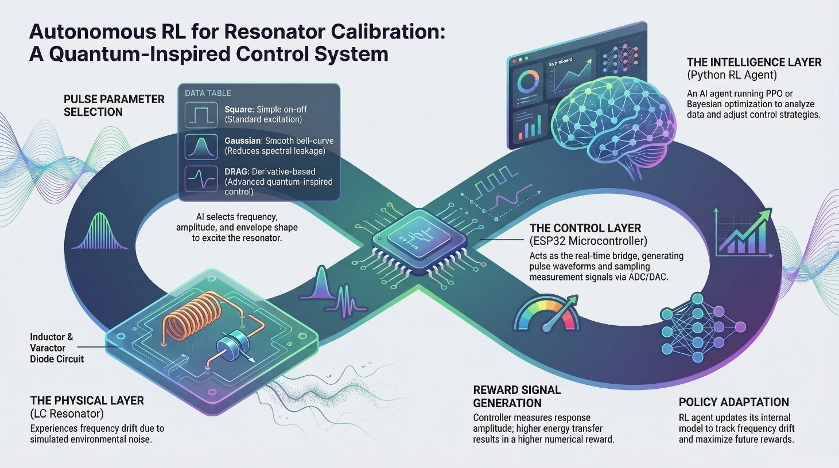
The final stage covers real-time dashboard development and experimental validation, where the system is stress-tested under controlled drift and noise conditions to measure tracking accuracy, convergence speed, and noise robustness, collectively demonstrating the viability of the proposed architecture as a classical analogue for quantum hardware calibration systems.

5. FLOWCHART AND SYSTEM SCHEMATICS

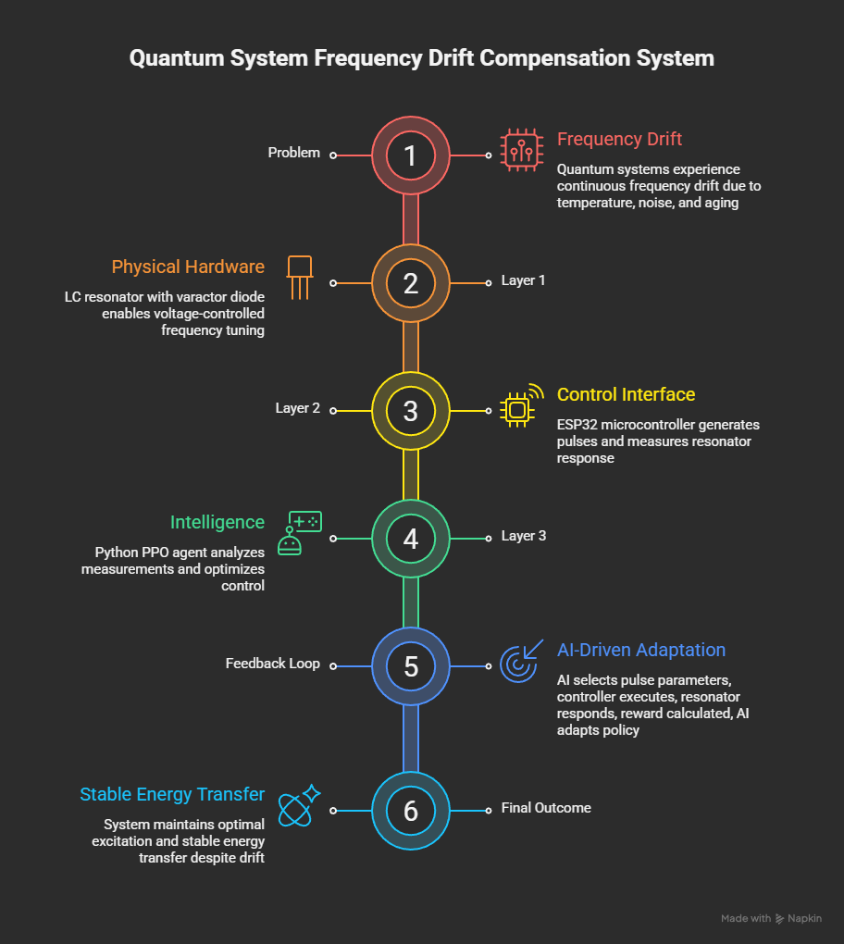

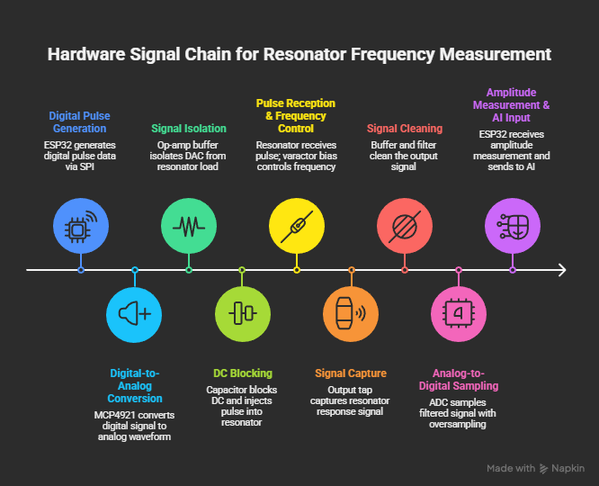
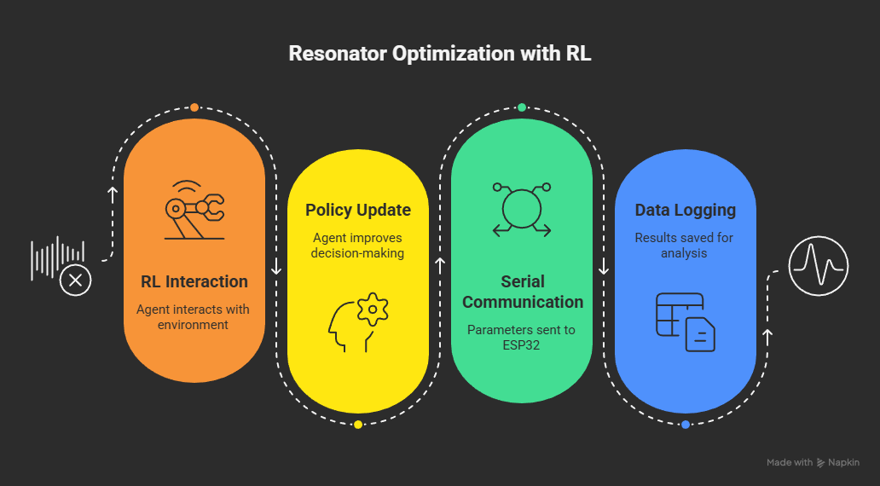

6. HARDWARE/SOFTWARE COMPONENTS

Hardware Components
Component | Use in Project
ESP32 Microcontroller | Acts as the main controller bridging the physical hardware and the Python AI layer
MCP4921 DAC | Converts digital pulse data from the ESP32 into analog waveforms to excite the resonator
TL072 / OPA2134 Op-Amp | Buffers the DAC output and isolates it from the resonator load
BB909 / MV209 Varactor Diode | Provides voltage-controlled capacitance to simulate resonant frequency drift
RF Inductor | Forms the LC tank circuit together with the varactor diode
MCP3202 ADC | Samples the resonator output amplitude and feeds it back to the ESP32
AMS1117-3.3 Voltage Regulator | Provides stable power to all analog and digital components
RC Low Pass Filter | Cleans the resonator output signal before ADC sampling

Software Components
Component | Use in Project
ESP32 Firmware (PlatformIO) | Handles real-time pulse generation, ADC sampling, and serial communication
pyserial | Manages serial communication between Python and the ESP32
stable-baselines3 | Provides the PPO reinforcement learning implementation
PyTorch | Serves as the deep learning backend for the PPO agent
NumPy / SciPy | Handles numerical computation and resonator simulation
pandas | Logs and manages experiment data
Plotly / Dash | Displays real-time system behavior on the visualization dashboard

7. PROJECT OUTCOMES

The successful implementation of this project is expected to produce the following outcomes:
- A fully functional closed-loop autonomous control system where a PPO-based reinforcement learning agent continuously tracks and compensates for resonant frequency drift in real time, without any direct knowledge of the resonator's internal parameters.
- Demonstrated convergence of the RL agent from random initial pulse parameters to an optimal control policy, showing measurable improvement in energy transfer over successive optimization steps.
- Stable resonator excitation maintained across a drift range of ±5% around the nominal resonance frequency, validating the system's ability to operate reliably in a non-stationary physical environment.
- A validated simulation environment built on the Lorentzian response model that accurately replicates hardware behaviour, serving as a reusable testbed for future control algorithm development.
- A real-time visualization dashboard displaying resonator response, pulse parameter evolution, reward convergence, and drift tracking, providing full observability of the system during operation.
- Quantitative performance benchmarks including resonance estimation error, energy transfer stability, optimization convergence speed, and control loop latency, collectively validating the system against the criteria used in real quantum hardware calibration benchmarks.
- A working classical analogue of the autonomous calibration architecture used in quantum computing laboratories, demonstrating that the core control problem of quantum hardware can be studied and prototyped using accessible low-cost electronics.

8. REFERENCES

Sl.No | Reference
1 | Pozar, D. M. (2011). Microwave Engineering (4th ed.). Wiley.
2 | Kelly, J., Barends, R., Campbell, B., Chen, Y., Chen, Z., Chiaro, B., ... & Martinis, J. M. (2014). Optimal Quantum Control using Randomized Benchmarking. Physical Review Letters, 112, 240504.
3 | Mnih, V., Kavukcuoglu, K., Silver, D., Rusu, A. A., Veness, J., Bellemare, M. G., ... & Hassabis, D. (2015). Human-level Control through Deep Reinforcement Learning. Nature, 518, 529–533.
4 | Schulman, J., Wolski, F., Dhariwal, P., Radford, A., & Klimov, O. (2017). Proximal Policy Optimization Algorithms. arXiv preprint arXiv:1707.06347.
5 | Baum, Y., Amico, M., Howell, S., Hush, M., Chernyavsky, M., Kohler, T., ... & Genest, C. (2021). Experimental Deep Reinforcement Learning for Error-Robust Gate-Set Design. PRX Quantum, 2, 040324.

