If you have secured a Job in Germany supposedly your employer has provided you the Binding Contract for Employment, A Pre-Approval Letter (Also Called as ZAV Letter issued by Federal Labour Department in Germany) then you are Eligible for National Visa.

Objective: In This Post I am documenting the challenges faced while getting the Visa to Germany also there is no such one place where I could obtain all the relevant information.

I wish to share my experience here for any of you hard working chap who has obtained employment from Germany but facing issues with getting visa appointment.

I also wish make clear what are the documents needed for ne including spouse. The documents checklist is very vague.

Another challenge is German Embassy hardly receives any call and VFS guys don’t tell much about the needed documents.

\*The Following post should be able to answer following questions.\*

Why it is so difficult to book an appointment with German Visa Embassy in India.

What are documents needed for Visa appointment.

I don’t see VFS Application Centre in Online Application.

Go to the Following URL

<http://www.vfs-germany.co.in/NewDelhi_NorthIndia/short_term_appointment_scheduling.html>

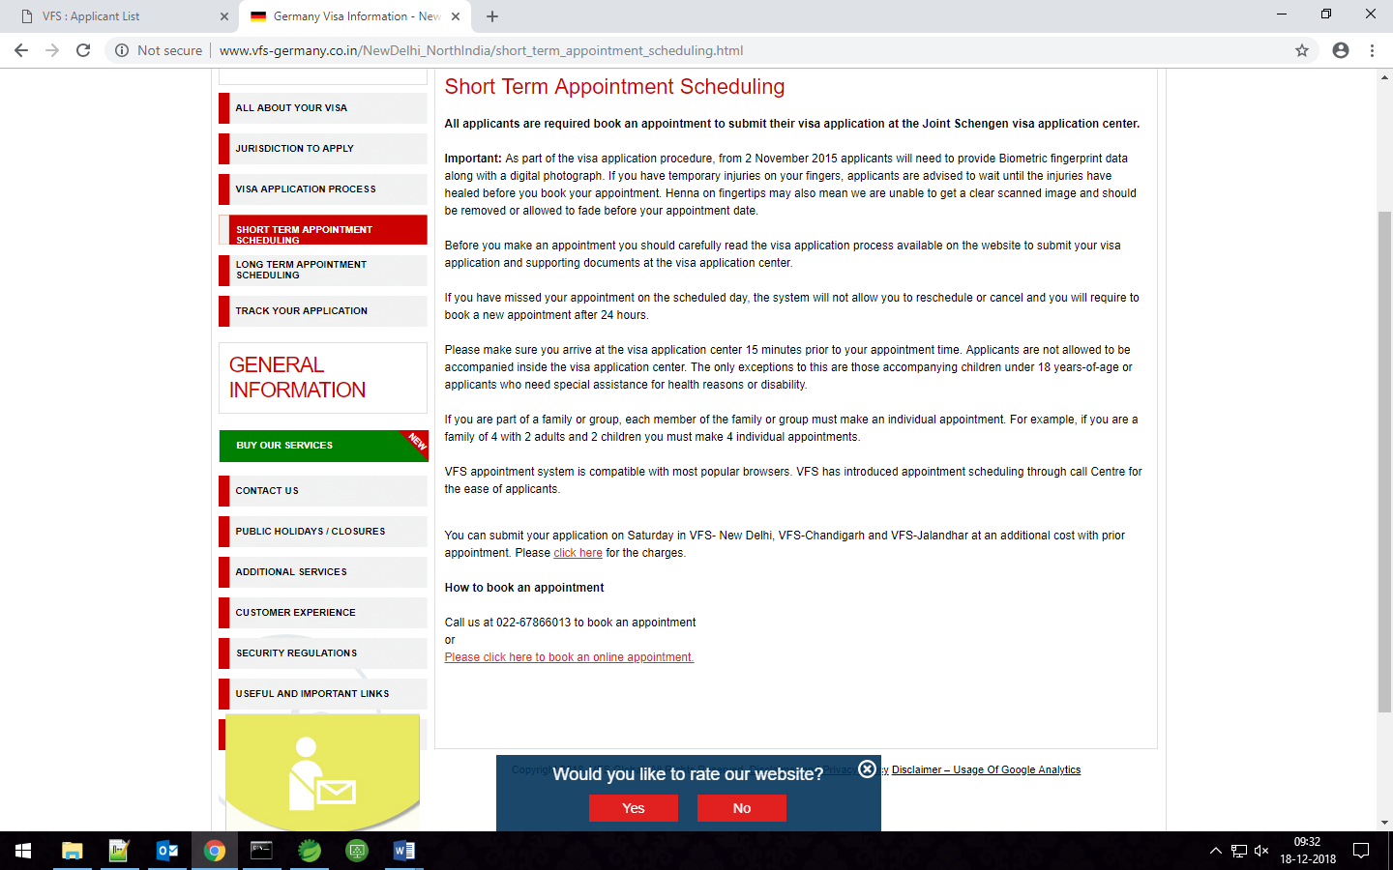

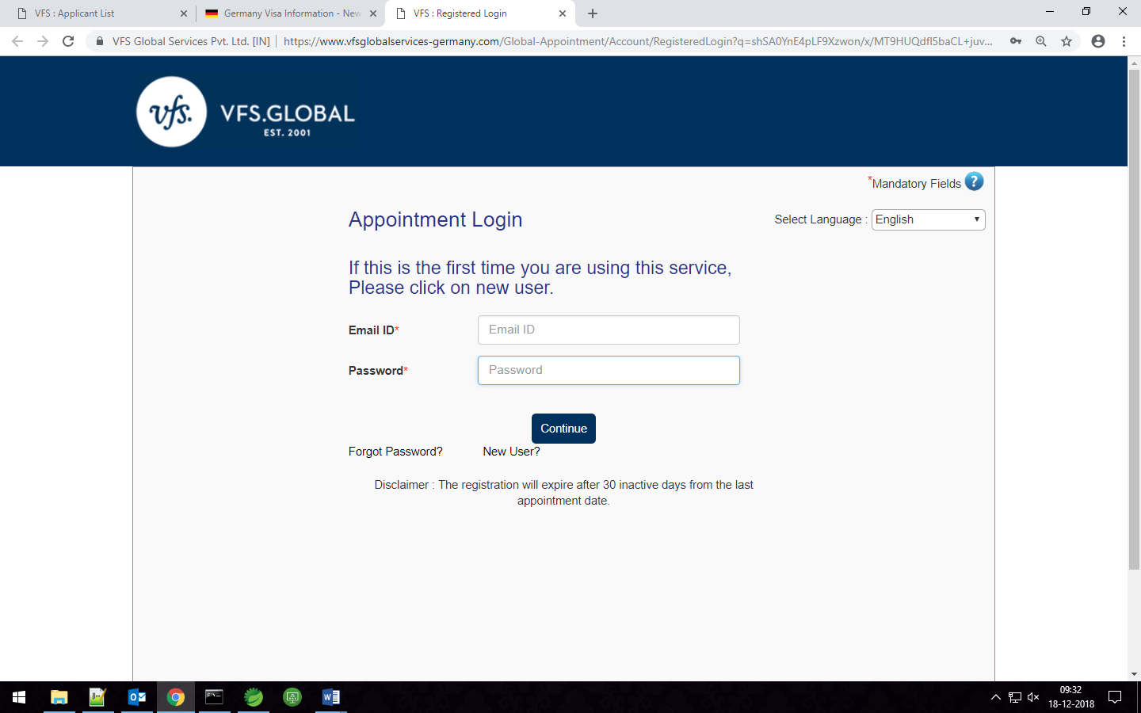

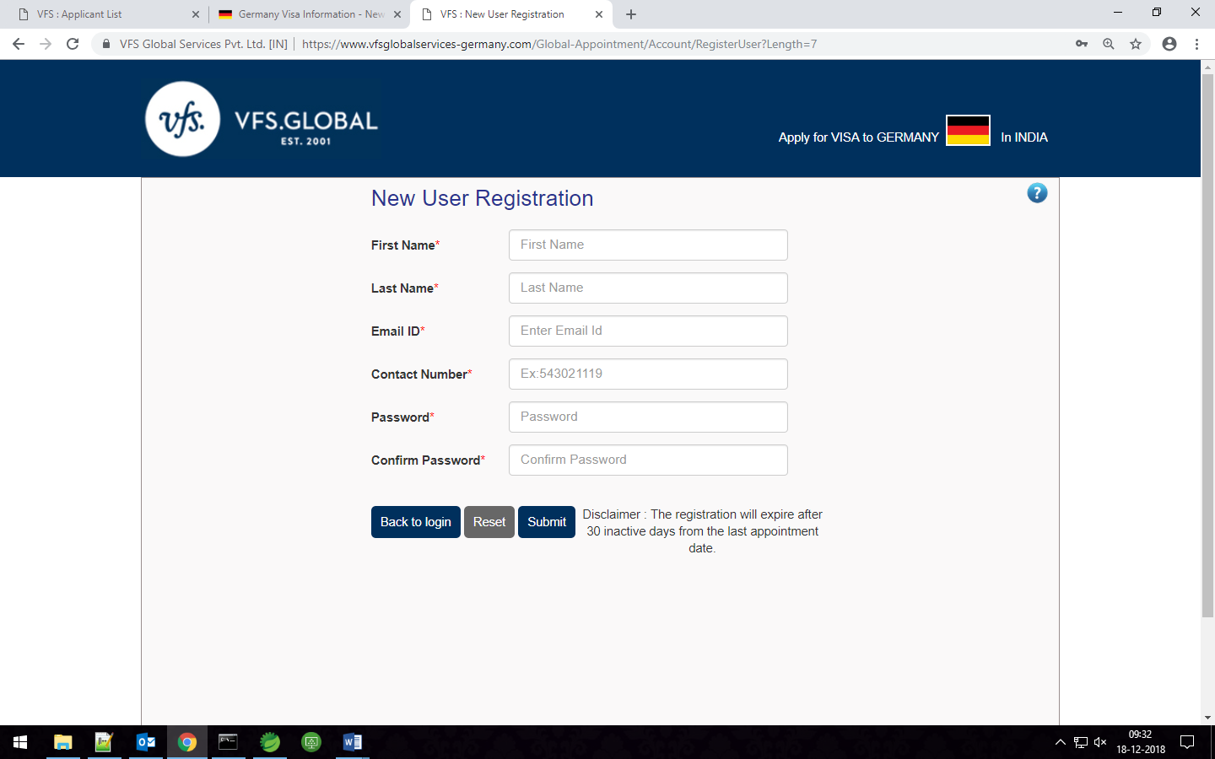

Right Option for Booking Appointment for National Visa.

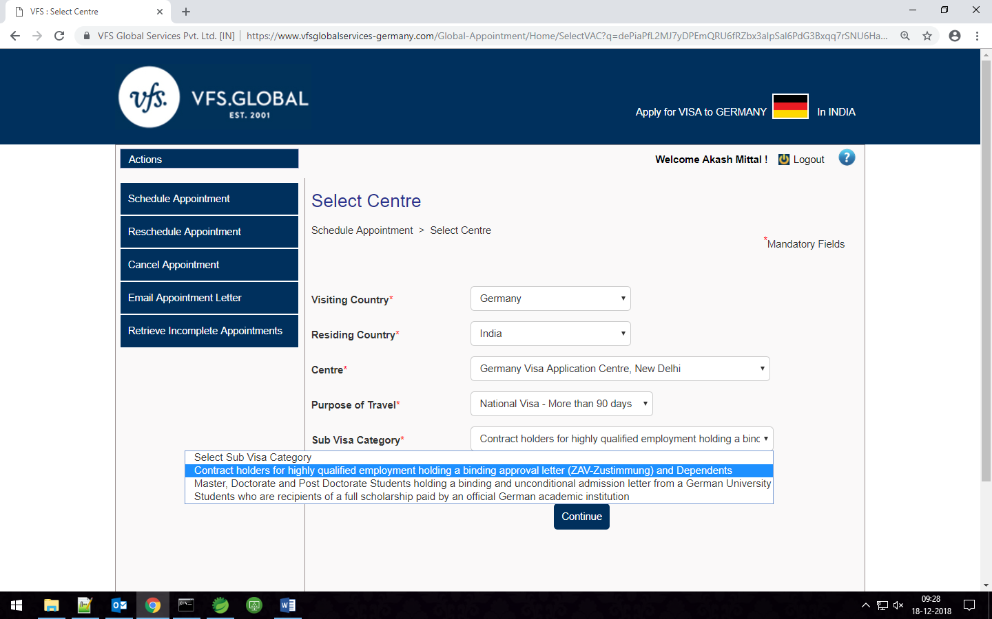

This is How Available Appointments look like.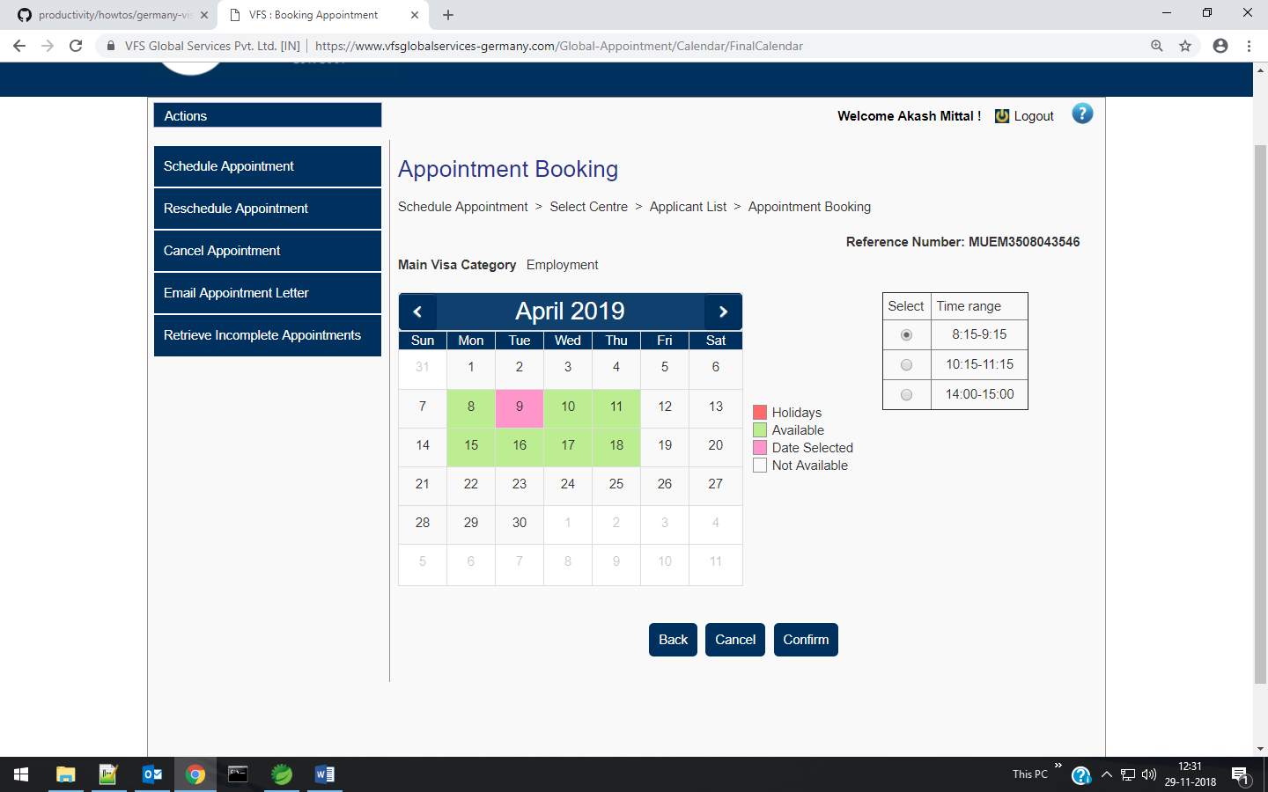

The Hard Way via German Embassy.

