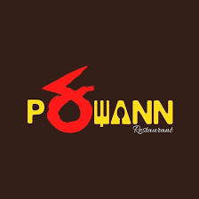

**M/S Pakwann Restaurant**

|  |
| --- |
| New Gandhi Nagar  Ghaziabad UP  201001  GSTIN: 09AAMFN9536G2AQ  -------------------------- |

****Retail Invoice*****

-------------------------

|  |  |  |
| --- | --- | --- |
| DATE | | TIME |
| 19/11/2018 | | 04:41PM |
|  | | |
| Memo#  Honey Chilli Potato 1 190  Chicken Spring Roll 1 210  Choco Lava Cake 2 70 | NO/18/89124  ----------  190.00  210.00  140.00 | |
|  |  | |

----------------------------

SUB TOTAL 540.00

----------------------------

**ORDER NUMBER # 54**

************************

Thank You

************************