AI-Driven Phishing Email Detection Using NLP
Comparative Analysis Report

1. Objective
To design and implement a machine-learning system that automatically detects phishing emails using text analysis and metadata features, applying data preprocessing, feature extraction, model training, and evaluation across four classifier families: Logistic Regression, Random Forest, Naive Bayes, and a simple Neural Network.

2. Dataset
The Phishing Email Detection dataset (Kaggle), containing 18,650 labeled emails: 11,322 legitimate (Safe) and 7,328 phishing, drawn primarily from the Enron corporate email corpus combined with known phishing/spam samples. After removing 16 rows with missing text, 18,634 emails remained for the pipeline.
Class balance: 60.7% Safe / 39.3% Phishing -- a mild imbalance, addressed via class-weighting during training rather than resampling.

3. Methodology

3.1 Data Cleaning
HTML tags were stripped, text was lowercased, URLs and punctuation were removed, and stopwords were filtered using NLTK's English stopword list. 92 rows with extreme length (up to 17 million characters, identified as data quality artifacts rather than genuine email content) were capped at 20,000 characters prior to cleaning.

3.2 Metadata Feature Extraction
Seven structural features were extracted from the raw text before cleaning (since cleaning destroys signals like URLs): character count, word count, URL count, presence of a URL, exclamation mark count, digit count, and capital-letter ratio.

3.3 Feature Engineering
Text was vectorized using TF-IDF (5,000 features, unigrams and bigrams, minimum document frequency of 5). The TF-IDF matrix was combined with the seven standardized metadata features into a single 5,007-dimension feature matrix. Train/test split (80/20, stratified) was performed before fitting the vectorizer and scaler, to prevent test-set information from leaking into feature preparation.

4. Model Comparison
All four classifiers were trained on the same held-out test set of 3,726 emails.
Model | Accuracy | Precision | Recall | F1 Score
Neural Network | 97.18% | 94.84% | 98.15% | 96.47%
Logistic Regression | 96.78% | 94.26% | 97.74% | 95.97%
Naive Bayes | 95.87% | 94.49% | 95.01% | 94.75%
Random Forest | 95.81% | 91.33% | 98.70% | 94.87%
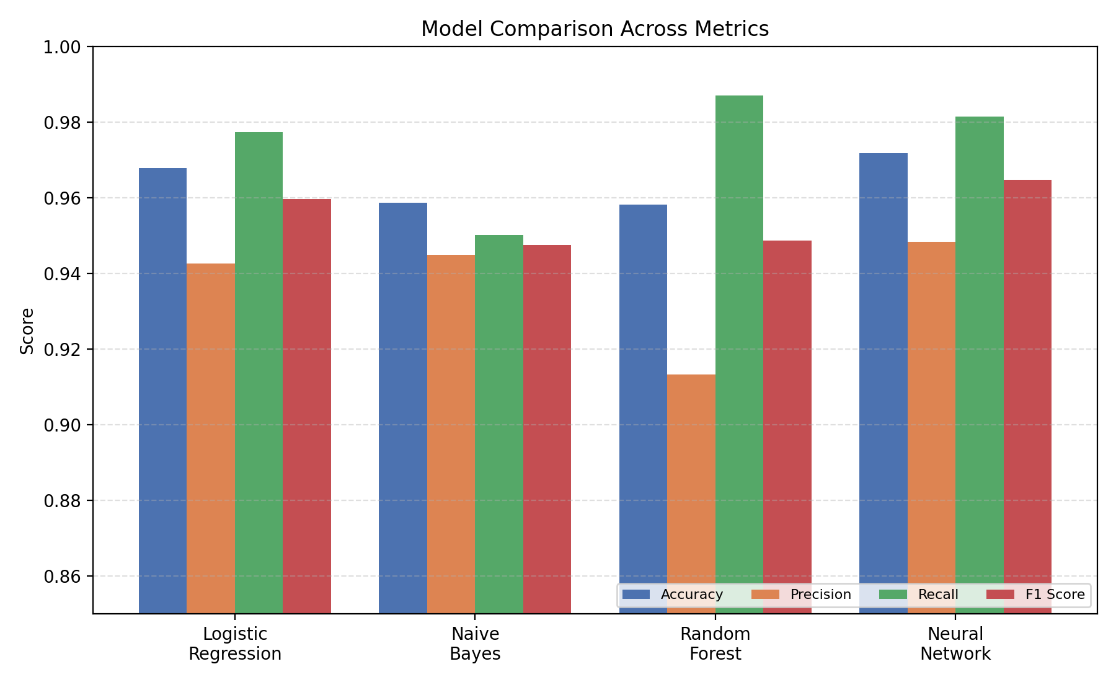

4.1 Key Observations
- The Neural Network achieved the best overall performance (97.18% accuracy, 96.47% F1), followed closely by Logistic Regression (96.78% / 95.97%).
- Random Forest achieved the single highest recall (98.70%), catching the most phishing emails, at the cost of the lowest precision (91.33%) -- more false alarms on legitimate email.
- Naive Bayes, trained on TF-IDF text alone (excluded from metadata due to its non-negativity requirement), landed within roughly one point of Logistic Regression -- demonstrating that phishing language alone carries substantial predictive signal even without structural features.
- Model choice in practice depends on the cost being optimized: Neural Network for best all-around performance, Logistic Regression for interpretability, Random Forest for maximum recall when missing phishing is the more costly error.

5. Feature Importance
Logistic Regression coefficients (directly interpretable, unlike tree-based importances) show the following patterns:

5.1 Top Phishing-Indicative Terms
- click, remove, free, http, money, site, removed, info -- consistent with the classic urgency/sales/call-to-action language predicted in the project brief.

5.2 Top Safe-Indicative Terms
- enron, thanks, wrote, university, vince, linguistics, edu -- reflecting this dataset's specific composition (Enron corporate correspondence and academic linguistics discussion threads) rather than legitimate email in general. This is an important generalization caveat: the model's notion of 'safe' is shaped by its training source.

5.3 Metadata Feature Value
Random Forest's feature importance ranking placed exclamation_count and caps_ratio among the single most predictive features overall, on par with top TF-IDF terms -- confirming that the engineered metadata features contributed genuine signal beyond word frequencies alone.

6. Error Analysis
Analysis of the Neural Network's misclassifications (78 false positives, 27 false negatives out of 3,726 test emails) surfaced three distinct patterns rather than random noise:
- Data quality: a subset of false positives are dataset rows with placeholder/empty body content, which carry no real signal to classify -- a source-data limitation rather than a model failure.
- Label ambiguity: some false negatives resemble general spam (e.g. newsletter-style content) rather than credential-theft phishing, reflecting a genuinely blurry boundary between the two categories even for human labelers.
- Content obfuscation: at least one false negative was padded with unrelated, plausible-sounding text (historical trivia, quotations) with no suspicious vocabulary present -- a deliberate evasion technique. This represents a structural blind spot in TF-IDF-based models, which key off word frequency rather than contextual meaning.

7. Conclusion & Recommendations
All four models exceeded 95% accuracy, confirming that phishing emails carry strong, learnable textual and structural signals detectable through classical NLP and machine learning techniques.
- Recommended for best overall performance: Neural Network.
- Recommended for interpretability / auditability: Logistic Regression.
- Recommended for maximum phishing recall: Random Forest.
- Future work: address the content-obfuscation blind spot with context-aware embeddings (e.g. transformer-based models); validate generalization on legitimate email sources beyond the Enron corpus; test robustness against modern LLM-generated phishing styles using supplementary synthetic datasets identified during dataset selection.

