# **Assignment: Dockerizing a Java Application and Deploying it on Kubernetes**

Name: Akash Nadigepu

ID: 290396

Github repo: [Akash-Nadigepu/spring-boot-hello-world: A simple Spring Boot app to send hello world message to a user](https://github.com/Akash-Nadigepu/spring-boot-hello-world/)

DockerHub repo: [akash6637/spring-boot-hello-world general | Docker Hub](https://hub.docker.com/repository/docker/akash6637/spring-boot-hello-world/general)

**Task 1: Fork and Clone Java Repo**

1. **Fork the repository on GitHub.**

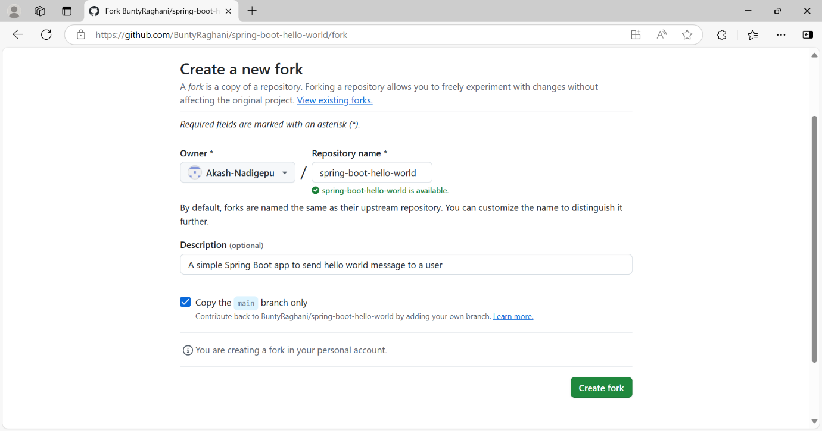

1. **Cloned it to into local machine.**

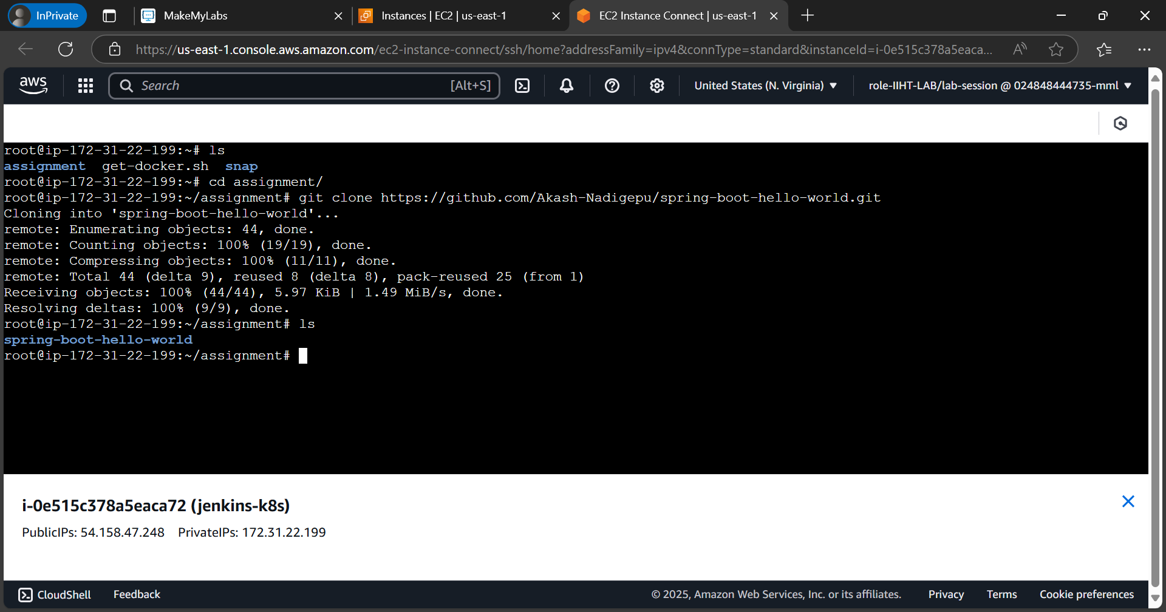

**Task 2: Define a Dockerfile**

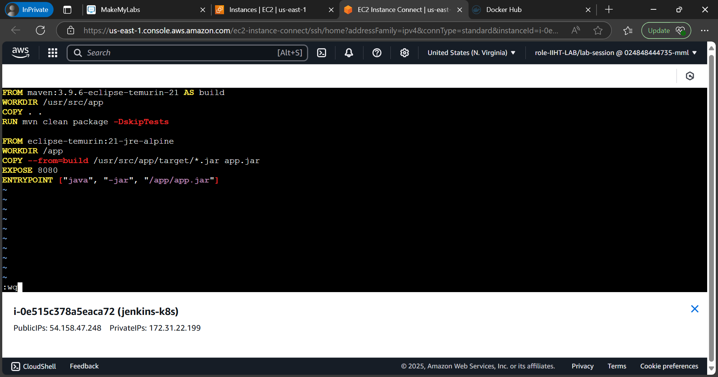

**Task 3: Build and Push Docker Image**

1. **Build the image:**

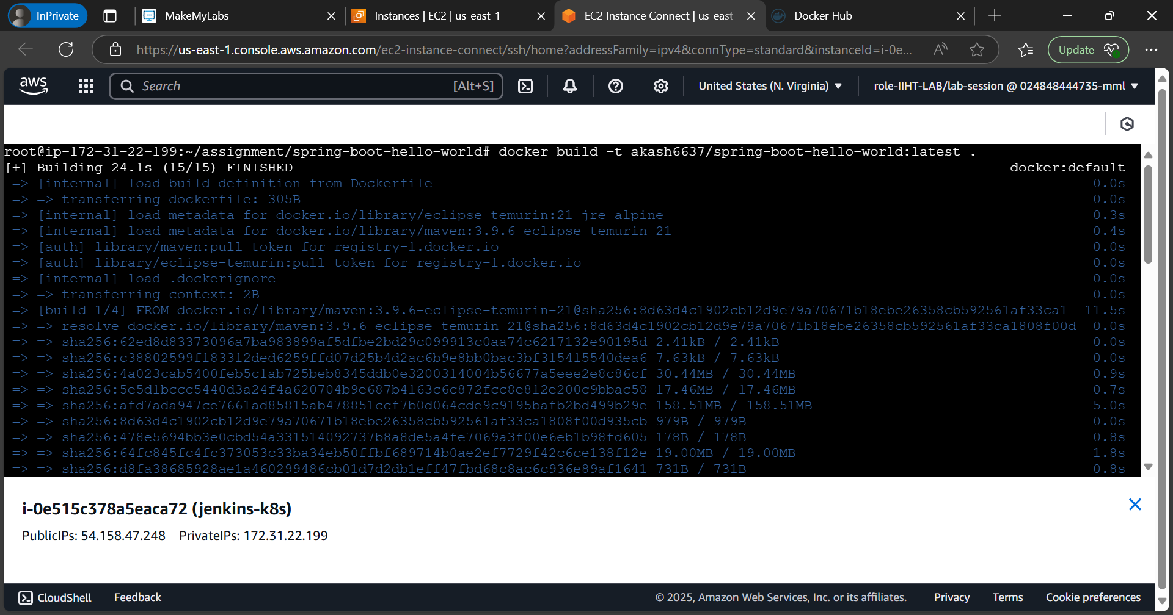

1. **Run the Container Locally**

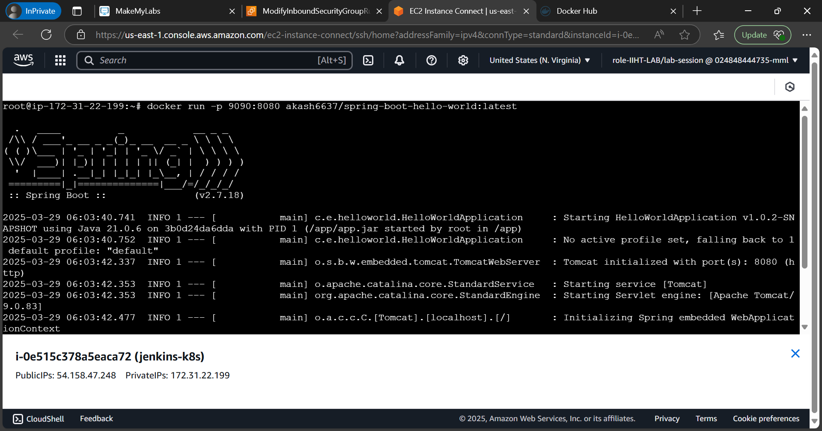

1. **Checking if it's running:**

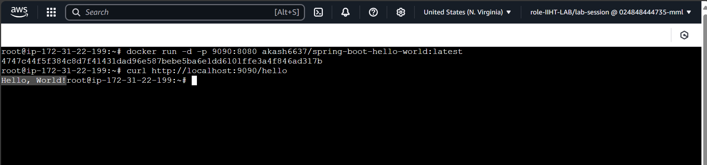

**Worked! It is printing Hello, World!**

1. **Push to DockerHub:**

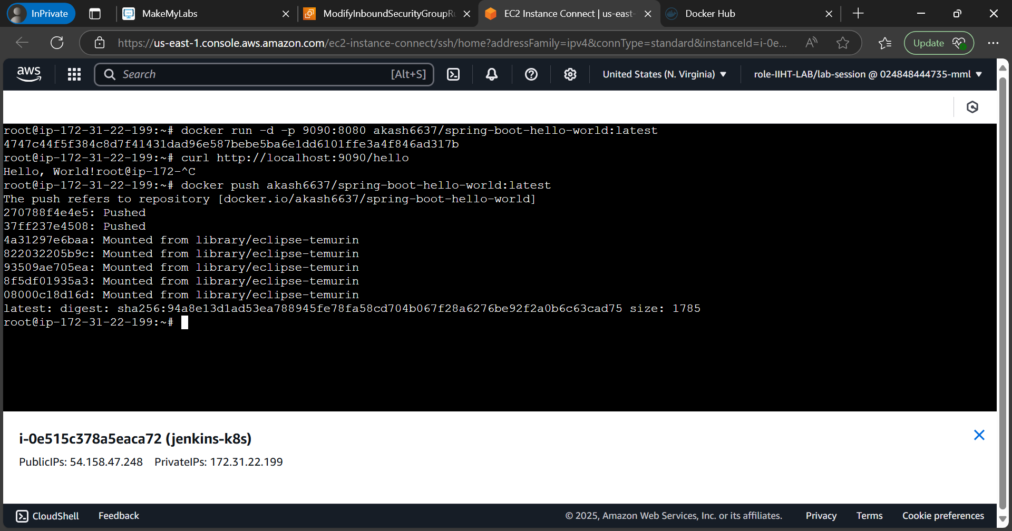

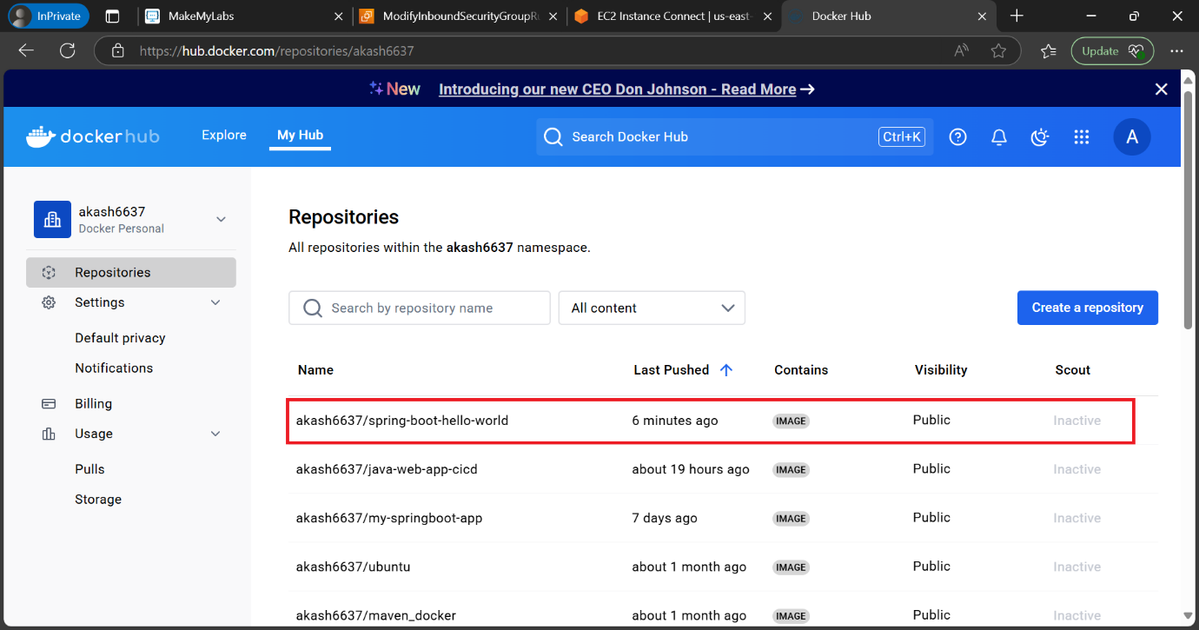

## **Task 4: Create a Kubernetes Deployment**

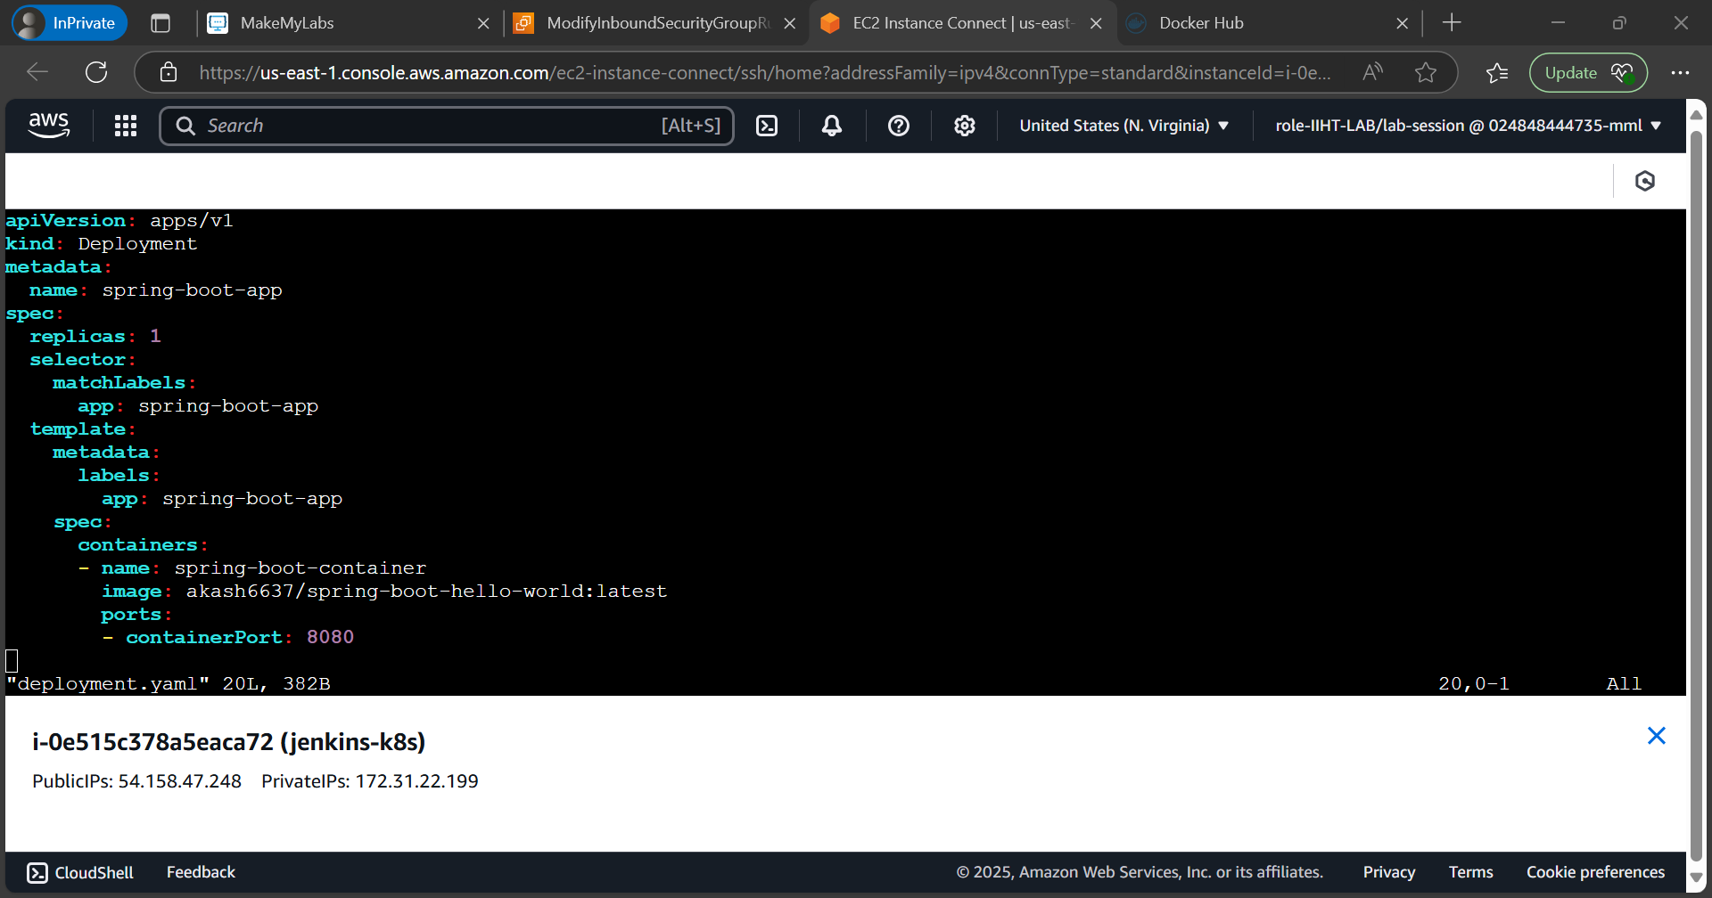

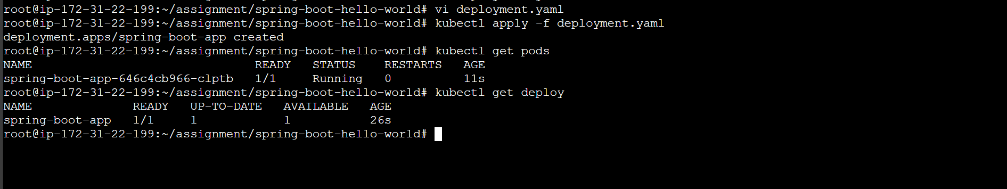

## **Task 5: Scale Up and Scale Down**

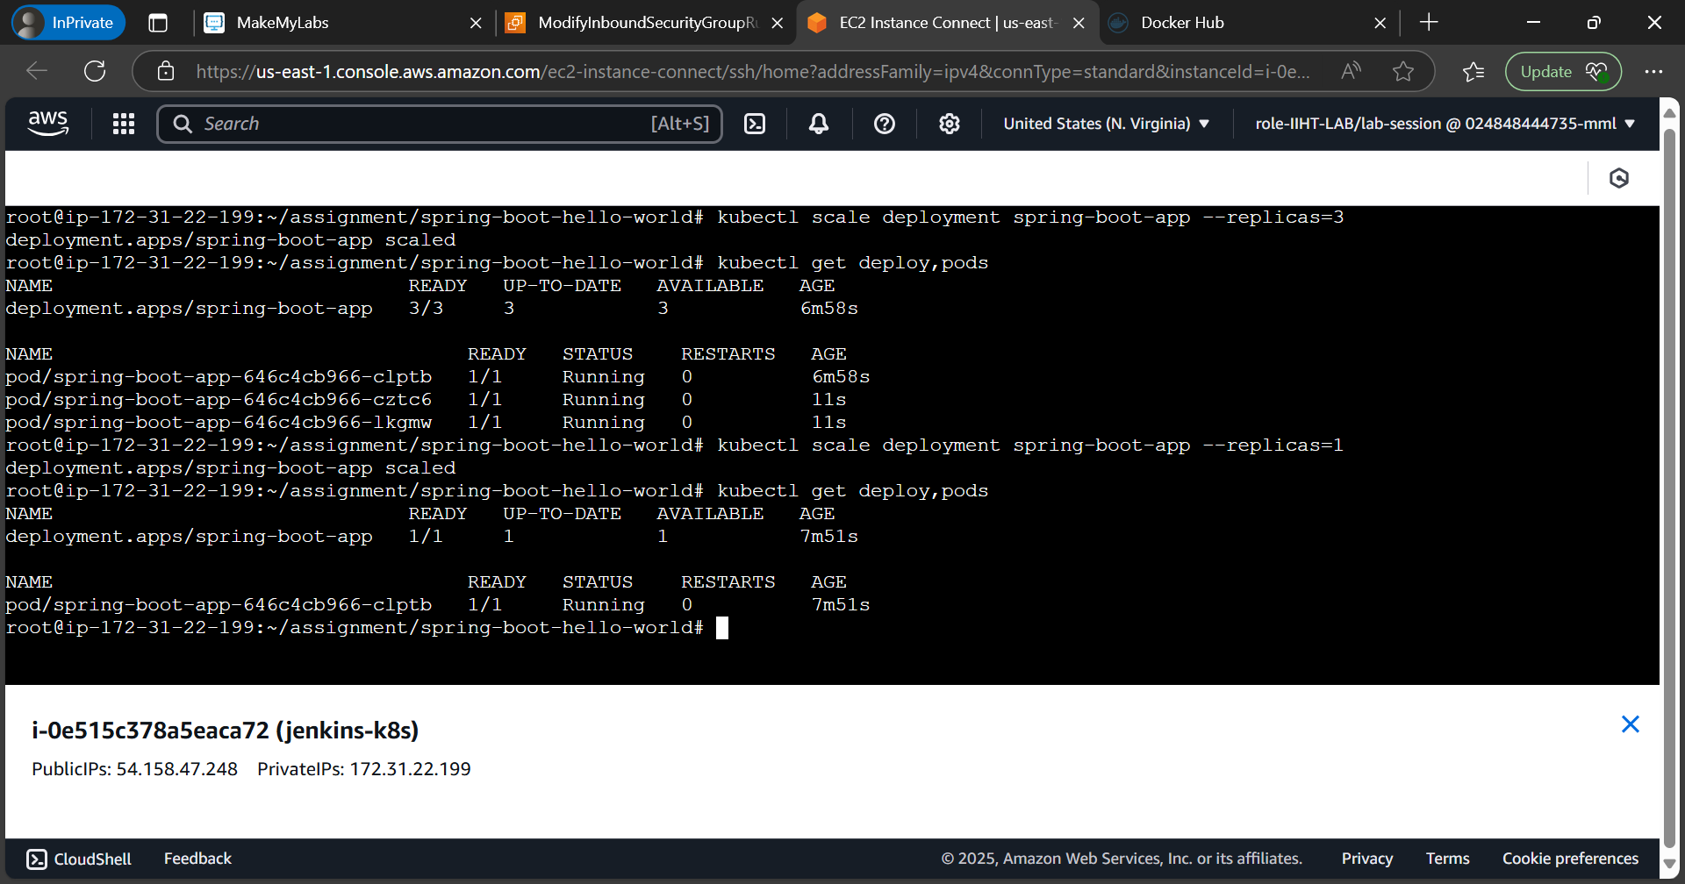

## **Task 6: Expose the Service Using NodePort**

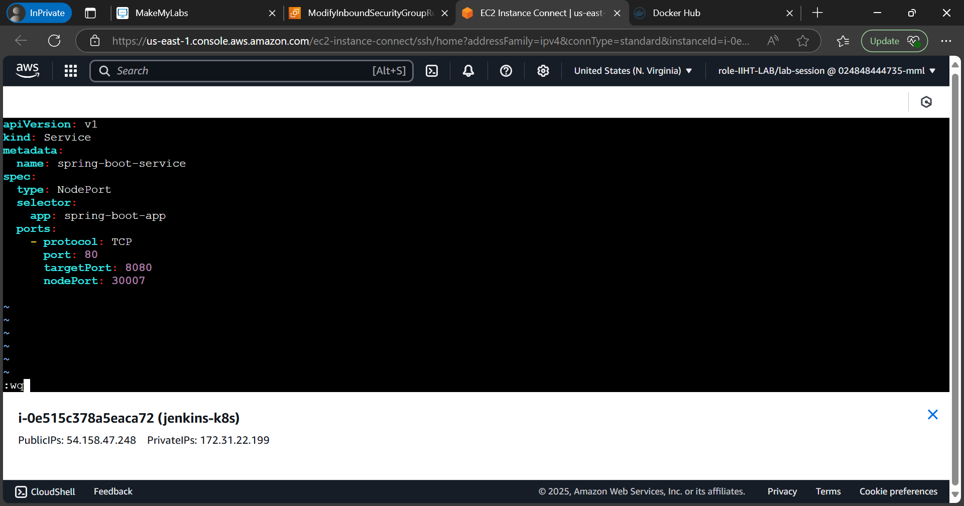

**Accessing the Application using NordePort :30007**

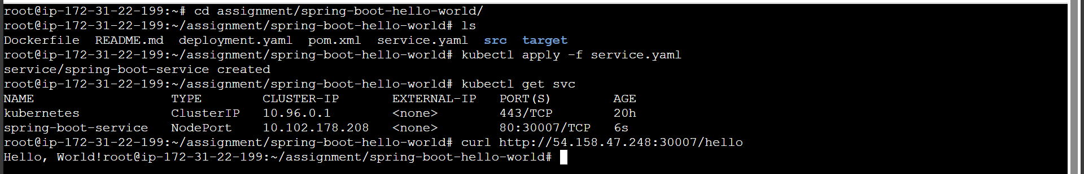

## **Task 7: Automate Deployment Using Jenkins**

