**Smart Home Anti-Theft System: A Novel Approach**

**for Near Real-Time Monitoring and Smart Home**

**Security for Wellness Protocol**

**Akash.A(180701017), Akash.V(180701018), Arun Kumar.M(180701035), Balaji.V(180701047), Chris Gavin.B(180701056)**

**Abstract:** The proposed research methodology aims to design generally implementable framework for providing a house owner/member with the immediate notification of an ongoing theft (unauthorized access to their premises). For this purpose, a rigorous analysis of existing systems was undertaken to identify research gaps. The problems found with existing systems were that they can only identify the intruder after the theft, or cannot distinguish between human and non-human objects. Wireless Sensors Networks (WSNs) combined with the use of Internet of Things (IoT) and Cognitive Internet of Things are expanding smart home concepts and solutions, and their applications. The present research proposes a novel smart home anti-theft system that can detect an intruder, even if they have partially/fully hidden their face using clothing, leather, fiber, or plastic materials. The proposed system can also detect an intruder in the dark using a CCTV camera without night vision capability. The fundamental idea was to design a cost-effective and efficient system for an individual to be able to detect any kind of theft in real-time and provide instant notification of the theft to the house owner. The system also promises to implement home security with large video data handling in real-time. The investigation results validate the success of the proposed system.The system accuracy has been enhanced, in scenarios where a detected intruder had not hidden his/her face, hidden his/her face partially, fully, and was detected in the dark.

**Keywords:** smart anti-theft system; intruder detection; unsupervised activity monitoring; smart home; partially/fully covered faces

**1. Introduction and Related Work**

In the modern era, security and surveillance are important issues. Recent acts of theft/terrorism have highlighted the urgent need for efficient video surveillance and on-the-spot notification of ongoing thefts to house owners and other household members. A number of surveillance solutions are currently available on the market, such as CCTV cameras and digital video recorders (DVRs) that can record the unauthorized activities of a trespasser, but cannot distinguish between human and non-human objects. In recent times, the ratio of theft has increased tremendously due to a lack of awareness and low availability of smart-gadgets. The task of face detection and the recognition of an intruder become very difficult when the intruder hides their face partially or fully using some type of material, such as plastic, leather, or fabric. Legacy systems cannot provide real-time theft notification to the house owner nor detect partially of fully obscured faces. It is also challenging for old systems to detect the intruder in the dark using a CCTV camera without night vision capability. The major flaw with this kind of arrangement is that it demands the 24/7 availability of a house owner or member, or manual video surveillance, which is almost impossible. In addition, it is a tedious task to go through all the recorded video clips after a possible theft has become known. It might be that the storage server contains a large amount of family member footage, which is of no use in identifying trespassers. The proposed approach can be applied to an IoT-based smart home monitoring system in near real-time. As shown in Figures 1 and 2, a smart home was designed and developed based on an integrated framework of sensors, cameras, and customized hardware to analyze unauthorized access. The system operates at two different levels: through a hardware interface and through a software interface. At the hardware interface level, an intelligent sensing node is deployed,connected to a central sensing node which acknowledges the data and sends it to the storage server. The software modules are into several further levels, including data logging, data retrieval, and storage. The main objective of the software is to detect and report unsupervised human activity using large data handling techniques as close to real-time a possible. The work is presented as follows. The initial section provides an introduction on legacy systems, potential issues, and their impact on society. Section 2 describes the necessity of the present research. It also describes the intelligent features of the system that can detect obscured faces using graphical and statistical methods. Subsequently, Section 3 presents the design and experimental setup of the system. It also describes two critical features: (i) the detection of obscured faces and (ii) detection of an intruder in the dark. Section 4 presents the methodologies in three different phases with graphical analysis and statistical results. The final section (Section 5) discusses the research outcomes.



Image of a smart building where a smart home monitoring and anti-theft system has

been installed.

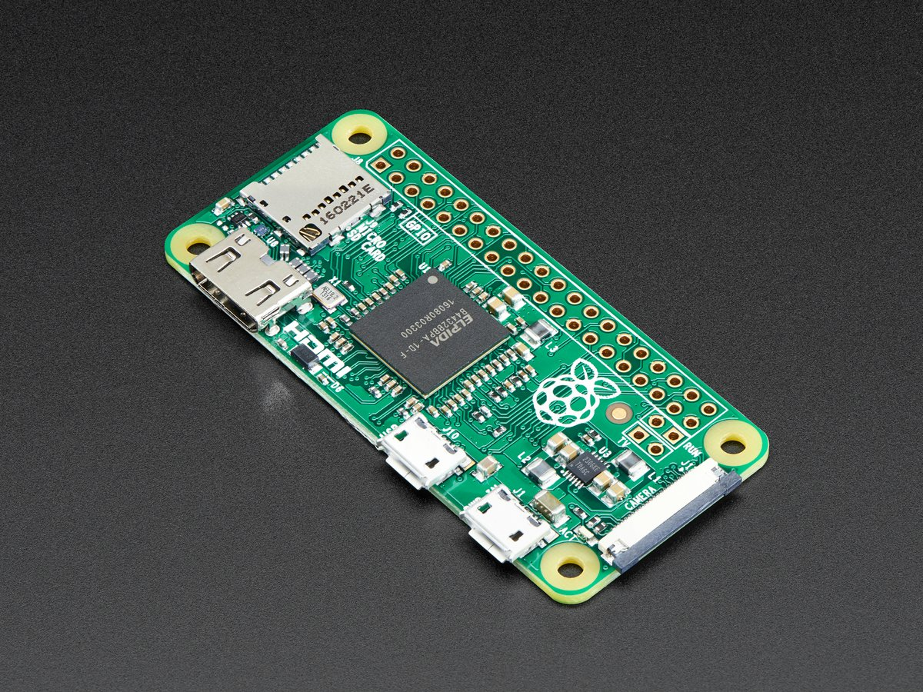

(a) (b)

**2. Necessity of a New IoT-Based Theft System**

Nowadays, intruders have become more technologically aware and have carried out burglaries using smart gadgets like gas-cutters, smart anti-lock systems, and many more. For such intruders, it isstraightforward to disconnect CCTV camera surveillance, which has an indirect connection to the digital video recorder and a database server residing at home. Therefore, there is a need to modify existing systems and propose an intelligent approach that can not only provide unsupervisedhuman activity monitoring, but can also stop an ongoing theft by notifying the house-owner at the earliest opportunity. All legacy systems work on the premise of object detection, object motion detection, and tracking. Such systems are prone to false alerts or notifications, which might result insending false emergency notifications to the house owner/member, the escape of the intruder after the theft, and unnecessary disruptions to the residents. To resolve these issues, a novel human activity monitoring detection, recognition, and home security approach is presented in the remaining sections.

**3. Design and Experimental Setup**

As shown in Figure a 5mp camera, Wi-Fi- and Bluetooth-enabled customized hardware with 512 GB RAM and acer laptop device were used. The camera was placed in each room of the smart home to protect the house from intruders equipped with smart gadgets. Nowadays, intruders often understand that the camera would be connected to a laptop/computer/tablet and can disconnect it to stop the system functioning. The customized hardware used in the system has Bluetooth and Wi-Fi capability, which allows placing the proposed system anywhere inside the smart home where Wi-Fi is available. Even in the case of power failure, the proposed system can still function if it is connected to a laptop/tablet with a hotspot internet connection. The system starts functioning when an intruder comes into the monitored area. The movement of an intruder is captured by a face detection module. The main function of the face detection module is to differentiate human objects from non-human objects. When any human action is detected, the camera is activated at a rate of 50 frames per second. After the initial frame has been captured, it is immediately sent to the house owner through sms and phone call.

start

On camera with program

Checking for movement in each frame

Movement detected

NO

YES

Take image and send to cloud message and call the owner

Checking for movement in each 100th frame

Movement detected

NO

YES

Take image and send to cloud, message the owner

**4.Outcome**

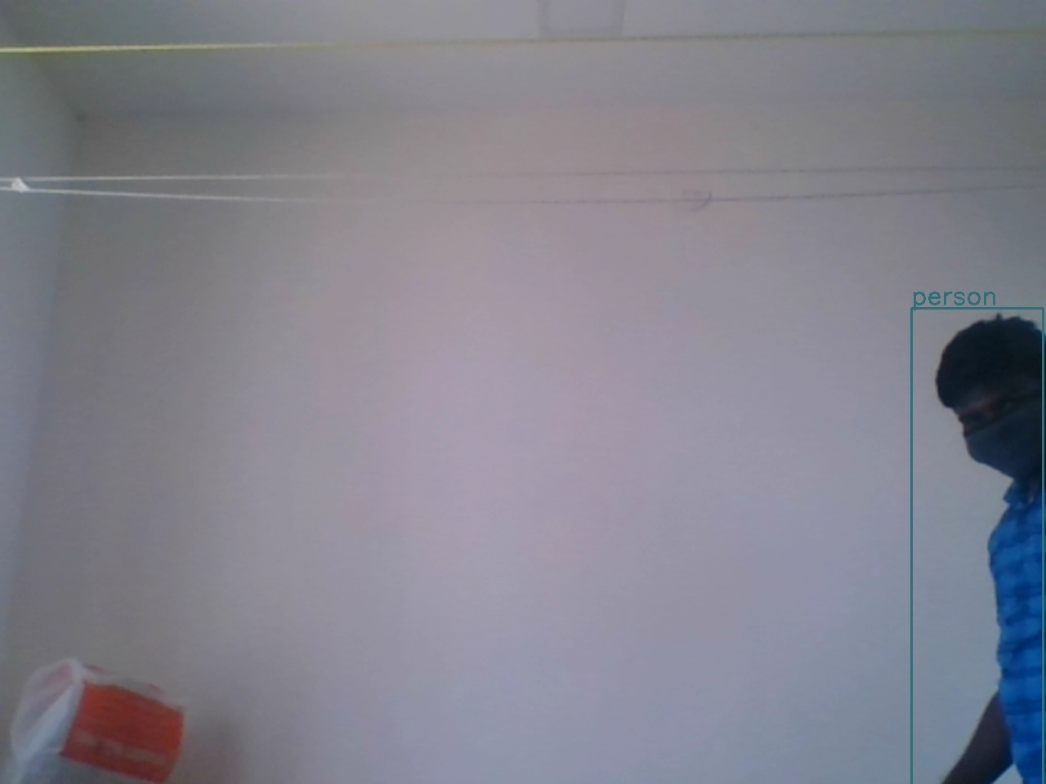

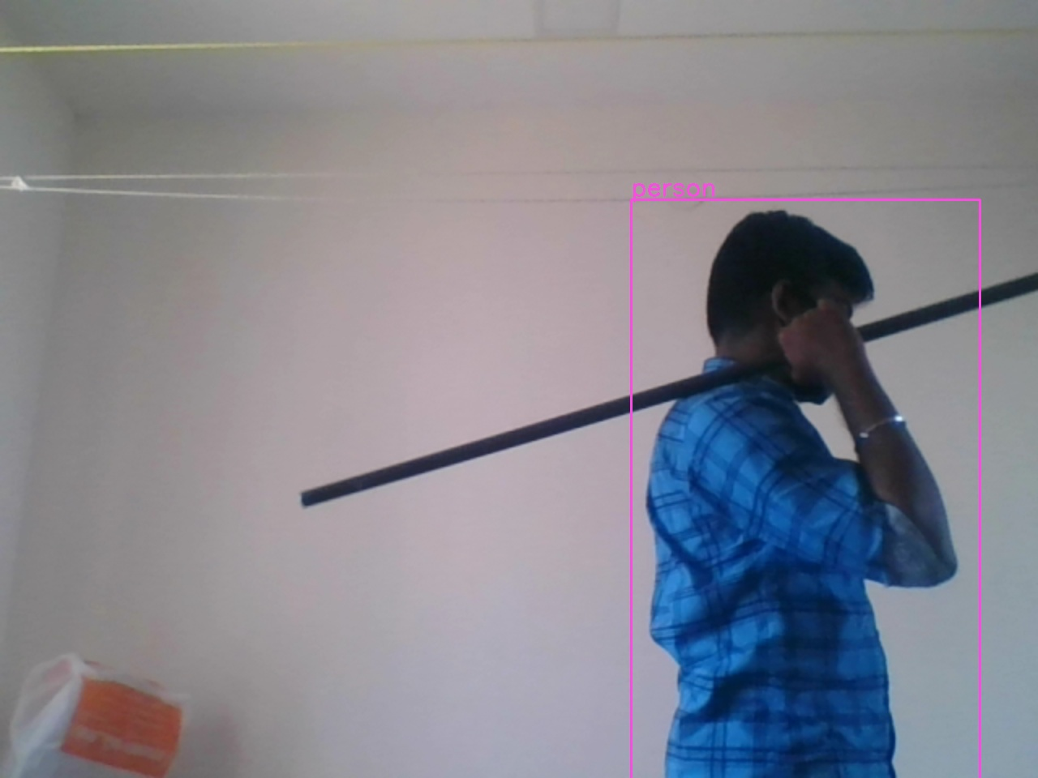

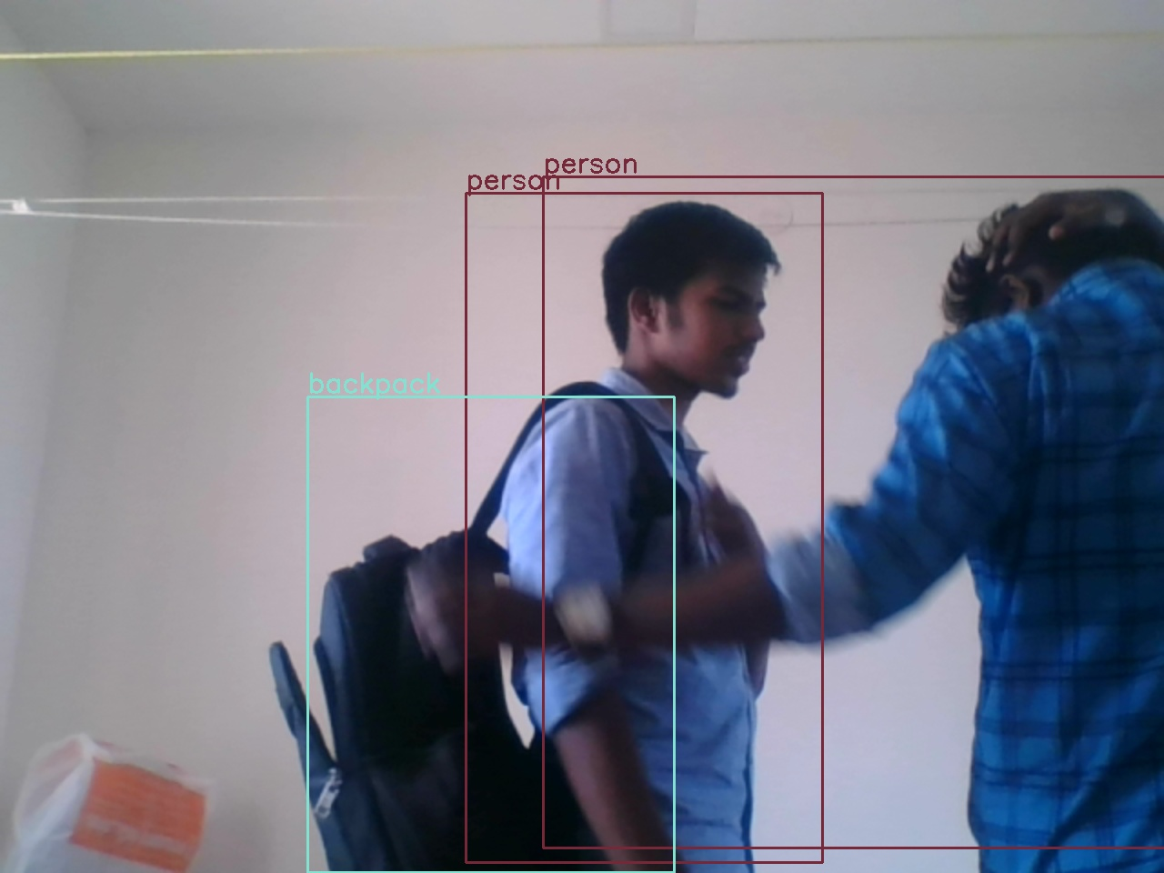

**5. Conclusions**

This Software requirements specification presents an innovative method to prevent smart home theft by providing spontaneous notification of ongoing intrusion. The research has provided a novel wireless sensing system for the surveillance and detection of a human intruder as well as instant notification of the intrusion to prevent theft. It eliminates the use of DVR for recording as well as the use of large amounts of memory for storage.The system can effectively identify a human intruder and prevent false alarms when the intruder is a non-human, by distinguishing between human and non-human objects. All of these processes lead to the instant notification of intrusion by providing real-time notification about the potential theft.The performance evaluation parameters of the Smart Home Antitheft System for intruder detection are recorded for the four different scenarios: (a) face not obscured, (b) face partially covered, (c) face fully covered, and (d) captured in the dark by an analog camera. The main advantage of the proposed system is that it requires only 50% cost of the DVR and other surveillance-based solutions available on the market.

**Author Contributions:** AK.A, AK.V, AK.M,B.V,CG.B conceived,

designed, and performed the experiments; the rest contributed to data analysis; all authors reviewed the manuscript.

**Conflicts of Interest:** The authors declare no conflict of interest.

**References:** answers.opencv.org, stackoverflow.com,

Stackexchange.com