# DESIGN AND IMPLEMENTATION OF 3 BIT SYNCHRONOUS and RIPPLE COUNTER

# By: V.S.Sai Rashwant(20BCE1332)

**AIM:**

To design and implement 3 bit synchronous up and 3 bit ripple down counter.

**Tools :**

LTSpice

**Circuit Diagram:** Synchronous Counter:

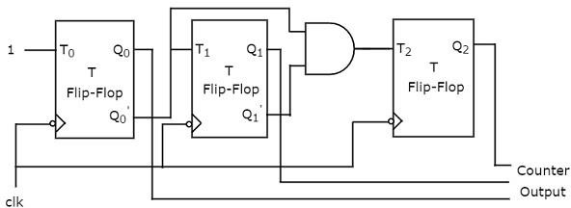

Truth Table

# TRUTH TABLE:

|  |  |
| --- | --- |
| **Present State QA QB QC** | **Next State QA+1 Q B+1 QC+1** |
| **0 0 0** | **0 0 1** |
| **0 0 1** | **0 1 0** |
| **0 1 0** | **0 1 1** |
| **0 1 1** | **1 0 0** |
| **1 0 0** | **1 0 1** |
| **1 0 1** | **1 1 0** |

|  |  |
| --- | --- |
| **1 1 0** | **1 1 1** |
| **1 1 1** | **0 0 0** |

3- bit Ripple counter –Down Counter

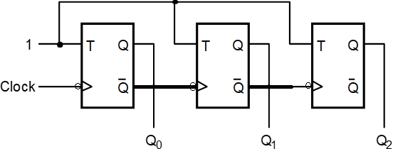

# TRUTH TABLE:

|  |  |
| --- | --- |
| **Present State QA QB QC** | **Next State QA+1 Q B+1 QC+1** |
| **0 0 0** | **1 1 1** |
| **1 1 1** | **1 1 0** |
| **1 1 0** | **1 0 1** |
| **1 0 1** | **1 0 0** |
| **1 0 0** | **0 1 1** |
| **0 1 1** | **0 1 0** |
| **0 1 0** | **0 0 1** |
| **0 0 1** | **0 0 0** |

**Procedure:**

* Open LT Spice.
* Open new schematic.
* Place 3 T flip flops.
* Make proper connections using connection wires.
* Place voltage sources and keep proper setting for it.
* Run the circuit and make note of the outputs.

**3 bit synchronous up:**

**Circuit:**

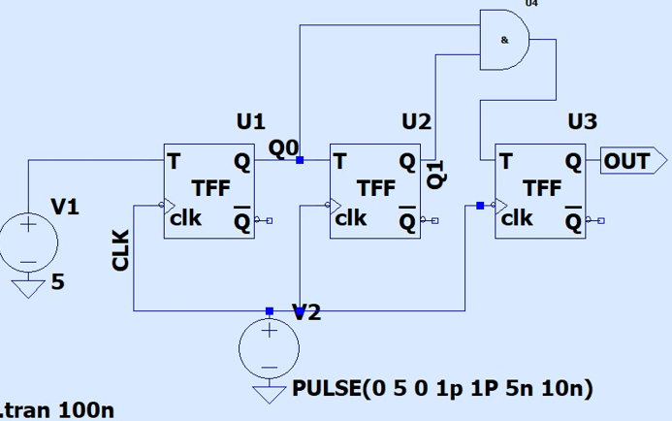

**Waveform:**

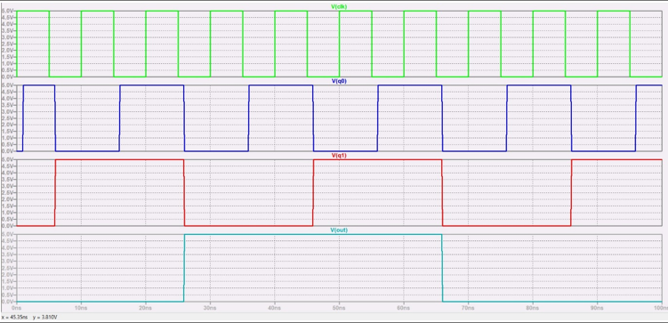

**3- bit Ripple counter –Down Counter:**

**Circuit:**

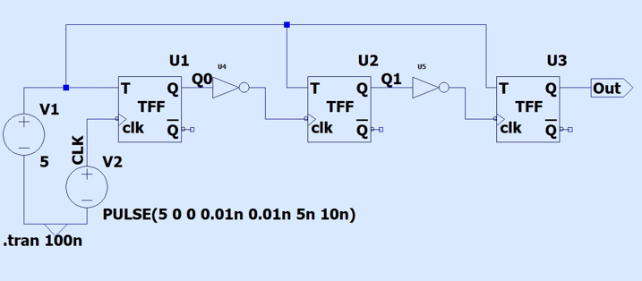

**Waveform:**

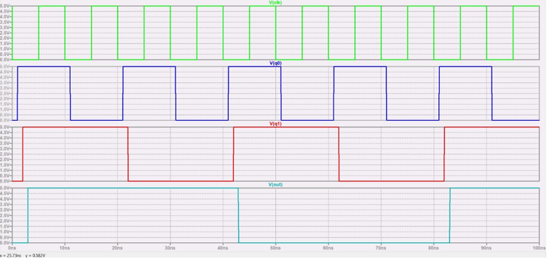

**Result:**

Thus a 3- bit Ripple counter –Down Counter and 3 bit synchronous up counters are implemented using the LTSpice software.