REPORT

Note to Self

Objective:

We all have secrets. Secret in mind is a burden. Sometimes we need a place to tell what's on mind frankly.

This is a blank place where you can express yourself and talk to yourself secretly. You can write anything as if you talk to yourself, and let them go.

Jot down ideas, take a memo, and take notes without decorated happiness or showing off. It will unburden yourself and you can feel better.

All thoughts, feelings and plans written down are archived as your own story. Only you can read them anytime later on.

Modules:

**1.Login / Sign in:**

Initialy our Home page will be displayed on to one’s screen on loading our website on one’s system. All the login and sign in Datas and safely stored into our reglog database . If you open any Note to Self features without Login that redirects to Login page If you already have an Note to Self account, then you can log in otherwise you can sign in and your information and then you can login to access the features of Note to Self.

Sign in:

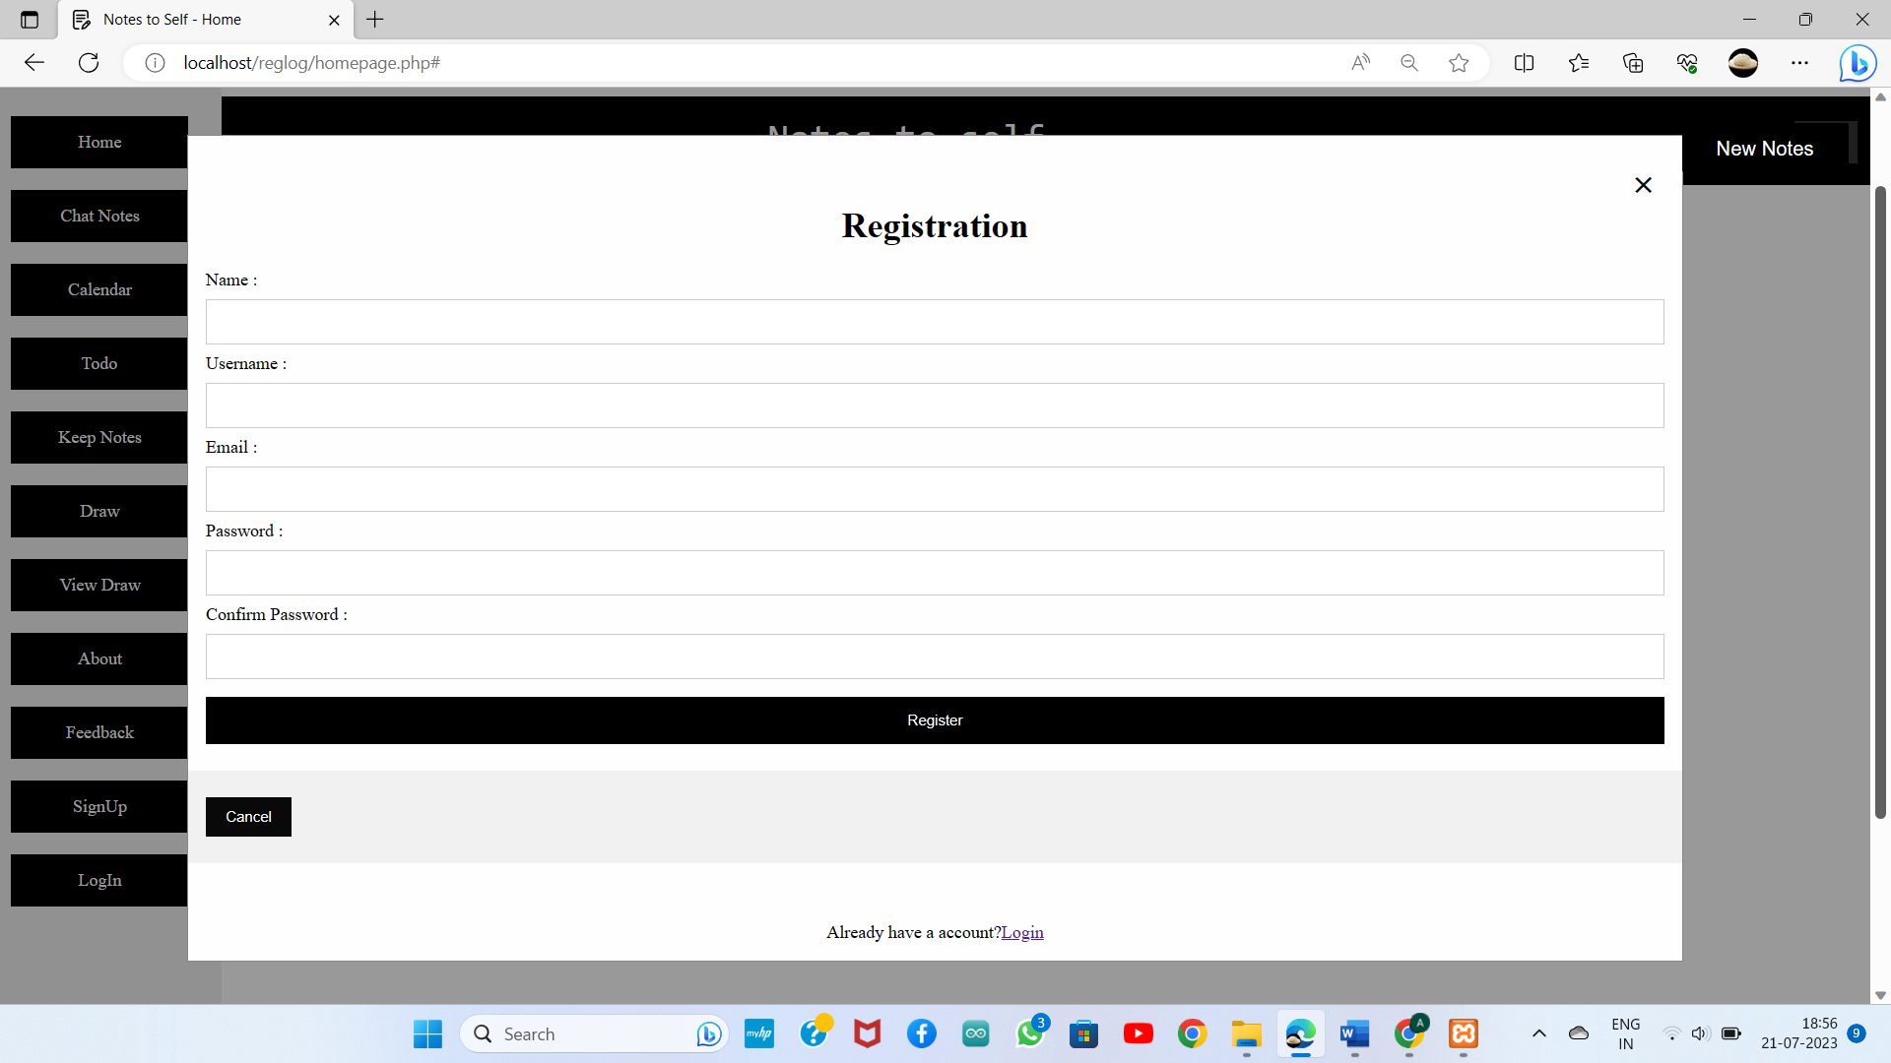

Log in:

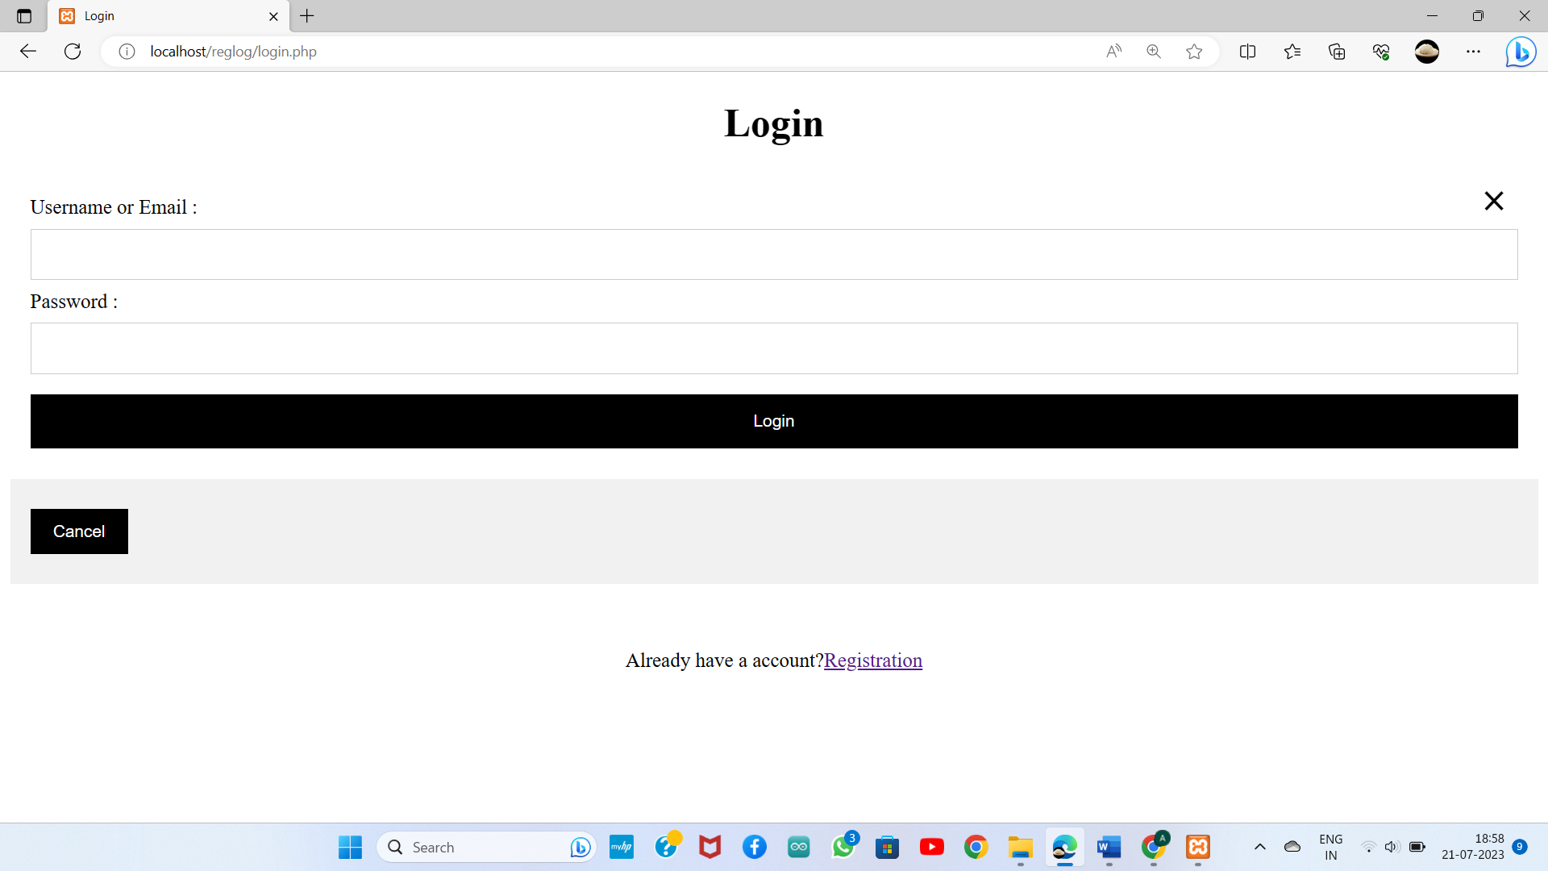

**2.Home page:**

The Home page that has Menu button if you touch it side menu navigation will open from left side. In that side menu user can traverse over the features of the **Note to Self**. Currently there are 5 features in Home page.

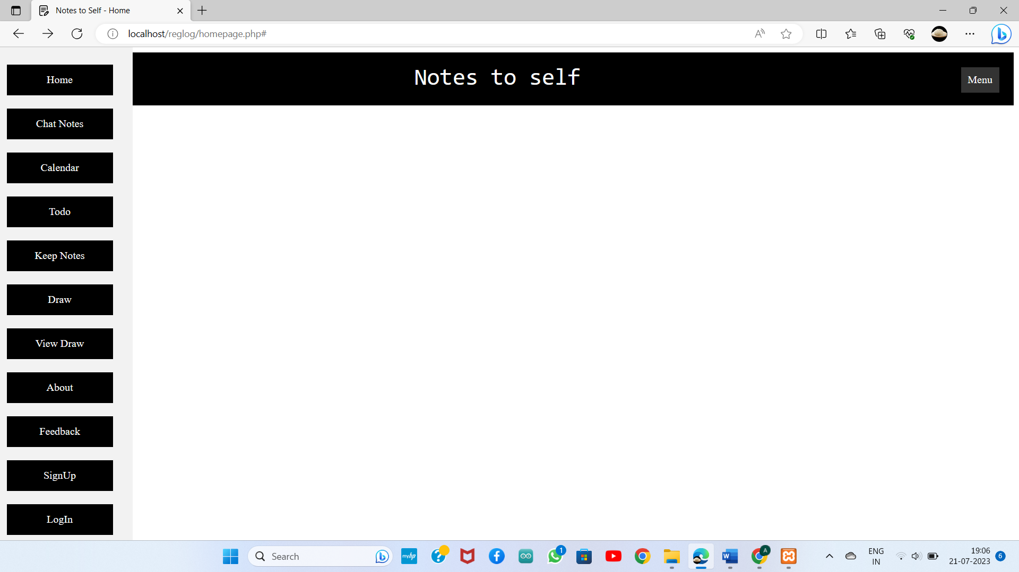

**3.Chat Notes:**

In chat interface that new notes button, by clicking New Notes

User can create Notes Title and Description of the notes.

By chat this chat interface user can type their Secrets

Send. User can create more notes title and send the

secrets.User can change the theme.

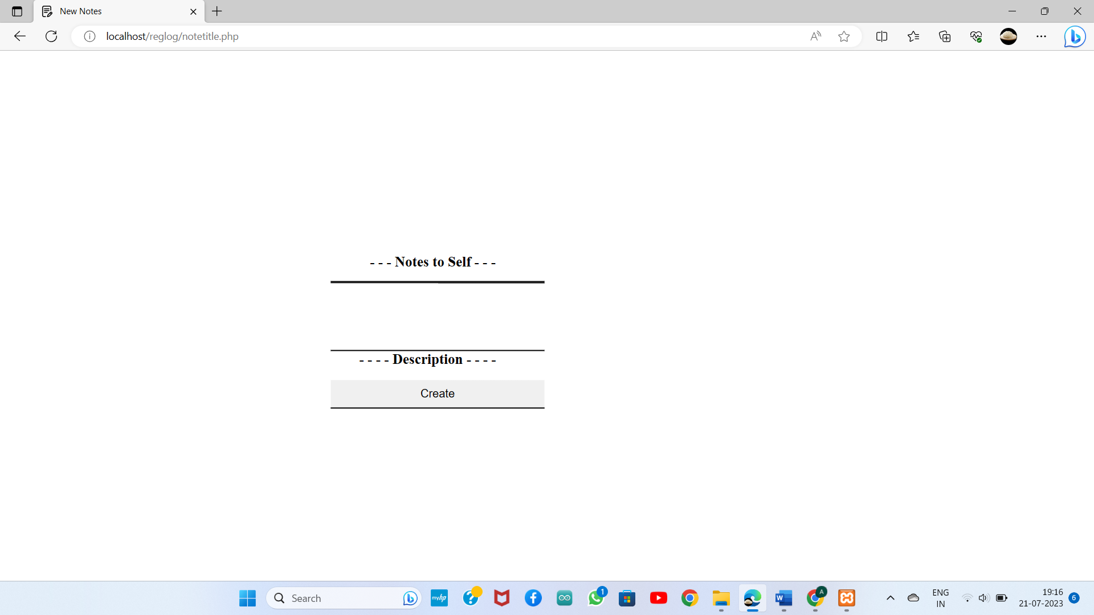

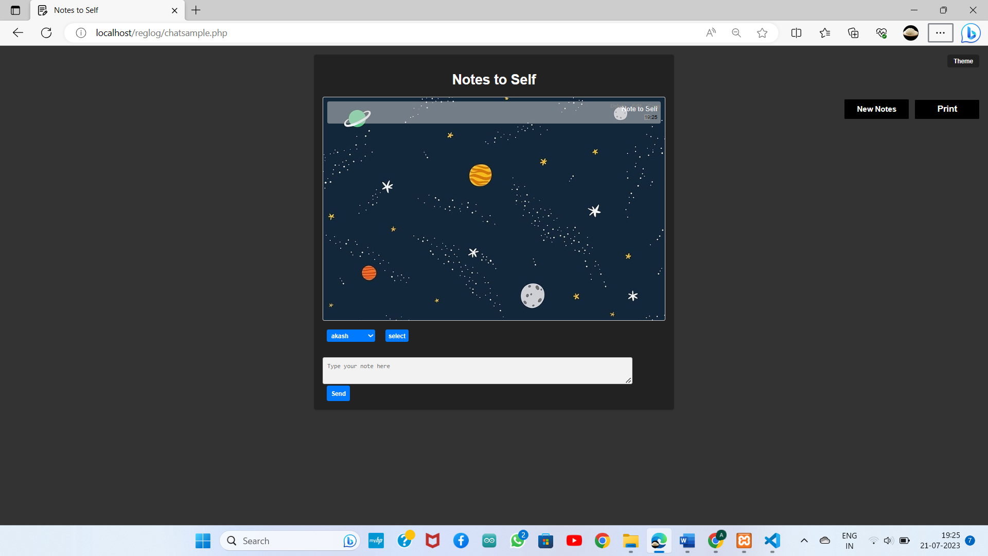

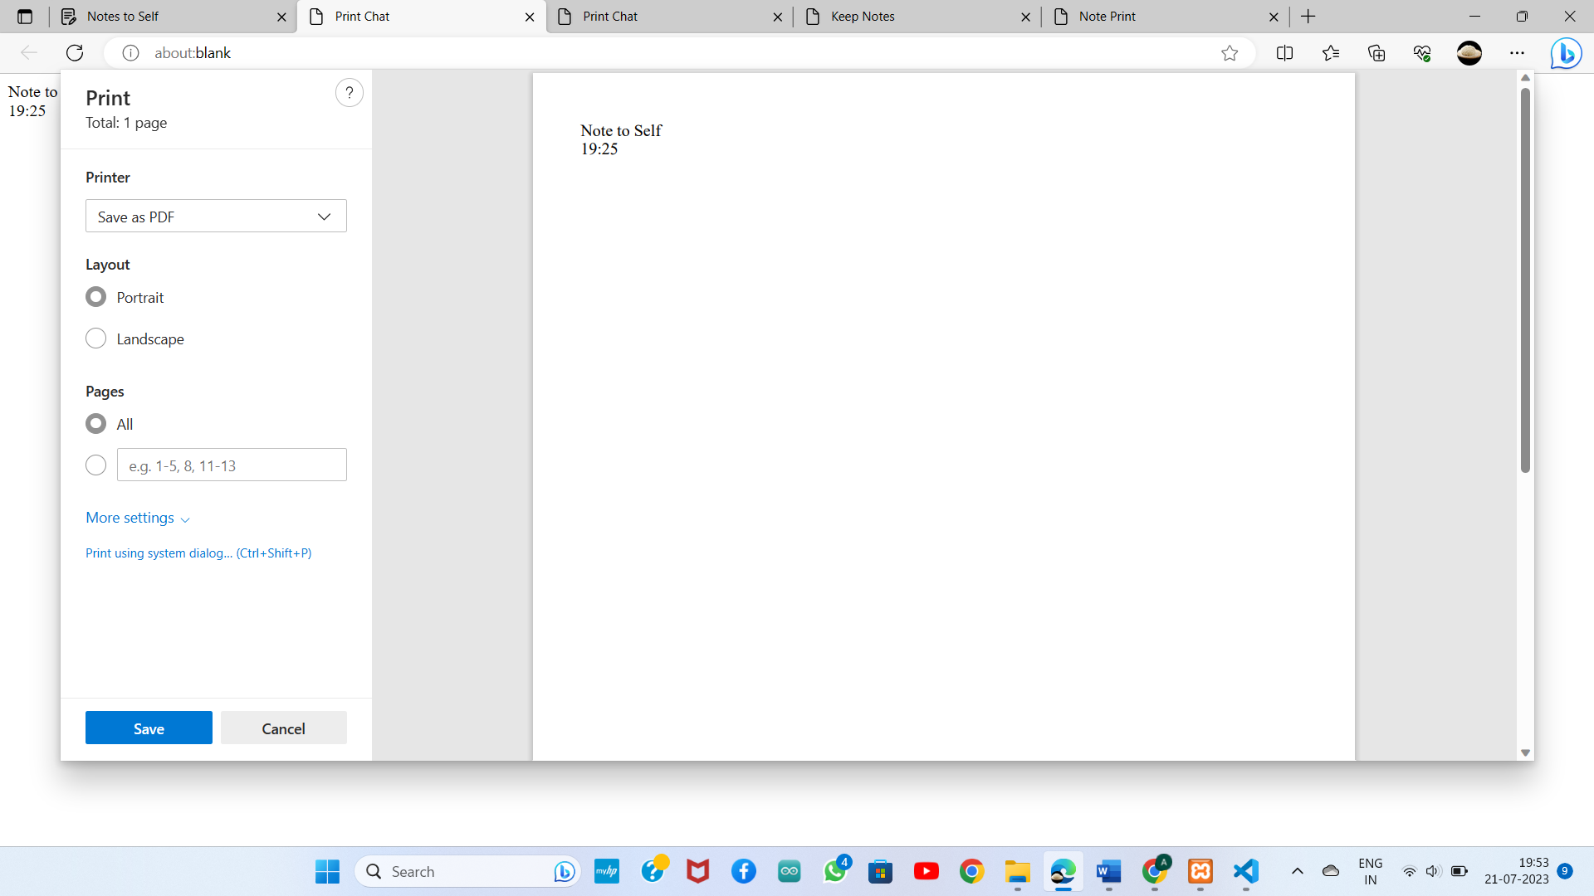

**4.Calander:**

User can add the events and view the events later.

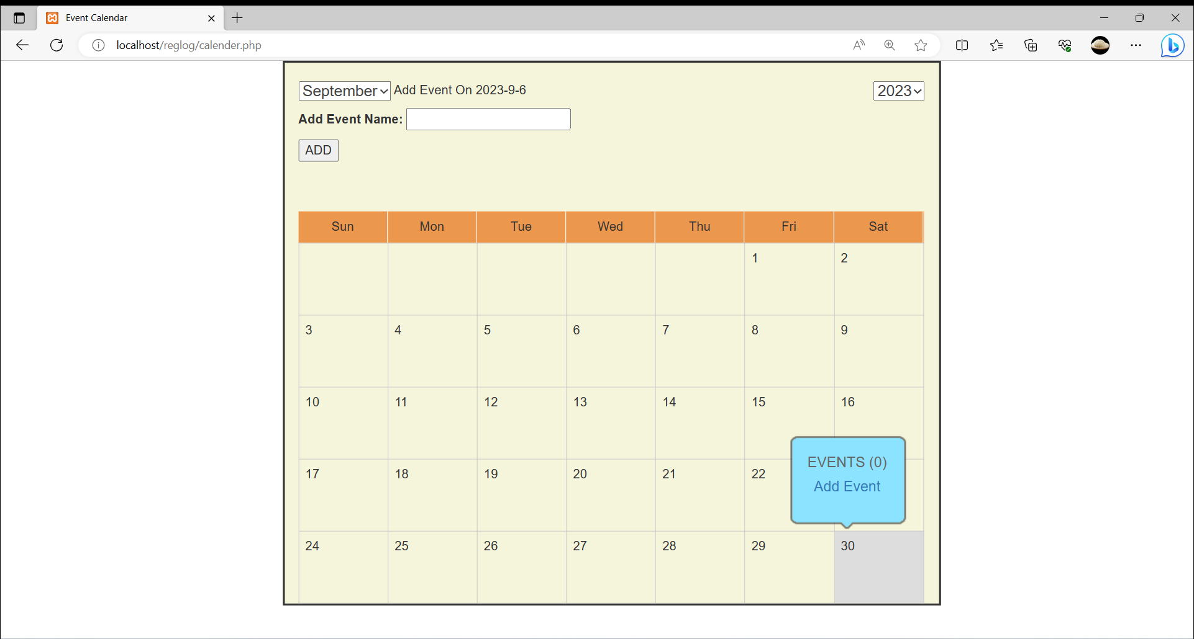

5.**Draw Notes:**

User can draw any thing in it and save it. It has more features like different color and different thickness pen and erase, redo, undo option. View the notes in another page called View Draw , it has delete button to delete the draw.

Save Draw:

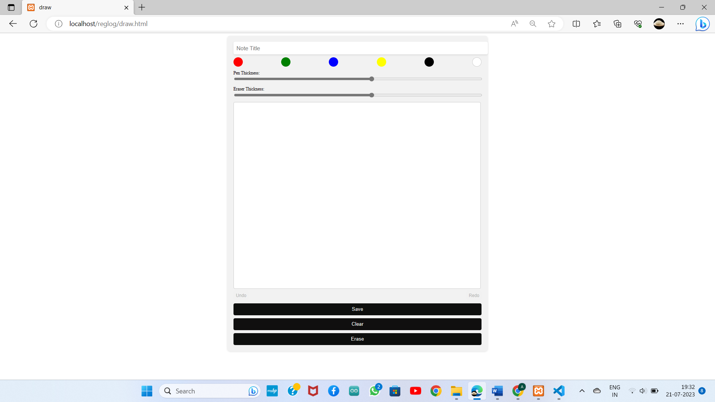

View Draw:

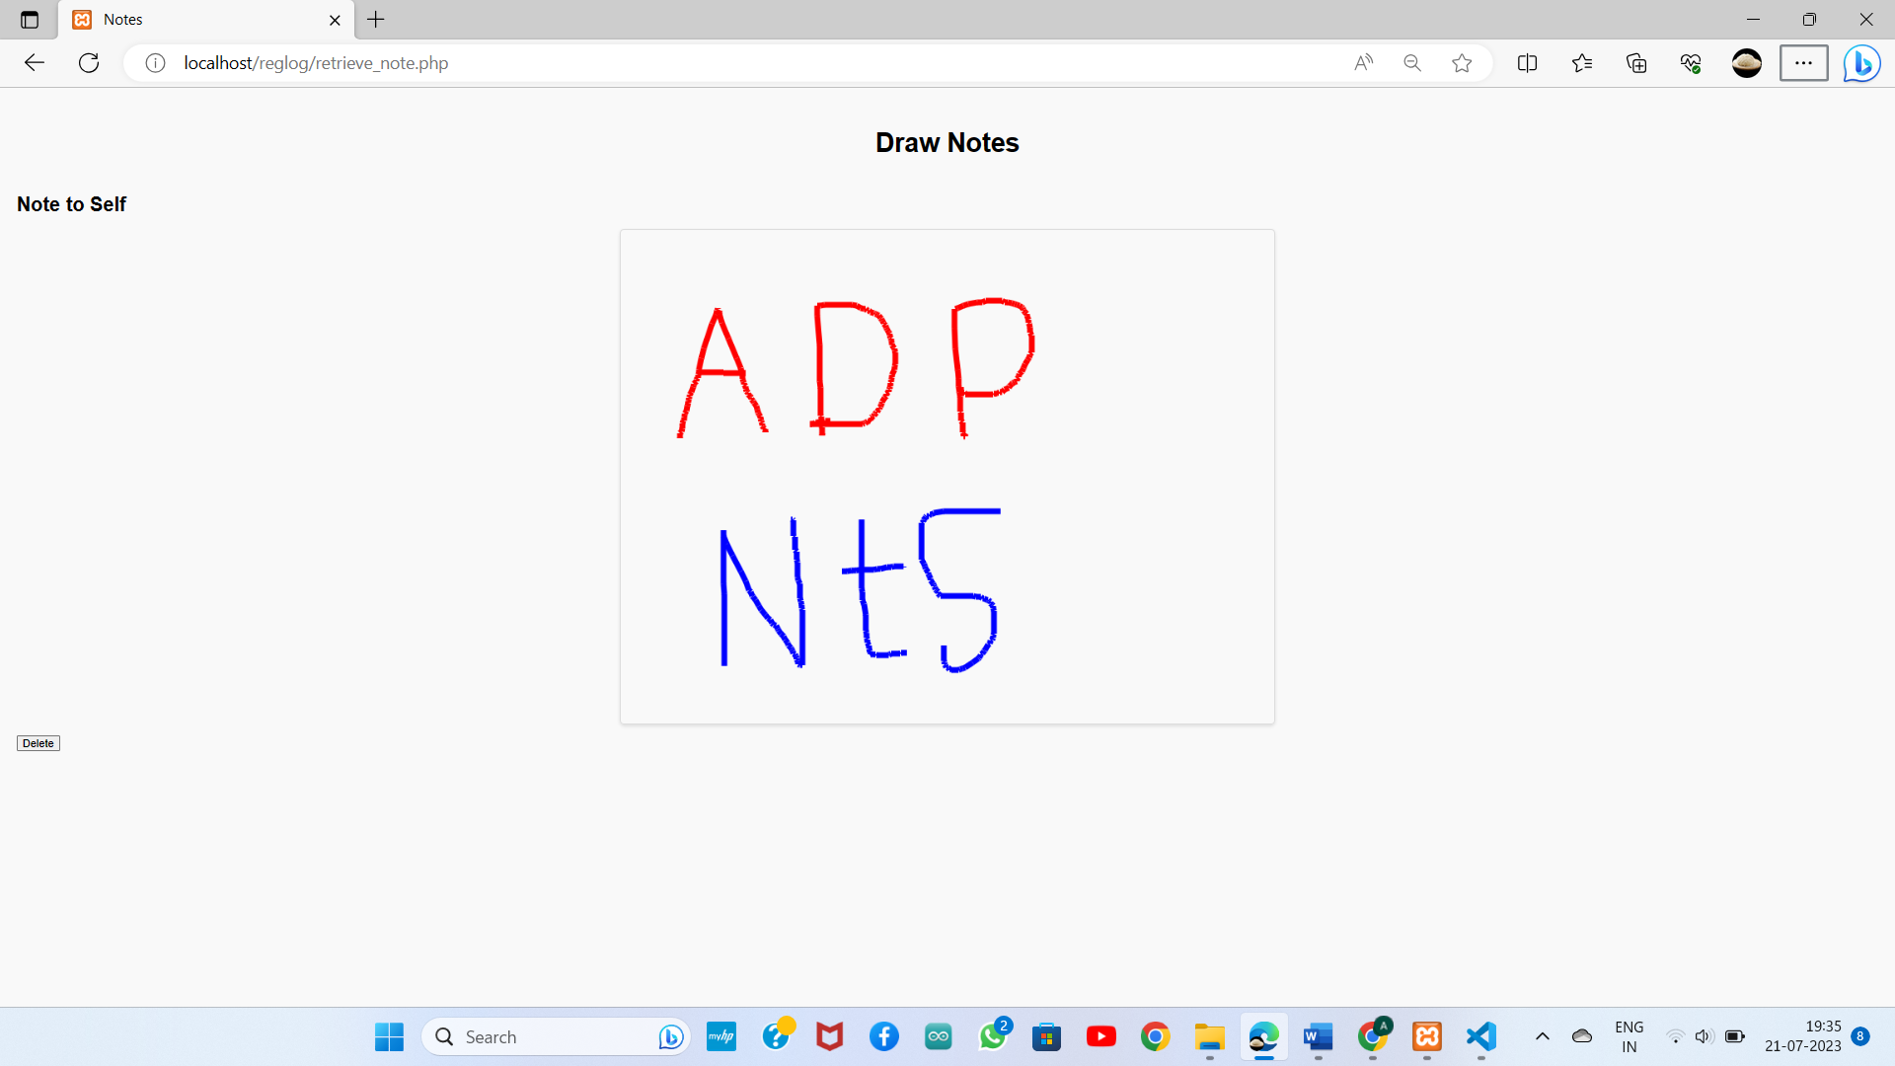

5.**To Do List:**

User can add to do list of the day, if it is completed user can strike through it and it has delete option to delete to do.

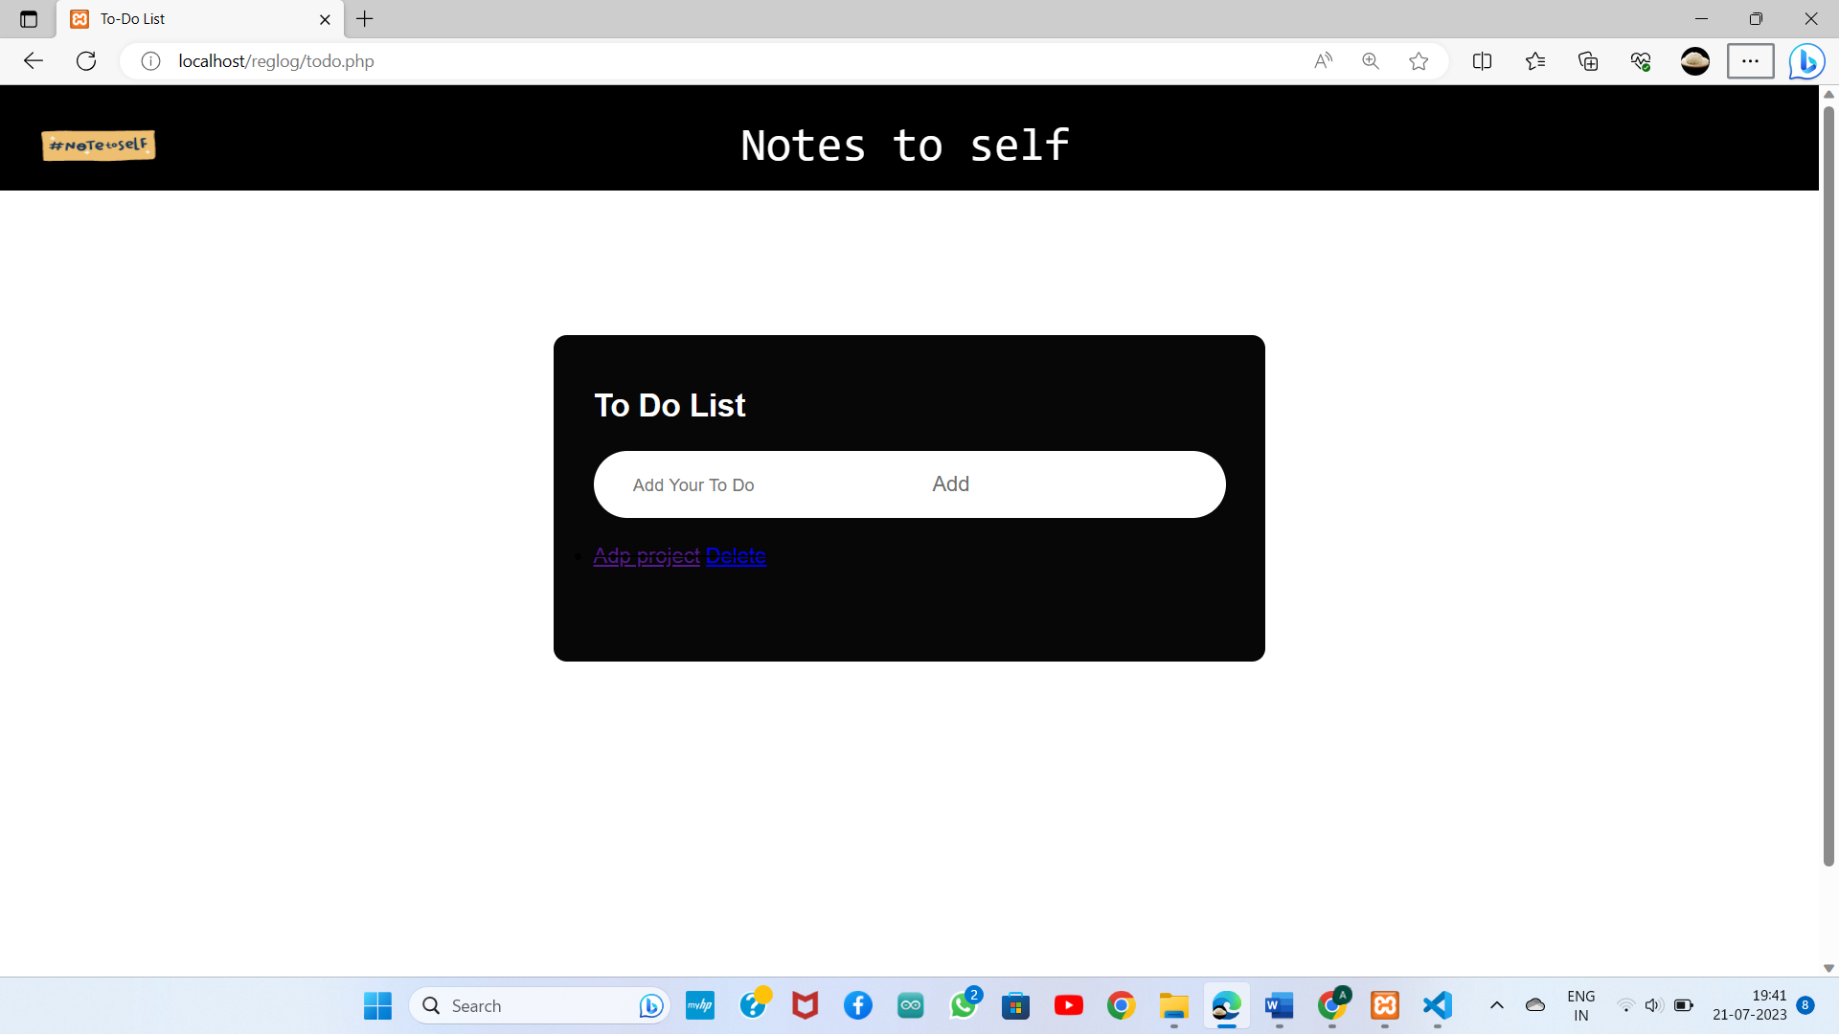

6.**Keep Notes:**

User can create enter title and description.

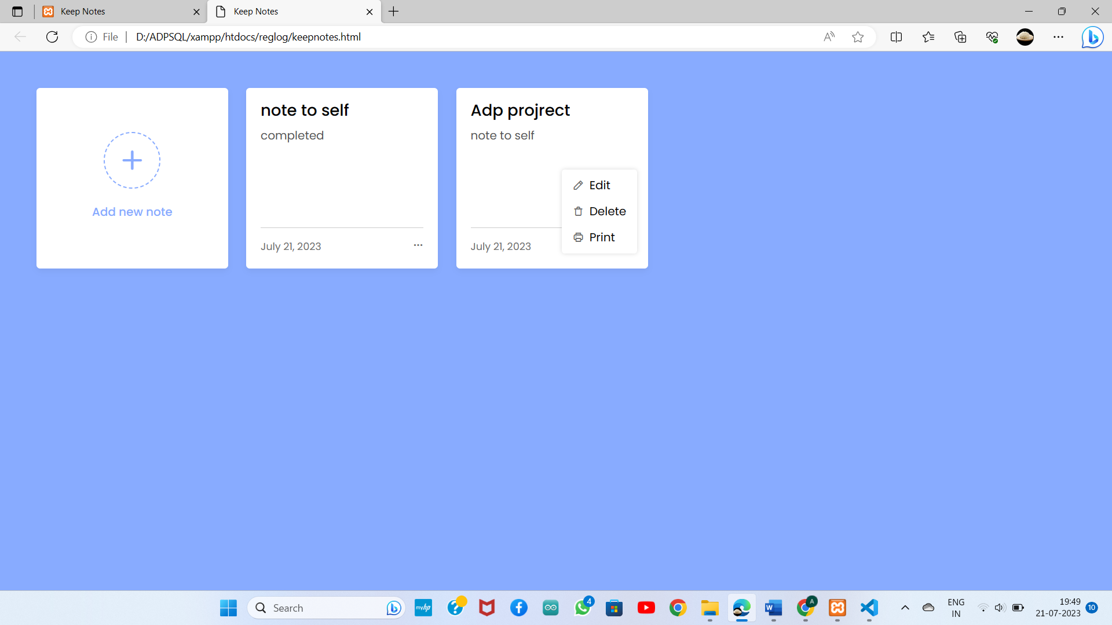

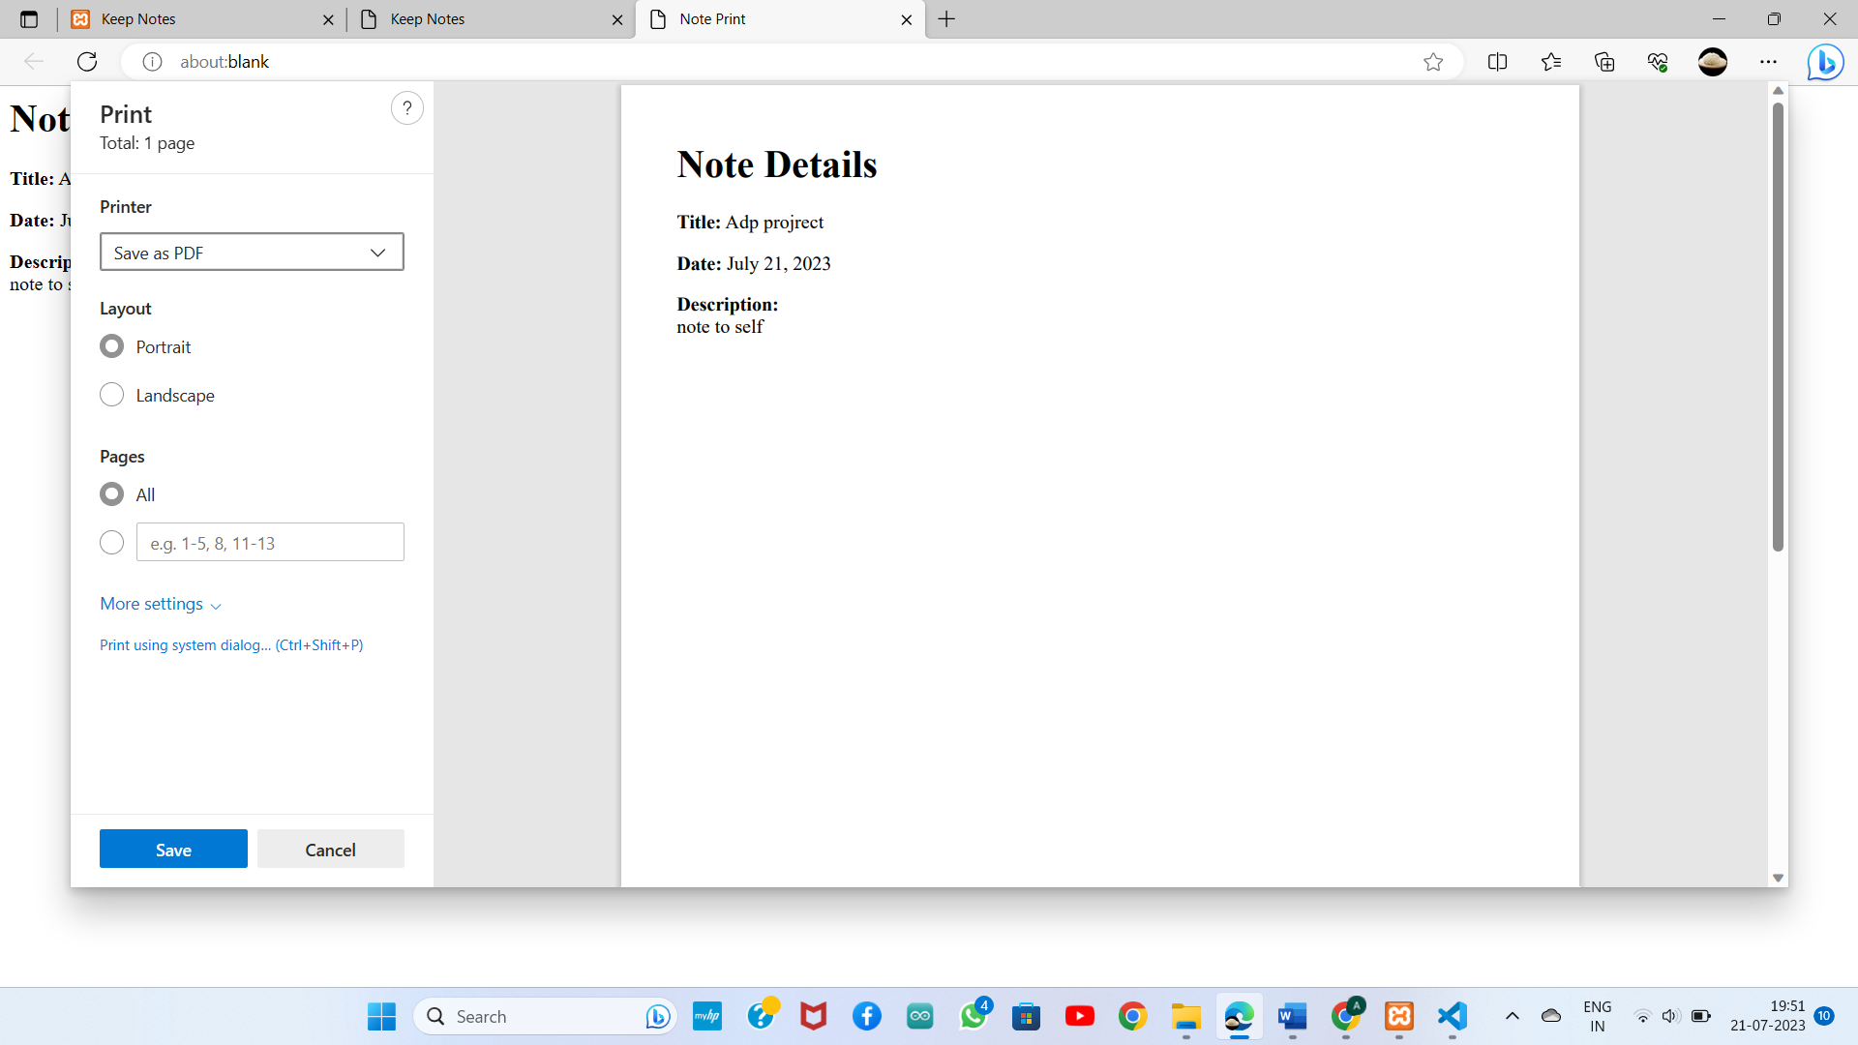

Feed Back Form:

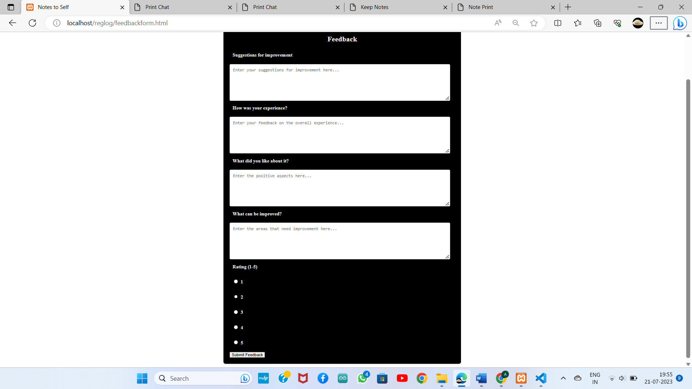

7.**About:**

The information about the members who worked on this project are sculptured in this about us page.

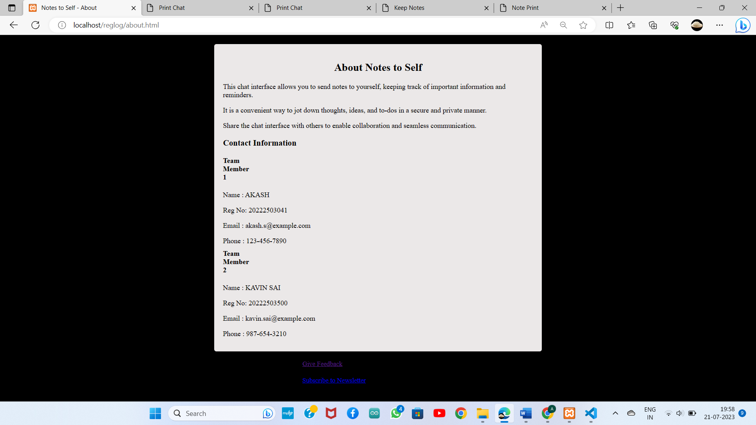

**Languages Used:**

1.HTML :

Hypertext Markup Language is used to create a webpage

2.CSS :

Cascading Style Sheets is used to give styles to webpage

3.JAVA SCRIPT :

JavaScript is used to create dynamically updating content, control multimedia, and pretty much everything else

4.PHP:

HyperText Preprocessor is used to integrate the web application with a database.

5.SQL:

Structured Query Language is used to fetch and update data in the database

**Syllabus covered:**

Module 1 : using html and css

Module 2 : incorporation of multimedia

Module 3: js and dynamic page

Module 5 : usage of servers and data base

Module 6: using structured query language

Module 7 : server side scripts and validation

Module 8 and 9: development of web application

**Complete overview:**

* Initially you can sign in and create your own database.
* Once you created the database for yourself, all the data which you are gained though our Notes to Self app will be stored in our **phpMyadmin Localhost.**
* If you are signed in then you can login and use our features.
* You can learn about us in our **about us** page.
* Once you logged in, you will be re-directed to your Home Page where 6 features will be displayed and you can click any one of them to open the feature page.
* In our **Chat** **Notes** you send your secrets in your chat interface.
* you can draw anything in it and save it. It has more features like different color and different thickness pen and erase, redo, undo option. View the notes in another page called View Draw, it has delete button to delete the draw.
* In chat interface that new notes button, by clicking New Notes
* User can create Notes Title and Description of the notes. By chat this chat interface user can type their Secret Send. User can create more notes title and send the secrets. User can change the theme. In keep notes, you can add title and start to write you note
* In To-do list, you can add list the task you need to perform on the date.
* We have provided calendar where you can make event notes and view it later.