Synopsis
Name | Roll No. | Division | Seat No.
Nitin Poojary | 45 | B | 19TIT108
Akash Sharma | 46 | A | 19TIT128

Topic Name: Small Solutions
Problem Statement:
Small Solutions is an android application that helps to connect Employer and Employee. Our application acts as a mediator between Employer and Employee by helping them contact with each other. Here Employer can hire Employee for their work according to their skill sets by looking at their profile, and for that employee have to be registered themselves mentioning their skills. All they have to do is sign up for an account select their category i.e. Employer/Employee and our interface will show them relevant interface accordingly.

Reason for selecting topic:
Many times it happens that people requires skilled people like plumbers, electrician, and other related works for their home, office, etc. and every time going out searching for such skilled people is time consuming and getting a skilled person is not a guarantee. So to save some of their precious time and to provide them with skilled workers this app will provide them with a pool of different categories of workers to choose from, and they can choose any one they want for their work just using their mobile phone.
Objectives/Features:
Small Solutions is a freely available android application created for people to help them find their clients easily. Basic features of our application are as followed:
- Easy Sign up feature for both Employer and Employee.
- Easy to understand user interface.
- Able to select category between Employer and Employee.
- Employee can make their Profile mentioning their skills and contact info.
- Employer can visit Profile of Employee.
- Employees can also visit Profile of their fellow employee and can be able to group with them if they need.
- Employee will get rating according to their performance from employer.
Scopes:
OUR APPLICATION WILL-
- Generate employment for skilled persons.
- Make easy to find skilled persons.
- Work as a communication channel in between employer and employee.
- Provide categories of work-fields to the employer so that employee can be searched easily.
- Very handy to operate for both.

Methodology:
SDLC Model: Iterative Waterfall Model

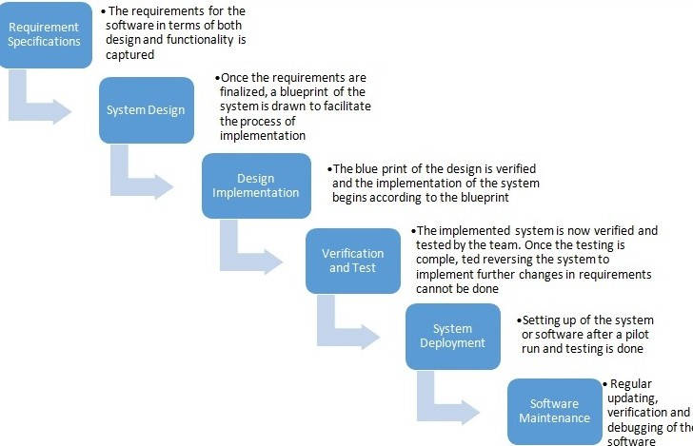

Requirement phase: In this phase we gather the requirements needed for our project and it allows us to make required changes at any stage of the project.
Design Phase: Design phase includes the designing of the various forms to be included in the project and if there is any problem in designs we can loopback to the phase.
Implementation Phase: Following the designs from the designing phase, the coding and implementation of the project is carried out.
Testing Phase: After the project is been implemented, the system is tested for finding the errors and defects. If no error has been detected the system is ready to be implemented in the feasible environment.
Maintenance Phase: The system is needed to be maintained after it is being deployed and this is done in the maintenance phase.
Why we are using this model in our project?
• Iterative development contrasts with a traditional waterfall model method in which each phase of the software development life cycle is “gated”.
• Coding doesn’t begin until design of the entire software application is complete and has gone through a phase gate review.
• In this model we are building and improving the product step by step.
• Hence, we can track the defects at early stage.
• This avoids the downward flow of the defects. In iterative waterfall model we can get the reliable user feedback.
• Requirements are stable, clear and fixed
• Application is small.
• There is no requirement which is not understood or not very clear as well as there is not ambiguous requirement.
• The tools and technology used is stable and is not dynamic.
• The project is small.

Software Requirements:
- Android Development Kit(Android Studio)
- Language – JAVA, XML
- Database – MySQL
Conclusion:
Documentation: July - February
Requirement | July-August | Knowing the components require to develop this app
Specification | August-September | Feasibility study in this Phase
Design | September-November | Designing the GUI interface
Coding | November-January | Implementing the coding for the Software
Testing | January-February | Fixing bugs after testing
Deployment | February-March | Maintaining the software
Benefits:
Our application helps to the people who face difficulties to find work or finding skilled person to work. Both can come to our platform to communicate each other.
References:
- https://www.geeksforgeeks.org/software-engineering-classical-waterfall-model/
- https://www.mbaskool.com/2013_images/stories/dec_images/bcon-waterfall.jpg

