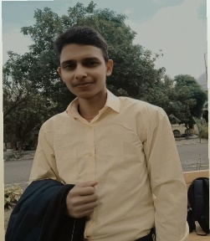**Contact**

**Phone: 9696684784**

**Email:** [**tiwariakash03789@gmail.com**](mailto:tiwariakash03789@gmail.com)

**LinkedIn: www.linkedin.com/in/akash-tiwari-82504b2b2**

**GitHub: https://github.com/Akash-Tiwari-890**

**About**

**A dedicated Computer Science Student and UX Designer with a proven track record of creating engaging user interface and improving user experiences.**

**Adept at conducting user research, designing prototypes, and collaborating with cross-functional team to deliver innovative solution.**

**Skills**

**Ui/UX Design: proficient with Sketch on Figma experienced in creating wireframe, prototype, high-fidelity design.**

**Front-End Development: Knowledgeable in HTML, CSS , JavaScript;**

**Capable of implementing responsive design principles.**

**Collaboration: Effective team player with strong communication skills ; experienced in working with developer , in participation of SIH collaborated with developer and worked as designer.**

**Problem- Solving: Effective team player with knack for identifying user pain point and conceptualizing creative solutions.**

**Projects2**

**Restaurant Menu Design: Develop a user-centric menu design that streamlined the ordering process and improved overall customer satisfaction.**

**Login Page UI: Design a secure and accessible login interface.**

**Shopping App UI: Created a shopping application interface that simplified the user journey, leading to increased user engagement.**

**Alumni portal: Build a Ui/UX design of a alumni portal.**

**Education**

**Bachelor of Computer Science and Engineering: University of Lucknow (currently pursuing 2nd Year)**

Certifications: Google UX design Professional Certificate, Coursera.

Language: English (Fluent)