**GitHub Profile** -> [Akash kafle](https://github.com/Akash-kafle)

**GitHub link** -> [github.com/Akash-kafle/DSA_Akash_kafle](https://github.com/Akash-kafle/DSA_Akash_kafle)

**\*NOTE:**

* The repository is private as stated.

**# Code implementation:**

**Functions:**

1. isEmpty():

* Returns true if the list is empty, and false otherwise

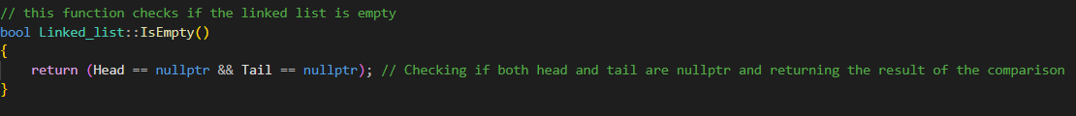

1. addToHead(data):

* Inserts an element to the beginning of the list

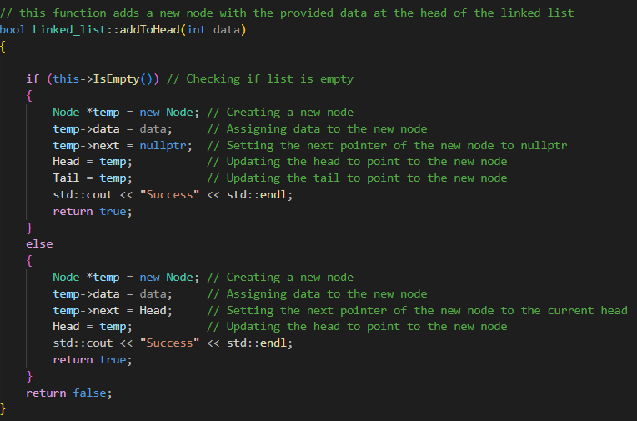

1. addToTail(data):

* Inserts an element to the end of the list

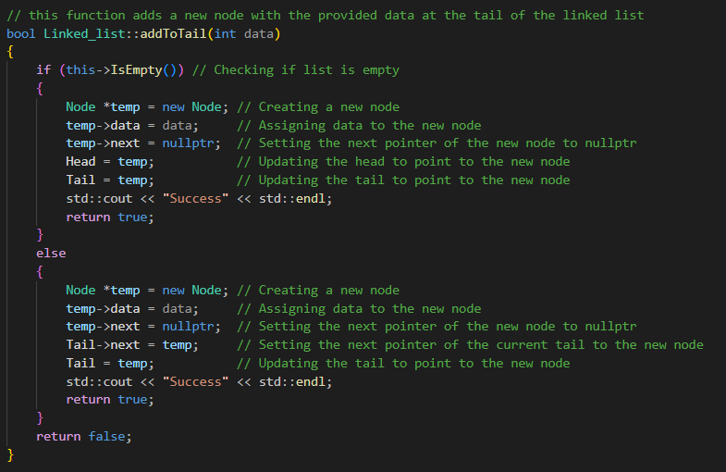

1. add( index, data):

* Inserts an element after the given index in the node and if the given index is not valid or has limits then it will be added to tail

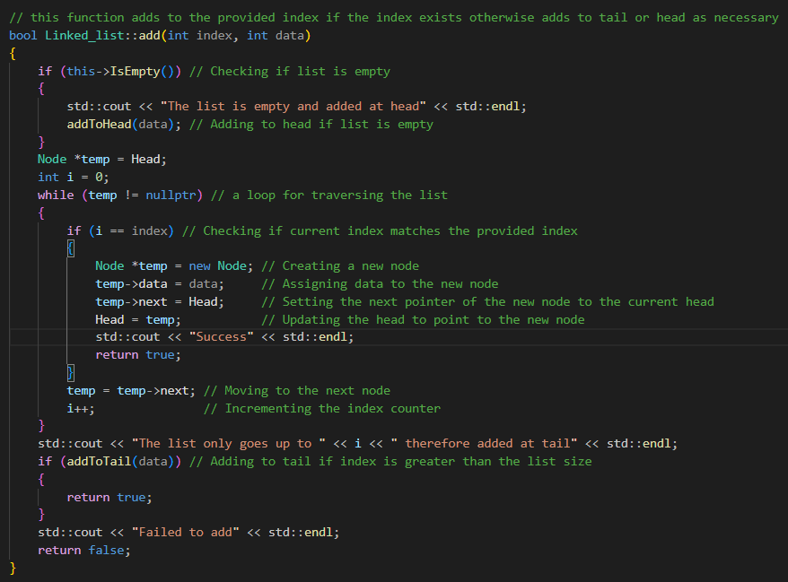

1. removeFromHead(&data):

* Removes the first node in the list

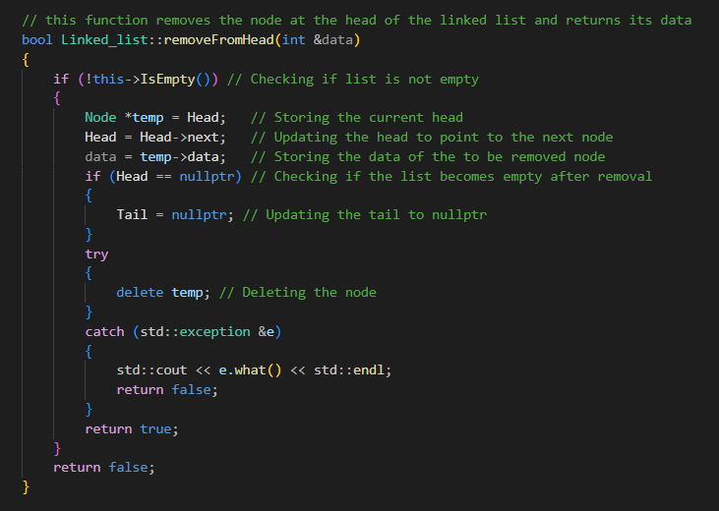

1. remove(data):

* Removes the node with the given data

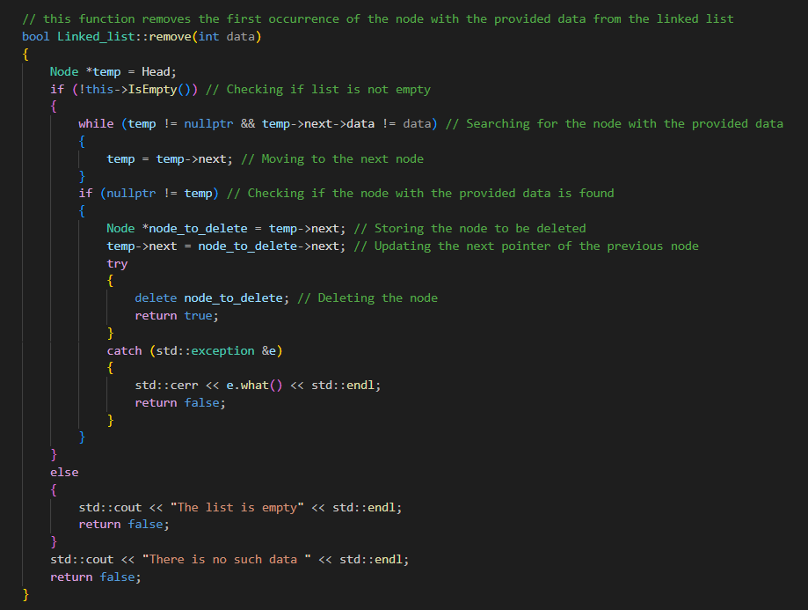

1. retrieve(data, outputNodePointer):

* Returns the pointer to the node with the requested data

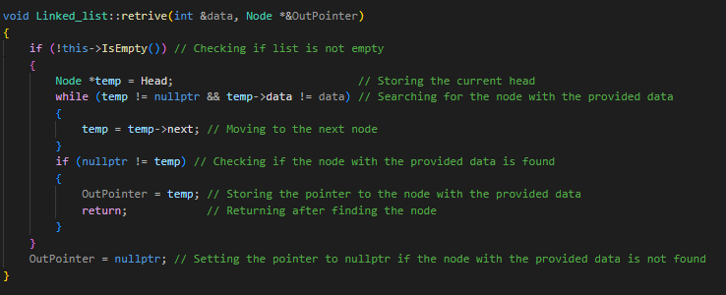

1. search(data):

* Returns true if the data exists in the list, and false otherwise

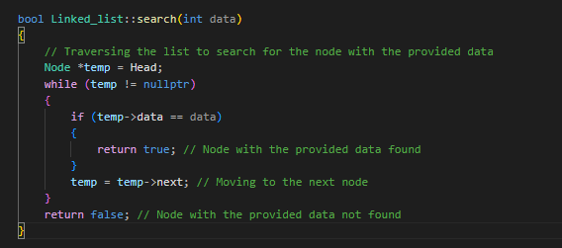

1. traverse():

* Displays the contents of the list

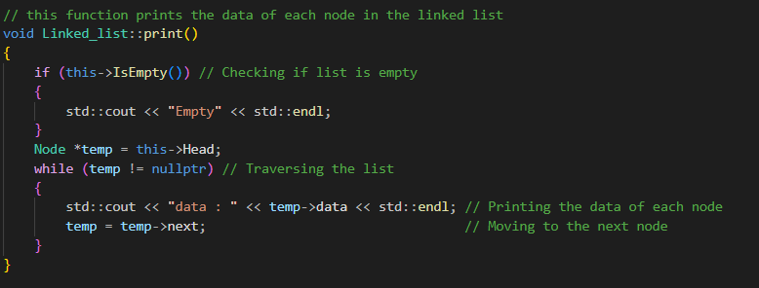

**# Main Function and it’s output:**

**Header File:**

* I have used the following class for the above mentioned linked list functions.They are separated in a separate file called ‘function.cpp’ which can be found in the GitHub.

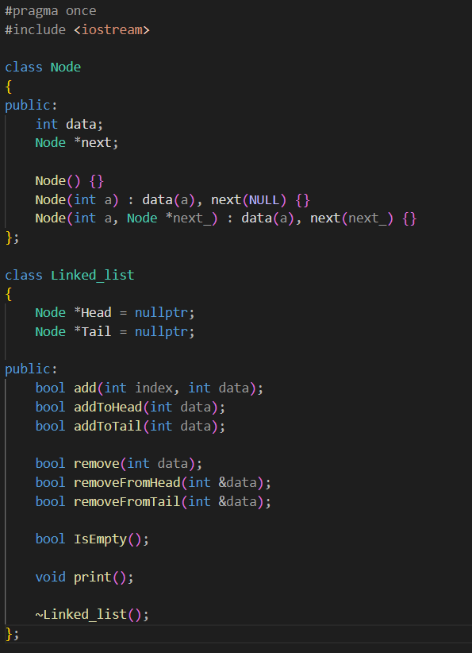

**Main Function:**

* Here, I have made sure to implement as much possible and made sure the program doesn’t crashes if the user mistakenly enters ‘char’ or ‘string’ literals in place of integers.
* I have also made it free to just add and remove as the lecturer wish and check for any loop holes in the code.

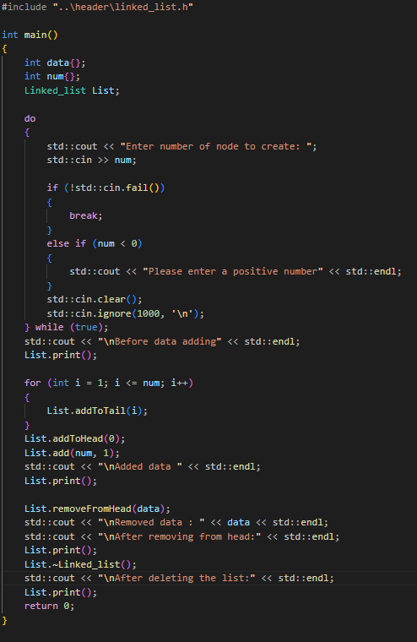

**Destructor function:**

* I have used this destructor to delete the existing pointers and other values. As to not have any memory leaks in the code.

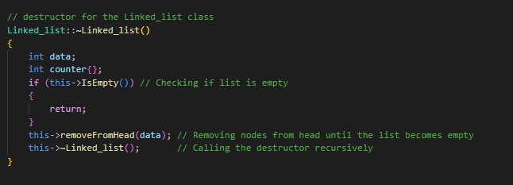

**Output:**

This is the output of the code presented above.

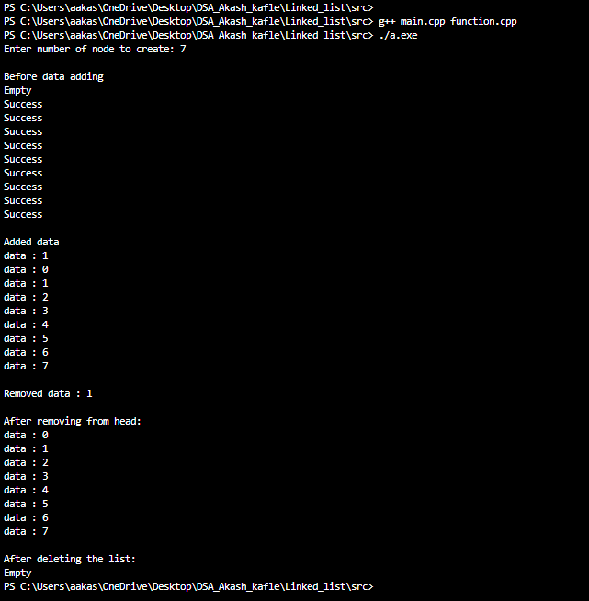

**# Final words:**

* Any improvements and review of the code for better is highly appreciated.
* If I have missed few things please mentions that in our upcoming classes.I will do my best to improve those missing points in the coming future labs.
* I have provided all the information of my GitHub profile above, at the top of the file.