1 Who is the highest paid C programmer?

select * from assessmentdatabase.programmer

where salary=(select max(salary) from assessmentdatabase.programmer

where prof1='c' or prof2='c');

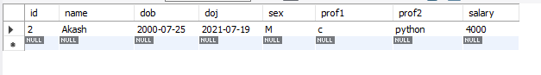

2 Who is the highest paid female cobol programmer?

select * from assessmentdatabase.programmer

where salary=(select max(salary) from assessmentdatabase.programmer

where (prof1='cobol' or prof2='cobol')) and sex='f';

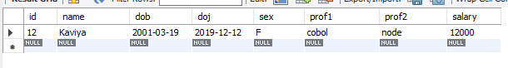

3 Display the name of the HIGEST paid programmer for EACH language (prof1)

select distinct name, salary, prof1

from assessmentdatabase.programmer

where (salary,prof1) in (select max(salary),prof1 from assessmentdatabase.programmer group by prof1);

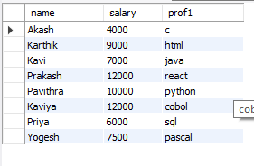

4 Who is the LEAST experienced programmer?

select abs(floor(datediff(doj,curdate())/365)) exp,name

from assessmentdatabase.programmer

where floor(datediff(curdate(),doj)/365) = (select min(floor(datediff(curdate(),doj)/365))

from assessmentdatabase.programmer);

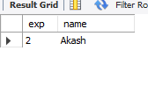

5 Who is the MOST experienced programmer?

select abs(floor(datediff(doj,curdate())/365)) exp,name,prof1,prof2

from assessmentdatabase.programmer

where floor(datediff(doj,curdate())/365) = (select max(floor(datediff(doj,curdate())/365))

from assessmentdatabase.programmer) ;

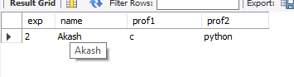

6 Which language is known by ONLY ONE programmer?

select prof1 from assessmentdatabase.programmer

group by prof1 having prof1 not in (select prof2 from assessmentdatabase.programmer) and count(prof1)=1

union

select prof2 from assessmentdatabase.programmer group by prof2 having prof2 not in

(select prof1 from assessmentdatabase.programmer) and count(prof2)=1;

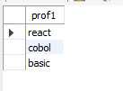

7 Who is the YONGEST programmer knowing DBASE?

select floor(datediff(curdate(),dob)/365) age, name, prof1, prof2

from assessmentdatabase.programmer

where floor(datediff(curdate(),dob)/365) = (select min(floor(datediff(date-dob)/365))

from assessmentdatabase.programmer where prof1 like 'dbase' or prof2 like 'dbase');

8 Which institute has MOST NUMBER of students?

select max(splace) from assessmentdatabase.studies;

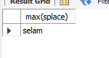

9 Who is the above programmer?

select name from assessmentdatabase.studies where splace=max(splace);

10 Which female programmer earns MORE than 3000/- but DOES NOT know C, C++, Oracle or Dbase?

select * from assessmentdatabase.programmer

where sex = 'f' and salary >3000 and (prof1 not in('c','c++','oracle','dbase') or prof2 not in('c','c++','oracle','dbase'));

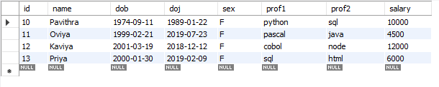

11 Which is the COSTLIEST course?

select course from assessmentdatabase.studies

where ccost = (select MAX(ccost) from assessmentdatabase.studies);

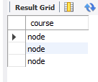

12 Which course has been done by MOST of the students?

select course from studies group by course having count(course);

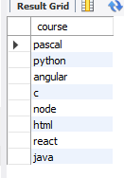

13 Display name of the institute and course Which has below AVERAGE course fee?

select splace,course from assessmentdatabase.studies

where ccost < (select avg(ccost) from assessmentdatabase.studies);

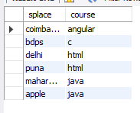

14 Which institute conducts COSTLIEST course?

select splace from assessmentdatabase.studies

where ccost = (select max(ccost) from assessmentdatabase.studies);

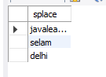

15 Which course has below AVERAGE number of students?

select course from assessmentdatabase.studies

where count(name)<(select avg(count) from assessmentdatabase.studies);

16 Which institute conducts the above course?

select splace from assessmentdatabase.studies

where course in (select course from assessmentdatabase.studies

group by course having count(name) < (select avg(count(name)) from assessmentdatabase.studies group by course));

17 Display names of the course WHOSE fees are within 1000(+ or -) of the AVERAGE fee.

select course from assessmentdatabase.studies

where ccost < (select avg(ccost)+1000 from assessmentdatabase.studies) and ccost > (select avg(ccost)-1000

from assessmentdatabase.studies);

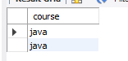

18 Which package has the HIGEST development cost?

select title,dcost from assessmentdatabase.software

where dcost = (select max(dcost) from assessmentdatabase.software);

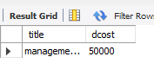

19 Which package has the LOWEST selling cost?

select title,scost from assessmentdatabase.software

where scost = (select min(scost) from assessmentdatabase.software);

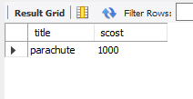

20 Who developed the package, which has sold the LEAST number of copies?

select name,sold from assessmentdatabase.software

where sold = (select min(sold) from assessmentdatabase.software);

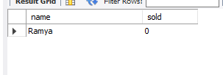

21 Which language was used to develop the package WHICH has the HIGEST sales amount?

select dev_in,scost from assessmentdatabase.software

where scost = (select max(scost) from assessmentdatabase.software);

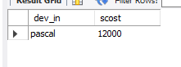

22 How many copies of the package that has the LEAST DIFFRENCE between development and selling cost were sold?

select sold,title from assessmentdatabase.software

where title = (select title from assessmentdatabase.software

where (dcost-scost)=(select min(dcost-scost) from assessmentdatabase.software));

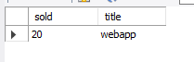

23 Which is the COSTLIEAST package developed in PASCAL?

select title from assessmentdatabase.software

where dcost = (select max(dcost) from assessmentdatabase.software

where dev_in like 'pascal');

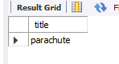

24 Which language was used to develop the MOST NUMBER of package?

select dev_in from assessmentdatabase.software

group by dev_in having max(dev_in) = (select max(dev_in) from assessmentdatabase.software);

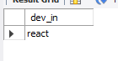

25 Which programmer has developed the HIGEST NUMBER of package?

select name from assessmentdatabase.software

group by name having max(name) = (select max(name) from assessmentdatabase.software);

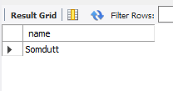

26 Who is the author of the COSTLIEST package?

select name,dcost from assessmentdatabase.software

where dcost = (select max(dcost) from assessmentdatabase.software);

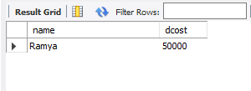

27 Display names of packages WHICH have been sold LESS THAN the AVERAGE number of copies?

select title from assessmentdatabase.software

where sold < (select avg(sold) from assessmentdatabase.software);

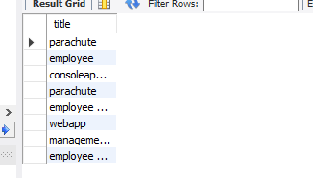

28 Who are the female programmers earning MORE than the HIGEST paid male programmers?

select name from assessmentdatabase.programmer

where sex = 'f' and salary > (select(max(salary))

from assessmentdatabase.programmer where sex = 'm');

29 Which language has been stated as prof1 by MOST of the programmers?

select prof1 from assessmentdatabase.programmer

group by prof1 having prof1 = (select max(prof1)

from assessmentdatabase.programmer);

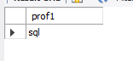

30 Who are the authors of packages, WHICH have recovered MORE THAN double the development cost?

select name from assessmentdatabase.software

where sold*scost > 2*dcost;

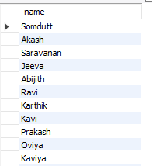

31 Display programmer names and CHEAPEST package developed by them in EACH language?

select name,title from assessmentdatabase.software

where dcost in (select min(dcost) from assessmentdatabase.software group by dev_in);

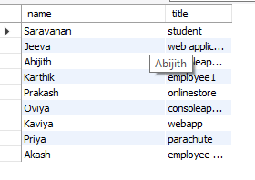

32Who is the YOUNGEST male programmer born in 1965?

select name from assessmentdatabase.programmer

where dob=(select (max(dob))

from assessmentdatabase.programmer where year(dob) ='1965');

33 Display language used by EACH programmer to develop the HIGEST selling and LOWEST selling package.

select name, dev_in from assessmentdatabase.software

where sold in (select max(sold) from assessmentdatabase.software group by name)

union

select name, dev_in from assessmentdatabase.software

where sold in (select min(sold) from assessmentdatabase.software group by name);

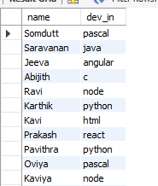

34 Who is the OLDEST female programmer WHO joined in 1992 6

select name from assessmentdatabase.programmer

where doj=(select (min(doj)) from assessmentdatabase.programmer

where year(doj)=1992);

35 In WHICH year where the MOST NUMBER of programmer born?

select distinct year(dob) from assessmentdatabase.programmer

where year(doj) = (select min(year(doj))

from assessmentdatabase.programmer);

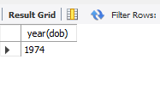

36 In WHICH month did MOST NUMBRER of programmer join?

select distinct month(doj) from assessmentdatabase.programmer

where month(doj) = (select max(month(doj)) from assessmentdatabase.programmer);

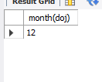

37 In WHICH language are MOST of the programmer's proficient?

select max(prof1)as highest_no_of_proficient_language

from assessmentdatabase.programmer;

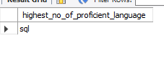

38 Who are the male programmers earning BELOW the AVERAGE salary of female programmers?

select name from assessmentdatabase.programmer

where sex = 'm' and salary < (select(avg(salary))from assessmentdatabase.programmer where sex = 'f');

