1 Display the details of THOSE WHO are drawing the same salary.

SELECT NAME,SALARY

FROM assessmentdatabase.PROGRAMMER

WHERE SALARY=ANY(SELECT SALARY FROM assessmentdatabase.PROGRAMMER GROUP BY SALARY HAVING

SALARY=SALARY AND COUNT(*)>1);

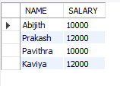

2 Display the details of software developed by male programmers earning MORE than 3000.

SELECT s.*

FROM assessmentdatabase.PROGRAMMER p, assessmentdatabase.software s

WHERE p.name=s.name and SALARY>3000 AND SEX='M';

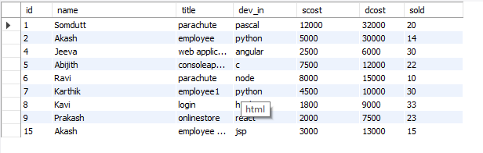

3 Display details of packages developed in PASCAL by female programmers.

SELECT *

FROM assessmentdatabase.PROGRAMMER P,assessmentdatabase.SOFTWARE S

WHERE P.NAME=S.NAME AND SEX='F' AND DEV_IN='PASCAL';

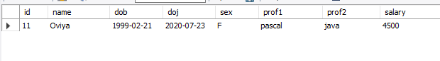

4 Display the details of the programmer WHO joined BEFORE 1990.

select * FROM assessmentdatabase.PROGRAMMER

where year(doj)<1990;

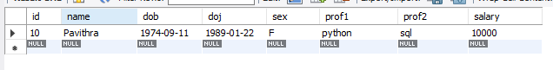

5 Display details of software developed in C by female programmers of PRAGATHI.

SELECT p.*,s.title,s.dev_in,st.splace,st.course

FROM assessmentdatabase.SOFTWARE S,assessmentdatabase.PROGRAMMER P,assessmentdatabase.STUDIES ST

WHERE S.NAME = ST.NAME AND P.NAME = S.NAME AND SEX='F' AND SPLACE='delhi';



6 Display NUMBER of packages NUMBER of copies sold and sales value of EACH programmer Institute-wise.

select st.splace,count(s.dev_in),count(s.sold),sum(s.sold*s.scost)

from assessmentdatabase.SOFTWARE S,assessmentdatabase.studies st

where s.name = st.name group by st.splace;

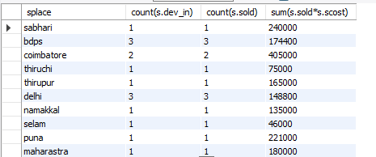

7 Display details of software developed in DBASE by male programmers WHO belong to the institute on which MOST NUMBER OF programmer’s studies.

8 Display the details of the software that was developed by male programmers born BEFORE 1965 and female programmers born AFTER 1975.

select s.* from assessmentdatabase.PROGRAMMER P,assessmentdatabase.software s

where s.name=p.name and (sex='m' and year(dob)<1964 )and (sex='f' and year(dob)>1975);

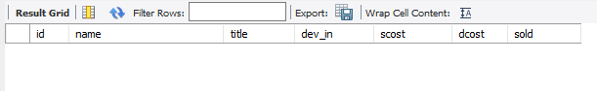

9 Display the details of the software that was developed in the language that is NOT the programmer’s first proficiency.

SELECT DISTINCT S.*

FROM assessmentdatabase.SOFTWARE S, assessmentdatabase.PROGRAMMER P

WHERE P.PROF1<>S.DEV_IN AND S.NAME=P.NAME;

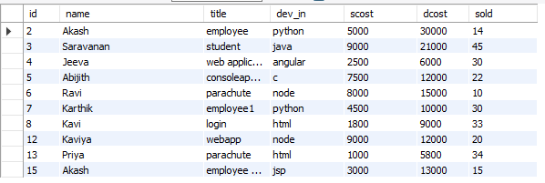

10 Display details of software that was developed in the language which is NEITHER first NOR second proficiency of the programmer.

SELECT S.*

FROM assessmentdatabase.SOFTWARE S, assessmentdatabase.PROGRAMMER P

WHERE S.NAME=P.NAME AND(DEV_IN <> PROF1 AND DEV_IN<>PROF2);

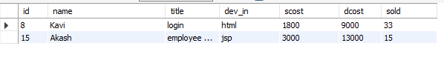

11 Display details of software developed by male students of SABHARI.

SELECT p.*,st.splace,s.dev_in

FROM assessmentdatabase.SOFTWARE S, assessmentdatabase.PROGRAMMER P,assessmentdatabase.STUDIES ST

WHERE S.NAME=P.NAME AND S.NAME=ST.NAME AND ST.NAME=P.NAME AND SEX='M' AND SPLACE='SABHARI';



12 Display the names of programmers WHO HAVE NOT developed any package.

SELECT NAME

FROM assessmentdatabase.PROGRAMMER

WHERE NAME NOT IN (SELECT NAME FROM assessmentdatabase.SOFTWARE);



13 What is the total cost of the software developed by the programmers by APPLE?

SELECT SUM(SCOST)

FROM assessmentdatabase.SOFTWARE S,assessmentdatabase.STUDIES ST

WHERE S.NAME=ST.NAME AND SPLACE='APPLE';

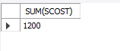

14 Who are the programmers WHO JOINED in the same day?

SELECT NAME,doj

FROM assessmentdatabase.PROGRAMMER

WHERE day(doj)=ANY(SELECT day(doj)

FROM assessmentdatabase.PROGRAMMER

GROUP BY day(doj) HAVING COUNT(*)>1);

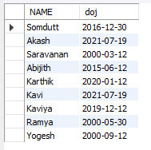

15 Who are the programmers WHO HAVE THE SAME PROF2?

SELECT NAME,prof2

FROM assessmentdatabase.PROGRAMMER

WHERE PROF2=ANY(SELECT PROF2

FROM assessmentdatabase.PROGRAMMER

GROUP BY PROF2 HAVING COUNT(*)>1);

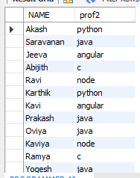

16 Display the total sales values of software, institutes-wise.

SELECT SPLACE,SUM(SOLD*SCOST)

FROM assessmentdatabase.SOFTWARE s,assessmentdatabase.STUDIES st

WHERE s.NAME=st.NAME GROUP BY SPLACE;

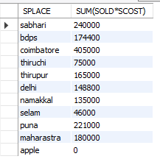

17 In which institutes did the person who developed the COSTLIEST package study?

SELECT SPLACE

FROM assessmentdatabase.SOFTWARE S,assessmentdatabase.STUDIES ST

WHERE S.NAME=ST.NAME

GROUP BY SPLACE,DCOST

HAVING MAX(DCOST)=(SELECT MAX(DCOST)

FROM assessmentdatabase.SOFTWARE);



18 Which language listed in prof1 and prof2 HAS NOT BEEN used to develop any package?

SELECT PROF1

FROM assessmentdatabase.PROGRAMMER

WHERE PROF1 NOT IN(SELECT DEV_IN

FROM assessmentdatabase.SOFTWARE)

UNION

SELECT PROF2

FROM assessmentdatabase.PROGRAMMER

WHERE PROF2 NOT IN(SELECT DEV_IN

FROM assessmentdatabase.SOFTWARE);

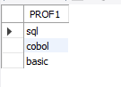

19 How much does the person WHO developed the HIGHEST selling package earn and WHAT course did he/she undergo?

SELECT s.name,P.SALARY,ST.COURSE

FROM assessmentdatabase.PROGRAMMER P,assessmentdatabase.SOFTWARE S,assessmentdatabase.STUDIES ST

WHERE P.NAME=S.NAME AND S.NAME=ST.NAME AND ST.NAME=P.NAME

AND SCOST=(SELECT MAX(SCOST)

FROM assessmentdatabase.SOFTWARE);

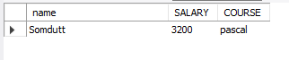

20 How many months will it take for each programmer to recover the cost of the course underwent?

SELECT P.NAME,round(CCOST/SALARY)

FROM assessmentdatabase.PROGRAMMER P,assessmentdatabase.STUDIES ST

WHERE ST.NAME=P.NAME;

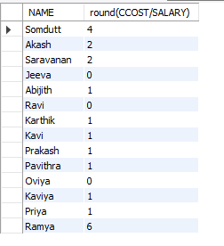

21 Which is the COSTLIEST package developed by a person with under 3 year’s expenences?

22 What is the AVERAGE salary for those WHOSE software's sales value is more than 50,000?

SELECT AVG(SALARY)

FROM assessmentdatabase.PROGRAMMER P,assessmentdatabase.SOFTWARE S

WHERE P.NAME=S.NAME AND SOLD*SCOST>50000;



23 How many packages were developed by the students WHO studied in the institute that Charge the LOWEST course fee?

SELECT COUNT(S.NAME)

FROM assessmentdatabase.SOFTWARE S,assessmentdatabase.STUDIES ST

WHERE S.NAME=ST.NAME

GROUP BY S.NAME,CCOST

HAVING MIN(CCOST)=(SELECT MIN(CCOST)

FROM assessmentdatabase.STUDIES);

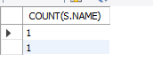

24 How many packages were developed by the person WHO developed the CHEAPEST package? Where did he\she study?

25 How many packages were developed by female programmers earning MORE than the HIGHEST paid male programmer?

SELECT COUNT(DEV_IN)

FROM assessmentdatabase.PROGRAMMER P,assessmentdatabase.SOFTWARE S

WHERE S.NAME=P.NAME AND SEX='F' AND SALARY>(SELECT MAX(SALARY)

FROM assessmentdatabase.PROGRAMMER P,assessmentdatabase.SOFTWARE S

WHERE S.NAME=P.NAME AND SEX='M');

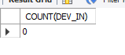

26 How many packages were developed by the MOST experienced programmers from BDPS?

27 List the programmers (from software table) and institutes they studied, including those WHO DIDN'T develop any package.

28 List each profit with the number of programmers having that prof1 and the number of packages developed in that prof1.

SELECT COUNT(*),SUM(SCOST*SOLD-DCOST) "PROFIT"

FROM assessmentdatabase.SOFTWARE

WHERE DEV_IN IN (SELECT PROF1

FROM assessmentdatabase.PROGRAMMER)

GROUP BY DEV_IN;

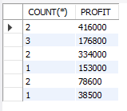

29 List programmer names (from programmer table) and number of packages EACH developed.

SELECT S.NAME,COUNT(DEV_IN)

FROM assessmentdatabase.PROGRAMMER P,assessmentdatabase.SOFTWARE S

WHERE P.NAME=S.NAME

GROUP BY S.NAME;

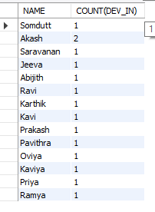

30 List all the details of programmers who have done a course at S.S.I.L

SELECT P.*

FROM assessmentdatabase.PROGRAMMER P,assessmentdatabase.STUDIES S

WHERE SPLACE='apple' AND P.NAME=S.NAME AND S.SPLACE='apple';

