**LeetCode-style SQL interview questions**

**[[](https://www.linkedin.com/in/parshvi-gupta-7720a479/)](https://www.linkedin.com/in/parshvi-gupta-7720a479/)**

**[Parshvi Gupta](https://www.linkedin.com/in/parshvi-gupta-7720a479/)**

AI Analytics and Data Science Specialist | Strategist and Innovator | MBA, IIT Roorkee

September 24, 2024

The following questions test fundamental SQL concepts like JOIN, GROUP BY, HAVING, RANK, and window functions.

**1. Get Employee Names with Salary Greater than X**

**Problem**: You are given a table Employee with the following structure:

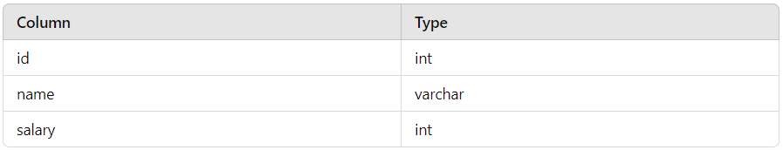

**Write an SQL Query to find the names of employees who earn more than a specific salary X.**

**Solution**:

SELECT name

FROM Employee

WHERE salary > X;

**2. Find Customers Who Never Ordered**

**Problem**: You are given two tables, Customers and Orders.

* Customers has the following structure:

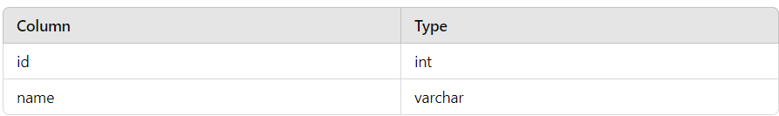

* Orders has the following structure:

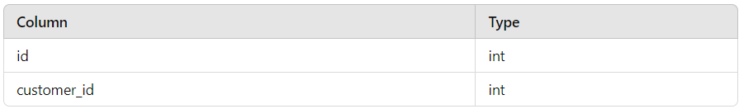

**Write an SQL query to find all customers who never placed an order.**

**Solution**:

SELECT name

FROM Customers c

LEFT JOIN Orders o

ON c.id = o.customer_id

WHERE o.customer_id IS NULL;

**3. Second Highest Salary**

**Problem**: You are given a table Employee:

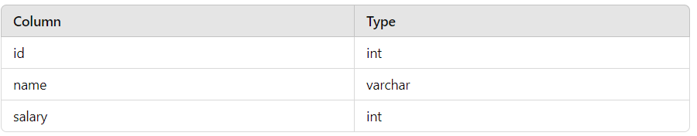

Write an SQL query to find the second-highest salary from the Employee table.

**Solution**:

SELECT MAX(salary) AS SecondHighestSalary

FROM Employee

WHERE salary < (SELECT MAX(salary) FROM Employee);

**4. Department with Highest Average Salary**

**Problem**: You are given two tables, Employee and Department.

* Employee has the following structure:

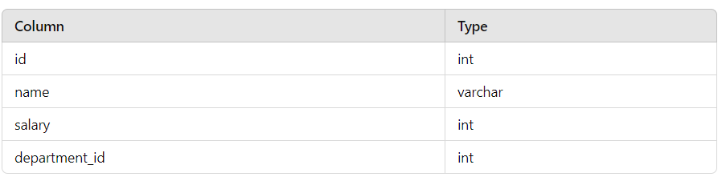

* Department has the following structure:

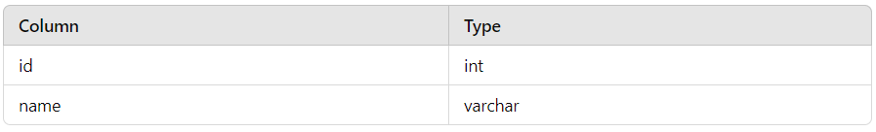

**Write an SQL query to find the department with the highest average salary.**

**Solution**:

SELECT d.name AS Department,

AVG(e.salary) AS AverageSalary

FROM Employee e

JOIN Department d

ON e.department_id = [**d.id**](http://d.id/)

GROUP BY [**d.name**](http://d.name/)

ORDER BY AverageSalary DESC

LIMIT 1;

**5. Find Duplicate Emails**

**Problem**: You are given a table Person:

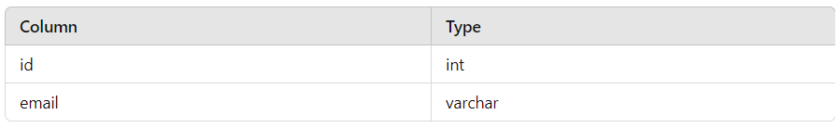

**Write an SQL query to find all duplicate emails.**

**Solution**:

SELECT email

FROM Person

GROUP BY email

HAVING COUNT(email) > 1;

**6. Rank Salaries**

**Problem**: You are given a table Employee with a salary column. **Write an SQL query to rank the salaries of all employees. In case of ties, employees should receive the same rank.**

**Solution**:

SELECT name, salary,

RANK() OVER (ORDER BY salary DESC) AS rank

FROM Employee;

**7. Employees Earning More Than Their Managers**

**Problem**: You are given a table Employee:

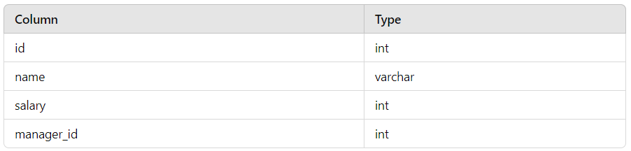

**Write an SQL query to find the employees who earn more than their managers.**

**Solution**:

SELECT [**e.name**](http://e.name/)

FROM Employee e

JOIN Employee m

ON e.manager_id = [**m.id**](http://m.id/)

WHERE e.salary > m.salary;

**8. Find Median Salary**

**Problem**: You are given a table Employee:

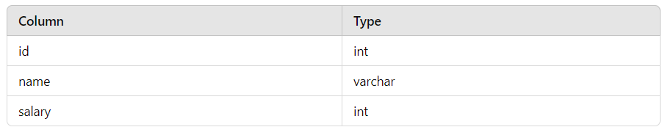

**Write an SQL query to find the median salary.**

**Solution**:

SELECT salary

FROM

( SELECT salary,

ROW_NUMBER() OVER (ORDER BY salary) AS row_num,

COUNT(*) OVER () AS total_count

FROM Employee ) AS t

WHERE row_num = total_count / 2 + 1 OR row_num = (total_count + 1) / 2;