SkillCommit: UI/UX Architecture Specification
AI-Powered Gamified Career GPS Design v2.0
Lead Architect: Akash Rengaraj | Status: Approved for MVP

Table of Contents

- Executive Summary & Vision
- User Psychology & Personas
- The Core User Journey
- Design Philosophy: The 3-Layer Paradigm
- Master Design System (Themes & Typography)
- Technical Implementation Directives

1. Executive Summary & Vision

Product Vision
SkillCommit bridges the gap between academic potential and industry reality. By leveraging a local RAG pipeline (Ollama) and RPG gamification mechanics, the platform transforms abstract career advice into highly actionable, personalized, and tracked daily technical tasks. It operates not as a passive to-do list, but as an active, intelligent career engine.

Target Audience Psychology & Pain Points
- B2C User (Technical Students): The modern technical student is highly analytical but prone to "analysis paralysis." They reject standard, flat corporate aesthetics (Material Design) and respond best to environments that feel like premium, professional developer tools. They require breathable layouts, clear directives, and immediate reward loops without overwhelming UI clutter.
- B2B User (Institutional Leads/HODs): Faculty and placement officers are time-poor and data-driven. They require clean, macro-level cohort mapping and automated early-intervention flags to identify bottlenecked students long before recruitment season begins.

2. The Core User Journey

The "Skill Commit" Psychological Loop
The platform relies on a frictionless, four-step behavioral loop to retain users and drive consistent progress:
- Analyze (The Delta): The RAG AI evaluates the gap between the student's current profile and their target industry role based on real-time market data.
- Generate (The Quest): The system assigns a hyper-personalized, atomic task (a micro-task taking 30–90 minutes).
- Execute (The Action): The student completes the task using contextual, AI-embedded resources directly within the app's clean glassmorphic reading interface.
- Reward (The Commit): The system grants XP, extends the user's visual "Commit Streak," and unlocks the next node in their professional Skill Tree.

3. Design Philosophy: The 3-Layer Paradigm

Layer | Design Style | Functional Intent
1. The Void | Background | Provides depth via procedural liquid orbs and solid base tones.
2. The Skeleton | Neumorphism | Defines functional tactile surfaces (Nav bars, primary triggers).
3. The Content | Glassmorphism | High-blur panels ensuring text legibility over motion layers.

4. Master Design System

Theme 1: "Prismatic Day" (Light Mode)
Optimized for daytime legibility and low cognitive load.
Element | Hex / CSS Value | Usage Directives
Canvas Base | #F0F4F8 (Ice White) | Structural background allowing white highlights to pop.
Liquid Orbs | #00C6FF & #9D50BB | Soft Cyan & Iris Violet. 30% opacity, 100px blur.
Glass Panel | rgba(255, 255, 255, 0.6) | High opacity for readability. 24px backdrop blur.
Glass Specular | rgba(255, 255, 255, 0.9) | Crisp white gradient border for glass edges.
Primary Text | #102A43 (Deep Navy) | High-contrast reading text (no pure black).

Theme 2: "Shadow Night" (Dark Mode)
Optimized for late-night developer environments. Reduced eye strain.
Element | Hex / CSS Value | Usage Directives
Canvas Base | #1C2128 (Shadow Black) | Soft dark gray. Replaces oppressive pure black.
Liquid Orbs | #00A8CC & #5E60CE | Muted Cyan & Indigo. 40% opacity, 100px blur.
Glass Panel | rgba(34, 40, 49, 0.5) | Tinted dark acrylic fill. 20px backdrop blur.
Glass Specular | rgba(255, 255, 255, 0.1) | Faint white border to catch imaginary ambient light.
Primary Text | #F8FAFC (Off-White) | Clean, bright readability for headers.

Typography Architecture
Category | Typeface | Psychological Impact
Headers | Space Grotesk | Geometric & Tech-forward
Body Copy | Inter | Clean UI legibility
Technical/XP | JetBrains Mono | Authentic Developer environment
[Visual Placeholder: Typography Specimen showing Space Grotesk, Inter, and JetBrains Mono]
[Visual Placeholder: Comparative Typography Scale showcasing Space Grotesk (H1-H3), Inter (Body), and JetBrains Mono (Data)]
- Headers: Space Grotesk (Geometric, tech-forward).
- Body Copy: Inter (Industry standard for clean UI legibility).
- Technical Data/XP: JetBrains Mono (Signals a developer environment).

Color Palette:
Light Mode:
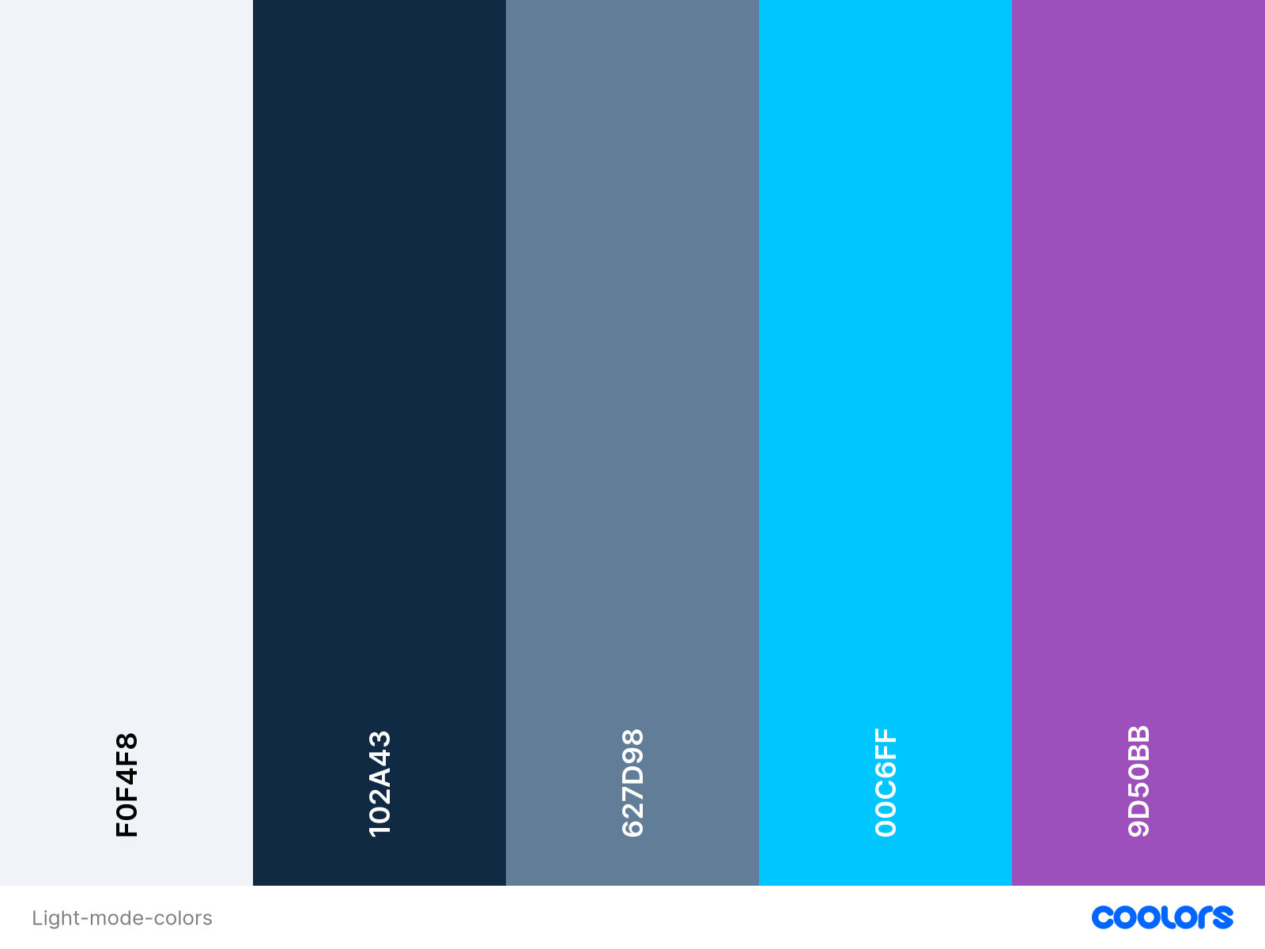
Dark Mode:
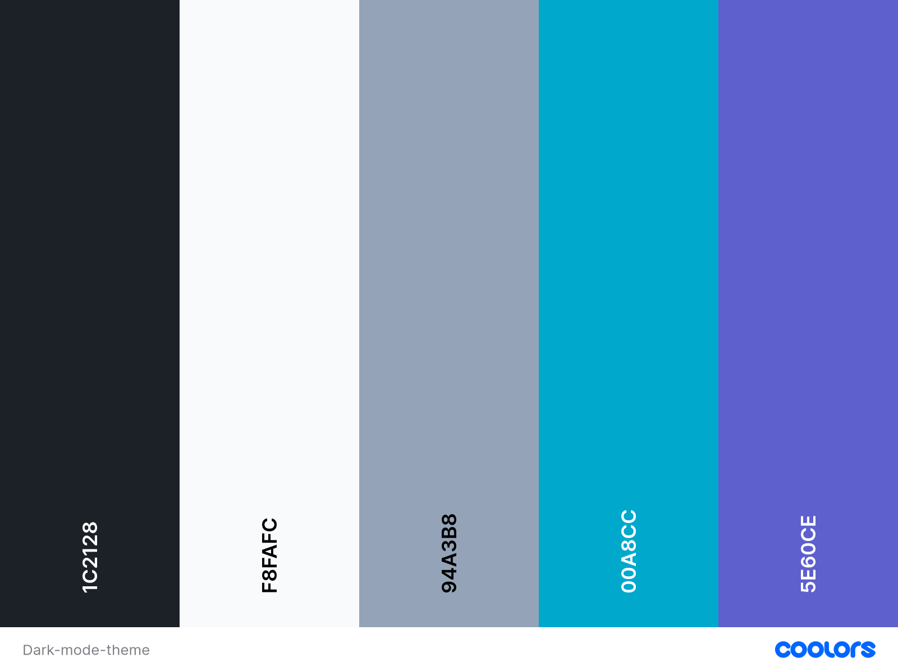

5. Mobile App Journey (B2C)

Screen 1: "Character Creation" (Onboarding Flow)
[Visual Placeholder: Mobile UI Mockup - Character Creation Chat Interface with pulsative Liquid Orbs background]
- Objective: Establish the initial Knowledge Graph frictionlessly.
- Layout: A single, central chat interface utilizing Glassmorphic message bubbles.
- Interaction: The AI acts as a "Career Architect," asking one conversational question at a time. The background liquid orbs pulse gently when the AI is processing the prompt.

Screen 2: The Command Center (Main Dashboard)
[Visual Placeholder: Mobile Dashboard Mockup - Showing Commit Green Streak Matrix and stacked Glassmorphic Quest Cards]
- Header Bar: Displays the user's Level and a vibrant XP progress bar.
- The Streak Matrix: A grid-based graph (mimicking GitHub contributions) using Commit Green (#10B981) to show daily consistency. Placed on a flat, non-neumorphic surface to reduce visual weight.
- The Quest Board: The top 3 AI-generated quests rendered as stacked Glassmorphic cards.
- Navigation: A clean Neumorphic bottom bar housing icons for Home, Skill Tree, and Profile.

Screen 3: The Quest Node (Task Execution)
- Layout: A full-screen Glassmorphic modal that slides up. The background darkens, bringing the text into sharp focus.
- Content: RAG-generated instructions and code snippets rendered in syntax-highlighted JetBrains Mono.
- Action: A massive Neumorphic "Commit Skill" button anchored at the bottom.
- Feedback: Tapping triggers heavy haptic feedback and a burst of green particles, visually tallying the XP gain.

Screen 4: The Skill Tree (Progression Tracker)
- Layout: A 2D panning and zooming map.
- State Management:
  - Completed Nodes: Solid borders with a faint cyan glow.
  - Available Nodes: Brightly outlined, pulsating slowly.
  - Locked Nodes: Muted, heavily frosted, with dotted prerequisite lines.

6. Web Dashboard Journey (B2B)

Design Philosophy for Institutions
The B2B portal shifts focus to information density. It retains the dual-theme palette but reduces the physical size of Liquid Glass blurs to prevent eye fatigue on large monitors, prioritizing clean typography and data visualization.

Screen 1: Cohort Command (The Overview)
- Layout: Neumorphic sidebar navigation with a vast, clean canvas for the main content area.
- Data Visualization (Mock Target: SKCET 2nd-Year AI & DS Cohort):
  - Skill Heatmaps: Visualizing the density of specific skills (e.g., "82% of the AI & DS batch has completed FastAPI basics").
  - Engagement Metrics: Average daily active users and "Commit Streak" health.
- Styling: Data cards use flat, solid base colors rather than heavy glass, with crisp 1px structural borders.

Screen 2: Intervention Matrix
- Objective: Identify bottlenecked students early.
- Layout: A dynamic, filterable data table.
- Alert System: Rows with critical "flags" (e.g., high technical XP but abandoned communication quests) are highlighted with a subtle, pulsating border, prompting faculty review.

Screen 3: Industry Alignment Tracker
- Layout: Split-pane view.
  - Left Pane: Live industry demands pulled from the RAG Vector DB.
[Visual Placeholder: Split-Pane Industry Alignment Tracker - Heatmap comparison between RAG market data and student cohort stats]
  - Right Pane: The specific cohort's aggregate progress toward those trending skills, resulting in a live "Placement Probability Score."

7. Component Library & Interactive Assets

States & Interaction Physics
- Neumorphic Primary Buttons:
  - Rest: Pressed out from the canvas.
  - Hover (Web)/Active (Mobile): The shadow inverts (Inset shadow) to look physically pressed into the screen, accompanied by a color shift in the text to Electric Cyan.
- Loading States: Instead of standard spinning wheels, utilize a slow, sweeping gradient mask that washes horizontally over the Glassmorphic cards to indicate AI generation in progress.
- Tooltips (Web): Small, stark Neumorphic bubbles with crisp text. Must appear instantly on hover to maintain a "fast-tool" feel.

Iconography
- Style: Sharp, unfilled linear icons (1.5px stroke weight).
- Usage: Icons inherit the color of their parent text element. Multi-colored icons are strictly prohibited to maintain a professional IDE aesthetic.

8. Technical Implementation Guidelines

Flutter (Mobile) Execution Directives
- Glassmorphism Performance: Use BackdropFilter combined with ImageFilter.blur. Wrap the filter in a ClipRRect to match the card's border radius (16px - 20px) to prevent infinite blur bleeding.
- Layering Optimization: Rasterize the Liquid background SVG/blobs if placed behind heavily scrolling ListViews to ensure a consistent 60fps on mid-range Android devices.
- Haptics: Implement flutter_vibrate. Bind Impact.light to card swiping and Impact.heavy to the "Commit Skill" action.

React (Web Dashboard) Execution Directives
- Light Mode Glass CSS Base:

.glass-card-light {
backdrop-filter: blur(24px);
background: rgba(255, 255, 255, 0.6);
border: 1px solid rgba(255, 255, 255, 0.8);
box-shadow: 0 8px 32px 0 rgba(31, 38, 135, 0.05);
}
- 

- Light Mode Neumorphism CSS Base:

.neumorphic-button-light {
background-color: #F0F4F8;
box-shadow: 6px 6px 12px rgba(180, 195, 210, 0.5), -6px -6px 12px #FFFFFF;
border-radius: 16px;
}
- 

- Background Motion: Use framer-motion for the slow drifting of background blur blobs. Utilize transform: translate3d to force GPU acceleration.

