**“Student Grade System”**



# Submitted to

**B.G.P.S,**

## RAJARSHI SHAHU INSTITUTE OF MANAGEMENT,

**Chhatrapati Sambhajinagar**

**In Partial ful fillment of the award for degree of Master of Computer**

**Applications (MCA)**

**Submitted By**

# “Mr. Akash Suresh Sultane”

**Under the Guidance Of**

# “Ms. Samreen Jahan

# ”

**“Student Grade System”**



**B.G.P.S,**

## RAJARSHI SHAHU INSTITUTE OF MANAGEMENT,

**Chhatrapati Sambhajinagar**

**MASTER OF COMPUTER APPLICATIONS (MCA)**

**Submitted By**

# “Mr. Akash Suresh Sultane”

**Under the guidance Of**

# “Ms. Samreen Jahan”

**B.G.P.S,**

**Rajarshi Shahu Institute of Management,**

**Chhatrapati Sambhajinagar**

Department Of

Master of Computer Applications

Certificate

This is to certify that **Mr.** **Akash Suresh Sultane** is our student of MCA –IV semester having a **Roll No.1459** and has submitted his project report/implant project report on

The topic of **“Student Grade System”** in the academic year 2023-24, as per the

Requirement of Dr. Babasaheb Ambedkar Marathwada University, Chhatrapati Sambhajinagar.

**Ms.Samree Jahan**

**Project Guide**

**Mr. Anil Wagh Dr.Ejaz Qureshi Head of Dept. Director**



# External Examiner



**Acknowledgement**

Constant inspiration and encouragement given by a number of individuals served as the driving force that enabled me to submit this project in the present form. This is an expression of my gratitude towards all such people.

First of all, I thank Almighty for His mercy on me always and with the invaluable asset of habit of hard work and perseverance which has proven to be the key factor behind this success.

I would like to express my sincere thanks to **Dr. Ejaz Ahmed Qureshi,** Director Rajarshi Shahu Institute of Management, Chhtrapati Sambhajinagar. Without his invaluable guidance and persistent encouragement this project work would not have been possible.

I would like to extend my gratitude and deeply indebted towards **Mr. Anil Wagh,** Assistant Professor and Head of MBA/MCA Department, **Rajarshi Shahu Institute of Management, Chhtrapati Sambhajinagar,** for all his precious suggestions, advices and valuable time which have made my project work experience productive and stimulating.

This project work would not have been possible without the constant assistance and mentoring of my respected project guide **Ms. Samreen Jahan.** I owe and respectfully offer my deepest gratitude to him.

I am also thankful to Shri J.K. Jadhav Chairman of BGPS’s Rajarshi Shahu Institute of management Chhtrapati Sambhajinagar, all Staff members for their constant motivation and support throughout my research work.

Mr. Akash Suresh Sultane

RollNo:1459

Rajarshi Shahu Institute of Management Chhtrapati Sambhajinagar

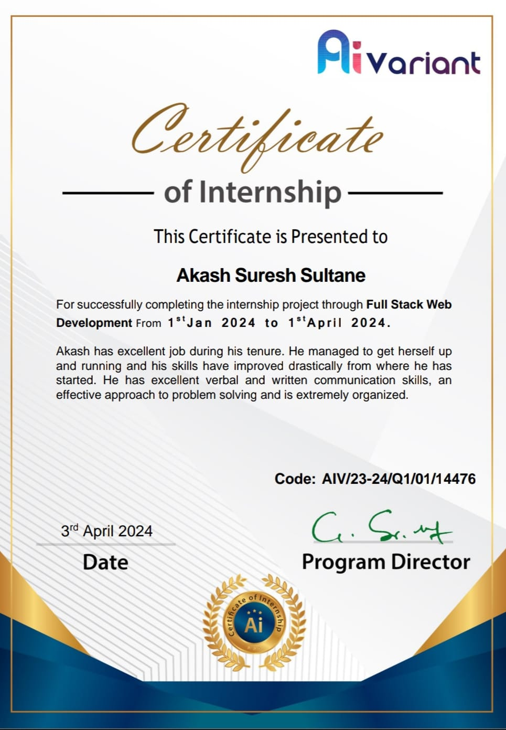



# DECLARATION

This is to declare that I am **Mr. Akash Suresh Sultane** student of Master of Computer Application (Course Period 2023-2024), **RAJARSHI SHAHU INSTITUTE OF MANAGEMENT,**

**CHHTRAPATI SAMBHAJINAGAR** Have given original data and information to the best of my knowledge in the project report entitled “**Student Grade System**” Under the guidance of **Ms. Samreen Jahan** and that no part of this information has been used for any other assignment but for the partial fulfillment of the requirement towards the completion of the MCA course.

I have prepared this report independently and I have gathered all the relevant information personally. I have prepared this project for partial fulfillment of **MCA** Graduate Course.

I also agree in principle not to share the vital information with any other person outside the organization and will not submit the project report to any other university.

Mr.Akash Suresh Sultane

RollNo:1459

Rajarshi Shahu Institute of Management Chhtrapati Sambhajinagar



## INDEX

|  |  |  |
| --- | --- | --- |
| **Sr.No** | **Contents** | **Page** |
| **1** | **Introduction** | **1** |
| **2** | **Scope Of Project** | **2** |
| **2.1** | **Introduction to Firm** | **3** |
| **3** | **About Course** | **4** |
| **4** | **Features** | **5** |
| **5** | **System Specification** | **13** |
| **6.1** | **System Analysis and Design** | **14** |
| **6..2** | **Data Flow Diagram** | **15** |
| **6.3** | **UML Diagram** | **16** |
| **6.4** | **ER Diagram** | **17** |
| **7** | **Soft Skills Course** | **18** |
| **8** | **Screen Shot** | **24** |
| **9** | **Conclusion** | **32** |
| **10** | Bibliography | **33** |

**List Of Figures/Screenshots**



|  |  |  |
| --- | --- | --- |
| **Sr.No** | **Contents** | **Page** |
| **3.5.1** | **Sql commands** | **10** |
| **4.1** | **Process Flow** | **14** |
| **4.2** | **Data Flow** | **15** |
| **4.3** | **Uml Diagram** | **16** |
| **4.4** | **ER Diagram** | **17** |
| **6.2** | **Login page** | **20** |
| **6.3** | **Home page** | **20** |
| **6.4** | **School year page** | **21** |
| **6.5** | **grade list page** | **21** |
| **6.6** | **student list** | **22** |
| **6.7** | **subject list** | **22** |
| **6.8** | **curriculum list** | **23** |
| **6.9** | **academic record** | **23** |
| **6.10** | **promote candidate candidate list** | **24** |
| **6.11** | **form 137 report** | **24** |
| **6.12** | **student list report** | **25** |
| **6.13** | **candidate report** | **25** |
| **6.14** | **user report** | **26** |

## INTRODUCTION

## In today's educational landscape, efficient and streamlined grading systems are crucial for both educators and students. Traditional paper-based methods can be time-consuming, prone to errors, and lack transparency. This project addresses these challenges by proposing the development of a Student Grade System.

## This system will be a software application designed to:

## Automate grading tasks: Reduce the time and effort spent on manual calculations and record-keeping.

## Improve data organization: Store and manage student grades, assignments, and course information in a centralized and secure location.

## Enhance communication: Provide a platform for instructors to share grades and feedback with students electronically.

## Increase transparency: Allow students to easily access their grades and track their progress throughout the course.

## This project will explore the functionalities, design considerations, and potential benefits of implementing a Student Grade System. It aims to demonstrate how such a system can contribute to a more efficient, organized, and transparent learning environment.

## 

.

**Scope of Project**

## User Management:

## Create and manage user accounts for instructors and students.

## Implement secure login and access controls based on user roles.

## Course Management:

## Allow instructors to create and manage courses.

## Define grading structures for each course, including assignment weights and point scales.

## Grade Entry:

## Provide instructors with a user-friendly interface to enter grades for various assignments, quizzes, and exams.

## Support different grading methods like points, percentages, and letter grades.

## Grade Recording and Storage:

## Securely store student grades and course information in a central database.

## Maintain a history of grades for each student to track progress over time.

## Grade Reporting:

## Generate reports for instructors summarizing student performance in a course.

## Allow students to view their grades and performance feedback electronically.

## (Optional) Implement functionalities for calculating class averages, identifying top performers, etc.

## INTRODUCTION TO FIRM

**Option 1: Project Overview**

This is a good choice if you're presenting the project to a general audience who might not be familiar with its purpose.

In today's educational environment, efficient and streamlined grading systems are essential for both educators and students. This project proposes the development of a Student Grade System designed to automate grading tasks, improve data organization, enhance communication, and increase transparency in the learning process.

**Option 2: Educational Institution Context**

If you're presenting within your school or university, you can tailor the introduction to highlight the specific needs the project addresses:

At [Name of Institution], we strive to continuously improve the learning experience for our students and faculty. Recognizing the challenges of traditional grading methods, this project explores the development of a Student Grade System. This system aims to streamline grading processes, enhance communication between instructors and students, and provide greater transparency in student performance.

## SERVICES

* **Performance Tracking**
* **Communication Tools**
* **Collaboration Features**
* **Analytics and Reporting**
* **Accessibility Features**

## 

## 3. ABOUT COURSE

### HTML

The Hypertext Markup Language or HTML is the standard markup language for documents designed to be displayed in a web browser. It can be assisted by technologies such as Cascading Style Sheets (CSS) and scripting languages such as JavaScript.

Web browsers receive HTML documents from a web server o from local storage and render the documents into multimedia web pages, HTML describes the structure of a web pages semantically and originally included use for the appearance of the document

HTML elements are the building blocks of HTML pages. With HTML constructs, images and other objects such as interactive forms maybe embedded into the rendered page. HTML provides a means o create structured documents by denoting structural semantics for text such as headings, paragraphs, list, links, quotes and other items. HTML elements ae delineated by tags, written using angle brackets. Tags such as <img /> and<input>directly intro duce content in to the page. Other tags such as

<p>surround and provide information about document text and may include other tags as sub-elements.

Browsers do no display the HTML tags but us them to interpret the content of the page.

HTML can embed programs written in a scripting language such as JavaScript ‘which affects the behaviour and content of web pages Inclusion of CSS defines the look and layout of content. The World Wide Web

Consortium(W3C),former maintainer of the IML and current maintainer

of the CSS standards, has encouraged the use of CSS over explicit presentational HTML since 1997. A form of HTML, known as HTML, is used to display video and audio, primarily using the <canvas> element, in collaboration with JavaScript.

The term HTMLS is essentially a buzzword that refers to a set of mode web technologies. This includes the HTML Living Standard, along with JavaScript APIs to enhance storage, multimedia, and hardware access. You may sometimes hear about "new HTMLS elements", or find HTMLS described as a new version of HTML. HTMLS was the successor to previous HTML versions and introduced new elements and capabilities to the language on top of the previous version, HTML 4.01, as well as improving or removing some existing functionality.

### FEATURES

* Ithasintroducednewmultimediafeatureswhichsupportaudioandvideocontrolsby using <audio> and <video> tags.
* There are new graphics elements including vector graphics and tags.
* Enrich semantic content by including <header><footer>,<article>,

<section>and<figure>area added.

* DragandDrop-Theusercangrabanobjectanddragitfurtherdroppingittoanew location.
* Geo-location services-It helps to locate the geographical location of a client.
* Web storage facility which provides web application methods to sore data on the web browser.
* Uses SQL data base to stored at a offline.
* Allowsdrawingvariousshapesliketriangle,rectangle,circle,etc.Capableof handling incorrect syntax.
* Easy DOCTYPE declaration i.e.<!doctypehtml>
* Easy character encoding i.e.<metacharset="UTF-8">

### 

### CSS (CASCADING STYLE SHEETS)

Cascading Style Sheets (CSS)is style sheet language used for describe in the presentation of a document written in a markup language such as HTML or XML(including XML dialects such as SVG, Math ML or XHTML), CSS is a corner stone technology of the World Wide Web, alongside HTML and JavaScript. CSS is designed to enable the separation of presentation and content including layout, colours,

And fonts. https://en.wikipedia.org/wiki/CSS – cite_note-3Thisseparationcanimprovecontentaccessibility;provide more flexibility andcontrolspecificationofpresentationcharacteristics;enablemultiplewebpagesohare formatting by specifying the relevant CSS in a separate

.css file, which reduces complexity and repetition in the structural content; and enablethe.ccs file to be cached to improve the page load speed between the pages that share the file and its formatting.

The name cascading comes from the specified priory scheme to determine which style rule applies if more than one rule matches a particular clement. This cascading priority scheme is predictable. The CSS specifications are maintained by the World Wide Web. Consortium (W3C). Inert media type (MIME type) text/css is registered for use with (CSS by RFC 2318 (March 1998). The W3C operates a free CSS validation service for CSS documents.

### TYPES OF CSS

* + Inline CSS
  + Internal or Embedded CSS
  + External CSS

#### 

#### Advantages of CSS:

* + CSS plays an important role, by using CSS you simply got to specify a repeated style for element once & use it multiple times as because CSS will automatically apply the required styles.
  + The main advantage of CSS is that style is applied consistently across variety of sites. One instruction can control several areas which is advantageous.
  + Web designers needs to use few lines of programming fore very page improving site speed.
  + Cascading sheet not only simplifies website development, but also simplifies the maintenance as a change of one line of code affects the whole web site and maintenance time.
  + It is less complex therefore theef fort are significantly reduced.
  + It helps to forms pontaneous and consistent changes.

#### Disadvantages of CSS:

* + CSS, CSS1 up to CSS3, result in creating of confusion among web browsers.
  + With CSS, what works with one browser might not always work with another. The web developers need to test for compatibility, running the program across multiple browsers.
  + There exists a scarcity of security.
  + Aftermakingthechangesweneedtoconfirmthecompatibilityiftheyappear.The similar change affects on all the browsers.
  + The programming language world is complicated for non-developers and beginners. Different levels of CSS i.e. CSS, CSS 2, CSS 3 are often quite confusing.

### JAVASCRIPT:

JavaScript, often abbreviated JS, is. programming language that’s one of the core technologies of the World Wide Web, alongside HTML and CSS. Over 97% of ‘websites use JavaScript on the client side for web page behavior, often incorporating third party libraries. JavaScript used by programmers crus the world to create dynamic and interactive web content like applications and browser. JavaScript is so popular that is the most used programming language in the world, used as client-side programming language by 97.0% of all websites.

The name JavaScript came from Netscape's support of Java applets within is browser: Many say it was also a marketing tactic o divert some attention from Java, which ‘was the most buzzed-about language at the time. Torun Java programs, the code must be fist compiled into an executable form.

#### Features of Javascript:

* + Scripting. Javascript executes the client-side scrip tin the browser.
  + Interpreter. The browser in terprets Java Script code.
  + Event Handling. Event sare actions.
  + Light Weight.
  + Case Sensitive.
  + Control Statements.
  + Objects as first-class Citizens.
  + Supports Functional Programming.

#### 

#### MySQL

MySQL is one of the most recognizable technologies in the modern big data ecosystem. Often called the most popular database and currently enjoying widespread, effective use regardless of industry, it’s clear that anyone involved with enterprise data or general IT should at least aim for a basic familiarity of MySQL.

With MySQL, even those new to relational systems can immediately build fast, powerful, and secure data storage systems. MySQL’s programmatic syntax and interfaces are also perfect gateways into the wide world of other popular query languages and structured data stores.

### ADVANTAGES

* + Portability
  + Seamless Connectivity
  + Data Security

### DISADVANTAGES

* + MySQL lower version(5.0orless)doesn't support ROLE, COMMIT and
  + Stored procedure.
  + MySQL does not support a very large database size as efficiently.
  + MySQL doesn't support SQL check constraints.

#### My SQL IN WEBDESIGN

MySQL determines the speed of when things load on your site and how fast you can access that stored data. It has a direct impact on site performance, which makes it an integral part of web design. Speed is king after all. If your database is not optimized, it makes it difficult to find the information you are looking for, takes up larger amounts of space due to duplicate data, and ultimately slows down your website.

In many cases, you won’t have to do much to keep the data base healthy.

However, being able to identify when things go wrong can help you trouble shoot problem sin an instant.

This is why many developers will use a tool that allows them to see all of the requests to the database in real-time. That way, the moment a request doesn’t go through, the developer can see what is causing the issue. So to sumit up, MySQL allows users to diagnose problems within the database and improve load times throughout their websites.

### SQL COMMANDS

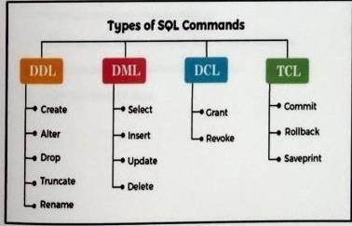

Fig3.5.1SQLCOMMANDS

## 

## PHP

PHP code is usually processed on a web server by a PHP interpreter implemented as module, a daemon or as a Common Gateway Interface (CGI) executable, On a web server, the result of the interpreted and executed PHP code - which maybe any type of data, such as generatedHTML, orbinaryimagedata-wouldformthewholeorpartofanHTTPresponse. Various web template systems, web content management systems, web frameworks exist which can be employed t orchestrate o facile the generation of that response. Additionally, PHP can be used for many programming asks outside he web. context such as standalone graphical applications and robotic drone control PHP code can also be directly executed from the command lin.

### PHP USES

* + PHP can generate dynamic page content
  + PHP can create, open, read, write, delete, and close files on the server.
  + PHP can collect form data.
  + PHP can send and receive cookies
  + PHP can add, delete, modify data in your database.
  + PHP can be used to control user access.
  + PHP can encrypt data.

### PHP MY ADMIN TOOL

Php My Admin is a free and open source administration tool for MySQL and MariaDB. As a portable web application written primarily in PHP, it has become one of the most popular MySQL administration tools, especially for web hosting services.

Php My Admin is a free software tool written in PHP, intended to handle the administration of MySQL over the Web. Php My Admin supports a wide range of operations on MySQL and MariaDB. Frequently used operations (managing databases, tables, columns, relations, indexes, users, permissions, etc) can be performed via the user interface, while you still have the ability to directly execute any SQL statement.

**Features**

* + Php My Admin supports MySQL and MariaDB common features
  + Php My Admin import data from CSV and SQL
  + Creating complex queries using Query-by-example(QBE)
  + Admin is tering multiple servers
  + Searching globally in a data base or a subset of it
  + Php MyAdmin Support Into DB tables and foreign keys
  + Php MyAdmin Check referential integrity in MyISAM tables
  + Create,edit,call,export and drop stored procedures and functions
  + Create, edit, export and drop events and triggers
* Php MyAdmin prepackaged with most web server packages(wamp, xampp, mamp, zend, lamp, ampps)
  + Php MyAdmin can interact with more than 80 different languages.
  + Php MyAdmin can run on any server or any OS(Windows, Linux, MacOS, Unix).
  + Create PDF graphics of your data base layout.
  + Trans form stored data into any format using a set of pre defined functions, like displaying BLOB-data as image or download-link.

**System Specifications**

Thissectiondescribesthehardwarecomponentsandsoftwarerequirementsneededfor effective and efficient running of the system

**Table:1 Hardware Requirements**

|  |  |  |
| --- | --- | --- |
| **SL** | **Hardware** | **Minimum System Requirement** |
| 01 | Processor | 2.4GHzProcessorspeed |
| 02 | Memory | 2 GBRA |
| 03 | Disk Space | 500 GB |

**Table:2 Software Requirements**

|  |  |  |
| --- | --- | --- |
| **SL** | **Software** | **Minimum System Requirement** |
| 01 | Operating System | Windows8, Windows10orMACOx 10.8,10.9, or 10.11,  LINUX |
| 02 | Database Management System | SQL |
| 03 | Runtime Environment | Visual Studio Code |

## 4. SYSTEM ANALYSIS AND DESIGN

**Process Flow**

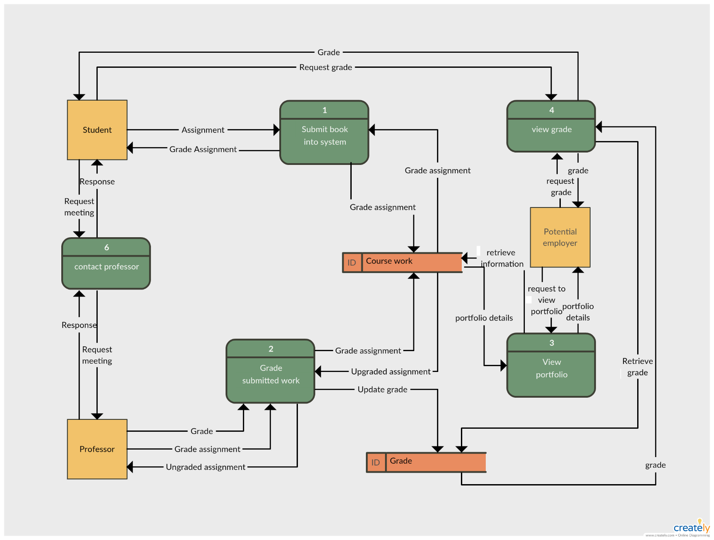

Fig4.1ProcessFlow

**Data flow Diagram**

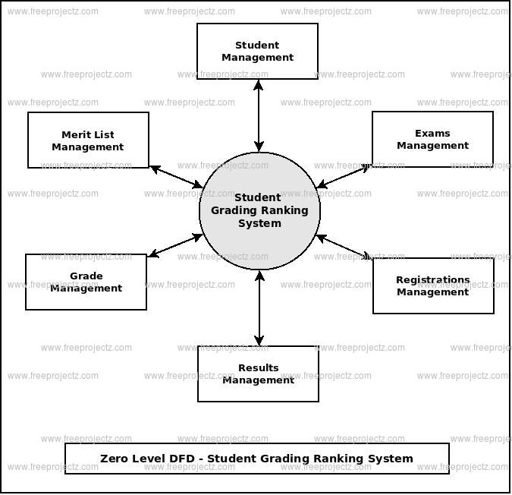

**UML Diagram**

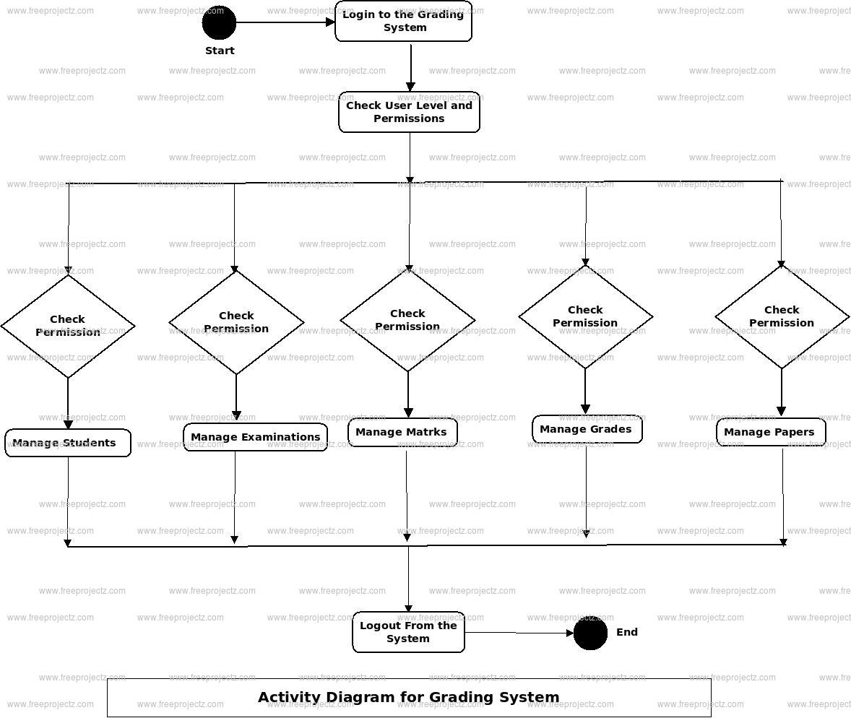

**ER Diagram**

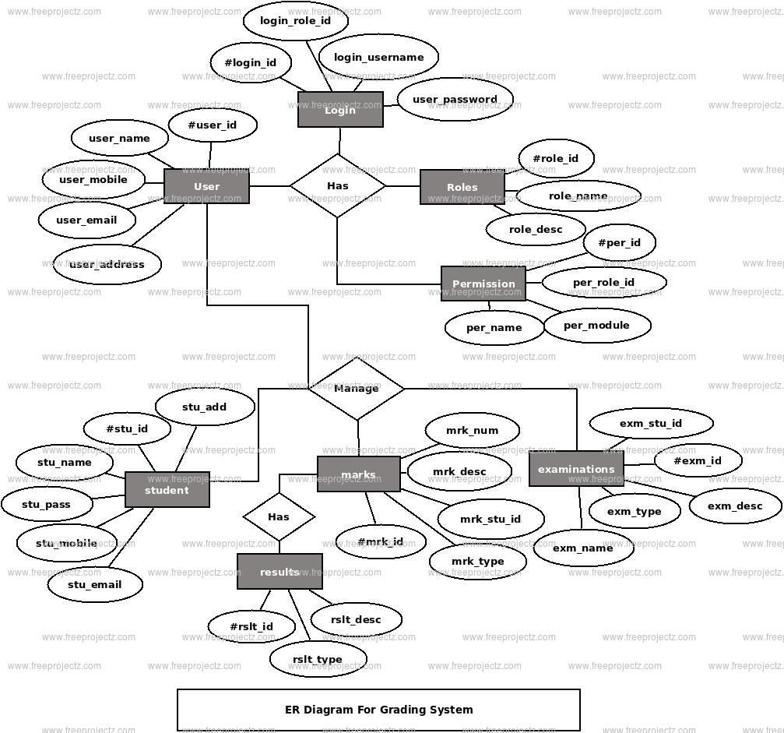

Fig4.4 ER Diagram

## SOFT SKILLS COURSE

To pics covered in soft skills course

## CHAMPIONSAT WORK

Transition is an ongoing process in everyone's life that takes place at different. This might be from the final years of school to the early years of higher education, also can be from the final years of campus to the early years of one's car. The transition campus to career needs more attention as it involves a lot of gaming. The shive of the planning must ensure that the person possesses the necessary skills to cope with the corporate asks, culture, and environment.

## TEAM WORK TASKS

Team of 10 students are created and asked to choose one captain and one vice- captain from team. Weekly tasks are assigned within tears to test the teamwork. After completion of tasks 10 winner teams are announced and their views and reviews are takes in meeting to know how an ideal team should be.

## ABOUT PROJECT

The site includes multiple pages such as

* Login page
* Home page
* School year page
* grade list page
* student list
* subject list
* curriculum list
* academic record
* promote candidate candidate list
* form 137 report
* student list report
* candidate report
* user report

<?php

require_once('mysql_connection.php');

session_start();

$type = $_GET['usertype'];

$selectquery = "SELECT * FROM accounts where usertype = '".$type."'";

$selectresult = mysqli_query($bd,$selectquery);

while ($row = mysqli_fetch_array($selectresult)){

$image = $row['picture'];

}

if(isset($_POST['login'])){

$username = $_POST['username'];

$password = $_POST['password'];

$query = "SELECT * FROM accounts where username='".$username."' and password = '".$password."' and usertype = '".$type."'";

$result = mysqli_query($bd,$query);

$row = mysqli_fetch_array($result);

if(is_array($row)) {

$_SESSION["id"] = $row['id'];

if($type == "ADMIN"){

header('location: view_accounts.php');

} elseif($type == "USER"){

header('location: view_records.php');

}

}

else

{

echo "<script>alert('Incorrect Username or Password!')</script>";

}

}

?>

<body>

<center>

<?php include('header.html');?>

</br>

<table width="25%">

<tr>

<th style="border: 4px solid #0909da;border-style: inset;border-radius: 10px;background-color: #88edfb;">

<center>

<form action="" method="post">

<table>

<tr>

<font style="font-size: 25px;"><strong>LOGIN FORM</strong></font>

</br>

<font style="font-size: 15px;"><strong>(<?php echo $type;?>)</strong></font>

</br>

</tr>

<?php

if($type == "ADMIN"){

?>

<tr>

<td colspan="2"><center><img src="images/logo2.jpg<?php echo $image;?>" style="width: 50%; height: 50%;background-color: #f9f5f5;border: 2px solid black;"></center></td>

</tr>

<?php } ?>

<tr>

<th>Username:</th>

<td><input type="text" name="username" required></td>

</tr>

<tr>

<th>Password:</th>

<td><input type="password" name="password" required></td>

</tr>

<tr>

<th colspan="2">

</br>

<input type="submit" name="login" value="Login" style="border-radius: 4px;border-color: #ab9090; padding: 5px 15px;font-size: 15px;">

<button style="border-radius: 4px;border-color: #ab9090; padding: 5px 0px;font-size: 15px;"><a href="index.php" style="text-decoration: none;cursor: default; padding: 5px 15px; color: black;">Back</a></button>

</th>

</tr>

</table>

</form>

</center>

</br>

</br>

</th>

</tr>

</table>

</center>

<?php include('header.html');?>

<?php include('teacher_header.php');?>

</br>

<table width="80%" cellspacing="0" style="border:3px solid #f35306;border-style: inset;">

<tr>

<th>

<table width="100%" cellspacing="0">

<tr>

<th colspan="10" style="border-bottom: 1px solid;background-color: #f7b553;padding: 5px 0px;font-size: 45px;">Students Records</th>

</tr>

<tr>

<th width=15%" style="background-color: #f38b5a;border-bottom: 1px solid;padding: 5px 0px;">Picture</th>

<th width="15%" style="background-color: #f38b5a;border-bottom: 1px solid;padding: 5px 0px;">Name</th>

<th width="7%" style="background-color: #f38b5a;border-bottom: 1px solid;padding: 5px 0px;">First Grading</th>

<th width="7%" style="background-color: #f38b5a;border-bottom: 1px solid;padding: 5px 0px;">Second Grading</th>

<th width="7%" style="background-color: #f38b5a;border-bottom: 1px solid;padding: 5px 0px;">Third Grading</th>

<th width="7%" style="background-color: #f38b5a;border-bottom: 1px solid;padding: 5px 0px;">Fourth Grading</th>

<th width="7%" style="background-color: #f38b5a;border-bottom: 1px solid;padding: 5px 0px;">Final Grade</th>

<th width="10%" style="background-color: #f38b5a;border-bottom: 1px solid;padding: 5px 0px;">Remarks</th>

<th colspan="2" style="background-color: #f38b5a;border-bottom: 1px solid;padding: 5px 0px;"></th>

</tr>

<?php

$query = "SELECT * FROM records where teacher_number = '".$_SESSION["id"]."' order by lastname ASC";

$result = mysqli_query($bd,$query);

while($row = mysqli_fetch_array($result)){

$id = $row['id'];

$firstname = $row['firstname'];

$lastname = $row['lastname'];

$mi = $row['mi'];

$first_grading = $row['first_grading'];

$second_grading = $row['second_grading'];

$third_grading = $row['third_grading'];

$fourth_grading = $row['fourth_grading'];

$final_grade = ($first_grading + $second_grading + $third_grading + $fourth_grading) / 4;

if($final_grade>=75){

$remarks = "PASSED";

} else {

$remarks = "FAILED";

}

$picture = $row['picture'];

?>

<tr>

<th style="background-color: #efb295;border-bottom: 1px solid;"><img src="images/<?php echo "$picture";?>" style="width: 40px; height: 40px;background-color: #f9f5f5;border: 2px solid black;"></th>

<th style="background-color: #efb295;border-bottom: 1px solid;"><?php echo "$lastname , $firstname $mi.";?></th>

<th style="background-color: #efb295;border-bottom: 1px solid;"><?php echo "$first_grading";?></th>

<th style="background-color: #efb295;border-bottom: 1px solid;"><?php echo "$second_grading";?></th>

<th style="background-color: #efb295;border-bottom: 1px solid;"><?php echo "$third_grading";?></th>

<th style="background-color: #efb295;border-bottom: 1px solid;"><?php echo "$fourth_grading";?></th>

<th style="background-color: #9df5f1;border-bottom: 1px solid;"><?php echo "$final_grade";?></th>

<th style="background-color: #efb295;border-bottom: 1px solid;"><?php echo "$remarks";?></th>

<th style="background-color: #efb295;border-bottom: 1px solid;" width="10%">

<a href="edit_student.php?id=<?php echo $row['id'];?>" style="text-decoration: none;padding: 0px 15px;color: black;background-color: #abb5fb;border: 2px solid black;border-style: outset;border-radius: 5px;">Edit</a>

</th>

<th style="background-color: #efb295;border-bottom: 1px solid;" width="10%">

<a href="delete_student.php?id=<?php echo $row['id'];?>" style="text-decoration: none;padding: 0px 15px;color: black;background-color: #abb5fb;border: 2px solid black;border-style: outset;border-radius: 5px;">Delete</a>

</th>

</tr>

<?php }?>

</table>

</th>

</tr>

</table>

</center>

**Screen Shots**

### 

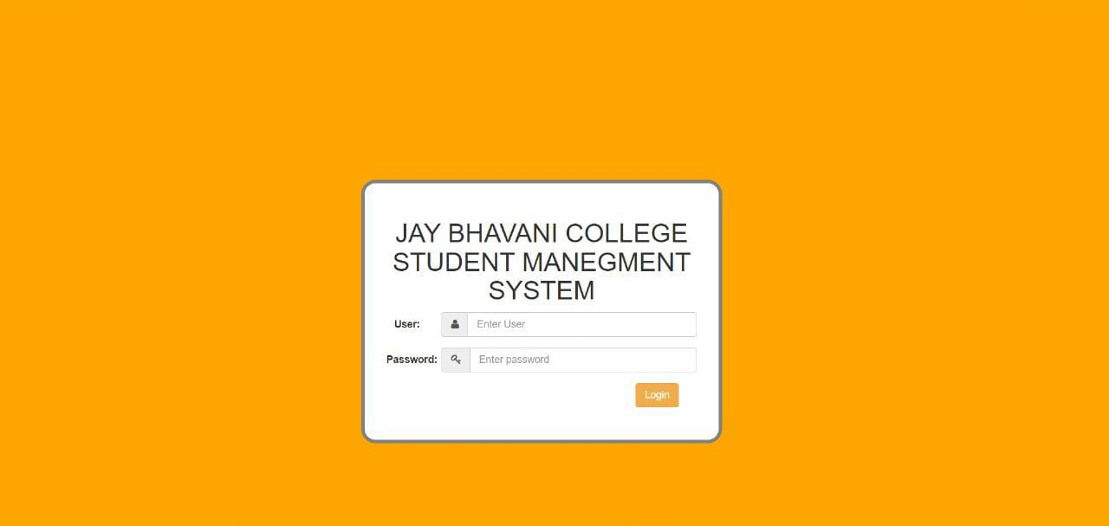

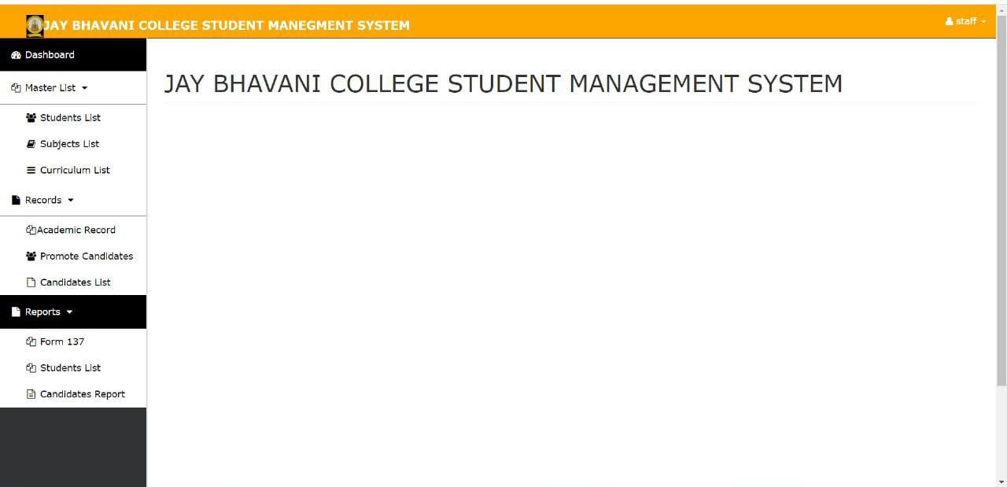

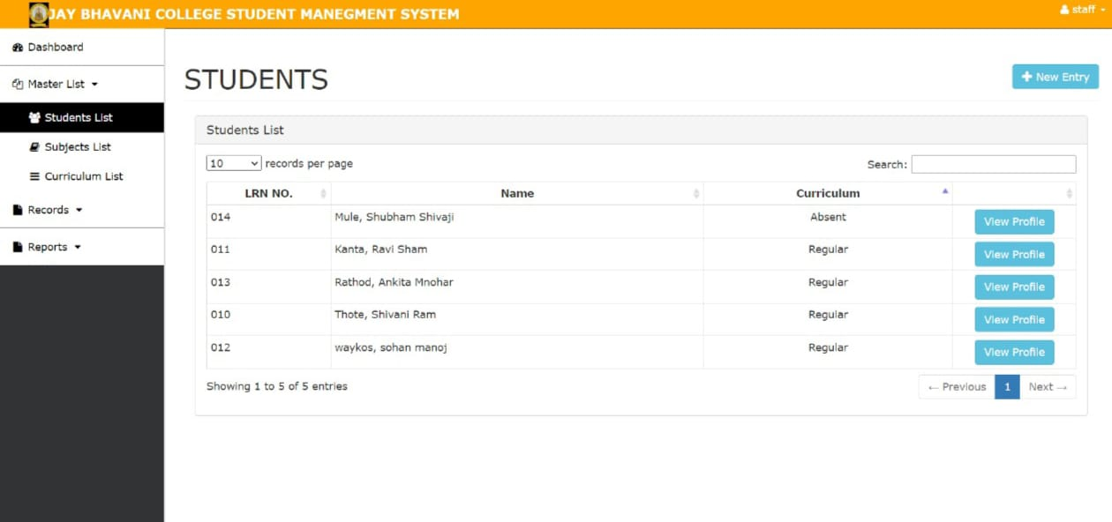

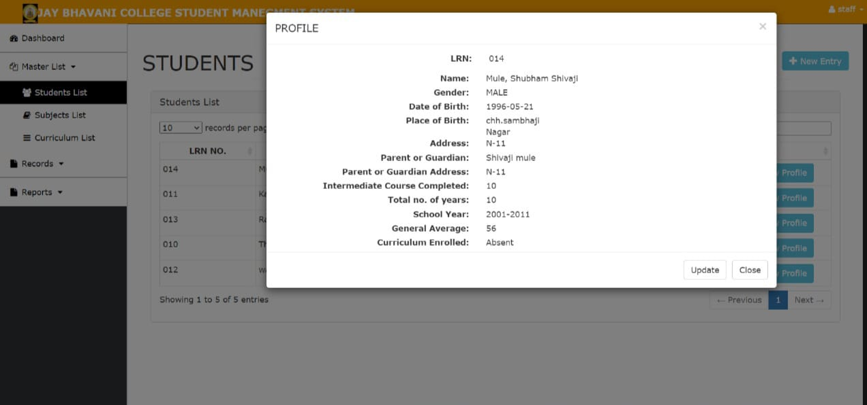

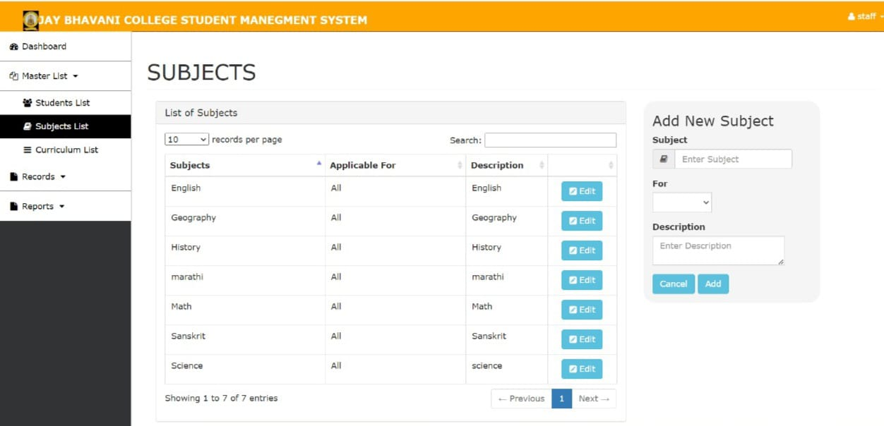

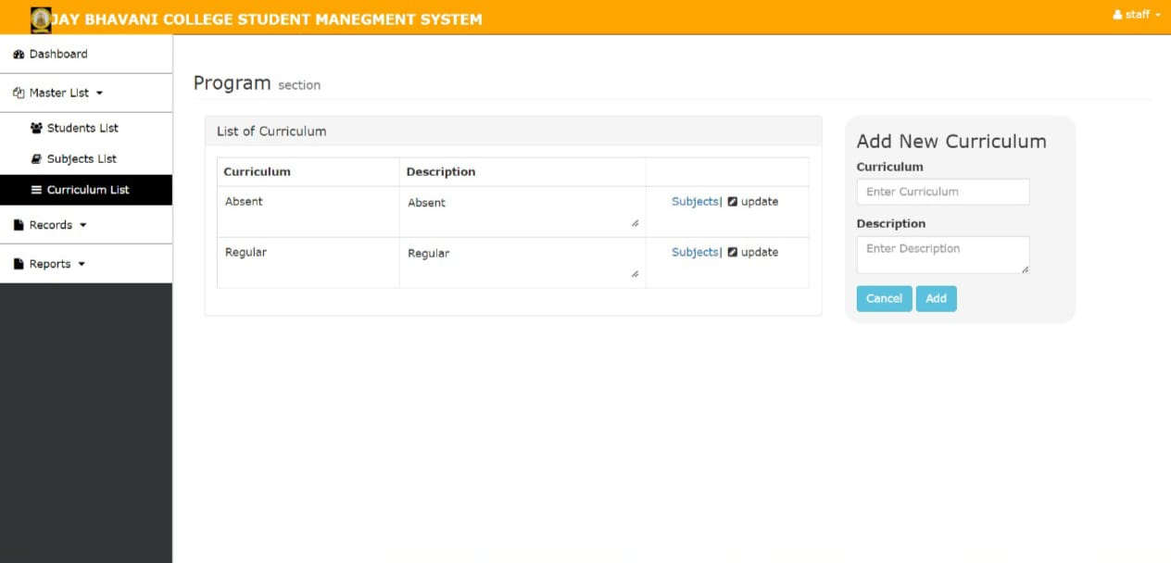

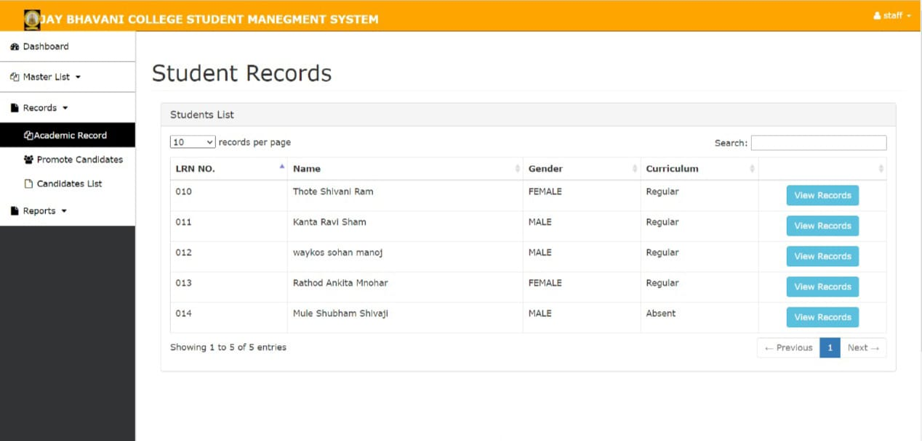

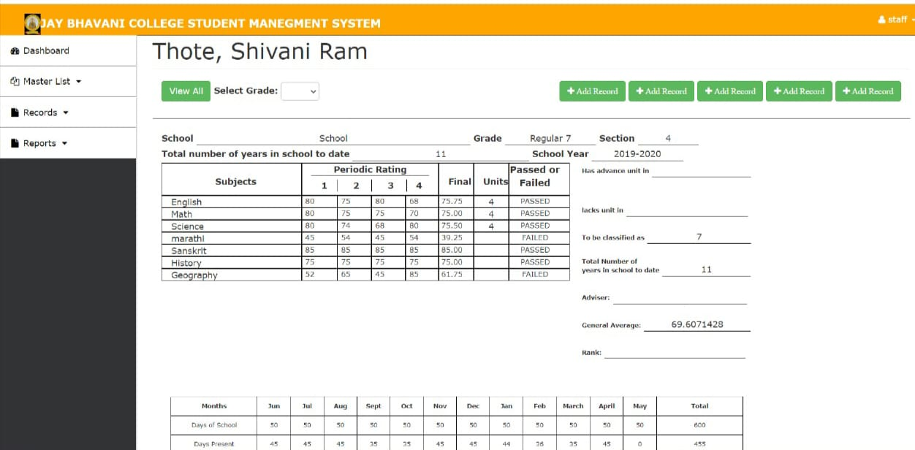

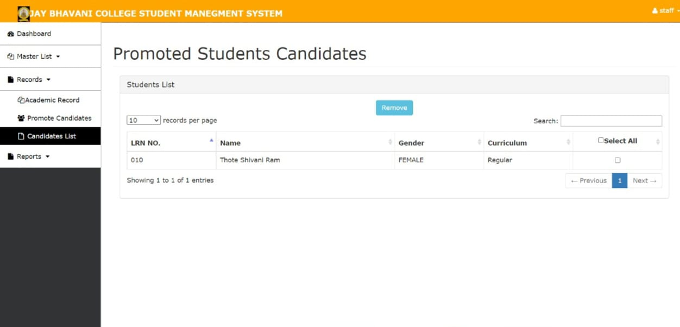

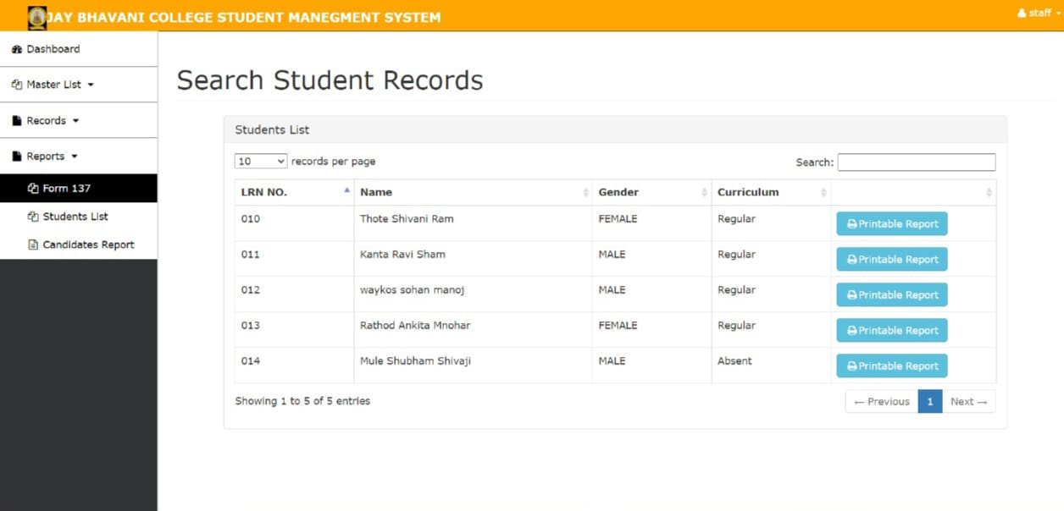

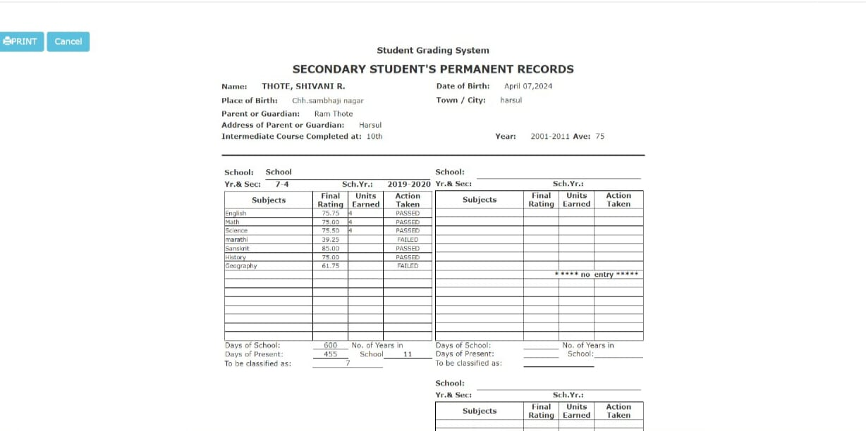

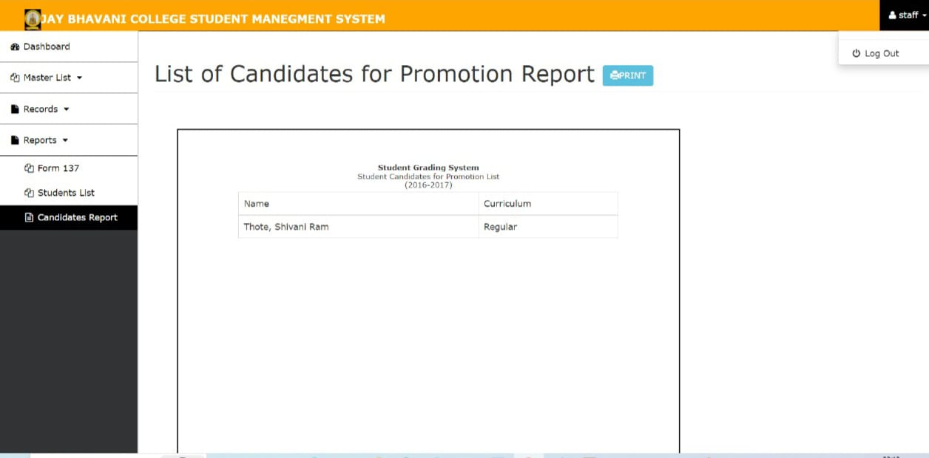

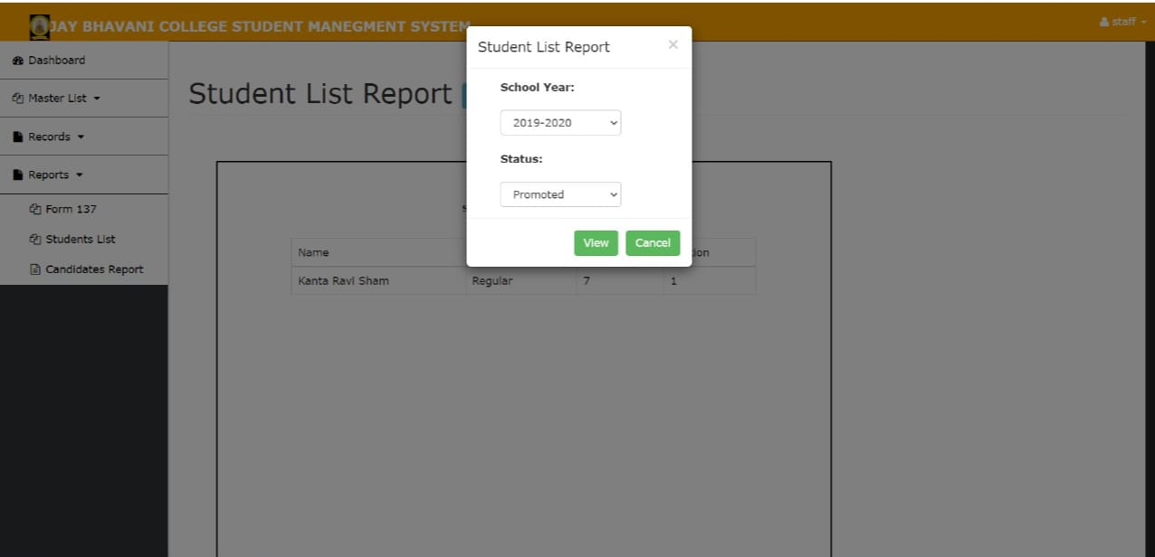

## 

## LEARNING OUT COME

* From Start to till today we get familiar with various technologies thoroughly.
* I can write SQLqueries
* I can create a web site using HTML,CSS and Java Script.
* To learn team work, group of few students are formed and assigned them with a new task weekly.
* Thisinternshiphelpedmetoboostmyconfidenceaswellaslearnedtomanage time.
* InthisinternshipIgetintroducedwithvarioustechnicalaspectsandalsobehavioural skills, communication skills, team work.
* This internship help edge a lot in improving my career as well as taught me self- leaning and self-motivation

## CONCLUSION

In a nut shell, this internship has been an excellent and rewarding experience. I can Conclude that there have been a lot I've learnt from my work at the training & research Centre. Needless to say, the technical aspects of the work I've done are not flawless and could be improved provided enough time. As someone with no prior experience in JavaScript whatsoever I believe my time spent in Training and discovering new languages was well worth it and contributed to finding unacceptable solution to an important aspect of web design and development. Two main thing that I've learned the importance of our time management skills and self-motivation. Although I have often stumbled upon these problems at University, they had to be approached differently in a working environment

**BIBLIOGRAPHY**

Books:

"Educational Assessment in Action" by Robert J. Linn: [invalid URL removed]

"Grading for Learning" by Joe Wolfe: [invalid URL removed]

"Learning Management Systems: Theories, Implementations, and Impact" by David Wiley: [invalid URL removed]

Articles:

"A Student Grading Management System: A Case Study of Mbarara Army Senior Secondary School" by Ronald Asiimwe, Moses Muhumuza, and Anatoli Baguma find this on ResearchGate: [invalid URL removed]

"The Impact of Grading Practices on Student Learning" by James McMillan [find this through your school library or online databases]

"Using Technology to Enhance Grading and Feedback" by The Center for Applied Special Technology (CAST) find this on CAST's website: https://www.cast.org/

Websites:

https://www.grafiati.com/en/help/ (Provides a bibliography on student grading and marking)

https://scholarworks.calstate.edu/downloads/0g354m31c?locale=pt-BR (Example project report on a student grading system