# 1. Database Concept

## 1.1 Introduction

Our client Relco Private Ltd is an IT Network Infrastructure Hardware distributer, they sell Network Hardware devices such as Servers, Routers, Switches, and LAN Cards to Small and Medium Size Enterprise (SMEs). SMEs buy IT Network Infrastructure devices to build their own IT Network Infrastructure such as Intranet and On Premise Cloud & data center solution.

Relco wants to develop a web based service which will be used internally by company stake holders to manage inventory stock and data related to sales and purchases done day to day. This web based service enable employees and other stake holders store information about suppliers, customers, products etc. Relco also want to implement Role based access control in system so the access to backend databases can be configured per user permissions. There will be three tables which will handle all transection of sales, purchase and product.

Tables

1. Products (pid, Type, make, model, price)
2. Server (model, make, cpu,no.of cpu, RAM )
3. Router (model, make, EPort, PVDM3 slots, RAM)
4. Switch (model, make, Eport, Ac Power, POE Power)
5. Suppliers (id, name, address, phone, email, billing Amount)
6. Customer (id, name, address, phone, email, amount, discount)

Tables with data

|  |  |  |  |
| --- | --- | --- | --- |
| Product Table | | | |
| **PID** | **Type** | **Model** | **Price** |
| 1 | Server | 6400 | $ 5,000 |
| 2 | Router | 2921 | $1,571 |
| 3 | Switch | 3925 | $ 2,000 |
| 4 | Server | 6450 | $ 5,000 |
| 5 | Router | 2951 | $ 1,000 |

|  |  |  |  |  |  |
| --- | --- | --- | --- | --- | --- |
| Server Table | | | | | |
| **Model** | **Make** | **CPU_TYPE** | **NO_OF_CPU** | **RAM** | **Qty** |
| 6400 | Dell | Pentium III Xeon | 4 | 8GB | 10 |
| R230 | Dell | Xeon E3 1200 v5 | 1 | 64GB | 10 |
| R430 | Dell | Xeon E5 2600 v3 | 2 | 384GB | 10 |
| R530 | Dell | Xeon E5 2600 v3 | 2 | 384GB | 10 |
| DL20 Gen9 | HPE | Xeon E3 1200 v5 | 4 | 64GB | 10 |

|  |  |  |  |  |  |
| --- | --- | --- | --- | --- | --- |
| Router Table | | | | | |
| **Model** | **Make** | **EPort** | **PVDM3_slot** | **RAM** | **Qty** |
| 2921 | Dell | 3 RJ-45 | 3 | 512 MB | 10 |
| 2951 | Dell | 2 RJ-45 | 3 | 512 MB | 10 |
| 3925 | Dell | 1 RJ-45 | 4 | 1 GB | 10 |
| 3945 | Dell | 1 RJ-45 | 4 | 1 GB | 10 |
| 3925E | Dell | 2 RJ-45 | 3 | 1 GB | 10 |

|  |  |  |  |  |  |
| --- | --- | --- | --- | --- | --- |
| Switch Table | | | | | |
| **Model** | **Make** | **Eport** | **Ac_Power** | **PoE_Power** | **Qty** |
| WS-C3560X-24T-L | Dell | 24 | 250W | - | 10 |
| WS-C3560X-24P-L | Dell | 24 | 715W | 435W | 10 |
| WS-C3560X-48P-L | Dell | 48 | 715W | 435W | 10 |
| WS-C3560X-48PF-L | Dell | 48 | 1100W | 800W | 10 |

|  |  |  |  |  |  |
| --- | --- | --- | --- | --- | --- |
| ID | Name | Address | Phone | Email | Billing Amount |
| 1 | Dell | Cherrywood Park, Cherrywood, Dublin, 18 | +353 12044014 | [dellenterpricesystem@dell.ie](mailto:dellenterpricesystem@dell.ie) | $16,000 |
| 2 | Cisco | Alfie Byrne Rd, North Dock, Dublin, DUBLIN 3 | +353 18192700 | [Ciscoenterpricesystem@cisco.ie](mailto:Ciscoenterpricesystem@cisco.ie) | $10,000 |
| 3 | HP | HP Inc.  Barnhall Rd., (Bldg DUB07-08)  P.C. None  Leixlip  Ireland | +353 18978088 | [Hpenterpricesystem@hp.ie](mailto:Hpenterpricesystem@hp.ie) | $5,000 |
| 4 | Huawei | 4 Custom House Quay, North Dock, Dublin | 00353-1-2343100 | [Huaweisupport@huawei.com](mailto:Huaweisupport@huawei.com) | $10,000 |

|  |  |  |  |  |  |  |
| --- | --- | --- | --- | --- | --- | --- |
| Customer | | | | | | |
| ID | Name | Address | Phone | Email | Amount | Discount |
| 1 | AIT | Bublin Road, Athlone | +353 11122233 | [admin@ait.ie](mailto:admin@ait.ie) | $2000 | $200 |
| 2 | TownApps | Bublin Road, Athlone | +353 12321236 | [admin@townapps.ie](mailto:admin@townapps.ie) | $3000 | $100 |

## 1.2 Errors and Anomalies

* The Customer table in current database design does not return any information about customer purchase.
* Current schema does not allow sales tracking.
* Quantity attribute in tables Server, Router and Switch is partially dependent on Make candidate key so Make attribute cannot be null.
* Discount in table Suppliers can only be derived from Billing_amount, so Billing_amount cannot be null. If Billing_amount becomes null Suppliers ID (primary key) does not return discount.
* Discount in table Customer can only be derived from Amount, so Amount attribute cannot be null. If Amount become null Customer ID (primary key) does not return discount.

# 2 Logical Design

## 2.1 ER Diagram

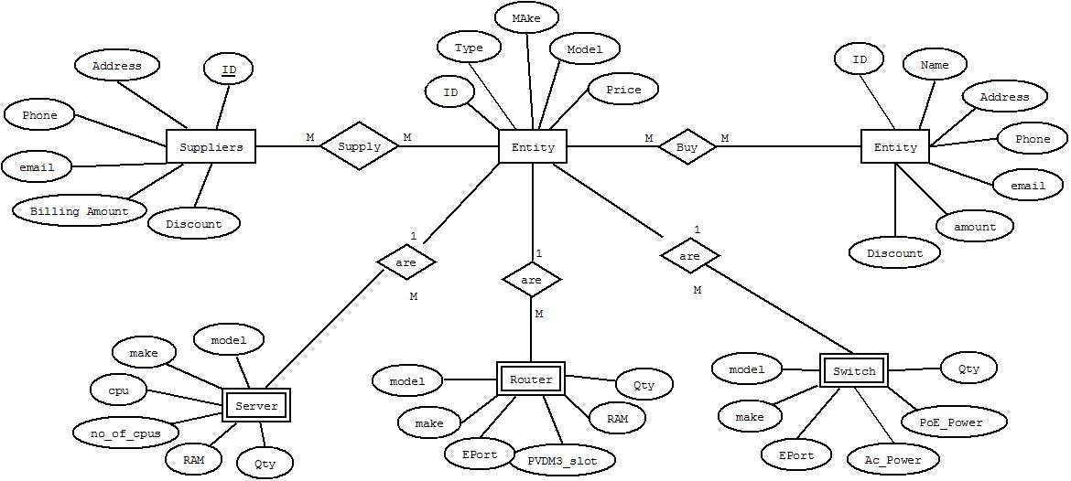

## 2.2 Normalization

### Tables in 1st Normal Form

|  |  |  |  |
| --- | --- | --- | --- |
| Product Table | | | |
| **PID** | **Type** | **Model** | **Price** |

|  |  |  |  |  |  |
| --- | --- | --- | --- | --- | --- |
| Server Table | | | | | |
| **Model** | **Make** | **CPU_TYPE** | **NO_OF_CPU** | **RAM** | **Qty** |

|  |  |  |  |  |  |
| --- | --- | --- | --- | --- | --- |
| Router Table | | | | | |
| **Model** | **Make** | **EPort** | **PVDM3_slot** | **RAM** | **Qty** |

|  |  |  |  |  |  |
| --- | --- | --- | --- | --- | --- |
| Switch Table | | | | | |
| **Model** | **Make** | **Eport** | **Ac_Power** | **PoE_Power** | **Qty** |

|  |  |  |  |  |  |
| --- | --- | --- | --- | --- | --- |
| Suppliers | | | | | |
| **ID** | **Name** | **Address** | **Phone** | **Email** | **Billing Amount** |

|  |  |  |  |  |  |  |
| --- | --- | --- | --- | --- | --- | --- |
| Customer | | | | | | |
| **ID** | **Name** | **Address** | **Phone** | **Email** | **Amount** | **Discount** |

### Tables in 2nd Normal Form

|  |  |  |
| --- | --- | --- |
| Product Table | | |
| **Model** | **Type** | **Price** |
| **Model is the candidate key** | | |

|  |  |  |  |  |
| --- | --- | --- | --- | --- |
| Server Table | | | | |
| **Model** | **Make** | **CPU_TYPE** | **NO_OF_CPU** | **RAM** |
| **Model and Make both candidate key** | | | | |

|  |  |
| --- | --- |
| ServerModel Table | |
| **Model** | **Qty** |
| **Model is a candidate key** | |

|  |  |  |  |  |
| --- | --- | --- | --- | --- |
| Router Table | | | | |
| **Model** | **Make** | **EPort** | **PVDM3_slot** | **RAM** |
| **Model and Make both candidate key** | | | | |

|  |  |
| --- | --- |
| RouterModel Table | |
| **Model** | **Qty** |
| **Model is a candidate key** | |

|  |  |  |  |  |
| --- | --- | --- | --- | --- |
| Switch Table | | | | |
| **Model** | **Make** | **Eport** | **Ac_Power** | **PoE_Power** |
| **Model and Make both candidate key** | | | | |

|  |  |
| --- | --- |
| SwitchModel Table | |
| **Model** | **Qty** |
| **Model is a candidate key** | |

|  |  |  |  |  |  |
| --- | --- | --- | --- | --- | --- |
| Suppliers | | | | | |
| **ID** | **Name** | **Address** | **Phone** | **Email** | **Billing Amount** |
| **ID is a candidate key** | | | | | |

|  |  |  |  |  |  |  |
| --- | --- | --- | --- | --- | --- | --- |
| Customer | | | | | | |
| **ID** | **Name** | **Address** | **Phone** | **Email** | **Amount** | **Discount** |

### Tables in 3nd Normal Form

|  |  |  |
| --- | --- | --- |
| Product Table | | |
| **Model** | **Type** | **Price** |
| **Model is primary key** | | |

|  |  |  |  |  |
| --- | --- | --- | --- | --- |
| Server Table | | | | |
| **Model_ID** | **Model** | **CPU_TYPE** | **NO_OF_CPU** | **RAM** |
| **Model_ID is a primary key and Model is foreign key** | | | | |

|  |  |
| --- | --- |
| ServerModel Table | |
| **Model** | **Qty** |
| **Model foreign key refers to product (model)** | |

|  |  |
| --- | --- |
| ServerMake Table | |
| **Model** | **Make** |
| **Model foreign key refers to product (model)** | |

|  |  |  |  |  |
| --- | --- | --- | --- | --- |
| RouterTable | | | | |
| **Model_ID** | **Model** | **EPort** | **PVDM3_slot** | **RAM** |
| **Model_ID is a primary key and Model is foreign key** | | | | |

|  |  |
| --- | --- |
| RouterModel Table | |
| **Model** | **Qty** |
| **Model foreign key refers to product (model)** | |

|  |  |
| --- | --- |
| RouterMake Table | |
| **Model** | **Make** |
| **Model foreign key refers to product (model)** | |

|  |  |  |  |  |
| --- | --- | --- | --- | --- |
| SwitchTable | | | | |
| **Model_ID** | **Model** | **Eport** | **Ac_Power** | **PoE_Power** |
| **Model_ID is a primary key and Model is foreign key** | | | | |

|  |  |
| --- | --- |
| SwitchModel Table | |
| **Model** | **Qty** |
| **Model foreign key refers to product (model)** | |

|  |  |
| --- | --- |
| SwitchMake Table | |
| **Model** | **Make** |
| **Model foreign key refers to product (model)** | |

|  |  |  |  |  |  |
| --- | --- | --- | --- | --- | --- |
| Suppliers | | | | | |
| **ID** | **Name** | **Address** | **Phone** | **Email** | **Billing Amount** |
| **ID is a primary key** | | | | | |

|  |  |  |  |  |  |  |
| --- | --- | --- | --- | --- | --- | --- |
| Customer | | | | | | |
| **ID** | **Name** | **Address** | **Phone** | **Email** | **Amount** | **Discount** |
| **ID is a primary key** | | | | | | |

|  |  |  |  |  |  |
| --- | --- | --- | --- | --- | --- |
| Purchase Table | | | | | |
| **ID** | **Supplier_id** | **Model** | **Qty** | **Date** | **Amount** |
| **ID is Primary key and Supplier_id refers to Supplier ID** | | | | | |

|  |  |  |  |  |  |
| --- | --- | --- | --- | --- | --- |
| Sales Table | | | | | |
| **ID** | **Customer_id** | **Model** | **Qty** | **Date** | **Amount** |
| **ID is Primary key and Customer_id refers to Supplier ID** | | | | | |

## 2.3 Cardinality

* M:M relationship between Supplier and Product table.
* M:M relationship between Product and Customer
* 1:M relationship between product and Server, Router, Switches