

CS 669: Pattern Recognition

Assignment 1 – Bayes Classifier
Odd Semester 2017

Inference Report

Submitted by –
Group 2
Deepesh Goel, B15312
Aayush Mishra, B15101
Akash Agrawal, B15303

Dataset 1 (2 Dimensional artificial data of 3 classes)

a) Linearly Separable dataset

Mean Vector for each case -

- Class 1 - [19.783 -5.867]^{T}
- Class 2 - [8.932 9.968]^{T}
- Class 3 - [-2.887 -4.941]^{T}

Case 1: Σ = σ²I (same for all classes)

Classification Accuracy (Class 1) – 1.0
Classification Accuracy (Class 2) – 1.0
Classification Accuracy (Class 3) – 1.0
Mean Classification Accuracy – 1.0
Precision (Class 1) – 1.0
Precision (Class 2) – 1.0
Precision (Class 3) – 1.0
Mean Precision – 1.0
Recall (Class 1) – 1.0
Recall (Class 2) – 1.0
Recall (Class 3) – 1.0
Mean Recall – 1.0
F-Measure (Class 1) – 1.0
F-Measure (Class 2) – 1.0
F-Measure (Class 3) – 1.0
Mean F-Measure – 1.0

Mean Covariance Matrix -

5.640 | 0
0 | 5.640

Confusion Matrices -

- Class 1, 2 and 3 (same for all the classes in this case)

125 | 0
0 | 250

- All classes together

125 | 0 | 0
0 | 125 | 0
0 | 0 | 125

Constant density contour plot for all the classes -
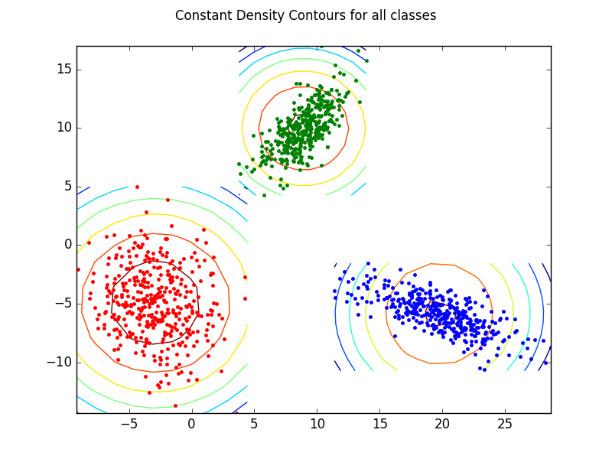

Pairwise Decision region plots -

- Class 1 and 2

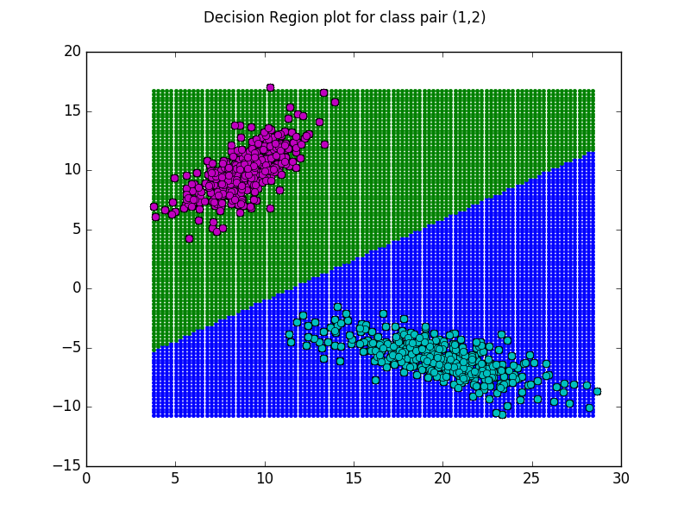
- Class 2 and 3
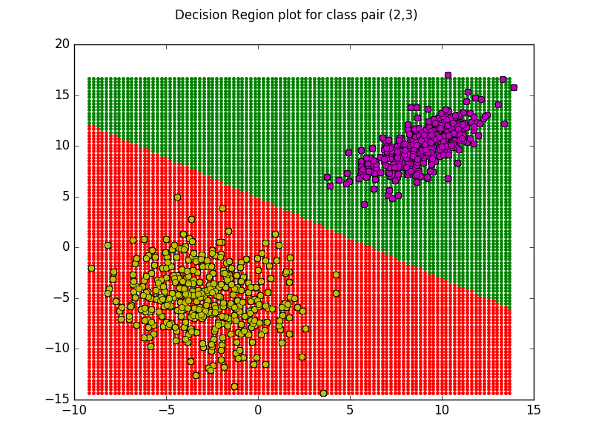
- Class 1 and 3

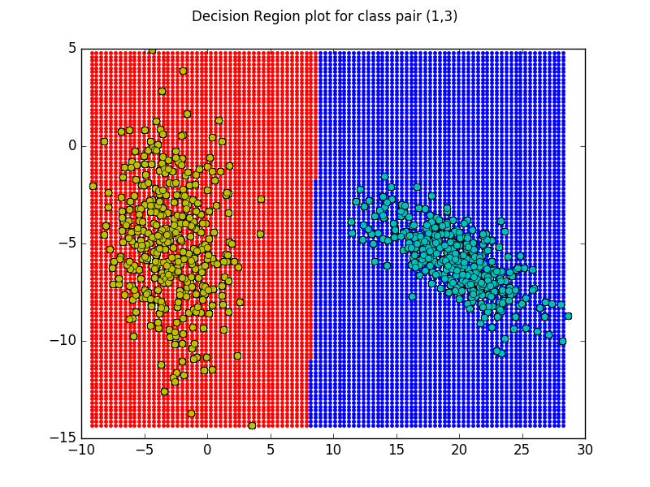
Decision region plot for all the classes -
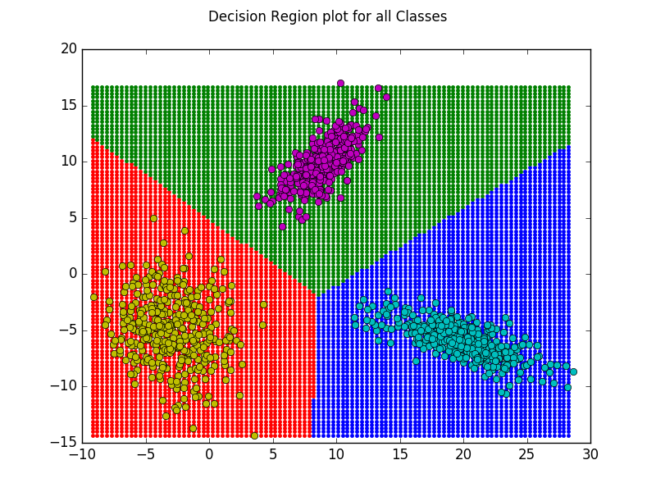

Case 2: Full covariace matrix(Σ) is same for all the classes

Classification Accuracy (Class 1) – 1.0
Classification Accuracy (Class 2) – 1.0
Classification Accuracy (Class 3) – 1.0
Mean Classification Accuracy – 1.0
Precision (Class 1) – 1.0
Precision (Class 2) – 1.0
Precision (Class 3) – 1.0
Mean Precision – 1.0
Recall (Class 1) – 1.0
Recall (Class 2) – 1.0
Recall (Class 3) – 1.0
Mean Recall – 1.0
F-Measure (Class 1) – 1.0
F-Measure (Class 2) – 1.0
F-Measure (Class 3) – 1.0
Mean F-Measure – 1.0

Mean Covariance Matrix -

6.179 | -0.784
-0.784 | 5.102

Confusion Matrices -

- Class 1, 2 and 3 (same for all the classes in this case)

125 | 0
0 | 250

- All classes together

125 | 0 | 0
0 | 125 | 0
0 | 0 | 125

Constant density contour plot for all the classes -

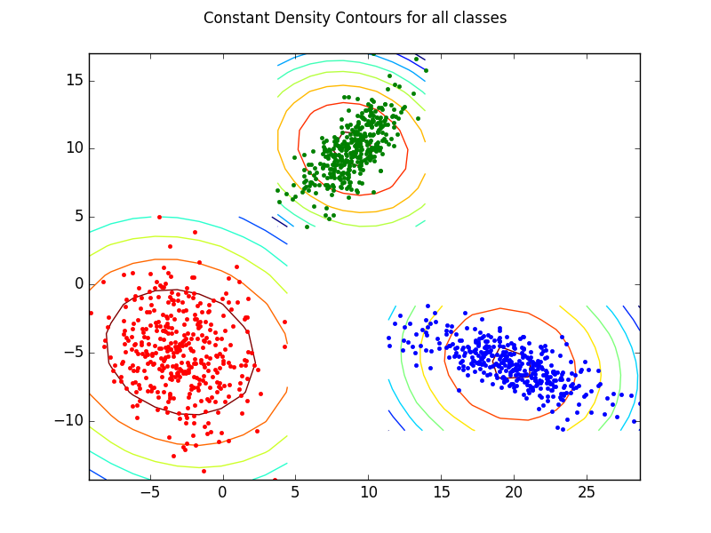

Pairwise Decision region plots -

- Class 1 and 2

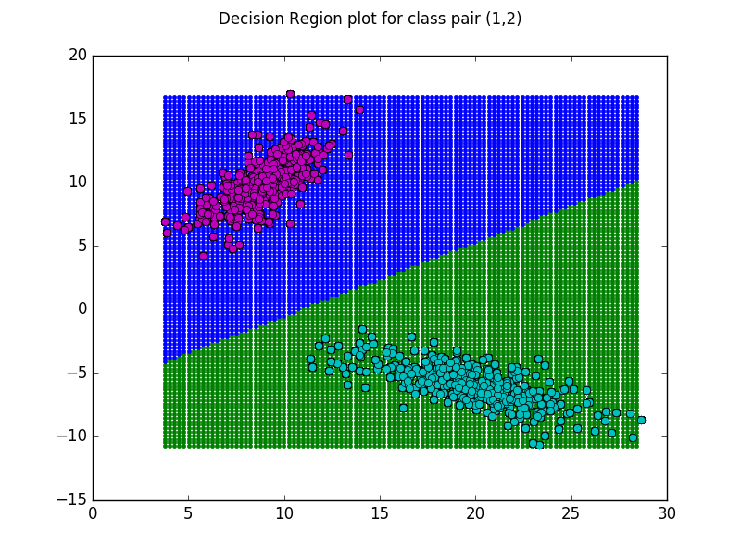
- Class 2 and 3
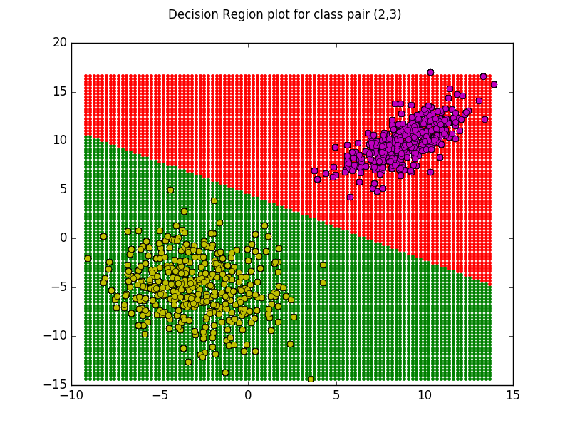
- Class 1 and 3

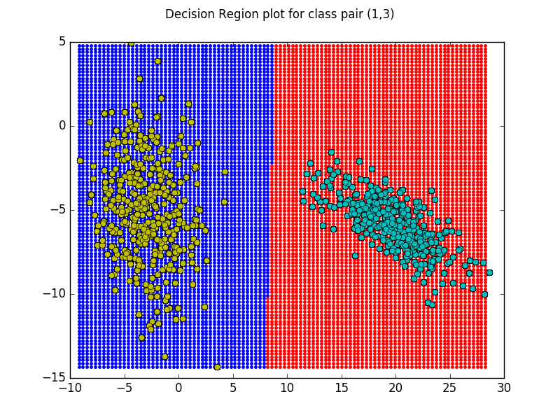

Decision region plot for all the classes -

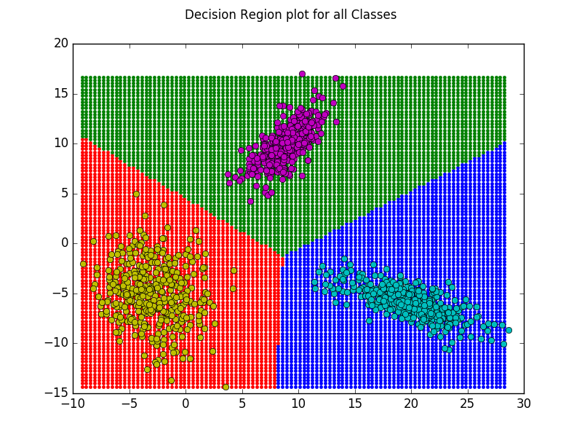

Case 3: Diagonal Covariance matrix (different for all classes)

Classification Accuracy (Class 1) – 1.0
Classification Accuracy (Class 2) – 1.0
Classification Accuracy (Class 3) – 1.0
Mean Classification Accuracy – 1.0
Precision (Class 1) – 1.0
Precision (Class 2) – 1.0
Precision (Class 3) – 1.0
Mean Precision – 1.0
Recall (Class 1) – 1.0
Recall (Class 2) – 1.0
Recall (Class 3) – 1.0
Mean Recall – 1.0
F-Measure (Class 1) – 1.0
F-Measure (Class 2) – 1.0
F-Measure (Class 3) – 1.0
Mean F-Measure – 1.0

Covariance Matrix for each class -

- Class 1

9.898 | 0
0 | 2.409

- Class 2

2.800 | 0
0 | 3.818

- Class 3

5.838 | 0
0 | 9.078

Confusion Matrices -

- Class 1, 2 and 3 (same for all the classes in this case)

125 | 0
0 | 250

- All classes together

125 | 0 | 0
0 | 125 | 0
0 | 0 | 125

Constant density contour plot for all the classes -

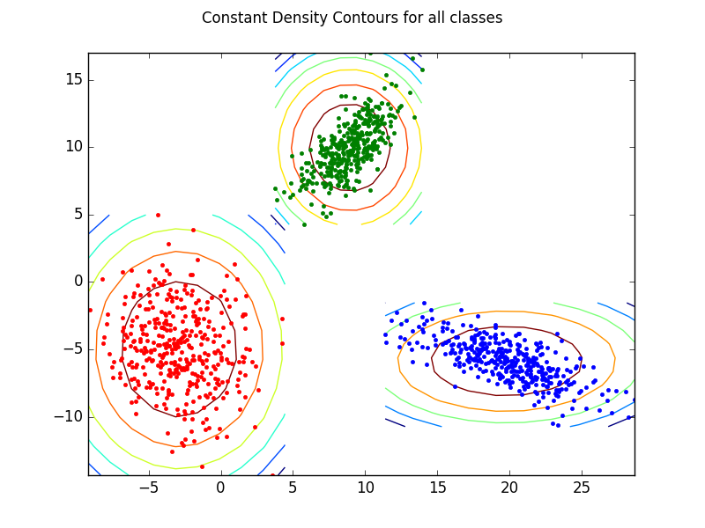

Pairwise Decision region plots -

- Class 1 and 2

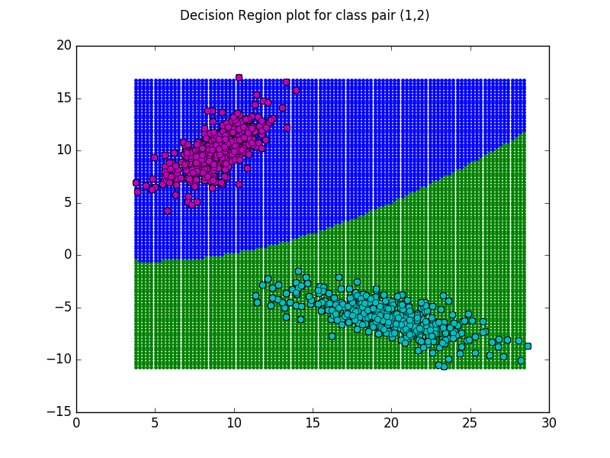
- Class 2 and 3

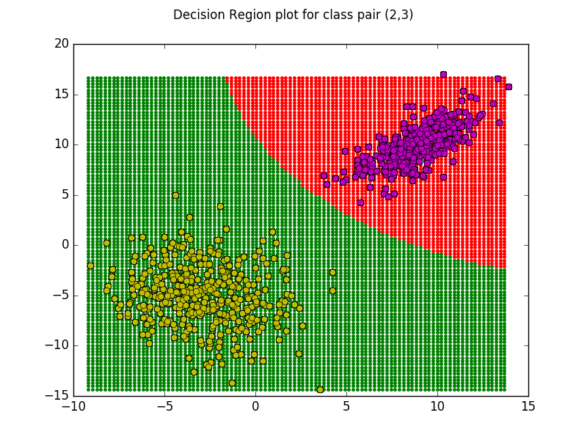
- Class 1 and 3

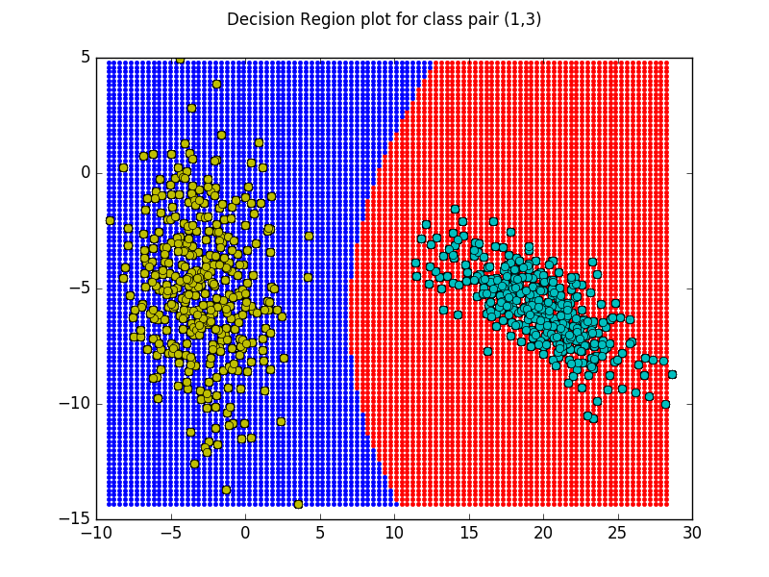
Decision region plot for all the classes -

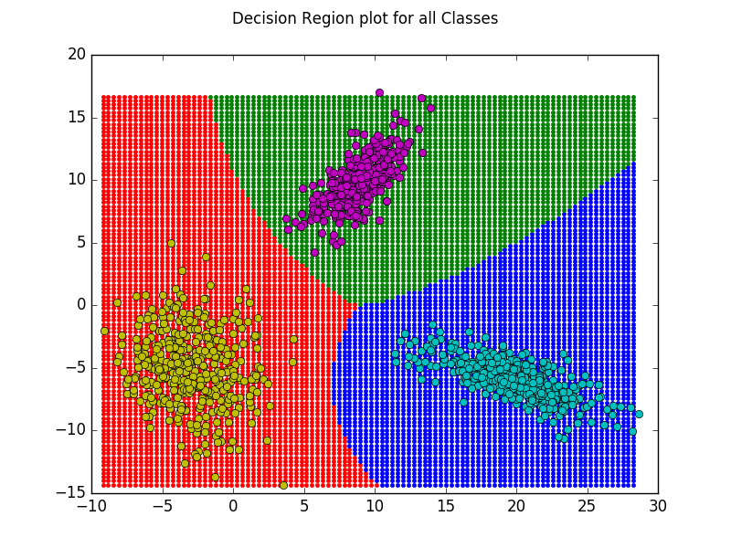
Case 4: Different full covariance matrix for each class

Classification Accuracy (Class 1) – 1.0
Classification Accuracy (Class 2) – 1.0
Classification Accuracy (Class 3) – 1.0
Mean Classification Accuracy – 1.0
Precision (Class 1) – 1.0
Precision (Class 2) – 1.0
Precision (Class 3) – 1.0
Mean Precision – 1.0
Recall (Class 1) – 1.0
Recall (Class 2) – 1.0
Recall (Class 3) – 1.0
Mean Recall – 1.0
F-Measure (Class 1) – 1.0
F-Measure (Class 2) – 1.0
F-Measure (Class 3) – 1.0
Mean F-Measure – 1.0

Covariance Matrix for each class -

- Class 1

9.898 | -3.443
-3.443 | 2.409

- Class 2

2.800 | 2.234
2.234 | 3.818

- Class 3

5.838 | -1.143
-1.143 | 9.078

Confusion Matrices -

- Class 1, 2 and 3 (same for all the classes in this case)

125 | 0
0 | 250

- All classes together

125 | 0 | 0
0 | 125 | 0
0 | 0 | 125

Constant density contour plot for all the classes -

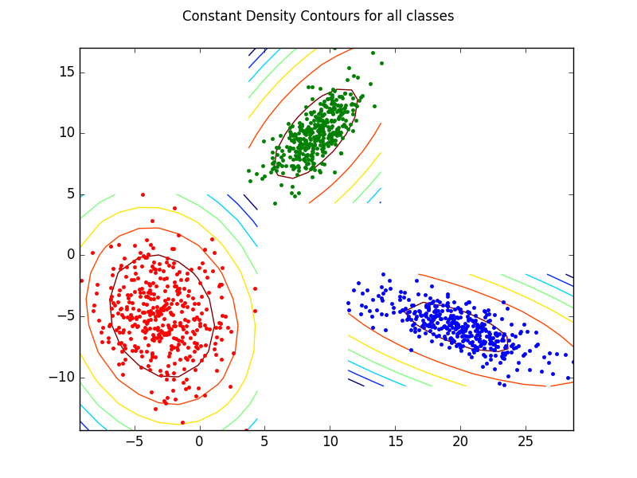
Pairwise Decision region plots -

- Class 1 and 2

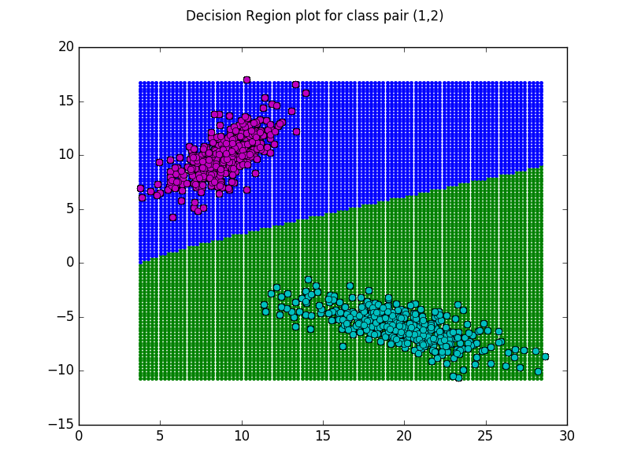
- Class 2 and 3

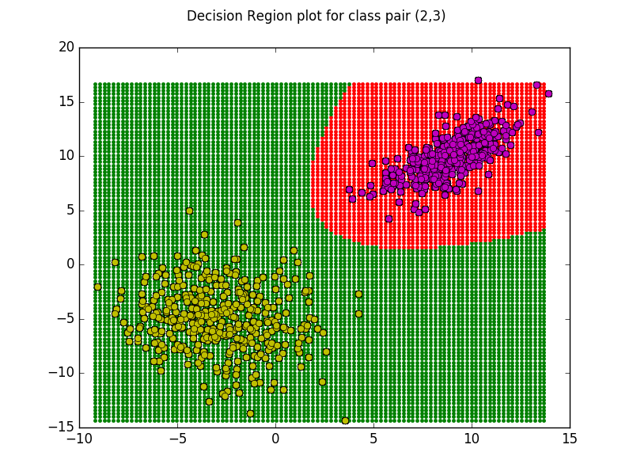
- Class 1 and 3
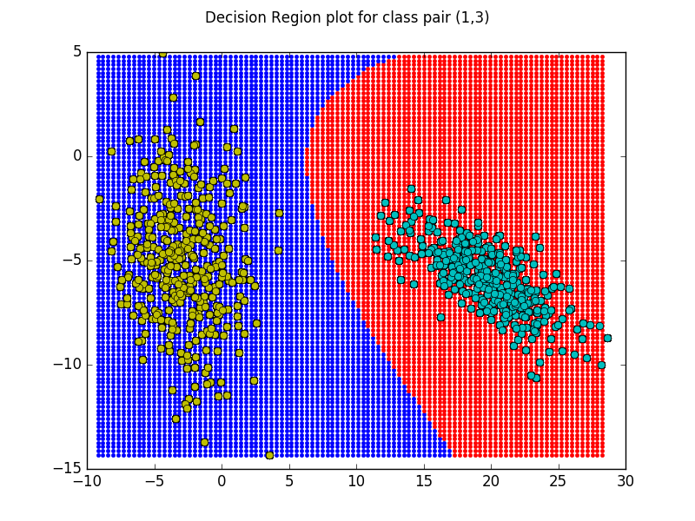
Decision region plot for all the classes -

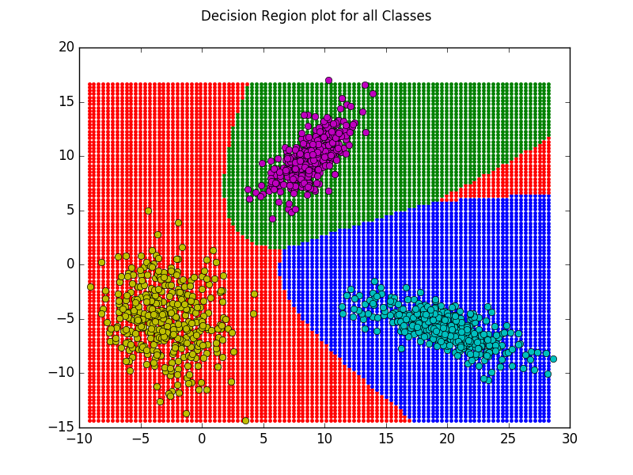

b) Non-Linearly Separable dataset

Mean Vector for each case -

- Class 1 - [1.551 0.712]^{T}
- Class 2 - [-0.448 -0.848]^{T}
- Class 3 - [3.052 -0.848]^{T}

Case 1: Σ = σ²I (same for all classes)

Classification Accuracy (Class 1) – 0.797
Classification Accuracy (Class 2) – 0.920
Classification Accuracy (Class 3) – 0.877
Mean Classification Accuracy – 0.865
Precision (Class 1) – 0.713
Precision (Class 2) – 0.868
Precision (Class 3) – 0.802
Mean Precision – 0.794
Recall (Class 1) – 0.656
Recall (Class 2) – 0.896
Recall (Class 3) – 0.840
Mean Recall – 0.797
F-Measure (Class 1) – 0.683
F-Measure (Class 2) – 0.882
F-Measure (Class 3) – 0.820
Mean F-Measure – 0.795

Covariance Matrix for each class -

- For All Classes

0.648 | 0
0 | 0.648

Confusion Matrices -

- Class 1

82 | 33
43 | 217

- Class 2

112 | 17
13 | 233

- Class 3

105 | 26
20 | 224

- All classes together

82 | 13 | 20
17 | 112 | 0
26 | 0 | 105

Constant density contour plot for all the classes -

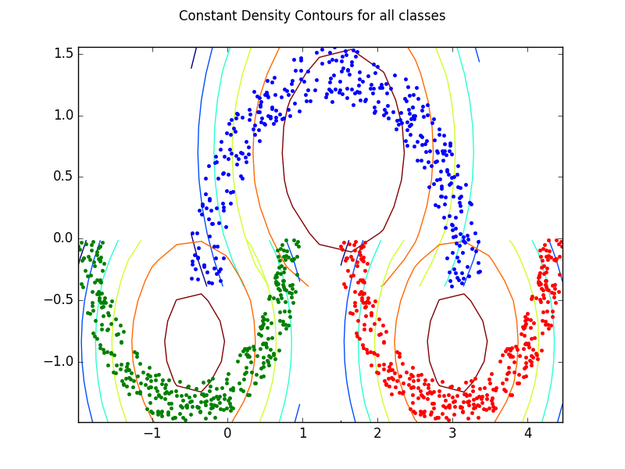
Pairwise Decision region plots -

- Class 1 and 2

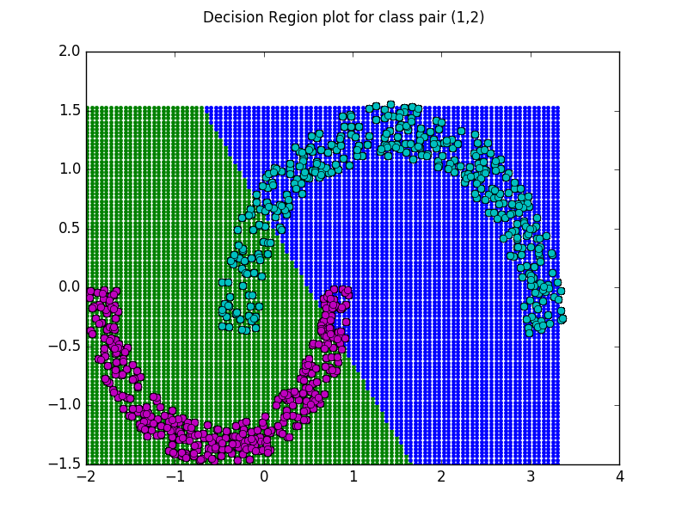
- Class 2 and 3

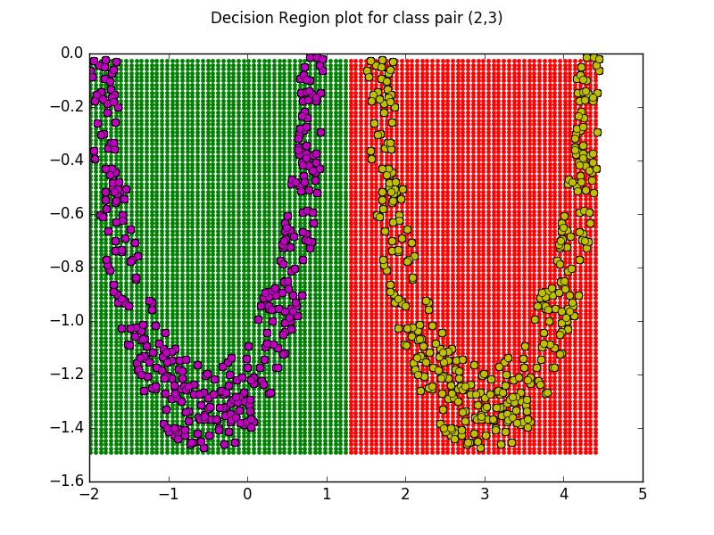
- Class 1 and 3

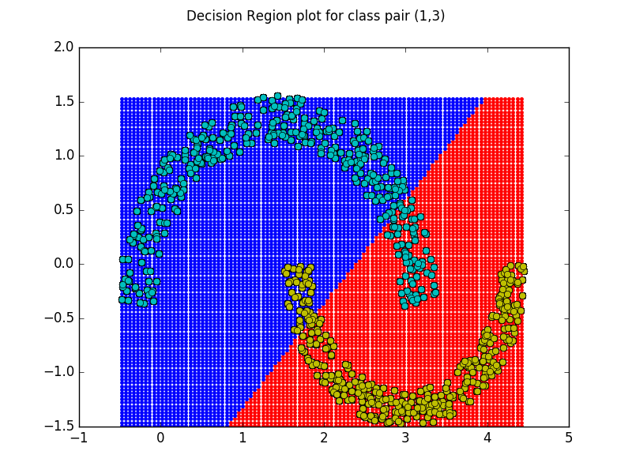
Decision region plot for all the classes -

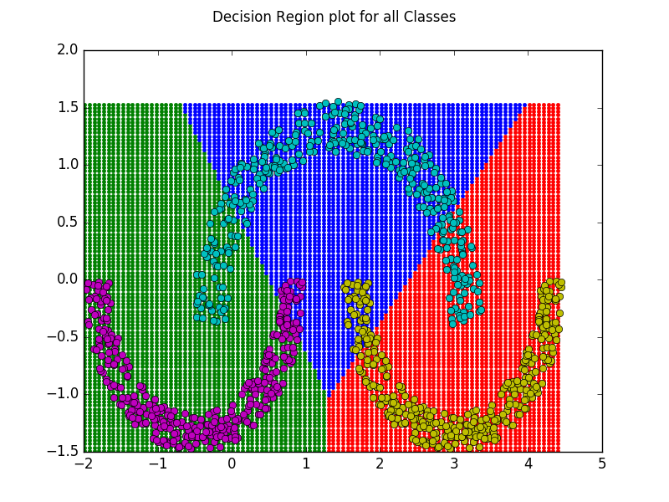
Case 2: Full covariace matrix(Σ) is same for all the classes

Classification Accuracy (Class 1) – 0.915
Classification Accuracy (Class 2) – 0.973
Classification Accuracy (Class 3) – 0.941
Mean Classification Accuracy – 0.943
Precision (Class 1) – 0.891
Precision (Class 2) – 0.946
Precision (Class 3) – 0.906
Mean Precision – 0.914
Recall (Class 1) – 0.848
Recall (Class 2) – 0.976
Recall (Class 3) – 0.920
Mean Recall – 0.915
F-Measure (Class 1) – 0.869
F-Measure (Class 2) – 0.961
F-Measure (Class 3) – 0.913
Mean F-Measure – 0.914

Average Covariance Matrix for each class -

1.079 | -0.002
-0.002 | 0.216

Confusion Matrices -

- Class 1

106 | 13
19 | 237

- Class 2

122 | 7
3 | 243

- Class 3

115 | 12
10 | 238

- All classes together

106 | 3 | 10
7 | 122 | 0
12 | 0 | 115

Constant density contour plot for all the classes -

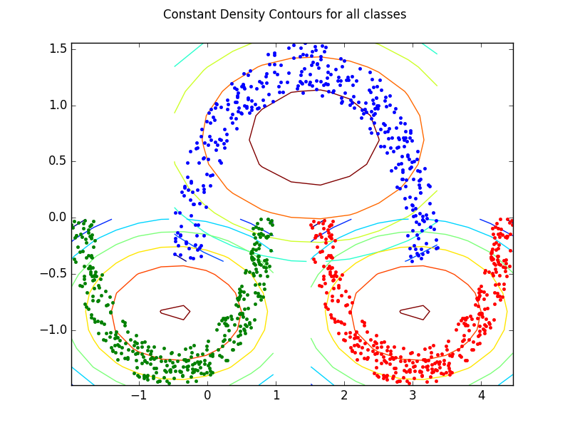
Pairwise Decision region plots -

- Class 1 and 2

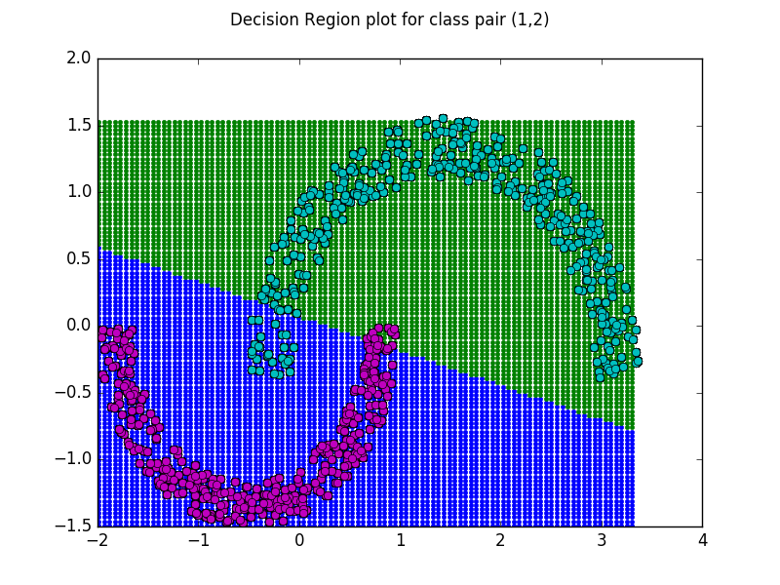

- Class 2 and 3

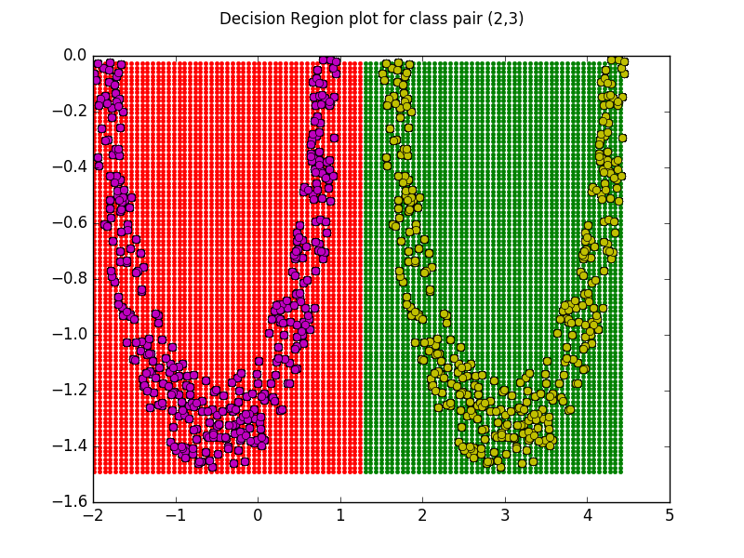
- Class 1 and 3
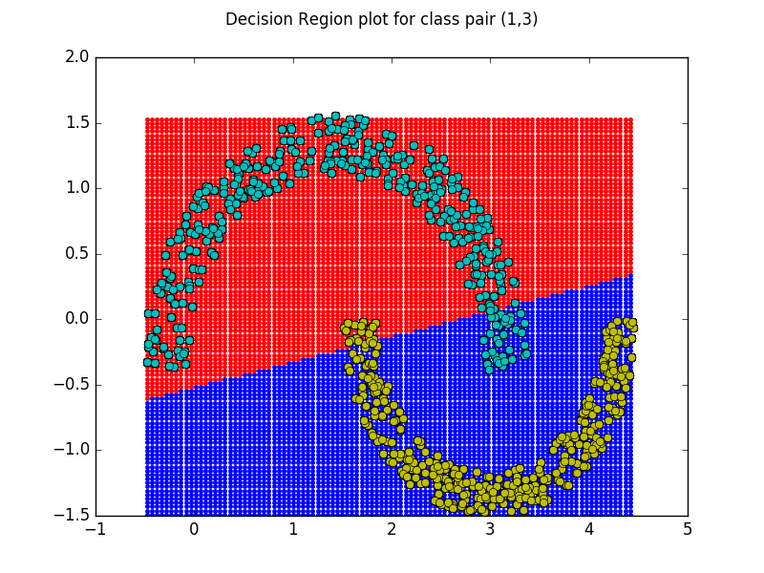
Decision region plot for all the classes -

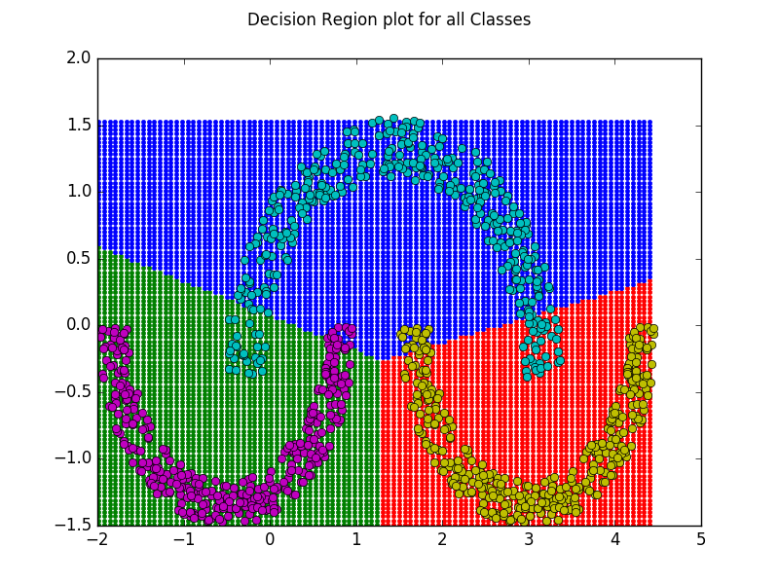

Case 3: Diagonal Covariance matrix (different for all classes)

Classification Accuracy (Class 1) – 0.904
Classification Accuracy (Class 2) – 0.971
Classification Accuracy (Class 3) – 0.933
Mean Classification Accuracy – 0.936
Precision (Class 1) – 0.845
Precision (Class 2) – 0.967
Precision (Class 3) – 0.903
Mean Precision – 0.905
Recall (Class 1) – 0.872
Recall (Class 2) – 0.944
Recall (Class 3) – 0.896
Mean Recall – 0.904
F-Measure (Class 1) – 0.858
F-Measure (Class 2) – 0.955
F-Measure (Class 3) – 0.900
Mean F-Measure – 0.904

Covariance Matrix for each class -

- Class 1

1.488 | 0
0 | 0.276

- Class 2

0.875 | 0
0 | 0.187

- Class 3

0.875 | 0
0 | 0.187

Confusion Matrices -

- Class 1

109 | 20
16 | 230

- Class 2

118 | 4
7 | 246

- Class 3

112 | 12
13 | 238

- All classes together

109 | 7 | 13
4 | 118 | 0
12 | 0 | 112

Constant density contour plot for all the classes -

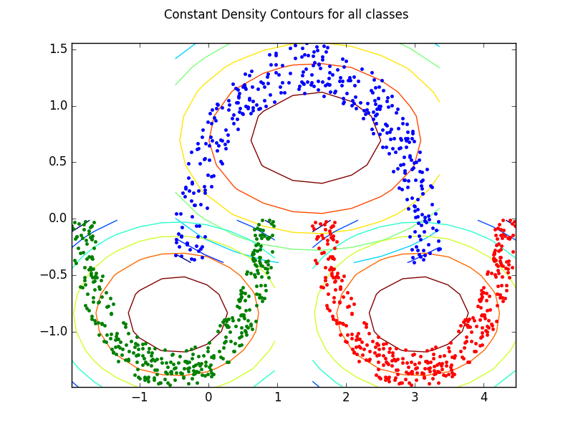

Pairwise Decision region plots -

- Class 1 and 2

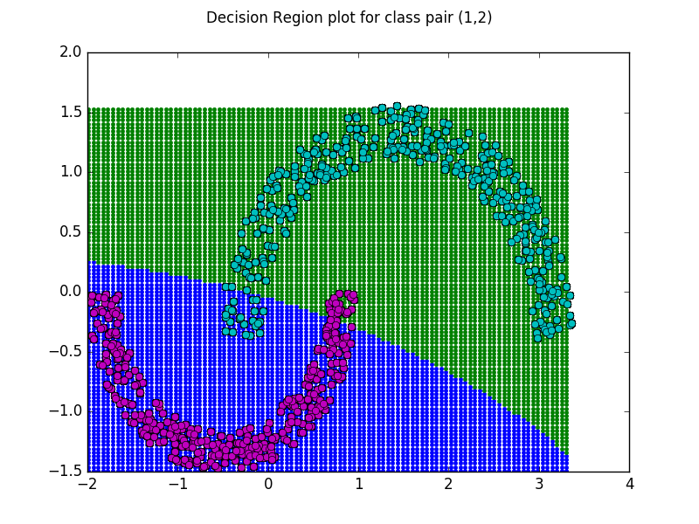
- Class 2 and 3
- Class 1 and 3

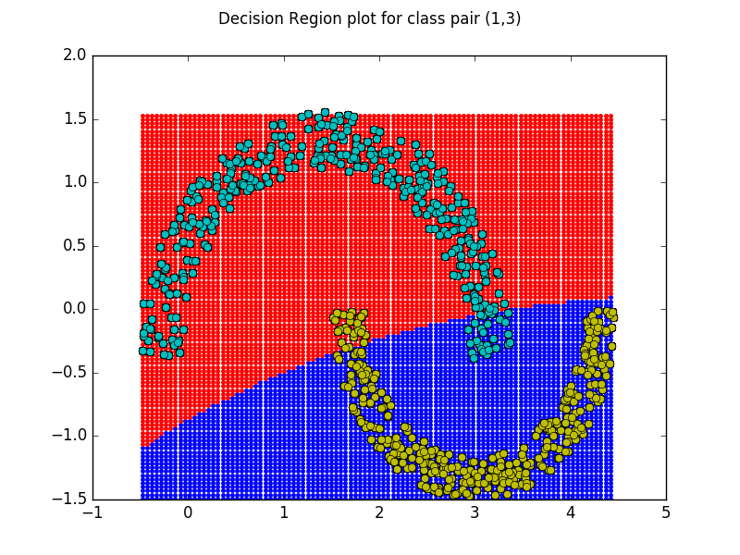
Decision region plot for all the classes -
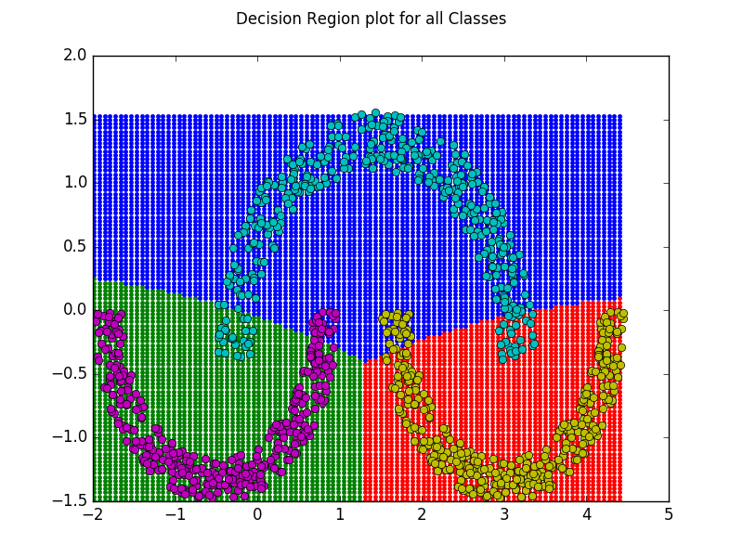
Case 4: Diffrerent full covariance matrix for each class

Classification Accuracy (Class 1) – 0.909
Classification Accuracy (Class 2) – 0.976
Classification Accuracy (Class 3) – 0.933
Mean Classification Accuracy – 0.939
Precision (Class 1) – 0.858
Precision (Class 2) – 0.960
Precision (Class 3) – 0.910
Mean Precision – 0.909
Recall (Class 1) – 0.872
Recall (Class 2) – 0.968
Recall (Class 3) – 0.888
Mean Recall – 0.909
F-Measure (Class 1) – 0.865
F-Measure (Class 2) – 0.964
F-Measure (Class 3) – 0.899
Mean F-Measure – 0.909

Covariance Matrix for each class -

- Class 1

1.488 | -0.039
-0.039 | 0.276

- Class 2

0.875 | 0.017
0.017 | 0.187

- Class 3

0.875 | 0.017
0.017 | 0.187

Confusion Matrices -

- Class 1

109 | 18
16 | 232

- Class 2

121 | 5
4 | 245

- Class 3

111 | 11
14 | 239

- All classes together

109 | 4 | 14
5 | 121 | 0
11 | 0 | 111

Constant density contour plot for all the classes -

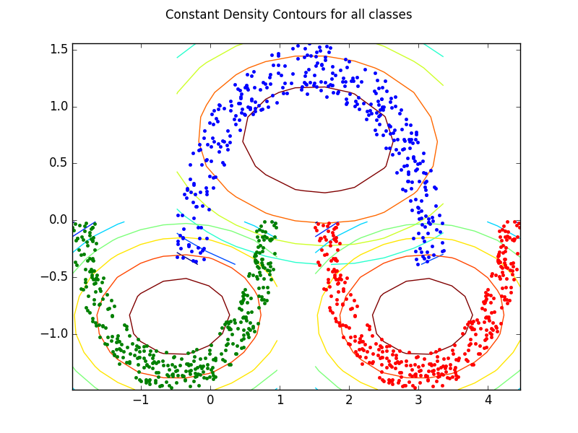
Pairwise Decision region plots -

- Class 1 and 2

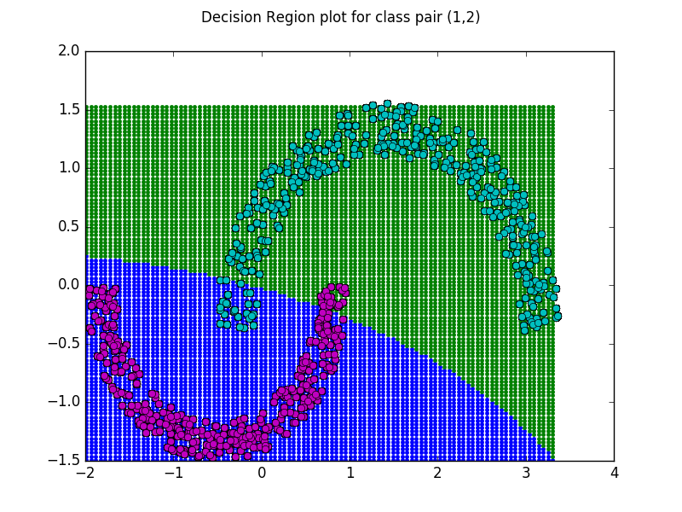
- Class 2 and 3

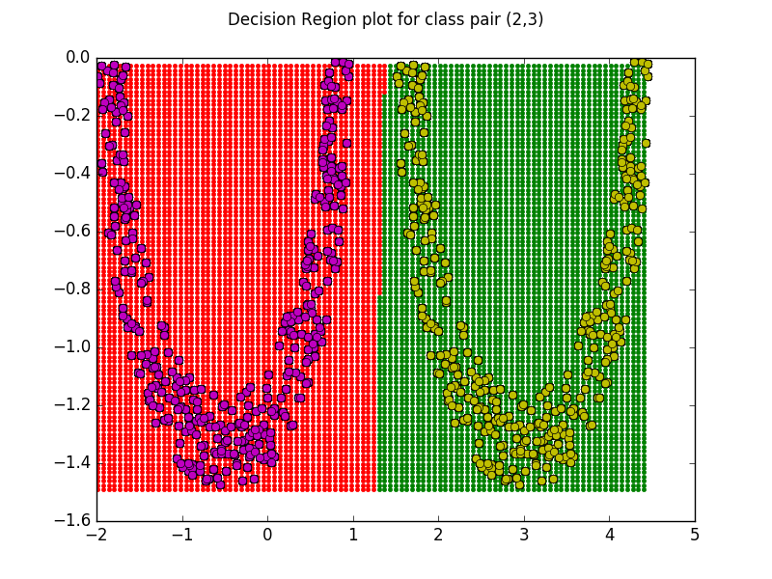
- Class 1 and 3
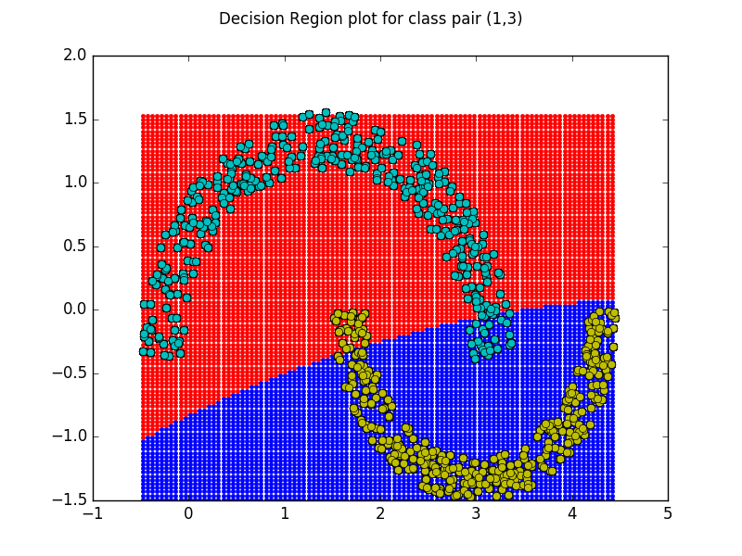

Decision region plot for all the classes -

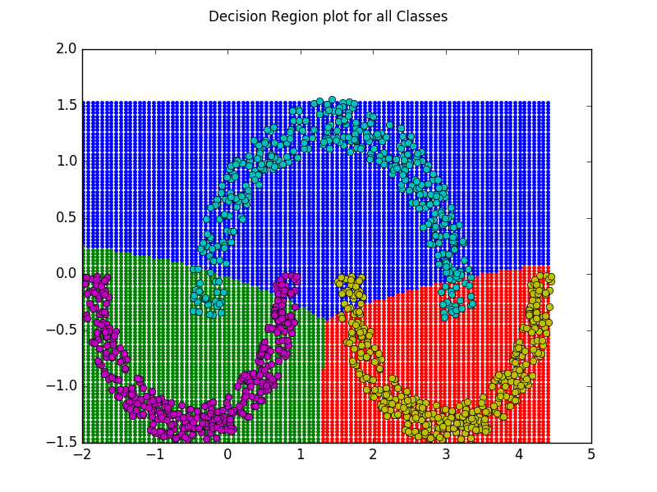

Dataset 2 (Real world dataset of 3 classes)

Mean Vector for each case -

- Class 1 - [316.284 2274.908]^{T}
- Class 2 - [369.999 761.888]^{T}
- Class 3 - [733.737 1121.756]^{T}

Case 1: Σ = σ²I (same for all classes)

Classification Accuracy (Class 1) – 0.996
Classification Accuracy (Class 2) – 0.978
Classification Accuracy (Class 3) – 0.977
Mean Classification Accuracy – 0.984
Precision (Class 1) – 1.0
Precision (Class 2) – 0.953
Precision (Class 3) – 0.975
Mean Precision – 0.976
Recall (Class 1) – 0.988
Recall (Class 2) – 0.986
Recall (Class 3) – 0.950
Mean Recall – 0.975
F-Measure (Class 1) – 0.994
F-Measure (Class 2) – 0.969
F-Measure (Class 3) – 0.962
Mean F-Measure – 0.975

Covariance Matrix for each class -

- For All Classes

5116.934 | 0
0 | 5116.934

Confusion Matrices -

- Class 1

590 | 0
7 | 1163

- Class 2

613 | 30
9 | 1108

- Class 3

514 | 13
27 | 1206

- All classes together

590 | 0 | 0
3 | 613 | 27
4 | 9 | 514

Constant density contour plot for all the classes -
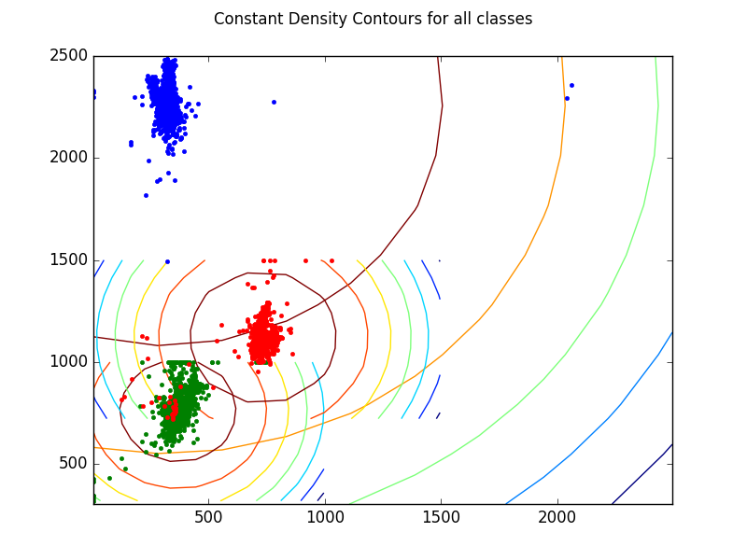

Pairwise Decision region plots -

- Class 1 and 2
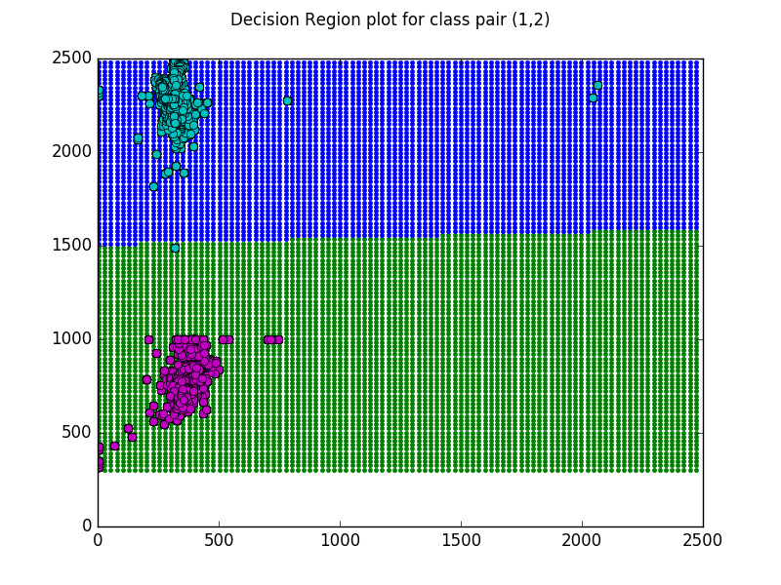

- Class 2 and 3

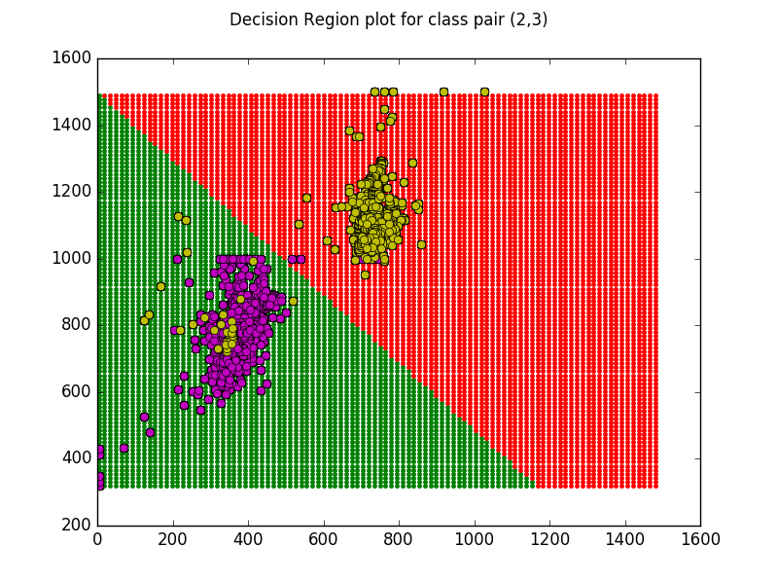

- Class 1 and 3

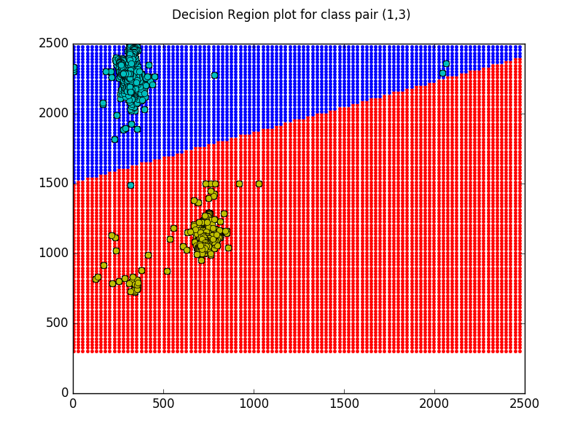

Decision region plot for all the classes -

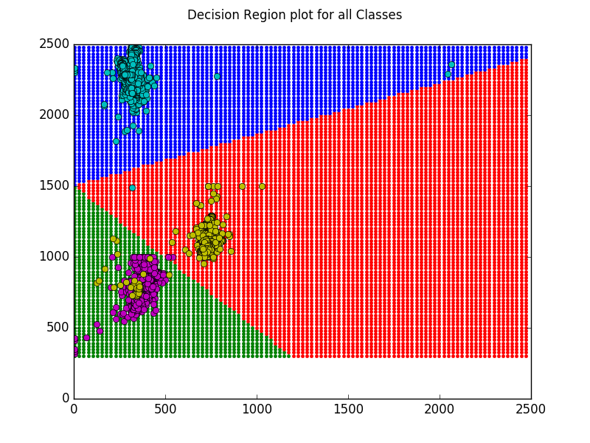
Case 2: Full covariace matrix(Σ) is same for all the classes

Classification Accuracy (Class 1) – 0.990
Classification Accuracy (Class 2) – 0.977
Classification Accuracy (Class 3) – 0.970
Mean Classification Accuracy – 0.979
Precision (Class 1) – 0.998
Precision (Class 2) – 0.952
Precision (Class 3) – 0.957
Mean Precision – 0.969
Recall (Class 1) – 0.972
Recall (Class 2) – 0.986
Recall (Class 3) – 0.946
Mean Recall – 0.968
F-Measure (Class 1) – 0.985
F-Measure (Class 2) – 0.968
F-Measure (Class 3) – 0.952
Mean F-Measure – 0.968
Average Covariance Matrix for each class -

3767.705 | 1524.447
1524.447 | 6466.162

Confusion Matrices -

- Class 1

580 | 1
17 | 1162

- Class 2

613 | 31
9 | 1107

- Class 3

512 | 23
29 | 1196

- All classes together

580 | 0 | 1
3 | 617 | 28
14 | 9 | 512

Constant density contour plot for all the classes -

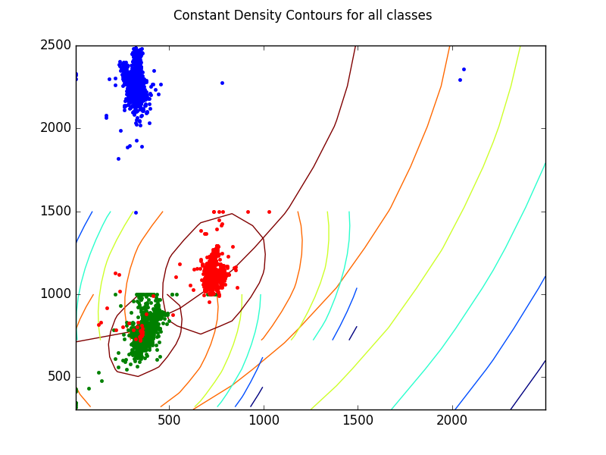
Pairwise Decision region plots -

- Class 1 and 2
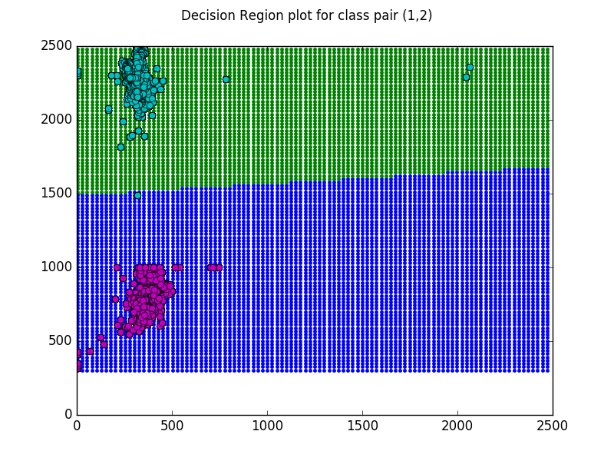
- Class 2 and 3

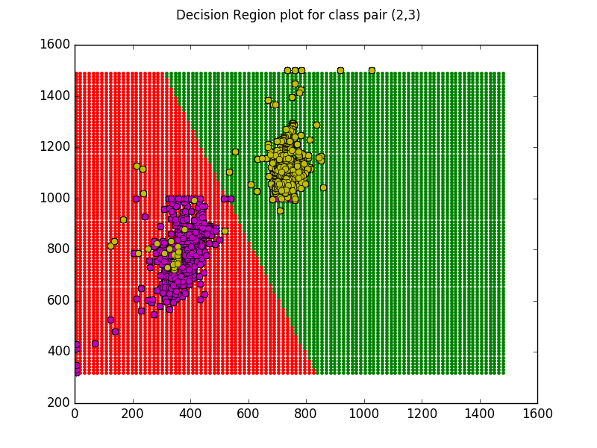
- Class 1 and 3

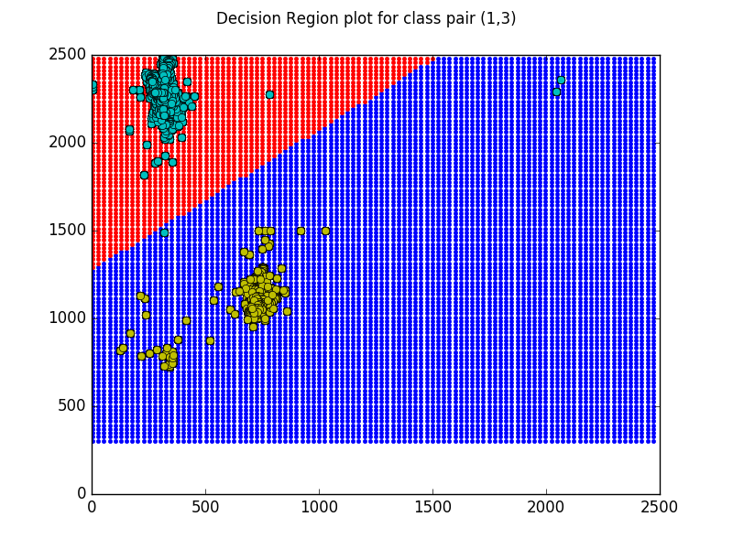
Decision region plot for all the classes -

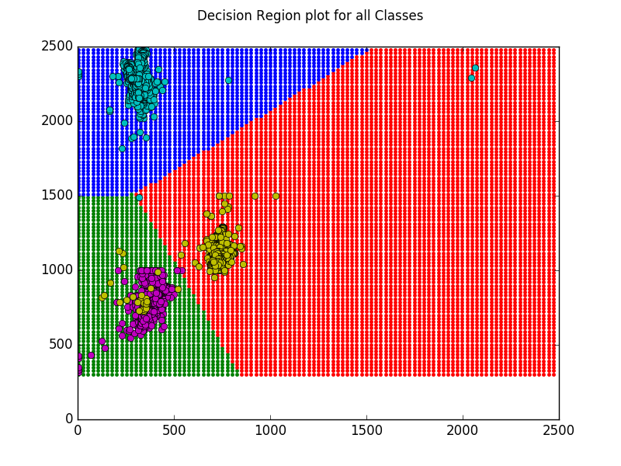
Case 3: Diagonal Covariance matrix (different for all classes)

Classification Accuracy (Class 1) – 0.992
Classification Accuracy (Class 2) – 0.978
Classification Accuracy (Class 3) – 0.973
Mean Classification Accuracy – 0.981
Precision (Class 1) – 0.998
Precision (Class 2) – 0.953
Precision (Class 3) – 0.964
Mean Precision – 0.972
Recall (Class 1) – 0.978
Recall (Class 2) – 0.986
Recall (Class 3) – 0.948
Mean Recall – 0.971
F-Measure (Class 1) – 0.988
F-Measure (Class 2) – 0.969
F-Measure (Class 3) – 0.956
Mean F-Measure – 0.971

Covariance Matrix for each class -

- Class 1

4487.057 | 0
0 | 7611.523

- Class 2

2145.310 | 0
0 | 6128.158

- Class 3

4670.748 | 0
0 | 5858.805

Confusion Matrices -

- Class 1

584 | 1
13 | 1162

- Class 2

613 | 30
9 | 1108

- Class 3

513 | 19
28 | 1200

- All classes together

584 | 0 | 1
3 | 613 | 27
10 | 9 | 513

Constant density contour plot for all the classes -

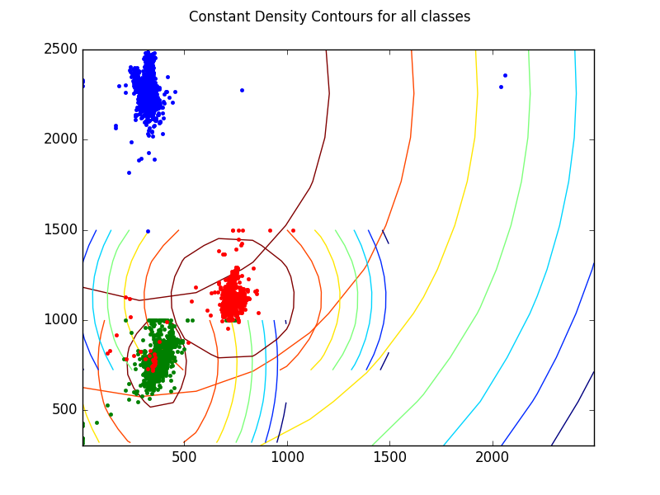

Pairwise Decision region plots -

- Class 1 and 2

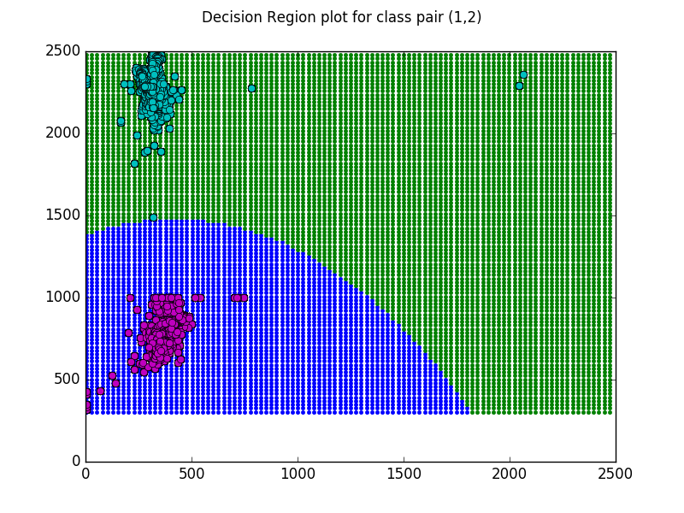
- Class 2 and 3
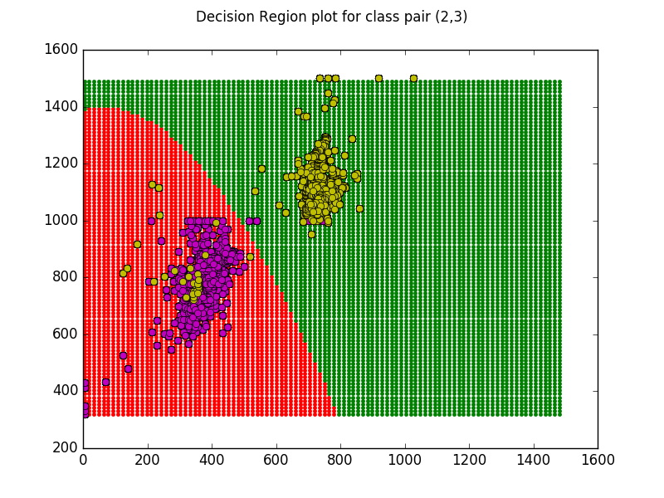
- Class 1 and 3

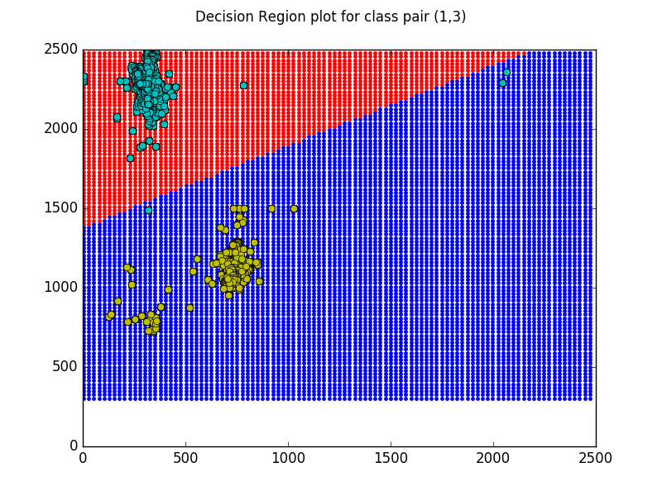
Decision region plot for all the classes -

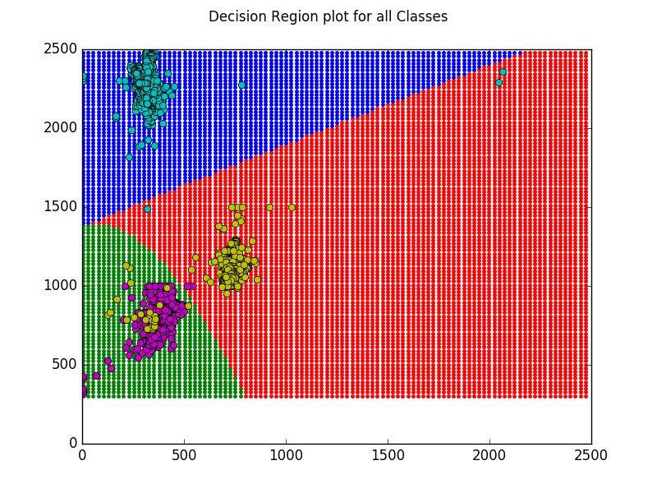

Case 4: Diffrerent full covariance matrix for each class

Classification Accuracy (Class 1) – 0.991
Classification Accuracy (Class 2) – 0.976
Classification Accuracy (Class 3) – 0.970
Mean Classification Accuracy – 0.979
Precision (Class 1) – 0.998
Precision (Class 2) – 0.952
Precision (Class 3) – 0.957
Mean Precision – 0.969
Recall (Class 1) – 0.975
Recall (Class 2) – 0.982
Recall (Class 3) – 0.946
Mean Recall – 0.968
F-Measure (Class 1) – 0.986
F-Measure (Class 2) – 0.967
F-Measure (Class 3) – 0.952
Mean F-Measure – 0.968

Covariance Matrix for each class -

- Class 1

4487.057 | -310.508
-310.508 | 7611.523

- Class 2

2145.310 | 2194.074
2194.074 | 6128.158

- Class 3

4670.748 | 2689.776
2689.776 | 5658.805

Confusion Matrices -

- Class 1

582 | 1
15 | 1162

- Class 2

611 | 31
11 | 1107

- Class 3

512 | 23
29 | 1196

- All classes together

582 | 0 | 1
3 | 611 | 28
12 | 11 | 512

Constant density contour plot for all the classes -

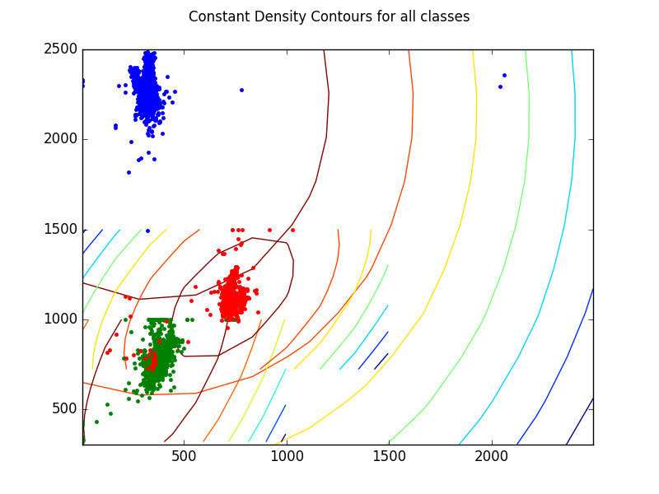
Pairwise Decision region plots -

- Class 1 and 2
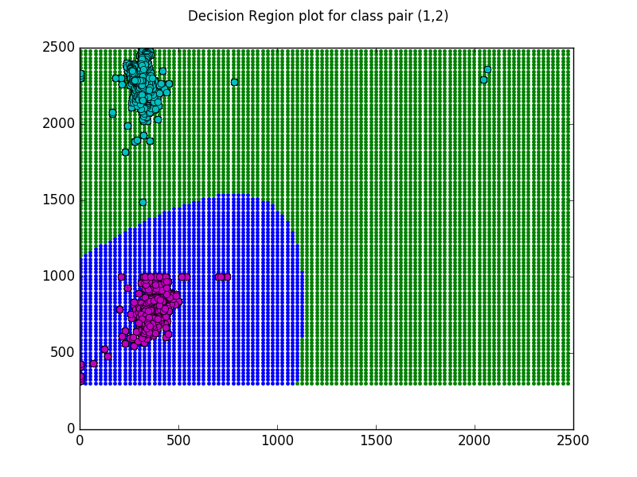
- Class 2 and 3

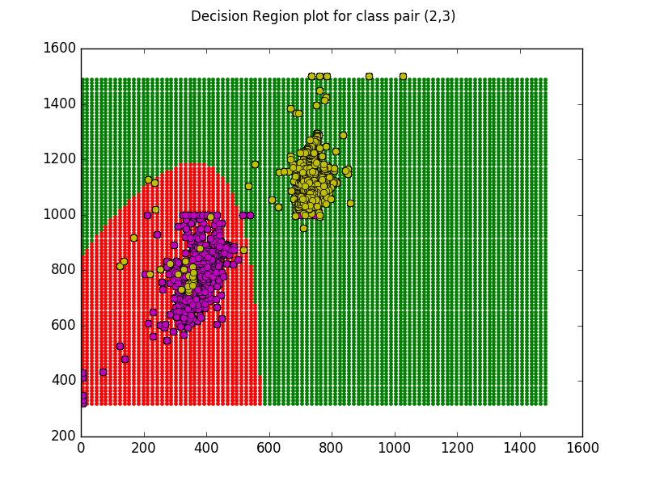
- Class 1 and 3

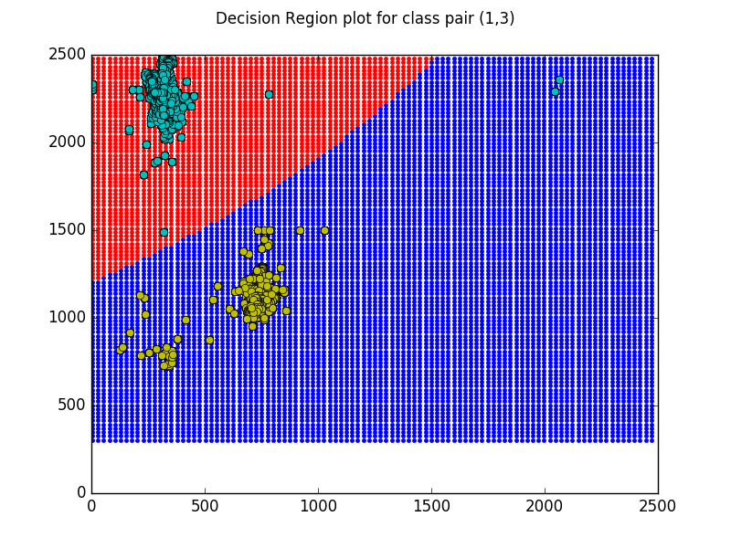

Decision region plot for all the classes -

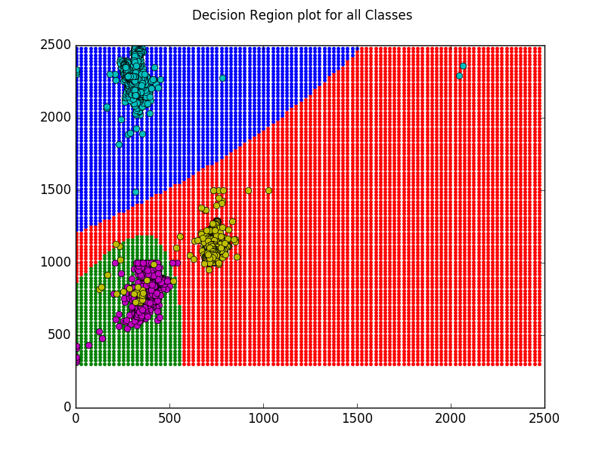

***********END**********

